Applications of GPS/GNSS in NOAA

Summary of the 23-24 October 2007 GPS/GNSS Workshop

Executive Summary – An internal NOAA workshop was held October 24-25 to assess the current utilization of and future needs for GPS/GNSS technologies. 52 representatives from across most line offices participated in the workshop which was hosted in Boulder by the directors of the NGS, NGDC, SWPC, and ESRL. GPS/GNSS is generally used within NOAA for navigational purposes, as might be expected, although some specific applications include tracking of radiosondes, storm damage marking, and datum referencing. NOAA also has several high-visibility applications including the On-line Positioning User Service (OPUS) for extremely precise geolocation and the Vertical Datum (VDatum) utility for converting among the various available reference systems that are facilitated or enhanced by GPS/GNSS. More specialized uses of GPS/GNSS within NOAA include tropospheric and space weather monitoring and verification/validation of more traditional NOAA sensor data products. Potential future uses for GPS include the monitoring of high-amplitude seismic waves and soil-moisture. An interesting special presentation by NIST on portable atomic clocks suitable for hand-held GNSS receivers offered future possibilities for improved capabilities including more rapid and accurate geopositioning. Information regarding meeting objectives, organizational participation, and presentation materials can be found at http://www.ngdc.noaa.gov/stp/gnssw2007/index.html.

Meeting Summary
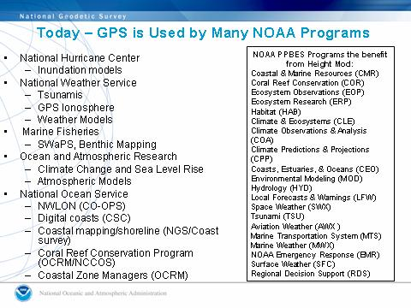
Applications of Global Positioning System (GPS) technologies within NOAA range from straightforward uses in navigation and tracking to more exotic uses in space weather monitoring and inundation modeling. In order to assess the degree to which NOAA uses GPS, or more generally, the Global Navigation Satellite System (GNSS) the Directors of the NGS, NGDC, SWPC, and ESRL organized a two-day technical workshop in Boulder. This NOAA-only meeting drew 52 participants from across most line offices focused on ways in which GPS/GNSS is and can be used in NOAA research and operations. In his opening remarks, Dave Zilkoski (Director, NGS) presented an overview of the many applications for GPS within NOAA. Figure 1, reproduced from this opening presentation, indicates that GPS technologies are pervasive within the organization. This report is a summary of the GPS/GNSS workshop. As can be inferred from Figure 1, a goal of the workshop was to gather the technical data on GPS applications which can be used to affect the NOAA Planning, Programming, Budgeting, and Execution System (PPBES) process.
Appendix A is a list of participants and their respective affiliations at the GPS/GNSS workshop. By design, only NOAA participation was solicited at this initial meeting, although an exception was made for Dr. John Kitching from NIST, who presented some atomic clock technologies particularly relevant to workshop participants. The agenda for the meeting is provided in Appendix B. Since the intent of the workshop was to foster cross-NOAA ties and maximize information flow the agenda was not broken down into related technologies. The program consisted of 22 technical talks, one policy presentation (FOUO) and a workshop kickoff by Dave Zilkoski (NGS). The final presentations are available from the workshop website at: http://www.ngdc.noaa.gov/stp/gnssw2007/.
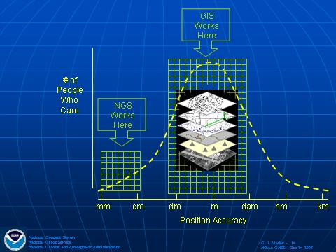
In 2007, NOAA is commemorating the 200th Anniversary of the founding of the "Survey of the Coast", the nation's first scientific agency and NOAA's earliest predecessor agency. The "Survey of the Coast", formed by President Thomas Jefferson, was tasked with surveying the coast of the nation to produce nautical charts in order to increase the safety of navigation along the nation's coastline. The first step in the coastal surveys was the establishment of a geodetic survey network. This network would be the foundation for all land and water surveys necessary to produce the nautical charts. Later geodetic surveys across the country, including those undertaken by Lewis and Clark, contributed to the current National Spatial Reference System (NSRS). Today, the NOAA National Geodetic Survey (NOS/NGS) is responsible for maintaining the NSRS, which provides the foundation for transportation and communication; mapping and charting; and a multitude of other scientific and engineering applications. Several talks presented by NGS representatives focused on how GPS contributes to defining geodetic reference frames, or datums. Steve Hilla (NOS/NGS) presented a review of how space geodesy techniques; very long baseline interferometry (VLBI), satellite laser ranging (SLR) and Doppler Orbitgraphy Radiopositioning Integrated by Satellite (DORIS) plus GPS, are used to maintain the International Terrestrial Reference Frame (ITRF) with accuracies at the sub-centimeter level. Rich Snay (NOS/NGS) and Giovanni Sella (NOS/NGS) discussed the infrastructure for NOAA’s Continuously Operating Reference Station (CORS) network which uses differential GPS techniques (user receiver measurements tied to nearby reference sites in the U.S.) to enable geodetic positioning from 1-to-10 cm versus unaugmented GPS accuracies of greater than 1 m. To this point, Gerry Mader (NOS/NGS) noted in his talk (see Figure 2) on the NGS On-line Positioning User Service (OPUS) that the majority of users for precise geolocation data, mostly represented by the Geospatial Information System (GIS) community, are satisfied with meter-level accuracies whereas NGS technologies support resolutions at least 2 orders of magnitude better. However, these higher accuracies are exactly what is needed by the geodetic surveying community and others who have now come to rely on OPUS for precise geolocation.
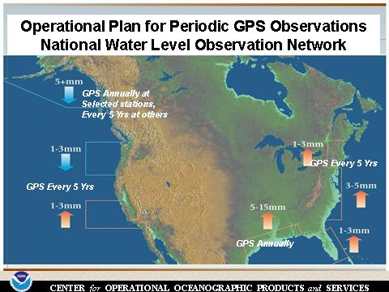
A number of talks discussing NOAA requirements indicated that these higher precision solutions are needed internally (as well as externally). Dave Zilkoski (NOS/NGS) discussed in general the benefits of accurate vertical datums (VDatum) derived from GPS and other techniques in NOAA’s National Height Modernization Program (NHMP) for storm-time evacuation route planning, levee inventories for coastal communities, inundation modeling and flood plain mapping, subsidence monitoring, and “true” sea-level rise. A number of presentations re-emphasized these points and went into further detail. Tom Landon (NOS/CO-OPS) discussed the operational plan for periodic GPS observations as a part of the National Water Level Observation Network (NWLON) requiring VDatum accuracies of up to 5 mm per year at selected coastal stations as shown in Figure 3.
GPS is used within NOAA in a variety of geo-positioning applications. Gerd Gland (NOS/OCS) discussed the value of GPS data in hydrographic surveying and provided specific requirements for positioning accuracies (horizontal and vertical) and resolutions. Joe Fucundo (NWS) presented data showing how GPS-enabled radiosondes are currently used to monitor upper atmospheric winds and can be used to measure other meteorological parameters. In follow-up discussions, Mr Fucundo noted that the NWS is starting to plan for an In-Situ Referencing System (ISRS) which is effectively a balloon-borne differential GPS referencing system for validating GPS-derived data products. Mike Aslaksen (NOS/NGS) demonstrated how GPS is used in shoreline mapping, airport runway surveys (vertical dimension) and airborne LIDAR applications. Both Rick Koehler (NWS/OCWWS) and John Kyle (NWS/CR) explained how GPS can facilitate storm/event mapping and related GIS applications. In particular, Dr Koehler noted how GPS waypoints from tornado damage trails can improve other, less accurate, geospatial positioning technologies such as the NEXRAD Weather Surveillance Radar 88 Doppler (WSR-88D) radar.
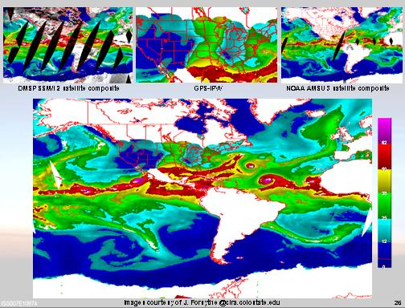
“One person’s noise is another person’s signal” was the way that Seth Gutman (OAR/ESRL) described the serendipitous use of GPS technologies for meteorology. Mr Gutman described how atmospheric signal delays on satellite-to-receiver links can be used to directly measure the Integrated Precipitable Water (IPW) under all weather conditions and how these data can significantly improve global IPW coverage when used in a system-of-systems approach as shown in Figure 4. By way of reciprocity these measurements, in turn, can be used to calculate the Zenith Tropospheric Delay (ZTD) for improved GPS geolocation.
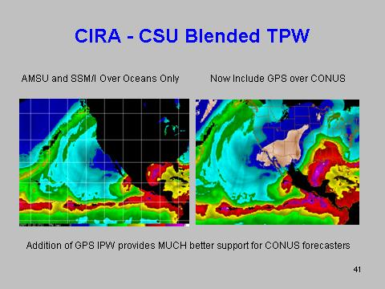
This synergistic theme of GPS and meteorology was further discussed by several other participants at the workshop. Lidia Cucurull (NESDIS/STAR) discussed the use of GPS in radio occultation (RO) measurements of refractivity and bending angle at the Joint Center for Satellite Data Assimilation (JCSDA) for applications in the National Center for Environmental Prediction’s (NCEP) Global Data Assimilation System (GDAS). Dr. Cucurull noted that GPS-RO data from the Constellation Observing System for Meteorology, Ionosphere and Climate (COSMIC) are currently being used operationally at NCEP. Tony Reale (NESDIS/STAR) presented an overview of the Integrated Product Validation System which includes GPS data, among other data sources, for meteorological sensor test and validation showing that the incorporation of GPS-derived products provides highly reliable and accurate atmospheric state parameters (temperature, pressure, and humidity). A specific example of the use of GPS for GOES IPW validation was provided by Dan Birkenheuer (OAR/ESRL) who noted that GPS IPW measurements were essential in identifying and correcting certain bias errors in the GOES data. Finally, Steven Weiss (NWS/SPC) presented a briefing and included several examples on the use of GPS IPW as an input to severe weather forecasts showing how the incorporation of GPS IPW improves the Rapid Update Cycle (RUC) model analyses and forecasts [Figure 5].
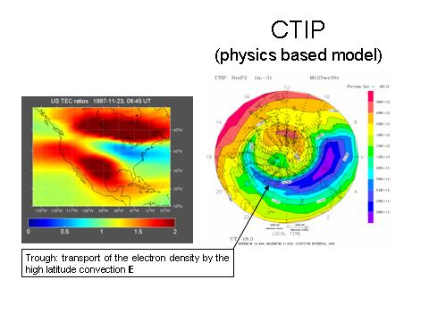
GPS also has a reciprocal relationship with space weather. In a discussion of the space weather impacts on GPS, Mihail Codrescu (NWS/SWPC) noted that the uncorrected ionospheric signal delay is the largest source of error in single-frequency GPS applications. Terry Onsager (NWS/SWPC) from the NWS Space Weather Prediction Center (SWPC) further noted the growing user segment requiring improved geo-positioning and navigational accuracies in such diverse applications as deep-sea oil drilling, surveying, aviation, and mining operations with a projected global production value exceeding $20B in 2008. In order to accommodate the increasing needs of the GPS user community the SWPC has operationalized the U.S. Total Electron Content (US-TEC) which, as described by Tim Fuller-Rowell (NWS/SWPC), can be used the reduce ionospheric errors in GPS applications. In an associated science talk, Eduardo Araujo-Pradere (NWS/SWPC) discussed an application of US-TEC in measuring and identifying sources of steep electron density gradients (in space and time) as shown in Figure 6.
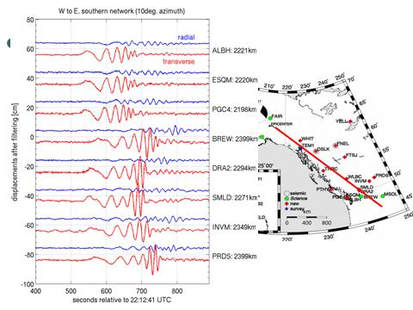
The GPS workshop also included several presentations on emerging and possible future applications for GPS within NOAA and on recent advances within NIST on miniature atomic clocks. Andria Bilich (NOS/NGS) described using; 1) high frequency (1 Hz) GPS sampling to directly measure seismic waves (Figure 7) and 2) GPS multipath to monitor changes in local soil moisture content and to image the surrounding land topography. Valery Zavorotny (OAR/ESRL) discussed the current state of and future possibilities for the GPS reflection technique within NOAA as an example of a bi-static radar (aircraft and/or satellite receiver) for determining ocean wind speed and direction, soil moisture content, and ocean sea surface heights (altimetry). John Kitching (NIST) presented an overview of the development of microfabricated atomic clocks which have potential applications for improved GPS positioning and navigation including faster satellite acquisition times, more precise altitude determination, improved anti-jam capabilities, and 3-satellite solutions.
The GPS/GNSS workshop concluded with an open discussion and written feedback session on both the technical and programmatic aspects of GPS for NOAA. The notes for this feedback session are provided in Appendix C. There was general consensus that this meeting revealed the extent to which GPS is used within NOAA for research and operations [Hilla, Murphy, Turner]. However, with regard to GLONASS it was noted that NOAA does not currently use this system [Denig]. While there is certainly some level of interest in this regard [Kyle, Turner, Hilla], it was noted that the benefits for the use of GLONASS are mixed [Mader]. Coverage was another area of concern, specifically, with respect to maintaining the GPS ground receiver network [Snay, Gutman, Mabie] although there appears to be limited data on “when is enough, enough” for the various applications [Facundo].
On the programmatic side, there was general concern expressed that NOAA corporate participation (program managers, goal team leads, senior leadership) was lacking at this workshop [Bower, Gutman, Cucurull, Koehler]. The recommendation was that increased visibility within NOAA and by NOAA stakeholders (external users) is needed before attempting to solicit corporate buy-in [Bower, Fromhertz, Landon, Gutman, Sella, Koehler, Murphy]. To this end, Dave Zilkoski laid out a roadmap for a meeting follow-up including preparation of a meeting summary (this document) with supporting materials and the drafting of a “white paper” addressing how NOAA can effectively integrate GPS into NOAA programs, propose periodic workshops (both technical or programmatic), and to convene a GNSS summit similar to those conducted for the Global Earth Observation System of Systems [Zilkoski].
In summary this workshop covered, in one broad stroke, the various uses of GPS technologies within NOAA. These uses are widespread, ranging for example from inundation modeling to space weather. NOAA scientists and technologists should be applauded for their innovative use of GPS in both research and operations. The anticipated next step is to prepare a strategic “white paper” with the eventual goal of engaging the PPBS process.
Recommendations – The following set of recommendations is provided for consideration by NOAA program managers, goal team leads, and other policy makers:
- NOAA should plan for an operational replacement of COSMIC to provide continued GPS-RO data at NCEP after 2011.
- NOAA should continue efforts to improve GPS positioning, both the precession and accuracy of positions as well as positioning software/applications with high ease-of-use.
- Applications for GPS should have stronger ties into the NOAA climate programs by maintaining a history of water-vapor variability at polar (climate) monitoring facilities, expanding continuous monitoring of water vapor in the mid-to-upper troposphere, and incorporating GPS water-vapor sensors at all Global Climate Observing System (GCOS) Upper-Air Network (GUAN) stations.
- NOAA should make full use of recent improvements in GPS applications by incorporating improved tropospheric modeling in the NOAA height modernization program and utilizing advancements in GPS geo-positioning in off-shore (see NWLON) and air-borne (radiosondes) applications.
- Facilitate the research-to-operations link for GPS applications in NOAA by funding basic and applied research incorporating novel GPS techniques and uses within NOAA, such as bistatic reflectometry, scatterometry and altimetry for soil moisture monitoring and sea-level measurements.
The way ahead – steps for implementing a NOAA-wide strategy for GPS/GNSS
- NOAA (NGS lead) should establish a GNSS Ad Hoc Group to prepare a white paper that documents the way forward/next steps (all Line Offices represented if possible). The white paper should address the following:
  - How NOAA can coordinate and integrate GNSS into NOAA programs in an organized manner as opposed to ad hoc,
  - How NOAA can continue to perform GNSS research activities,
  - Identify ways to share ideas such as semi-annual workshops and a convening a "GNSS Seminar" similar to the recent (22Oct07) GEOSS seminar,
  - Identify ways to involve other partners and NOAA Program Managers within less technical but more programmatic forum,
  - Summarize how GNSS can help NOAA address future Climate Services such as “True” Sea Level Rise Values, more accurate hurricane intensity and tracking models, soil moisture measurements,
  - Define how GPS activities within NOAA support GEOSS objectives.
- The GNSS Ad Hoc Group should prepare briefings to Goal Team Leads on GNSS applications. These briefings should include/highlight; 1) cross-cutting applications of GNSS in NOAA, 2) socioeconomic benefits of NOAA applications in GNSS, and 3) recommendations for senior management actions.
- The GNSS Ad Hoc Group, with the assistance of NGS, should use NOAA CORS to identify and document NOAA positioning requirements by identifying programs that GNSS may help to advance their program objectives.
- The GNSS Ad Hoc Group should identify and work with (at least 5) NOAA Program Managers to integrate GNSS activities into their program plans (such as the incorporation of VDatum and National Gravity Plan in the Tsunami and CEO program plans). The focus should be less on the technical aspects of GPS and more on the socioeconomic benefits of the derived information, more focus on how the average person can use results.
- NGS should identify and document “real” CORS requirements (spacing, type, location, etc) for every NOAA Program that’s currently using CORS – NSRS, GPS-MET, etc. NGS should include these requirements in the NOAA Consolidated Operational Requirements List (CORL).
- NOAA (NGS Lead) should establish a permanent email distribution list for critical GPS information of interest to stakeholders within NOAA and other federal agencies,
- NOAA (NGS Lead) should establish an internal web page that is a repository of information on NOAA GPS applications and expertise where presentations, papers, etc. can be shared within the NOAA GPS community.
- The GNSS Ad Hoc Group should create a list of resources/experts in NOAA to answer questions and support decisions.
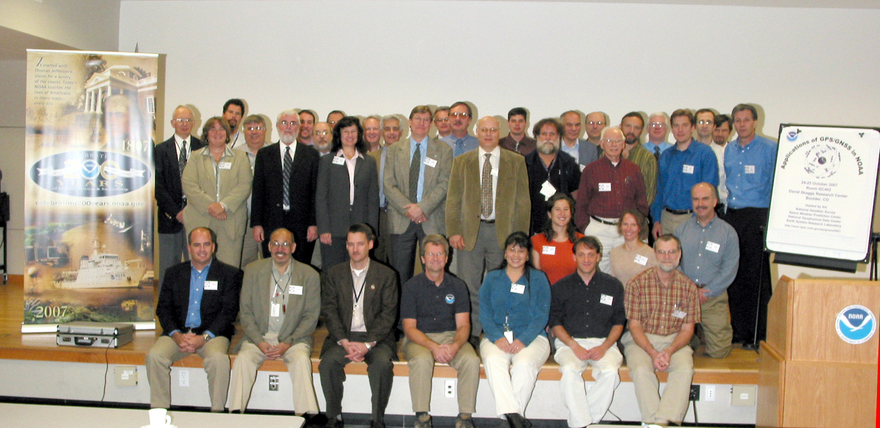
Appendix A
Applications of GPS/GNSS in NOAA
Attendee List
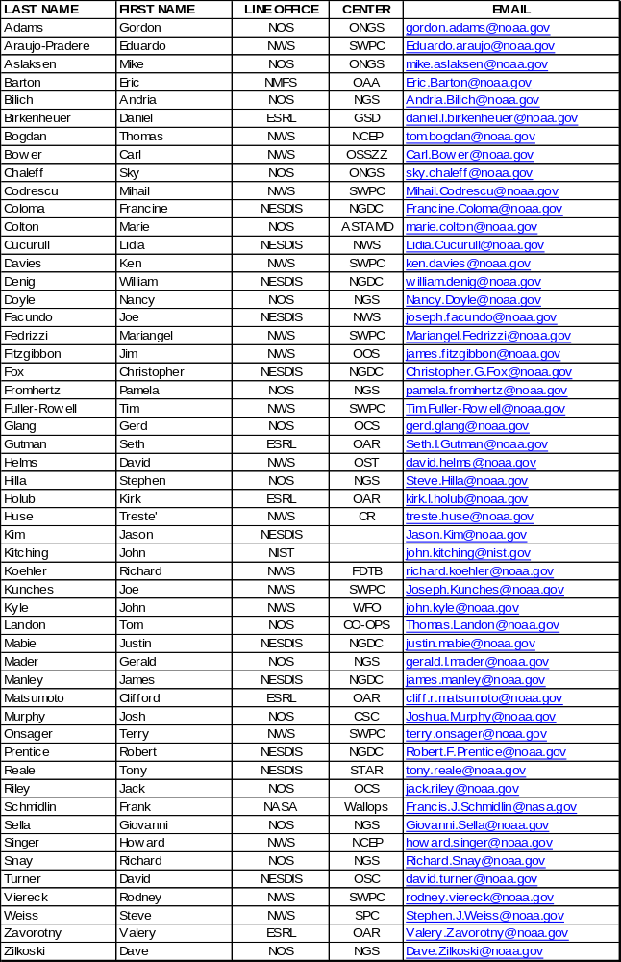
Appendix B
Applications of GPS/GNSS in NOAA
Agenda
Dates: 24-25 October 2007
Location: GC402, David Skaggs Research Center (DSRC), Boulder, CO
Purpose: Conduct a technical forum for NOAA scientists/offices involved with GNSS
Outcome: Brief technical report to NOAA management on the NOAA use of GNSS
Website: http://www.ngdc.noaa.gov/stp/gnssw2007/index.html

Wednesday: October 24th

Session 1 (Chair: Chris Fox): 08:30 – 10:00; Opening remarks, intros etc
08:30 – 09:00 Registration / Meet & greet
09:00 – 09:15 Welcome – Chris Fox & Tom Bogdan (local hosts)
09:15 – 09:30 Meeting logistics (agenda, restrooms, cafeteria, etc) – Bill Denig
09:30 – 10:00 GNSS and NOAA: Imagine the Possibilities – Dave Zilkoski

10:00 – 10:20 Break

Session 2 (Chair: Rich Snay): 10:20 – 12:00
10:20 – 10:40 Mike Aslaksen/NGS NGS Airborne & Field Operations
10:40 – 11:00 Gerg Glang/OCS GPS for NOAA Hydrographic Surveying
11:00 – 11:20 Andria Bilich/NGS New Scientific Applications with Existing CGPS Capabilities – Earthquakes, Soil Moisture, and Environmental Imaging
11:20 – 11:40 Tom Landon/CO-OPS GPS Requirements for the National Water Level Program
11:40 – 12:00 David Turner/NESDIS GPS Policy, Modernization, and International Cooperation

12:00 – 13:00 Lunch

Session 3 (Chair: Seth Gutman): 13:00 – 14:40
13:00 – 1320 Tim Fuller-Rowell/SWPC US-Total Electron Content (US-TEC)
13:20 – 13:40 Joe Facundo/NWS How NWS Radiosondes Compute Upper Level Winds Using GPS
13:40 – 14:00 Joe Kunches/SWPC SWPC Products & Services
14:00 – 14:20 John Kyle/WFO The GIS Side of GPS . . . NWS Grand Junction, CO
14:20 – 14:40 John Kitching/NIST Chip Scale Atomic Clock

14:40 – 15:00 Break

Session 4 (Chair: Fran Coloma): 15:00 – 16:50
15:00 – 15:40 Gerry Mader/NGS The Online Positioning User Services; Kinematic GPS Positioning; Why We Do Antenna Calibration
15:40 – 16:10 Steve Weiss/SPC SPC Use of GPS IPW Data as an Input to Our Severe Weather Forecasting Mission (video link)
16:10 – 16:30 Valery Zavorotny/ESRL Current State of GPS/GNSS Reflection Technique
16:30 – 16:50 E. Araujo-Pradere/SWPC On the Source of Steep TEC Gradients that Impact GPS

16:50 – End of Business Day

18:00 – 21:00 Optional Evening Social Time (Host: Bill Denig)
18:00 – 19:00 Dark Horse Saloon – Red Sox versus the Rockies
19:00 – 21:00 Dinner at Carelli’s of Boulder

Thursday, October 25th

Session 5 (Chair Andria Bilich): 08:30 – 10:20
08:30 – 09:00 Dave Zilkoski/NGS Overarching Objectives of NOAA's National Height Modernization Program
09:00– 09:20 Seth Gutman/OAR Geodesy and Meteorology: Serendipity, Synergy & Reciprocity
09:20 – 09:40 Mihail Codrescu/SWPC Influence of the Ionosphere on GPS
09:40 – 10:00 Rich Snay/NGS Application of the Continuously Operating Reference Station (CORS) System
10:00 – 10:20 Dan Birkenheuer/ESRL Use of GPS Data to Improve Understanding of GOES Water Vapor Measurements

10:20 – 10:40 Break

Session 6 (Chair: Mihail Codrescu): 10:40 – 12:00
10:40 – 11:00 Lidia Cucurull/NWS Use of GPS RO in Operations at NCEP
11:00 – 11:20 Steve Hilla/NGS Reference Frames for GPS Applications and Research
11:20 – 11:40 Rich Koehler/FDTB NWS and GPS/GNSS: Meeting the geospatial data needs in hydrology and meteorology
11:40 – 12:00 Tony Reale/SMCD NOAA Satellite Product Integrated Validation

Wrap-up
12:00 – 12:10 Wrap-up (Bill Denig)

END OF WORKSHOP
Appendix C
Take Aways – Unedited (24 Oct 07)

1. Oral Input:

DaveZ – get group together to discuss what we’ve learned and what the next step is to moving forward. Increase visibility in NOAA of the uses of GNSS. Group should develop short paper to engage program managers.

Some ppts are not suitable for sharing with the public.

Denig – while working with GPS, not currently utilizing GLONASS. Or is L2C of GPS more important to address?

John Kyle Regarding geo-political status, should GLONASS be used?

Dave Turner – possible switch to CDMA format, but will continue current format. State Dept is trying to get GLONASS to adopt CDMA. No one saying not to pursue use of GLONASS.

Steve Hilla – Russians use GLONASS as military as well, so worthwhile continuing use.

Mader – Combinations of GPS and GLONASS currently worsen double differencing, integer-fixed results. Coverage is better though. L2C unnecessary for mm level, but will help Real-time

Snay – one of the GPS augmentations (NDGPS) critical to tropo and iono modeling might be decommissioned. NOAA submitted reply to FedReg Notice. Won’t affect precise positioning much.

Seth - Space Weather Prediction has operational concerns about maintaining reliable sites. Current CORS provided densification and detail, but backbone is insecure; need to insure NOAA management understands this.

Facundo – agrees (“when is enough, enough?”). Funding for sites needs to know how many are critical. In five years, NOAA will need how much for the networks we need? What is the bottom line to support requirements? NGS can’t support in the time they see necessary for independent reference 30km in atmosphere. Challenge is that there is no reference to test it against. Atomic clock development can help development of radiosonde and other devices necessary to validate position where met data is collected.

Justin ? (NDCD)– Goal of maintaining reliable network. Datacenter is used to geo-political situation. Wants to establish cooperation policy that will work even if conflicts arise.

Mader – battery issue?

Carl – more GNSS visibility in NOAA – need broader audience than these users.
Denig – this was first step.

Carl – not enough information yet for asking for money?
Are Program Managers and External People enough to move forward?

Denig- not anticipating advocacy approach but more an analysis report – how is it being used within NOAA?

Pam – Determine the goals in reaching senior mgmt before moving forward?

2. Paper Input:

Tom Landon, NOS/CO-OPS:
- Need to communicate with other NOAA Line Offices to determine common areas of interest and seek out joint milestones on projects of mutual interest.
- Think to the future and incorporate long-range goals int PPBES to ensure success.

Seth Gutman, NWS:
- Prepare briefings to Goal Team Leads on GNSS applications Include/highlight:
- Cross-cutting Applications
- Costs and Benefits
- Recommendations to Management
- Create a list of resources/experts in NOAA to answer questions and support decisions.

Giovanni Sella, NOS/NGS
- Modify existing data ingestion to meet needs of other NOAA groups.
- Identify new applications that can be used to justify existing efforts.
- Fundamental mission requirements have to be met by NOAA funding, not external partnerships.
- Who are our users? Which overlap between GPS products?

Steve Hilla, NOS/NGS
- What I’ve learned from the GNSS Workshop: I’ve learned that the NWS really does a lot of hand-held GPS. Maybe NOAA could benefit from a hand-held receiver that would also allow the receiver to output raw pseudo-range (and carrier-phase?) observations. This would enable post-processing software to give much better accuracy for certain applications.

Lidia Cucurull, NWS
- I couldn’t attend the whole meeting due to conflict with a parallel workshop/meeting on GPS Radio Occulation at UCAR. It is very important that both meetings couldn’t have been accommodated better.
- In addition, I would like to make a comment on the fact that no NOAA Managers were present at the meeting at UCAR, were the future of GPS RO (at least COSMIC and follow-on missions) is being debated. All the other Agencies attended the meetings. Due to the fact that GPS RO from COSMIC is being assimilated in operations at NOAA, I quite do not understand it.

Rick Koehler, NWS
- Much effort in providing accurate positions
- Multiple uses of GPS signals
- Need more focus on how the average person can use results
- Outreach and cooperation within NOAA helps everyone.

Dave Turner, Contractor support to NOAA/NESDIS/OSC
- The workshop was an excellent way to bring experts together within NOAA who all reply on GPS/GNSS.
- Follow-up is required to take advantage of the event. Suggestions:
  - A permanent email distribution list for critical GPS information such as GPS experts and noaa.gov
  - an internal NOAA web page that is a depository of information on NOAA GPS applications and expertise where presentations, papers, etc. can be shared with the NOAA GPS community.

Josh Murphy, NOS/CSC
- It’s amazing how much is going on re: GPS in NOAA
- I feel that we should focus more on GIS users – after all, they represent a large subset of the user community.
- It’s clear that there are links to emerging theme areas (sea level rise/community resiliences) -> we need to focus less on the technical aspects of GPS and more on the benefits of the derived information.
- Great job – very fascinating – would love to be involved in the next steps.

Dave Zilkoski, NOS/NGS
- Short summary of meeting
- List of references for each presentation (link to digital copy of paper)
- Web site with symmetry, references and presentations
- PDF of summary, references and presentation
- Ad Hoc Group prepares a white paper that documents the way forward/next steps (all Line Offices represented if possible)
- The white paper should address the following:
- How NOAA can coordinate and integrate GNSS into NOAA programs (in an organized manner as opposed to ad hoc).
- How NOAA can continue to perform GNSS research activities
- Ways to show ideas such as semi-annual workshops
- Ways to involve other partners and NOAA Program Managers (less technical, more programmatic).
- Convene a “GNSS Seminar” (like GEOSS seminar held 10/22/07)
- Summary of how GNSS can help NOAA address future Climate Services such as “True” Sea Level Rise Values, more accurate hurricane intensity and tracking models, soil moisture measurements
- How activities can help GEOSS
- Identify and work with (at least 5) Program Managers to integrate GNSS activities into their program plans (such as VDatum and National Gravity Plan are needed by Tsunamai and CEO Programs).
- Identify and document “real” CORS requirements (spacing, type, location, etc) for every NOAA Program that’s currently using CORS – NSRS, GPS-MET, etc.
- Use NOAA CORS to identify and document NOAA positioning requirements (identify programs that GNSS may help to advance their program).

Nancy Doyle, NOS/NGS

- Possible agenda for One-day GNSS Seminar [NOTE that when I mentioned the seminar, the response was not positive – people wanted to know what the Goals were and did not feel the group is ready for this]
Attendees would be internal (esp. Program Managers and Senior Management) as well as external stakeholders. Focus is on non-technical outline of users.
- Basics
  - CORS
  - TEC
  - IONO
- NOAA Internal Users
- Soil Moisture
- Weather Modeling
- GIS
- GOES
- Lunch
- External/future Users
- Google
- Regionalization
- International
- CORS
- Global geoid and global TEC
- Need to identify potential NOAA users (clients) that are unaware of what GNSS can offer. Positioning is critical to data analysis regarding coral reefs, for example.

