ASRE Strategic Plan to Improve Forecasts of Clouds and Irradiance for Solar Power Applications (CISPA)

Background
Since 2010, the ASRE has focused primarily on improving NOAA’s wind forecasts. This effort has been conducted in two large projects, WFIP and WFIP2. A smaller project was performed at DOE’s request to provide guidance on requirements for an observation network to support offshore wind power. DOE has provided to NOAA $6.9M and NOAA base funds have provided $10.6M for these projects. This amounts to $17.5M for these three projects, not including DOE funding for XPIA, which was funded outside the ASRE program. Additionally, to improve solar forecasts, DOE provided $1M for a project.

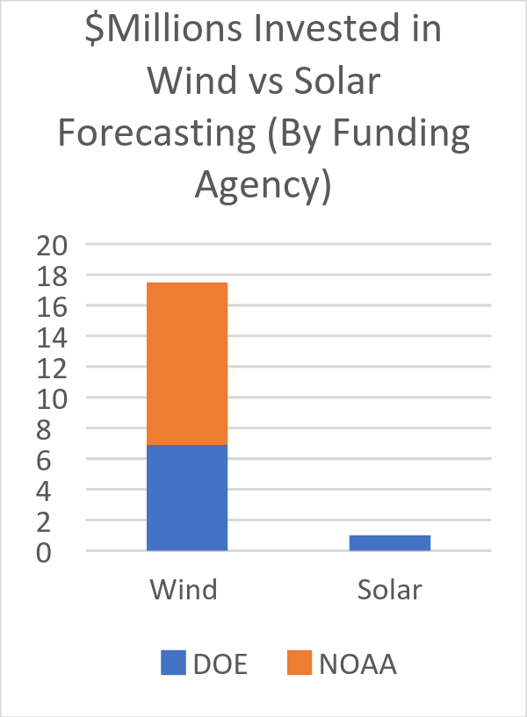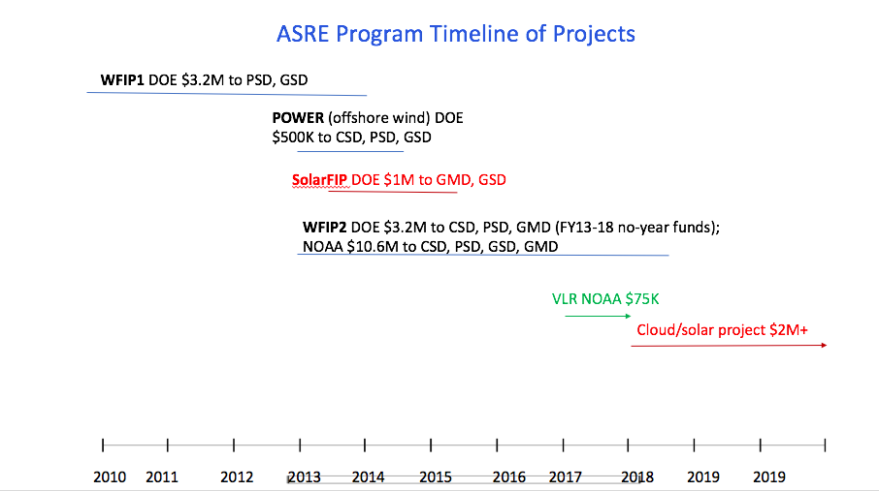

At end of 2016 in the US, ~80 GW wind and ~42 GW solar PV capacity existed. More solar PV capacity than wind capacity is now being installed. During 2016, 8 GW wind and 15 GW PV were installed. Estimates for 2017 are that 9 GW wind and 16 GW PV will be installed. See figures below. In addition to the disproportionate allocation of prior research dollars (17.5 to 1, wind to solar), this exponential growth in installed solar capacity intensifies the need for us to improve NOAA’s forecasts of clouds and solar irradiance.
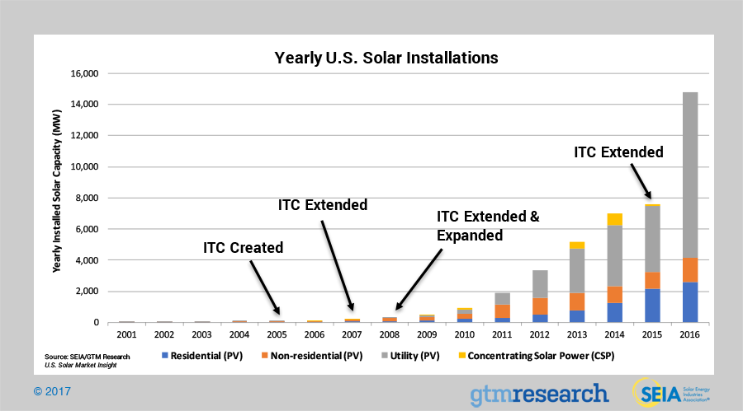
-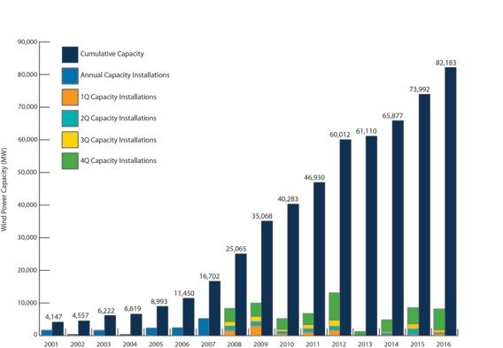
Yearly solar installations (MW) Yearly wind installations (MW)

In light of the disproportionate allocation of prior research dollars (17.5 to 1, wind to solar) and the exponential growth in installed solar capacity and its recent dominance over wind in annual MW installations, the ASRE Program has prepared this strategic plan to improve NOAA’s forecasts of clouds and solar irradiance, to support the nation’s greater and more efficient use of solar power. Furthermore, the errors in forecasts of surface irradiance (clouds) are greater than the errors in turbine-heights winds. Therefore, the potential improvement in forecast skill is greater for the former than the latter. [Improving understanding of the physical processes driving the formation and dissipation of clouds has the potential to benefit modeling and predictions across a range of scales, including climate scales.]

Overview of the CISPA Project

The project aims to improve understanding, modeling, and forecasting of clouds, the primary attenuator of solar irradiance, which is the fuel for solar power. The project focuses on shallow cumulus clouds primarily but also deep tropospheric clouds, and possibly coastal stratus, which affect solar power production particularly in Southern California. The project targets improvements in the cloud fraction, overlap, and water content. Both explicit and sub-grid-scale clouds will be addressed in the modeling. The project is expected to last 3-5 years.

The project will leverage existing data sets, including the DOE ARM sites and LASSO project, NOAA SURFRAD and ISIS networks, Fluxnet, Aeronet, University of Oregon, Oklahoma mesonet, and existing intensive field program data sets. However, a few key instruments (RadSys, W-band radar, CLAMPS, radiometers) may be deployed to measure cloud, moisture, and dynamical variables as deemed necessary.

Both global (FV3) and regional (HRRR) models will be used. The 24-48-hour forecast is what the utility industry calls the “day-ahead” forecast, and is what they use for key decision-making. Utilities and grid operators use the day-ahead forecast in “unit commitment,” in which they decide which generators will be used to meet demand in the following 24-48-hour period. Solar forecasts with higher skill and with uncertainty information allow the industry to save money by optimizing the mix of generators committed and by avoiding unneeded generation capacity.

The project will develop probabilistic forecasts to provide more skillful deterministic forecasts and a PDF of cloud properties. We will leverage existing in-house ensembles, particularly the FV3 and HRRR-based ensembles to provide probability forecasts of shallow cumulus clouds. This in-house ensemble capability uses SPP, SKEB, and SPPT, as well as perturbations of initial and boundary conditions. Stochastic physics parameterizations within the FV3 currently under development will be evaluated and potentially modified.

Data assimilation will be employed to diagnose model behavior and error. Additionally, the project will develop data assimilation techniques for improved cloud analysis.

Process-oriented, regime-specific verification will be developed and employed to diagnose model error and identify potential methods to reduce such error. Certain conditions, e.g., partial cloudiness or seasonality, will be prioritized for model improvements.

Since cloud morphology is strongly dependent on large scale atmospheric dynamical forcing and the background thermodynamic profiles, model skill for these processes and parameters will be evaluated. In particular large scale divergence, the vertical velocity profile, moisture convergence, and humidity and temperature profiles will be analyzed from both the models and from observations.
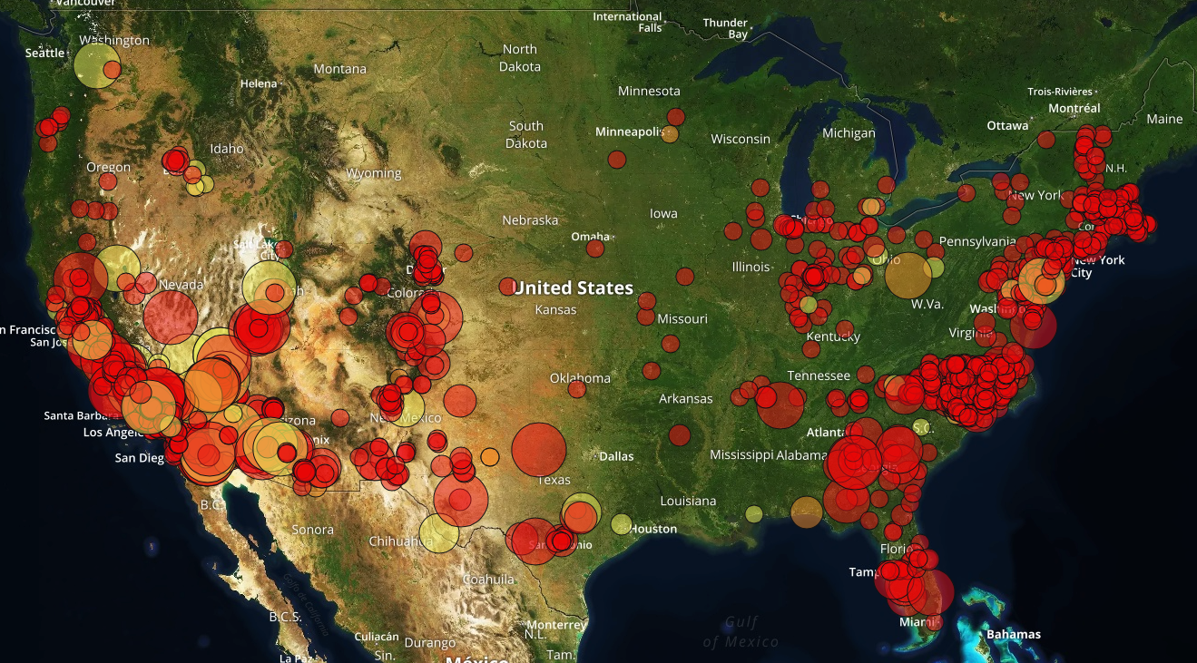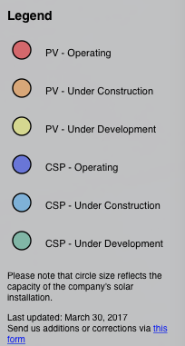

This map illustrates the March 2017 installed solar PV capacity.

Science Questions of the CISPA Project
- What is the skill of NOAA’s NWP models (global and regional) at forecasting shallow cumulus overlap, path, timeliness, and fraction relative to deep tropospheric clouds?
- What is the skill of NOAA’s NWP models (global and regional) at forecasting marine stratocumulus?
- Under what conditions (regimes) do our models have higher or lower skill for the above?
- What processes contribute to lack of skill (e.g., surface processes, turbulent transport, advection, large scale dynamical forcing, etc.)
- When looking at areas of needed improve (temp and spatial uncertainties)
- What is the model-scale dependence?
- Do we have right interaction between shallow cumulus, deep cumulus, and microphysics?
- Do we need 3D treatment of radiative transfer? (Latitude-dependent, model resolution?)
- How do inconsistent assumptions in the radiation scheme about the degree of overlap or spreading of shallow cumulus clouds in the vertical column versus the assumptions in the turbulence scheme lead to biases and other errors in the downward shortwave radiation at the surface?

State of the Art (Joe and Kathy – Use SURFRAD and SOLRAD data to quantify forecast skill of the HRRR and FV3. This section will address the first three science questions above.)

Processes (Joe & Wayne – This section will address the fourth through sixth science questions above.)
Shallow cumulus result from a delicate balance among sensible and latent heat fluxes (vertical and horizontal/advective), mean vertical motion, and vertical temperature and humidity profiles. Until recently, the major missing process in NWP models has been the non-local vertical transport due to thermals a.k.a. large eddies, which efficiently carry heat and moisture away from the surface to the boundary layer top and above by overshooting. The addition of the mass flux component to the boundary layer scheme, resulting in the MYNN-EDMF scheme, aims to add this missing process. Testing and tuning this code will be a key part of the project. In so doing, we will need to monitor all the other processes mentioned. The land surface must be carefully handled in order to produce correct fluxes. In addition, the mean vertical velocity, humidity, and temperature profiles will be evaluated in conjunction with the cloud fields to better understand and partition the sources of cloud model forecast errors.

Coastal stratus or stratocumulus are even more complex. The key additional process is radiative cooling at the cloud top, which drives most or all of the turbulent mixing. Existing boundary layer schemes don’t address this well or at all. The very strong and sharp inversion at cloud top is critical, and may put strong demands on the vertical resolution of the model. In addition, if we are interested in marine clouds over land, the winds that drive the cloud inland from where they are formed over the water must be well-represented. This requires accurate portrayal of the surface fluxes (over both land and sea), development of the sea-breeze, and accurate representation of the background wind fields.

Modeling (Joe & Wayne - This section will address the seventh through ninth science questions above.)
Improving forecasts of downward shortwave radiation involves more accurate prediction of the primary components needed in the direct calculation of radiative fluxes. These primary variables include (1) areal coverage of resolved- and subgrid-scale clouds, (2) the subgrid-scale cloud fraction, (3) the resolved- and subgrid-scale mixing ratios and number concentrations, (4) the resolved- and subgrid-scale cloud depths, (5) the assumptions made in the radiation scheme regarding the cloud properties: overlap and particle size. The following questions need to be addressed in order to quantify how errors in these primary components (or subcomponents) of the model contribute to errors in the downward shortwave radiation at the surface? And how may these errors vary under different weather regimes?
- Can SW-down errors be attributed to poor areal coverage of resolved-scale water and ice clouds?
- Can SW-down errors be attributed to poor subgrid cloud fractions?
- Can SW-down errors be attributed to poor subgrid liquid/ice mixing ratios and number concentrations?
- Can SW-down errors be attributed to poor subgrid cloud depths?
- Can SW-down errors be attributed to assumptions in the radiation scheme about the degree of subgrid cloud overlap (i.e., the amount of spreading of shallow cumulus clouds in the vertical column?
- Can SW-down errors be attributed to assumptions in the radiation scheme mean particle/droplet size used in the scattering and absorption of incoming radiation?
- Can SW-down errors be attributed to the lack of 3D treatment of radiative transfer, especially for DNI? (also latitude-dependent, model resolution?)
Errors in the primary components of the radiative calculations are not likely to be isolated to the direct representation of clouds and radiation in the model. Errors in the primary components may be traceable to secondary components of the model that can impact the primary components. These secondary components include (1) the turbulent transport of heat and moisture, (2) the surface fluxes of heat and moisture, (3) the degree of representation of surface heterogeneity, (4) the initial and/or boundary conditions and (5) the advection of heat and moisture. Therefore, in order to accurately predict the primary components, it must be determined how errors in these secondary components (or subcomponents) of the model contribute to errors that can ultimately lead to errors in downward shortwave radiation at the surface. Also, it must be determined how these these errors may vary under different weather regimes?
- Can errors in the primary components be attributed to the turbulent transport of moisture, heat, or momentum?
- Can errors in the primary components be attributed to the entrainment processes at the top of the boundary layer?
- Can errors in the primary components be attributed to poor surface heat and moisture fluxes in parts of the diurnal cycle?
- Can errors in the primary components be attributed to the lack of surface heterogeneity in the model parameterizations?
- Can errors in the primary components be attributed to the initial and/or boundary conditions or by large-scale advection?
The errors in the secondary components may be due to tertiary components, errors in the primary components or even due to errors in the parameterization of the secondary components themselves, feeding back over successive model time steps. In order to quantify the causes and study the evolution of errors in downward shortwave radiation, a set of model components representing a collection of processes at various scales and/or complete feedback loop must be assessed and developed collectively. Research questions must address how errors in the representation of these multi-scale processes or the interactions of various physical parameterizations contribute to errors in the downward shortwave radiation at the surface? And of course, how may these errors from different components vary under different weather regimes?
- Do we have right depiction of the total collective turbulent moisture & heat transport (small- and large-eddy mixing, small buoyant plumes, large precipitating plumes) represented by the respective turbulence schemes (eddy diffusivity, mass-flux, and deep-convective schemes)?
- Shallow-cumulus feedback loop: Do errors in the cloud-radiation interaction impact the surface energy balance, which in turn impacts the turbulent transport and entrainment, which feed back on the cloud properties.
- Do the turbulent schemes (and their associated subgrid cloud schemes) correctly interact with the microphysics scheme to properly represent the total liquid/ice in the observed atmosphere?
- Can errors in any scheme be correlated to errors in another scheme? Can important relationships or feedbacks be determined to explain the errors in downward shortwave radiation?

Existing Data Sets to Leverage [SURFRAD and SOLRAD: Kathy & Allison; DOE ARM: Dave. We agreed to make a list (table?) that Kathy will start, showing: sites, and at each site, the instrumentation, observations, and their precision and accuracy; data products (e.g., RadFlux, etc.). From this list, we will identify gaps in existing data sets, which will guide which additional instruments need to be deployed.]

Case Studies (Wayne. An early task will be to identify days at existing sites with good shallow cumulus clouds. Which, if any, meteorological conditions should be considered, e.g., deep convection absent?)

The DOE LASSO project will provide several case studies that can be the cornerstone of our initial effort. The LASSO alpha 1 release contains six cases from 2015, and the alpha 2 release will have approximately 12 cases from 2016. The package for each case includes pre-digested observation products from carefully-chosen combinations of instruments, along with large-eddy simulations and the analyses used to drive them. We will run our models in single column mode for these cases. A detailed process-level understanding of the strengths and weaknesses of the models can be achieved in this simplified setting. The single-column runs should include variable and/or stochastic elements related to the ensemble designs discussed below under “Probability Forecasts.” We may also choose to look at the cases in full 4D model runs, which could be done if archived runs exist, or require the ability to run the full model retrospectively.

Deployment of Instrumentation
This project will largely leverage existing data sets. If needed, targeted instruments may be deployed. For instance, the NSSL CLAMPS suite could be deployed in summer of 2018 to the Southeastern United States or the mobile ARM facility could be deployed in Year 3 or later. In addition, the PSD W-band radar and microwave radiometers could be deployed at any number of sites, including for observations of coastal stratus.

Probability Forecasts (Wayne)

Clouds are robust phenomena in the atmosphere, but often less so in models. A single deterministic forecast is unlikely to have clouds exactly right in location, quantity, and timing. Therefore, we will include probabilistic elements in the project from the beginning. The ensembles with stochastic perturbations being explored for the existing HRRRE and HRRR-like ensemble projects as well as for the FV3 ensembles can be used. In addition, because initial conditions are particularly critical for clouds, ensembles may need to be initialized with varying initial conditions. An early task in the project should be to design ensemble case study experiments to inform later decisions about 4D ensemble runs. Computing resources will be a concern for 4D ensemble experiments.

GFS-based experimental calibrated probability forecasts are available daily through the GEFS and GEFS2 systems, including 4 component surface radiation. Similar products will become available in the near future for the FV3-based next-generation GEFS. The skill of the calibrated GEFS2 radiative forecasts should be made to provide a baseline to compare to the deterministic FV3, HRRRE, and against the future FV3-based GEFS. In addition, post-processing techniques should be developed that can be applied to FV3 forecasts using relatively short training periods, on the order of several months.

Data Assimilation (Terra & Dave)

Sub-grid-Scale Variability (Kathy)
To tackle partial cloudiness conditions, we will deploy a local area array of small, easily deployed radiation systems for sub-grid scale cloud studies (3 RadSys Systems, - GHI, NDI, NDHI, Cloud information products). This small array of 3 radiometer systems (RadSys) will be strategically spaced at the DOE ARM SGP or around a central SURFRAD station. These systems are designed specifically to provide the observations needed for the Radiative Flux Analysis (RadFlux) product retrievals (e.g. clear-sky direct, diffuse, and total solar irradiance, cloud fraction). The solar radiometer array would be aimed at providing statistical distributions for sub-grid-scale variability information for models with resolutions similar to the RAP and HRRR models (1-13 km resolution) and better estimates and understanding of forecast uncertainties and development/improvements in model physics and RRTMG. The observations would be used for evaluating and quantifying uncertainties in solar forecasts for localized weather events and to study statistical distribution studies and probabilities for ramp events in different time horizons.

Process-Oriented, Regime-Specific Verification (Dave and Joe)

Additional Details of Modeling Approach from a Previous Proposal by Joe
Improve the consistency between the boundary layer subgrid clouds and the overlap assumptions used within the radiation scheme. Clouds in numerical weather prediction models are represented by a microphysics scheme when a model grid cell becomes fully saturated. Clouds that are smaller than the model grid cell (subgrid clouds) are represented by empirical relationships between the cloud properties (areal fraction, liquid water content) and mean grid cell properties or other subgrid-scale properties. For example, a shallow-cumulus cloud field is represented as a mean cloud areal fraction and cloud water mixing ratio resulting from the evolution of a mass-flux scheme (i.e., plume model) within a column of model grid cells with a certain saturation deficit at each model level. The shallow-cumulus subgrid clouds can extend through many model layers, but even the most state-of-the-science mass-flux schemes do not provide information on the changes in vertical coherency of the clouds due to wind shear or changes in static stability. In order to represent the interaction of the short- and longwave radiation with the subgrid clouds, assumptions need to be made within the radiation scheme regarding the degree of overlap or spreading of the shallow-cumulus clouds in the vertical column of model grid cells. Traditionally, the development of subgrid cloud parameterizations and radiation schemes have been performed independently. Inconsistent assumptions made in the radiation and turbulence schemes on the development of these subgrid clouds can cause serious biases in the downward shortwave radiative forcing at the surface by 20-40% (Neggers et al. 2011, JGR).
The main challenges in the representation of the subgrid clouds include: (1) the diurnal evolution, (2) the cloud base, (3) the cloud depth, and (4) the liquid water content. Improvements in each of these aspects of the subgrid clouds is needed for accurate predictions of solar resources. This requires accurate measurements of downward shortwave radiation, cloud cover, cloud depth, liquid cloud water content, and surface fluxes to compare with the model simulations.
The main challenges for the cloud overlap assumptions include: (1) flexible decorrelation length scales for different vertical wind shears and model vertical grid spacing, (2) different assumptions for different types of subgrid clouds (stratus, shallow-cumulus, and deep-cumulus), and (3) complications due to multiple layers of clouds.
Model testing must be performed in single-column mode as well as full three-dimensional simulations. The model testing framework should include the ability to replace certain model fields with observable quantities, such as cloud fraction or liquid water content, to test the impact of different cloud overlap assumptions.

