ASRE Strategic Plan to Improve Forecasts of Clouds and Irradiance for Solar Power Applications (CISPA)

Background
Since 2010, the ASRE has focused primarily on improving NOAA’s wind forecasts. This effort has been conducted in two large projects, WFIP and WFIP2. A smaller project was performed at DOE’s request to provide guidance on requirements for an observation network to support offshore wind power. DOE has provided to NOAA $6.9M and NOAA base funds have provided $10.6M for these projects. This amounts to $17.5M for these three projects, not including DOE funding for XPIA, which was funded outside the ASRE program. Additionally, to improve solar forecasts, DOE provided $1M for a project.

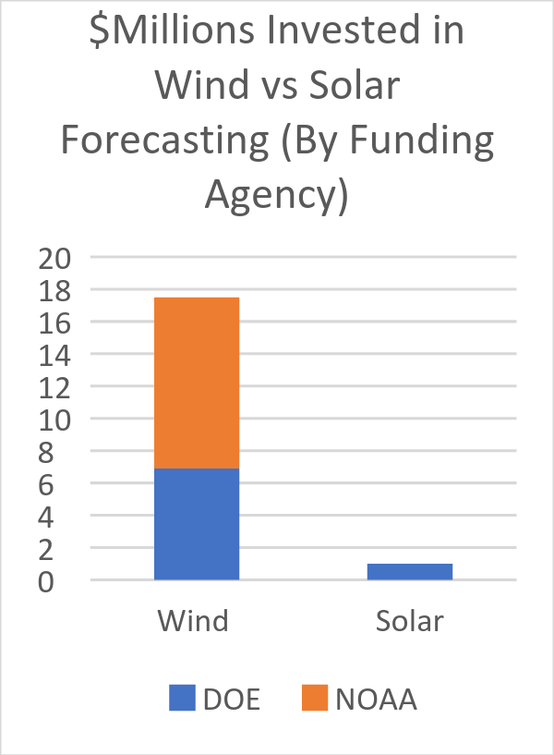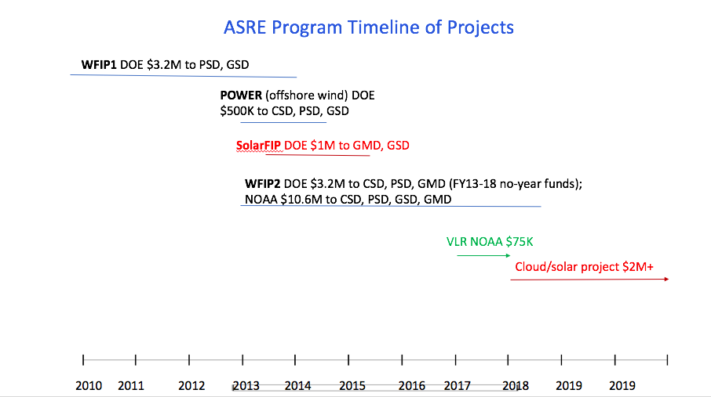

At end of 2016, ~80 GW wind and ~42 GW solar photovoltaic (PV) capacity existed in the US. More solar PV capacity than wind capacity is now being installed; for example, during 2016, 8 GW wind and 15 GW PV were installed. Estimates for 2017 are that 9 GW wind and 16 GW PV will be installed (see figures below). In addition to the disproportionate allocation of prior research dollars (17.5 to 1, wind to solar), this exponential growth in installed solar capacity intensifies the need for us to improve NOAA’s forecasts of clouds and solar irradiance.
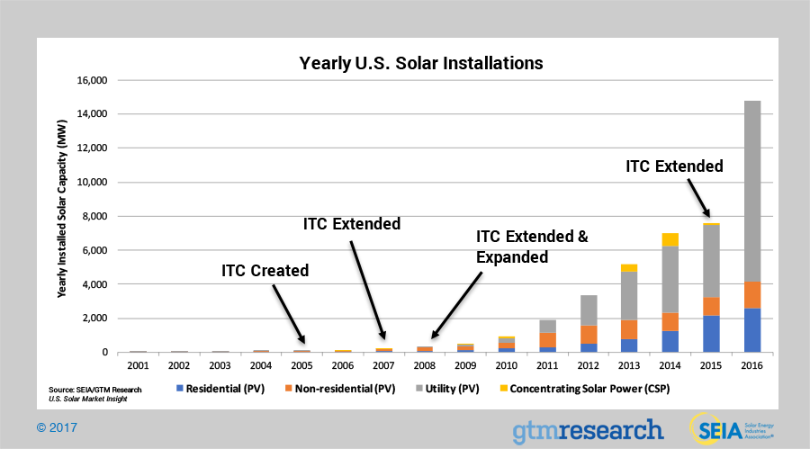
-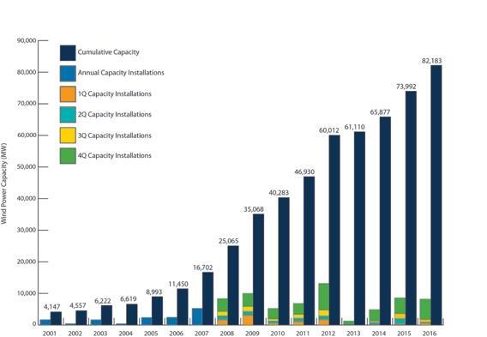
Yearly solar installations (MW) Yearly wind installations (MW)

In light of the disproportionate allocation of prior research dollars (17.5 to 1, wind to solar) and the exponential growth in installed solar capacity and its recent dominance over wind in annual MW installations, the ASRE Program has prepared this strategic plan to improve NOAA’s forecasts of clouds and solar irradiance, to support the nation’s greater and more efficient use of solar power. Furthermore, the errors in forecasts of surface irradiance (which is due primarily to the errors in forecasting clouds) are greater than the forecast errors in turbine-heights winds. Therefore, the potential improvement in forecast skill is greater for the former than the latter. [Improving understanding of the physical processes driving the formation and dissipation of clouds has the potential to benefit modeling and predictions across a range of scales, including climate scales.]

Overview of the CISPA Project

The project aims to improve understanding, modeling, and forecasting of clouds, the primary attenuator of solar irradiance, which is the fuel for solar power. The project focuses on shallow cumulus clouds primarily, and possibly coastal stratus (which affect solar power production particularly in Southern California). The project targets improvements in the cloud fraction, cloud timing (i.e., when do clouds develop), cloud vertical overlap, and water content. Both explicit and sub-grid-scale clouds will be addressed in the modeling. The project is expected to last 3-5 years.

The project will leverage existing data sets, including the DOE ARM sites and LASSO project, NOAA SURFRAD and SolRad networks, Fluxnet, Aeronet, University of Oregon, Oklahoma mesonet, and more. However, a few key instruments (e.g., a RadSys from GMD) will be deployed to measure sub-grid scale variability.

The objective is to improve cloud forecasts in both global (FV3) and regional (HRRR) models. This project will target the 24-48-hour forecast (this is called the “day-ahead” forecast in the industry). Utilities and grid operators use the day-ahead forecast in “unit commitment,” in which they decide which generators will be used to meet demand in the following 24-48-hour period; this is a key decision-making component of solar energy utilities. Solar forecasts with higher skill and with uncertainty information allow the industry to save money by optimizing the mix of generators committed and by avoiding unneeded generation capacity.

The project will develop probabilistic forecasts to provide more skillful deterministic forecasts and a PDF of cloud properties. We will leverage existing in-house ensembles, particularly the HRRR-based ensembles to provide probability forecasts of shallow cumulus clouds. This in-house ensemble capability uses SPP, SKEB, and SPPT, as well as perturbations of initial and boundary conditions.

Data assimilation will be employed to diagnose model behavior and error. Additionally, the project will develop data assimilation techniques for improved cloud analysis.

Process-oriented, regime-specific verification will be developed and employed to diagnose model error and identify potential methods to reduce such error. Certain conditions, e.g., partial cloudiness or seasonality, will be prioritized for model improvements.

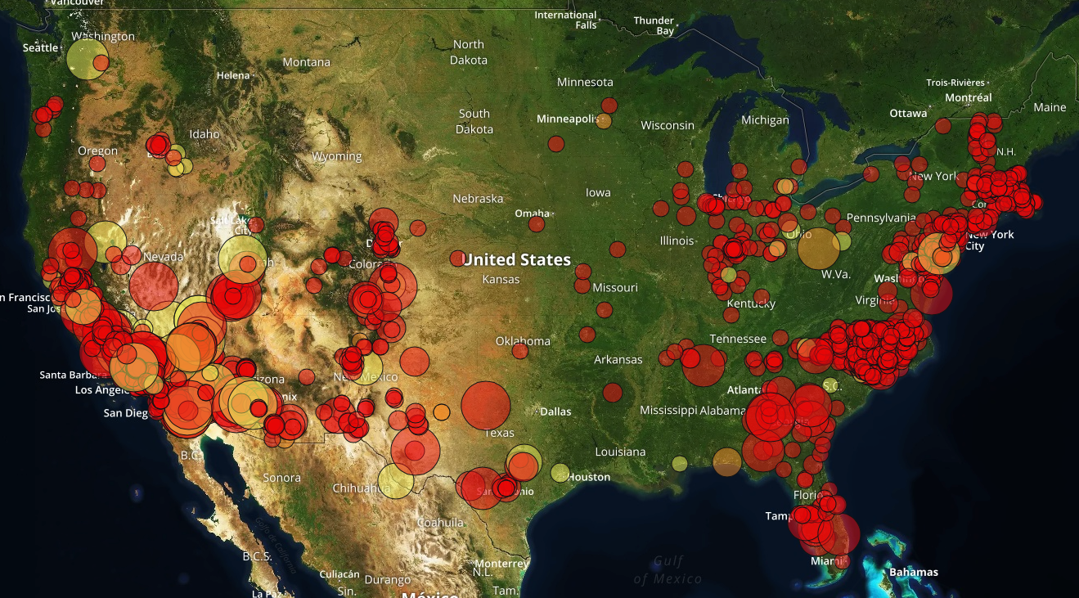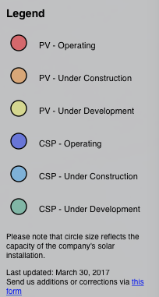

This map illustrates the March 2017 installed solar PV capacity.

Science Questions of the CISPA Project
- What is the skill of NOAA’s NWP models (global and regional) at forecasting shallow cumulus overlap, total water path, timing, and fraction?
- What is the skill of NOAA’s NWP models (global and regional) at forecasting marine stratocumulus?
- Under what conditions (regimes) do our models have higher or lower skill for the above?
- What processes contribute to lack of skill (e.g., surface processes, turbulent transport, etc.)
- Are the model parameterizations that contribute to shallow cumulus clouds sensitive to the horizontal resolution of the model? If so, can the parameterizations be improved to be independent of model-resolution?
- Do we have right interaction between shallow cumulus, deep cumulus, and microphysics?
- Do we need 3D treatment of radiative transfer? (Latitude-dependent, model resolution?)
- How do inconsistent assumptions in the radiation scheme about the degree of overlap or spreading of shallow cumulus clouds in the vertical column versus the assumptions in the turbulence scheme lead to biases and other errors in the downward shortwave radiation at the surface?

State of the Art (Joe and Kathy – Use SURFRAD and SOLRAD data to quantify forecast skill of HRRR. Can we easily do so for FV3? This section will address the first three science questions above.)

(I have tried to put my thoughts here very coarsely. Can definitely be reworded.)
This step will also help to investigate the cause and effect characteristics of model error. For example, it can be investigated whether the errors in cloud forecasting is due to an error in moisture advection. In addition, it can be investigated whether the clouds are being formed by the correct processes. Such as if the measurements show cloud formation due to boundary layer processes, then it can be checked if the models show similar forecasts.

Processes (Joe & Wayne – This section will address the fourth through sixth science questions above.)
Shallow cumulus result from a delicate balance among sensible and latent heat fluxes (vertical and horizontal/advective), mean vertical motion, and vertical temperature and humidity profiles. Until recently, the major missing process in NWP models has been the non-local vertical transport due to thermals a.k.a. large eddies, which efficiently carry heat and moisture away from the surface to the boundary layer top and above by overshooting. The addition of the mass flux component to the boundary layer scheme, resulting in the MYNN-EDMF scheme, aims to add this missing process. Testing and tuning this code will be a key part of the project. In so doing, we will need to monitor all the other processes mentioned. The land surface must be carefully handled in order to produce correct fluxes. In addition, the mean vertical velocity, humidity, and temperature profiles will be evaluated in conjunction with the cloud fields to better understand and partition the sources of cloud model forecast errors.

Coastal stratus or stratocumulus are even more complex. The key additional process is radiative cooling at the cloud top, which drives most or all of the turbulent mixing. Existing boundary layer schemes don’t address this well or at all. The very strong and sharp inversion at cloud top is critical, and may put strong demands on the vertical resolution of the model. In addition, if we are interested in marine clouds over land, the winds that drive the cloud inland from where they are formed over the water must be well-represented. This requires accurate portrayal of the surface fluxes (over both land and sea), development of the sea-breeze, and accurate representation of the background wind fields.

Modeling (Joe & Wayne - This section will address the seventh through ninth science questions above.)
Improving forecasts of downward shortwave radiation involves more accurate prediction of the primary components needed in the direct calculation of radiative fluxes. These primary variables include (1) areal coverage of resolved- and subgrid-scale clouds, (2) the subgrid-scale cloud fraction, (3) the resolved- and subgrid-scale mixing ratios and number concentrations, (4) the resolved- and subgrid-scale cloud depths, (5) the assumptions made in the radiation scheme regarding the cloud properties: overlap and particle size. The following questions need to be addressed in order to quantify how errors in these primary components (or subcomponents) of the model contribute to errors in the downward shortwave radiation at the surface? And how may these errors vary under different weather regimes?
• Can SW-down errors be attributed to poor areal coverage of resolved-scale water and ice clouds?
• Can SW-down errors be attributed to poor subgrid cloud fractions?
• Can SW-down errors be attributed to poor subgrid liquid/ice mixing ratios and number concentrations?
• Can SW-down errors be attributed to poor subgrid cloud depths?
• Can SW-down errors be attributed to assumptions in the radiation scheme about the degree of subgrid cloud overlap (i.e., the amount of spreading of shallow cumulus clouds in the vertical column?
• Can SW-down errors be attributed to assumptions in the radiation scheme mean particle/droplet size used in the scattering and absorption of incoming radiation?
• Can SW-down errors be attributed to the lack of 3D treatment of radiative transfer, especially for DNI? (also latitude-dependent, model resolution?)
Errors in the primary components of the radiative calculations are not likely to be isolated to the direct representation of clouds and radiation in the model. Errors in the primary components may be traceable to secondary components of the model that can impact the primary components. These secondary components include (1) the turbulent transport of heat and moisture, (2) the surface fluxes of heat and moisture, (3) the degree of representation of surface heterogeneity, (4) the initial and/or boundary conditions and (5) the advection of heat and moisture. Therefore, in order to accurately predict the primary components, it must be determined how errors in these secondary components (or subcomponents) of the model contribute to errors that can ultimately lead to errors in downward shortwave radiation at the surface. Also, it must be determined how these these errors may vary under different weather regimes?
• Can errors in the primary components be attributed to the turbulent transport of moisture, heat, or momentum?
• Can errors in the primary components be attributed to the entrainment processes at the top of the boundary layer?
• Can errors in the primary components be attributed to poor surface heat and moisture fluxes in parts of the diurnal cycle?
• Can errors in the primary components be attributed to the lack of surface heterogeneity in the model parameterizations?
• Can errors in the primary components be attributed to the initial and/or boundary conditions or by large-scale advection?
The errors in the secondary components may be due to tertiary components, errors in the primary components or even due to errors in the parameterization of the secondary components themselves, feeding back over successive model time steps. In order to quantify the causes and study the evolution of errors in downward shortwave radiation, a set of model components representing a collection of processes at various scales and/or complete feedback loop must be assessed and developed collectively. Research questions must address how errors in the representation of these multi-scale processes or the interactions of various physical parameterizations contribute to errors in the downward shortwave radiation at the surface? And of course, how may these errors from different components vary under different weather regimes?
• Do we have right depiction of the total collective turbulent moisture & heat transport (small- and large-eddy mixing, small buoyant plumes, large precipitating plumes) represented by the respective turbulence schemes (eddy diffusivity, mass-flux, and deep-convective schemes)?
• Shallow-cumulus feedback loop: Do errors in the cloud-radiation interaction impact the surface energy balance, which in turn impacts the turbulent transport and entrainment, which feed back on the cloud properties.
• Do the turbulent schemes (and their associated subgrid cloud schemes) correctly interact with the microphysics scheme to properly represent the total liquid/ice in the observed atmosphere?
• Can errors in any scheme be correlated to errors in another scheme? Can important relationships or feedbacks be determined to explain the errors in downward shortwave radiation?

Existing Data Sets to Leverage [SURFRAD and SOLRAD: Kathy & Allison; DOE ARM: Dave. We agreed to make a list (table?) that Kathy will start, showing: sites, and at each site, the instrumentation, observations, and their precision and accuracy; data products (e.g., RadFlux, etc.). From this list, we will identify gaps in existing data sets, which will guide which additional instruments need to be deployed.]

There are many existing datasets that exist, funded both by NOAA and other agencies, that can be brought to bear on this problem (see Kathy’s table). However, these datasets are inhomogeneous, both in where they are located across the county and in the geophysical variables that they observe. Thus, several strategies must be included to utilize these observations well.

The most “basic” observational node, from a CISPA perspective, is a ground-based radiation station that measures upwelling and downwelling longwave (LW) and shortwave (SW) radiative fluxes. Ideally, the downwelling SW fluxes are measured by their components (i.e., direct normal irradiance and diffuse irradiance); however, sites that measure downwelling total irradiance are also quite useful. As our goal is to improve the accuracy of SW flux at the surface as predicted by a NWP model for solar energy applications, these SW observations are a key component required to evaluate the NWP model itself. Furthermore, a variety of cloud parameters such as cloud fraction and cloud radiative forcing can be derived from these radiative flux observations (if they are paired with surface meteorology observations, which is usually the case), and cloud fraction is another key geophysical variable that can be compared with NWP model output. Thus, the surface radiative flux observations from NOAA (e.g., SURFRAD and SOLRAD), DOE (e.g., the ARM SGP network), and other sources (e.g., Univ of Oregon, Oklahoma Mesonet) will be extremely useful for characterizing the uncertainties in the downwelling SW flux over different regions of the country and in different meteorological conditions.

However, shallow cumulus (and marine stratocumulus) are very sensitive to the temperature and humidity fields in which they form, and thus additional observations of temperature and humidity profiles are needed. The NWS launches radiosondes at about 70 locations across CONUS, but only at 00 and 12 UTC; however, these times are not optimal for looking at the development of the thermodynamic structure convective boundary layer (CBL) and in particular at the top of the CBL where daytime shallow cumulus are frequently found. Thus, higher temporal resolution data are needed. There are only a few instruments currently available to provide these needed thermodynamic profiles. One is the operational Raman lidar at the ARM SGP site. Another is the Atmospheric Emitted Radiance Interferometer (AERI) which measures downwelling spectral infrared radiance at the surface from which thermodynamic profiles can be retrieved. These retrieved profiles have lower vertical resolution than radiosondes, with typically at most 5-10 pieces of independent pieces of information in the profile. There are 5 AERIs deployed at the ARM SGP site; one at the central facility (with the Raman lidar) and four at boundary facilities located in a circle about 40 km from the central facility. AERIs have also been incorporated into mobile facilities, such as the CLAMPS facility from NSSL and the SPARC facility from the University of Wisconsin - Madison. Multi-channel microwave radiometers (MWRs) are also able to profile water vapor and temperature, albeit at a much lower resolution (MWRs typically only have 2-3 pieces of independent information). However, as MWRs are more affordable than the AERI, there are more MWRs deployed. The CLAMPS facility has a MWR. ESRL/PSD has two MWRs. The New York Mesonet has deployed about 15 MWRs across the state. Earth Networks has also deployed somewhere between 10-20 MWRs across CONUS, primarily in Texas and California. However, data from the New York Mesonet and Earth Networks is not freely available, and we would have to develop some relationship with them to get access to the data.

Wind profile measurements, and in particular the vertical velocity and its higher order moments, are also extremely useful for understanding the turbulent nature of the CBL and the cumulus at the top of the CBL. The ARM program has deployed Doppler lidars with each of the 5 AERIs in the SGP domain, and has deployed three 915 MHz wind profiling radars about 15 km from the SGP central facility. ESRL/CSD has several Doppler lidars, and ESRL/PSD has a couple relocatable wind profiling radars. The CLAMPS and SPARC facilities both have Doppler lidars. The New York Mesonet has deployed Doppler lidars with each of its MWRs (but the same data limitation exists here). NOAA’s PSD has deployed about eight 449 MHz wind profiling radars along the west coast of California, as well as about six 915 MHz systems deployed more inland in Washington, Oregon, and California.

Lastly, to understand cloud macrophysical and microphysical properties, instruments that are able to provide profile information are very useful. The most common cloud profiling instrument is the ceilometer. There are nearly 1000 ceilometers across CONUS as part of the NWS/FAA ASOS network; however, these instruments really only provide measurements of cloud base height. If these data were saved more frequently (e.g., order 10-s) and horizontal wind data were available (e.g., from a radar wind profiler), then the data could be analyzed to provide measurements of cloud chord length and thereby allow distributions of cloud horizontal size to be developed in different regions. Thus, we can only really develop these horizontal cloud size distributions at locations with Doppler lidars (i.e., the five ARM SGP site locations, the NY Mesonet (see caveat above about data availability), and with mobile instruments from CLAMPS/SPARC/CSD. Total sky imagers (TSI), which take hemispheric pictures of the sky cover every 30 seconds (typically) provide another way to get at cloud size distributions and cloud fraction. The ARM SGP site has a TSI, and GMD staff have significant experience with TSI data. Lastly, surface SW broadband radiometer data can also be used to estimate cloud fraction.

All of these instruments provide a measure of cloud base height or cloud fraction. To get information on cloud top height distributions, or more importantly cloud overlap, cloud radars that operate at millimeter wavelengths must be used. The only operational cloud radar in CONUS is at the SGP central facility; however, the University of Miami also has a cloud radar that is operated nearly continuously at their campus research site and Brookhaven National Laboratory and Pacific Northwest National Laboratory occasionally operate cloud radars at their locations (primarily under the auspices of ARM for testing purposes). PSD has two cloud radars that have been deployed for field experiments, but these are not run regularly.

To get microphysical properties in cumulus, there are fewer options as the instrumentation becomes much more expensive. The easiest microphysical property to observe is liquid water path (LWP), which is the vertical integral of the total amount of liquid water in the column of air above a location. The most common instrument to measure LWP is MWR; however, the uncertainty in the LWP from a MWR is about 25 g/m2 and the LWP in shallow cumulus ranges from 10 g/m2 to about 250 g/m2 with the most common value being about 75 g/m2. Thus, the relative uncertainty in LWP from a MWR can be very large. AERI’s are also very sensitive to LWP but are only able to observe LWP up to about 60 g/m2 afterwhich the cloud becomes fully opaque. By combining AERI and MWR observations into a single retrieval, LWP can be retrieved over its entire dynamic range (from 5 to 500 g/m2) with less than 20% relative uncertainty. ARM has MWRs collocated with each of its AERIs, and thus there are five sites in the SGP region that have both instruments. CLAMPS also has both an AERI and a MWR.

Another useful microphysical property is the effective radius of the liquid cloud drops in the cloud. The AERI is able to provide effective radius observations for clouds with LWP from about 5 to 50 g/m2 with a relative uncertainty of 10 to 25%. Effective radius can also be retrieved from a combined cloud radar / MWR dataset, although the relative uncertainty in this observation can be 30 to 50%. Clouds with smaller effective radii are “brighter” than clouds with larger effective radii (if the LWP is the same in both clouds). The cloud albedo is a strong function of LWP and effective radius, although the former is more important than the latter).

This section provides a listing of the various observations that we could use to study the macro- and microphysical properties shallow cumulus, the environmental conditions in which they live, and how the cloud properties covary with their environment. It is this connection between the environment, which includes the surface fluxes that provide both moisture and drive the turbulence, that we need to understand and represent in our NWP models if we want to improve our ability to forecast shallow convective clouds and their impact on surface SW radiation. This requires a dataset that is as comprehensive as possible. The ARM SGP site provides this comprehensive dataset, including profiling observations at 5 locations in the SGP region which will greatly increase the statistical sampling of the atmosphere. Furthermore, the ARM program has been collecting these observations for many years, and thus there is a huge archive of data that can be mined.

Case Studies (Wayne. An early task will be to identify days at existing sites with good shallow cumulus clouds. Which, if any, meteorological conditions should be considered, e.g., deep convection absent?)

The DOE LASSO project will provide several case studies that can be the cornerstone of our initial effort. The LASSO alpha 1 release contains six cases from 2015, and the alpha 2 release will have approximately 12 cases from 2016. The package for each case includes pre-digested observation products from carefully-chosen combinations of instruments, along with large-eddy simulations and the analyses used to drive them. We will run our models in single column mode for these cases. A detailed process-level understanding of the strengths and weaknesses of the models can be achieved in this simplified setting. The single-column runs should include variable and/or stochastic elements related to the ensemble designs discussed below under “Probability Forecasts.” We may also choose to look at the cases in full 4D model runs, which could be done if archived runs exist, or require the ability to run the full model retrospectively.

Deployment of Instrumentation
This project will leverage existing data sets. If needed, targeted instruments may be deployed. For instance, the NSSL CLAMPS suite could be deployed in summer of 2018 to the Southeastern United States or the mobile ARM facility could be deployed in Year 3 or later.

Probability Forecasts (Wayne)

Clouds are robust phenomena in the atmosphere, but often less so in models. A single deterministic forecast is unlikely to have clouds exactly right in location, quantity, and timing. Therefore, we will include probabilistic elements in the project from the beginning. The ensembles with stochastic perturbations being explored for the existing HRRRE and HRRR-like ensemble projects as well as for the FV3 ensembles can be used. In addition, because initial conditions are particularly critical for clouds, ensembles may need to be initialized with varying initial conditions. An early task in the project should be to design ensemble case study experiments to inform later decisions about 4D ensemble runs. Computing resources will be a concern for 4D ensemble experiments.

Data Assimilation (Terra & Dave)

Sub-grid-Scale Variability (Kathy)
To tackle partial cloudiness conditions, we will deploy a local area array of small, easily deployed radiation systems for sub-grid scale cloud studies (3 RadSys Systems, - GHI, NDI, NDHI, Cloud information products). This small array of 3 radiometer systems (RadSys) will be strategically spaced at the DOE ARM SGP or around a central SURFRAD station. These systems are designed specifically to provide the observations needed for the Radiative Flux Analysis (RadFlux) product retrievals (e.g. clear-sky direct, diffuse, and total solar irradiance, cloud fraction). The solar radiometer array would be aimed at providing statistical distributions for sub-grid-scale variability information for models with resolutions similar to the RAP and HRRR models (1-13 km resolution) and better estimates and understanding of forecast uncertainties and development/improvements in model physics and RRTMG. The observations would be used for evaluating and quantifying uncertainties in solar forecasts for localized weather events and to study statistical distribution studies and probabilities for ramp events in different time horizons.

Process-Oriented, Regime-Specific Verification (Dave and Joe)

Additional Details of Modeling Approach from a Previous Proposal by Joe
Improve the consistency between the boundary layer subgrid clouds and the overlap assumptions used within the radiation scheme. Clouds in numerical weather prediction models are represented by a microphysics scheme when a model grid cell becomes fully saturated. Clouds that are smaller than the model grid cell (subgrid clouds) are represented by empirical relationships between the cloud properties (areal fraction, liquid water content) and mean grid cell properties or other subgrid-scale properties. For example, a shallow-cumulus cloud field is represented as a mean cloud areal fraction and cloud water mixing ratio resulting from the evolution of a mass-flux scheme (i.e., plume model) within a column of model grid cells with a certain saturation deficit at each model level. The shallow-cumulus subgrid clouds can extend through many model layers, but even the most state-of-the-science mass-flux schemes do not provide information on the changes in vertical coherency of the clouds due to wind shear or changes in static stability. In order to represent the interaction of the short- and longwave radiation with the subgrid clouds, assumptions need to be made within the radiation scheme regarding the degree of overlap or spreading of the shallow-cumulus clouds in the vertical column of model grid cells. Traditionally, the development of subgrid cloud parameterizations and radiation schemes have been performed independently. Inconsistent assumptions made in the radiation and turbulence schemes on the development of these subgrid clouds can cause serious biases in the downward shortwave radiative forcing at the surface by 20-40% (Neggers et al. 2011, JGR).
The main challenges in the representation of the subgrid clouds include: (1) the diurnal evolution, (2) the cloud base, (3) the cloud depth, and (4) the liquid water content. Improvements in each of these aspects of the subgrid clouds is needed for accurate predictions of solar resources. This requires accurate measurements of downward shortwave radiation, cloud cover, cloud depth, liquid cloud water content, and surface fluxes to compare with the model simulations.
The main challenges for the cloud overlap assumptions include: (1) flexible decorrelation length scales for different vertical wind shears and model vertical grid spacing, (2) different assumptions for different types of subgrid clouds (stratus, shallow-cumulus, and deep-cumulus), and (3) complications due to multiple layers of clouds.
Model testing must be performed in single-column mode as well as full three-dimensional simulations. The model testing framework should include the ability to replace certain model fields with observable quantities, such as cloud fraction or liquid water content, to test the impact of different cloud overlap assumptions.

CLAMPS (Collaborative Lower Atmospheric Mobile Profiling System) and SPARC (SSEC Portable Atmospheric Research Center) are both trailer-based boundary layer profiling facilities. They have been used in a multitude of field experiments including PECAN and VORTEX-SE. These facilities, together with instruments from CSD, PSD, and GMD, can be deployed in the field to help augment other instrument network(s), if we desire.

