A research proposal to the NOAA Climate Program Office

Program Element*_Earth System Science (ESS)*

Funding Opportunity # NOAA-OAR-CPO-2013-2003445

Competition: Understanding and Improving Prediction of Tropical Convection using Results from the DYNAMO (Dynamics of the Madden-Julian Oscillation) Field Campaign

DUNS#:  16-2008767

Proposal Title: **A Quantitative Analysis of Convective Mass Flux Parameterizations Using Direct Observations from the DYNAMO Field Program**

Starting Date: August 2013

Duration: 2013 – 2016

Budget: Year 1: 165,692

Year 2: 169,874

Year 3: 171,980

Total: 507,546

Christopher W. Fairall Wm. Alan Brewer

Principal Investigator CO-PI

Title Physicist Title Physicist

Affiliation NOAA/ESRL/PSD Affiliation NOAA/ESRL/CSD

325 Broadway R/PSD­­3 325 Broadway R/CSD3

Boulder, CO 80305 Boulder, CO 80305

(303) 497-3253 (303) 497 - 7859

Email chris.fairall@noaa.gov Email alan.brewer@noaa.gov

_____________________________

William D. Neff

Institutional Representative

Director, NOAA/ESRL/Physical Sciences Division

325 Broadway R/PSD

Boulder, CO 80305

(303) 497-6265

**william.neff@noaa.gov**

**A Quantitative Analysis of Convective Mass Flux Parameterizations Using Direct Observations from the DYNAMO Field Program**

A proposal submitted for funding opportunity NOAA-OAR-CPO-2013-2003445  
Program: ESS, DYNAMO (S. Lucas, program manager)

Specific Topic: *Understanding and Improving Prediction of Tropical Convection using Results from the DYNAMO (Dynamics of the Madden-Julian Oscillation) Field Campaign*

**PRINCIPAL INVESTIGATORS:**

Christopher W. Fairall (ESRL lead PI)

NOAA/ESRL

325 Broadway R/PSD3

Boulder, CO 80305

chris.fairall@noaa.gov

(303) 497-3253

Wm. Alan Brewer

NOAA/ESRL

325 Broadway R/CSD3

Boulder, CO 80305

alan.brewer@noaa.gov

(303) 497-7859

TOTAL COST: $507,546

PSD COST: $268,613

CSD COST: $238,933

PERFORMANCE PERIOD: 2013 Aug 1 – 2016 Sept 30

SUBMITTING DATE OF PROPOSAL: 2012 November 06

**2. Abstract**

**Title**: A Quantitative Analysis of Convective Mass Flux Parameterizations Using Direct Observations from the DYNAMO Field Program

**PIs**: Christopher W. Fairall and W. Alan Brewer, NOAA ESRL, Boulder, CO

**Total proposed cost:** $507,846

**Budget period:** 2013 August 1 – 2016 September 30

The 2011 DYNAMO investigation of the Madden Julian Oscillation (MJO) included an elaborate, multiplatform observation field study with ships, islands, and aircraft in the Indian Ocean. The R/V *Revelle* was a primary platform for surface-based near-surface, boundary-layer, cloud, and precipitation observations. Observations from platforms (and sets of platforms) must be integrated for the next stage of research. We propose to address this (partly) using observations made on *Revelle*, with narrow focus on direct analysis of a specific *DYNAMO hypothesis* for MJO initiation – pre-moistening of the lower free troposphere by shallow convection. The mechanism for this pre-moistening is vertical transport of water (vapor plus liquid) by shallow convective clouds. Mass flux approximations form the core of must cumulus parameterizations (see Lappen and Randall, ‘Toward a Unified Parameterization of the Boundary Layer and Moist Convection’, Parts I, II, and III) but the application to shallow convection has historically been neglected because of the observational difficulty – conventional scanning precipitation radars are not suitable for non- or weakly-precipitating clouds.

We propose a project that can be completed with existing data from DYNAMO - focusing on two unique NOAA ship-based remote sensors: the 94-GHz cloud Doppler radar and the high resolution Doppler lidar – but also drawing on other sources of data (microwave radiometer, ceilometer, surface fluxes, rawinsondes, and the C-band radar). The time series of *radar in-cloud* turbulence profiles will be combined with time series of *lidar clear-air* turbulence profiles. This will allow – for the first time – direct observations of updraft/downdraft structure with sufficient time/space resolution to measure profiles of convective velocity distributions with the shallow convective cloud explicitly partitioned in the time series. Creation of combined Doppler turbulence retrievals will have synergies with area average statistics from scanning precipitation radar (S. Rutledge). The C-band data will define a larger-scale convective context for our analysis. Data from the NOAA P-3 aircraft flux runs will give additional information on profiles of cloudy vs ‘environment’ moisture concentration. Characterization of the convective mass flux profiles will then allow us to address directly the role of shallow convection in the transport of moisture from the boundary layer into the lower troposphere.

**3. Results from prior research**

**Collaborative Research: Ship-based Observations of Air-sea Interaction and Stratocumulus Cloud-Aerosol-Drizzle Processes in VOCALS**

GC08-252a C. W. Fairall, NOAA Earth System Research Laboratory

GC08-252b S. E. Yuter, North Carolina State University

The PIs carried out a ship-based measurement program to obtain statistics on key surface, boundary layer, low-cloud macrophysical and microphysical, and radiative properties relevant to the VOCALS REx field program in October-November 2008 in the vicinity of the Woods Hole Oceanographic Institution climate buoy at 20S 85W. We supply three types of essential observations: 1. C-band Doppler radar observations of the evolution of cloud and precipitation structures, necessary for understanding cloud processing of aerosols and feedbacks proposed for the maintenance of POCs. 2. Atmospheric soundings, providing the basic state of the atmosphere for all components of VOCALS REx and modeling activities. 3. Ship-based time series of cloud, surface, and flux properties to quantify air-sea interaction and close heat budgets of the upper ocean and atmospheric boundary layer. Observations were be made with the NOAA Earth Systems Research Laboratory (ESRL) seagoing flux, cloud observing system and clear-air Doppler lidar, plus the ESRL wind profiler and scanning C-band Doppler radar resident on the research vessel *Ron Brown*. This is collaborative effort between ESRL, North Carolina State University (NCSU), and Oregon State University (OSU).

Data from the cruises are available on the NOAA/ESRL/PSD ftp server

<ftp://ftp.etl.noaa.gov/et6/cruises/>. Data from 7 years of research cruises in the eastern Pacific Ocean were synthesized into a consistent format. This southeastern Pacific synthesis data set can be browsed and downloaded from <http://people.oregonstate.edu/~deszoeks/synthesis.html> , and is documented and used to evaluate fluxes in 16 coupled general circulation models (de Szoeke et al 2009, de Szoeke et al. 2010). Generations of coupled climate models have had warm SST errors in the southeastern tropical Pacific Ocean. Compared to observations, coupled models used in the IPCC Fourth Assessment have too much radiative warming due to insufficient stratus clouds. Observations of the surface heat budget imply 30 Wm-2 cooling of the surface by the subsurface ocean, which many models also do not simulate.

One hypothesis tested in VOCALS was whether drizzle is a necessary condition for the formation and maintenance of pockets of open-cell convection (POCs). Precipitation observations from the C-band radar tell a subtler story. Cloud and precipitation images from satellite were classified into closed-cell conditions (unbroken clouds) or open-cell conditions (broken clouds). Some open-cell scenes were observed that had drizzle, and *some* *open-cell scenes had no C-band radar-detectable drizzle*. Closed-cells were also observed both with and without C-band radar detectable drizzle. The W-band radar is sensitive to light drizzle that evaporates completely below cloud base.

Using combined measurements from the Doppler lidar, the C-Band precipitation radar, in-situ aerosol composition, gas phase concentration, and thermodynamic variables, Brewer and colleagues have identified over 150 outflows that passed over the ship. They have combined the data to characterize outflows for closed and open cell convection under varying conditions. In addition, they have used the high resolution scanning of the lidar to provide information about complex flows associated with precipitating open cells. These data together with large eddy simulation results to show open cellular structure represents a system of coupled oscillators that produce cell sizes of characteristic size, and precipitation of a characteristic frequency (Feingold et al. 2010).

The project has led to five publications in print, one submitted, and one in press; nine conference presentations/preprints have been produced and two articles have been published in *CLIVAR Exchanges*.

**4. Statement of Work**

**Introduction**

The Madden-Julian Oscillation (MJO) dominates tropical intraseasonal variability on time scales of 30-90 days. Its active phase consists of a planetary-scale eastward-propagating westward wind and enhanced convection anomaly, marked by a negative anomaly of outgoing longwave radiation emitted from high convective cloud tops. Thus convection, upward motion, and precipitation are enhanced during the active phase and suppressed in the quiescent phase of the MJO.

Tropical convection is highly unpredictable, often lasting only hours and extending tens of kilometers horizontally. Statistical forecasts (Waliser et al. 2006) are skillful when initialized by an MJO anomaly that has already developed, but do not predict the initial development of the MJO anomaly in the Indian Ocean. Many deterministic atmospheric and coupled general circulation models fail to simulate significant MJO variability at all (Lin et al 2006). Presumably the lack of MJO variability in models and the “prediction gap” in the early development of the MJO, are due in part to inadequate parameterizations of the processes responsible for the generation and propagation of the MJO anomaly. One theory suggests that while the Kelvin response is forced by deep latent heating from precipitating convection, antecedent shallow convective heating gradually destabilizes the troposphere (Wu 2003). A related free tropospheric “moisture mode” has been postulated to explain the time scale of the MJO by integrating moisture detrained from successive convective clouds (e.g. Raymond and Fuchs 2009). Evidence of progressively deepening humidity anomalies (Lin and Johnson 1996, Kiladis et al. 2005) supports these mechanisms.

TRMM observations suggest that convection with bottom-heavy heating profiles precedes top-heavy heating and efficiently precipitating clouds in the progression of the MJO (Zhang et al. 2010). Reanalyses and soundings from tropical Indian and Pacific islands show MJO anomalies in the upper troposphere lag anomalies in the lower troposphere (Kiladis et al. 2005). Soundings and the Tropical Rainfall Measuring Mission (TRMM) satellite precipitation radar show shallow diabatic heating in front, i.e. east, of the deep convection anomaly, and rearward tilting with height of diabatic heating anomalies associated with the MJO. This behavior is not simulated in many models (Lin et al. 2004).

While the model issues are vast and complex, Benedict and Randall’s (2011) comparisons of conventional GCM simulations with the CSU *super parameterization* model showed the importance of both air-sea coupling and resolving convection down to very small scales. This highlights the importance of parameterization of shallow convection and its ensemble of clouds. Clouds have a significant effect on the radiation and production of buoyant potential energy in the atmospheric column. Solar radiative warming of the ocean and thermal radiative cooling of the free troposphere accumulates buoyant potential energy in the atmosphere, while moist convection removes that buoyancy. Clouds form over regions of warm sea surface temperature and inhibit radiative creation of potential energy in the atmospheric column. Cloud radiative forcing cools the ocean and inhibits thermal radiative cooling of the troposphere.

In addition to shallow trade cumulus and deep cumulonimbus clouds, over the tropical warm pools, mid-sized cumulus congestus clouds detrain moisture at the freezing level in the middle troposphere (Johnson et al. 1999). Kikuchi and Takayabu (2004) relate these cloud types to the progression of an MJO cycle. These studies suggest cumulus congestus convection moistens the free troposphere, preconditioning it for deeper subsequent convection. The accumulation of moisture in the free troposphere could provide atmospheric memory linking the short episodic time scales of convection to the intraseasonal time scale of the MJO.

As GCM and regional models are run at increasing resolution a point is reached where the deep convective cumulus parameterization is ‘turned off’ and deep convection is captured by the resolved scales of the model. However, it is well known that a spectrum of cloud-coupled vertical mixing processes remain that are not captured by the resolved scale (the so-called ‘terra incognita’ between cumulus parameterization and conventional boundary-layer turbulence parameterizations).

**Statement of the Problem**

While the future of climate modeling is in higher resolution (convection/cloud permitting) approaches where so-called cumulus parameterization is not used, there will still be a requirement for subgrid-scale turbulent transport for boundary layers. ‘Boundary layers’ in this context covers the spectrum from cloud-free mixed layer, stratocumulus BL, decoupled stratocumulus BL, trade cumulus and even ‘warm ‘rain’ or shallow precipitating cumulus where convection is weak and sporadic but cloud elements tend to be sufficiently separated so there is little cross interaction. A unified approach to represent all of these regimes has been a goal of the modeling community for decades. To quote the *acknowledgments* section from Randall et al. (1992) – “D. Randall has been working on this for longer than he cares to admit” – and this was in 1992!

The principal aim of BL parameterizations is to represent the profiles of vertical fluxes of the dynamical variables. The simplest (and most common approach) is 1st-order closure or eddy diffusion coefficient representation with the vertical gradient:

 (1)

Where *w* is vertical velocity (air motion) and x the concentration of some atmospheric variable (temperature, moisture, ..) where *x* is separated into mean, *X,* and turbulent, *x’*, components. The eddy diffusion coefficient, *K*, is typically given as

 (2)

where *l* is a mixing length scale, *e* the turbulent kinetic energy (so *e*1/2 is a mixing velocity scale) and *s* accounts for stability (buoyancy effects) – see Bretherton and Park (2009) for details on an implementation in CAM3. While (1) and (2) work well in the surface layer, it has long been known that this approach is inadequate in the bulk of the BL where large eddies carry most of the flux and the flux is poorly defined by the **local gradient** of the mean. Many BL parameterizations now add terms to (1)

 (3)

In many cases (e.g., Canuto et al. 2005) these higher order terms are referred to as ‘Non Local’ flux terms although that is often a misnomer. For example, one such term from Canuto et al is

 (4)

which is mathematically the **local** gradient of a 3rd-order moment. Thus, this is a higher order closure that allows the addition of more tunable constants to the parameterization but it does not actually solve the problem that local gradients cannot represent all components of the flux in real-world boundary layers. Consider a BL with a subcloud mixed layer and a mixture of active and inactive clouds capped by a stronger inversion (Fig. 3). There is essentially no vertical gradient in the mixed layer but the fluxes are substantial. In the cloud layer, fluxes may be carried principally in active cloud towers for broken cloud cases while in radiatively driven stratocumulus clouds fluxes may be carried more by downdrafts.

Mass flux parameterizations offer a different approach that is inherently **non-local** because it captures the BL circulation that drives the fluxes. In this approach the atmosphere is divided into updraft (updraft fraction σ, concentration *Xu*) and downdraft regions such that

 (5)

Here the flux is represented as (Albrecht1983)

 (6)

where *Mu* is a convective mass flux velocity. More recently, this formulation has been changed slightly (Lappen and Randall 2001a)

 (7)

where

 (8)

This approach has been carried forward using higher order closure (HOC) development analogous to HOC turbulent models – see the excellent introductory material in Lappen and Randall (2001a) for a broader perspective. Thus, relationships between *M\** and the profiles of vertical velocity variance, skewness, and the rate of dissipation of TKE (ε) have been developed. Of course, to actually compute the flux (*Xu*-*Xd*) must be obtained; this is done via closures that connect the circulation parameters and the boundary conditions (Lappen and Randall 2001b; de Roode and Bretherton 2003).

Mass flux approximations form the core of most cumulus parameterizations but the general application to conventional boundary layers and shallow convection (see Lappen and Randall, Parts I, II, and III) has until recently been neglected. One interesting exception is Angevine et al. (2010) with implementation of a hybrid approach in NOAA’s WRF model where fluxes are represented as the sum of local gradient and mass-flux terms. While theoretical developments have advanced this method considerably, direct observations of the key parameters have been extremely difficult. This situation changed recently with the development of high-resolution surface-based Doppler lidar and cloud radar that can make direct measurements of updrafts, downdrafts, vertical velocity variance and skewness, and TKE dissipation rate from the surface through the entire boundary layer (Ghate et. 2010, 2011, 2012; Ansmann et al. 2010). Lappen and Randall (2001a) note the need for observations of the PDF of the velocity plus characterization of the size and mean distance between updrafts – also observable with remote sensors (Ansmann et al. 2010).

The deployment of two unique ESRL observing platforms – motion stabilized Doppler lidar and Doppler W-band radar – on R/V *Revelle* for three months in the tropical Indian Ocean during the DYNAMO/CINDY field program has produced an astounding, comprehensive data set to compute many key statistical parameters to attack this problem. We propose a three-year project to process and synthesis these observations and then produce an extensive statistical analysis of the key variables. The time series of *radar in-cloud* turbulence profiles will be combined with time series of *lidar clear-air* turbulence profiles. This will allow – for the first time – direct observations of updraft/downdraft structure with sufficient time/space resolution to measure profiles of convective velocity distributions with the shallow convective cloud explicitly partitioned in the time series. Creation of combined Doppler turbulence retrievals will have synergies with area average statistics from scanning precipitation radar (S. Rutledge). The C-band data will define a larger-scale convective context for our analysis. Data from the NOAA P-3 aircraft flux runs will give additional information on profiles of cloudy vs ‘environment’ moisture concentration. Characterization of the convective mass flux profiles will then allow us to address directly the role of shallow convection in the transport of moisture from the boundary layer into the lower troposphere. The remainder of this proposal is as follows: after a brief description of relevant observations from DYNAMO, we will outline our approach including a summary of previous work, details on required preprocessing steps, and our analysis plan.

**DYNAMO Observations**

**Table 1. Summary of instruments and measurements deployed on the ship by PIs de Szoeke, Brewer, Fairall, Johnson, Rutledge.**

|  |  |  |  |
| --- | --- | --- | --- |
| **Instrument** | **measurement** | **sampling frequency** | **spatial range** |
| microwave radiometer | column water vapor and liquid | 20 seconds | column integral |
| Doppler W-band radar | clouds, precipitation, vertical velocity | 10 minutes | 12 km profile |
| Doppler Lidar (HRDL) | wind, turbulence, and aerosol backscatter intensity | 20 minutes | 6 km radius; MABL profile |
| Ceilometer | cloud base height, cloud fraction | 20 seconds | 8 km |
| surface meteorology | air temperature, humidity, pressure, SST, wind | 10 minutes | in situ |
| solar and IR radiometers | surface downwelling radiative fluxes | 10 minutes | in situ |
| surface turbulent fluxes | surface sensible heat flux, evaporation, wind stress vector | 10 minutes | in situ |
| rawinsondes (Johnson) | atm. pressure, temperature, humidity, and wind | 3 hour  (8 per day) | 20 km profile |
| Doppler C-band radar (Rutledge) | precipitation, mesoscale organization | 10 minutes | 120 km radius volume |

*Eddy-covariance surface flux observations*

In addition to the high-accuracy slow sensors, the RV *Revelle* was equipped with fast sensors that sample at 10 Hz. The sonic anemometer samples density (temperature) and the three-dimensional velocity vector while a fast optical sensor measures water vapor and carbon dioxide (CO2). Inertial accelerometers on the mast and GPS sensors are used to add the ship’s course, speed, and wave motion to the anemometer. High rate data are windowed and filtered, and products of perturbation quantities yield turbulent fluxes of zonal and meridional velocity (the surface wind stress vector) and temperature and water vapor flux (Edson et al.1998). The flux of CO2 can also be calculated. Covariance fluxes are routinely computed at 10-minute temporal resolution, capturing a representative sample of MABL turbulent eddies, yet resolving the mesoscale variability of fluxes from one 10-minute covariance to the next.

### *Clear-air Measurements*

NOAA’s High Resolution Doppler Lidar (HRDL) made continuous, motion-stabilized, measurements from the RV *Revelle* for three months during the observational period of DYNAMO. Using aerosol carried by the air as scatting targets, HRDL measured dynamics in the cloud-free, *clear-air* portion of the MABL. It operated with a twenty minute repeating pattern of azimuthal and elevation scans and spent half of the pattern staring vertically. The instrument measures the line-of-site wind speed and aerosol backscatter signal strength with 30 meter along-beam spatial resolution two times a second (Grund et al., 2001, Brewer et al., 2006). These measurements are combined to calculate vertical profiles of the horizontal wind speed and direction, aerosol backscatter signal strength, vertical velocity variance and skewness, and horizontal variance every 20 minutes.

*Cloud remote sensing*

Cloud measurements, including cloud base height and time-average cloud fraction from a pulsed lidar ceilometer, column integrated water vapor and liquid from a microwave radiometer, and Doppler spectra and moments from the ESRL W-band (3.17 mm) motion-stabilized Doppler cloud radar (Moran et al 2012) were also made from the RV *Revelle*. The multichannel microwave radiometer included a 90-GHz channel to improve liquid water path accuracy. A radiative-transfer based physical retrieval method was used to improve liquid water path retrievals (Zuidema et al. 2005).

The motion-stabilized 3.17 mm cloud radar makes fast observations (one profile every 0.3 s), has very good vertical resolution (25-m range gates) and enough sensitivity to detect Rayleigh scattering from cloud droplets. Using this resolution, it is sensitive to reflectivity above about -38 dBZ at 1-km range, thus detecting reflectivity and vertical velocity in non-precipitating clouds and weak rain that evaporates before reaching the surface. Stabilization of the cloud radar allows Doppler velocity information to be used in retrievals so quantitative information about cloud and drizzle size distributions will be available (Frisch et al. 1995 and 1998, Kollias and Albrecht 2000). The range gate resolution and dwell times of the lidar and radar were the same.

This set of instruments allows computation of cloud statistics, including cloud fraction, vertical profiles, cloud base and top heights, and joint probability distributions of reflectivity and velocity. When combined with measurements of downward longwave and shortwave radiative fluxes, they allow computation of visible optical thicknesses and surface cloud radiative forcing (Fairall et al. 2008).

**Scientific Objectives**

*Background on Application of Remote Sensors to Mass-Flux Structures*

Our objective is to obtain statistics of observable variables linking turbulent fluxes to atmospheric convection, with the broader goal of improving their representation in numerical weather prediction models. Early ground-breaking work was done on this using aircraft observations (Young 1988a,b) but in recent years advances (sensitivity, temporal and spatial resolution) in surface-based remote sensors have permitted their application to this problem. Recent examples include a cloud-radar based study of continental stratocumulus clouds (Ghate et al. 2010) and a lidar-based study of continental clear sky and broken clouds (Ansmann et al. 2010). Ghate et al. has followed up the continental cloud study with a similar cloud radar-based analysis for trade wind cumulus clouds (Ghate et al. 2011). More recently, Ghate et al. (2012) have done a combined Doppler lidar and Doppler cloud radar study of marine stratocumulus clouds during NOAA’s VOCALS field program off Chile. Fig. 4 shows an example from Ghate et al. (2012). Here profiles of velocity variance and skewness are computed and updraft/downdraft statistics are not restricted to a tophat (either/or) distribution but are shown as a function of velocity threshold. In Fig. 5 we show distributions of mass flux as a function of vertical velocity – the skewed nature of the mixing is apparent in the large tail on the downdraft side of this distribution. Ansmann et al. (2010) give an example (Fig. 6) of relating updraft/downdraft statistics to the **scale** (size) of the eddy – one of the missing pieces of information noted by Lappen and Randall (2001a).

The VOCALS study used combined Doppler lidar and radar data from the same systems we deployed on DYNAMO. The techniques, at least for stratocumulus clouds, are well-developed. These preliminary studies have demonstrated the power of modern fast remote sensors. Our proposed study will take a significant step forward. The very large DYNAMO database will allow us to separate different regimes (suppressed and moderately convective) and to examine clear versus cloudy elements independently. Because the lidar samples some depth into clouds, we can also ensure the consistency of the statistics where lidar and radar overlap.

*Pre-processing Requirements*

During the DYNAMO field experiment measurements of surface, MABL, and free tropospheric meteorology were made with a combination of in situ measurement and ship based remote sensing observations by Doppler lidar, Doppler cloud radar, a microwave radiometer, and a ceilometer. Raw data were archived and all first-stage processing is complete including the key derived parameters such as surface fluxes, cloud fraction, cloud base height statistics, column water (liquid and vapor). Considerable effort has been made to quality control, post-calibrate, and spiff-up the lidar and cloud radar profile time series. The principal preprocessing tasks are to produce a time-synched time series of vertical velocity profiles merged from lidar and radar fields. We will also lowpass filter and time match the fast 18-m time series of *u*, *v*, *w*, *Tair*, *qair*, and *P* to the lidar/radar time series to permit correlations with the BL processes.

The radar data require additional processing to separate the turbulent air motions from precipitation gravitational fall velocity variations. Shupe et al. (2008), Pinsky et al. (2009), and Ghate et al. (2012) describe different algorithms for this separation. We have been evaluating these methods and give an example for one hour of data from VOCALS. Fig. 7 shows the time-height cross section of backscatter intensity and Doppler velocity for a stratocumulus cloud on Nov. 18, 2008. Cloud top is at 1300 m and cloud base is at 950 m. In Fig. 8 we show probability distributions of vertical velocity at 5 heights from cloud base up to cloud top. The total velocity, turbulent component, and the particle fall component are shown. The turbulent velocity has a mean near zero and the width is associated with the turbulent velocity variance. The gravitational (fall velocity) component is small near cloud top where there are few drizzle drops and increases down through the cloud. The width of this distribution is caused by both the width of the drizzle size spectrum and temporal variations in drizzle microphysics. This method works effectively for stratocumulus but may not be appropriate for broken clouds. This we be explored on the project.

*Statistical Analysis Approach*

An example of time-matched lidar and radar returns from DYNAMO is given in Fig. 9 (a complete set of similar images from legs 2 and 3 are available at: <ftp://ftp1.esrl.noaa.gov/psd3/cruises/DYNAMO_2011/Revelle/Scientific_analysis/wBand_Lidar/> . Individual clouds are apparent in the radar reflectivity. Note the lidar stares vertically to match the radar 50% of the time. The other 50% it executes horizontal scans that allow us to measure the wind profile and to spatially map the cloud elements within 5 km of the ship. The horizontal scans allow us to place each cloud passing overhead in a size and spacing context. The nature of this scanning will affect our analysis strategy. We will do statistics on cloud only, clear air only, and combined (joint) cloud-clear air samples. Profiles of M*, σ, velocity variance, skewness, and dissipation rate will be computed directly in different composites. Derived parameters such as the dissipation time scale and effective turbulent diffusion coefficient will also be computed. One focus will be on computing probability distribution functions to assess the sensitivity to the assumed tophat distribution. The surface variable time series will allow us to compute the matching of surface and BL layer variables (see discussion in Randall et al. 2001) – a key aspect in diagnosing (*Xu*-*Xd*). The fast pressure measurements will allow us to identify the surface pressure signature of the convective elements as a function of scale.

Because of our focus on boundary-layer transport in undisturbed and shallow convective regimes, only part of the DYNAMO data will be used. About 70% of the observation days are classified are suppressed or disturbed with the remaining 30% being deep convection associated with the MJO. Low cloud fraction and mean daily precipitation were 0.20 and 1.9 mm/day during suppressed conditions; corresponding values are 0.24 and 6.7 mm/day for disturbed and were 0.40 and 17.4 mm/day for MJO conditions. We plan to generate separate composites initially based on daily cloud fraction (0-0.1, 0.1 - 0.2, …) and not consider MJO days. We will compute standard statistics for clear air (lidar only, cloud periods excluded), cloudy (radar only), and combined clear regions plus cloudy regions. The 10-min vertical samples of the lidar set a natural scale of about 5 km for the analysis. Many clouds less than 5 km in horizontal extent can be sampled entirely by combined radar/lidar. For smaller clouds it is also straightforward to also do a plume analysis where we can analyze velocity statistics in and below the cloud element versus the clear region immediately adjacent to the cloud (note 2 km extent was the maximum considered by Ansmann et al. 2010). The vertical range of the lidar in fair weather conditions is limited to the trade wind boundary layer (about 2 km). Analysis of velocity statistics for stronger warm rain convection that has penetrated the trade inversion will be limited to the radar. However, we anticipate that the cloud elements dominate the updraft structures at that altitude.

*Model Context*

Our analysis offers several paths to improvement of BL and convective parameterizations in models. At a fundamental level, we will compute variables directly applicable to the mass-flux approach – observations of updraft fractional coverage (σ) and convective mass flux velocity (*M\**). We can examine explicitly more fundamental aspects of this approach by computing PDF’s and velocity or spatially resolved statistics (e.g, Figs. 4, 5, 6, 8) which may guide future conceptual improvements. We can further examine the actual error contained in the tophat assumption which, for example, leads to a relationship between σ, *M\** and direct observables (Randall et al. 2001)

 (9)

where *Sw* is the skewness of vertical velocity. Also

 (10)

Thus, directly measured σ and *M\** can be compared to tophat-derived values from observations of variance and skewness.

Our analysis will also provide insight on other commonly used BL parameterizations. K-theory based approaches require values for *l*, *s*, and *e* in (2). In 1.5-order models *e* is obtained via a prognostic equation and *l*, *s* are diagnosed or prescribed. In so-called *e*-ε models a prognostic equation is used for ε and *l* may be diagnosed via

 (11)

In other cases the dissipation time scale is computed as

 (12)

Because profiles of *e*, ε, *Sw*, and are all directly observed, we have a uniquely powerful way to dig into the details of parameterizations. Even the convective contribution to the eddy diffusion coefficient is observable

 (13)

*Synergy with other modeling and observational activities*

This convective analysis will allow us to expand our current collaboration on air-sea fluxes with S. Chen (NRL) and the Navy COAMPS regional coupled model. COAMPS is a very high resolution atmospheric model with a variety of BL submodels. Our analysis offers the potential for a major upgrade in the COAMPS BL parameterizations. The other principal collaboration will be with C. Wang (NPS) and S. Chen (U. Miami) on flux and radar observations from the NOAA P-3. Those observations will be a perfect complement to our fixed-point time averages. The DYNAMO results will be directly applicable to model physics work ongoing at ESRL/PSD under the leadership of J.W. Bao. This includes direct collaboration with: NWS/EMC on model physics in NOAA Hurricane WRF development; ESRL/GSD on physics in their global model developments (hydrostatic and non-hydrostatic); Wayne Angevine at CSD on combined K-theory and mass flux BL parameterization in air quality WRF applications; and the joint PSD/GSD effort in WRF applications to renewable energy forecasting and climatology.

**Project Responsibilities, Schedule, and Data Policy**

This project involves processing and analysis of observations obtained during the DYNAMO field program (Sept. 1 – Dec. 9, 2011). Quality-controlled data sets of these measurements have already been posted on the NOAA ESRL ftp server and NCAR EOL field catalog. The principal data processing tasks remaining involve combing data from many different sources (flux, lidar, radar, microwave radiometer, ceilometer, raw flux system variables), processing of the cloud radar to separate turbulent and rain fall velocity components, spatial mapping of cloud elements, and the extensive statistical analysis associated with the goals of the study.

Both PIs participated in the DYNAMO Field program and are familiar with all experimental aspects. PI Fairall will be responsible for the flux and cloud systems, including the 3-mm W-band cloud radar and flux system. PI Brewer will be responsible for the lidar, C-band, and rawinsonde data. Computation of the mass flux statistics will be done jointly. All new and value-added data produced on this project will be publically available. Progress will be posted each year.

*Year 1*

*Filter and map near-surface meteorological variables to the lidar/radar time series

*Investigate turbulence-fall velocity portioning and select a method (or methods)

*Develop software to identify cloud elements on lidar horizontal scans.

*Year 2*

*\**Create conditional data samples and run initial gross statistics.

*Investigate normalization methods to combine different samples

*Compute initial plume/entity analysis

*Submit paper on turbulence-fall velocity analysis and DYNAMO cloud/rain microphysics

*Year 3*

*Complete analysis of standard statistics, normalized statistics, and plumes.

*Submit paper on results

**Relevance to the Earth System Science Program Goals**

Measuring and analysis of air-sea interaction and atmospheric convection during DYNAMO with ship-based in situ measurement of turbulent and radiative fluxes, Doppler lidar, and cloud remote sensing, including Doppler cloud radar, directly addresses the NOAA Climate Program Office Earth System Science goal of *understanding and improving prediction of tropical convection* by providing “a process-level understanding of the climate system through observation, modeling, research analysis and field studies to support the development of improved climate models and predictions in support of NOAA’s mission.”

**References**

Albrecht, B. A., 1983: A cumulus parameterizataion for climate studies of the tropical atmosphere. Part I: Modfel formulation and sensitivity tests. *J. Atmos. Sci.,* **40**, 2166-2182.

Angevine, W.M., J. Jiang, and T. Mauritsen, 2010: Performance of an eddy diffusivity – mass flux scheme for shallow cumulus boundary layers. *Mon. Wea. Rev*., **138**, 2895-2912.

Ansmann, A., J. Fruntke, and R. Engelmann, 2010: Undraft and downdraft characterization with Doppler lidar: Cloud-free versus cumuli-topped mixed layer. *Atos. Chem. Phys*., **10**, 7845-7858.

Benedict, J.J., and D.A. Randall, 2011: Impacts of idealized air-sea coupling on Madden-Julian Oscillation structure in the superparameterized CAM*. J. Atmos. Sci.,* **68**, 1990-2008.

Bretherton, C.S., and S. Park, 2009: A new moist turbulence parameterization in the Community Atmosphere Model. *J. Clim*., **22**, 3422-3448.

Brewer, W.A., Tucker, S., Post, M.J., Machol, J., Intrieri, J., McCarty, B., Sandberg, S., Hardesty, R.M., 2006: Characterizing boundary layer winds and turbulence using ship-based coherent Doppler lidar measurements. *Proc. 7th International Symposium on Tropospheric Profiling: Needs and Technologies*, 7.11-12.

Canuto, V., Y. Cheng, and A.M. Howard, 2005: What causes the divergences in local second-order closure models? *J. Atmos. Sci.*, **62**, 1645-1651 .

De Roode, S.R, and C.S. Bretherton, 2003: Mass-flux budgets of shallow cumulus clouds. *J. Atmos. Sci.*, **60**, 137-151.

de Szoeke, S. P., C. W. Fairall, and S. Pezoa, 2009: Ship observations of the tropical Pacific Ocean along the coast of South America. *J. Clim.*, **22,** 458-464, doi:10.1175/2008JCLI2555.1.

de Szoeke, S. P., C. W. Fairall, P. Zuidema, D. E. Wolfe, and L. Bariteau, 2010: Surface flux observations on the southeastern tropical Pacific Ocean and attribution of SST errors in coupled ocean-atmosphere models. *J. Climate*, **23**, 4152-4174.

Edson, J. B., A. A. Hinton, K. E. Prada, J. E. Hare, and C. W. Fairall, 1998: Direct covariance flux estimates from mobile platforms at sea. *J. Atmos. and Oceanic Tech.*, **15**, 547-562.

Fairall, C. W., T. Uttal, D. Hazen, J. Hare, M. F. Cronin, N. Bond, and D. E. Veron, 2008: Observations of cloud, radiation, and surface forcing in the equatorial eastern Pacific. *J. Clim.*, **21,** 655-673.

Feingold, G., I. Koren, H. Wang, H. Xue, and W. A. Brewer, 2010: Precipitation-generated oscillations in open cellular cloud fields. *Nature*, **466,** 849-852.

Frisch, A. S., C. W. Fairall, and J. B. Snider, 1995: Measurement of Stratus Cloud and Drizzle Parameters in ASTEX with a Ka-Band Doppler Radar and a Microwave Radiometer. *J. Atmos. Sci.*, **52,** 2788-2799.

Frisch, A. S., G. Feingold, C. W. Fairall, T. Uttal, and J. B. Snider, 1998: On cloud radar and microwave radiometer measurements of stratus cloud liquid water profiles. *J. Geophys. Res*., **103**, 23195-23197.

Ghate, Virendra P., Bruce A. Albrecht, and P. Kollias, 2010: Vertical velocity structure of nonprecipitating continental boundary layer stratocumulus clouds. *J. Geophys. Res*., **115**, D13204, doi:10.1029/2009JD013091.

Ghate, Virendra P., Mark A. Miller, and L. DiPretore, 2011:Vertical velocity structure of marine boundary layer treade wind cumulus clouds. *J. Geophys. Res*., **116**, D16206, doi:10.1029/2010JD015344.

Ghate, Virendra P., Bruce A. Albrecht, Mark A. Miller, Alan Brewer, and C.W. Fairall, 2012: Turbulence and radiation in stratocumulus topped marine boundary ayer: A case study from VOCALS-Rex. *J. Geophys. Res*., submitted.

Grund, C. J., Banta, R. M., George, J. L., Howell, J. N., Post, M. J., Richter, R. A., Weickmann, A. M. 2001: High-resolution Doppler lidar for boundary layer and cloud research. *J. Atmos. Oceanic Technol.*, **18**, 376-393.

Johnson, R. H., T. M. Rickenbach, S. A. Rutledge, P. E. Ciesielski, and W. H. Schubert, 1999: Trimodal characteristics of tropical convection. *J. Clim.*, **12,** 2397-2418.

Kikuchi, K., and Y. N. Takayabu, 2004: The development of organized convection associated with the MJO during TOGA COARE IOP: Trimodal characteristics. *Geophys. Res. Lett.*, **31**.

Kiladis, G. N., K. H. Straub, and P. T. Haertel, 2005: Zonal and vertical structure of the Madden-Julian Oscillation. *J. Atmos. Sci.*, **62,** 2790-2809.

Kollias, P. and B. A. Albrecht, 2000: The turbulent structure in a continental stratocumulus cloud from millimeter radar wavelength radar observations. *J. Atmos. Sci*., **57**, 2417-2434.

Lappen, C., and D.A. Randall, 2001a: Toward a unified parameterization of the boundary layer and moist convection. Part I: A new type of mass-flux model. *J. Atmos. Sci.*, **58**, 2021-2036.

Lappen, C., and D.A. Randall, 2001b: Toward a unified parameterization of the boundary layer and moist convection. Part II: Lateral mass exchanges and subplume-scale fluxes. *J. Atmos. Sci.*, **58**, 2037-2051.

Lappen, C., and D.A. Randall, 2001c: Toward a unified parameterization of the boundary layer and moist convection. Part III:Simulations of clear and cloudy convection. *J. Atmos. Sci.*, **58**, 2052-2072.

Lin, X., and R. H. Johnson, 1996: Heating, moistening, and rainfall over the Western Pacific warm pool during TOGA COARE. *J. Atmos. Sci.*, **53**, 3367-3383,

Lin, J., B. Mapes, M. Zhang, and M. Newman, 2004: Stratiform precipitation, vertical heating profiles, and the Madden-Julian Oscillation. *J. Atmos. Sci.*, **61**, 296-309.

Lin, J. and 15 coauthors, 2006: Tropical intraseasonal variability in 14 IPCC AR4 climate models. Part I: Convective signals. *J. Clim.*, **19**, 2665-2690.

Moran, K., S. Pezoa, C. Fairall, T. Ayers, A. Brewer, C. Williams, and S. de Szoeke, 2012: A motion stabilized W-band radar for shipboard cloud observations and airborne studies of sea spray. *Bound.-Layer Meteor*., **141**, 3-24, DOI 10.1007/s10546-011-9674-5.

Pinsky, M., O. Krasnov, H.W.J. Russchenberg, and A. Khain, 2010: Investigation of the turbulent structure of a cloud-capped mixed layer using Doppler radar. J*. Appl. Meteor. Clim*., **49**, 1170-1190.

Randall, D.A., Q. Shao, and C.-H. Moeng, 1992: A second-order boundary-layer model. *J. Atmos. Sci.*, **49**, 1903-1923.

Raymond, D. J., and Ž. Fuchs, 2009: Moisture modes and the Madden-Julian Oscillation. *J. Clim.,* **22,** 3031-3046, doi:10.1175/2008JCLI2739.1.

Shupe, M.D., P. Kollias, M. Poellot, and E. Eloranta, 2008: On deriving veritcal air motions from cloud radar Doppler spectra. *J. Atmos.* *Oceanic Tech.,* **25**, 547-557.

Waliser, D. and Coauthors, 2006: The experimental MJO Prediction Project. *Bull. Amer. Meteorol. Soc.*, **87,** 425-431.

Wu, Z. 2003: A shallow CISK, deep equilibrium mechanism for the interaction between large-scale sonvection and large-scale circulations in the tropics. *J. Atmos. Sci.*, **60**, 377-392.

Young, G.S., 1988a: Turbulence structure of the convective boundary layer. Part I: Variability of normalizede turbulence statistics. *J. Atmos. Sci.*, **45**, 719-726.

Young, G.S., 1988b: Turbulence structure of the convective boundary layer. Part II: Phoenix 78 aircraft observations of thermals and their environment. *J. Atmos. Sci.*, **45**, 727-735.

Zhang, C., J. Ling, S. Hagos, W.-K.Tao, S. Lang, Y. N. Takayabu, S. Shige, M. Katsumata, W. S. Olson, T. L’Ecuyer, 2010. MJO signals in latent heating: Results from TRMM retrievals. *J. Atmos. Sci.* doi: 10.1175/2010JAS3398.1.

Zuidema, Paquita, C. W. Fairall, E. Westwater, and D. Hazen, 2005: Ship-based liquid water path estimates in marine stratus. *J. Geophys. Res*., **110(20)**, Art. No. D20206.

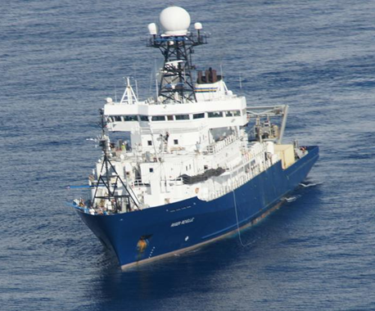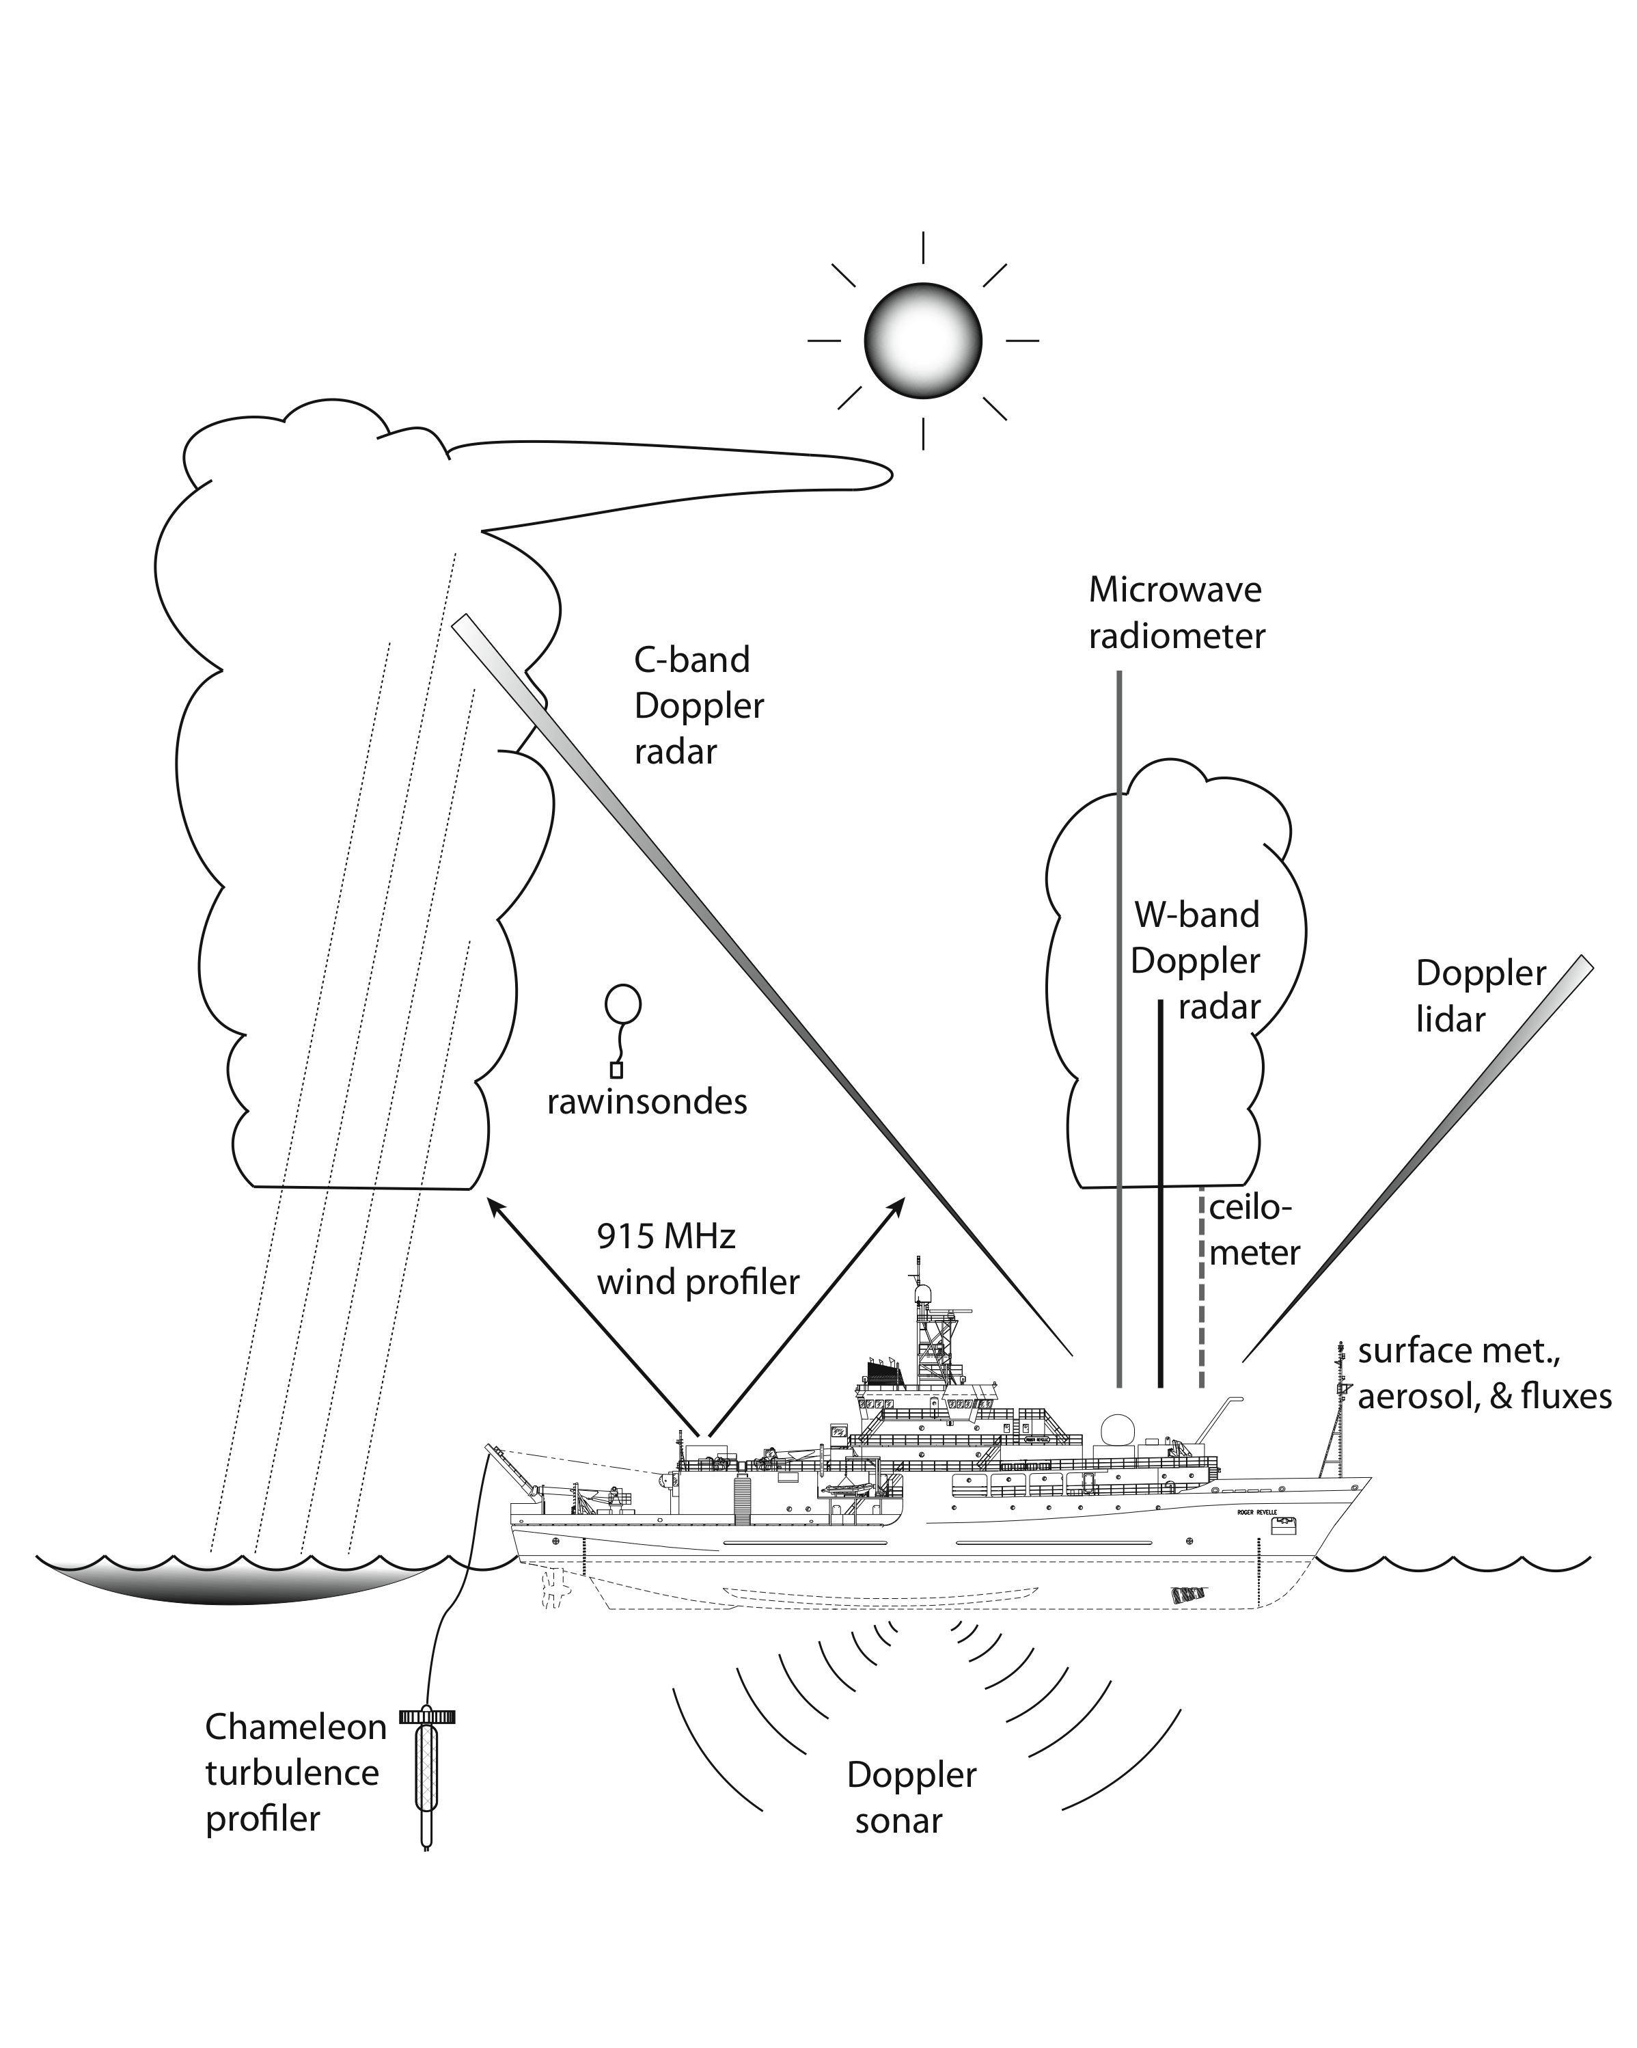

**Figure 1**. Schematic of some observations made during DYNAMO from R/V *Revelle*.

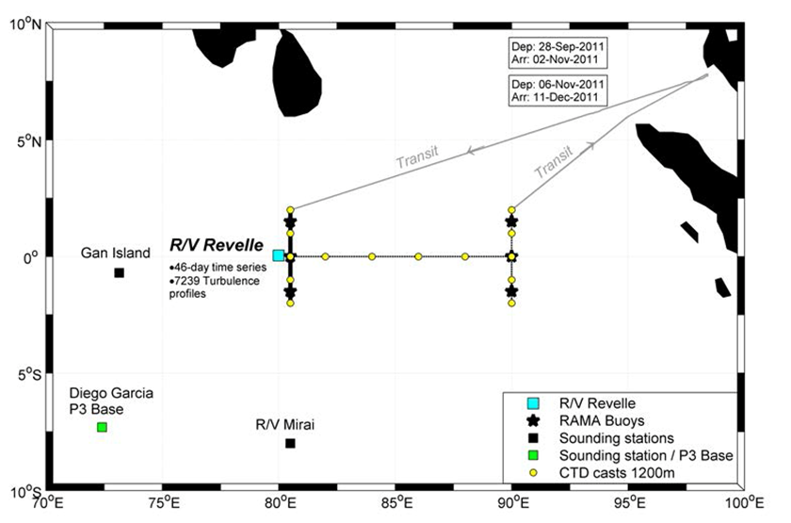

**Figure 2.** Ship track for *Revelle* during DYNAMO legs 2-3.



**Figure 3.** Schematic diagram showing the general conditions associated with a marine fair weather boundary layer. SHF, surface heat flux: LHF, latent heat flux; LCL, lifting condensation level; LFC, level of free convection; ML, mixed layer (after Ghate et al. 2011).

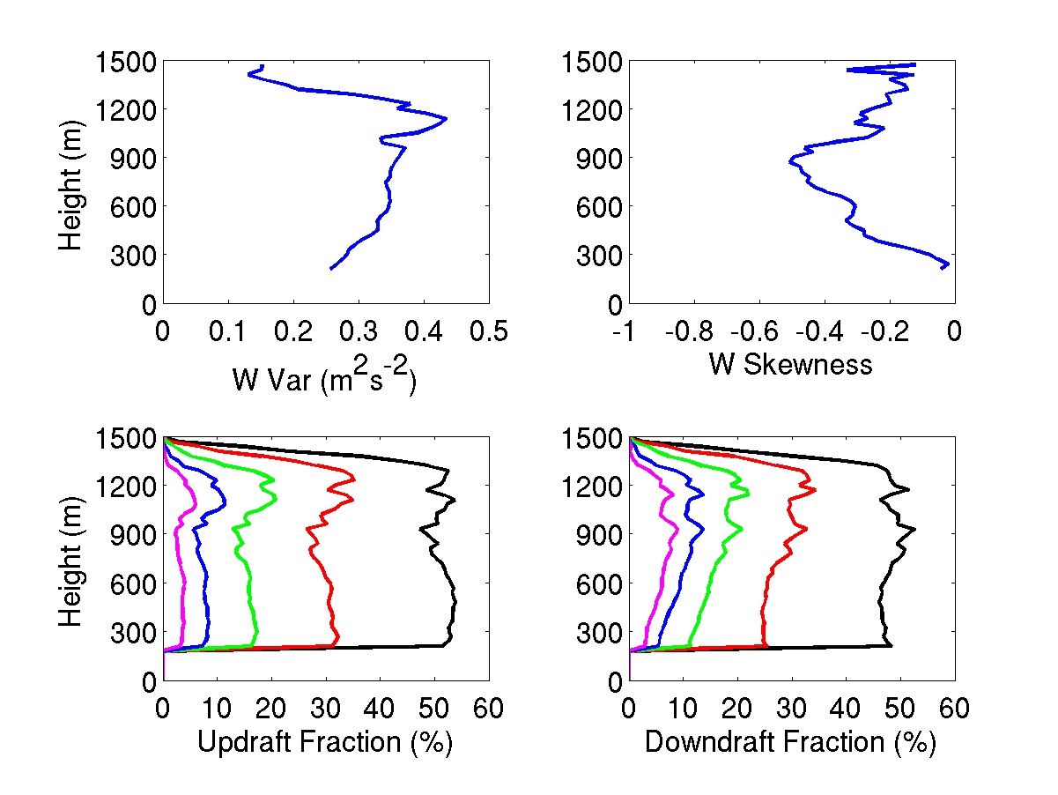

**Figure 4.**  Averaged profile of vertical velocity variance (top left) and vertical velocity skewness (top right) from Nov. 27, 2008, in the VOCALS field study in the stratocumulus region off Chile. The updraft and downdraft fractions are shown in the bottom panels with thresholds of 0 ms-1 (black), 0.25 ms-1 (red), 0.50 ms-1 (green), 0.75 ms-1 (blue) and 1 ms-1 (magenta). The thresholds are similar in magnitude but negative for the downdraft fraction (Ghate et al. 2012). Cloudbase is at 950 m. Negative skewness implies convection is driven by cloudtop radiative cooling.

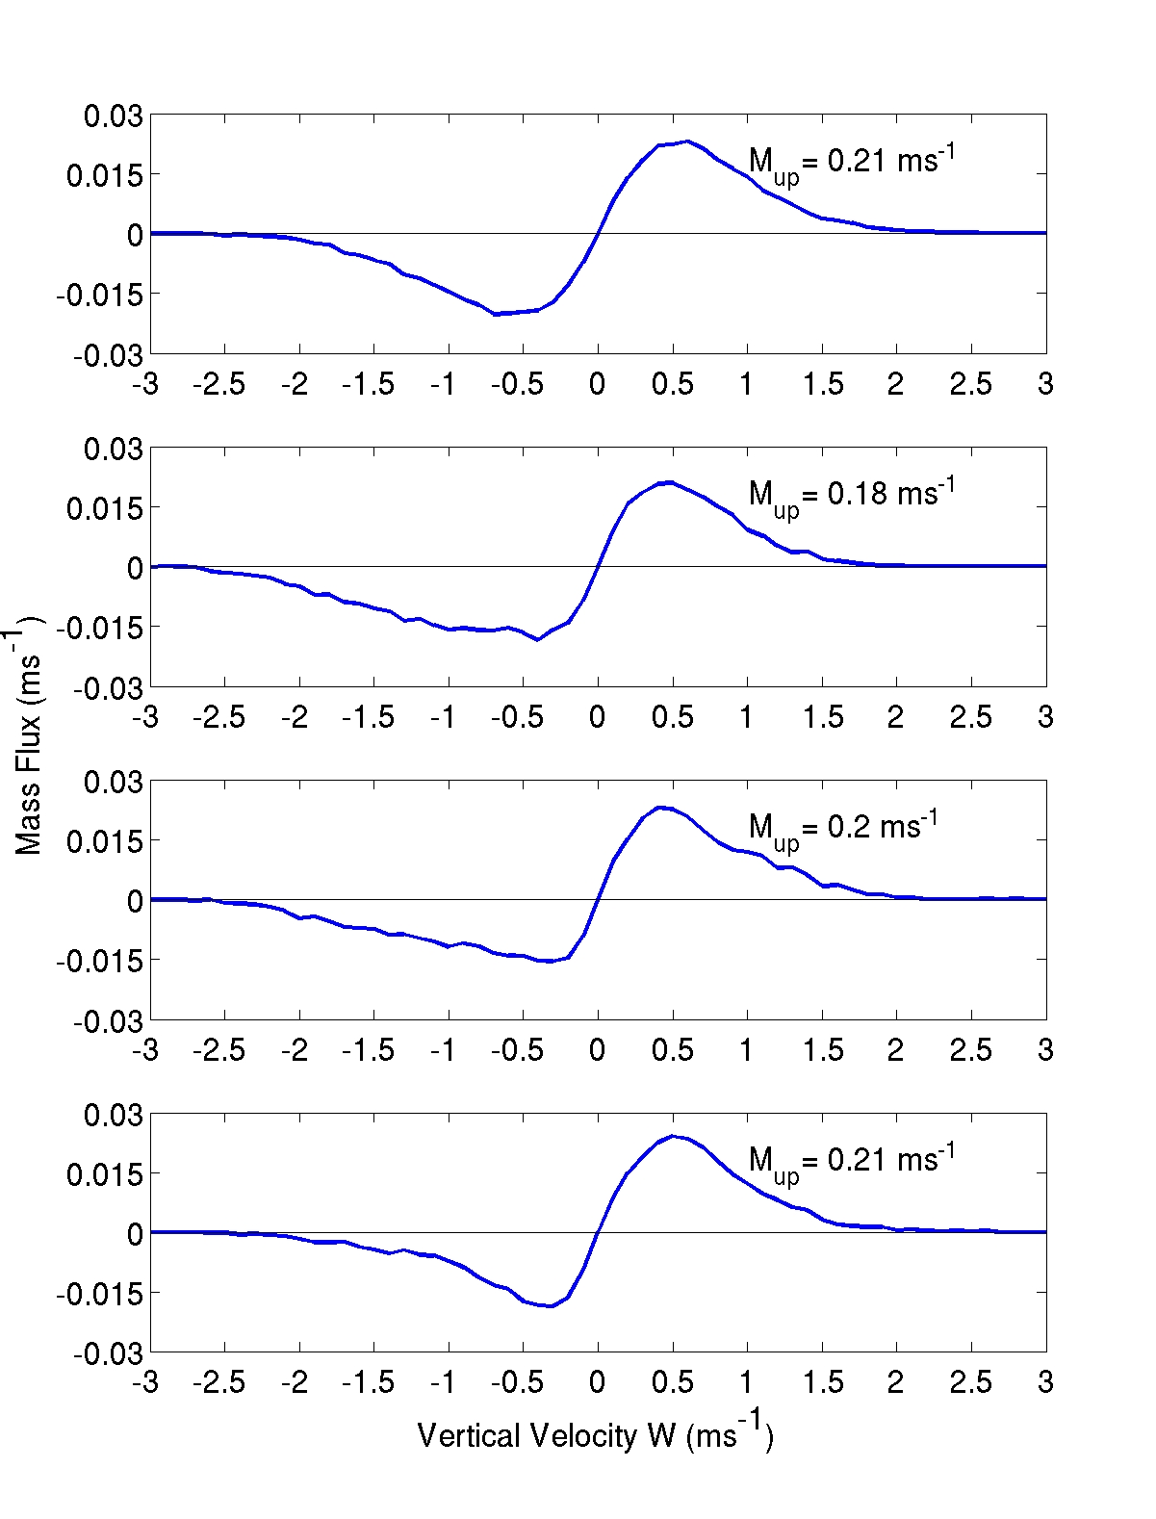

**Figure 5**. As in Fig. 4, but averaged profile of velocity binned mass-flux at 1200 m (top), 900 m, 600 m and 300 m (bottom) from VOCALS. The updraft mass-flux at each level is also reported in the respective panels. The long tail on the downdraft side of the distribution is consistent with cloudtop radiative cooling and negative skewness. Cloud top is at 1400 m and cloud base is at 950 m.



**Figure 6**. Updraft mean (top) and downdraft mean (bottom) vertical velocity as a function of draft horizontal extent. Average values (symbols) are presented for 8 horizontal sizes. The statistical results consider all updraft and downdraft events observed at three heights over two days. After Ansmann et al. 2010.

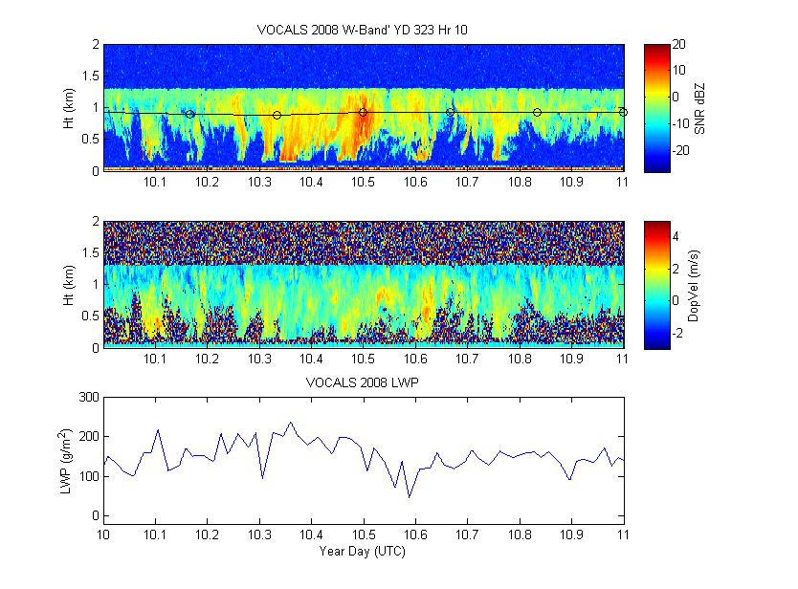

**Figure 7**. Sample W-band radar time-height cross section for one hour on November 18 during the VOCALS field program in 2008. Upper panel – signal to noise ratio; middle panel Doppler velocity; bottom panel – liquid water path. The black line in the SNR panel is the cloud base height interpolated from 10-min averages. The radar SNR sensitivity threshold is -18 dB (equivalent to -38 dBZ at a range of 1 km). Radar returns below the cloud base indicate subcloud drizzle, much of which evaporates before reaching the surface.

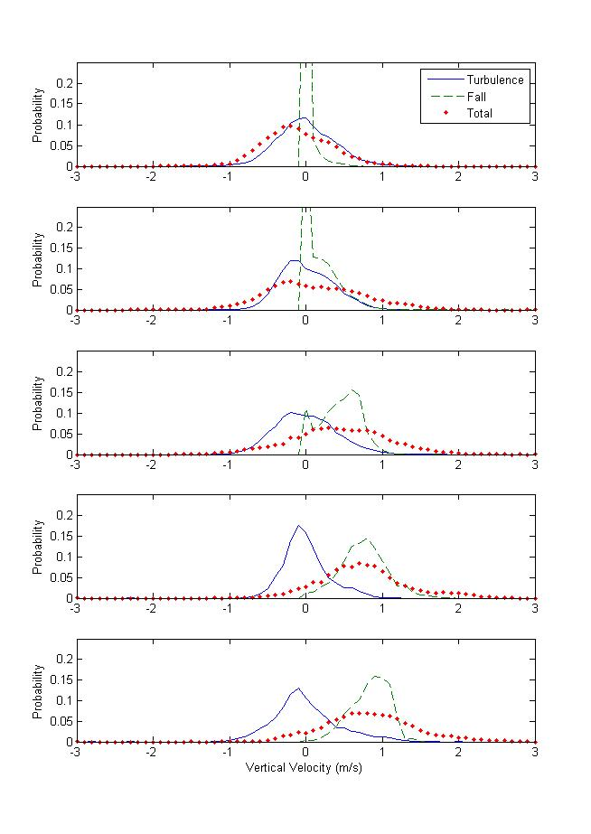

**Figure 8.** Probability distributions of vertical velocity (from the case in Fig. 7) as a function of height: the upper panel is near cloud top, the lower panel is near cloud base. The red dots are the raw observed Doppler velocity. The turbulent velocity (solid blue) and gravitational velocity (dashed green) are obtained using the method of Pinksy et al. (2010). At cloud base the observed velocity variance is dominated by variations in particle gravitational fall velocity (drizzle) while at cloud top it is dominated by turbulent motions of cloud drops.

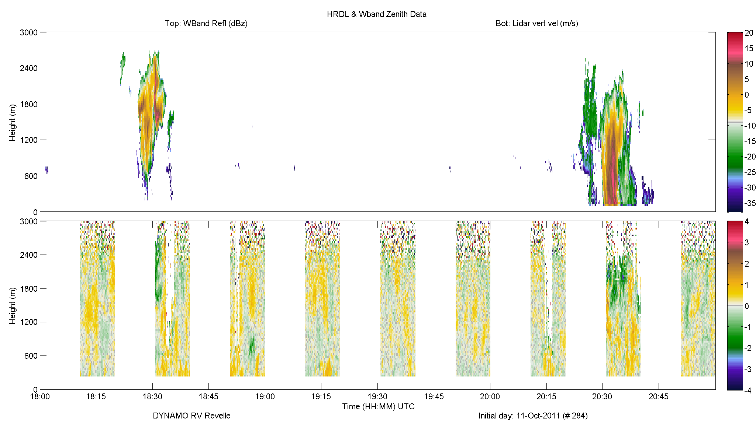

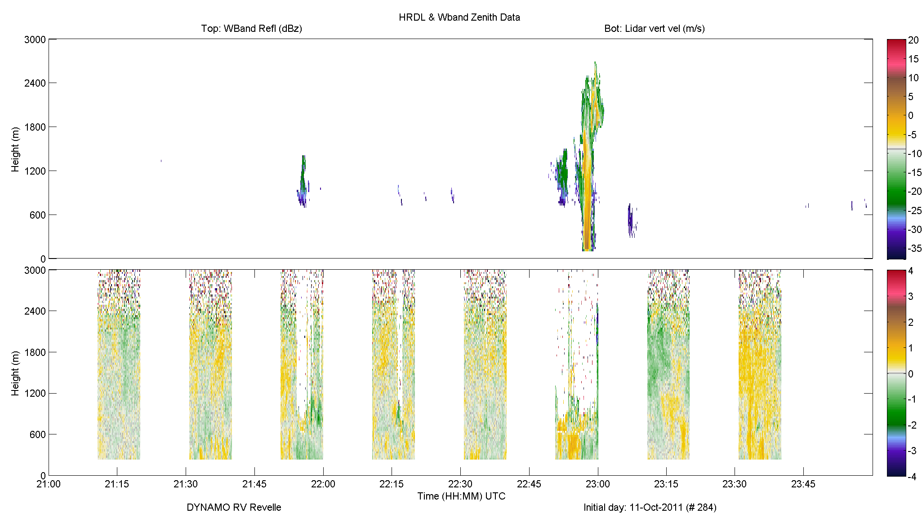

**Figure 9.** Consecutive sample 3-hr time-height cross sections of Doppler cloud radar backscatter (upper panel) and Doppler lidar vertical velocity (lower panel). The lidar is in vertically stare mode in alternate 10-min intervals. In the other interval it is horizontally scanning. The radar is vertically staring full time. Clouds are apparent as the colored regions in the radar backscatter (note lidar may not penetrate into the cloud). Cloud base in these examples is about 600 m and the trade inversion is at 2400 m. Returns from the radar below 600 m are precipitation. Reflectivities greater than -18 dBZ are likely to include precipitation.

**5. Budget Justification**

This proposal will be a collaborative effort between ESRL/PSD and ESRL/CSD, with PSD taking responsibility cloud and flux observations and CSD taking responsibility for lidar and sounding observations and integration of the time series. Analysis will be done jointly. Included in the budget is support for salary, supplies, travel, and publications.

**NOAA EARTH SYSTEM RESEARCH LABORATORY:**

**Salaries.**

Partial support for a postdoc is requested for all three years.

Support requested for preprocessing, (Bariteau), radar analysis (Hartten), flux analysis (Grachev), and synthesis (Brewer)

ESRL PI salary (C. Fairall) is not charged to project.

**Publications.** Start in Year 1 and increase slightly in Years 2 and 3.

**Travel.** Each of the three years includes funds for travel for meetings with collaborators at Oregon State University and CUU plus post-DYNAMO conferences.

**Supplies.** Nominal funds for supplies to support research are requested.

**Equipment.** None.

**IT and Admin support.** Nominal charges at PSD for support functions.

**6. Curriculum Vitae**

**CHRISTOPHER W. FAIRALL**

Supervisory Physicist/Chief

Weather and Climate Physics Branch, Physical Sciences Division

NOAA Earth Systems Research Laboratory Boulder, CO

**EDUCATION**

Ph.D., Solid State Physics, Michigan State University, 1970.

B.S., Physics and Mathematics, Florida State University, 1966.

**EMPLOYMENT**

1971-1977 Adjunct Professor of Physics, Naval Postgraduate School, Monterey, CA.

1978-1983 Principal Staff Member, BDM Corporation, Monterey, CA.

1982 Visiting Scientist, RISO National Laboratory, Denmark.

1983-1985 Assistant Professor of Meteorology, Pennsylvania State University

1986-1989 Associate Professor of Meteorology, Pennsylvania State University

1989-Pres. NOAA Earth Systems Research Laboratory, Boulder, CO.

**RESEARCH INTERESTS**

Remote Sensing: ground-based Doppler wind profilers, Sodar and Radar, integrated sounding systems, clear-air turbulence, cloud radiative/microphysical properties.

Air/Sea Interaction: air/sea/ice flux measurements and parameterizations, sea spray, marine and Arctic boundary layers and clouds, particle and gas fluxes.

Boundary Layer Physics: mesoscale interactions, radiative transfer and closure models.

**Selected Honors, Awards and Fellowships**

Fellow, Cooperative Institute for Research in Environmental Sciences, 1999

Fellow, American Meteorological Society, elected 2000

NOAA Administrator’s Award for Scientific Achievement, 2003

Chair, World Climate Research Program Working Group on Surface Fluxes, 2003-2011

Sverdrup Gold Medal, American Meteorology Society, awarded 2009

**PUBLICATIONS (2010 - 2012)**

Andreas, E. L, P.O.G Persson, R.E. Jordan, T.W. Horst, P.S. Guest, A.A. Grachev, and C.W. Fairall, 2010: Parameterizing turbulent exchange over sea ice in winter.  *J. Hydrometeor.*, **11**, 87-104.

Blomquist, B. W., B. J. Huebert, C. W. Fairall, and I. C. Faloona, 2010: Determining the sea-air flux of dimethylsulfide by eddy correlation using mass spectrometry. *Atmos. Meas. Tech*., **3**, 1-20.

Ludovic Bariteau, J. Hueber , K. Lang, D. Helmig, C. W. Fairall, and J. E. Hare, 2010: Ozone deposition velocity by ship-based eddy correlation flux measurements.  *Atmos. Meas. Tech.*, **3**, 441-455, [DOI:10.5194/amt-3-441-2010](http://www.atmos-meas-tech.net/3/441/2010/amt-3-441-2010.html).

Andreas, E. L, T. W. Horst, A. A. Grachev, P. O. G. Persson, C. W. Fairall, P. S. Guest, and R. E. Jordan, 2010: Parameterizing turbulent exchange over summer sea ice and the Marginal Ice Zone.  *Quart. J. Roy. Met. Soc.*, **136**, 927-943.

DeSzoeke, Simon P., C. W. Fairall, D.E. Wolfe, L. Bariteau, and P. Zuidema 2010: Surface flux observations in the southeastern tropical Pacific and attribution of SST errors in coupled ocean-atmosphere models. *J. Clim.*, **23**, 4152-4174.

Andreas, E.L., K.F. Jones, and C.W. Fairall, 2010: The production velocity of sea spray droplets. *J. Geophys. Res.*, **115**, C12065, doi:10.1029/2010JC006458.

Woods, R., and 32 coauthors, 2011: The VAMOS Ocean-Cloud-Atmosphere-Land Study Regional Experiment (VOCALS-REx): goals, platforms, and field operations. *Atmos. Phys. Chem. Disc.*, **11**, 2627-654, doi:10.5194/acp-11-627-2011.

De Leeuw, G., C.W. Fairall, E.L Andreas, M.D. Anguelova, E.R. Lewis, C. O’Dowd, M. Schulz, and S.E. Schwartz, 2011: Primary production of sea spray aerosol. *Rev. Geophys.*, **49**, RG2001, doi:10.1029/2010RG000349.

Rowe, M.D., J.A. Perlinger, and C.W. Fairall, 2010: Parameterization of internal boundary layer growth in offshore flow using an internal boundary layer transport exchange model. *Bound.-Layer Meteorol*., **140**, 87-103, DOI: 10.1007/s10546-011-9598-0.

Rowe, M.D., C.W. Fairall, and J.A. Perlinger, 2011: Chemical sensor resolution requirements for near-surface measurements of turbulent fluxes*. Atmos. Chem. Phys.*, **11**, 5263–5275, doi:10.5194/acp-11-5263-2011.

Bianco, L., J.-W. Bao, C. W. Fairall, and S. A. Michelson, 2011: Impact of sea spray on the surface boundary layer.  *Bound.-Layer Meteorol*., **140** , DOI 10.1007/s10546-011-9617-1.

Lauvset, S. K., W. R. McGillis, L. Bariteau, C. W. Fairall, T. Johannessen, A. Olsen, and C. J. Zappa, 2011: Direct measurements of CO2 flux in the Greenland Sea, *Geophys. Res. Lett.*, **38**, L12603, doi:10.1029/2011GL047722.

Grachev, A. A., Ludovic J. Bariteau, J. Hueber, K. Lang, D. Helmig, C. W. Fairall, and J. E. Hare, 2011: Near-surface Ozone fluxes from ship-based eddy-correlation measurements during TexAQS 2006. *J. Geophys. Res.,* **116**, D13110, doi:10.1029/2010JD015502.

Yang, M., B.W. Blomquist, C.W. Fairall, S.D. Archer, and B.J. Huebert, 2011: Effects of sea surface temperature and gas solubility on air-sea exchange of Dimethylsulfide (DMS).  *J. Geophys. Res*., **116**, C00F05, doi:10.1029/2010JC006526.

Bocquet, F., D. Helmig, B. A. Van Dam, and C. W. Fairall, 2011: Evaluation of the flux gradient technique for measurement of ozone surface fluxes over snowpack at Summit, Greenland.  *Atmos. Meas. Tech.*, **4**, 2305-2321, doi:10.5194/amt-4-2305-2011.

Edson, J.B., C.W. Fairall, Ludovic Bariteau, C.J. Zappa, A. Cifuentes-Lorenzen, W.M. McGillis, S. Pezoa, J.E. Hare, and D. Helmig, 2011: Eddy-covariance measurement of CO2 gas transfer velocity during the 2008 Southern Ocean Gas Exchange Experiment: Wind speed dependency. *J. Geophys. Res.*, **116**, doi:10.1029/2011JC007022.

Fairall, C.W., Mingxi Yang, Ludovic Bariteau, J.B. Edson, D. Helmig, W. McGillis, S. Pezoa, J.E. Hare, B. Huebert, and B. Blomquist, 2011: Implementation of the COARE flux algorithm with CO2, DMS, and O3. *J. Geophys. Res.*, **116**, C00F09, doi:10.1029/2010JC006884.

Moran, K., S. Pezoa, C. Fairall, T. Ayers, A. Brewer, C. Williams, and S. de Szoeke, 2012: A motion stabilized W-band radar for shipboard cloud observations and airborne studies of sea spray. *Bound.-Layer Meteor*., **141**, 3-24, DOI 10.1007/s10546-011-9674-5.

Helmig, D., E.K. Lang, L. Bariteau, L. Ganzeveld, C.W. Fairall, J.E. Hare, P. Boylan, and J. Hueber, 2012: Atmosphere-ocean ozone fluxes during the TexAQS 2006, STRATUS 2006, GOMECC 2007, GasEX 2008, and AMMA 2008 cruises. *J. Geophys. Res.,* doi:10.1029/2011JD015955.

Bao, J.-W., C. W. Fairall, S. A. Michelson, L. Bianco, 2011: Parameterizations of sea-spray impact on the air-sea momentum and heat fluxes. *Mon. Wea. Rev*., **139**, 3781–3797, doi: <http://dx.doi.org/10.1175/MWR-D-11-00007.1> .

Zuidema, P., ZX. Li, R.J. Hill, Ludovic Bariteau, Bob Rilling, C.W. Fairall, W. A. Brewer, B. A. Albrecht, and J.E. Hare, 2012: On trade wind cumulus cold pools*. J. Atmos. Sci*., **69**, 258-280, DOI: 10.1175/JAS-D-11-0143.1.

Grachev, A.A., Edgar L. Andreas, C. W. Fairall, Peter S. Guest, P. Ola G. Persson, 2012**:** Outlier problem in evaluating similarity functions in the stable atmospheric boundary layer. *Bound.-Layer Meteorol.*, **144**, 137–155, DOI 10.1007/s10546-012-9714-9.

**FIVE OTHER RELEVANT PUBLICATIONS**

Frisch, A. S., G. Feingold, C. W. Fairall, T. Uttal, and J. B. Snider, 1998: On cloud radar and microwave radiometer measurements of stratus cloud liquid water profiles. *J. Geophys. Res.*, **103**, 23195-23197.

Fairall, C.W., A.B. White, J.B. Edson, and J.E. Hare, 1997: Integrated shipboard measurements of the marine boundary layer. *J. Atmos. Oceanic Tech.,* **14**, 338-359.

Webster, P. J., C. W. Fairall, P. W. Hacker, R. Lukas, E. F. Bradley, and S. Godfrey, 2002: The Joint Air-Sea Monsoon Interaction Experiment (JASMINE) Pilot study. *Bull. Am. Met. Soc.*, **83**, 1603-1630.

Zuidema, Paquita, C. W. Fairall, E. Westwater, and D. Hazen, 2005: Ship-based liquid water path estimates in marine stratus. *J. Geophys. Res*., **110(20)**, Art. No. D20206.

Fairall, C. W., J. E. Hare, T. Uttal, D. Hazen, Meghan Cronin, Nicholas A. Bond, and Dana Veron, 2008: A seven-cruise sample of clouds, radiation, and surface forcing in the Equatorial Eastern Pacific. *J. Clim*., **21**, 655-673.

**WM. ALAN BREWER**

Lidar Development Group Leader

Chemical Sciences Division

Earth System Research Laboratory, NOAA

325 Broadway, Boulder, Colorado 80305-3328

(303) 497-7859 / [alan.brewer@noaa.gov](mailto:alan.brewer@noaa.gov)

**Employment -**

Present - 2000 Lidar Development Group Leader, NOAA/ESRL

1998 - 2000 Physicist, NOAA/ETL

1997 - 1995 Research Associate, University of Colorado, CIRES (NOAA/ETL)

1995 - 1994 National Research Council Post-Doctoral Fellowship, NOAA/ETL

**Education -**

1994 - PhD. Physics, University of Colorado, JILA

1988 - M.S. Physics, University of Colorado

1986 - B.S. Physics, Denison University

**Awards and Fellowships -**

1986 - Phi Beta Kappa, Sigma Xi

1994 - National Research Council Post Doctoral Fellowship at NOAA/ETL.

**Professional Memberships**

American Geophysical Union

**Eight Related Open Literature Articles:**

Yelena L. Pichugina, Robert M. Banta, W. Alan Brewer, Scott P. Sandberg, R. Michael Hardesty. (2012) Doppler Lidar–Based Wind-Profile Measurement System for Offshore Wind-Energy and Other Marine Boundary Layer Applications. *J. Appl. Meteorol. Clim.,* **51**:2, 327-349.

Zuidema, P., Z. Li, R.J. Hill, L. Bariteau, B. Rilling, C. Fairall, W.A. Brewer, B. Albrecht, and J. Hare, [On trade wind cumulus cold pools](http://dx.doi.org/10.1175/JAS-D-11-0143.1).  *J. Atmos. Sci.*, **69**(1), 258-279, doi:10.1175/JAS-D-11-0143.1, 2012.

Feingold, G., I. Koren, H. Wang, H. Xue, and W. A. Brewer, 2010: Precipitation-generated oscillations in open cellular cloud fields. *Nature*, **466**, doi:10.1038 / nature09314.

Tucker S.C., W. A. Brewer, R. M. Banta, C. J. Senff, S. P. Sandberg, et al., 2009: Doppler lidar estimation of mixing height using turbulence, shear, and aerosol profiles. *J. Atmos. Ocean. Tech.*, **26**, 673-688.

Day B.M., B. Rappenglück, A.B. Clements , S.C. Tucker, and W.A. Brewer, 2009: Nocturnal boundary layer characteristics and land breeze development in Houston, Texas during TexAQS II, *Atmos. Env*., In press.

Hill, R.J., W.A. Brewer, and S.C. Tucker, 2008: Platform-Motion Correction of Velocity Measured by Doppler Lidar. J. Atmos. Oceanic Technol., **25**, 1369–1382.

Daniel Wolfe , Alan Brewer , Sara Tucker , Allen White , David White , David Welsh , Dominique Ruffieux , Christopher W. Fairall , Michelle Ratterree , Janet M. Intrieri , Brandi McCarty , Daniel Law, 2004: Shipboard multisensor merged wind profiles from the New England Air Quality Study 2004. *J Geophys. Res*., **112**, D10S15.

Fairall, C. W., L. Bariteau, A. A. Grachev, R. J. Hill, D. E. Wolfe, W. A. Brewer, S. C. Tucker, J. E. Hare andW. M. Angevine, 2006: Turbulent bulk transfer coefficients and ozone deposition velocity in the International Consortium for Atmospheric Research into Transport and Transformation. *J. Geophys. Res.*, **111**(D23), 10.1029/JD007597.

**7. Current and Pending Support**

**CHRISTOPHER FAIRALL**

**Current Support**

**Title**: High Resolution Climate Data from Research and Volunteer Observing Ships

**PI**: C. Fairall : 2 mo/yr **Amount**: $290,000 for FY 13

**NOAA Climate Observations and Monitoring Division**

**Title** Collaborative research: Ship-based measurement of air-sea fluxes, the atmospheric boundary layer, and clouds during MJO development.

**PIs:** Chris Fairall (2 mo/yr), Simon de Szoeke, Wm. Alan Brewer

**Amount:** $473.9k for PSD, FY 2011-14

**NOAA CPO** NA11OAR4310076

**Title**: A Next-generation Integrated Earth System Analysis–Coupling between the Ocean and Atmosphere

**PI**: Michele Rienecker NASA/GMAO, C. Fairall (1 mo/yr)

**Amount**: $385,621 for FY11-FY14

**NASA ROSES 2010** NNH10ZDA001N–MAP

**Title**: Quantifying the Role of Atmospheric Forcing in Ice Edge Retreat and Advance Including Wind-wave Coupling

**PIs:** Chris Fairall (1 mo/yr) and O. Persson

**Amount:** $473.9k for PSD, FY 2013-17

**Office of Naval Research**

**Pending Support**

**Title:** Collaborative Research: IDEAr – Interfacial and Diapycnal Exchanges in the Arctic

**PIs:** B. Loos, D. Ho, M. McPhee, P. Schloesser, W. Asher, Chris Fairall (1 mo/yr)

**Amount:** $433.9k for PSD, 3/1/13 - 2/28/16

**National Science Foundation**

**W. ALAN BREWER**

**Current Support**

**Title** Collaborative research: Ship-based measurement of air-sea fluxes, the atmospheric boundary layer, and clouds during MJO development

**PIs:** Chris Fairall, Simon de Szoeke, Wm. Alan Brewer (6,3,3 mos. for FY12,13,14)

**Amount:** $495.1k for CSD, FY 2011,12,13 **NOAA CPO:** J. Todd

**Title** Boundary Layer Processes in the Indian Ocean MJO

**PI:** Wm. Alan Brewer **Amount:** $352.1k FY 2012,13,13,14

**Person-Months (Total):** (5,4,4 for FY12,13,14) **ONR:** Scott Harper

**Pending Support**

**Title** Collaborative Proposal: Interrogating Tropical Cold Pools with DYNAMO Observations and Modeling **PIs:** Paquita Zuidema, Steve Krueger, Simon de Szoeke, Wm. Alan Brewer (0,0,0 mos. for FY12,13,14)

**Amount:** $75k for CSD, FY 2012,13,14 **NOAA CPO:** Sandy Lucas

PSD BUDGET



CSD BUDGET



COMBINED BUDGET

|  |  |  |  |  |  |  |  |  |  |
| --- | --- | --- | --- | --- | --- | --- | --- | --- | --- |
|  | 2011 | | 2012 | | 2013 | |  | 3 year total | |
|  | Radar | Lidar | Radar | Lidar | Radar | Lidar |  | Radar | Lidar |
| **Sal+benefit** | 56083 | 65018 | 58888 | 61585 | 61832 | 59069 |  | 176803 | 185671 |
| **other obj** | 29628 | 4562 | 31332 | 7670 | 30851 | 9205 |  | 91810 | 21437 |
| **noaa oh** | 0 | 10400 | 0 | 10400 | 0 | 11024 |  | 0 | 31825 |
|  |  |  | 0 | 0 | 0 | 0 |  |  |  |
| **sub-total** | 85711 | 79980 | 90219 | 79655 | 92682 | 79298 |  | 268613 | 238933 |
| **Total** | 165692 | | 169874 | | 171980 | |  | 507546 | |
|  |  |  |  |  |  |  |  |  |  |
|  | 2011 | | 2012 | | 2013 | |  |  |  |
|  | Radar | Lidar | Radar | Lidar | Radar | Lidar |  |  |  |
| Supplies & Materials | 2,447 | 0 | 2,791 | 1,200 | 1,928 | 1,200 |  |  |  |
| Publication Costs | 5,000 | 1,600 | 5,250 | 3,500 | 5,513 | 4,500 |  |  |  |
| Travel | 4,000 | 2,962 | 4,200 | 2,970 | 4,410 | 3,505 |  |  |  |