Earth Systems Research Laboratory
Physical Science Division
Weather and Climate Physics Branch

Chris Fairall, Daniel E. Wolfe, Sergio Pezoa, and Ludovic Bariteau,
NOAA Earth System Research Laboratory
Boulder, CO USA

Background on Measurement Systems

The Physical Science Division (PSD) air-sea flux and cloud group conducts measurements of fluxes and near-surface bulk meteorology during field programs on the Ronald H. Brown (RHB) .
The air-sea flux system consists of six components:
(1) A fast turbulence system with ship motion corrections mounted on the jackstaff. The jackstaff sensors are: GILL Sonic anemometer, Fast Ozone Sensor’s inlet, LiCor LI-7500 fast CO₂/hygrometer, and a Systron-Donner motion-pak.
(2) A mean T/RH sensor in an aspirator on the jackstaff.
(3) Solar and IR radiometers (Eppley pyranometers and pyrgeometers) mounted on top of a seatainer on the 02 deck.
(4) A near surface sea surface temperature sensor consisting of a floating thermistor deployed off port side with outrigger (Sea Snake).
(5) A Riegl laser rangefinder wave gauge mounted on the jackstaff.
(6) An optical rain gauge mounted on the jackstaff. Slow mean data (T/RH, PIR/PSP, etc) are digitized on a Campbell 23x datalogger and transmitted via a combination of RS-232 and wireless as 1-minute averages. A central data acquisition computer logs all sources of data via RS-232 digital transmission:
Atmospheric aerosols are measured with a Particle Measurement Systems (PMS) Lasair-II aerosol spectrometer. The Lasair-II draws air through an intake and uses scatter of laser light from individual particles to determine the size. The PSD system is normally mounted in a seatainer on the 02 deck with the intake on the upwind side of the container.

PSD/Flux also operates five remote systems:
- Vaisala CT-25K cloud base ceilometer
- Doppler C-band 5.6 GHz scanning- weather radar
- 915 MHz vertically pointed Doppler radar wind profiler
- Tera Scan Satellite receiver (Sea Space)
- Radiometrics 1100 2-channel microwave radiometer

The ceilometer is a vertically pointing lidar that determines the height of cloud bottoms from time-of-flight of the backscatter return from the cloud. The time resolution is 30 seconds and the vertical resolution is 15 m.
The Doppler C-Band radar normally operates in 2 modes. Every 10 minutes 2 tasks are scheduled: a 125 km volume scan at 11 elevation angles (0.0, 0.5, 1.0, 2.0, 3.0, 4.0, 5.0, 10, 15, 20, and 30 degrees) and a 250 km 1-degree surveillance scan.
The microwave radiometer operates at ~20 and 30 GHz and is normally mounted on a corner of the O2 deck seatainer. This passive system monitors the total column liquid water and water vapor producing points every 15 secs.
The 915-MHz radar profiler radar is permanently mounted on the RHB. It continuously monitors the winds above the ship from 150 to 5000m.
A Tera Scan (SeaSpace) satellite receiver collects High Resolution Picture Transmission (HRPT) data from NOAA’s polar orbiting satellites (12, 14, 15, 17, 18). This system is permanently mounted on the RHB and is available on all cruises to visiting scientists or for ship operations.

PSD is also the mentor for the weather balloon operations on board the RHB. A Vaisala MW31 system is maintained by PSD and available to visiting scientists upon request. Expendables (balloons, radiosondes, helium, etc) are the responsibility of the person(s) requesting use of this system. Recently this system has been upgraded to handle RS92 digital GPS radiosondes and ozondesondes.

Instrumentation Set-up
The primary flux sensors are mounted on the forward jackstaff. This takes approximately 2-3 days to complete. Data cables are run from the mast into the main computer room. Three data loggers are mounted on the forward starboard side. From these data-loggers cables are run into the Science Office forward of the main computer room. Two computers are setup in this lab and connected to the ship’s internet. Power to the instruments is supplied by the AC connections at the bottom of the jackstaff. A water hose is run from the O2 deck fresh water connection to the top of the jackstaff for rinsing the LiCor sensor window. The sea surface temperature sensor (sea snake) is attached to a mounting arm located port-side O1 Deck.

Our 20’ seatainer, normally placed on the O2 deck, will “NOT” be deployed on PNE. The flux system radiometers will be mounted on a pole attached to the railing somewhere along the O2 deck. The Mailbox radiometer will be mounted on the railing somewhere along the O3 deck. The aerosol particle sensor will housed in the Howard University van on the O2 deck.

The balloon sounding system stored in Boulder will be deployed on the ship along with the Ozonesonde set-up equipment.

The laser ceilometer is mounted on the aft winch house deck. Data cables are run to a data computer setup in the Hydro lab (with connection to the ship’s internet).

The C-Band Doppler weather radar antenna is locked down between scientific cruises. It is unsecured prior to a cruise. The main computer and electronics are located in the bridge aft control station. A remote terminal to monitor and operate the radar is located in the Computer lab. This radar is normally only run when a trained operator from PSD is on board.

The radar wind profiler antenna is mounted forward of the aft winch house. Its electronics are located in the Computer Lab. Prior to a scientific cruise this system is turned on. . This radar is normally only run when a trained operator from PSD is on board.
- NOTE: Both the C-Band radar and Radar Wind Profiler use a dual-GPS antenna mounted above the star-board bridge wing , feeds into the Sea Path system, for ship motion information.

The Tera Scan satellite receiver is located in the Computer lab. This system can run unattended as long as it is connected to the ship’s internet where it automatically receives satellite ephemeris data. A GPS receiver also allows the system to automatically up date the ship’s position. The satellite dish located on the aft winch house deck. Polar orbiting satellite images captured by this system are available throughout the ship’s internet. See example below.

Additional information on all these systems is available by contacting:
D. Wolfe, S Pezoa, or C. Fairall
NOAA Earth System Research Laboratory
325 Broadway
Boulder, CO USA 80305
303-497-6204 daniel.wolfe@noaa.gov
303-497-3253 chris.fairall@noaa.gov
303-497-6441 sergio.pezoa@noaa.gov
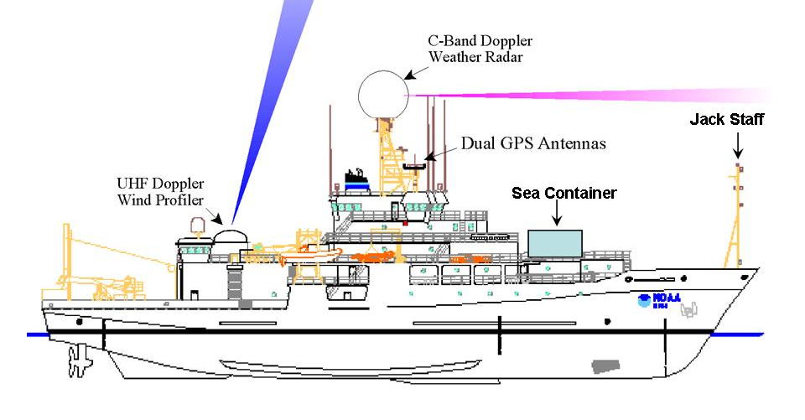
Prior to Satellite Internet

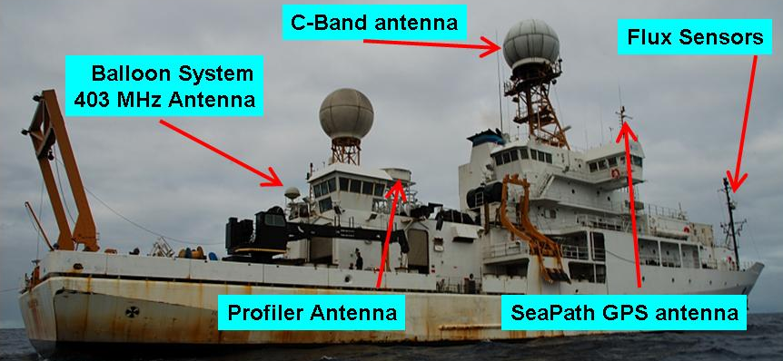
Stratus 2006
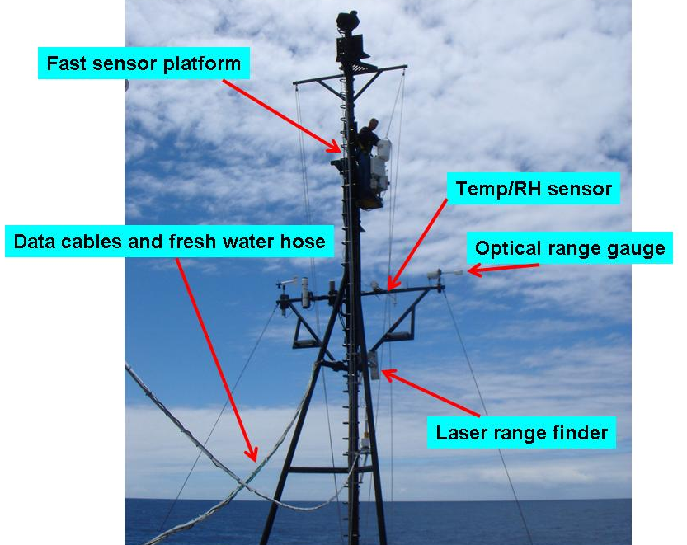
Forward Jack staff with PSD Flux sensors

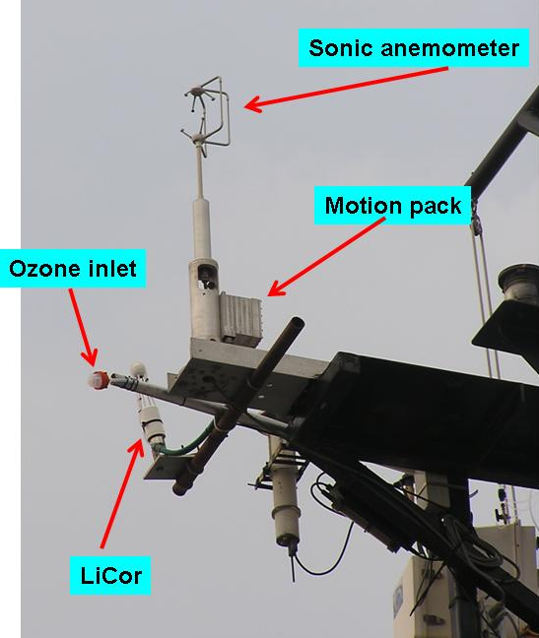
Fast sensor platform configuration
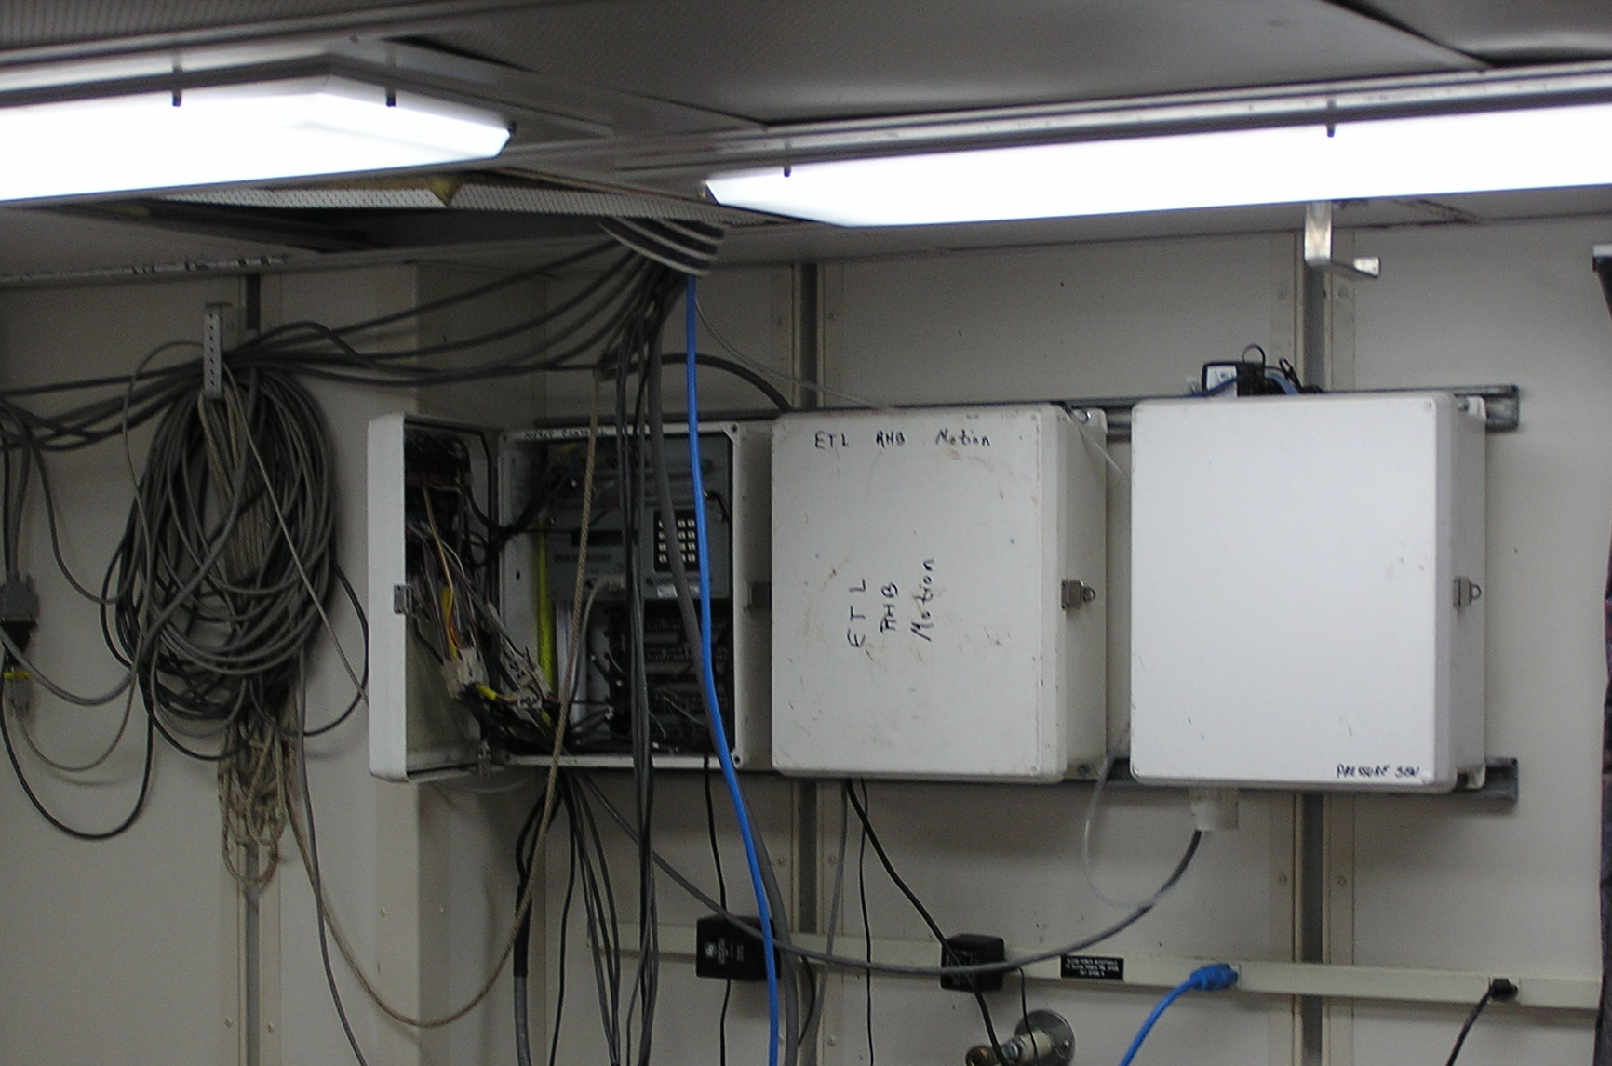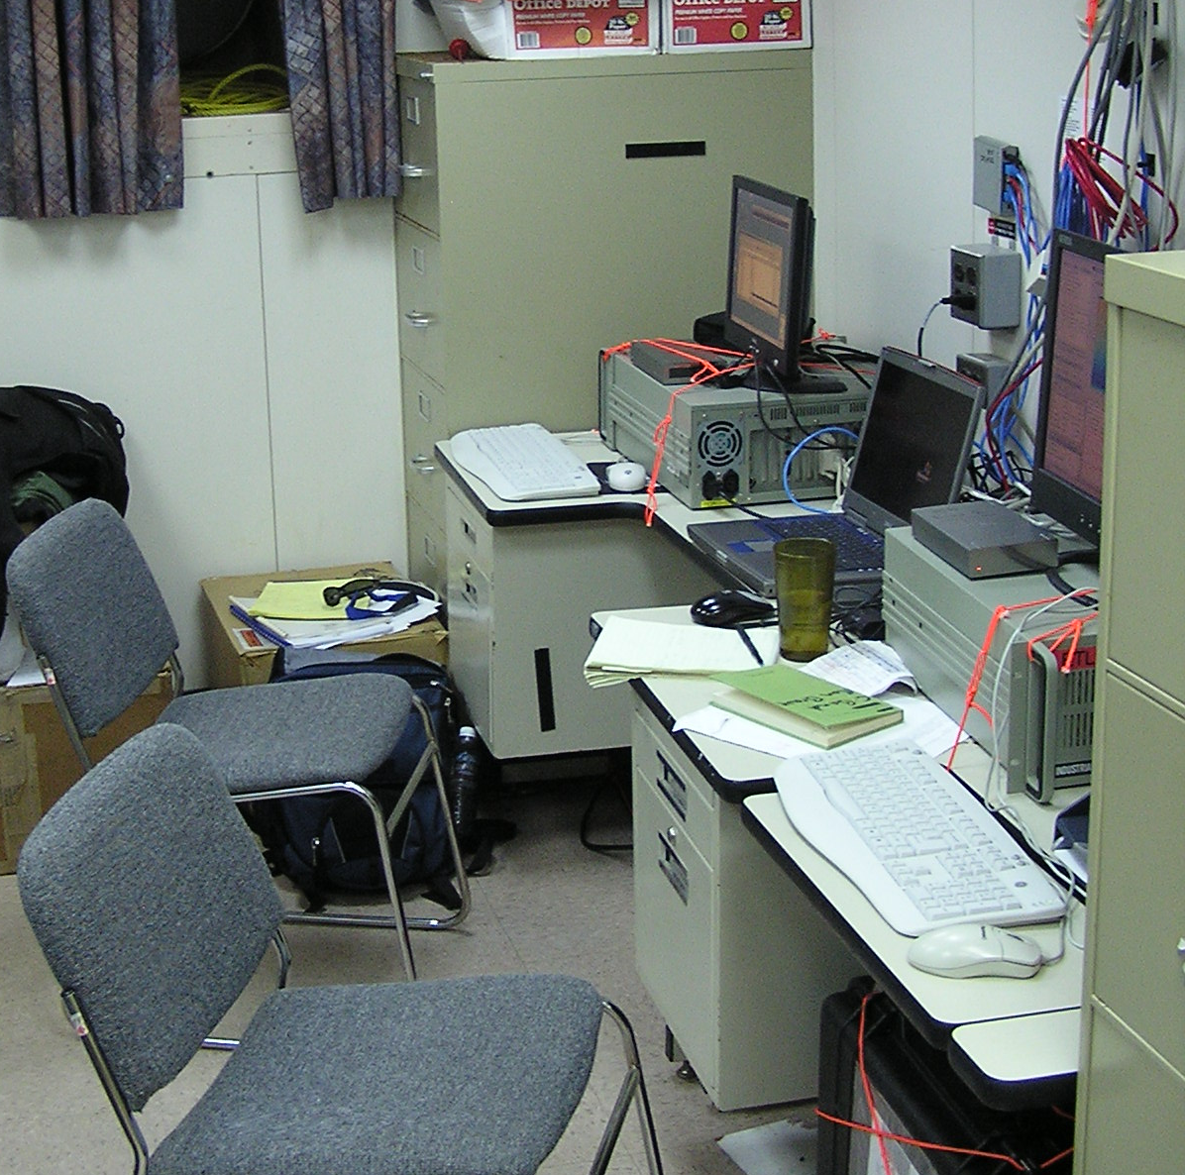
Data loggers in main computer room Flux computers in forward science office

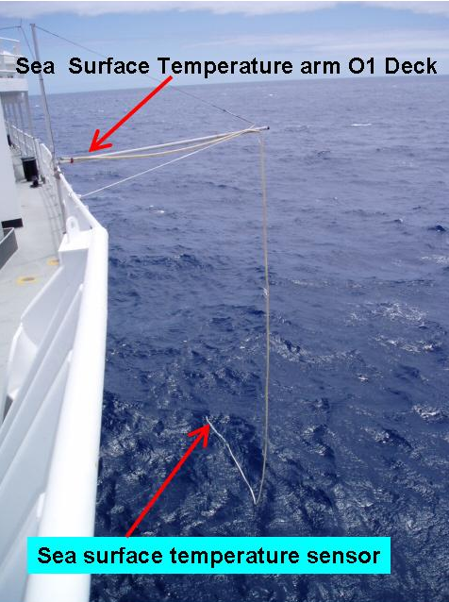
Sea Surface Temperature sensor port-side O1 Deck

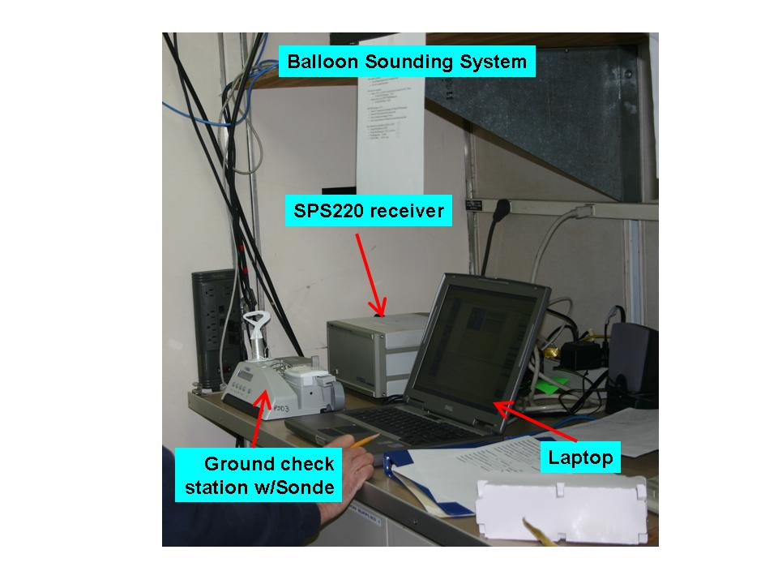
PSD balloon sounding system in Hydro-Lab (receiving station)
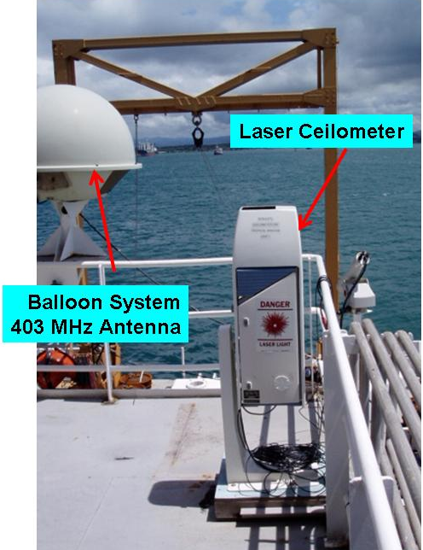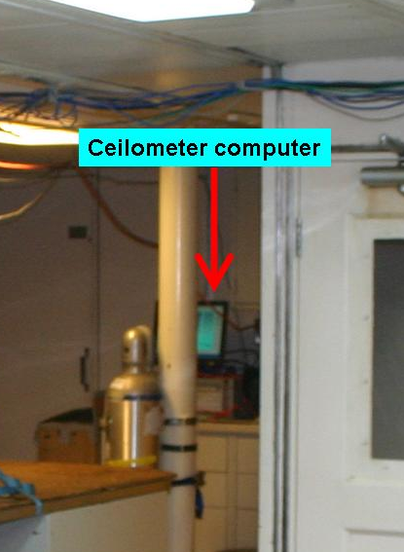
Ceilometer on O2 Deck Ceilometer PC in Hydro-Lab
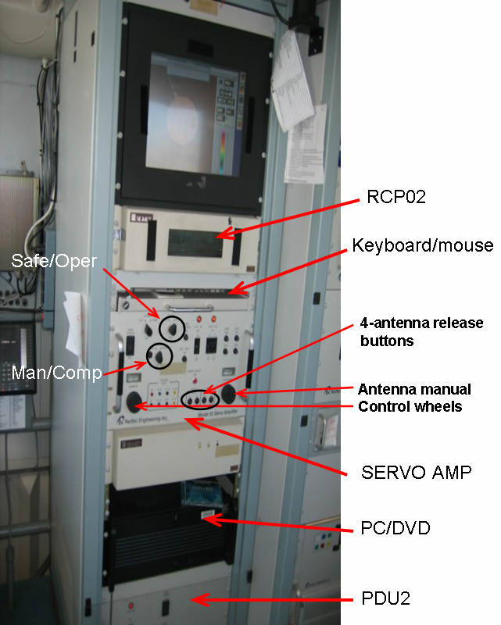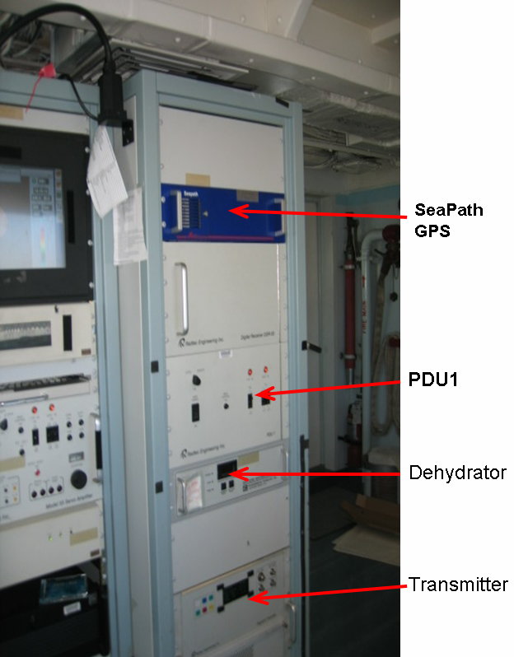
C-Band Weather Radar equipment racks near bridge aft control station

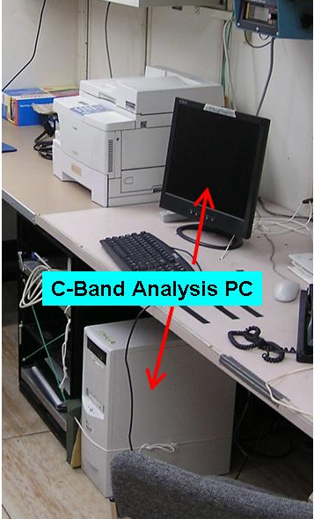
C-Band analysis PC in the in the Computer Lab
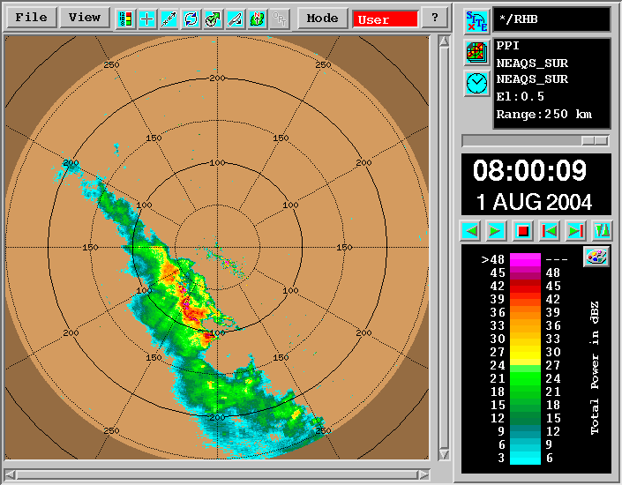
Example of C-Band Doppler radar reflectivity from a 0.5 degree surveillance scan.(NEAQS) 2004 08:00 UTC August 1, 2004.

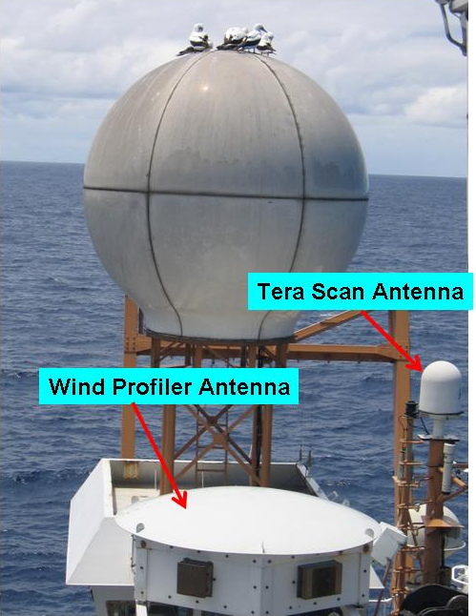
PSD wind profiler and Tera Scan antennae near aft winch house

Profiler Electronics and Tera Scan satellite receiver system in the Computer Lab
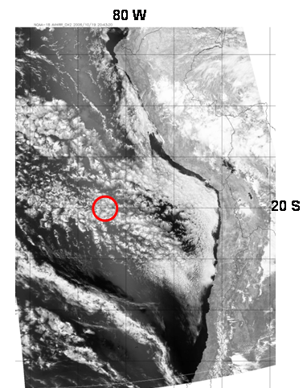
Example of Tera Scan satellite visible image NOAA-18 2043 UTC October 19, 2006. Red circle is the location of the STRATUS buoy (20 S, 85W)

