NOAA PSD W-Band Radar

Results from P-3 Test Flight July 30, 2013.

**Background:** The PSD Wband radar was installed on the NOAA WP-3 NRF43 in late July, 2013 (Fig. 1). A test flight was made on July 30. The flight track was W of Tampa with most observations taking place 1700-1859 GMT. Initial altitude was about 3.6 km then at 1817 decreased to 2.0 km (see Fig. 2 and 3). A series of circles were made with the aircraft rolled over at 10, 15, or 20 deg. Most of the data were +-10 deg. roll.

**Radar Settings:** The radar was operated in two modes but only the basic mode data are shown here. The second mode had problems and was not usable. Mode one:

Number range gates=150; Range resolution=25 m; Distance to range gate(1)=463 m; Distance to range gate(150)=4183 m; Number Doppler velocity bins=128; Doppler Bin Resolution: 0.12 m/s; Number spectral averages=9; Minimum detectable SNR=-20; Minimum detectable dBZ @ 1 km=-30; Dwell=0.3 s; antenna diameter=12 “, 46 dB gain, 0.7 deg beamwidth; wavelength=3.17 mm

The radar is a full Doppler Spectra processor. All Doppler spectra (1 mean spectrum every 0.3 s) are saved. The spectra are processed for standard first 3 moments (0th, 1st, 2nd) for reflectivity, mean Doppler velocity, and mean Doppler width.

**Sample Return Data:** The simplest visual display of the radar data is a time-height cross section of the 3 moments (Fig. 4). The return from the ocean surface is apparent as the bright region at a range of 3.6 km initially then decreasing to 2.0 km. The surface return occurs at a range equal to the aircraft altitude when the radar is nadir pointing. When the radar is off-nadir, the range is given by Rng=Altitude/Cos(θ). An example of a single reflectivity profile is shown in Fig. 5; the peak of the surface return is visible at about 2.1 km range; peak value is close to 50 dBZ. We have processed the time series to find the range and the dBZ value corresponding to the maximum return for the entire record. From the P3 navigation data, we also know the altitude and the pitch/roll of the aircraft. Figure 6 shows a plot of Range-Altitude compared to Altitude(1/ Cos(θ)-1). This suggests that the radar range accuracy is within 1 range bin.

**Processing for Radar Surface Cross-section:** The antenna PSD radar has an absolute calibration and with careful determination of losses in the system the absolute reflectivity accuracy is good. We assume that the surface cross-section,σ0, is related to the reflectivity, η, via

 (1)

where Z is the reflectivity factor and 180 converts conventional dBZ from mm6/m3 unit to m3. Using (1) we can convert to normalized radar cross-section (NRCS)

 (2)

The corrects are 1.6 dB for the 2-way window attenuation and 4.2 dB for 2-way atmospheric water vapor absorption at 2 km altitude. The final result is

 (3)

**Cross-section and NRCS results.** The time series of surface return information has been analyzed for various aspects of the radar performance. A simple depiction is NRCS vs the tilt angle of the incident beam (assumed to the aircraft roll angle). Fig. 7 shows a plot of data from the 2.0 km runs, where several roll angles were maintained for periods on the order of a few minutes. The black dots are the individual NRCS values (3 Hz); the red symbols are averages of σ0 from (1) that are then expressed in dB. These results are similar to those of Li et al. (2005). The rapid decrease with angle suggest light winds (on the order of 2-3 m/s), which is crudely consistent with flight-level measurements. There are several models of the surface roughness (optical to radar) as a function of angle. The models generally express the angular dependence as approximately [tan(θ)]-2 reasonably near nadir. A fit of our data to [tan(θ)]-2 is quite good and comparable to Li et als. (2005) results. Fig. 9 shows values of the surface Doppler velocity divided by the sin(θ) for angles exceeding 5 deg. At constant altitude, the motion of the aircraft normal to the aircraft horizontal axis is negligible relative to the air. Since the aircraft is executing a fixed angle turn, the interpretation is the observed Doppler is due to the mean motion vector of the air at flight level relative to surface. In this case, a net wind-surface current motion of about 3.5 m/s from about 180 deg (southerly). In other words, flight level wind speed is about 3.5 m/s.

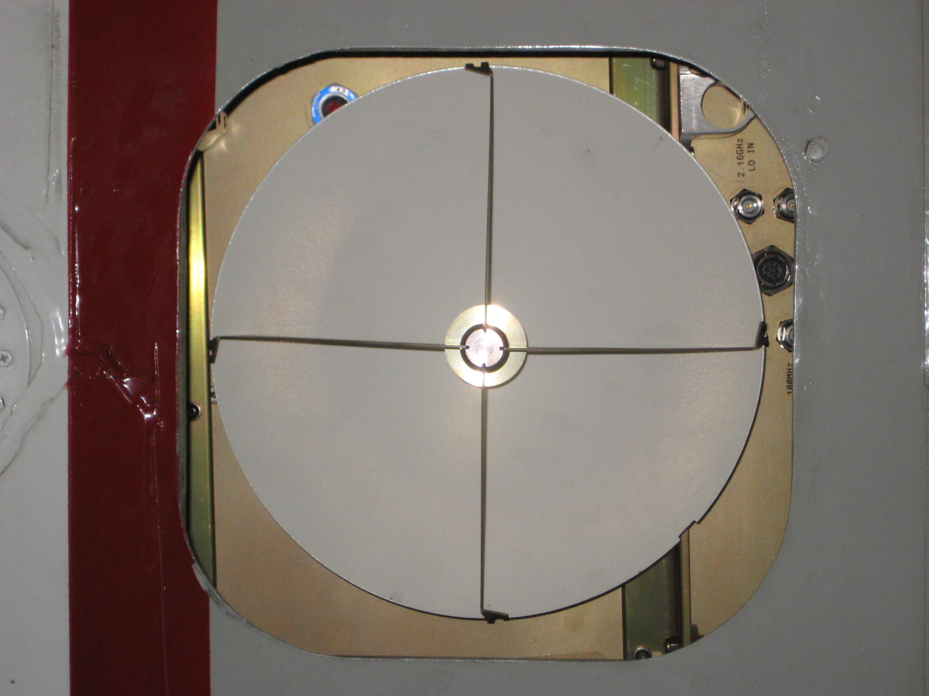

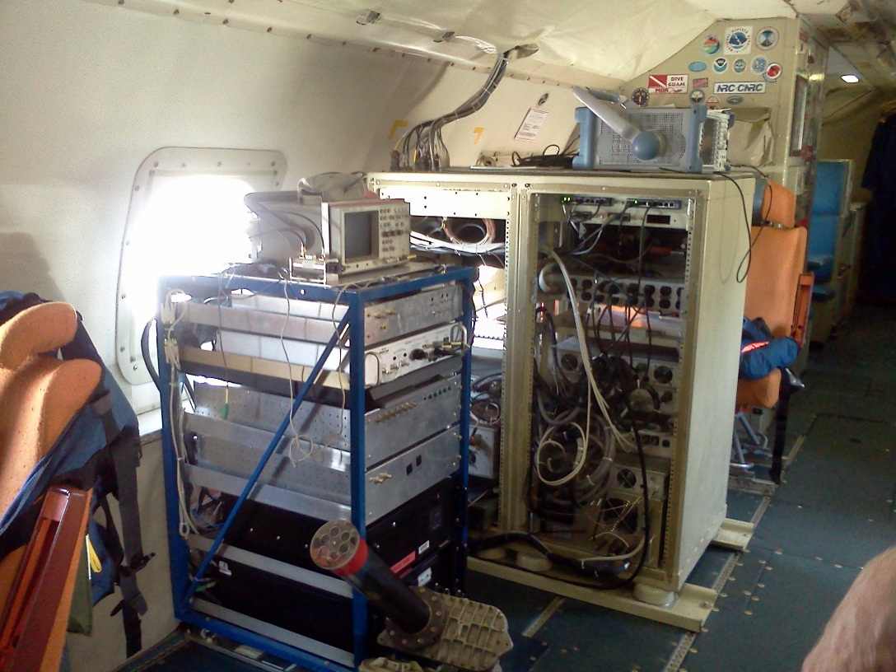

Figure 1. Upper panel: View of W-Band antenna from the port on the bottom of the aircraft prior to installation of the window; lower panel, Radar hardware in the P-3 cabin (left, blue frame)

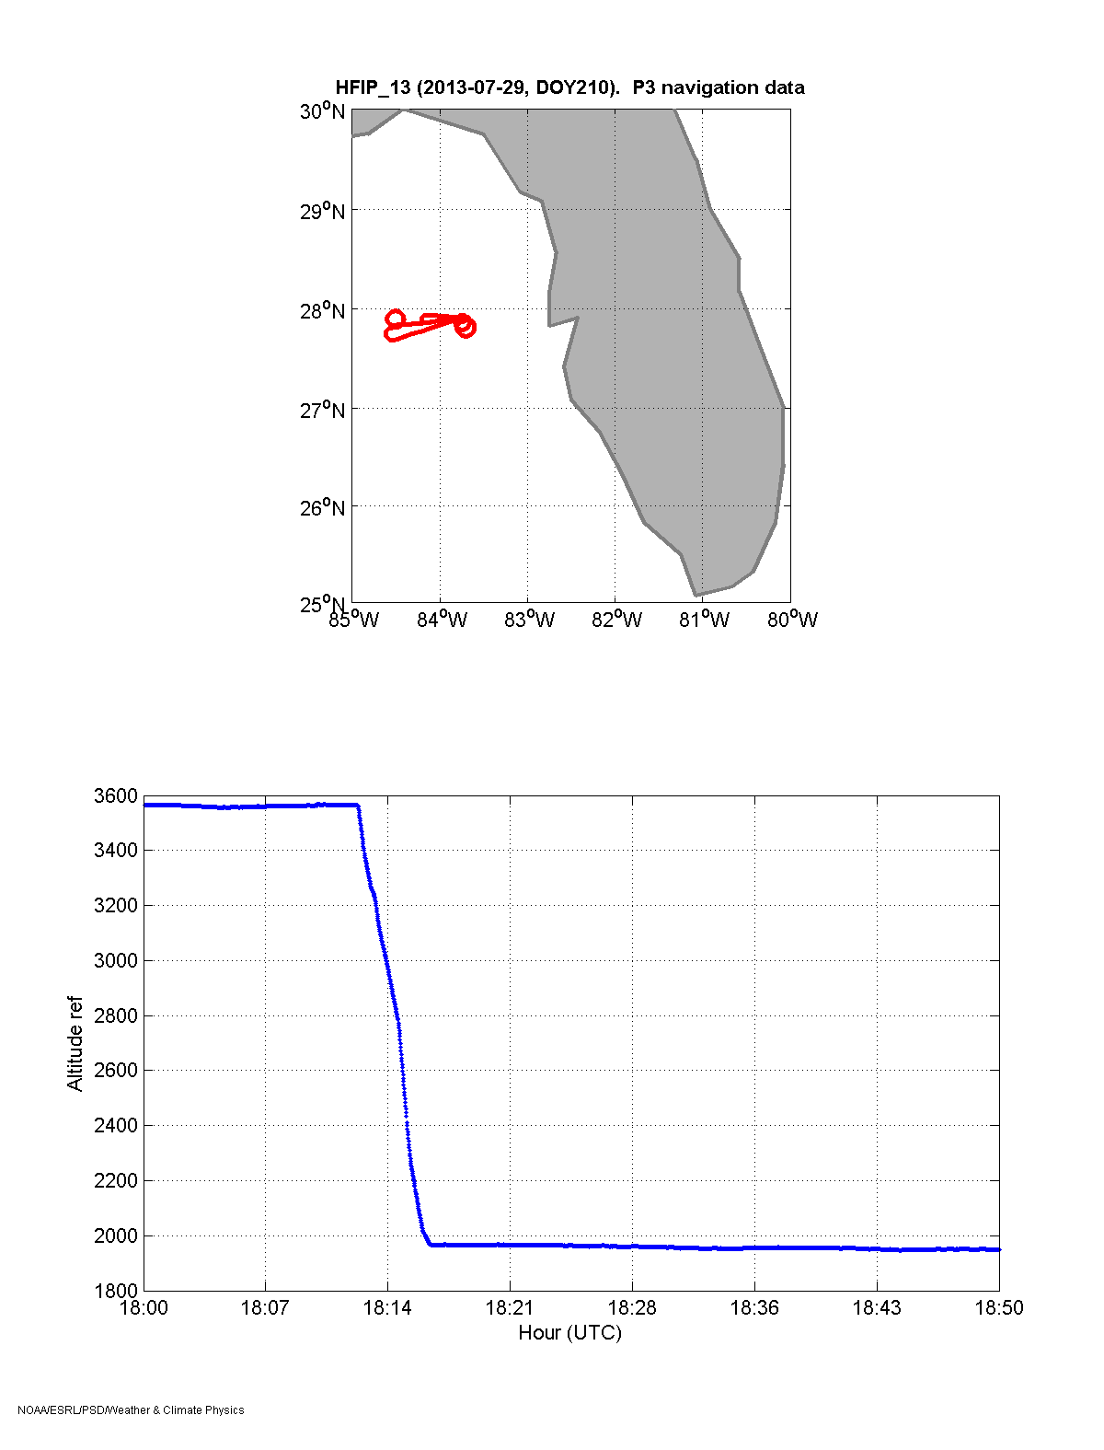

Figure 2. Upper panel, Flight track for 1800 on July 29, 2013; Lower panel, altitude time series.

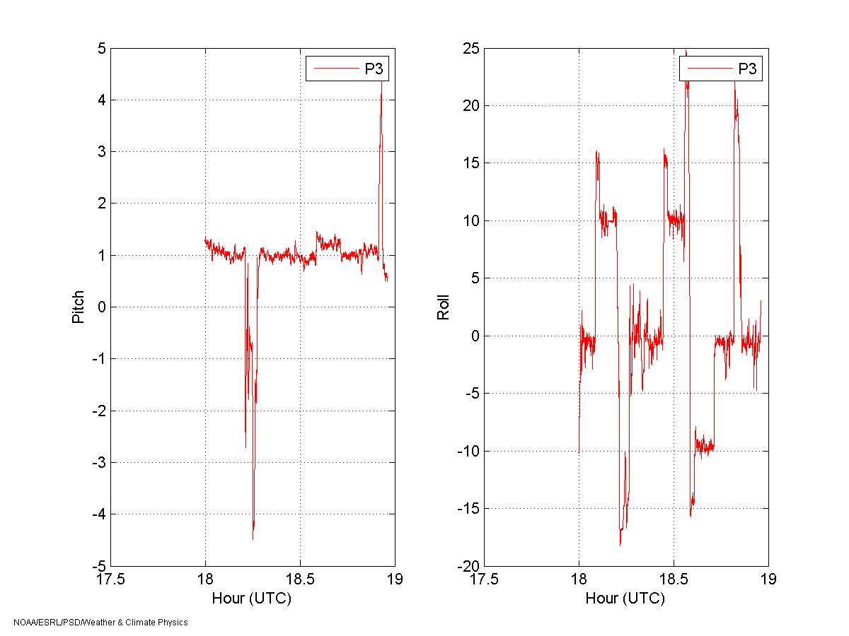

Figure 3. Left panel, pitch time series 1800 on July 29, 2013; Right panel, roll time series.

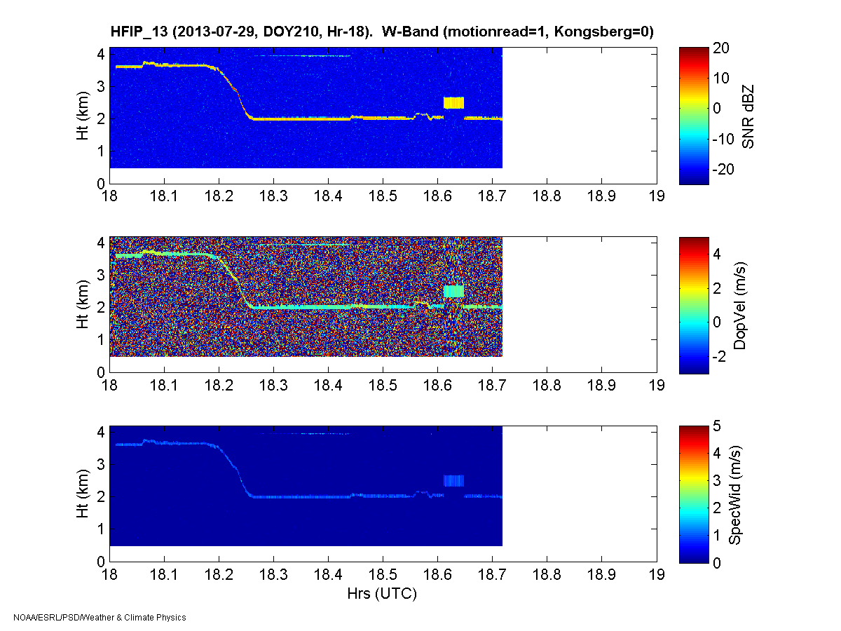

Figure 4. Time-height cross-section for 1800 on July 29,2013: upper panel, SNR; middle panel, Doppler velocity; lower panel, Doppler width. The block artifact at 18.65 is where the radar mode was being changed (unsuccessfully).





Figure 5. Single profile of reflectivity vs range at one time during 1800. The peak of the reflectivity is assumed to be the return from the surface. A blowup of the profile (lower panel) shows only one range gate on the atmospheric side of the surface return is contaminated.

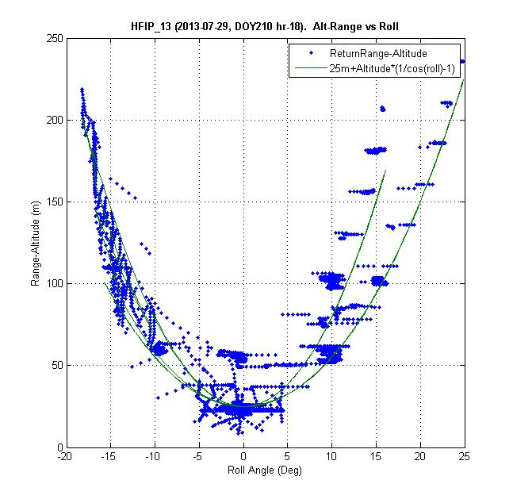

Figure 6. Range to the surface return -Altitude for the 1800 hour of data. The green line is 25+ Altitude(1/ Cos(θ)-1).

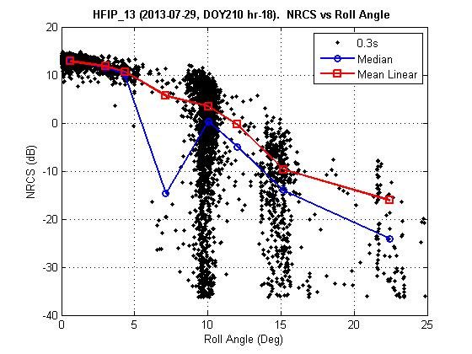

Figure 7. NRCS as a function of aircraft roll angle for flight section 1800 GMT with the aircraft at flight level 2.0 km. The aircraft pitch is about 1 degree but the exact alignment with the radar beam in the pitch direction is not known. The dots are the individual data at 0.3 s time resolution. The blue line is the median NRCS (dB) and the red line is the mean of σ0 converted to dB.

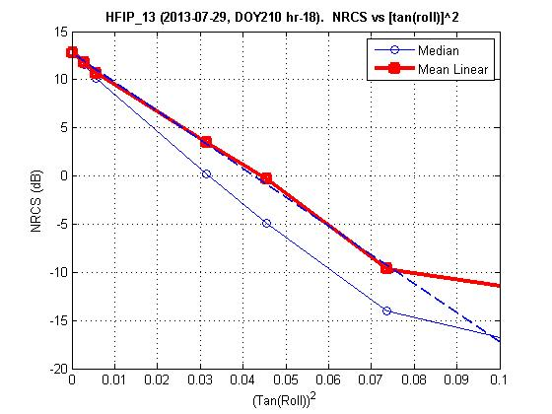

Figure 8. Angular behavior of NRCS fit to (tan(θ))2 model (dashed line).

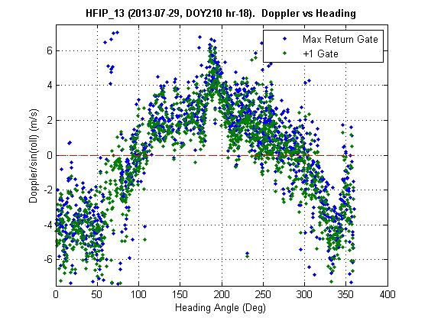

Figure 9. Surface-parallel Doppler velocity from the radar surface return as a function of beam pointing direction (0 is North).