COARE36 and the Wave Conundrum
The current version of the model is based on two basic relationships relating waves and roughness

(1a)
(1b)

(1a) was given in Edson et al. 2013 with a=0.09 and b=2.0. I have found it is a good fit to the UNSW wave model, although a and b have a weak wind speed dependence (Fig. 1). I think the current version of coare36 has a=0.2 and b=2.2. The best fit to HIWINGS observations is a=0.3 and b=2.3. (1b) is also a fit to the UNSW wave model and is a good representation of HIWINGS observations (Fig. 2).
One question that comes up is how to reconcile (1a) with the wind-speed only coare35 representation. To look at that, I computed the value of Cp with (1a,b) that yields the same Cdn10 as coare35. An example is shown in Fig. 3 for a=0.2 and b=2.2. I have done this for the three sets of a,b shown above. The results are in Fig. 4 where data from HIWINGS and also values deduced from Edson’s inverse wave age curve (his Fig. 9b). One interesting result is Edson’s values of a,b give a poor fit to his Cp values. His Cp’s are better fit by a=0.2 and b=2.2. Not sure why that is except that perhaps his wave heights are not compatible with (1b). The HIWINGS observations are better matched by a=0.3 and b=2.3. Fig. 5 shows the same thing but plotting u*/Cp instead of Cp.
It gets more amusing when we look at the wave height results (Fig.6). Notice that Edson a,b values produce wave heights that decline with wind speed up to 20 m/s. The b=2.2 set suggests 4 m waves at u10n=20 m/s – that is not my personal exerience. The b=2.3 set fits the HIWINGS data fairly well but notice it yields 13 m waves at u10n=30 m/s.
All of this combined reveals a basic problem with (1). In order to produce drag coefficients that level off or at least have a weaker increase with wind speed above 25 m/s, (1a and 1b) require older and larger waves!! That does not seem reasonable to me. I don’t see how we can level off drag coefficients at high winds speeds with this structure.

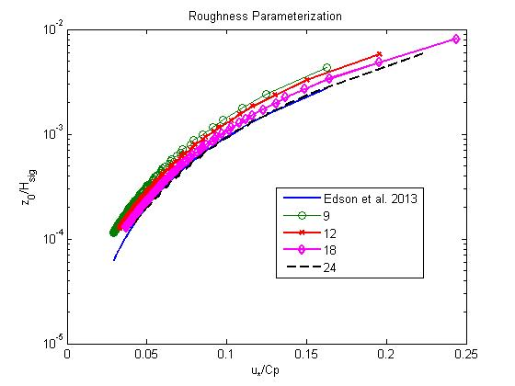
Figure 1. Surface roughness normalized by significant wave height vs inverse wave age.

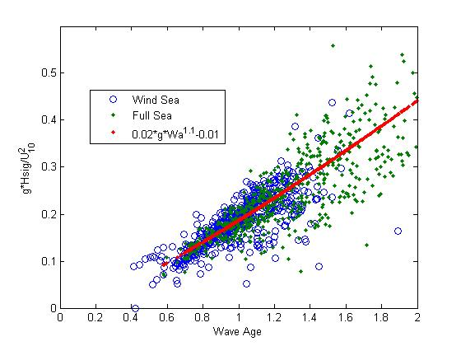
Figure 2. Normalized significant wave height vs wave age from HIWINGS.

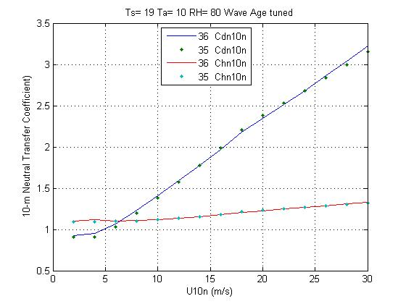
Figure 3. Cd10n and Ch10n using coare35 wind speed only formula and coare36 wave age formula (b=2.2) with Cp adjusted to match coare35.
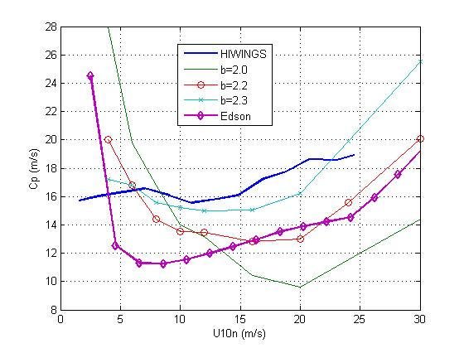
Figure 4. Cp vs Un10 from various sources: HIWINGS observations and Edson Fig. 9b. The other lines are effective Cp required so coare36 Cd10n fits the coare35 (Charnock) specification.
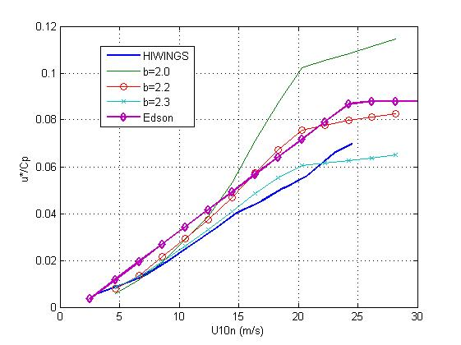
Figure 5. As in Fig. 4 but for inverse wave age.
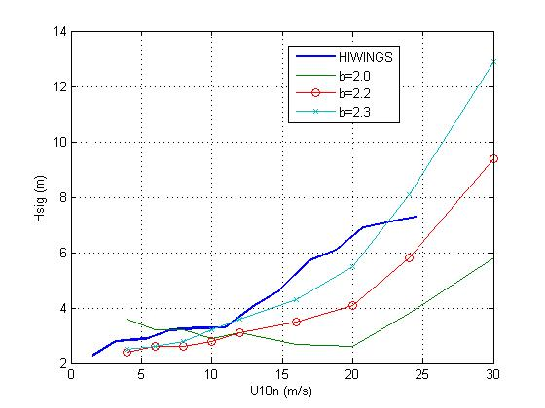
Figure 6. As in Fig.4 but for significant wave height.

