Sea Spray Wband Radar Module
NOAA HFIP2013 Hurricane Field Program

Principal Investigator: Chris Fairall (ESRL) and Joe Cione (HRD)

HRD Point of Contact: Joe Cione

Links to IFEX Goal 3: Improve our understanding of the physical processes important in intensity change for a TC at all stages of its lifecycle.

Air–sea exchanges of heat and momentum are important elements in understanding and skillfully predicting hurricane intensity, but the magnitude of the corresponding wind-speed dependent bulk exchange coefficients is uncertain at hurricane force wind speeds. One potentially important aspect of surface flux interactions is the influence of sea spray. Fairall et al. (2009) have developed a parameterization of sea spray that is linked to energy going to breaking waves. This parameterization has seen application in several numerical simulation studies (Bianco et al. 2011; Bao et al. 2011). However, the model contains an adjustable scaling parameter that can be determined by direct field observations of sea spray droplet spectra. Attempts during CBLAST to do these measurements with optical droplet imaging probe (CIP) were not successful because of the impracticality of flying low enough in strong winds (U10>30 m/s). For HFP13 we plan to obtain these measurements using a profile Doppler cloud radar operating at W-band (94 GHz) frequency. The radar has been deployed on ship since 2008 and was recently repackaged for deployment on NOAA P-3 aircraft (Moran et al. 2012). Measurements of sea spray are required for the HFIP Model Physics and Model Strategy milestones.

Profiles of full Doppler spectra from the radar will be recorded. We will also archive the first 3 moments of the spectra (dBZ, mean velocity, Doppler width). Nominal radar operating characteristics (subject to adjustment) will be 3 Hz dwell, 20 m range resolution, 175 range gates. The maximum range will be nominally 3.5 km so sea spray will only be observed when the aircraft is below 3.5 km altitude (11,500 ft). At those setting, the sensitivity threshold of the radar is -33 dBZ at a 1 km range. However, detection of the full droplet spectrum will require a signal of about -23 dBZ at 1 km or -17.5 dBZ at 3.5 km. Note that -17 dBZ corresponds to a thin stratus cloud; drizzle is -5 to 5 dBZ, light rain is 15 dBZ. Turbulent

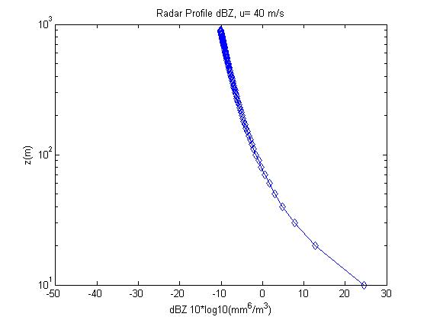

Figure 1. Profile of radar backscatter intensity (dBZ) estimated from PSD seaspray model for a 10-m wind speed of 40 m/s.

transport theory allows us to relate the profile of droplet concentration to the surface source strength
(Fairall et al. 2009, 20012). Fig. 1 shows an example where the profile of radar dBZ is computed using the PSD sea spray model. This suggests that sea spray looks much like drizzle to the radar and that we have about 10 dBZ extra sensitivity to detect sea spray. An estimate of observational accuracy required to validate the model/parameterizations is given in Table 1.

Table 1. Airborne W-band Doppler radar accuracies and resolutions
Attribute | Required | PSD Wband Specification
Sampling interval | 0.5 s | 0.3 s
Horizontal resolution | 50 m | 30 m
Vertical resolution | 10 m | 25 m
Accuracy | 1 dBZ, 0.2 m/s | 1 dBZ, 0.05 m/s
Sensitivity dBZ@3.5 km FL | -5 | -17.5

It is assumed that the observation program will be in the Atlantic/Caribbean/Gulf of Mexico theatre of operations. The observations of interest here require operation outside of significant precipitation. Rain in the line of sight below the aircraft will be indistinguishable from sea spray and will mask the profiles of sea spray that is required to estimate the surface source. Clouds will probably not be a problem, but cloud-free locations are much less likely to have precipitation contamination. So, we request the sea spray module be flown between rain bands (similar to the entrainment module of 2012). It is not necessary to fly in a radial direction; azimuthal direction is acceptable. Interpretation of the radar profiles will require additional information: 10-m wind speed (SFMR) and high-speed navigational information (IMU) are required. Profiles of wind speed, temperature and humidity (dropsondes) will be useful. Doppler lidar would be very useful.

REFERENCES

Bao, J.-W., C. W. Fairall, S. A. Michelson, L. Bianco, 2011: Parameterizations of sea-spray impact on the air-sea momentum and heat fluxes. Mon. Wea. Rev., 139, 3781–3797, doi: http://dx.doi.org/10.1175/MWR-D-11-00007.1 .

Bianco, L., J.-W. Bao, C. W. Fairall, and S. A. Michelson, 2011: Impact of sea spray on the surface boundary layer. Bound.-Layer Meteorol.,140 , DOI 10.1007/s10546-011-9617-1.

Esteban-Fernandez D, Durden SL, Chaubell J, Cooper KB, 2010: Design considerations for a dual-frequency
radar for sea spray measurement in hurricanes. In: Geoscience and Remote Sensing Symposium
(IGARSS), 2010 IEEE International, pp 2896–2899, 25–30 July 2010. doi:10.1109/IGARSS.2010.
5653198

Fairall, C. W., M. Banner, W. Peirson, R. P. Morison, and W. Asher, 2009: Investigation of the physical scaling of sea spray spume droplet production. J. Geophys., Res., 114, C10001, doi:10.1029/2008JC004918.

Fairall, C.W., C.J. Zappa, M.L. Banner, R.P. Morison, S. Brumer, X. Yan, and W.L. Peirson, 2012: A Laboratory Study of Sea Spray from Breaking Waves: Part I - Profiles of Droplet Microphysical Properties. Paper 5.1 Proceed. American Meteorological Society, 18th Conference on the Air-Sea Interaction, 9-13 July, 2012, Boston, MA.

Moran, K., S. Pezoa, C. Fairall, T. Ayers, A. Brewer, C. Williams, and S. de Szoeke, 2012: A Motion Stabilized W-band Radar for Shipboard Cloud Observations and Airborne Studies of Sea Spray. Bound.-Layer Meteor., 141, 3-24, DOI 10.1007/s10546-011-9674-5.

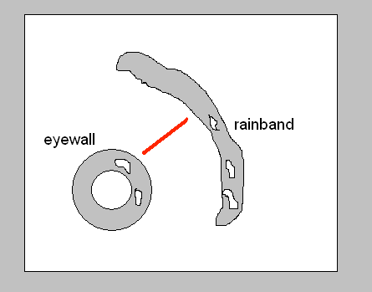

Figure. 2. Plan view of the preferred location for rain-free region. Red line shows a sample aircraft track, but a track along a fixed radial arc is acceptable too. This figure is borrowed from the Hurricane Boundary Layer Entrainment Flux Module from 2012.

