Flux Analysis From Stratus Cruises 2001-2010
C. Fairall and Ludovic Bariteau
March 30, 2011
The flux files from each stratus cruise (2001, 2004, 2005, 2006, 2007, VOCALS, 2010) where appended into a single file with 55 data columns and 18484 10-min samples. The standard flux and transfer coefficient program developed for the 2003 COARE paper was run. Results are shown for the grand average properties (stress/Cd – 6535 10-min samples; Hlatent/Ce – 6414 10-min samples). The stress data were restricted by relative wind direction within 60 deg of the bow and ship speed less than 5 m/s. Latent heat flux data were similarly restricted plus CO2 concentration greater than 340 ppm, and standard deviation of water vapor fluctuations within a specified limit (0.15 g/kg) of the bulk similarity value. The last two restrictions were an attempt to edit out contamination of the LiCor7500.
The first two figures show the 10-m neutral drag coefficient and the individual stress components as a function of wind speed. The drag coefficient compares reasonably well with the COARE values. There is a significant cross-stream stress but it is sufficiently small such that the magnitude of the stress vector is essentially the same as the streamwise component. The stress-wind vector difference is 11 deg.
The next two figures show similar results for latent heat (a mean of covariance and ID values was used for the direct measurements). The neutral 10-m mositure transfer coefficient is about 3% lower than the COARE value (depending on combinations of means and medians). Note, a 4% correction has been applied to the covariance Hl value to account for sensor separation; no correction was applied to the ID values. On balance, this suggest the COARE3.0 value, which is based on the somewhat inferior OPHIR fast hygrometer, is a few percent too high.
The last figure shows the measured uncertainty for a single 10-min sample of latent heat and momentum fluxes (essentially the scatter within a given wind speed bin) compared with the similarity theory equations from Blomquist et al. 2010 using a=1.0 (Blomquist used a=2.0). Apparently stress is even more difficult (relative to scalar fluxes) to measure than expected.
Based on this analysis, COARE3.0 works very well in the Stratus region. It is possible the cooling by evaporation is overestimated by as much 3 W/m², although this is on the edge of the final accuracy of the measurements.
Blomquist, B.W., B.J. Huebert, C.W. Fairall, I.C. Faloona, 2010: Determining the sea-air flux of dimethylsulfide by eddy correlation using mass spectrometry. Atmos. Meas. Tech., 3, pp 1-20, doi:10.5194/amt-3-1-2010.

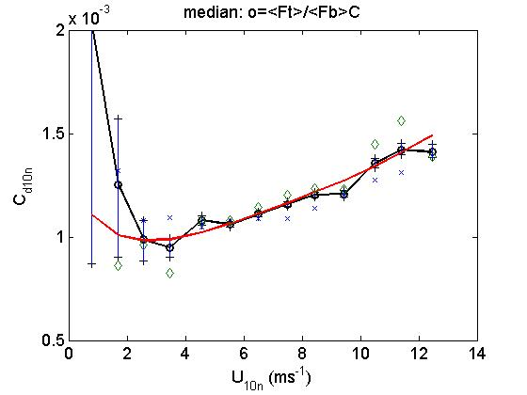
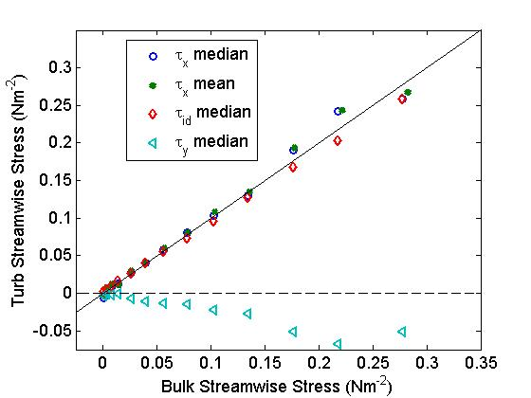

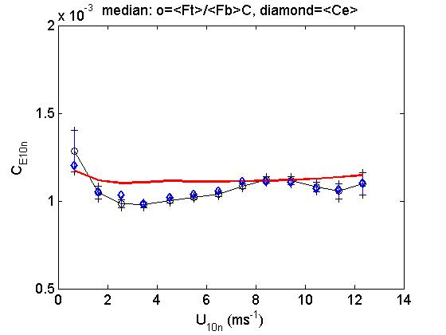
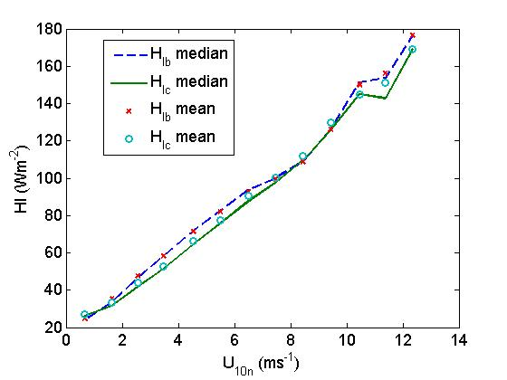
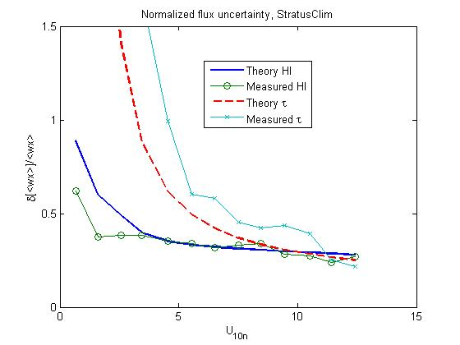

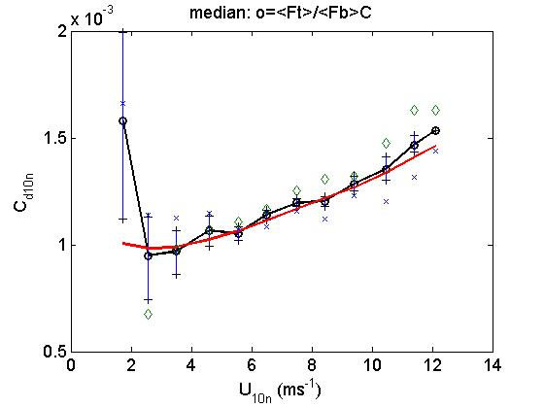
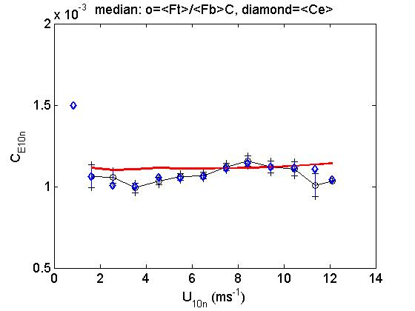
Hourly Flux Results.

