**Background**

Estimation of errors in standard PSP radiative flux radiometers (pyranmeters) begins with the relationship of the radiance (radiant flux from a particular location in the sky), *I*, to the irradiance (total flux normal to a horizontal plane), *R* (W/m2)

, (1)

where φ is the azimuth angle, θ is the zenith angle, and *d*Ω=sin(θ)dθdφ is the incremental solid angle.

A pyranometer produces a voltage approximately proportional to the downwelling solar radiation integrated over the hemisphere of the sky. We assume the downwelling flux is a combination of the direct beam of the sun, *Is*, at angular position (ϕs ,θs) which occupies a small solid angle, *d*Ωs, plus forward scattered radiation, *Id*, usually referred to as the ‘diffuse component’. For our purposes here, we assume the diffuse component is approximately isotropic (independent of φ and θ); thus the integral for an ideal sensor becomes.

 (2)

Now consider the simple case of a non-ideal sensor where the absorption of solar radiation depends on zenith angle as described by the response function, *f*(θ). The effective flux of the diffuse component will be an integral

 (3)

If the response function is 1.0 then the integral yields 0.5 and the measured diffuse flux is the correct flux. In Fig. 1 we show that the angular factor sin(θ) cos(θ) peaks at θ=45 deg. The response function commonly takes a form near 1.0 at θ near zero and decreases modestly as zenith angle increases, often with some slight downward curvature.

It is easy to demonstrate that for reasonably weak angular dependence of *f*(θ) normalizing by the value at θ=45 deg causes the error in (3) to cancel to first order. This is the principal reason that one approach to calibrating pyranometers is to set the flux-voltage calibration coefficient to give the correct solar flux when the solar zenith angle near 45 deg. For example we select a linear dependence for *f*(θ)

 (4)

where a and b are small coefficient and then compute an effective response function by normalizing

 (5)

In Fig. 1 we show the integrand in (3) using *f*(θ) from (4) with a=0.03 and b=0.003, which yields *f*(45)=0.895. It is clear that the normalized line does not obey the ideal behavior but the overestimate for θ<45 cancels the underestimate for θ>45. For this specific case the integral using (4) is 0.4475 while the integral using the normalized form is 0.5000. Of course this cancelation only works for a linear angular dependence; if there is significant curvature then there will be a second-order error. In that case, accuracy may be improved by considering some non-linear behavior of *f*(θ). Also note that the values obtained from the pyranometer will overestimate the flux under clear conditions when the sun is near zenith.

**Rooftop Calibrations**

In the last 7 years we have conducted a series of radiometer intercomparison studies at sea plus two rooftop calibrations (see Table 1 and Fig. 2). In the terms discussed above we write the calibration relationship as

 (6)

where *Rst* represents a standard measurement of total solar flux, ΔV the thermopile output voltage of a specific pyranometer, and αcal the linear calibration coefficient. Methods to determine αcal differ. For example, Eppley Laboratories use an integrating light sphere for *Rst*; the BSRN program uses rooftop measurementswith a direct/diffuse standard and set *f*(45)=1.0; WHOI uses a calibrated PSP as a standard and does a linear regression of the instrument to the standard flux.

A sample result from the rooftop calibration in Boulder is shown in Fig. 3. In this case the NOAA GMD standard consists of a suntracking pyroheliomete for the direct flux and a shaded Eppley model 848 (Black and White) pyranometer for the diffuse (Dutton ..ref). Results for an Eppley PSP and a Kipp and Zonen CM22 are shown. Individual points on the graphs are 1-min averages. A clear-sky model (Fairall et al. 2008) is used to select values in specified transmission coefficient (*T*=*Rs*/*Rslcear*); in this example we restrict the example to roughly clear skies (0.9<*T*<1.1). From Fig. 3 we see a significant departure from the ideal ‘cosine response’ with the PSP but the CM22 is essentially ideal (i.e., *f*(θ) is a constant). The lines on the graphs are fits for *f*(θ). A simple way to capture the curvature is with a second-order polynomial regression. However, we found more consistent results with a least-squares fit to a form

 (7)

which, unlike a simple polynomial in θ, always produces a maximum at θ=0. The fits shown in Fig. 3 use θ0=50 Deg (we have not explored optimizing this value). We can add an additional constraint by normalizing so that *f*(45)=1.0

 (8)

Or

 (9)

In this context *a* is the ratio of the sensitivity at zenith to that at 45 Deg.

Given a specified value for θ0, the coefficients αcal and *a* characterize the sensitivity of a given pyranometer. However, this concept is well defined when applying (2) with separate measurements of the direct and diffuse components. When clouds are present the balance of direct and diffuse components changes considerably; thus, the true cosine response of a radiometer is only straightforwardly determined when direct and diffuse fluxes are measured separately (or, the portioning can be determined). A simple solution to this problem is to allow the *a* coefficient to be a function of *T*. This requires additional information (the specification of the clear sky flux and solar zenith angle via a simple model). Fig. 4 shows clear sky fits for 7 pyranometers: two are from Fig. 3 and the others are from the WHOI rooftop observations. In the WHOI case, we have used a CM22 as the standard since the Boulder observations suggest it is a reasonable transfer standard as far as cosine response is concerned. The four PSP’s are clearly more similar too each other than to the other units. In Fig. 5 we show fits from one of the PSP’s for different ranges of solar transmission coefficient. The non-cosine behavior maximizes for *T* on the order of 0.65 (no idea why).

Because the four Eppley PSP’s in Fig. 4 are so similar we feel emboldened to average the fits to create a generic ‘Eppley PSP’ effective cosine correction as a function of mean transmission coefficient. Recall this is not a true cosine response associated with the direct solar beam but an effective response for the global solar flux. The results are shown in Fig. 6.

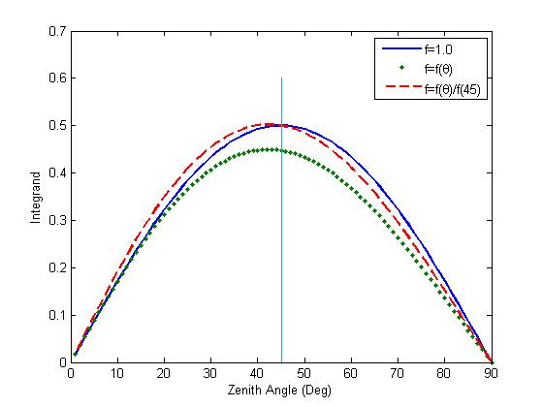

Figure 1. Angular factor in the integral of (2) using *f*=1.0 - solid blue line, *f* from (4) - dotted line, and *f* normalized to 45 deg – dashed red line.

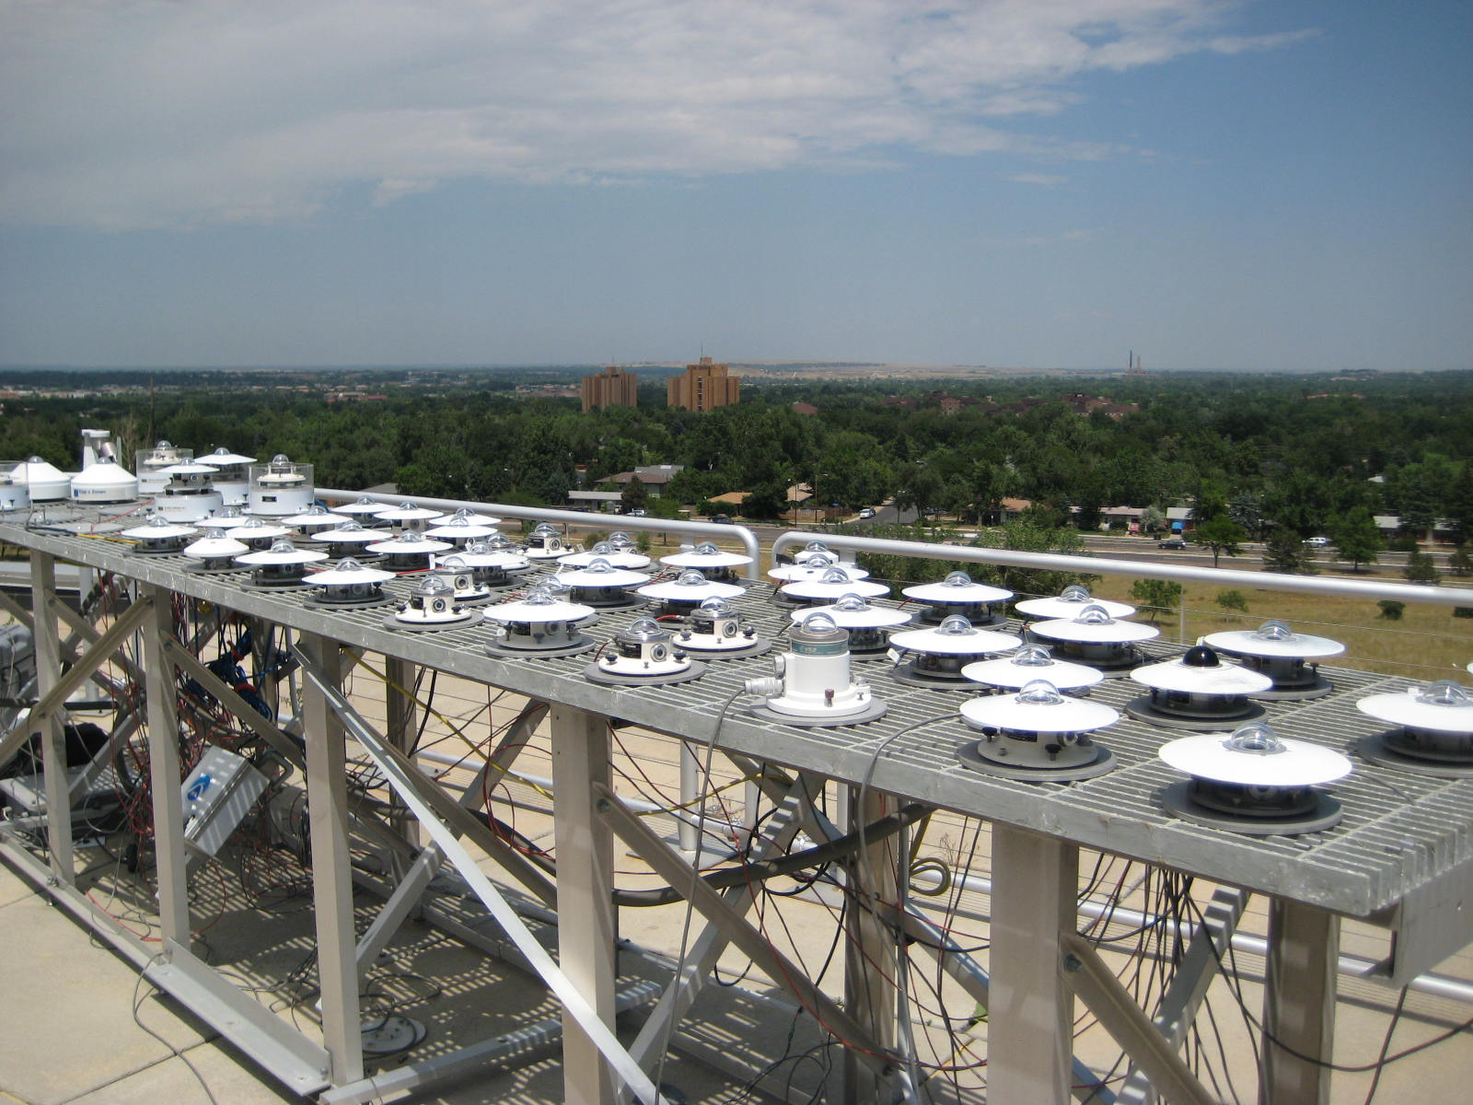

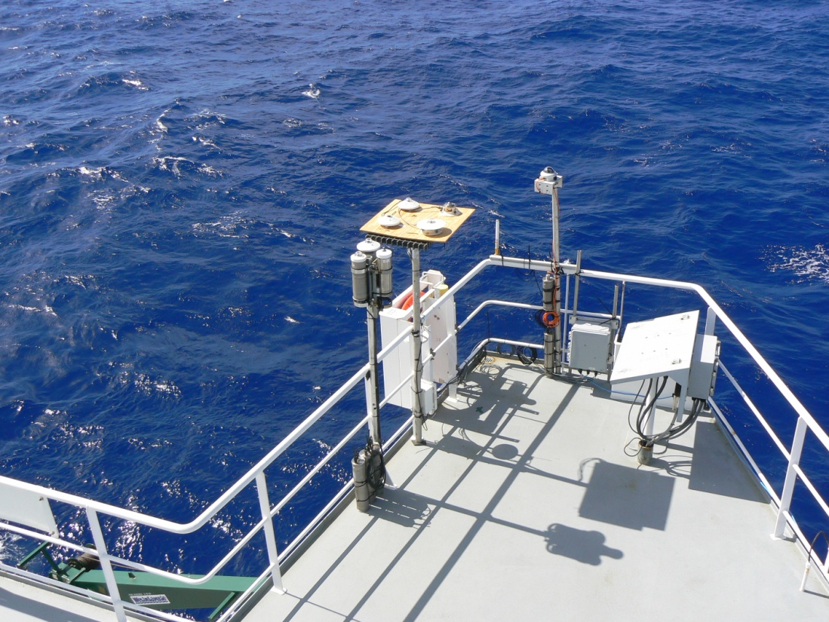

Figure 2. Photographs from recent rooftop calibration at NOAA GMD rooftop radiometer calibration site at Boulder, CO (upper panel) and seagoing intercomparison on NOAA ship Ronald H. Brown (lower panel).

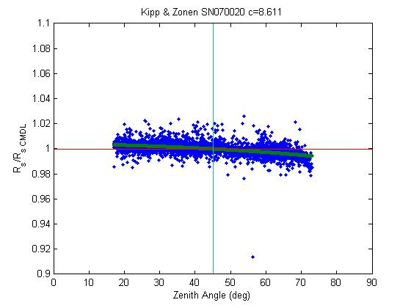

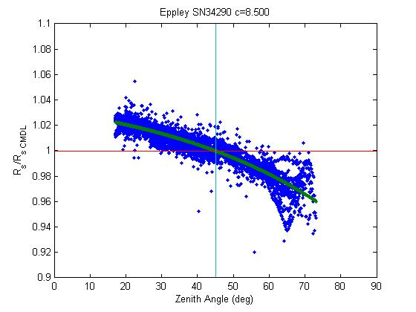

Figure 3. Sample response functions for two pyranometers (upper panel – Kipp and Zonen; lower panel - Eppley PSP) from 2008 Boulder rooftop calibration. These points are restricted to transmission coefficients between 0.9 and 1.1 (essentially clear skies). The calibration standard is the NOAA GMD global flux (sum of direct and diffuse components). The line is the exponential fit of the output voltage to standard flux normalized by the value at zenith angle of 45 deg.

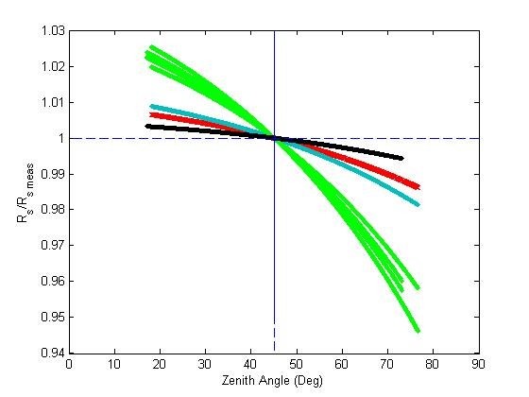

Figure 4. Ensemble of clear-sky calibration fits to different pyranometers from Boulder and Woods Hole rooftop deployments – four different Eppley PSP (green), Kipp and Zonen CM21 (blue), Eppley 848 (red), Kipp and Zonen CM22 (black).

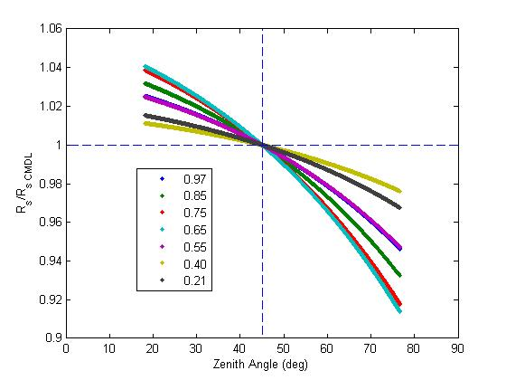

Figure 5. Ensemble of calibration fits to a single Eppley PSP pyranometer from the Woods Hole rooftop deployments – colors denote different values of the transmission coefficient. The fit is done to observations for *T* ranging from 0.9-1.1, 0.8-0.9, 0.7-0.8, 0.6-.07, 0.5-0.5, 0.3-0.5, and 0.1-0.3; mean *T* values for the intervals shown in the legend.



Figure 6. The average coefficient *a* from (9) for four Eppley PSP’s as a function of solar transmission coefficient. The clear sky flux is estimated from a simple model (Iqbal 1988).