Air-sea heat and momentum fluxes in the Southern Ocean
Vidhi Bharti^{1,2}, Byron W. Blomquist³, Christopher W. Fairall³, Yi Huang^{1,2}, Alain Protat⁴, Peter P. Sullivan³, Steven T. Siems^{1,2}, Michael J. Manton¹
¹School of Earth, Atmosphere and Environment, Monash University, Victoria, Australia
²Australian Research Council Centre of Excellence for Climate System Science, Monash University, Victoria, Australia
³National Oceanic and Atmospheric Association, Earth Systems Research Laboratory, Physical Sciences Division, Boulder, CO, USA
⁴Australian Bureau of Meteorology, Melbourne, Victoria, Australia
Corresponding author: Vidhi Bharti (vidhi.bharti@monash.edu)

Abstract
The Clouds, Aerosols, Precipitation, Radiation, and atmospherIc Composition Over the southeRn oceaN (CAPRICORN) experiment was carried out in March-April 2016 onboard the R/V Investigator studying the momentum (τ), sensible (H_{s}) and latent (H_{l}) heat fluxes over the Australian sector of the Southern Ocean including over one cyclonic cold-core and one anticyclonic warm-core mesoscale oceanic eddy. The direct flux measurements obtained with the NOAA PSD flux system are compared with those obtained by the Coupled Ocean-Atmosphere Response Experiment (COARE) 3.5 bulk model and neutral transfer coefficients are studied. We find that while 10-m neutral drag and latent-heat transfer coefficients depend linearly on the magnitude of the mean 10-m wind vector (U_{10n}) for >4 ms⁻¹, they exhibit no linear correlation with wind-sea (γ_{w}) or full sea significant wave height (γ). The root mean square (RMS) uncertainties in COARE 3.5 estimates of τ, H_{s} and H_{l} are 25%, 73% and 24% respectively with mean biases of 7%, 30%, and 12%. Further, the variability in COARE 3.5 bulk fluxes is investigated with respect to wind-wave conditions, oceanic eddies, precipitation events and extratropical cyclones encountered during the voyage. The main observed variability is an increase in γ_{w} (∼35%), τ (∼85%), H_{s} + H_{l} (∼52%) over the warm eddy as compared to average voyage values. During the passage of 9 extratropical cyclones, an increase in τ (∼55% average) and a decrease in H_{s} (∼117%) and H_{l} (∼64%) is noted in the warm sector, compared to pre-storm conditions, but the pattern reverses behind the cold front.

- Introduction
The current energy budget of the Southern Ocean (SO) remains a challenge in global climate models due to large uncertainties associated with air-sea fluxes (Bourassa et al., 2013; Cerovečki, Talley, & Mazloff, 2011; Dong, Gille, & Sprintall, 2007; Trenberth & Fasullo, 2010). Several past studies have been conducted over the SO to understand the various aspects of momentum, sensible and latent heat fluxes (Hande, Siems, Manton, & Belusic, 2012; Hausmann, Czaja, & Marshall, 2016; Herman, 2015; Jiang, Gille, Sprintall, Yoshimura, & Kanamitsu, 2012; Messager, Speich, & Key, 2012; Morrow, Church, Coleman, Chelton, & White, 1992; O’Neill, Chelton, & Esbensen, 2003; Schulz, Josey, & Verein, 2012; Slonaker & van Woert, 1999; Song & Yu, 2012). Nevertheless, the environmental dependencies of air-sea interaction remain uncertain owing to inadequate reliable sampling and limited research into key intrinsic processes.
The SO is well-known for extreme wind-wave conditions where precipitation, sea spray and cloud cover play crucial roles in determining the air-sea heat and momentum fluxes. The strong winds cause wave-breaking and produce massive amounts of sea spray influencing energy and mass exchange significantly at the interface (Andreas & Monahan, 2000; Richter & Sullivan, 2014). The region is also characterized by intense oceanic eddy activity coupled with storm tracks due to its unique geographic location. The prominence of mesoscale oceanic eddies in the Antarctic Circumpolar Current due to the polar front substantially contributes to the poleward heat transport and generates vertical transport of momentum deep into the ocean (Hausmann & Czaja, 2012; Olbers, Willebrand, & Eden, 2012). However, their distinct contributions to the ocean heat budget are yet to be fully resolved despite recent evidence of their influence on marine atmospheric boundary layer turbulence, cloud properties and precipitation (Bôas, Sato, Chaigneau, & Castelão, 2015; Frenger, Gruber, Knutti, & Münnich, 2013; Greatbatch, Zhai, Eden, & Olbers, 2007). Further, the SO meteorology is dominated by extratropical cyclones where turbulent fluxes can significantly vary within different sectors. Previous studies suggest that surface fluxes are related to the sea state and affect storm evolution including precipitation (Beare, 2007; Persson et al., 2008). The diurnal variability of sea surface temperature (Kawai & Wada, 2007) and sensible cooling due to rainfall are basic aspects of air-sea interaction yet to be fully understood in the SO.
The global climate community set a goal to resolve individual components of the surface heat budget accurate within 5 Wm⁻² at 1° spatial resolution and 3-6 h temporal resolution (Curry et al., 2004). However, different surface flux products report large variances and inconsistencies in the magnitude of fluxes over the SO (Liu, Xiao, & Chen, 2011; Yu et al., 2011). The biases in satellite infrared retrievals of sea surface temperature, large uncertainties of cloud properties, mesoscale eddies and atmospheric fronts as well as inadequate representation of diurnal fluctuations of sea surface temperature could be the potential sources of errors in satellite flux products. Reanalyses models are progressively improving yet their performance must be evaluated over this region.
Acquiring direct flux measurements has several logistical challenges, particularly in high wind regions (>15 ms⁻¹) but are crucial for the modulation of indirect flux parameterization schemes. The Coupled Ocean-Atmosphere Response Experiment (or COARE) bulk parameterization model for air-sea fluxes was developed initially for implementation in the tropics and mid-latitudes (Brunke, Fairall, Zeng, Eymard, & Curry, 2003; James B. Edson et al., 2013; Fairall, Bradley, Hare, Grachev, & Edson, 2003). Since its publication in 1996 (Fairall, Bradley, Rogers, Edson, & Young, 1996), it has become a popular method to estimate turbulent fluxes over the air-sea interface. However, the model has not been extensively validated for Polar oceans featuring diverse conditions notably extreme and light wind conditions, rough sea state, extratropical cyclones, mesoscale eddies, and large near-surface ocean temperature gradients.
Considering these issues and the need for new observations, a field campaign was carried out onboard R/V Investigator, named ‘CAPRICORN (Clouds, Aerosols, Precipitation, Radiation, and atmospherIc Composition Over the southeRn oceaN) 2016’ project in March – April 2016 to collect high quality in situ observations of fluxes, clouds, aerosols, precipitation and ocean properties over the Australian sector of the SO. One of the major objectives was to advance our knowledge of the boundary layer structure and the surface energy budget in this region. The ship departed from Hobart (Tasmania) on March 14, 2016, starting from 43° latitude reaching 53° latitude touching the Sub-Antarctic front and returned Hobart by April 15, 2016. One cyclonic cold core eddy (or cold eddy) and one anticyclonic warm core eddy (or warm eddy) were sampled during the voyage.
In the present paper, we report on comparisons between direct and parameterized flux estimates, assessing their sensitivity under varying wind, precipitation and sea-state conditions. An evaluation of flux transfer coefficients with respect to wind speed and wave parameters is performed. Further, the paper addresses the basic aspects of flux variability under specific sea state, wind conditions, precipitation, oceanic eddies and extratropical cyclonic fronts encountered during the voyage using COARE 3.5 bulk fluxes. Through the present study, we attempt to understand the physical mechanisms modulating the air-sea interactions in the SO.

- The CAPRICORN Experiment
This voyage was one of the first efforts to quantify the turbulent fluxes over the Australian sector of the SO featuring high wind speeds. Figure 1a depicts the ship track during the voyage along with the marked (dashed ellipses) locations of the cold core and warm core eddies. Figure 1b shows a spatial map of gridded sea level anomalies (GSLA) which was used to identify the nature and location of mesoscale oceanic eddies.
The measurements were taken during multiple transects over the cold eddy for 6 days from March 30, 2016, to April 5, 2016, starting from the western edge of the eddy at 146.01°E, 50.37°S. The size of the cold eddy was approximately 140 x 110 km. The warm eddy was part of a forming meander (roughly 120 km wide) and was sampled for approximately 4 days starting from April 6 to April 10, 2016. However, only two transects were conducted due to time limitations.
- Instrumentation

The National Oceanic and Atmospheric Administration, Physical Sciences Division (NOAA PSD) air-sea flux system (table 1) consists of a fast turbulence system for wind speed and water vapour with ship motion corrections, solar and infrared (IR) radiation sensors, bulk pressure, temperature, and humidity sensors, and an optical rain gauge. Most were installed on the bow jackstaff of the ship at a height of 19.5 - 21m above the water. A sea surface temperature sensor (sea snake) consisting of a floating thermistor (depth ~5 cm) was deployed off the port-side bow outrigger boom. The observations (table 1) were obtained at a sampling rate of 1 Hz and 10 Hz for slow and fast sensors, respectively.

- Surface and synoptic conditions
The average sunrise to sunset duration lasted from 0600 to 1900 local time but the actual daylight decreased during the months of March - April which included the autumnal equinox in the Southern Hemisphere. 9 extratropical cyclones were encountered throughout the voyage. The rainfall events were observed ~30% of the voyage duration with average hourly precipitation rate of 0.56 mmh⁻¹ and a maximum rain rate of 19.88 mmh⁻¹. The time series of atmospheric and oceanic measurements are shown in figure 2. During the voyage, 10-m neutral wind speed U_{10n} ranged from 0.40 - ~21 ms⁻¹ with average speed recorded as ~10 ms⁻¹.

The sea state can be described using various wave parameters. Earlier research indicated that the Charnock parameter (α) and, in turn, the sea surface roughness (z₀) should be affected by the fetch and wave steepness, which are functions of wave age and height respectively (Drennan, Taylor, & Yelland, 2005 and references therein). In the present paper, significant wave height γ (mean height of the upper third of the height distribution), wind-sea significant wave height γ_{w} and inverse wave age $({u_{*}}/{C_{p})}$are used to define the sea state. Significant wave height, γ, accounts for the open ocean (i.e. combined wind-sea and swell heights), whereas γ_{w} is the wave height for wind-sea waves. It is calculated after applying a separation frequency (F_{w}) that partitions the wave spectrum into wind-sea and swell peaks. The wave age is defined as, ${C_{p}}/{u_{*} }$with $C_{p}= {gT_{p}}/{2π}$ defined as the phase speed of the dominant wave where $T_{p}$ is the spectrum peak period and $u_{*}$ is the friction velocity. The non-dimensional wave age captures the actual development of the sea state in response to wind stress over time and has a value of about 30 for a fully developed sea with values below and above it for a younger and decaying sea state, respectively. The inverse wave age $({u_{*}}/{C_{p}})$ is often used because this form compresses the range of old, swell dominated seas and expands the range of young sea state conditions. For fully developed sea, ${u_{*}}/{C_{p}}$ is ≈0.03 with larger values indicative of younger sea. ${u_{*}}/{C_{p}}$ ranges from 0.002 to 0.14 with mean as 0.029 during the voyage.

- Identifying weather fronts
The traversal of cyclonic storms is associated with sudden changes in wind speed, wind direction, precipitation and sea state, subsequently impacting surface fluxes. The extratropical cyclones are defined with two criteria: First, hourly Himawari-8 satellite images of cloud top pressure (CTP) and cloud top temperature (CTP) are visually analysed and the band of clouds having CTP < 550 hPa and CTT <-25°C moving from west to east passing above the ship are associated with the passage of extratropical cyclones. Second, based on the surface observations of pressure (P), temperature (T_{a}) and wind direction (W), a cyclonic event is identified as when -
$\frac{d^{2}P}{dt^{2}}>0.1 hPah^{-2}, \frac{{dT}_{a}}{dt}<-0.2°Ch^{-1} and \frac{dW}{dt}<-5°h^{-1}$ (1)
which was used in (Wang, Siems, Belusic, Manton, & Huang, 2015). Figure 2a identifies cold fronts on the time series of the surface pressure. As outlining the precise boundaries of the warm sector and the cold front is ambiguous, the leading edge of the cloud cover defines the start of the warm sector. Thus, the duration of the cloud band above the ship is characterized as the midst (or midst-) of the cyclone. The relative minimum of pressure accompanied by precipitation near (mostly just before) the trailing edge of the cloud band defines the location of the cold front. The 12-hours prior to the start of the cloud cover is assumed as pre-cyclonic (or pre-) conditions. The 12-hour window after the end of the cloud band defines the post-frontal (or post-) conditions. Altogether, 9 cyclones were identified during the voyage (table 2) with two during the cold eddy (31 March and 04 April) and one during the warm eddy (06 April) sampling. We examined flux variability for strictly pre and post-frontal conditions, noting, however, that pre- and post-frontal boundaries of a cyclone are highly variable and difficult to delineate precisely.

- Results
- Comparison of COARE 3.5 bulk fluxes with turbulent fluxes
As a result of preliminary quality control, ~48% of the 10-minute measurements of latent heat flux using eddy covariance (EC) and inertial dissipation (ID) methods were discarded due to wet conditions and sea salt contamination on the water vapour sensor optics (Licor LI7500). The 10-minute direct measurements were then processed to hourly averages based on an additional set of selection criteria (as discussed in (Fairall et al., 2003) and (Zeng, Zhao, & Dickinson, 1998), as follows: i) relative wind direction with respect to bow (minimum -60° to maximum 60° with max std dev 15° over 10 minutes), ii) rain rate (max 1 mm h⁻¹), iii) ship speed (max standard deviation 0.6 m s⁻¹ and max speed 3.5 m s⁻¹), iv) ship heading (max std dev 5°), v) port-starboard platform velocity from ship roll (max std dev 0.8 m s⁻¹), and vi) flow distortion tilt angle at the top of the bow jack staff (max 10°). Figure 3(a) shows the change in wind stress values with respect to relative wind direction from the bow and change in relative wind direction with respect to mean airflow tilt angle justifying the criteria (i) and (vi).
Filtered, hourly mean turbulent fluxes (average of filtered, hourly EC and ID observations) were compared with the hourly COARE 3.5 bulk model outputs (Bariteau, Fairall, Blomquist, & Pezoa, 2018). The COARE fluxes are computed with wind speed in the earth frame, which ignores the contribution of surface currents. The ship provided two sources to estimate currents (the 25 m deep range on the acoustic Doppler current profiler (ADCP) and a surface drift estimates), but these were poorly correlated, and we decided not to use them. Surface current magnitudes were 0-1 ms⁻¹ with an average magnitude of about 0.5 ms⁻¹ (this value represents an error of 8% in τ and 4% in H_{s} and H_{l}). Overall, H_{l} values measured by EC method are noisy and are lower by 18% as compared to ID values. H_{s} and H_{l} are positive when transporting energy away from the surface (i.e. into the atmosphere). The momentum flux is positive downward (i.e. from the atmosphere to the ocean). Radiation is positive when directed towards the ocean. The description of COARE 3.5 bulk model can be found in the Supporting Information.
The turbulent and bulk model heat and momentum fluxes correlate strongly (~93%) at hourly time scales as shown in figure 3. Some discrepancies can be noticed as shown in table 3. This discrepancy is larger in H_{l} values where COARE 3.5 displays a wider range of values as compared to the observations, but the means and medians agree closely for H_{s}. Further, the model displays a slight increase in the H_{l} bias (~21 Wm⁻²) during rain events as opposed to H_{s} (~6 Wm⁻²). COARE 3.5 tends gives lower estimates of fluxes irrespective of wind speed (U_{10n}) and stability conditions (figures not included). Overall, COARE 3.5 gives lower values of H_{s} and H_{l} but exhibits good agreement with direct measurements of τ over the SO. The significance of the disagreement and EC/ID fluxes with COARE is difficult to evaluate because this is our first experience with this particular sonic anemometer and its characteristics are not well-established. The disagreement between EC and ID fluxes is unusually large and weakens the validity of the comparison.

- Evaluation of neutral transfer coefficients

The neutral transfer coefficients are evaluated as functions of $U_{10n}$ , γ, γ_{w} and inverse wave age$({u_{*}}/{C_{p})}$. Figure 4 shows the comparison between measured and modelled transfer coefficients with error bars with respect to $U_{10n}$. The average value of the coefficient is plotted per bin with a width of 1 ms⁻¹. However, there are fewer than 5 data points for <3 ms⁻¹ and >17 ms⁻¹ wind speeds, hence, the comparison cannot be considered valid in these ranges. We also cannot account for <1 ms⁻¹ conditions in the present analysis due to the lack of data.

The agreement is within 20% between measured and modelled C_{d10n} between 3-18 ms⁻¹ wind speeds. Similarly, a close agreement (to within ~8% and ~11% respectively) is found for C_{e10n} and C_{h10n} between 4-13 ms⁻¹. A high value of 3.8 x 10⁻³ is found for measured C_{d10n} for low wind speed <3 ms⁻¹ but limited sample size accounts for the high uncertainty. The mean modelled C_{d10n} is 1.4 (± 0.04) x 10⁻³ and both C_{e10n} and C_{h10n} are 1.1 (± 0.04) x 10⁻³ for wind speeds 3-17 ms⁻¹. The mean measured C_{h10n} (1.2 x 10⁻³) is slightly lower than measured C_{e10n} (1.4 x 10⁻³), which was also observed by Large & Pond, (1982). However, the measured C_{h10n} displays a completely different relationship to wind speed as opposed to C_{d10n} and C_{e10n} as shown in figure 4b.

The neutral drag coefficient has been noted to increase for wind speed >5 ms⁻¹ and towards low wind speeds (Smith, 1988; Yelland et al., 1998). Fairall et al., (2003) observed a rise in C_{d10n} for winds <1 ms⁻¹ and at 20 ms⁻¹ from its minimum value of 1.0 x 10⁻³ at 3 ms⁻¹. Our calculations show a minimum at 4-5 ms⁻¹ bin for bulk C_{d10n} but 3 ms⁻¹ for measured C_{d10n}. Both bulk and measured C_{d10n} increase for wind speed >5 ms⁻¹. Measured C_{e10n} is maximum 3.6x10⁻³ at 3 ms⁻¹ but minimum 1.0x10⁻³ at 5 ms⁻¹ and increases with wind speed thereafter consistent with Fairall et al., (2003). Measured C_{h10n} initially decreases with wind speed, becomes minimum at 6 ms⁻¹ and rises with wind speed thereafter.

Surface waves act as the roughness elements that COARE models using the aerodynamic roughness length ($z_{0}$) which characterizes the neutral transfer coefficients. The COARE 3.0 model incorporates the velocity roughness length as a function of specified wave properties such as significant wave height, wavelength of spectrum peak and inverse wave age. However, Edson et al., (2013) found that surface roughness formulations match observations well without wave information in COARE 3.5 as wave age varies almost linearly with wind speed. Here, an attempt is made to investigate the wave age dependency of transfer coefficients. C_{d10n} and C_{e10n} are evaluated as a function of inverse wave age and significant wave heights, γ for drag but γ_{w} for C_{e10n} as swells are also expected to have a measurable effect on wind profiles contributing to surface roughness and drag.

C_{d10n} and C_{e10n} both vary almost linearly with $u_{*}$ when $C_{p}$ is kept constant as depicted in figure 5a and 5b. Similar variation is observed when $u_{*}$ is kept constant. This implies that the transfer coefficients are more of a direct function of wind speed rather than $C_{p}$ as observed by Edson et al., (2013) as well. However, neither of the transfer coefficients exhibit any significant linear correlation with γ.

Further, the relation between the roughness length scaled by significant wave height as proposed by Donelan, Dobson, Smith, & Anderson, (1993) and wave age ${C_{p}}/{u_{*} }$is investigated using the voyage data. The roughness length for rough flow can be calculated as: $z_{0}^{rough}= z_{0}- z_{0}^{smooth}=10e^{{-κ}/{C_{d10n}^{0.5}}}- 0.11ν/{u_{*}}$ (James B. Edson et al., 2013) where $z_{0}^{smooth}$ is roughness of the ocean when it is aerodynamically smooth, $z_{0}$ is total roughness length, κ is von Kármán’s constant and ν is the kinematic viscosity of air. Previous studies (Dobson, Smith, & Anderson, 1994; Donelan et al., 1993; James B. Edson et al., 2013; Smith et al., 1992) used this linear approach to explore the association between sea state (specifically wave age) and roughness length:
$\frac{z_{0}^{rough}}{γ}=D{\left(\frac{u_{*}}{C_{p}}\right)}^{2}$ (2)
Where $z_{0}^{rough}$ is roughness length for rough flow and D is a numerical constant. Eq. (2) is implemented using individual estimates of $z_{0}^{rough}$, ${u_{*}}/{C_{p}}$, γ and γ_{w} as shown in figure 5c. In COARE 3.5, D=0.09 is used to model the effect of wave age and sea state (James B. Edson et al., 2013). Here, 6.9<$C_{p}$<30.4 and 0.02<$u_{*}$<1.6 are found during the voyage. Using linear regression, the values of D are reported as comparatively higher with values 0.16 and 0.13 for wind sea and full sea, respectively, over the study region.

- Flux variations over mesoscale ocean eddies

The cold and warm eddies sampled during the voyage substantially impacted the surface flux distributions. The distributions of 10-minute COARE 3.5 bulk fluxes over six atmospheric/oceanic states as - voyage including eddies, voyage without eddies, the cold eddy, the warm eddy, no-rain conditions and rainy conditions are shown in figure 6. Further, table 4 depicts the mean bulk fluxes and flux-related state variables for these six states. It is noted that these forcings are not independent and it is extremely difficult to single out the effect of each forcing with our limited samples. For instance, precipitation events and frontal passages occurred over eddies as well.

A 32% increase in U_{10n} over the warm eddy leads to higher wind stress. The average wind stress over the warm eddy is higher (mean 0.39 Nm⁻²) than that over the cold eddy (mean 0.19 Nm⁻²) and the entire voyage (mean 0.21 Nm⁻²). The γ_{w} also increases over warm eddy by ~35% and by ~20% during rainy conditions as compared to the average voyage values. Further, the mean net enthalpy flux (H_{s} + H_{l}) over the warm eddy (~141.2 Wm⁻²) is nearly 15 times greater in magnitude than over the cold eddy (~-9.14 Wm⁻²). The net hourly air-sea flux for the voyage without eddies is ~109 Wm⁻², higher than for the voyage with eddies (~92 Wm⁻²). Despite the increase in wind stress, both H_{s} and H_{l} (mean ~12 Wm⁻² and 47 Wm⁻² respectively) decrease during rain events as compared to no-rain conditions (mean H_{s} as ~19 Wm⁻² and H_{l} as ~89 Wm⁻²). Conclusively, the ocean acts as a heat and moisture source over the warm eddy and as a sink over the cold eddy.

- Rain heat flux (H_{r}) variations

Low-intensity rainfall events (<5 mmh⁻¹) accounted for 90.7% of total frequency of rainfall events, along with 5.6% of heavy (5 – 10 mmh⁻¹) and 3.4% of very heavy (>10 mmh⁻¹) rainfall events. On average, H_{r} remains largely positive albeit much smaller than H_{s} and H_{l} (figure 6). The positive H_{r} indicates that the raindrops are colder than T_{s} inducing the heat into the atmosphere from the ocean (Gosnell, Fairall, & Webster, 1995). Only over the cold core eddy, has it been found to be negative along with both H_{s} and H_{l}.

It is observed that although H_{r} remains small (~2 Wm⁻²) for low intensity rainfall (<5 mmh⁻¹), it increases corresponding to the rain rate and becomes very large, nearly of the order of the H_{l} or larger (>100 Wm⁻²) during heavy rainfall events (>20 mmh⁻¹) over the SO as shown in figure 7. H_{r} varied considerably over the cold and warm eddies. Over the cold eddy, H_{r} remains always negative (average -3.5 Wm⁻²) irrespective of the rain rate. The fluxes have been found to be positive only for a single rainfall event corresponding to 20-25 mmh⁻¹ rain rate over the cold eddy. In contrast, over the warm eddy, H_{r} becomes large positive (>85 Wm⁻²) for rain rates greater than 10 mmh⁻¹ and increases thereafter. However, the sample size remains limited. Further, for rain rates greater than 20 mmh⁻¹, H_{r} becomes even larger than H_{l} with a difference of more than 20 Wm⁻². A closer analysis reveals that T_{a} remains lower than T_{s} over the ocean, and the warm eddy during both rain or no-rain conditions. The negative H_{l} occurs when T_{a} > T_{s} and q > q_{s} leading to fog conditions and negative H_{r} (i.e. lower T_{s} than temperature of raindrops inducing heat into the ocean). Negative H_{l} was mostly observed over the cold eddy (~43% times) than during the whole voyage (~6% times). These results indicate that the cold eddy (warm eddy, respectively) is contributing to net heat gain (net heat loss, respectively) to the ocean even during precipitation with increasing rain rate.

- Marine atmospheric boundary layer stability
Static stability affects the convection in the boundary layer and can be used in conjunction with the momentum and heat flux variability to characterize the marine atmospheric boundary layer stability (Archer, Colle, Veron, Veron, & Sienkiewicz, 2016). As per Monin Obukhov Similarity Theory, the Monin-Obukhov dimensionless stability parameter ξ is defined as z/L where z is the height of measurement and L is the Obukhov length. The stability parameter determines the stratification in the surface layer (Foken, 2008) with the following classification used in this paper: (i) ξ < -1 very unstable, (ii) -1 < ξ < -0.5 unstable, (iii) -0.5 < ξ <0 unstable close to neutral, (iv) 0 < ξ < 0.5 stable close to neutral, (v) 0.5 < ξ < 1 stable, (vi) ξ > 1 very stable. The values of stability parameter during the voyage are mostly concentrated between -0.5 and 0.5, corresponding to near neutral conditions with a weakly unstable atmosphere in more than two thirds of the observations, promoting free convection. This is not unusual over the ocean surface where the sea surface is generally warmer than the air. Mostly stable stratification is dominant over the cold eddy as the air is warmer than the ocean (mean ~ 0.7 °C), in contrast to over the warm eddy where ΔT is found to be lowest (~-2.12 °C) causing unstable stratification. Perfect neutral stratification i.e. ξ=0 was never observed during the voyage. It is also noticeable that unstable conditions prevail irrespective of rainy or non-rainy conditions. Further, the stable stratification is also observed in the warm sector of extratropical cyclone. ξ is observed to be mostly unstable close to neutral (average -0.17) during pre- conditions but in the warm sector or midst- conditions stable close to neutral stratification (average ξ is 0.15) is observed which again becomes unstable close to neutral (average ξ -0.3) in the post- frontal conditions.

81.9% of the total wind stress samples are concentrated at -0.5< ξ <0.5 with a slightly higher mean of 0.23 Nm⁻² than the overall average of 0.21 Nm⁻². Further, both H_{s} and H_{l} peak with mean as 30.4 Wm⁻² and 108.3 Wm⁻² respectively during unstable close to neutral stratification i.e. -0.5< ξ <0. We note that the sample size is small (<2%) during stable stratification when ξ >0.5. Both H_{s} and H_{l} show increasing average values with stratification moving from highly unstable (<-0.5) or highly stable (>0.5) towards unstable close to neutral regime (-0.5< ξ <0). During stable stratification i.e. ξ >0.5, H_{s} is strictly negative (mean -14 Wm⁻²) i.e. directed towards the ocean and H_{l} is mostly negative with mean -9.9 Wm⁻². Whereas during unstable regime i.e. ξ <-0.5, H_{s} and H_{l} are mostly positive releasing heat and moisture with mean 18.7 Wm⁻² and 70.6 Wm⁻², respectively.

- Extratropical cyclonic storms
The location and timing of surface sensible and moisture flux affect the cyclone evolution and development (Persson et al., 2008; Persson, Hare, Fairall, & Otto, 2005). Figure 9 displays H_{s}, H_{l} and τ distributions during pre-, post- and midst- conditions over the passage of 9 extratropical cyclones during the voyage. In all the 9 cases, ΔT rises during midst- conditions followed by a sharp decrease after the cold front arrives (figures not included). γ_{w} is observed to rise often during post- conditions but no distinct pattern can be noted.
U₁₀ and τ increase during midst- conditions as compared to pre- conditions and then decrease in post- conditions in most of the cases. Mean τ increases from 0.18 Nm⁻² in pre- conditions to 0.3 Nm⁻² in the midst- and then fall back again to 0.24 Nm⁻² implying an increase in U₁₀ and stress corresponding to the frontal passage. Despite the increasing U₁₀, both H_{s} and H_{l} values decline significantly during midst- conditions. The reduction in H_{s} is due to a rise in T_{a}, which reduces and sometime changes the sign of ΔT. Likewise, the reduction of H_{l} is due to moistening in the warm sector, which increases q and reduces and sometimes changes the sign of Δq. At times, the moistening causes the surface layer to saturate leading to fog formation. The heat fluxes rise subsequently following the passage of the cold front and a dip in T_{a} (mean 9.6 °C in post-). The mean H_{s} and H_{l} reach a minimum in the midst- conditions with means of -4 and 37.8 Wm⁻², respectively. The fluxes rise dramatically (mean 36.5 and 133.5 Wm⁻², respectively) behind the cold front. The minimum H_{s} and H_{l} values in the midst- are observed over the cold eddy (31 March and 04 April). Conclusively, an increase in τ (~55% average) and a decline in H_{s} (~117%) and H_{l} (~64%) is noted in the warm sector, compared to pre-storm conditions. This pattern reverses behind the cold front as τ decreases by ~16% but H_{s} and H_{l} increase by ~1000% and ~266% respectively, compared to the warm sector values as observed in the present study.
- Discussion and Conclusion

The CAPRICORN experiment, lasting from 14 March 2016 to 15 April 2016 onboard the R/V Investigator, provided a unique opportunity to study the variabilities in momentum and heat fluxes over the Australian sector of the Southern Ocean. Although the voyage lasted only for a month, it was the first time such high-quality air-sea flux observations were collected using NOAA PSD flux system over this sector of the Southern Ocean. Prior to this, the NOAA flux system was deployed during the Southern Ocean Gas Exchange Experiment (GasEx) which was carried out in the southwest Atlantic sector of the Southern Ocean (50°S, 40°W) in 2008 (Edson et al., 2011). The direct flux measurements were compared with COARE 3.5 bulk fluxes on which the surface flux variability was analysed during R/V Investigator voyage. The main results of this study are summarized below:

- The COARE 3.5 bulk algorithm gives lower mean estimates of momentum and heat fluxes when compared with hourly turbulent fluxes (average of fluxes from eddy covariance (EC) and inertial dissipation (ID) methods) during the CAPRICORN 2016 voyage. The root mean square uncertainties in bulk estimates of τ, H_{s} and H_{l} are 25%, 73% and 24% respectively at 1-hr time scales for over the Southern Ocean region which is always higher when compared with relative uncertainties in turbulent fluxes. Larger RMSE is noted in bulk H_{s} and H_{l} during rain events as compared to no-rain events. COARE 3.5 always gives lower mean estimates compared to turbulent fluxes irrespective of wind speed and stability conditions. Altogether, there is higher relative uncertainty in bulk fluxes over the study region. Fairall et al., (2003) found bulk estimates to be accurate within 5% and 10% for wind speeds of 0-10 ms⁻¹ and 10-20 ms⁻¹, respectively, using various cruise data over tropics and mid-latitudes.

- A good agreement for measured and modelled C_{d10n} for wind speeds 3-18 ms¯¹ is observed. C_{d10n} and C_{e10n} reach a minimum at 3 and 5 ms⁻¹ respectively, and increase linearly thereafter with increasing wind speed as observed by Fairall et al., (2003) but opposed to DeCosmo et al., (1996). C_{h10n} reaches a minimum at 6 ms⁻¹ and rises with wind speed thereafter. Contrary to what was noted by Smith, (1988) and DeCosmo et al., (1996). However, the sample size is significant only for the 6-17 ms⁻¹ range. C_{d10n} and C_{e10n} are 0.8x10⁻³ and 1.0x10⁻³ at 5 ms⁻¹ respectively and become 2.2x10⁻³ and 1.6x10⁻³ at 17 ms⁻¹ respectively. Further, both C_{e10n} and C_{d10n} increase with the friction velocity and display similar behaviour with inverse wave age $({u_{*}}/{C_{p}})$ as observed in Edson et al., (2013) as well for C_{d10n}. Neither of the transfer coefficients exhibit any significant linear correlation with significant wave height, γ. Additionally, the scaled roughness length versus inverse wave age give numerical constant D as 0.16 and 0.13 for wind sea and full sea respectively over the study region, slightly higher than 0.09 which is used in COARE 3.5.

- γ_{w} , τ, H_{s} and H_{l} increase significantly by approximately 35%, 85%, 108% and 40%, respectively, over the warm eddy as compared to the overall mean voyage values. Whereas, over the cold eddy, τ, H_{s} and H_{l} decrease by approx.7%, 189% and 92% as compared to the mean voyage values. No significant change in γ_{w} is observed over the cold eddy. Previous studies have reported strong secondary circulations due to sea surface temperature fronts causing rougher sea and enhanced vertical mixing over warmer water (O’Neill et al., 2003; Small et al., 2008; Sweet, Fett, Kerling, & La Violette, 1981).

- H_{r} increases with rain rate and becomes of the order of H_{s} and higher for rain rate >5 mmh⁻¹. H_{r} also becomes as large as H_{l} and higher for rain rate >20 mmh⁻¹. Higher mean rain rate (1.2 mmh⁻¹ for warm eddy and 0.8 mmh⁻¹ for cold eddy) and mean H_{r} (6.1 Wm⁻² for warm eddy and -1.5 Wm⁻² for cold eddy) are observed over the warm eddy as compared to the cold eddy. However, high rain rates are rare and light precipitation (<1.5 mmh⁻¹) dominates the Southern Ocean as observed by Wang et al., (2015). Additionally, the observed rain rate is exceptionally high during the voyage which indicates probable flaws in the optical precipitation sensor itself.

- Stable stratification is not a common occurrence over the Southern Ocean sector but was observed over the cold eddy and during the warm sector of frontal passages. Wind stress and wind speed are high during weakly unstable and weakly stable regimes (-0.5<ξ<0.5) whereas sensible and latent heat fluxes peak during unstable close to neutral regime (-0.5<ξ<0). Enhancement in turbulence due to detached atmospheric eddies is observed when L<-150 called as unstable close to neutral or UVCN regime (Sahlee, Smedman, Hogstrom, & Rutgersson, 2008; Smedman, Om, Sahl´, & Johansson, 2007).

- A rise in τ (~55%) and a decrease in H_{s} (~117%) and H_{l} (~64%) is noted in the warm sector, compared to pre-storm conditions, but the pattern reverses behind the cold front leading to a decrease in τ (~16%) but an increase in H_{s} (~1000%) and H_{l} (~266%) respectively. Similar observations were also recorded by Persson et al., (2005) which concluded that fluxes in the warm sector have a positive impact on the storm development. However, the range of flux values varies substantially for each storm and γ_{w} is not observed to increase steadily from the warm sector to post-frontal regime in the present study as opposed to Persson et al., (2008).
It is important to note that the physical processes are not independent as precipitation events, the passage of cyclones and sampling of eddies coincide. Further, these results are based on limited sampling. The clouds and boundary layer effects during the CAPRICORN experiment are not included in the present study as these are being studied separately.

Acknowledgement
This research is supported by ARC Centre of Excellence for Climate System Science (grant DP150102894). PSD participation was supported by NOAA's Climate Program Office, Climate Observation Division. The authors wish to thank the CSIRO Marine National Facility (MNF) for its grant of sea time on Investigator and associated personnel, scientific equipment, and data management. Finally, we would like to acknowledge the crucial roles played by Tom Trull (CSIRO), the lead chief scientist, Tegan Sime, the MNF voyage manager, and the Investigator crew to make this research voyage a success. The helpful comments of two reviewers are acknowledged.

Appendix

List of variables
γ significant wave height of full sea, m
γ_{w} significant wave height of wind sea waves, m
γ_{s} significant wave height of swell waves, m
$u_{*}$ friction velocity, ms⁻¹
$C_{p}$ phase speed of dominant waves, ms⁻¹
T_{p} spectrum peak period, s
$g$ gravitational acceleration, ms⁻²
$U_{10}$ 10-m wind speed, ms⁻¹
$U_{10n}$ 10-m neutral wind speed, ms⁻¹
t time, s
P pressure, hPa
T_{a} air temperature, °C
T_{s} sea surface temperature, °C
W wind direction, radian
$ρ$ air density, kgm⁻³
L_{v} latent heat of vaporization, Jkg⁻¹
C_{d} drag coefficient
C_{h} sensible heat transfer coefficient or Stanton number
C_{e} latent heat transfer coefficient or Dalton number
c_{p} isobaric specific heat of air, Jkg⁻¹K⁻¹
θ potential temperature, K
q air specific humidity, gkg⁻¹
q_{s} sea surface saturation specific humidity, gkg⁻¹
Δq sea surface saturation and air specific humidity difference, gkg⁻¹
H_{s} sensible heat flux, Wm⁻²
H_{l} latent heat flux, Wm⁻²
H_{r} rain heat flux, Wm⁻²
τ wind stress or momentum, Nm⁻²
w vertical wind velocity, ms⁻¹
U_{g} gustiness, ms⁻¹
G gustiness factor, ms⁻¹
R rain rate, mmh⁻¹
c_{pw} specific heat capacity of liquid water, Jkg⁻¹K⁻¹
α_{w} Clausius- Clayperon wet-bulb factor
ΔT air and sea surface temperature difference, °C
B_{o} bulk Bowen ratio
$z_{0}^{rough}$ roughness length for rough flow, m
$z_{0}^{smooth}$ roughness length for smooth flow, m
$z_{0}$ total roughness length, m
κ von Kármán’s constant, dimensionless
ν kinematic viscosity of air, m²s⁻¹
z height, m
L Obukhov length, m
ξ Monin-Obukhov stability parameter, dimensionless

References
Andreas, E. L., & Monahan, E. C. (2000). The Role of Whitecap Bubbles in Air–Sea Heat and Moisture Exchange. Journal of Physical Oceanography, 30, 433–442. https://doi.org/10.1175/1520-0485(2000)030<0433:TROWBI>2.0.CO;2
Archer, C. L., Colle, B. A., Veron, D. L., Veron, F., & Sienkiewicz, M. J. (2016). On the predominance of unstable atmospheric conditions in the marine boundary layer offshore of the U.S. northeastern coast. J. Geophys. Res. Oceans, 120, 3372–3380. https://doi.org/10.1002/2015JC011421.Received
Bariteau, L., Fairall, C., Blomquist, B., & Pezoa, S. (2018). CAPRICORN 2016 Field campaign: surface meteorological data and turbulent fluxes collected from the RV Investigator by the National Oceanographic and Atmospheric Administration (NOAA) in the Indian and South Pacific Oceans from 2016-03-14 to 2016-04-15 (NC. https://doi.org/10.7289/V5Q81BBC
Beare, R. J. (2007). Boundary layer mechanisms in extratropical cyclones. Quarterly Journal of the Royal …, 133(October), 503–515. https://doi.org/10.1002/qj
Bôas, A. B. V., Sato, O. T., Chaigneau, A., & Castelão, G. P. (2015). The signature of mesoscale eddies on the air-sea turbulent heat fluxes in the South Atlantic Ocean. Geophysical Research Letters, 42, 1856–1862. https://doi.org/10.1002/2015GL063105.1.
Bourassa, M. A., Gille, S. T., Bitz, C., Carlson, D., Cerovecki, I., Clayson, C. A., … Wick, G. A. (2013). High-latitude ocean and sea ice surface fluxes: Challenges for climate research. Bulletin of the American Meteorological Society, 94(3), 403–423. https://doi.org/10.1175/BAMS-D-11-00244.1
Brunke, M. A., Fairall, C. W., Zeng, X., Eymard, L., & Curry, J. A. (2003). Which Bulk Aerodynamic Algorithms are Least Problematic in Computing Ocean Surface Turbulent Fluxes? Journal of Climate, 16(4), 619–635. https://doi.org/10.1175/1520-0442(2003)016<0619:WBAAAL>2.0.CO;2
Cerovečki, I., Talley, L. D., & Mazloff, M. R. (2011). A comparison of southern ocean air-sea buoyancy flux from an ocean state estimate with five other products. Journal of Climate, 24(24), 6283–6306. https://doi.org/10.1175/2011JCLI3858.1
Curry, J. A., Bentamy, A., Bourassa, M. A., Bourras, D., Bradley, E. F., Brunke, M., … Zeng, X. (2004). Seaflux. Bulletin of the American Meteorological Society, 85(3), 409–424. https://doi.org/10.1175/BAMS-85-3-409
DeCosmo, J., Katsaros, K. B., Smith, S. D., Anderson, R. J., Oost, W. A., Bumke, K., & Chadwick, H. (1996). Air-sea exchange of water vapor and sensible heat: The Humidity Exchange Over the Sea (HEXOS) results. Journal of Geophysical Research: Oceans, 101(C5), 12001–12016. https://doi.org/10.1029/95JC03796
Dobson, F. W., Smith, S. D., & Anderson, R. J. (1994). Measuring the relationship between wind stress and sea state in the open ocean in the presence of swell. Atmosphere - Ocean, 32(1), 237–256. https://doi.org/10.1080/07055900.1994.9649497
Donelan, M. A., Dobson, fred W., Smith, S. D., & Anderson, robert J. (1993). On the Dependence of Sea Surface Roughness on Wave Development. Journal of Physical Oceanography. https://doi.org/10.1175/1520-0485(1995)025<1905:CODOSS>2.0.CO;2
Dong, S., Gille, S. T., & Sprintall, J. (2007). An assessment of the Southern Ocean mixed layer heat budget. Journal of Climate, 20(17), 4425–4442. https://doi.org/10.1175/JCLI4259.1
Drennan, W. M., Taylor, P. K., & Yelland, M. J. (2005). Parameterizing the Sea Surface Roughness. Journal of Physical Oceanography, 35(5), 835–848. https://doi.org/10.1175/JPO2704.1
Edson, J. B., Fairall, C. W., Bariteau, L., Zappa, C. J., Cifuentes-Lorenzen, A., McGillis, W. R., … Helmig, D. (2011). Direct covariance measurement of CO2gas transfer velocity during the 2008 Southern Ocean Gas Exchange Experiment: Wind speed dependency. Journal of Geophysical Research: Oceans, 116(11), 1–24. https://doi.org/10.1029/2011JC007022
Edson, J. B., Jampana, V., Weller, R. a., Bigorre, S. P., Plueddemann, A. J., Fairall, C. W., … Hersbach, H. (2013). On the Exchange of Momentum over the Open Ocean. Journal of Physical Oceanography, 43(8), 1589–1610. https://doi.org/10.1175/JPO-D-12-0173.1
Fairall, C. W., Bradley, E. F., Hare, J. E., Grachev, A. A., & Edson, J. B. (2003). Bulk parameterization of air-sea fluxes: Updates and verification for the COARE algorithm. Journal of Climate, 16(4), 571–591. https://doi.org/10.1175/1520-0442(2003)016<0571:BPOASF>2.0.CO;2
Fairall, C. W., Bradley, E. F., Rogers, D. P., Edson, J. B., & Young, G. S. (1996). Bulk parameterization of air-sea fluxes for Tropical Ocean-Global Atmosphere Coupled-Ocean Atmosphere Response Experiment. Journal of Geophysical Research. https://doi.org/10.1029/95JC03205
Foken, T. (2008). Micrometeorology. (C. J. Nappo, Ed.). Springer-Verlag Berlin Heidelberg. https://doi.org/10.1007/978-3-540-74666-9
Frenger, I., Gruber, N., Knutti, R., & Münnich, M. (2013). Imprint of Southern Ocean eddies on winds, clouds and rainfall. Nature Geoscience, 6(8), 608–612. https://doi.org/10.1038/ngeo1863
Gosnell, R., Fairall, C. W., & Webster, P. J. (1995). The sensible heat of rainfall in the tropical ocean. Journal of Geophysical Research: Oceans. https://doi.org/10.1029/95JC01833
Greatbatch, R. J., Zhai, X., Eden, C., & Olbers, D. (2007). The possible role in the ocean heat budget of eddy-induced mixing due to air-sea interaction. Geophysical Research Letters, 34(7), 1–5. https://doi.org/10.1029/2007GL029533
Hande, L. B., Siems, S. T., Manton, M. J., & Belusic, D. (2012). Observations of wind shear over the Southern Ocean. Journal of Geophysical Research Atmospheres, 117(12), 1–19. https://doi.org/10.1029/2012JD017488
Hausmann, U., & Czaja, A. (2012). The observed signature of mesoscale eddies in sea surface temperature and the associated heat transport. Deep-Sea Research Part I: Oceanographic Research Papers, 70, 60–72. https://doi.org/10.1016/j.dsr.2012.08.005
Hausmann, U., Czaja, A., & Marshall, J. (2016). Estimates of air-sea feedbacks on sea surface temperature anomalies in the Southern Ocean. Journal of Climate, 29(2), 439–454. https://doi.org/10.1175/JCLI-D-15-0015.1
Herman, A. (2015). Trends and variability of the atmosphere–ocean turbulent heat flux in the extratropical Southern Hemisphere. Scientific Reports, 5(14900). https://doi.org/10.1038/srep14900
Jiang, C., Gille, S. T., Sprintall, J., Yoshimura, K., & Kanamitsu, M. (2012). Spatial variation in turbulent heat fluxes in Drake Passage. Journal of Climate, 25(5), 1470–1488. https://doi.org/10.1175/2011JCLI4071.1
Kawai, Y., & Wada, A. (2007). Diurnal sea surface temperature variation and its impact on the atmosphere and ocean: A review. Journal of Oceanography, 63(5), 721–744. https://doi.org/10.1007/s10872-007-0063-0
Large, W. G., & Pond, S. (1982). Sensible and Latent Heat Flux Measurements over the Ocean. Journal of Physical Oceanography. https://doi.org/10.1175/1520-0485(1982)012<0464:SALHFM>2.0.CO;2
Liu, J., Xiao, T., & Chen, L. (2011). Intercomparisons of air-sea heat fluxes over the Southern Ocean. Journal of Climate, 24(4), 1198–1211. https://doi.org/10.1175/2010JCLI3699.1
Messager, C., Speich, S., & Key, E. (2012). Marine atmospheric boundary layer over some Southern Ocean fronts during the IPY BGH 2008 cruise. Ocean Science, 8(6), 1001–1023. https://doi.org/10.5194/os-8-1001-2012
Morrow, R., Church, J., Coleman, R., Chelton, D., & White, N. (1992). Eddy momentum flux and its contribution to the Southern Ocean momentum balance. Nature, 360, 40–46.
O’Neill, L. W., Chelton, D. B., & Esbensen, S. K. (2003). Observations of SST-induced perturbations of the wind stress field over the Southern Ocean on seasonal timescales. Journal of Climate, 16(14), 2340–2354. https://doi.org/10.1175/2780.1
Olbers, D., Willebrand, J., & Eden, C. (2012). The Circulation of the Southern Ocean. In Ocean Dynamics (pp. 1–704). Springer-Verlag Berlin Heidelberg. https://doi.org/10.1007/978-3-642-23450-7
Persson, P. O. G., Hare, J. E., Fairall, C. W., & Otto, W. D. (2005). Air–sea interaction processes in warm and cold sectors of extratropical cyclonic storms observed during FASTEX. Quarterly Journal of the Royal Meteorological Society, 131(607), 877–912. https://doi.org/10.1256/qj.03.181
Persson, P. O. G., Hare, J. E., Nance, L. B., Walter, B., Noaa, C., & Psd, E. (2008). Impact of Air-Sea Interactions on Extra-Tropical Cyclones. In ECMWF Workshop on Ocean-Atmosphere Interactions (pp. 123–146).
Richter, D. H., & Sullivan, P. P. (2014). The Sea Spray Contribution to Sensible Heat Flux. Journal of the Atmospheric Sciences, 71(2), 640–654. https://doi.org/10.1175/JAS-D-13-0204.1
Sahlee, E., Smedman, A.-S., Hogstrom, U., & Rutgersson, A. (2008). Reevaluation of the Bulk Exchange Coefficient for Humidity at Sea during Unstable and Neutral Conditions. J. Physical Oceanography, 38(1), 257–272. https://doi.org/10.1175/2007JPO3754.1
Schulz, E. W., Josey, S. A., & Verein, R. (2012). First air-sea flux mooring measurements in the Southern Ocean. Geophysical Research Letters, 39(16), 1–9. https://doi.org/10.1029/2012GL052290
Slonaker, R. L., & van Woert, M. L. (1999). Atmospheric moisture transport across the Southern Ocean via satellite observations. Journal of Geophysical Research, 104(D8), 9229–9249. https://doi.org/10.1029/1999JD900045
Small, R. J., DeSzoeke, S. P., Xie, S. P., O’Neill, L., Seo, H., Song, Q., … Minobe, S. (2008). Air-sea interaction over ocean fronts and eddies. Dynamics of Atmospheres and Oceans, 45, 274–319. https://doi.org/10.1016/j.dynatmoce.2008.01.001
Smedman, A.-S., Om, U. H. ogstr¨, Sahl´, E., & Johansson, C. (2007). Critical re-evaluation of the bulk transfer coefficient for sensible heat over the ocean during unstable and neutral conditions. Quarterly Journal of the Royal …, 133(October), 937–948. https://doi.org/10.1002/qj
Smith, S. D. (1988). Coefficients for sea surface wind stress, heat flux, and wind profiles as a function of wind speed and temperature. Journal of Geophysical Research: Oceans, 93(C12), 15467–15472. https://doi.org/10.1029/JC093iC12p15467
Smith, S. D., Anderson, R. J., Oost, W. A., Kraan, C., Maat, N., De Cosmo, J., … Chadwick, H. M. (1992). Sea surface wind stress and drag coefficients: The HEXOS results. Boundary-Layer Meteorology, 60(1–2), 109–142.
Song, X., & Yu, L. (2012). High-latitude contribution to global variability of air-sea sensible heat flux. Journal of Climate, 25(10), 3515–3531. https://doi.org/10.1175/JCLI-D-11-00028.1
Sweet, W., Fett, R., Kerling, J., & La Violette, P. (1981). Air-Sea Interaction Effects in the Lower Troposphere Across the North Wall of the Gulf Stream. Monthly Weather Review. https://doi.org/10.1175/1520-0493(1981)109<1042:ASIEIT>2.0.CO;2
Trenberth, K. E., & Fasullo, J. T. (2010). Simulation of present-day and twenty-first-century energy budgets of the southern oceans. Journal of Climate, 23(2), 440–454. https://doi.org/10.1175/2009JCLI3152.1
Wang, Z., Siems, S. T., Belusic, D., Manton, M. J., & Huang, Y. (2015). A climatology of the precipitation over the Southern Ocean as observed at Macquarie Island. Journal of Applied Meteorology and Climatology, 54(12), 2321–2337. https://doi.org/10.1175/JAMC-D-14-0211.1
Yelland, M. J., Moat, B. I., Taylor, P. K., Pascal, R. W., Hutchings, J., & Cornell, V. C. (1998). Wind Stress Measurements from the Open Ocean Corrected for Airflow Distortion by the Ship. Journal of Physical Oceanography, 28(7), 1511–1526. https://doi.org/10.1175/1520-0485(1998)028<1511:WSMFTO>2.0.CO;2
Yu, L., Zhang, Z., Zhong, S., Zhou, M., Gao, Z., Wu, H., & Sun, B. (2011). An inter-comparison of six latent and sensible heat flux products over the southern ocean. Polar Research, 30(SUPPL.1), 1–27. https://doi.org/10.3402/polar.v30i0.10167
Zeng, X., Zhao, M., & Dickinson, R. E. (1998). Intercomparison of bulk aerodynamic algorithms for the computation of sea surface fluxes using TOGA COARE and TAO data. Journal of Climate, 11(10), 2628–2644. https://doi.org/10.1175/1520-0442(1998)011<2628:IOBAAF>2.0.CO;2

Table 1: List of instruments onboard R/V Investigator comprising the NOAA PSD flux system
Instrument |  | Parameters | Units | Sensor height (z) |  | Sampling rate
Ultrasonic 3-axis anemometer (Metek uSonic-3) | Wind speed U_{z}  Wind direction |  | ms⁻¹ |  | 21 m | 10 Hz
Systron-Donner motion-pak unit | inertial navigation system |  |  |  |  | 10 Hz
Precision Spectral Pyranometer (Eppley PSP) | solar downwelling radiative flux |  | Wm⁻² |  | 12 m | 1 Hz
Precision Infrared Radiometer (Eppley PIR/pyrgeometer) | IR downwelling radiative flux |  | Wm⁻² |  | 12 m | 1 Hz
Vaisala/HMT335 | Air temperature (T_{a})  Humidity |  | °C  g/kg |  | 19.5 m | 1 Hz
Vaisala/PTB220 | Pressure |  | mbar |  |  | 10 Hz
Floating (YSI 46040) Thermistor, deployed off port side with outrigger (Sea Snake) | Near-skin sea surface temperature  (T_{s}) |  | °C |  | -0.05 m | 10 Hz
Optical precipitation sensor (ORG-815 DA) | Rain rate |  | mmh⁻¹ |  | 20 m | 1 Hz
Li-COR 7500 Open Path CO2/H2O Gas Analyzer | Densities of carbon  dioxide and water vapour |  | Kgm⁻³ |  | 21 m | 10 Hz
Riegl laser altimeter | Wave height γ |  | m |  | 20 m | 10 Hz

Table 2: Details of the 9 identified extratropical cyclones during R/V Investigator voyage
 | From | To
1. | 16 March 15 UTC | 17 March 14 UTC
2. | 22 March 02 UTC | 23 March 04 UTC
3. | 24 March 13 UTC | 24 March 21 UTC
4. | 25 March 07 UTC | 25 March 22 UTC
5. | 29 March 05 UTC | 29 March 23 UTC
6. | 31 March 05 UTC | 01 April 08 UTC
7. | 04 April 01 UTC | 05 April 05 UTC
8. | 06 April 21 UTC | 07 April 23 UTC
9. | 08 April 12 UTC | 09 April 11 UTC

Table 3: Error statistics for hourly turbulent fluxes as measured by eddy covariance (EC) and inertial dissipation (ID) methods and hourly COARE 3.5 bulk fluxes for the voyage
 | Wind stress (506) |  |  |  | Sensible heat flux (506) |  |  |  | Latent heat flux (304)
 | EC | ID | EC+ID | COARE | EC | ID | EC+ID | COARE | EC | ID | EC+ID | COARE
Mean | 0.22 | 0.21 | 0.21 | 0.20 | 29.08 | 24.86 | 26.9 | 18.9 | 102.5 | 125.3 | 115.9 | 102.2
Coeff of variation = RMSE*100/Mean | 0.9 | 0.9 | 23.8 | 25 | 56.1 | 63.4 | 51.3 | 73.1 | 38.7 | 31.6 | 21.5 | 24.4
Mean error | 0.002 |  | 0.015 |  | 4.21 |  | -7.98 |  | -22.69 |  | -13.7
RMSE | 0.05 |  | 0.05 |  | 15.77 |  | 13.82 |  | 39.67 |  | 25
Percent bias | 1.07 |  | 7.26 |  | 16.95 |  | -29.6 |  | -18.11 |  | -11.85

Table 4: Mean bulk fluxes and flux-related state variables corresponding to six categories as discussed in section 3.3. Refer to appendix for full variable names and units.
 | Voyage | w/o eddies | Cold eddy | Warm eddy | No rain | rain
U_{10n} | 10.01 | 9.33 | 10.02 | 13.42 | 9.27 | 11.63
τ | 0.21 | 0.18 | 0.19 | 0.39 | 0.17 | 0.30
T_{a} | 10.17 | 11.11 | 8.92 | 7.09 | 10.42 | 9.63
T_{s} | 11.45 | 12.80 | 8.07 | 9.09 | 12.02 | 10.21
ΔT | -1.28 | -1.69 | 0.85 | -1.99 | -1.60 | -0.58
H_{s} | 16.70 | 21.25 | -14.96 | 34.86 | 18.72 | 12.29
q | 6.20 | 6.45 | 6.30 | 4.84 | 5.94 | 6.78
q_{s} | 8.49 | 9.20 | 6.72 | 7.26 | 8.78 | 7.88
Δq | 2.29 | 2.74 | 0.41 | 2.42 | 2.83 | 1.09
H_{l} | 76.03 | 88.08 | 5.82 | 106.34 | 89.13 | 47.44

Figure 1: (left) The voyage path of the cruise from 14 March 2016 to 15 April 2016. The ship left Hobart and travelled as far south as 53° latitude (right) Map showing the timeline of the voyage in the solar day and gridded sea level anomalies (GSLA) in meters during R/V Investigator voyage.

Figure 2: Time series of (a) surface pressure, P in mbar with passages of cold fronts shown as dashed lines and rain rate in mmh⁻¹ (b) surface air temperature, T_{a} and sea surface temperature, T_{s} in °C (c) Sensible heat flux, H_{s} , latent heat flux, H_{l} and rain heat flux, H_{r} in Wm⁻² (d) Specific humidity, q, and sea surface saturation specific humidity, q_{s} in gkg⁻¹ (e) 10-m neutral wind speed, U_{10n} in ms⁻¹ and full sea significant wave height, γ in meters during R/V Investigator voyage. The x-axis represents the solar day.

Figure 3: (a) (left) Scatterplot between wind stress, τ, obtained by inertial dissipation method (ID) and COARE 3.5 bulk model grouped by relative wind direction (in degree). (right) scatterplot between relative wind direction (in degree) and mean airflow tilt angle (in degree). Scatterplots for hourly flux values obtained from eddy covariance method (EC), inertial dissipation method (ID), together as the direct method and COARE 3.5 bulk parameterization model for (a) wind stress τ, (b) Sensible heat flux H_{s}, and (c) Latent heat flux H_{l} during R/V Investigator voyage. The line represents 1:1 line in all scatter plots.

Figure 4: The measured and modelled 10-m neutral transfer coefficient for (a) momentum, C_{d10n} (b) sensible, C_{h10n} (c) latent heat flux C_{e10n} as a function of 10-m neutral wind speed U_{10n}. Error bars indicate statistical uncertainty of one standard deviation for the distribution for each wind speed bin.

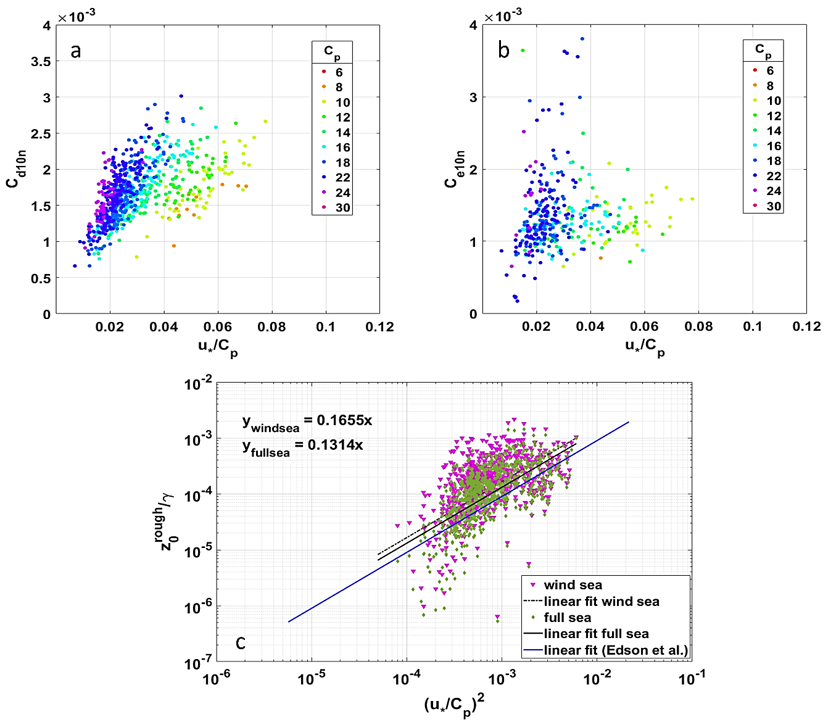
Figure 5: The measured 10-m neutral transfer coefficient for (a) momentum, C_{d10n} (b) latent heat flux, C_{e10n} as functions of inverse wave age $({u_{*}}/{C_{p})}$. (c) The surface roughness, $z_{0}^{rough}$ scaled by significant wave height, γ as a function of inverse wave age on log-log scale. Edson et al. represents the relation when D=0.09.

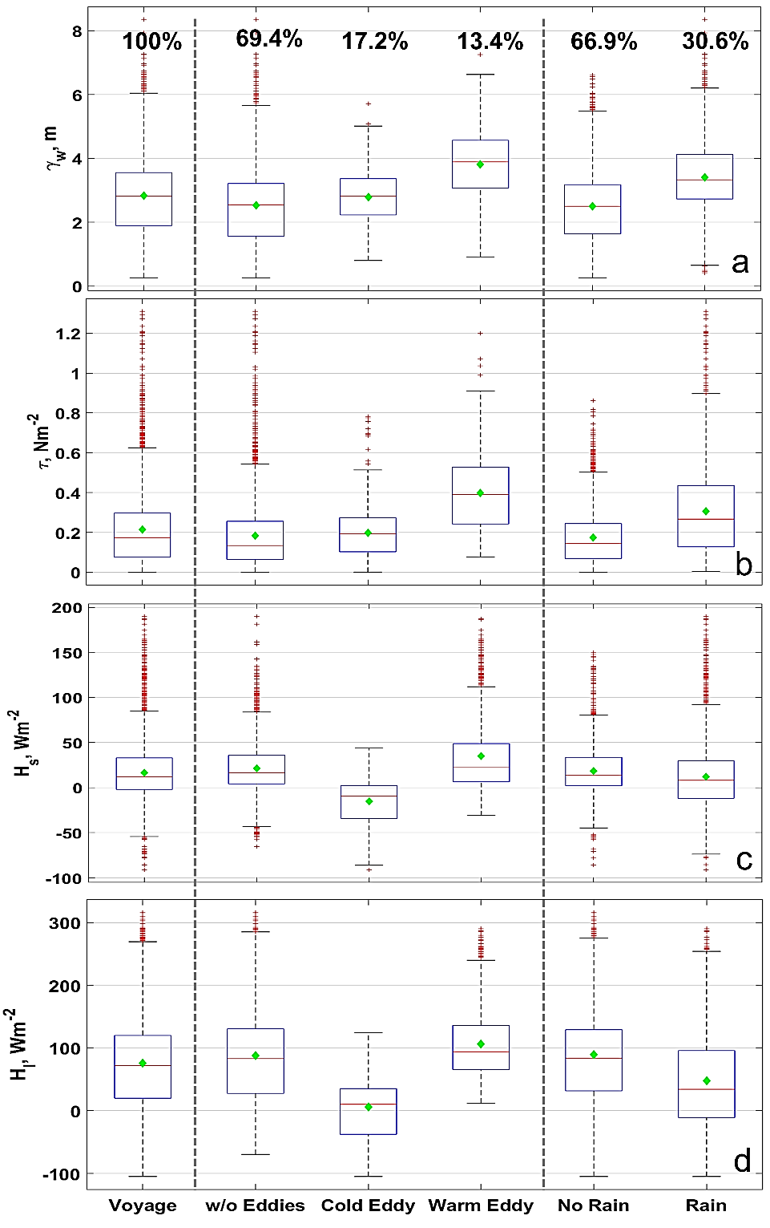
Figure 6: (a) Wind-sea significant wave height, γ_{w} (b) Wind stress, τ (c) Sensible heat flux, H_{s} (d) Latent heat flux, H_{l} distributions using COARE 3.5 bulk fluxes during the voyage, over the eddies and during rainy conditions. A diamond indicates mean and red line indicates median of the distribution. The sample size for each distribution is given in % in (a) and is same for the rest. Missing data is excluded.

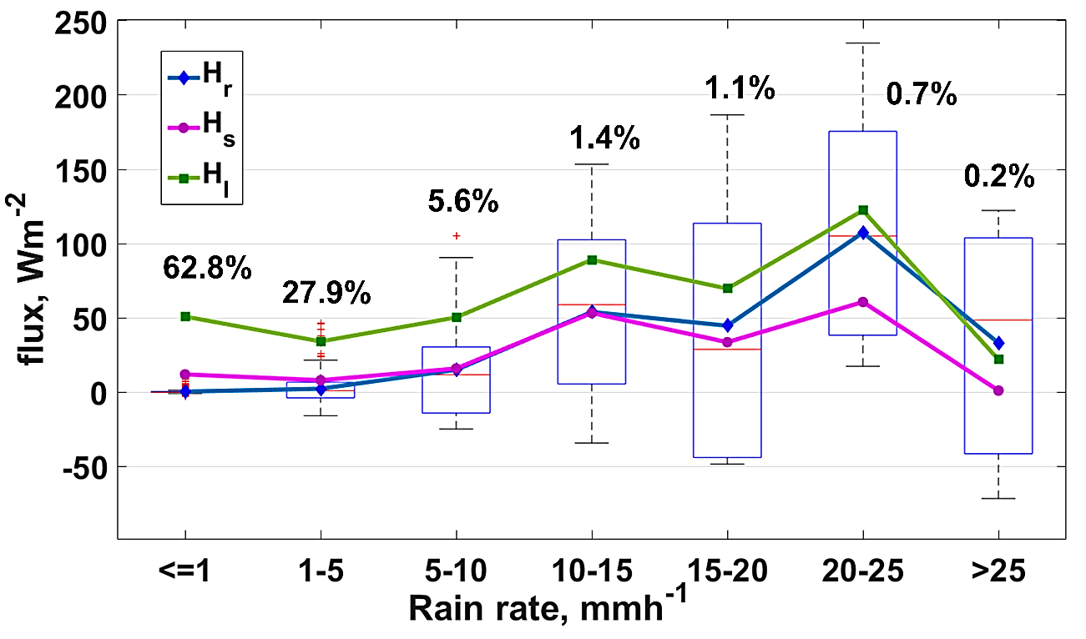
Figure 7: Distribution rain heat flux (H_{r}) along with mean values for each bin during the voyage classified on rain rate, R (mmh⁻¹) using 10-minute flux values. Mean values of H_{s} and H_{l} are also plotted for each bin. The % of data is mentioned for each distribution out of all rain events i.e. when R >0 mmh⁻¹.

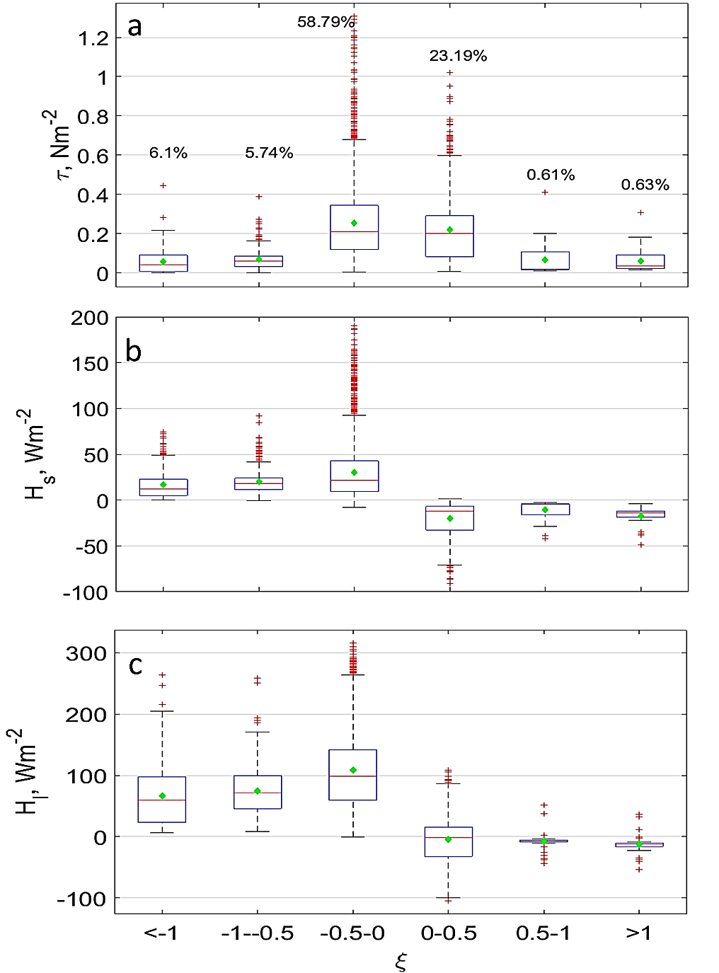
Figure 8: Distributions of (a) wind stress, τ (b) Sensible heat flux, H_{s} and (c) Latent heat flux, H_{l} categorized on the Monin-Obukhov stability parameter (ξ=z/L). The % of data for each distribution is given for τ (same for H_{s} and H_{l}). Missing data is excluded.

Figure 9: (a) Wind-sea significant wave height, γ_{w} (b) Wind stress, τ (c) Sensible heat flux, H_{s} (d) Latent heat flux, H_{l} distributions using COARE 3.5 data shown here as boxplots as noted during pre-, midst- and post- conditions of 9 extratropical cyclones. The x-axis represents the dates where Suffix-M is for March and Suffix-A is for April month respectively. The average distributions of fluxes are calculated by combining all pre-, midst- and post- distributions separately.

