Stratus 2019 Bulk Meteorology System Ship-Based (April 8-27, 2019) aboard R/V Cabo de Hornos.

The PSD Flux Measurement System used on R/V Cabo de Hornos consists of six components (Table 1):

- Solar and infrared radiation sensors. Radiometers are mounted on top of bridge house 16m from Sea Surface.
- Bulk Meteorology sensors (air temperature, relative humidity, atmospheric pressure and precipitation). Instruments are mounted on the top of a portable weather tower 16.4 meters from sea level.
- One differential GPS units measuring heading and pitch information, installed above pilot house-port side about 16.4 meters from sea level.
- A sea surface temperature measurement made with a floating thermistor deployed of port on the port side with outrigger.

Table 1. Instruments and measurements for air-sea interaction studies
Item | System | Measurement
1 | Bulk Meteorology | Air Temp, Relative Humidity,Wind Speed,Wind Direction, Atmospheric Pressure, Rain Rate.
2 | Pyranometer &Pyrgeometer | Downward solar radiative, IR flux
3 | GPS and Heading | Ship SOG, COG,Lat,Lon GPS and Heading
4 | Sea Snake | Near Surface Sea Temp
5
6

Instrument measurements are logged in a PC supplied by PSD. The systems will run continuously through the cruise, special attention on Julian days 103, 104 , 108 and 114 on Strauts19 data comparison for buoy deployment and recovery. The ship’s SCS data is provided in ASCII format from a Vaisala bulk meteorology system located in the main ship mast. This data will be stored for later processing .

Figure A-1. ESRL/PSD mast mounted on the Cabo de Hornos, showing the location of weather tower.

Figure A-2. ESRL/PSD mast mounted on the Cabo de Hornos, showing the location of weather tower.

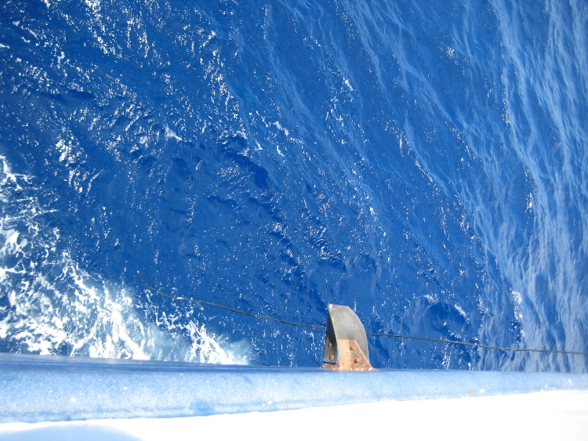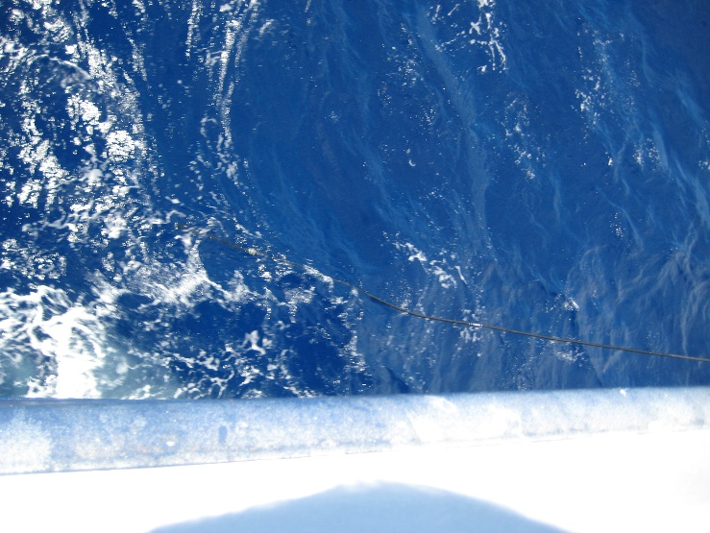

Figure A-3. Sea snake” is on the port side about 15m from the tower.
Figure A-4. ESRL/PSD radiometers mounted on deck above the pilot house about 16.4m from sea level.

Stratus 2019 Schedule

Day 1 Monday April 8 2019
- Install PSD System on Board (Installation started on Saturday 6 after equipment was loaded.
Day 2 Tuesday April 9 2019.
- 0:01 :Leave port, deploy 2 drifters
- 7:00 :CTD cast#1 to 500 m, with SHOA and WHOI CTD
- 8:30: CTD cast#2 to 1500 m with WHOI acoustic releases(3).
- 14:00 deply drifter #10
- 15:00 enters EEZ around San Felix Island
- Continue transit towards Stratus18 buoy
Day 3 Wednesday April 10 2019
- Transit to towards Stratus18
Day 4 Thursday April 11 2019
- 12:00 Arrive at Stratus18 target area
- Multibeam on, Bathymetry survey
Day 5 Friday April 12 2019
- Deployment location selected
- Test run all day
Day 6 Saturday April 13 2019
- 00:01 Test run ends
- 9:00 Start deployment
- 19:00 Deployment ends
- WP 22 28.287S, 85 38.932
Day 7 Sunday April 14 2019
- Cancelled all activities due a search and rescue mission
Day 8 Monday April 15 2019
- 9:00 Search and rescue cancelled
- Transit toward drifting buoy Stratus17
- 19:00 Drifter deployment
- 23:59 Drifter deployment
Day 9 Tuesday April 16 2019
- Transit toward drifting buoy
Day 10 Wesnesday april 17 2019
- Transit toward drifting buoy
- 04:00 Drifter deployment#4
- 09:00 Drifter deployment#5
- 14:00 Drifter deployment#6
- 19:00 Drifter deployment #7
- 24:00 Drifter deployment #8
Day 11 Wesnesday April 18 2019
- Drifters #9 to 13 deployment
- Arrive at drifting buoy location W105 30’ S 14 55’
- Recovery procedure started at 7:00
- CTD after recovery
Day 12-15 Wesnesday April 19 to Monday April 22 2019
- Transit to Stratus 17 anchor site. 19°38.3203’S, 84°55.099’W (-19.6387,-84.9183)
Day 16 Tuesday April 23 2019
- Recovery Anchor site started 6:00 AM – ended 12:00 PM
- Start transit to Stratus 18 site for comparison
Day 17 Wednesday April 24 2019
- Arrival Stratus 18 site at 5:00 AM
- Location :22° 27.699’S, 85°38.590’W (-22.4617,-85.6432
- Transit to Valparaiso start 20:00
- Arrival ~Sunday 28 April 2019

Stratus 2018 Flux measurements result

Adjustments and modifications to hardware and software were finalized three day after leaving Valparaiso (April 9) on route to Stratus 18 deployments.
Seasnake extension cable needed to be remade due to water in the connector (the cable was drop in sea water in installation at the pier). PIR1 umbrella came loose on day 114 ( fixed on day 115) . PSD measurements compared well to ship heading, wind direction /speed and atmospheric temperature and pressure. Issues with Campbell datalogger started on April 13, intermittent minute timestamps were not created while files were written, making some hours of the days unprocessed (fig 5). Different attempts were made to correct this unseeing problem, increasing the datalogger buffer and adding a serial port flush to the end of the scan resolved the problem (fig 6). The lack of testing the PSD system before sailing created issues that could have been potentially avoided, hardware setup was done in a 1-1/2 days leaving many steps undone, there was not enough time for setup due the loading logistics.

Days 108 and 114 could be used to compare Stratus 18 deployment, changes on scheduled deployment and comparison brought the ship to deployment site on a later day due to ship emergency calls at sea. Attempt to run Stratus comparison matlab were made unsuccessfully but Stratus personnel was able to use our data to stablish a preliminary comparison that looks in agreement between PSD and buoy hourly data, post processing is expected to follow.

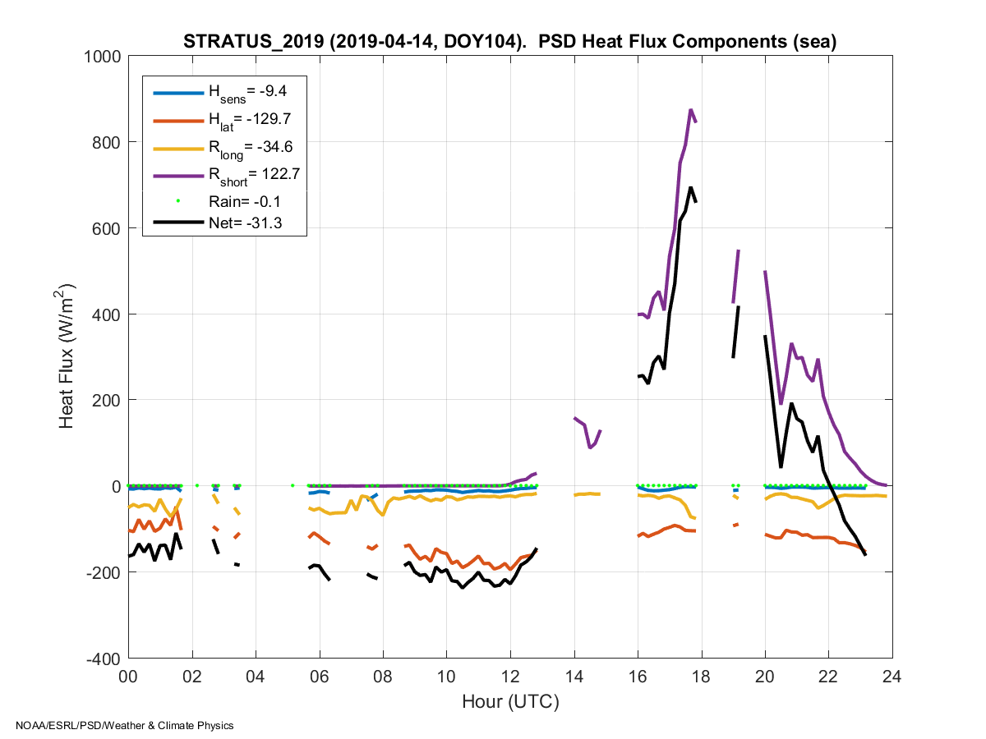
Figure 5. data lost due to no timestamp.

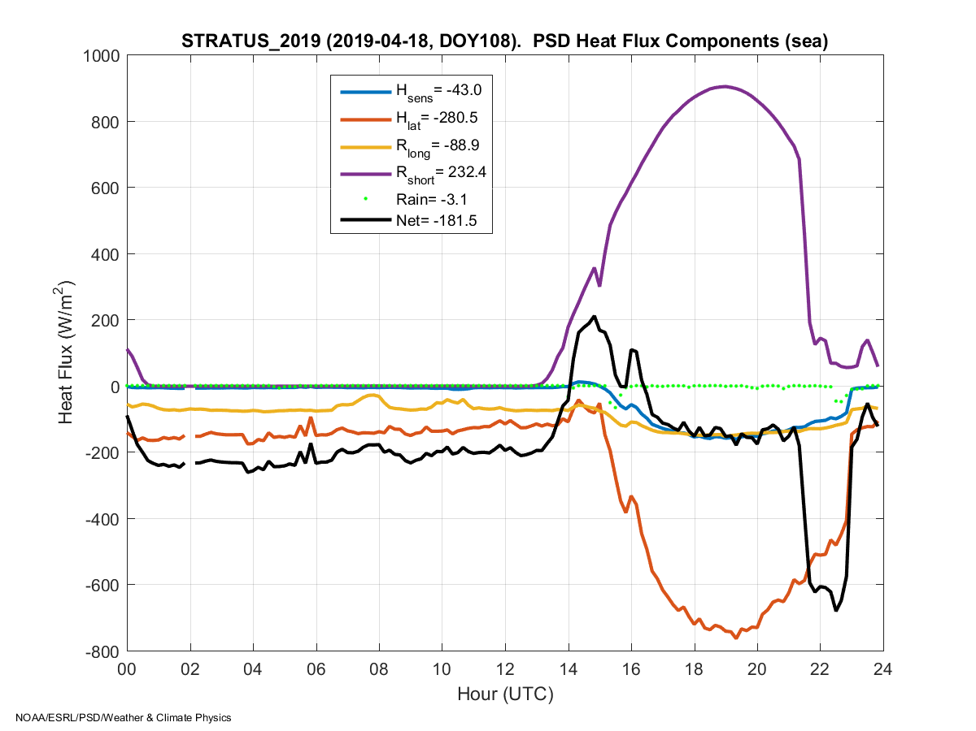
Figure 6. fixed timestamp issue.

Stratus 2018 Flux System Ship-Based Sensors Coefficient Table

Sensor | Calibration coefficient | Make / Model | Serial Number | Date of calibration
Precision Spectral Pyranometer | 0.009 | K&Z/ CM22 | 15713050122 | June, 2018
Precision Spectral Pyranometer | 0.00951 | K&Z/CMP22 | 15521170518 | May, 2018
Precision Infrared Radiometer | 0.00392 | Eppley / PIR 1 | 38521F3 | April, 2018
Precision Infrared Radiometer | 0.0026 | Eppley / PIR 2 | 38519F3 | April, 2018
Vaisala Weather Transmitter |  | WXT-520 | G2950002 | Feb, 2017
Temp / Humidity | n/a | Vaisala/HMT335 | C1110008
Class A Barometer | n/a | Vaisala/ PTB220 | A2710002
Sea Snake thermistor 0C to 40C | C4=0.001399937 C5=0.00237854 C6=0.000000097 | YSI 46031 series | n/a
GPS and Heading |  | Hemisphere/Crecent VS110 | 072235040014
Datalogger |  | Campbell/CR1000 | 46973

