Report on R/V Sally Ride meteorological and seawater measurements

PISTON 2019 field experiment in Philippine Sea
2 - 27 Sept 2019

Prepared by: Elizabeth J Thompson
NOAA Earth System Research Lab, Physical Sciences Division (NOAA ESRL PSD)
Contact: elizabeth.thompson@noaa.gov
325 Broadway, Boulder, CO, 80305

Summary:
For the PISTON experiment, ESRL PSD installed and operated two sets of meteorological, radiative, rain, and seawater measurement systems aboard the Sally Ride. This report summarizes differences between the NOAA PSD measurements and that made by the ship.

Recommendations:
- Both TSGs should be cleaned with Tritenex between cruises. The bow TSG was not cleaned prior to PISTON 2019. However, when the TSGs were both sampling seawater from the bow port, they read similar values: negligible differences in T, < 0.02 PSU differences in salinity. These are within Seabird SBE 45 manufacturer specifications.

- Though not currently possible, it would be ideal for the bow and seachest pumps to remain open throughout each cruise so that each water source be sampled by separate TSGs (SBE45 thermosalinograph instrument). This is not currently possible because the two plumbing lines share the same overflow. Water is either pumped from the sea chest or the bow. The same water is sampled by both TSGs. When bow water is being pumped, the bow TSG samples it first and the main lab TSG samples second. When seachest water is being pumped, it is measured first by the main lab TSG and second by the bow TSG. It is more disruptive to the science sampling to switch between TSGs and/or pumped seawater location during the cruise. It would be ideal to sample seawater properties from both places and then choose the “best” value in post-processing depending on flow rate, such as if a pump lost flow rate due to unfavorable pitch or roll.

- Compared to independent calibrated measurements made during PISTON, biases in both of the ship TSGs appear to be present and should be corrected:

- Documentation and data file headers should be improved to more clearly document how seawater is being measured - from which location and at which levels. Currently, the .MET files provided by the ship have confusing headings for the TSGs. The numbering is not explained in any of the written documentation and is not internally consistent. For all variables except flow rate, the numbering system is currently as follows:
  - Not numbered, first TSG mentioned in file = TSG located in bow thruster room
  - -2, second TSG mentioned = TSG located in the main lab
  - -3, third TSG mentioned = not valid for this cruise, might have been used for a prior cruise
  - -4, fourth TSG mentioned = not valid for this cruise, might have been used for a prior cruise
For flow rate, however:
- FI is for TSG-1 in bow thruster room
- FI-2 is for the PCO2 pump (which isn’t reporting data)
- FI-3 is for TSG-2 in main lab
It is recommended that these variable names be renumbered in the .MET files to be internally consistent (all -2 values be for TSG in main lab, all unnumbered (first) values be for bow thruster TSG, and all -3 and -4 data columns simply be deleted because they do not normally contain data.

Moreover, it is recommended that documentation be provided to the science party regarding where the bow and seachest intakes are located along the ship. This documentation has been prepared and provided below and shown in Figures 1-2.

Ship bow intake = starboard hole at 3.6 m depth, 0.3-0.6 m forward and below bow thruster vent, feeds into bow thruster room. Pump loses prime and takes in water if ship pitches excessively. The air bubbles contaminate the seawater measurements.

Seachest intake = port vent between 2.3-3.4 m depth, 0.6-0.9 m aft and just above bilge keel, feeds into engine room.

TSG-1 (sometimes the first value that is unnumbered) on ship's .MET files = TSG located in bow thruster room (SBE45).
If seawater is pumped from bow intake, this TSG samples the water first.
If seawater is pumped from seachest, this TSG re-samples water after TSG-2.
Flow rate variable = FI.

TSG-2 on ship's .MET files = TSG located in main lab.
If seawater is pumped from bow intake, this TSG resamples the water after TSG-1
If seawater is pumped from seachest, this TSG samples the water first.
Flow rate variable = FI-3.

Data from both TSGs are bad when flow rate is not sufficiently high, or too high:
bad = find(FI < 1.75 or FI > 3.5) , where FI is in units of L/min as provided in original dataset.

The precise location of the water intakes along the ship, and relative to water line, is important in interpreting the measurements for scientific purposes. An unknown amount of flow distortion occurs as water flows around the ship, which may encourage mechanical mixing of water properties between different depths. Temperature and salinity, and therefore also density, can vary greatly between 0-5 m.

As a final word of caution, these subsurface data streams should these data ever be interpreted as measurements of “sea surface temperature” or “sea surface salinity”. They are not currently listed as sea surface data in the data files, but this terminology is mentioned (erroneously) in the supporting documentation provided by the ship.

- The long wave radiation sensor could be improved. Figure 3 shows an example of one day’s worth of day. The ship’s long wave radiation measurement (green, SCS line) was noisier (exhibited greater variance) and was often anomalously low at times compared to the two NOAA PSD IR measurements.
- The documentation about sea level pressure is calculated was difficult to find. The steps are repeated here for reference, and could be added to the reference material provided by the ship. Barometric pressure is measured at the unit. It must be corrected for its altitude off water to provide a measure of the mean sea level pressure.
zpim = 15.24 ; elevation of pressure sensor
p_correction [mb] = 1013.25 *( 1 - ( 1 - zpim/44307.69231 ) ^5.253283 );
p_sealevel [mb] = p_measured + p_correction

- Rain rate in mm/hour could be provided. Cumulative rain is measured by the ship’s RM Young sensor at 1 sec frequency, 1 Hz. The value decreases periodically due to sloshing and evaporation, then jumps suddenly to higher values when precipitation occurs. Only strongly positive differences from one time to the next should be used to calculate rate. The following procedure was used to calculate rain rate:

Other issues encountered on PISTON 2019 that were resolved, or will be resolved soon
- Humidity was incorrectly calculated prior to day 267, Sept 24, because incorrect calibration coefficients were used. It is likely not possible to reprocess the data
- The WAMOS X-band radar processing system was reporting incorrect time series data because an incorrect configuration file was being used by the automatic onboard processing system.

Figures:

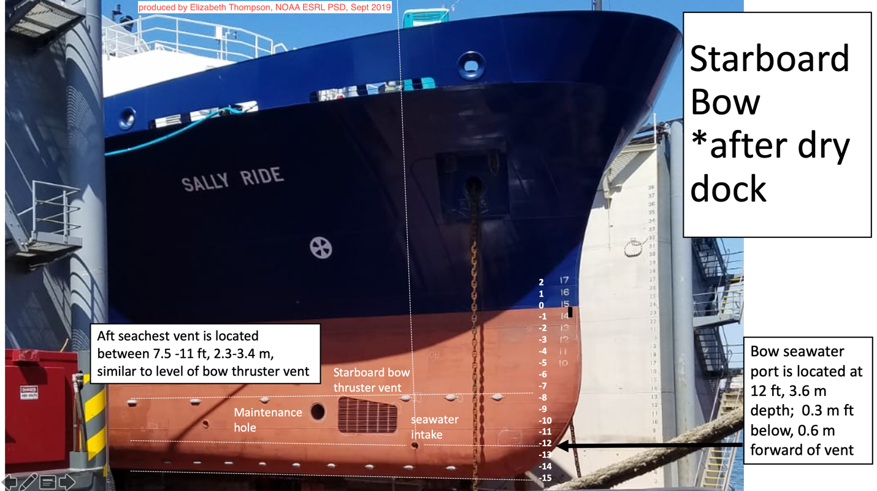
Figure 1: Starboard bow view of ship and the port used to pump water to the bow thruster room.

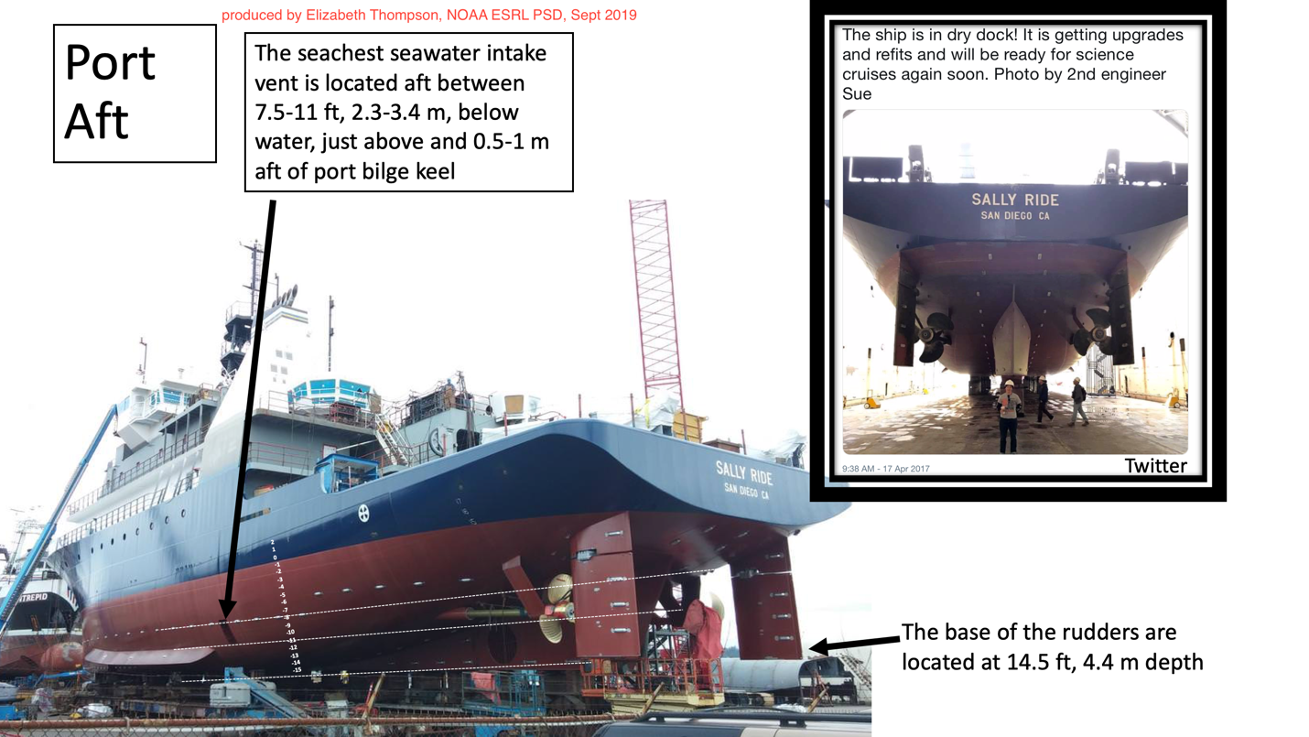
Figure 2: portside aft view of ship and the vent used to pump water to the sea chest in the engine room.
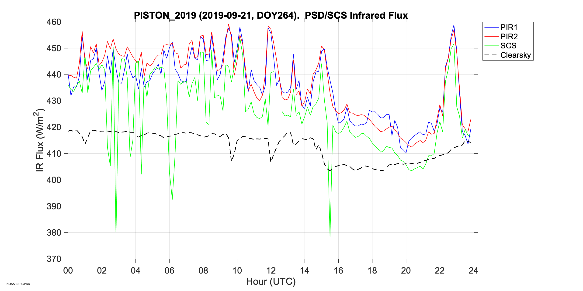
Figure 3: The ship’s long wave radiation measurement (green, SCS line) was noisier (exhibited greater variance) and was often anomalously low at times compared to the two NOAA PSD IR measurements. Clear sky radiation is calculated as a function of latitude, mean atmospheric properties assuming no cloud cover, and latitude.

