Regarding trends in the sea-surface temperature and 2-m air temperature difference over the oceans.
C.W. Fairall
NOAA Physical Science Laboratory
Boulder, CO 80305 USA

Introduction
Current effort to recast temperature trends involve reconciling the difference in surface temperature (T_{s}) vs the air temperature (T_{a}) at a height of 2m above the mean ocean surface. The data record contains many decades of in situ observations of both – principally from ships but with a growing number of buoys in the last three decades. Satellites provide another source of T_{s} data but satellite estimates of T_{a} are still problematical (Cronin et al. 2019). One interesting issue is an apparent difference in observed trends in these two variables with the increase T_{a} being about 10% greater than T_{s}. Sidestepping the question of the accuracy of global T_{s} and T_{a} observations, it is on interest to ponder physical mechanisms that might explain different rates of change for T_{s} and T_{a} for greenhouse-induced warming.
One well-understood physical constraint is the relationship between turbulent fluxes and gradients of the mean variables in the surface layer The heat transfer coefficient, C_{H}, is essentially independent of wind speed (Fairall et al. 2011), so for this discussion we can neglect the effects of buoyancy and write
(1)
Thus, temporal change sea-air temperature difference must be matched with changes in the sensible heat flux. If T_{s} changes 0.1 C per decade and T_{a} changes 0.11 C per decade, the difference is only 0.01 C which is equivalent to a change in H_{s} of 0.1 Wm⁻². We expect changes the other individual terms (net radiative flux and latent heat flux) of the net surface energy budget (Q_{net} = Rad_{net}-H_{s}-H_{l}) to be on the order of 1 Wm⁻² (Blunden et al. 2018: Zhang et al. 2018). A change in surface temperature by itself changes H_{s} and H_{l} by comparable amounts, so it is actually surprising that the change is sea-air temperature difference is so small. While the surface energy budget needs to balance, we don’t expect H_{s} to act as a valve to compensate the other terms.
Some insight can be gained by considering the budget equation for temporal changes in the atmospheric boundary layer temperature. Large areas of the tropics and subtropics are dominated by subsidence where the sea-air temperature difference is naturally regulated by a balance of heating of the air by surface heat flux and entrainment flux vs radiative cooling by boundary-layer clouds (Lilly 1968; Albrecht 1993). Condensation/evaporation by rainfall can be cooling or warming depending on how much condensation occurs in the boundary layer vs how much rainfall reaches the surface. These processes maintain annual average sea-air temperature differences of 0.5-1.0 C and near-surface relative humidity about 80% in those regions. Annual variations in sea-air temperature difference from high quality buoy observations at three subtropical sites (Weller et al. 2018) are about 10-25% of the annual variation of T_{s} (about 1 C). The observations also show the mean annual cycle in T_{a} about 10% larger than in T_{s} at those sites. Details are provided below. Thus, the natural regulation that maintains the sea-air temperature difference is affected by changes in the radiative and advective forcing. At midlatitudes variability in T_{a} associated with storms is very large and mean values are averages over a spectrum of processes. At high latitudes sea-air (or ice-air) difference tends to be negative (Persson et al. 2002) on the order of -1 C in winter and 0 in summer (when T_{s} is fixed at the melting point and low clouds dominate). Over Arctic sea ice in winter the insulating properties of snow lead to large variations in T_{s} associated with variations in clouds with the interface temperature changing much faster than T_{a} (Intrieri et al. 2002). Large regions of midlatitude oceans are affected by poleward advection of warm air over increasingly cold water that causes T_{s}-T_{a} to be near zero and even negative. Because of the complexity of physical processes driving T_{s} and T_{a} from equator to pole, it is problematical to identify a simple explanation for warming to T_{a} to be slightly larger than T_{s}. Indeed, it is difficult to explain how the warming rates are so similar.
Detailed background on surface energy balance
One well-understood physical constraint is the relationship between turbulent fluxes and gradients of the mean variables in the surface layer. For potential temperature, the profile can be expressed
(a1)
Hs is the sensible heat flux, ρ the density of air, c_{p} the specific heat of air, u* the friction velocity, z the height above the surface, z_{0t} the roughness length of temperature, ψ_{H} a function to account for buoyancy effects, and L the Monin-Obukhov stability length. Details can be found in Cronin et al. (2019). While (1) describes the profile, it also forms the basis of methods to relate surface fluxes to mean variables:
(a2)
Relationships such as (a2) form the basis for setting the surface flux boundary conditions in atmospheric models. The heat transfer coefficient, C_{H}, is essentially independent of wind speed (Fairall et al. 2011), so for this discussion we can neglect the effects of buoyancy and write
(a3)
The net surface energy flux is approximately
(a4)
Assume the surface fluxes react to a change in radiative flux by changing T_{s} and T_{a} (noting that q_{a} is not changing as per Zhang et al. 2018)
(a5)
Where γ is about 0.067. From increases in global ocean heat content (Blundin et al. 2017), we expect . Putting in typical mean values and
(a6)
A change of T_{s} of 0.1 C in a decade implies about a 2.2 Wm⁻² flux due to increases in upward longwave flux and latent heat flux. If the changes in T_{a} and T_{s} are comparable, then sensible heat does not contribute and the change in radiative forcing would be about 2.9 Wm⁻². If T_{a} remains fixed, it changes the balance by about 1.1 Wm⁻².
Detailed background on boundary-layer regulation
Another approach to addressing regulation of the sea-air temperature difference is to look at the temperature budget equation for a mixed layer (ML) we assume the 2-m air temperature is an adequate surrogate for the ML potential temperature,
(a7)
Here R_{n} is the net radiative flux and MF_{r} is the mass flux of precipitation. For a mixed layer in steady state, the time derivative is 0 and we represent the vertical gradient as the difference in flux at the top of the ML and at the surface.
(a8)
where W_{e} is the entrainment velocity, h the height of the ML, H the length scale of the horizontal gradient, and T_{land} the effective air temperature over land. The + symbol subscripts denote the value of a variable just above the boundary layer and the 0 is at the surface. Rearranging to obtain an expression for the sea-air temperature difference
(a9)
For typical stratocumulus regions (Ghate et al. 2015) we expect entrainment to be 5E-3 ms⁻¹, wind speed 7 ms⁻¹, the radiative flux divergence -50 Wm⁻², T_{a+}-T_{s} to be 5 C, and h=1e3 m. Because drizzle is generated within the ML but does not reach the surface, there is no net heating by precipitation. In Tradewind regions precipitation evaporation is about one tenth the radiative term according to Albrecht (1993). Advection is not negligible but on the order of 0.2-0.5 C. From (a9) we compute the temperature terms due to entrainment (-1.8 C) and radiative cooling (+2.8 C) balance T_{s}-T_{a} at about 1.0 C. Notice that if T_{s} increases and T_{a+} does not change, then the entrainment term will cause T_{a} to decrease relative T_{s}. Thus, some compensation by cloud radiative and/or advective processes is likely necessary to cause T_{a} to increase.
Brief analysis of NOAA ORS buoy timeseries
I did a simple trend analysis of data from three NOAA ORS buoys that have been deployed in Tradewind regions (Stratus since 2000, NTAS since 2001, and WHOTS since 2004). A sample time series for Ta, qa, Rsolar, and Rir is shown for the Stratus buoy in Fig. 1. The annual cycle is fairly large. I removed the mean annual cycle (see Fig. 2) and then computed the trend and the uncertainty in the trend. The results are shown in the Table below (CF is radiative cloud forcing – Measured mean cloud flux minus the flux expected in clear sky conditions. Whereas the ORS are a fairly short time series (16-20 years) the data are very accurate and at locations characterized by extensive horizontal homogeneity. There are no changes in local surface conditions associated with human activities (e.g., parking lots, skyscrapers, land-use changes, etc).

 | SITE | Rsolar | Rir | CF | Ta | qa
 |  | W/m^2/dec | W/m^2/dec | 1/Dec | C/dec | g/kg/dec
Slope | Stratus | 3.2 | 1.8 | 0.04 | 0.2 | -0.04
Uncert. | Stratus | 2.1 | 0.8 | 0.02 | 0.09 | 0.07
Slope | NTAS | 2.6 | 0.6 | 0.01 | 0.08 | -0.04
Uncert. | NTAS | 1.5 | 0.6 | 0.02 | 0.06 | 0.07
Slope | WHOTS | 4.4 | 1 | -0.01 | 0.3 | 0.03
Uncert. | WHOTS | 2.2 | 1.5 | 0.03 | 0.1 | 0.13

The variations in surface radiative flux can be separated into the annual cycle (Fig. 1) and subseasonal fluctuations monthly time scales The monthly fluctuations are due to variations in clouds (Fig. 3).
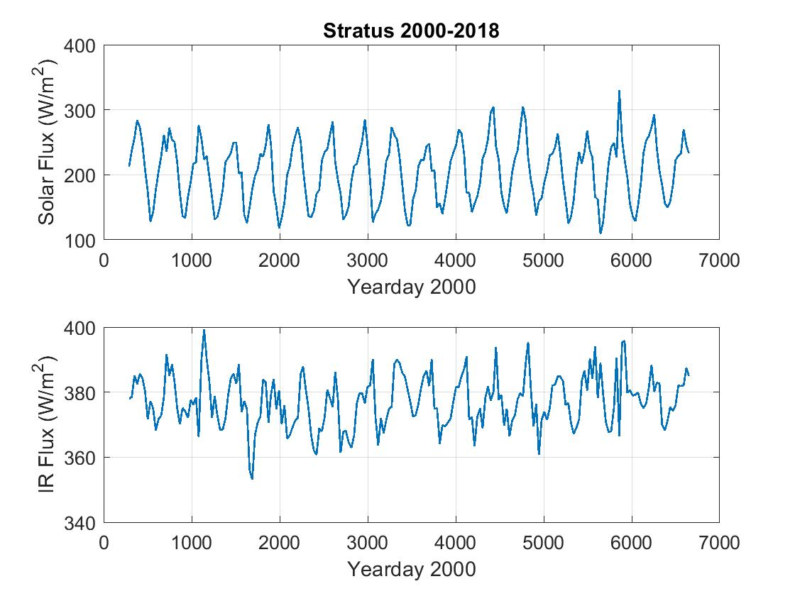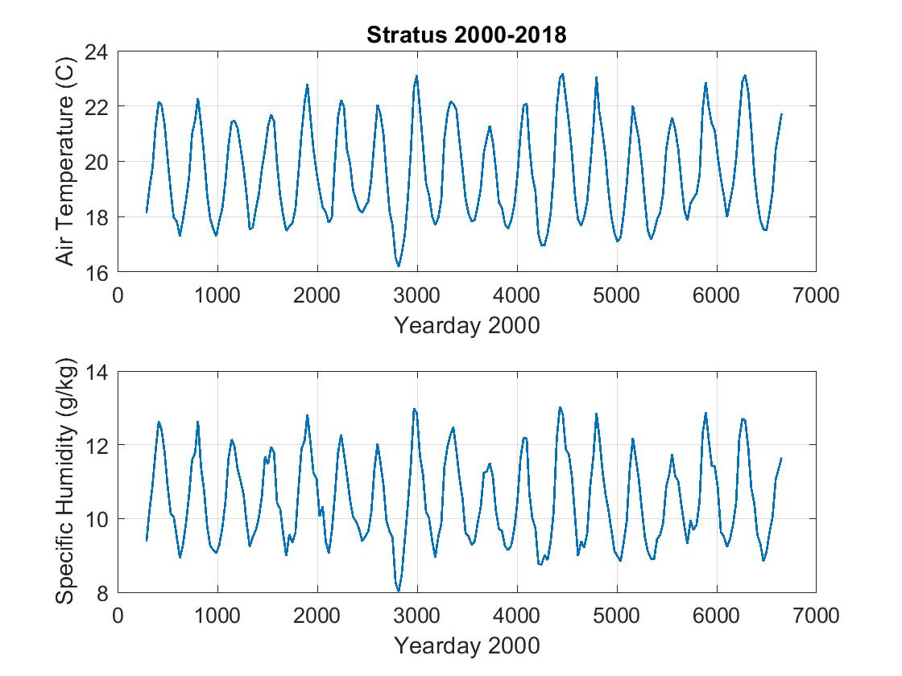

Figure 1. Time series of solar flux, IR flux, air temperature, and specific humidity from the NOAA ORS Stratus buoy of Chile. The x-axis is days since Jan 1, 2000.
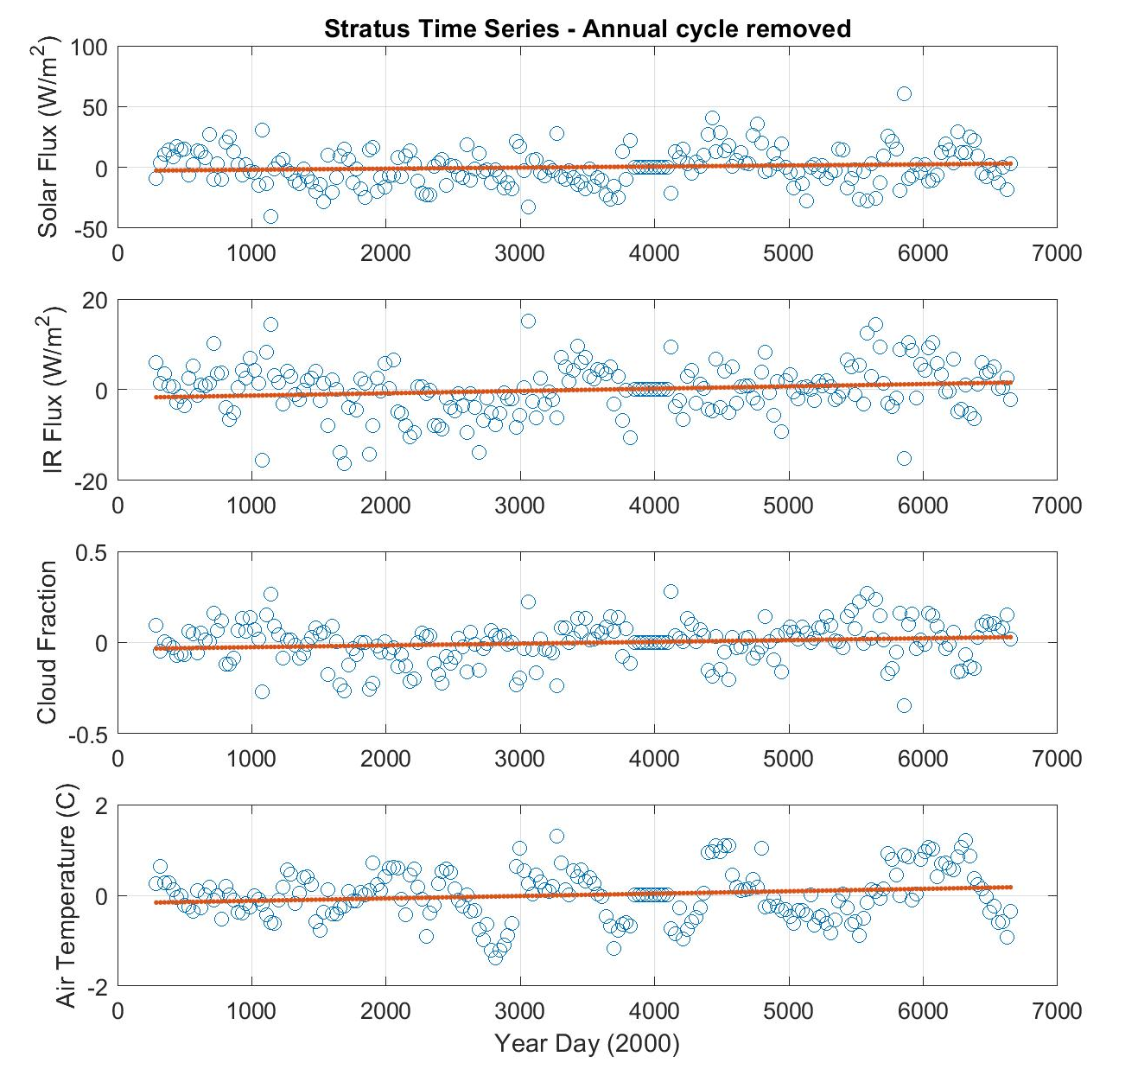
Figure 2. Trend time series with annual cycle removed of solar flux, IR flux, air temperature, and specific humidity from the NOAA ORS Stratus buoy of Chile. The x-axis is days since Jan 1, 2000. The red line is a linear regression fit to the data; the slope gives the overall trend.

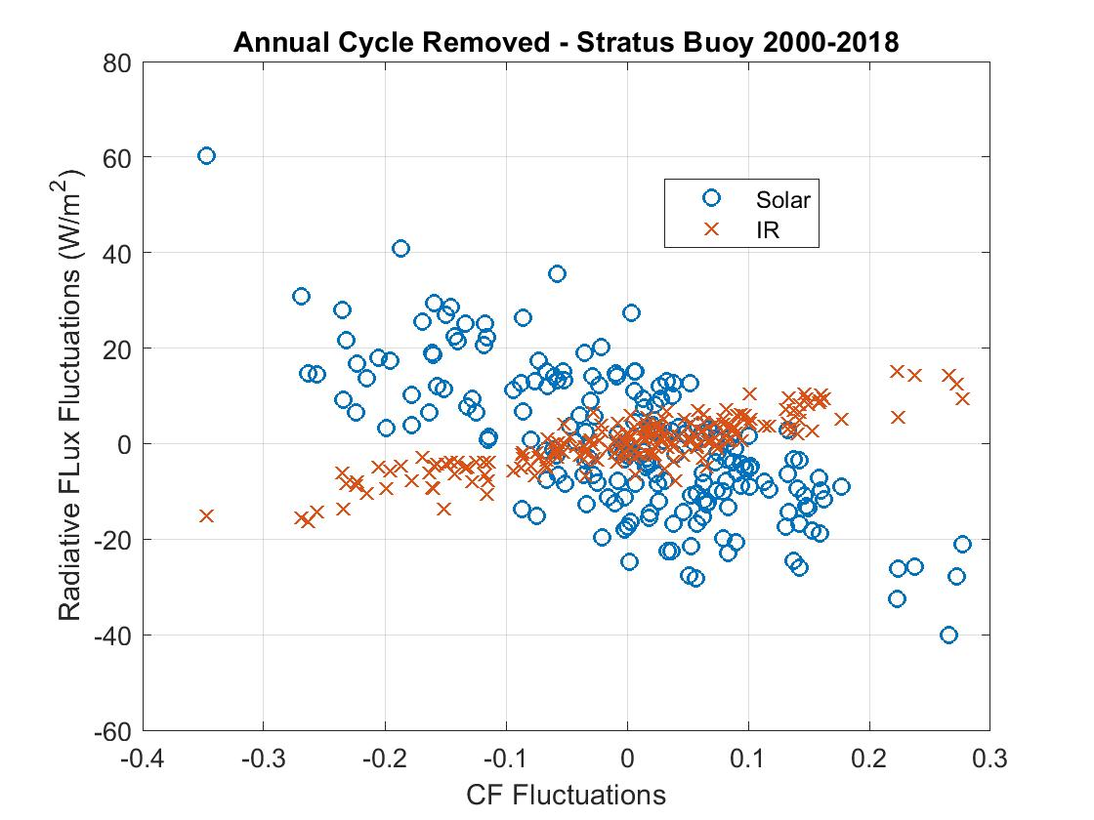
Figure 3. Correlation of downward solar and IR radiative flux at a one- month time scale with variations in clouds (as characterized by cloud forcing, CF). Thus, the variations in monthly radiative flux anomalies is principally caused by clouds.

REFRENCES
Albrecht, B.A., 1993: Effects of precipitation on the thermodynamic structure of the trade wind boundary layer. J. Geophs. Res., 98, 7327-7337.
Blundin, J., D.S. Arndt, and G. Hartfield, Eds., 2018: State of the Climate in 2017. Bull. Amer. Meteor. Soc., 99, Si-S310, DOI:10.1175/2018BAMSStateofthe Climate.1.
Cronin MF, Gentemann CL, Edson J, Ueki I, Bourassa M, Brown S, Clayson CA, Fairall CW, Farrar JT, Gille ST, Gulev S, Josey SA, Kato S, Katsumata M, Kent E, Krug M, Minnett PJ, Parfitt R, Pinker RT, Stackhouse PW Jr, Swart S, Tomita H, Vandemark D, Weller RA, Yoneyama K, Yu L and Zhang D (2019). Air-Sea Fluxes With a Focus on Heat and Momentum. Front. Mar. Sci. 6:430. doi: 10.3389/fmars.2019.00430
Fairall, C.W., Mingxi Yang, Ludovic Bariteau, J.B. Edson, D. Helmig, W. McGillis, S. Pezoa, J.E. Hare, B. Huebert, and B. Blomquist, 2011: Implementation of the COARE flux algorithm with CO₂, DMS, and O₃. J. Geophys. Res., 116, C00F09, doi:10.1029/2010JC006884.
Ghate, Virendra P., Mark A. Miller, Bruce A. Albrecht, and C. W. Fairall, 2015: Thermodynamic and radiative structure of stratocumulus topped boundary layers. J. Atmos. Sci., 72, 430-451, doi: http://dx.doi.org/10.1175/JAS-D-13-0313.1.
Intrieri, J. M. C. W. Fairall, M. D. Shupe, P. O. G. Persson, E. L. Andreas, P. S. Guest, and R. E. Moritz, 2002: Annual cycle of cloud forcing at SHEBA. J. Geophys. Res., 107, NO. C10, 8039, doi:10.1029/2000JC000439, 2002.
Lilly, D.K. 1968: Models of cloud-topped mixed layers. Q.J.R. Meteorol. Soc., 94, 292-309.
Persson, P. O. G., C. W. Fairall, E. L. Andreas, P. Guest, and D. Perovich, 2002: Measurements near the Atmospheric Surface Flux Group tower at SHEBA: Near surface conditions and surface energy budget. J. Geophys. Res., 107, NO. C10, 8045, doi:10.1029/2000JC000705, 2002.
Weller, R. A. 2018: Observing surface meteorology and air-sea fluxes. In: Observing the oceans in real time – Instruments, Measurement and Experience. Eds. R. Venkatsen, A. Tandon, E. D’Asaro, and M. A. Atmanand. Springer. Doi: 10.1007/978-3-319-66493-4.
Zhang, Rongwang, Xin Wang, and Chunzai Wang, 2018: On simulations of global oceanic latent heat flus in the CMIP5 multimodel ensemble. J. Clim., 31, 7111-7128, DOI: 10.1175/JCLI-D-0713.1.

