Underway TSG data readme and best practices for R/V Sally Ride

Elizabeth J. Thompson
NOAA Physical Sciences Laboratory
elizabeth.thompson@noaa.gov
Fall 2020

Two thermosalinigraph SBE45 models are on board (Figure 1, Figure 2), which each measure water being pumped from one of two different locations on the ship hull. Seawater T and S are measured by the TSGs. The water can be pumped from one of two locations on the ship hull: either the starboard bow or the aft engine room area. These two intakes are connected by a series of pipes such that they cannot both be pumped or opened independently, since the water mixes in between. The 2 TSGs on board sample the same water, just at different times depending on which intake and pump is being used as the source of seawater. The two TSGs are not independent because they share common plumbing, and they are not necessarily calibrated equally. Therefore, the data from the two TSGs are not independent and should not be averaged together or even compared for science purposes. The TSG data to use on each cruise should be the one that measures closest to the intake being used to pump in seawater.

Two potential intakes:
- The ship bow intake = starboard hole at 3.6 m depth, 0.3-0.6 m forward and below bow thruster vent, feeds into bow thruster room.
- The seachest intake = port vent between 2.3-3.4 m depth, 0.6-0.9 m aft and just above bilge keel, feeds into engine room.

Two potential TSGs to get data from:
- TSG1 on ship's .MET files = TSG located in bow thruster room. Flow rate variable = FI
- TSG2 on ship's .MET files = TSG located in main lab. Flow rate variable = FI-3

Two outcomes for using TSG data:
- If the water is being pumped from the seachest, it is sampled first by TSG2 and then resampled by TSG1 after traveling through pipes on the ship. TSG2 should be used as the main data stream.
- If water is being pumped from the bow, it is sampled first by TSG1 and then resampled by TSG2 after traveling through pipes on the ship. TSG1 should be used in the main data stream

It is recommended to pump water from the aft seachest an use TSG2 as the main data stream. This is because the bow intake is closer to the water line and the ship bow pitches and rolls substantially. This causes the pump to lose its prime readily and often, and for the data quality to immediately begin to suffer. It's advised to not switch the direction or source of the flow during the cruise. This changes the flow and whether TSG1 or TSG2 are sampling water first/second. This abruptly changes the values of T and S sampled by the sensors, and requires multiple corrections as a function of time.

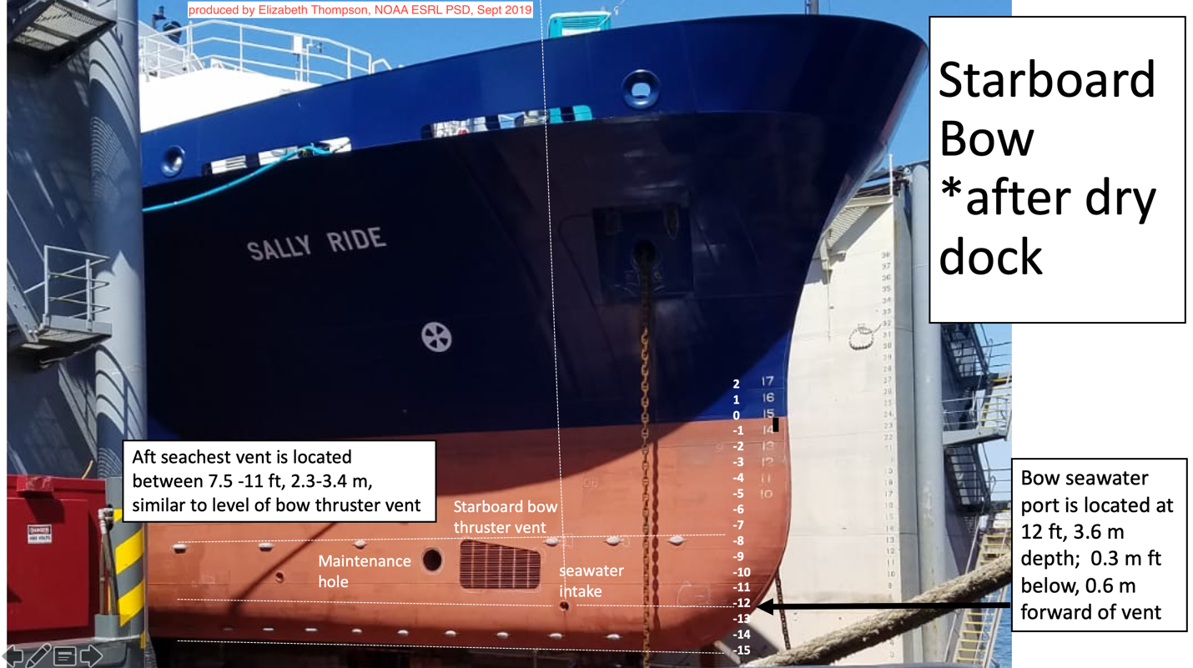
Figure 1: Starboard bow view of ship, showing the port used to pump water to the bow thruster room.

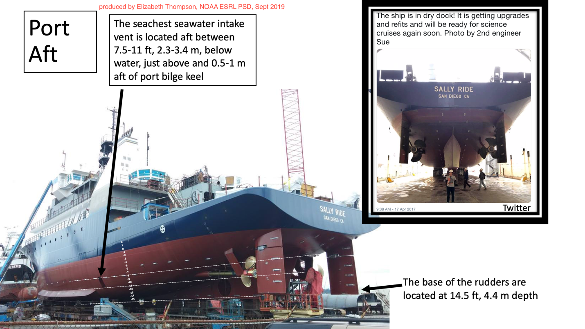
Figure 2: portside aft view of ship, showing the vent used to pump water to the sea chest in the engine room.

It is recommended to examine the flow rate recorded for each TSG to ensure good data quality of T and S. TSG data from a cruise in 2019 was only considered good when consistently high flow was recorded, approximately 1.75 L/min > flow rate > 3.5 L/min. Values above and below these general levels were discarded. Additional spikes in flow rate over short periods of time were also found to be associated with biased T and S measurements compared to an independently calibrated data source. These times identified and then removed and/or smoothed in time with neighboring values for production of the final data time series.

The exact flow distortion around ship's hull, and subsequent mixing, is unknown. However, it is suspected that the properties of seawater sampled at the port are mostly representative of a mixture of water between the surface and the depth of the intake valve.

Multiple calibrations are recommended on every cruise (applies to all ships)

It is recommended for the ship to clean the TSGs with Tritenex and for them to send the TSGs, CTDs, and thermistors back to Seabird as often as possible or as practical. During a cruise it is recommended to conduct a careful calibration of the TSGs with the ship rosette CTD or another independent data source from the science party periodically on every cruise: at the very beginning, throughout, and at the end. Careful calibration would mean letting the CTD equilibrate to the subsurface water, as is likely standard procedure for CTD casts. Example: Let the rosette get dunked below 10 m and let it sit there for several minutes. Then bright it back up slowly to about 5 m without cresting above water for maybe 15-30 m to establish a long-enough dataset for calibration purposes to the TSGs at 3-5 m on the ship hull. Do this calibration when it is not raining and very late at night, such as between the hours of midnight and an hour before sunrise so that the water column is well mixed. During the daytime, temperature gradients exist in the upper few meters due to absorption of solar radiation. After rain, the surface water can be significantly cooler until the freshwater is mixed downward by wind. Since the T offset can sometimes be related to ship speed and latitude (due to changing T of surrounding seawater), it is recommend to repeat the calibration throughout the cruise to be sure of the offset diagnosis. Salinity offsets in TSGs and CTDs are known to exist and also to drift in time because the calculation of S depends on how clean the sensor is. Biofouling changes the measurement accuracy over time. It is typical to detect significant drifts in TSG and CTD biases of S during a single cruise, such as in a single 4-week cruise on Ride. This is why it'd be recommended to do multiple calibration CTD/TSG checks throughout the cruise, particularly right away at the beginning and at the end.

More info regarding readmes and MET files provided to the science party…

Documentation and data file headers should be improved relative to what was used in fall 2019 to more clearly document how seawater is being measured, such as providing the text above to explains where water is sampled from and it’s actual depth relative to water line. As of Fall 2019, the .MET files provided by the ship also had confusing headings for the TSGs. The numbering is not explained in any of the written documentation and is also not internally consistent.
For all variables except flow rate, the numbering system was as follows:
Not numbered = first TSG mentioned in file. This is the TSG located in bow thruster room
-2 suffix = second TSG mentioned in file. This is the TSG located in the main lab
-3 suffix =third TSG mentioned. This header is not valid for this cruise. It might have been used for a prior cruise
-4 suffix = fourth TSG mentioned This header is not valid for this cruise. It might have been used for a prior cruise

For flow rate numbering, however,
FI is for first TSG-1 in bow thruster room
FI-2 is for the PCO2 pump (which wasn’t reporting data during PISTON)
FI-3 is for second TSG-2 in main lab

It is recommended that these variable names be renumbered in the .MET files to be internally consistent (all -2 values could be for TSG in main lab, all unnumbered or -1 values could be for bow thruster TSG, and all -3 and -4 data columns could be deleted because they do not typically contain data.

As a final word of caution for seawater measurements and their metadata or readmes provided on the ship, these data streams from subsurface measurements should never be interpreted or labeled as “sea surface temperature” or “sea surface salinity”. They are not currently listed as sea surface data in the data files, but this terminology is erroneously mentioned in the supporting documentation provided by the ship. In order for true sea surface temperature or salinity to be measured, a number of different methodologies would be required:
- a surface-following contact measurement must be made outside the ship wake
- subsurface data must be processed through the COARE 3.6 bulk flux algorithm (Fairall et al. 1996) to account for two physical effects:
- diurnal warming above 5-10 m (can be up to 5 deg C when winds are weak and solar insulation is strong)
- the cool skin effect produced by evaporation and heat loss by sensible, latent, and radiative fluxes in the upper 0.2 - 1 mm (order 0.1 - 0.5 deg C depending on wind speed and air temperature)

