Annual Progress Report to
NOAA’s Climate Observations Program

High Resolution Climate Data from Research and Volunteer Observing Ships
December 2010

Period covered by this report: Oct 1, 2009 - Sept 30, 2010
Project Manager: C.W. Fairall, Chief of Weather and Climate Physics Branch
Physical Science Division
NOAA Earth System Research Laboratory, 325 Broadway, Boulder, CO 80305
303-497-3253 Chris.Fairall@noaa.gov
Finance Contact: Jo Novosel, 303-497-6588 Jo.Novosel@noaa.gov
Division Director: William D. Neff

ABSTRACT

This project focuses on the measurement of direct high-resolution air-sea fluxes on one to two cruises per year and on the development and use of a roving standard flux measuring system deployed on a series of NOAA and UNOLS research vessels to promote the improvement of climate-quality data from those platforms. Direct measurement of air-sea turbulent fluxes of sensible heat, latent heat, and momentum are critical for the development of model parameterizations of fluxes, and this project provides a strategy for maintaining regular flux observations within the climate context and provides a critical tool for providing a systematic calibration for flux observations from UNOLS and NOAA vessels.

PROJECT SUMMARY

Direct covariance air-sea fluxes are performed on several oceanic cruises each year, and ESRL has developed a roving standard flux measuring system to be deployed on research vessels on an opportunistic basis. This latter task aims to encourage the UNOLS and NOAA fleet toward high-quality climate observations from these platforms. An adjunct task is maintenance and operation of the C-band scanning Doppler radar on the NOAA ship Ronald H. Brown. Because buoys and most ships and satellites rely on bulk methods to estimate fluxes, another aspect of this project is the use of direct measurements to improve the NOAA/COARE bulk flux algorithm. Originally, one of the scheduled cruises was the annual TAO buoy tending cruise along the 95W and 110W buoy lines on the Ronald Brown, but after several years of participation, the TAO cruise deployment was discontinued in favor of participation in an annual cruise to the equatorial Atlantic Ocean with NOAA/AOML as part of the African Multidisciplinary Monsoon Analyses (AMMA) and Saharan Dust studies (now part of the PIRATA Northeast Extension; PNE). In 2000, a second cruise was added to participate in the annual turn-around of the Stratus climate buoy at 20S, 85W. Due to the success of the Stratus cruise participation and the fruitful collaboration with WHOI, and in order to maintain a more relevant connection with the climate reference buoys, ESRL now also participates in the annual turn-around of the Northwest Tropical Atlantic Station (NTAS) reference buoy at 15N, 51W. Furthermore, ESRL has added frequent participation in the annual WHOI Hawaii Ocean Time Series Station (WHOTS) reference buoy redeployment at 23N, 158W aboard the Kilo Moana.
A full suite of direct, inertial-dissipation, and bulk turbulent fluxes of sensible heat, latent heat, and momentum are measured along with IR and solar radiative fluxes, precipitation, and associated bulk meteorological properties. This effort represents a partial transition of research from the OGP CLIVAR PACS program to operations under the Climate Observations Division (COD).
The project development is the result of a NOAA-sponsored workshop on high-resolution marine measurements (Smith et al., 2003, Report and Recommendations from the Workshop on High-Resolution Marine Meteorology, COAPS Report 03-01, Florida State University, pp38) which identified three important issues with the planned NOAA air-sea observation system: 1) the need for a data quality assurance program to firmly establish that the observations meet the accuracy requirements, 2) the need for observations at high time resolution (about 1 minute), 3) and the need to more efficiently utilize research vessels, including realizing their potential for the highest quality data and their potential to provide more direct and comprehensive observations. For seasonal time scales, the net air-sea flux (sum of 5 flux components) must be constrained within 10 Wm⁻². Buoys and VOS systems are required to operate virtually unattended for months, so considerations of practical issues (e.g., power availability, instrument ruggedness, safe access, etc) are balanced against inherent sensor accuracy and optimal sensor placement. As discussed above, an important function of the in situ measurements is to provide validation data to improve NWP and satellite flux fields. High time resolution and more direct observations are invaluable for interpreting surface flux measurements and diagnosing the source of disagreements; such information can be provided by suitably equipped research vessels (R/V). Thus, the accuracy of buoy and VOS observations must be improved and supplemented with high-quality, high time resolution measurements from the US R/V fleet (which is presently underutilized). The necessity for both high time resolution and high accuracy places extreme demands on measurements because some sources of error (such as the effect of ship flow distortion on wind speed) tend to average out over a large sample. To accomplish this task will require a careful intercomparison program to provide traceability of buoy, VOS, and RV accuracy to a set of standards.
This project directly addresses the need for accurate measures of air-sea exchange in the Program Plan for Building a Sustained Ocean Observing System for Climate (Sections 5.2-5.4), and it is a joint effort by ESRL and Dr. Robert Weller of the Woods Hole Oceanographic Institution (WHOI). The ESRL Air-Sea Interaction Group website can be found at: http://www.esrl.noaa.gov/psd/psd3/air-sea/. ESRL also cooperates with Dr. Frank Bradley (CSIRO, Canberra Australia) on precipitation and radiative flux observations, Dr. Meghan Cronin (NOAA PMEL) on buoy-ship intercomparisons and climate variability analysis, and Dr. Wade McGillis (Univ. Columbia) on gas fluxes. A project website has been established (High Resolution Climate Observations http://www.esrl.noaa.gov/psd/psd3/air-sea/oceanobs/ ). An associated website (http://www.esrl.noaa.gov/psd/psd3/wgsf/ ) contains a handbook on best practices for flux measurements plus a database of high-resolution flux data. This work will be closely monitored by the WCRP Working Group on Surface Fluxes (WGSF) which is chaired by C. Fairall. This gives the project high visibility in the CLIVAR, GEWEX, and SOLAS programs. This project will be managed in cooperation with JCOMM (and other) panels as per instructions of David Goodrich.
Users of the data from this project include numerous individual collaborators (J. Edson at UConn, B. Huebert at UHawaii, B. Ward at Galway, M. Bourassa at FSU, W. McGillis at LDEO, F. Bradley at CSIRO, M. Cronin at PMEL, R. Wanninkhof at AOML, R. Weller at WHOI, A. Beljaars at ECMWF) and many projects/programs worldwide (SAMOS, GOSUD, SeaFlux, USGCRP, WCRP, SOLAS, SURFA, OceanSites, CLIVAR, VOCALS, UNOLS, TAO). Specific applications include global model algorithm development and intercomparison, satellite product intercomparison, in situ (buoy and ship) intercomparison studies, application of the NOAA/COARE model for flux parameterization, and improved climate observation capabilities.
This project directly addresses the Climate Observation and Monitoring Program deliverables for improved observations of Air-Sea Exchange, and for accurate measurement of Sea Surface Temperature.

FY2010 ACCOMPLISHMENTS

ESRL participated in three research cruises, including deployment on the UNOLS R/V Atlantis for a major multi-institutional, multi-platform experiment (CalNex) during May-June off the coast of California, a climate reference buoy cruise (Stratus) on the Ronald H. Brown in January, and further participation on the February CLIVAR cruise on the Brown. Unfortunately, system failures occurred during this last cruise, and the turbulent flux package had to be powered off. The preliminary raw and processed data from these three cruises can be found at ftp://ftp.etl.noaa.gov/et6/cruises .
The NOAA CalNex field campaign was designed to investigate coastal marine atmospheric processes which are integral to air quality and climate. The ship observations were one element of the larger scientific effort, and ESRL’s turbulent flux package and W-band cloud radar were included in the shipboard observations.
As usual, the Stratus cruise was aimed at the turn-around of the Dr. R. Weller’s WHOI climate reference buoy near 20S, 85W, and the observations included an intercomparison period before recovery and after deployment of the buoys.
A preliminary version of the comprehensive report from the 2009 WHOTS cruise has been completed (see Figs. 1 and 2). This report discusses the intercomparisons between the ESRL roving flux standard with the R/V Kilo Moana observation system, the two buoy meterological packages, and the WHOI mean meteorological portable system. As the R/V Kilo Moana is a twin-hulled catamaran, there are important considerations discussed in the report with respect to sensor placement and measurement strategy.
We continue our cooperation with Dr. Huai-Min Zhang of NOAA NCDC on the SURFA project (http://www.ncdc.noaa.gov/oa/rsad/air-sea/surfa.html). ESRL has downloaded to the SURFA website surface flux fields from the ECMWF and the German DWD operational global forecast models and has begun the process of evaluating the data sets. During the next year, we will continue the data evaluation and formulate the process of comparison with in situ data.
In the Spring of 2008, ESRL deployed the roving flux standard on the WHOI R/V Knorr for the ICEALOT cruise (http://saga.pmel.noaa.gov/Field/icealot/). This was the first deployment of the roving flux standard for intercomparison on a UNOLS vessel. The data have been archived on the updated ESRL website (http://www.esrl.noaa.gov/psd/psd3/cruises/) and a report on the comparison between the ship’s instrumentation and the flux standard is available:
ftp://ftp1.esrl.noaa.gov/psd3/cruises/ICEALOT_2008/KNORR/Scientific_analysis/Reports/).
A review paper on air-sea fluxes for high latitude climate observations (Bourassa et al., 2010) prepared by the WCRP High Latitude Flux Working Group will be published in the Bulletin of the American Meteorological Society. The title of the article is “High latitude ocean and sea ice surface fluxes: Requirements and challenges for climate research”.
The PI of this project has been chair the WCRP Working Group on Surface Fluxes (WGSF) since 2003. He also serves on the International Geophysical Union International Climate Dynamics and Meteorology Working Group A (Boundary Layers and Air-Sea Interaction). In 2004 he was invited to join the SOLAS Focus 2 (air-sea flux physics) Working Group to develop the Surface Ocean-Lower Atmosphere Study (SOLAS) International Implementation Plan and has been named to the US SOLAS Advisory Group. In 2008 he joined the CLIVAR High Latitude Flux Working Group (http://www.usclivar.org/hlat.php ). He was awarded the 2009 Sverdrup Gold Medal by the American Meteorological Society for outstanding contributions to the scientific knowledge of interactions between the oceans and the atmosphere.

Outreach and Education

Outreach efforts during the reporting period center on educational contacts through the University of Colorado CIRES Outreach program and the NOAA Teacher-at-Sea program.

PUBLICATIONS (FY 2010)

DeSzoeke, Simon P., C. W. Fairall, D.E. Wolfe, L. Bariteau, and P. Zuidema 2009: Surface flux observations in the southeastern tropical Pacific and attribution of SST errors in coupled ocean-atmosphere models. J. Clim., 23, pp 4152-4174.
Bourassa, M., S. Gille, C. Bitz, D. Carlson, I. Cerovecki, M. Cronin, W. Drennan, C. Fairall, R. Hoffman, G. Magnusdottir, R. Pinker, I. Renfrew, M. Serreze, K. Speer, L. Talley, and G. Wick, 2009: High-Latitude ocean and sea ice surface fluxes: Requirements and challenges for climate research. Bull. Am. Met. Soc., accepted.
Bariteau, L., D. Helmig, C.W. Fairall, J.E. Hare, J. Hueber, and E.K. Lang, 2010: Determination of oceanic ozone deposition by ship-borne eddy covariance measurements. Atmos. Meas. Tech., 3, pp 441-455.
Fairall, C. & Co-Authors, 2010: Observations to Quantify Air-Sea Fluxes and Their Role in Climate Variability and Predictability in Proceedings of OceanObs’09: Sustained Ocean Observations and Information for Society (Vol. 2), Venice, Italy, 21-25 September 2009, Hall, J., Harrison D.E. & Stammer, D., Eds., ESA Publication WPP-306.
Ghate, V.P., B.A. Albrecht, C.W. Fairall, and R.A. Weller, 2009: Climatology of surface meteorology, surface fluxes, cloud fraction, and radiative forcing over the southeast Pacific from buoy observations. J. Clim., 22, pp 5527-5540.
Woods, R., and 32 coauthors, 2010: The VAMOS Ocean-Cloud-Atmosphere-Land Study Regional Experiment (VOCALS-REx): Goals, platforms, and field operations. Atmos. Chem. Phys. Discuss., 10, 20769-20822, 2010. www.atmos-chem-phys-discuss.net/10/20769/2010/.

CONFERENCES (FY 2010)

17th Conference on Air-Sea Interaction, Annapolis MD, Sept. 2010
Parameterization of sea-spray impact on air-sea momentum and heat fluxes in weather and climate prediction models
J.-W. Bao, S.A. Michelson, C. Fairall and L. Biano http://ams.confex.com/ams/17Air17Sat9Coas/techprogram/paper_174866.htm

17th Conference on Air-Sea Interaction, Annapolis MD, Sept. 2010
Development of global air-sea gas transfer products
J.E. Hare, D. Jackson, T. Bell, M. Johnson, and G. Wick. http://ams.confex.com/ams/17Air17Sat9Coas/techprogram/paper_174791.htm

15th Symposium on Meteorological Observation and Instrumentation, Atlanta GA, Jan. 2010
Advances in measurement of shortwave and longwave radiation at sea
C.W. Fairall, E.F. Bradley, R.A. Weller, and R. Lucas http://ams.confex.com/ams/90annual/techprogram/paper_160868.htm

15th Symposium on Meteorological Observation and Instrumentation, Atlanta G, Jan. 2010
Shipboard meteorological sensor comparison: ICEALOT 2008
D.E. Wolfe, and L.ThomasArrigo http://ams.confex.com/ams/90annual/techprogram/paper_158699.htm

19th Symposium on Boundary Layers and Turbulence, Keystone CO, Aug. 2010
Outlier problem for gradient-based scaling in the stable boundary layer
A.A. Grachev, E.L. Andreas, C.W. Fairall, P.S. Guest, and P.O.G. Persson http://ams.confex.com/ams/19Ag19BLT9Urban/techprogram/paper_173354.htm

19th Symposium on Boundary Layers and Turbulence, Keystone CO, Aug. 2010
Retrieval of cloud microphysical and turbulence profiles using the NOAA/PSD W-band cloud radar from R/V Ronald H. Brown during the VOCALS-Rex field program
C.W. Fairall, S.P. deSzoeke, W.A. Brewer, P. Zuidema, and V.P. Ghate http://ams.confex.com/ams/19Ag19BLT9Urban/techprogram/paper_173297.htm
Attached Publications
The referred papers and the reports assessing the Knorr and Kilo Moana are available as .pdf files from ftp://ftp.etl.noaa.gov/users/cfairall/oceanobs/pubs/fy10/

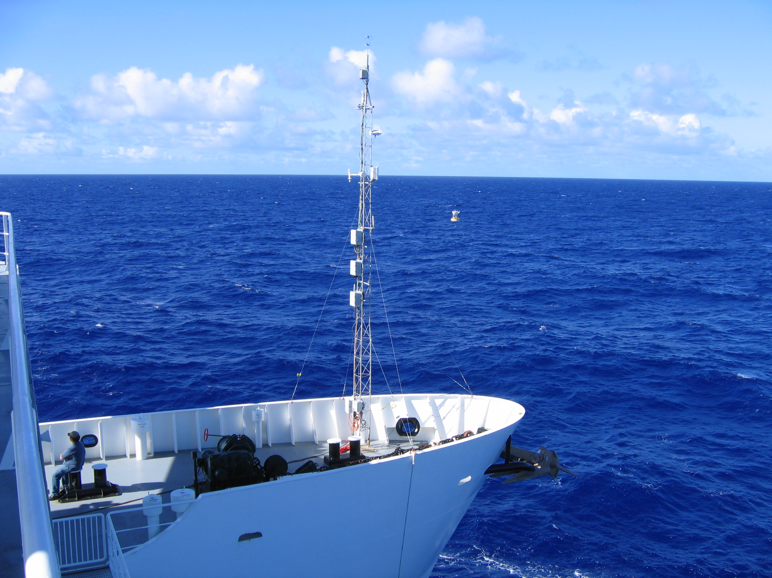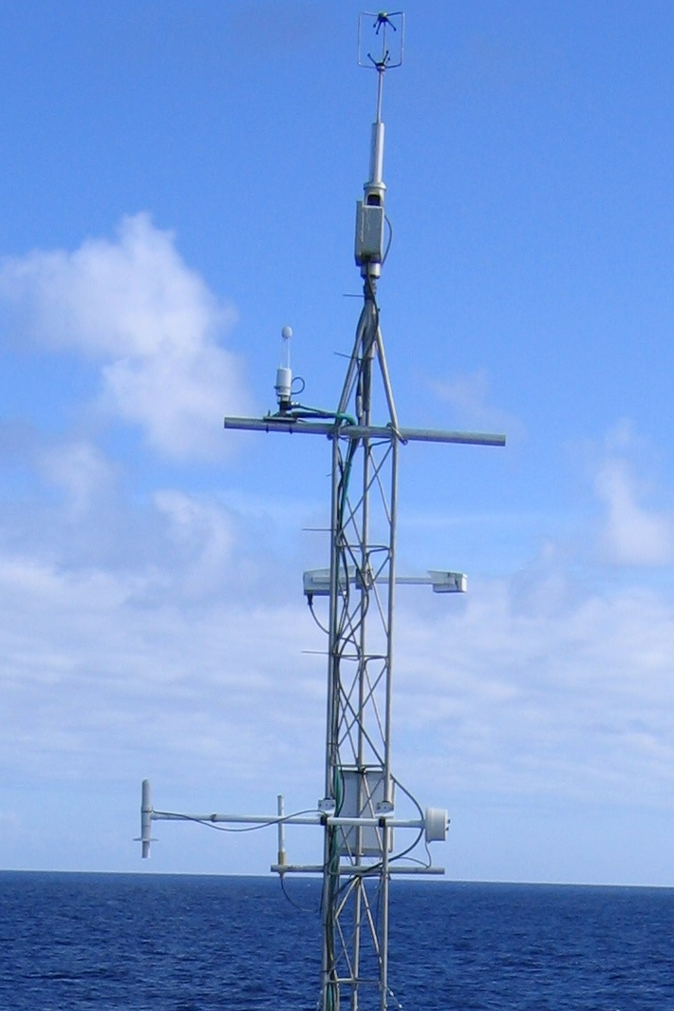
Figure 1. Left: Flux tower deployed at the bow of the portside pontoon on the R/V Kilo Moana during the WHOTS09 cruise. The sea surface thermistor, i.e. ‘sea snake’, can be seen on the inboard side of the pontoon (red arrow). Right: Close-up view of the tower and its instruments.
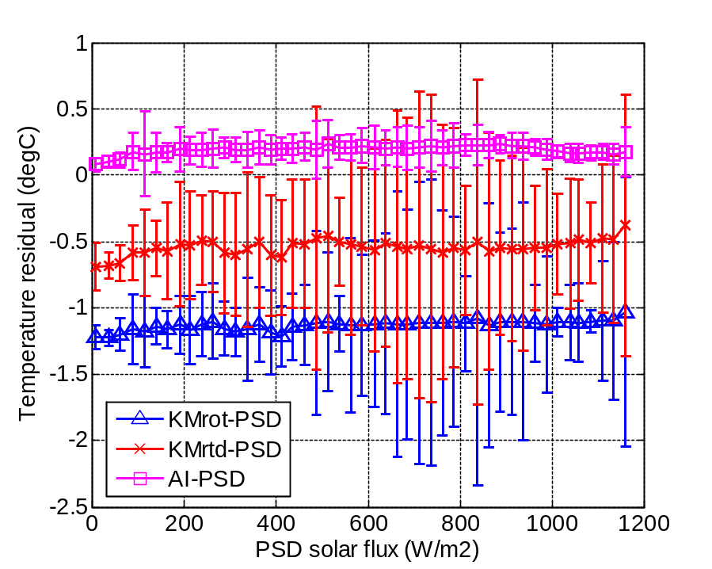
Figure 2. Dependence of air temperature residuals (relative to the PSD sensor) on solar radiation for the two ship sensors (blue and red) and the AutoIMET (magenta). This results shows substantial bias (-0.5 and -1.2 C) in the R/V Kilo Moana air temperature measurements.

