Progress Report

Project Title
  - Optional Project Subtitle

Period of Activity: 01 October 2013 – 30 September 2014

Principal Investigator  Christopher W. Fairall  NOAA ESRL/PSD  325 Broadway  Boulder, CO 80305 |  | Financial Contact  Brian Gorton  NOAA ESRL/PSD  325 Broadway  Boulder, CO 80305
Signature Date |  |  | Signature Date
Budget Summary
FY 2014: $296,000

High Resolution Climate Data from Research and Volunteer Observing Ships
Principal Investigator
Christopher W. Fairall
NOAA ESRL/PSD
325 Broadway
Boulder, CO 80305

Table of Contents

1. Project Summary 2
2. Scientific and Observing System Accomplishments 2
3. Outreach and Education 4
4. Publications and Reports 5
4.1. Publications by Principal Investigators 6
4.2. Other Relevant Publications 7
5. Slides 8

Project Summary

Direct covariance air-sea flux measurements are performed on several oceanic cruises each year, and ESRL has developed a roving standard flux measuring system to be deployed on research vessels on an opportunistic basis. This latter task promotes high-quality climate observations from UNOLS and NOAA research vessel fleet and from NOAA Flux Reference Buoys. Currently, climate data from 31 research vessels are archived at the Shipboard Automated Meteorological and Oceanographic Systems (SAMOS) at Florida State University. Flux Reference Bouy data are available at OceanSITES (http://www.oceansites.org/ ). Because buoys and most ships and satellites rely on bulk methods to estimate fluxes, another aspect of this project is the use of direct measurements to improve the NOAA/COARE bulk flux algorithm – a state-of-the-art community resource. A full suite of direct, inertial-dissipation, and bulk turbulent fluxes of sensible heat, latent heat, and momentum are measured along with IR and solar radiative fluxes, precipitation, and associated bulk meteorological properties. This effort represents a partial transition of research from NOAA’s climate research programs to operations under the Climate Observations Division (COD). Cruises have been conducted on four NOAA ships, seven UNOLS ships, three non-US ships, and one Coast Guard icebreaker to TAO buoys along the 95W and 110W, the PIRATA Northeast Extension (PNE), Indian Ocean RAMA, the Northwest Tropical Atlantic Station (NTAS) reference buoy, and the WHOI Hawaii Ocean Time Series Station (WHOTS) reference buoy.

The project development is the result of a NOAA-sponsored workshop on high-resolution marine measurements (Smith et al., 2003, Report and Recommendations from the Workshop on High-Resolution Marine Meteorology, COAPS Report 03-01, Florida State University, pp38) which identified three important issues with the planned NOAA air-sea observation system: 1) the need for a data quality assurance program to firmly establish that the observations meet the accuracy requirements, 2) the need for observations at high time resolution (about 1 minute) and, 3) the need to more efficiently utilize research vessels, including realizing their potential for the highest quality data and their potential to provide more direct and comprehensive observations. A second aspect of this project involves direct measurement and parameterization (gas transfer versions of the NOAA COARE model) of sea-air exchange of trace gases. For seasonal time scales, the net air-sea flux (sum of 5 flux components) must be constrained within 10 Wm⁻². Buoys and VOS systems are required to operate virtually unattended for months, so considerations of practical issues (e.g., power availability, instrument ruggedness, safe access, etc.) are balanced against inherent sensor accuracy and optimal sensor placement. As discussed above, an important function of the in situ measurements is to provide validation data to improve NWP and satellite flux fields. High time resolution and more direct observations are invaluable for interpreting surface flux measurements and diagnosing the source of disagreements --such information can be provided by suitably equipped research vessels (R/V). Thus, the accuracy of buoy and VOS observations must be improved and supplemented with high-quality, high time resolution measurements from the US R/V fleet (which is presently under-utilized). The necessity for both high time resolution and high accuracy places extreme demands on measurements because some sources of error (such as the effect of ship flow distortion on wind speed) tend to average out over a large sample. To accomplish this requires a careful intercomparison program to provide traceability of buoy, VOS, and RV accuracy to a set of standards.

This project directly addresses the need for accurate measures of air-sea exchange in the Program Plan for Building a Sustained Ocean Observing System for Climate (Sections 5.2-5.4), and it is a joint effort by ESRL and Dr. Robert Weller of the Woods Hole Oceanographic Institution (WHOI). The ESRL Air-Sea Interaction Group website can be found at http://www.esrl.noaa.gov/psd/psd3/air-sea/ . ESRL also cooperates with Dr. Frank Bradley (CSIRO, Canberra Australia) on precipitation and radiative flux observations, Dr. Meghan Cronin (NOAA PMEL) on buoy-ship intercomparisons and climate variability analysis, and Dr. Wade McGillis (Univ. Columbia) on gas fluxes. A project website has been established (High Resolution Climate Observations http://www.esrl.noaa.gov/psd/psd3/air-sea/oceanobs/ ). An associated website (http://www.esrl.noaa.gov/psd/psd3/wgsf/ ) contains a handbook on best practices for flux measurements plus a database of high-resolution flux data. This gives the project high visibility in the CLIVAR, GEWEX, and SOLAS programs. This project is managed in cooperation with JCOMM.

Users of the data and parameterizations from this project include numerous individual collaborators (J. Edson at UConn, B. Huebert at U. Hawaii, B. Ward at Galway, M. Bourassa at FSU, W. McGillis at LDEO, F. Bradley at CSIRO, M. Cronin at PMEL, R. Wanninkhof at AOML, R. Weller at WHOI, A. Beljaars at ECMWF) and many projects/programs worldwide (SAMOS, GOSUD, SeaFlux, USGCRP, WCRP, SOLAS, SURFA, OceanSITES, CLIVAR, VOCALS, UNOLS, TAO). Specific applications include global model algorithm development and intercomparison, satellite product intercomparison, in situ (buoy and ship) intercomparison studies, application of the NOAA/COARE model for flux parameterization, and improved climate observation capabilities

Scientific and Observing System Accomplishments

This project principally addresses the Climate Observation and Monitoring Program deliverables for improved observations of Air-Sea Exchange and Ocean Carbon Uptake and Content.

All tasks/milestones detailed in the work plan for 2014 were addressed.

*Three field deployments of the PSD flux system. The full PSD flux system (Figs. 1 and 2) was deployed on a major multi-leg cruise on the R/V Knorr at the end of FY13 and continued into FY14. This interagency-funded, international campaign is study of the physics/chemistry of air-sea trace gas transfer in very high winds (HiWinGS). The cruise track is shown in Fig. 3. The roving standard was deployed on the NOAA R/V Hi`ialakai in July 2014 for the WHOTS 2014 buoy redeployment cruise. The standard was also deployed on R/V Mirai in September/October 2014 in the N. Pacific and Beaufort and Chukchi Seas (Fig. 4). The Mirai deployment was the start of a new cooperation with JAMSTEC and will complement observations our group is making this summer and fall on the Swedish icebreaker Oden. This will contribute to a new effort at PSD to investigate fluxes in the Arctic in connection with climate variability of sea ice.
This project yielded valuable data in the critical but much undersampled high latitude region (Bourassa et al. 2013).

* We continued our cooperation with Dr. Huai-Min Zhang of NOAA NCDC on the Surface Flux Analysis (SURFA) project (http://www.ncdc.noaa.gov/oa/rsad/air-sea/surfa.html). We have started to work on the topic of improving/validating various global flux products as highlighted at the recent CLIVAR-GSOP Ocean Synthesis and Air-Sea flux evaluation Workshop. Initially we will focus on surface flux fields for the DYNAMO field program. We have collaborated with Dr. Lisan Yu (WHOI OAFlux product) and Dr. Rachel Pinker (MODIS-derived SW/LW radiative fluxes) and Simon deSzoeke (OSU) to produce a flux field time series for the entire DYNAMO study period using 4 different turbulence and 4 different radiation products. For general amusement, check out a movie of the OAFLux product for the DYNAMO period: ftp://ftp1.esrl.noaa.gov/users/cfairall/oceanobs/pubs/fy13/IO_FluxMovie.wmv . In situ observations from ships and buoys will be used to evaluate the synthesized product. Flux products were compared to PSD flux observations for the DYNAMO field program and played a key role in analysis of coupling of fluxes to MJO (see deSzoeke et al. 2014, The MJO and Air-Sea Interaction in TOGA COARE and DYNAMO).
In 2013 we saw significant scientific accomplishments as noted through major publications and synthesis efforts. This included breakthroughs made in the direct measurement of sea-air fluxes of trace gases and new releases of the NOAA COARE flux algorithm. Matlab versions of 3.5 are available at: ftp://dynamo.dms.uconn.edu/Warm_Layer_COARE_35/ ftp://ftp1.esrl.noaa.gov/users/cfairall/bulkalg/cor3_5/ .
In 2014 one major accomplishment was obtaining new observations at high latitudes and very strong winds (Figs. 3 and 4). An example is given in Fig. 5 where the time series of direct measurements of CO2 flux are show at wind speeds up to 28 m/s. A preliminary analysis of the data can be summarized as the gas transfer velocity as a function of wind speed (Fig. 6). Here we compare the direct observations with the NOAA COAREG3.1 (gas transfer version of COARE bulk flux algorithm). The results suggest the transfer for CO2 does not increase as much with wind speed as expected while DMS appears normal. This may be due to the flattening of whitecap fraction at the higher wind speeds (DMS is much less driven by whitecaps). Another significant accomplishment was the comparison of gridded surface products (WHOI OAFlux and TropFlux) with direct measurements PSD observations in DYNAMO and TOGA COARE (deSzoeke et al. 2014). The results are surprisingly good (Fig. 7) – a testimony to both the measurements and the models. Finally, we did a comparison of the PSD ship observations with the WHOI Flux Reference site buoys at the Stratus mooring off Chile. We compared 1-years of observations from the buoy maintenance cruises (10-yr buoy file supplied by Bob Weller). Results are summarized in a short data report (Fairall, 2014, A PSD ship – WHOI Stratus Buoy Comparison). Mean differences for meteorological variables and fluxes were all within SAMOS guidelines except for shortwave radiative flux and latent heat flux (see Table 1). However, the ship-buoy difference contains both ship and buoy biases, so we can say the buoy is clearly within the guidelines.

We do not have a data management plan; our project is compliant with NOAA guidelines. Field processed data summaries for each cruise are transmitted at the end of the day to our ftp site (ftp://ftp1.esrl.noaa.gov/psd3/cruises/ ) with cruise-specific directories – these are publically available. For example, images of the various flux time series as posted in realtime (daily) for the recent WHOTS cruise can be seen at:
ftp://ftp1.esrl.noaa.gov/psd3/cruises/WHOTS_2014/Hiialakai/flux/Raw_Images/
and daily processed ASCII files are available at
ftp://ftp1.esrl.noaa.gov/psd3/cruises/WHOTS_2014/Hiialakai/flux/Processed/
The full raw time series is added after the cruise. Updates after postprocessing are posted as they become available.

Outreach and Education

Our group is engaged in a variety of outreach/education activities under this project. The range of activities includes lectures for middle and high school science teachers (done through the CIRES outreach office http://www.screencast.com/users/IndependentLearning/folders/CoSEE ), judging at local science fairs and the annual National Ocean Science Bowl competition (regional level held at CU in Boulder), and hosting Teachers in the Lab and or Teachers at Sea. Currently the PI (C. Fairall) is on the PhD committee of one student at University of Colorado (Bariteau) and one at Colorado State University (Thompson). Check out Ludovic Bariteau’s extensive blog for the HiWinGS project http://cires.colorado.edu/blogs/airseagas/ .

In 2011 we started developing a hands-on short course on methods, techniques, and instruments for meteorological observations from ships (done in cooperation with Shawn Smith at FSU) intended for seagoing MetTechs. The inaugural course was presented at the RVTech meeting in New Orleans in Dec. 2011. A second training for NOAA ship techs was held at Newport, OR in January, 2012; the third was Newport again in January, 2013; the fourth in Norfolk, VA, 2014. Course materials are available at ftp://ftp1.esrl.noaa.gov/users/cfairall/oceanobs/outreach/ .

A third aspect of PSD outreach is in the form of technology transfer of our flux observation methods to other research entities. In the past we have transferred designs, methods, and software to other universities and laboratories around the work. Recent examples are University of Hawaii and University of Galway (Ireland). We are presently developing a relationship with Korean Polar Research Institute (KOPRI) to aid them in deploying a full seagoing flux capability on their new icebreaker (R/V Araon). Another example – C. Fairall is on the science advisory panel for the new University of Alaska research vessel (R/V Sikuliaq) that is currently under sea trials. A compilation of recent collaborations is given in Table 1.

Table 1. Summary of research vessels with collaborations by the ESRL seagoing flux group.
Nation | Ship | Institute | Contact
Korea | Araon | KOPRI | S. Park
UK | Clark | NOC | M. Yelland
Ireland | Celtic Explorer | U. Galway | B. Ward
Germany | Meteor | U.Hamburg | S. Kinne
France | L’Atalante | IFREMER | A. Weill
Australia | S. Surveyor | Aus. BOM | E. Schulz
India | Sindhu Sankalp | NIO Goa | V. Kumar
US | Sikuliaq | U. Alaska | M. Edwards
Japan | Mirai | JAMSTEC | Jun Inoue

Publications and Reports

Publications by Principal Investigators

*Published

Ghate, Virendra P., Bruce A. Albrecht, Mark A. Miller, Alan Brewer, and Christopher W. Fairall, 2013: Turbulence and radiation in stratocumulus topped marine boundary layer: A case study from VOCALS-Rex. J. Appl. Met. Clim., 53, 117–135. doi: http://dx.doi.org/10.1175/JAMC-D-12-0225.1.

Vecherin, S.N., V.E. Ostashev, C.W. Fairall, D.K. Wilson, and L. Bariteau, 2013: Sonic anemometer as a small acoustic tomography array. Bound.-Layer Meteorol149, 165–178, DOI 10.1007/s10546-013-9843.

Mechoso, Carlos R., Robert Wood, Robert Weller, Christopher S Bretherton, Anthony D Clarke, Hugh Coe, C.W. Fairall, J Tom Farrar, Graham Feingold, Rene Garreaud, Carmen Grados, James C McWilliams, Simon P de Szoeke, Sandra E Yuter, and Paquita Zuidema, 2013: Ocean-Cloud-Atmosphere-Land Interactions in the Southeastern Pacific: The VOCALS Program. Bull. Am. Meteorol. Soc., 95, 357–375. doi: http://dx.doi.org/10.1175/BAMS-D-11-00246.1.

Yang, M., P. Nightingale, Rachael Beale, Peter S. Liss, Byron Blomquist, and C.W. Fairall, 2013: Atmospheric deposition of Methanol over the Atlantic Ocean. . Proc. Nat. Academ. Sci. USA, 110, DOI: 10.1073/pnas.1317840110, 20034-20039.

Blomquist, B. W., L. Bariteau, J. W. Edson, C. W. Fairall, J. E. Hare, W. R. McGillis, B. J. Huebert, S. D. Miller, and E. S. Saltzman, 2013: Advances in ship-based air-sea CO2 flux measurement by eddy covariance. Bound.-Layer Meteorol., 152, 245–276, DOI 10.1007/s10546-014-9926-2.

Moum, J.A., Simon P. de Szoeke, William D. Smyth, James B. Edson, H. Langley DeWitt, Aurélie J. Moulin, Elizabeth J. Thompson, Christopher J. Zappa, Steven A. Rutledge, Richard H. Johnson and Christopher W. Fairall, 2014: Air-sea interactions from westerly wind bursts during the November 2011 MJO in the Indian Ocean. Bull. Am. Meteor. Soc., doi:10.1175/BAMS-D-12-00225.

Coburn, S., I. Ortega, R. Thalman, B. Blomquist, C. W. Fairall, and R. Volkamer, 2014: Measurements of diurnal variations and Eddy Covariance (EC) fluxes of glyoxal in the tropical marine boundary layer: description of the Fast LED-CE-DOAS instrument. Atmos. Meas. Tech., 7, 3579–3595, www.atmos-meas-tech.net/7/3579/2014/, doi:10.5194/amt-7-3579-2014.

*In Press

Ghate, Virendra P., Mark A. Miller, Bruce A. Albrecht, and C. W. Fairall, 2014: Thermodynamic and radiative structure of stratocumulus topped boundary layers. J. Atmos. Sci., accepted.

De Szoeke, Simon P., James B. Edson, June R. Marion, Christopher W. Fairall, and Ludovic Bariteau, 2014: The MJO and Air-Sea Interaction in TOGA COARE and DYNAMO. J. Clim., accepted.

*Data Reports

Fairall, C.W., 2014: A PSD ship – WHOI Stratus Buoy Comparison. NOAA ESRL Tech. Report, Boulder, CO, 2 pp.

Attached Publications
The referred papers and the conference proceedings are available as .pdf files from ftp://ftp1.esrl.noaa.gov/users/cfairall/oceanobs/pubs/fy14/ .

Other Relevant Publications

This project has produced 47 refereed publications since beginning in 2003 (see ftp site for cumulative list). So far in calendar year 2014, these publications received a total of 192 citations; cumulative total since 2003 is 1414 citations. One paper (Bulk parameterization of air-sea fluxes: Updates and verification for the COARE algorithm) has received 652 citations since publication in 2003. This paper was cited in Blunden et al., 2011: State of the Climate in 2010. Bull. Am. Meteor. Soc., 92, S1-S266.

Raw, processed, value-added, and synthesized data from this project are freely available at the ftp site (ftp://ftp1.esrl.noaa.gov/psd3/cruises/ ). Use of these data is too extensive to track. But as an example, the recent NOAA-sponsored field study VOCALS had a number of publications in a special issue of Atmospheric Chemistry and Physics. At least 10 of those papers used data from this project [Abel et al., Allen et al., Boutel and Able, Bretherton et al., Brunke et al., Georges and Wood, Jazel et al., Rahn and Garreaud, Wang et al., Wyant et al.). As another example, in the recent Southern Ocean GASEX field program special issue in JGR, 7 of the 13 papers used data from this project.

5. Slides
Attached separately.

Table 1. Comparison of PSD ship and WHOI buoy observations from 10 years of observations at the Straus buoy (20 S 85 W) for the period 2000-2010. Comparison of the ship and buoy platforms for all cases (N=939) when the ship was within 1 degree of the nominal buoy position and for 510 cases when the ship was within 0.25 degrees. The PSD mean wind, air temperature, and humidity were computed from PSD heights (zu_psd=17.7 m; zt_psd=15.5 m) to the same height as the buoy sensors (zu_buoy 3.3 m; zt_buoy=2.89 m) using the reference feature in the algorithm. Re-computation of buoy fluxes with COARE3.0 gives the same results as fluxes in the buoy flux file. From these results we can examine the mean bias (Δ) and 1-hrly standard deviation (σ), which will depend on the horizontal separation limits (we chose 1 degree and 0.25 degree). Note that the quantity gives an estimate of the sampling uncertainty of the mean bias.

Variable | Buoy | Ship | Δ₁ | σ₁ | Δ_{0.25} | σ_{0.25} | σ_{1/N}^{1/2} | SAMOS
SST, C | 18.90 | 19.01 | 0.11 | 0.18 | 0.12 | 0.16 | 0.006 | 0.1
U, m/s | 6.49 | 6.63 | 0.14 | 0.96 | -0.05 | 0.61 | 0.03 | 0.2
T_{air}, C | 18.20 | 18.26 | 0.07 | 0.35 | 0.10 | 0.32 | 0.01 | 0.2
Qair, g/kg | 9.65 | 9.58 | -0.08 | 0.42 | -0.19 | 0.36 | 0.01 | 0.3
RH, % | 74.6 | 74.7 | -0.9 | 3.9 | -1.9 | 2.7 | 0.12 | 2
P, mb | 1018.3 | 1017.3 | -1.0 | 2 | -0.5 | 1.8 | 0.07 | 2
SWR, W/m² | 223.7 | 223.9 | 0.3 | 83 | -6 | 78 | 2.7 | 5
LWR, W/m² | 377.4 | 381.0 | 3.5 | 14.5 | 4.9 | 12.9 | 0.5 | 5
H_{s}, W/m² | -5.9 | -6.3 | -0.4 | 5.0 | 0 | 3.7 | 0.16 | 5
H_{l}, W/m² | -93.0 | -101.0 | -7.0 | 14.3 | -7.7 | 14.3 | 0.55 | 5
τ, N/m² | 0.080 | 0.080 | 0.0 | 0.023 | -0.005 | 0.016 | 5e-4 | -
H_{N}, W/m² | 78 | 75 | -2.9 | 73 | -7.7 | 67 | 2.4 | 10

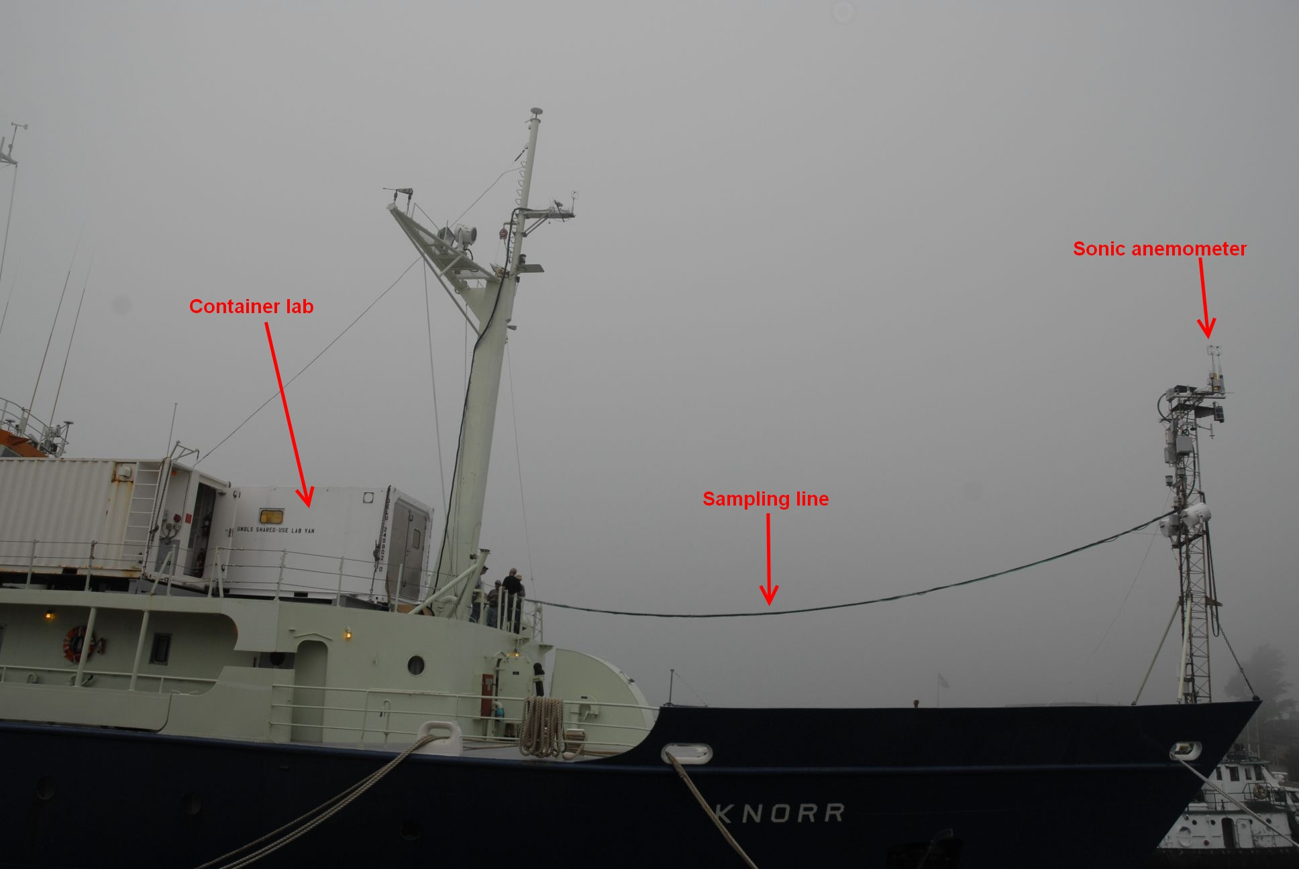

Figure 1. Side view of the R/V Knorr showing the 30m-sampling line from the container lab up to the location of the mast flux sensors for HiWinGS 2013.

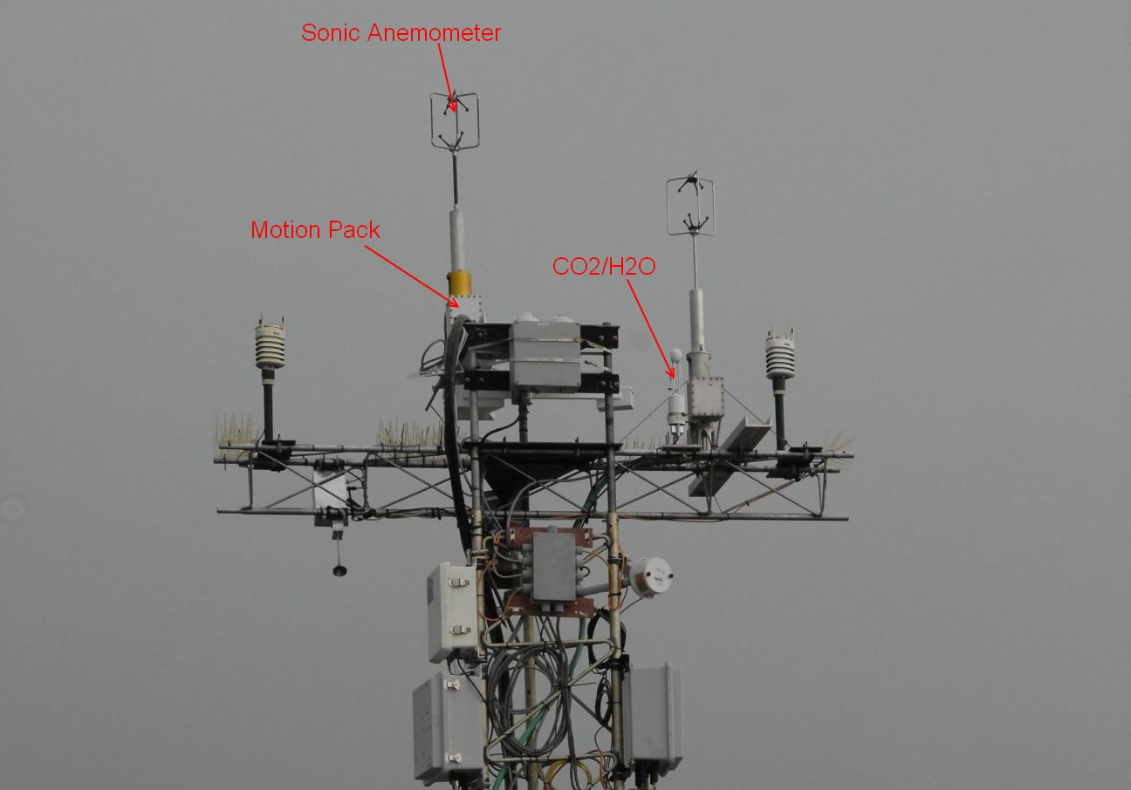
Figure 2. R/V Knorr forward mast with flux instrumentation setup for HiWinGS 2013.
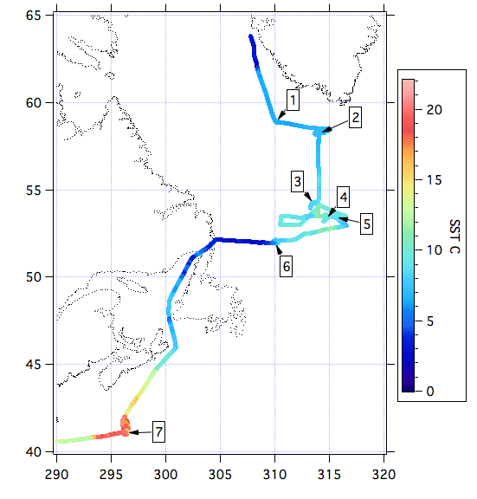

Figure 3. R/V Knorr cruise track for HiWinGS 2013. The color bar indicates SST.

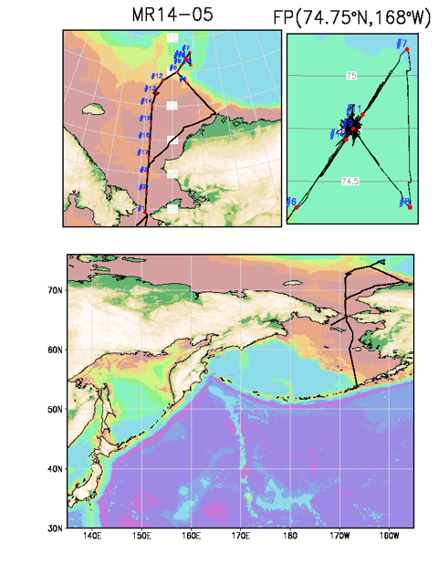

Figure 4. R/V Mirai cruise track for MR14-05 in Aug. – Oct. 2014.

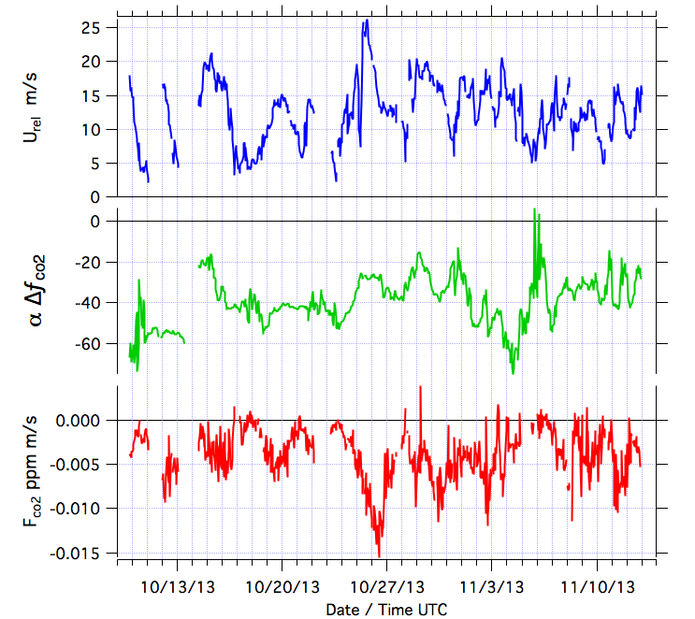

Figure 5. Time series of wind speed (upper), DPCO2 (middle), and measured CO2 flux during leg 2 of HiWinGS 2013.

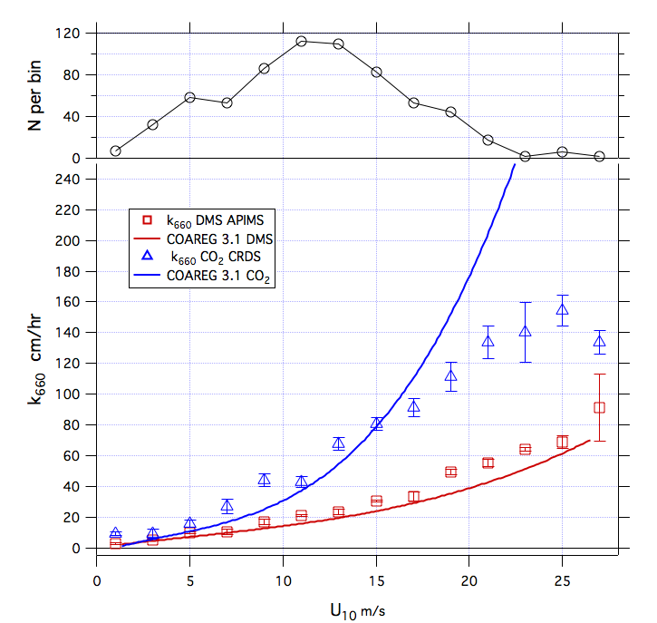
Figure 6. Summary (preliminary analysis) of observed and modeled transfer velocity for CO2 (blue) and DMS (red) from HiWinGS 2013. The lines are from COAREG3.1 gas transfer model. Upper panel shows the number of 1hr samples.

Figure 7. TropFlux and OAFlux gridded flux products compared with ship observations from the R/V Revelle for DYNAMO in 2011 and (b) from the R/V Moana Wave for TOGA COARE in 1992-1993 (from deSzoeke et al. 2014).

