Progress Report

High Resolution Climate Data from Research and Volunteer Observing Ships

Period of Activity: 01 October 2014 – 30 September 2015

|  |  |  |  |  |  |  |
| --- | --- | --- | --- | --- | --- | --- |
| **Principal Investigator**  Christopher W. Fairall  NOAA ESRL/PSD  325 Broadway  Boulder, CO 80305 | | **Financial Contact**  Brian Gorton  NOAA ESRL/PSD  325 Broadway  Boulder, CO 80305 | | | |  |
| |  |  | | --- | --- | | Signature | Date | | | | Signature Date | |  | |
|  |  | | |  | | |
|  |  | | |  | | |
| **Budget Summary**  FY 2015: $296,450 |

High Resolution Climate Data from Research and Volunteer Observing Ships

**Principal Investigator**

Christopher W. Fairall

NOAA ESRL/PSD

325 Broadway

Boulder, CO 80305

**Table of Contents**

1. Project Summary 2

2. Scientific and Observing System Accomplishments 2

3. Outreach and Education 4

4. Publications and Reports 5

4.1. Publications by Principal Investigators 6

4.2. Other Relevant Publications 7

5. Slides 8

# Project Summary

ESRL has developed a roving standard flux measuring system to be deployed on research vessels on an opportunistic basis and direct covariance air-sea flux measurements are performed on several oceanic cruises each year. This latter task promotes high-quality climate observations from UNOLS and NOAA research vessel fleet and from NOAA Flux Reference Buoys. Currently, climate data from 31 research vessels are archived at the Shipboard Automated Meteorological and Oceanographic Systems (SAMOS) at Florida State University. Flux Reference Bouy data are available at OceanSITES (<http://www.oceansites.org/> ). Because buoys and most ships and satellites rely on bulk methods to estimate fluxes, another aspect of this project is the use of direct measurements to improve the NOAA/COARE bulk flux algorithm – a state-of-the-art community resource. A full suite of direct, inertial-dissipation, and bulk turbulent fluxes of sensible heat, latent heat, and momentum are measured along with IR and solar radiative fluxes, precipitation, and associated bulk meteorological properties. This effort represents a partial transition of research from NOAA’s climate research programs to operations under the Climate Observations Division (COD). To date, cruises have been conducted on four NOAA ships, nine UNOLS ships, four non-US ships, and one Coast Guard icebreaker to TAO buoys along the 95W and 110W, the PIRATA Northeast Extension (PNE), Indian Ocean RAMA, the Northwest Tropical Atlantic Station (NTAS) reference buoy, and the WHOI Hawaii Ocean Time Series Station (WHOTS) reference buoy.

The project development is the result of a NOAA-sponsored workshop on high-resolution marine measurements (Smith et al., 2003, *Report and Recommendations from the Workshop on High-Resolution Marine Meteorology*, COAPS Report 03-01, Florida State University, pp38) which identified three important issues with the planned NOAA air-sea observation system: 1) the need for a data quality assurance program to firmly establish that the observations meet the accuracy requirements, 2) the need for observations at high time resolution (about 1 minute) and, 3) the need to more efficiently utilize research vessels, including realizing their potential for the highest quality data and their potential to provide more direct and comprehensive observations. A second aspect of this project involves direct measurement and parameterization (gas transfer versions of the NOAA COARE model) of sea-air exchange of trace gases. For seasonal time scales, the net air-sea flux (sum of 5 flux components) must be constrained within 10 Wm-2. Buoys and VOS systems are required to operate virtually unattended for months, so considerations of practical issues (e.g., power availability, instrument ruggedness, safe access, etc.) are balanced against inherent sensor accuracy and optimal sensor placement. As discussed above, an important function of the *in situ* measurements is to provide validation data to improve NWP and satellite flux fields. High time resolution and more direct observations are invaluable for interpreting surface flux measurements and diagnosing the source of disagreements --such information can be provided by suitably equipped research vessels (R/V). Thus, the accuracy of buoy and VOS observations must be improved and supplemented with high-quality, high time resolution measurements from the US R/V fleet (which is presently under-utilized). The necessity for both high time resolution and high accuracy places extreme demands on measurements because some sources of error (such as the effect of ship flow distortion on wind speed) tend to average out over a large sample. To accomplish this requires a careful intercomparison program to provide traceability of buoy, VOS, and RV accuracy to a set of standards.

This project directly addresses the need for accurate measures of air-sea exchange in the *COD Strategic Plan,* specifically Observing Systems, Climate Monitoring, and Data Stewardship (Section 2.14) and Understanding and Modeling (Sections 2.20 and 2.21), and it is a joint effort by ESRL and Dr. Robert Weller of the Woods Hole Oceanographic Institution (WHOI). The ESRL Air-Sea Interaction Group website can be found at <http://www.esrl.noaa.gov/psd/psd3/air-sea/> . ESRL also cooperates with Dr. Frank Bradley (CSIRO, Canberra Australia) on precipitation and radiative flux observations, Dr. Meghan Cronin (NOAA PMEL) on buoy-ship intercomparisons and climate variability analysis, and Dr. Wade McGillis (Univ. Columbia) on gas fluxes. A project website has been established (High Resolution Climate Observations <http://www.esrl.noaa.gov/psd/psd3/air-sea/oceanobs/> ). An associated website (<http://www.esrl.noaa.gov/psd/psd3/wgsf/> ) contains a handbook on best practices for flux measurements plus a database of high-resolution flux data. This gives the project high visibility in the CLIVAR, GEWEX, and SOLAS programs. This project is managed in cooperation with JCOMM.

Users of the data and parameterizations from this project include numerous individual collaborators (J. Edson at UConn, B. Huebert at U. Hawaii, B. Ward at Galway, M. Bourassa at FSU, W. McGillis at LDEO, F. Bradley at CSIRO, M. Cronin at PMEL, R. Wanninkhof at AOML, R. Weller at WHOI, A. Beljaars at ECMWF) and many projects/programs worldwide (SAMOS, GOSUD, SeaFlux, USGCRP, WCRP, SOLAS, SURFA, OceanSITES, CLIVAR, VOCALS, UNOLS, TAO). Specific applications include global model algorithm development and intercomparison, satellite product intercomparison, *in situ* (buoy and ship) intercomparison studies, application of the NOAA/COARE model for flux parameterization, and improved climate observation capabilities

# Scientific and Observing System Accomplishments

This project principally addresses the Climate Observation and Monitoring Program deliverables for improved observations of **Air-Sea Exchange** and **Ocean Carbon Uptake and Content**.

All tasks/milestones detailed in the work plan for 2015 were addressed.

*Four field deployments of the PSD flux system. The full PSD flux system (Fig. 1) was deployed on a major two-leg cruise on the NOAA R/V *Ronald H. Brown* during the CALWATER2 cruise, January-February 2015. This interagency-funded campaign is a study of so-called atmospheric rivers (AR) and their effects on precipitation on the US West coast. The cruise track is shown in Fig. 2. The roving standard was deployed on the Chilean R/V *Cabo de Hornos* in April 2015 for the Straus cruise and on NOAA R/V *Hi`ialakai* in July 2015 for the WHOTS 2015 buoy redeployment cruise. In September the newly constructed PSD Arctic-hardened roving flux system was deployed on R/V *Sikuliaq* for a 45 day cruise in the Beaufort Sea (Fig. 3). This project will yield valuable data in the critical but much undersampled high latitude region (Bourassa et al. 2013) of the Arctic.

* We continued our cooperation with Dr. Huai-Min Zhang of NOAA NCDC on the Surface Flux Analysis (SURFA) project (<http://www.ncdc.noaa.gov/oa/rsad/air-sea/surfa.html>). We have started to work on the topic of improving/validating various global flux products as highlighted at the recent *CLIVAR-GSOP Ocean Synthesis and Air-Sea flux evaluation Workshop*. Initially we focused on surface flux fields for the DYNAMO field program. Last year we collaborated with Dr. Lisan Yu (WHOI OAFlux product) to produce a flux field time series for the entire DYNAMO study period using 4 different turbulence and 4 different radiation products. We have continued this work, doing comparisons of the OAFlux product with fluxes measured off California in the CALWATER2 project (see below).

In 2015 we saw significant scientific accomplishments as noted through major publications and synthesis efforts. This included improvements made in the direct measurement of sea-air fluxes including trace gases and new releases of the NOAA COARE seaspray flux algorithm. Matlab scripts of version 12 are available at: <ftp://ftp1.esrl.noaa.gov/users/cfairall/onr_droplet/parameterization/version12/> .

Another accomplishment was the development of a new version of the PSD flux system that is hardened for harsh polar environments (see Fig. 3). This was done in response to increased NOAA interest in Arctic climate processes. The changes principally consist of replacing previous sensor technology with heated models to combat freezing sea spray, fog, or rime-ice growth plus the ability to operate at near-saturation relative humidity and very low temperatures. We have been also working ice-resistance radiative flux sensors, but that has not been completed.

In 2015 one major accomplishment was analysis of new observations from the N. Pacific storm track (CALWATER2) and comparisons with the WHOI OAFlux product. An example of preliminary results is shown in Fig. 4, where sensible and latent heat fluxes are shown. The flux product does a good job of capturing the predominantly stable conditions (negative sensible heat flux); there appears to be a low bias in the product for latent heat flux in the core of the atmospheric river. Fig. 5 shows an example of the OAFLux field for a day during CALWATER2 when an AR is present. The AR is visible as the SW to NE band of high U10 values. Notice that the latent heat flux become much smaller north of about 32 deg. Latitude where warm air advection over increasing cooler water is suppressing the turbulent exchange.

We currently do not have a data management plan but a plan will be completed in FY16. Our project is compliant with NOAA guidelines. Field processed data summaries for each cruise are transmitted at the end of the day to our ftp site (<ftp://ftp1.esrl.noaa.gov/psd3/cruises/> ) with cruise-specific directories – these are publically available. For example, images of the various flux time series as posted in realtime (daily) for the recent WHOTS cruise can be seen at:

<ftp://ftp1.esrl.noaa.gov/psd3/cruises/WHOTS_2014/Hiialakai/flux/Raw_Images/>

and daily processed ASCII files are available at

<ftp://ftp1.esrl.noaa.gov/psd3/cruises/WHOTS_2014/Hiialakai/flux/Processed/>

The full raw time series is added after the cruise. Updates after postprocessing are posted as they become available.

# Outreach and Education

Our group is engaged in a variety of outreach/education activities under this project. The range of activities includes lectures for middle and high school science teachers (done through the CIRES outreach office <http://cires.colorado.edu/education-outreach/projects/past-projects/cosee/> ), judging at local science fairs and the annual National Ocean Science Bowl competition (regional level held at CU in Boulder), and hosting Teachers in the Lab and or Teachers at Sea. Currently the PI (C. Fairall) is on the PhD committee of two student at University of Colorado (Bariteau and DuVivier) and one at Colorado State University (Thompson). Two other students received PhD’s in 2014. Check out Ludovic Bariteau’s extensive blog for the HiWinGS project <http://cires.colorado.edu/blogs/airseagas/> .

In 2011 Dan Wolfe started developing a hands-on short course on methods, techniques, and instruments for meteorological observations from ships (done in cooperation with Shawn Smith at FSU) intended for seagoing MetTechs. The inaugural course was presented at the RVTech meeting in New Orleans in Dec. 2011. A second training for NOAA ship techs was held at Newport, OR in January, 2012; the third was Newport again in January, 2013; the fourth in Norfolk, VA, 2014, the fifth in Corvalis in November 2014. Course materials are available at <ftp://ftp1.esrl.noaa.gov/users/cfairall/outreach/> .

A third aspect of PSD outreach is in the form of technology transfer of our flux observation methods to other research entities. In the past we have transferred designs, methods, and software to other universities and laboratories around the work. Recent examples are University of Hawaii and University of Galway (Ireland). We are presently developing a relationship with Korean Polar Research Institute (KOPRI) to aid them in deploying a full seagoing flux capability on their new icebreaker (R/V *Araon*). Another example – C. Fairall is on the science advisory panel for the new University of Alaska research vessel (R/V *Sikuliaq*) that is currently at sea with the PSD flux system aboard (Sep-Nov, 2015 for the ONR SeaState project). A compilation of recent collaborations is given in Table 1.

|  |  |  |  |
| --- | --- | --- | --- |
| **Table 1.** Summary of research vessels with collaborations by the ESRL seagoing flux group. | | | |
| **Nation** | **Ship** | **Institute** | **Contact** |
| Korea | Araon | KOPRI | S. Park |
| UK | Clark | NOC | M. Yelland |
| Ireland | Celtic Explorer | U. Galway | B. Ward |
| Germany | Meteor | U.Hamburg | S. Kinne |
| France | L’Atalante | IFREMER | A. Weill |
| Australia | S. Surveyor | Aus. BOM | E. Schulz |
| India | Sindhu Sankalp | NIO Goa | V. Kumar |
| US | Sikuliaq | U. Alaska | M. Edwards |
| Japan | Mirai | JAMSTEC | Jun Inoue |

# Publications and Reports

## Publications by Principal Investigators

***\*Published***

Ghate, Virendra P., Mark A. Miller, Bruce A. Albrecht, and C. W. Fairall, 2015: Thermodynamic and radiative structure of stratocumulus topped boundary layers. *J. Atmos. Sci*., **72**, 430-451, doi: <http://dx.doi.org/10.1175/JAS-D-13-0313.1>.

De Szoeke, Simon P., James B. Edson, June R. Marion, Christopher W. Fairall, and Ludovic Bariteau, 2015: The MJO and Air-Sea Interaction in TOGA COARE and DYNAMO. *J. Clim.*, **28**, 597–622. doi: <http://dx.doi.org/10.1175/JCLI-D-14-00477.1>

Grachev, Andrey A. , Edgar L Andreas, C. W. Fairall, Peter S. Guest, and P. Ola G. Persson, 2015: Similarity theory based on the Dougherty-Ozmidov length scale. *Quart. J. Roy. Met. So*c., **141**, doi: <http://dx.doi.org/10.1002/qj.2488> .

***\*In Press***

Chen, S., M. Flatau, T. Jensen, T. Shinoda, J. Schmidt, P. May, J. Cummings, M. Liu, P. Ciesielski, C. Fairall, R. Lien, D. Baranowski, N. Chi, S. deSzoeke, and J. Edson, 2015: A Study of CINDY/DYNAMO MJO Suppressed Phase. *J. Atmos. Sci.* doi:10.1175/JAS-D-13-0348.1, in press.

Ralph, F. M., K. A. Prather, D. Cayan, J.R. Spackman, P. DeMott, M. Dettinger, C. Fairall, R. Leung, D. Rosenfeld, S. Rutledge, D. Waliser, A. B. White, J. Cordeira, A. Martin, J. Helly, and J. Intrieri, 2016: CalWater Field Studies Designed to Quantify the Roles of Atmospheric Rivers and Aerosols in Modulating U.S. West Coast Precipitation in a Changing Climate. *Bull. Amer. Meteor. Soc.*, in press.

***\*Data Reports***

Fairall, C.W., S. Pezoa, Dan Wolfe, Janet Intrieri, Byron Blomquist, 2015: Description of preliminary bulk fluxes from NOAA ESRL/PSD Observations: CALWATER2 Daily flux summary files (Version 3). <ftp://ftp1.esrl.noaa.gov/psd3/cruises/CALWATER_2015/RHB/flux/Allcruise_met_flux_v3/flux5hf_readme_CALWATER2_2015_v3.pdf>

Blomquist, B., 2015: Draft report on WHOTS-2015 and NOAA Ship Hi’ialakai.

<ftp://ftp1.esrl.noaa.gov/psd3/cruises/WHOTS_2015/Hiialakai/Scientific_analysis/report/>

Blomquist, B. and C.W. Fairall, 2015: A note on comparisons of PSD ship-based flux measurements and the WHOI OAFlux product during CALWATER2.

***Attached Publications***

The referred papers and the conference proceedings are available as .pdf files from <ftp://ftp1.esrl.noaa.gov/users/cfairall/oceanobs/pubs/fy15/> .

## Other Relevant Publications

This project has produced 52 refereed publications since beginning in 2003 (see ftp site for cumulative list). So far in calendar year 2015, these publications received a total of 282 *Google-Scholar* citations; cumulative total since 2003 is 2902 citations. One paper *(Bulk parameterization of air-sea fluxes: Updates and verification for the COARE algorithm*) has received 1066 citations since publication in 2003. This paper was cited in Blunden et al., 2011: State of the Climate in 2010. *Bull. Am. Meteor. Soc.,* **92**, S1-S266.

Raw, processed, value-added, and synthesized data from this project are freely available at the ftp site (<ftp://ftp1.esrl.noaa.gov/psd3/cruises/> ). Use of these data is too extensive to track. But as an example, the recent NOAA-sponsored field study VOCALS had a number of publications in a special issue of Atmospheric Chemistry and Physics. At least 10 of those papers used data from this project [Abel et al., Allen et al., Boutel and Able, Bretherton et al., Brunke et al., Georges and Wood, Jazel et al., Rahn and Garreaud, Wang et al., Wyant et al.). As another example, in the recent Southern Ocean GASEX field program special issue in JGR, 7 of the 13 papers used data from this project.

**5. Slides**

Attached separately.

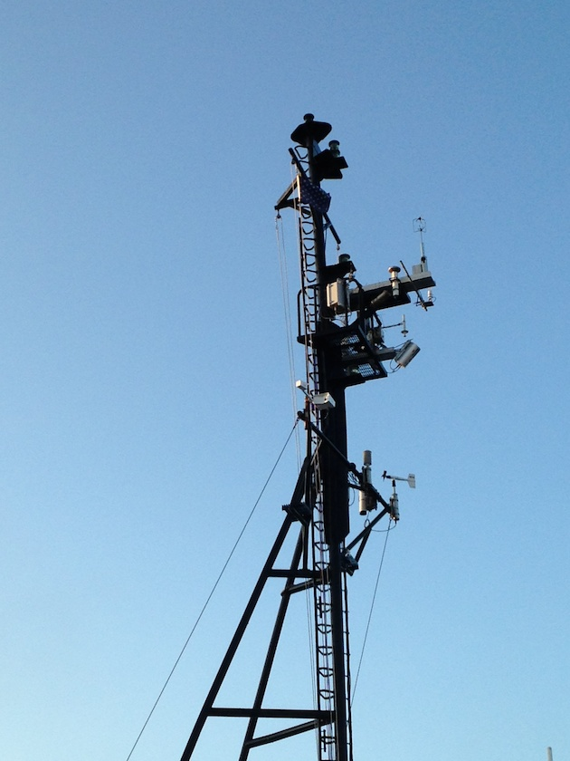

**Figure 1.** PSD flux instruments on the RHB jackstaff for CALWATER2 2015.



**Figure 2**. RHB cruise track for CALWATER2.

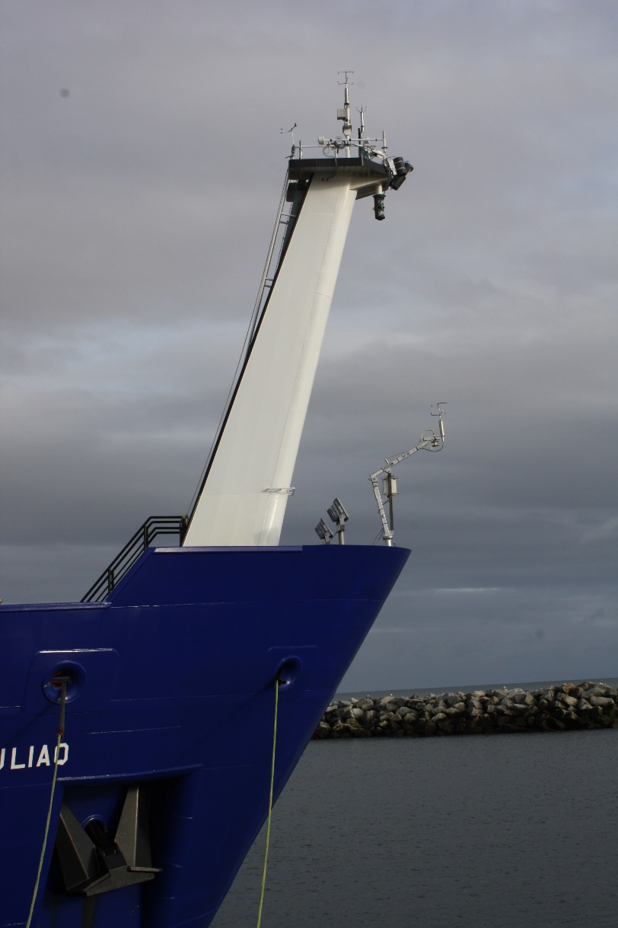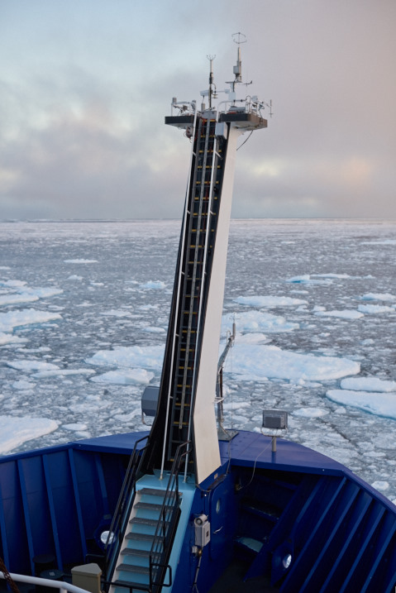

**Figure 3**. PSD turbulence sensors mounted on the *R/V Sikuliaq f*oremast in Nome, AK (left) and in the field N. of Prudoe Bay, AK (right). PSD installed a second mast on the bow with duplicate sensors. The sensors include two sonic anemometer/thermometers, a ship motion system, fast humidity and fast pressure sensors, mean temperature and relative humidity, rain/snow rate, and a scanning lidar wave sensor. Radiative flux and IR sea surface sensors are mounted elsewhere.

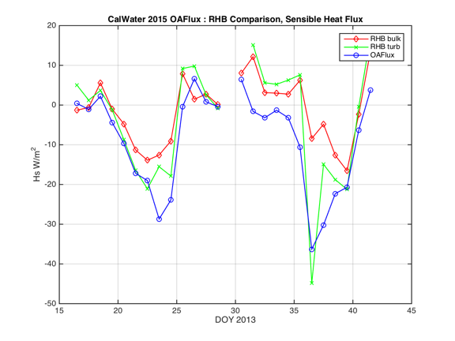

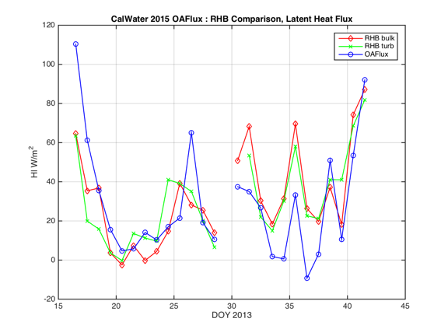

**Figure 4.** Time series of daily averaged heat flux for the Ronald H. Brown (RHB) and the co-located OAFlux gridpoint. *Turb* refers to directly measured flux and *bulk* refers to computations from mean variables using COARE. Upper panel, sensible heat; lower panel, latent heat.

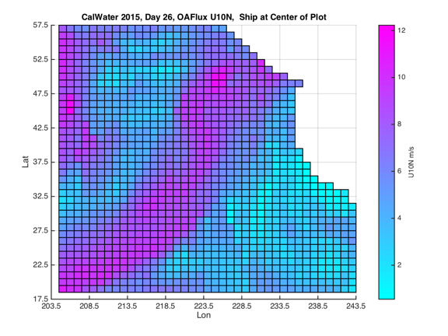

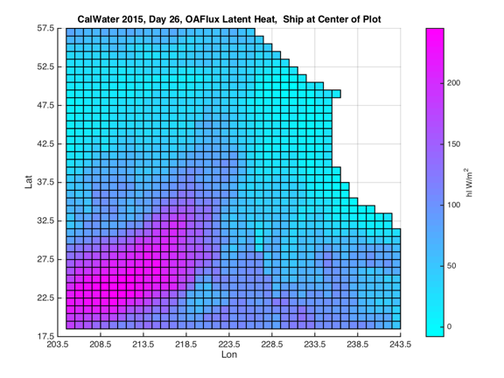

**Figure 5.** Gridded fields from OAFlux product for Jan. 26, 2015: upper panel, *U10*; lower panel, latent heat flux.