Progress Report
  - High Resolution Climate Data from Research and Volunteer Observing Ships

Period of Activity: 01 October 2015 – 30 September 2016

Principal Investigator  Christopher W. Fairall  NOAA ESRL/PSD  325 Broadway  Boulder, CO 80305 |  | Financial Contact  Brian Gorton  NOAA ESRL/PSD  325 Broadway  Boulder, CO 80305
Signature Date |  |  | Signature Date
Budget Summary
FY 2016: $296,623

High Resolution Climate Data from Research and Volunteer Observing Ships
Principal Investigator
Christopher W. Fairall
NOAA ESRL/PSD
325 Broadway
Boulder, CO 80305

Table of Contents

1. Project Summary
2. Scientific and Observing System Accomplishments
3. Outreach and Education
4. Publications and Reports
4.1. Publications by Principal Investigators
4.2. Other Relevant Publications
5. Data and Publication Sharing
6. Project Highlight Slides

Project Summary

ESRL has developed a roving standard flux measuring system to be deployed on research vessels on an opportunistic basis and direct covariance air-sea flux measurements are performed on several oceanic cruises each year. This latter task promotes high-quality climate observations from UNOLS and NOAA research vessel fleet and from NOAA Flux Reference Buoys. Currently, climate data from 31 research vessels are archived at the Shipboard Automated Meteorological and Oceanographic Systems (SAMOS) at Florida State University. Flux Reference Bouy data are available at OceanSITES (http://www.oceansites.org/ ). Because buoys and most ships and satellites rely on bulk methods to estimate fluxes, another aspect of this project is the use of direct measurements to improve the NOAA/COARE bulk flux algorithm – a state-of-the-art community resource. A full suite of direct, inertial-dissipation, and bulk turbulent fluxes of sensible heat, latent heat, and momentum are measured along with IR and solar radiative fluxes, precipitation, and associated bulk meteorological properties. This effort represents a partial transition of research from NOAA’s climate research programs to operations under the Climate Observations Division (COD). To date, cruises have been conducted on four NOAA ships, nine UNOLS ships, five non-US ships, and one Coast Guard icebreaker to TAO buoys along the 95W and 110W, the PIRATA Northeast Extension (PNE), Indian Ocean RAMA, the Northwest Tropical Atlantic Station (NTAS) reference buoy, the WHOI Hawaii Ocean Time Series Station (WHOTS) reference buoy, and the Southern Ocean Flux Station (SOFS) south of Tasmania.

The project development is the result of a NOAA-sponsored workshop on high-resolution marine measurements (Smith et al., 2003, Report and Recommendations from the Workshop on High-Resolution Marine Meteorology, COAPS Report 03-01, Florida State University, pp38) which identified three important issues with the planned NOAA air-sea observation system: 1) the need for a data quality assurance program to firmly establish that the observations meet the accuracy requirements, 2) the need for observations at high time resolution (about 1 minute) and, 3) the need to more efficiently utilize research vessels, including realizing their potential for the highest quality data and their potential to provide more direct and comprehensive observations. A second aspect of this project involves direct measurement and parameterization (gas transfer versions of the NOAA COARE model) of sea-air exchange of trace gases. For seasonal time scales, the net air-sea flux (sum of 5 flux components) must be constrained within 10 Wm⁻². Buoys and VOS systems are required to operate virtually unattended for months, so considerations of practical issues (e.g., power availability, instrument ruggedness, safe access, etc.) are balanced against inherent sensor accuracy and optimal sensor placement. As discussed above, an important function of the in situ measurements is to provide validation data to improve NWP and satellite flux fields. High time resolution and more direct observations are invaluable for interpreting surface flux measurements and diagnosing the source of disagreements --such information can be provided by suitably equipped research vessels (R/V). Thus, the accuracy of buoy and VOS observations must be improved and supplemented with high-quality, high time resolution measurements from the US R/V fleet (which is presently under-utilized). The necessity for both high time resolution and high accuracy places extreme demands on measurements because some sources of error (such as the effect of ship flow distortion on wind speed) tend to average out over a large sample. To accomplish this requires a careful intercomparison program to provide traceability of buoy, VOS, and RV accuracy to a set of standards.

This project directly addresses the need for accurate measures of air-sea exchange in the COD Strategic Plan, specifically Observing Systems, Climate Monitoring, and Data Stewardship (Section 2.14) and Understanding and Modeling (Sections 2.20 and 2.21), and it is a joint effort by ESRL and Dr. Robert Weller of the Woods Hole Oceanographic Institution (WHOI). The ESRL Air-Sea Interaction Group website can be found at http://www.esrl.noaa.gov/psd/psd3/air-sea/ . ESRL also cooperates with Dr. Frank Bradley (CSIRO, Canberra Australia) on precipitation and radiative flux observations, Dr. Meghan Cronin (NOAA PMEL) on buoy-ship intercomparisons and climate variability analysis, and Dr. Wade McGillis (Univ. Columbia) on gas fluxes. A project website has been established (High Resolution Climate Observations http://www.esrl.noaa.gov/psd/psd3/air-sea/oceanobs/ ). An associated website (http://www.esrl.noaa.gov/psd/psd3/wgsf/ ) contains a handbook on best practices for flux measurements plus a database of high-resolution flux data. This gives the project high visibility in the CLIVAR, GEWEX, and SOLAS programs. This project is managed in cooperation with JCOMM.

Users of the data and parameterizations from this project include numerous individual collaborators (J. Edson at UConn, B. Huebert at U. Hawaii, B. Ward at Galway, M. Bourassa at FSU, W. McGillis at LDEO, F. Bradley at CSIRO, M. Cronin at PMEL, R. Wanninkhof at AOML, R. Weller at WHOI, A. Beljaars at ECMWF) and many projects/programs worldwide (SAMOS, GOSUD, SeaFlux, USGCRP, WCRP, SOLAS, SURFA, OceanSITES, CLIVAR, VOCALS, UNOLS, TAO). Specific applications include global model algorithm development and intercomparison, satellite product intercomparison, in situ (buoy and ship) intercomparison studies, application of the NOAA/COARE model for flux parameterization, and improved climate observation capabilities

Scientific and Observing System Accomplishments

This project principally addresses the Climate Observation and Monitoring Program deliverables for improved observations of Air-Sea Exchange and Ocean Carbon Uptake and Content.

All tasks/milestones detailed in the work plan for 2016 were addressed.

*Three field deployments of the PSD flux system. The full PSD flux system (Fig. 1) was deployed on the Australian R/V Investigator during the CAPRICORN cruise, March-April 2016. This international campaign is a study of oceanographic processes in the S. Ocean south of Tasmania. The cruise track is shown in Fig. 2; a sample comparison for downward IR flux is shown in Fig. 3. The roving standard was deployed on NOAA R/V Hi`ialakai in July 2016 for the WHOTS 2016 buoy redeployment cruise. In September 2015 the newly constructed PSD Arctic-hardened roving flux system was deployed on R/V Sikuliaq for a 45 day cruise in the Beaufort Sea that was completed Nov. 6. This project yielded valuable data in the critical but much undersampled high latitude region (Bourassa et al. 2013) of the Arctic.

* We continued our cooperation with Dr. Huai-Min Zhang of NOAA NCDC on the Surface Flux Analysis (SURFA) project (http://www.ncdc.noaa.gov/oa/rsad/air-sea/surfa.html). We have started to work on the topic of improving/validating various global flux products as highlighted at the recent CLIVAR-GSOP Ocean Synthesis and Air-Sea flux evaluation Workshop. Initially we focused on surface flux fields for the DYNAMO field program. We have continued this work, doing comparisons of the OAFlux product with fluxes measured off California in the CALWATER2 project. Here the fluxes and bulk variables from the ship have been compared with WHOI OAFlux and SURFA/ECMWF (see Fig. 4).
In 2016 we saw significant scientific accomplishments as noted through major publications and synthesis efforts. This included progress on a PSD flux synthesis database which combines data into one handy-dandy, easy to use file, from 30 cruises in our archive (60,000 1 hr observations). A preliminary version was generated and is being assessed for data quality (see Fig. 5 for a map of the cruise tracks). The plan is to combine it with a similar database from U. Connecticut (J. Edson) and produce a single, grand database. These data will be made publically available and used to produce version 4 of the NOAA COARE flux algorithm.
Another accomplishment was the development of a new version of the PSD flux system that is streamlined for fully automated operation. The intention is to reduce costs by deploying a system that does not require PSD personnel to actually go on the cruise. A prototype was tested on the WHOTS cruise in July 2016.
We developed a data management plan (see section 5).

- Outreach and Education

Our group is engaged in a variety of outreach/education activities under this project. The range of activities includes lectures for middle and high school science teachers (done through the CIRES outreach office http://cires.colorado.edu/education-outreach/projects/past-projects/cosee/ ), judging at local science fairs and the annual National Ocean Science Bowl competition (regional level held at CU in Boulder), and hosting Teachers in the Lab and or Teachers at Sea. Currently the PI (C. Fairall) is on the PhD committee of one student at University of Colorado (Bariteau). Two other students received PhD’s in 2016. Check out Ludovic Bariteau’s extensive blog for the HiWinGS project http://cires.colorado.edu/blogs/airseagas/ or Ola Persson’s from the Sea State cruise http://ciresblogs.colorado.edu/iceontheedge/ .

In 2011 Dan Wolfe started developing a hands-on short course on methods, techniques, and instruments for meteorological observations from ships (done in cooperation with Shawn Smith at FSU) intended for seagoing MetTechs. The inaugural course was presented at the RVTech meeting in New Orleans in Dec. 2011. A second training for NOAA ship techs was held at Newport, OR in January, 2012; the third was Newport again in January, 2013; the fourth in Norfolk, VA, 2014, the fifth in Corvalis in November 2014. Course materials are available at ftp://ftp1.esrl.noaa.gov/BLO/Air-Sea/outreach/ .

A third aspect of PSD outreach is in the form of technology transfer of our flux observation methods to other research entities. In the past we have transferred designs, methods, and software to other universities and laboratories around the work. Recent examples are University of Hawaii and University of Galway (Ireland). Another example – C. Fairall is on the science advisory panel for the new University of Alaska research vessel (R/V Sikuliaq) that is currently at sea with the PSD flux system aboard (Sep-Nov, 2015 for the ONR SeaState project). A compilation of recent collaborations is given in Table 1.

Table 1. Summary of research vessels with collaborations by the ESRL seagoing flux group.
Nation | Ship | Institute | Contact
Korea | Araon | KOPRI | S. Park
UK | Clark | NOC | M. Yelland
Ireland | Celtic Explorer | U. Galway | B. Ward
Germany | Meteor | U.Hamburg | S. Kinne
France | L’Atalante | IFREMER | A. Weill
Australia | Investigator | Aus. BOM | E. Schulz
India | Sindhu Sankalp | NIO Goa | V. Kumar
US | Sikuliaq | U. Alaska | M. Edwards
Japan | Mirai | JAMSTEC | Jun Inoue

Publications and Reports

Publications by Principal Investigators

*Published

Chen, S., M. Flatau, T. Jensen, T. Shinoda, J. Schmidt, P. May, J. Cummings, M. Liu, P. Ciesielski, C. Fairall, R. Lien, D. Baranowski, N. Chi, S. deSzoeke, and J. Edson, 2015: A Study of CINDY/DYNAMO MJO suppressed phase. J. Atmos. Sci.., 72, 3755-3779, doi:10.1175/JAS-D-13-0348.1.

Peng, Ge, Lei Shi, Steve Stegall, and C.W. Fairall: 2016: An evaluation of HIRS near-surface air temperature product in the Arctic with SHEBA data. J. Atmos. Oceanic Tech., 33, 453-460, DOI: http://dx.doi.org/10.1175/JTECH-D-15-0217.1.

Ralph, F. M., K. A. Prather, D. Cayan, J.R. Spackman, P. DeMott, M. Dettinger, C. Fairall, R. Leung, D. Rosenfeld, S. Rutledge, D. Waliser, A. B. White, J. Cordeira, A. Martin, J. Helly, and J. Intrieri, 2016: CalWater Field Studies Designed to Quantify the Roles of Atmospheric Rivers and Aerosols in Modulating U.S. West Coast Precipitation in a Changing Climate. Bull. Amer. Meteor. Soc., 97, DOI: http://dx.doi.org/10.1175/BAMS-D-14-00043.1.

Yang, M., T G Bell, B. W. Blomquist, C. W. Fairall, I. M. Brooks and P. D. Nightingale, 2016: Air-sea transfer of gas phase controlled compounds. 7th International Symposium on Gas Transfer at Water Surfaces, IOP Publishing IOP Conf. Series: Earth and Environmental Science, 35, 012011 doi:10.1088/1755-1315/35/1/012011

Thomson, Jim, and 27 coauthors, 2016: Emerging trends in the sea state of the Beaufort and Chukchi seas. Ocean Modeling, 105, 1-12, http://dx.doi.org/10.1016/j.ocemod.2016.02.009.

Jung, Thomas, and 25 co-authors, 2016: Advancing polar prediction capabilities on daily to seasonal time scales. Bull. Am. Meteor. Soc., 97, 1631-1647, DOI: http://dx.doi.org/10.1175/BAMS-D-14-00246.1, accepted.

*In Press

C.O. Collins III, B. Blomquist, B. Lund, W.E. Rogers, J. Thomson, M. Smith, M. Doble, P. Wadhams, A. Kohout, O. Perrson, C. Fairall, D. Wang, and H.C. Graber, 2017: Doppler correction for 1-D wave frequency spectra measured on moving platforms. J. Atmos. Oceanic Tech., to appear.

*Reports

Thomson et al., 2016: ONR Sea State DRI Cruise Report R/V Sikuliaq, Fall 2015.
ftp://ftp1.esrl.noaa.gov/psd3/cruises/SeaState_2015/SikuliaqSeaStateDRICruiseReport.pdf

Attached Publications
The referred papers and the conference proceedings are available as .pdf files from ftp://ftp1.esrl.noaa.gov/BLO/Air-Sea/oceanobs/pubs/fy16/ .

Other Relevant Publications

This project has produced 56 refereed publications since beginning in 2003 (see ftp site for cumulative list). So far in calendar year 2016, these publications received a total of 282 Google-Scholar citations; cumulative total since 2003 is 3558 citations. One paper (Bulk parameterization of air-sea fluxes: Updates and verification for the COARE algorithm) has received 1216 citations since publication in 2003. In 2016 the 114 citations can be broken down as modeling - 28, analysis - 36, parameterization – 9, satellite – 9, and engineering – 2. The paper On the Exchange of momentum over the open ocean was cited in Blunden and Arndt, 2016: State of the Climate in 2015. Bull. Am. Meteor. Soc., 97, S1-S275.

Raw, processed, value-added, and synthesized data from this project are freely available at the ftp site (ftp://ftp1.esrl.noaa.gov/psd3/cruises/ ). Use of these data is too extensive to track.
Two recent examples include Ruppert and Johnson, On the cumulus diurnal cycle over the tropical warm pool, JGR, 2016; and, Mathews et al., The surface diurnal warm layer in the Indian Ocean during CINDY/DYNAMO, J. Clim., 2014.

Data and Publication Sharing

Field processed data summaries for each cruise are transmitted at the end of the day to our ftp site (ftp://ftp1.esrl.noaa.gov/psd3/cruises/ ) with cruise-specific directories – these are publically available (70 cruises at this writing). For example, images of the various flux time series as posted in realtime (daily) for the recent CAPRICORN cruise can be seen at:
ftp://ftp1.esrl.noaa.gov/psd3/cruises/CAPRICORN_2016/Investigator/flux/Raw_Images/
and daily processed ASCII files are available at
ftp://ftp1.esrl.noaa.gov/psd3/cruises/CAPRICORN_2016/Investigator//flux/Processed/
The full raw time series is added after the cruise. Updates after postprocessing are posted as they become available. High-resolution data undergo thorough review and post-processing, and are made available to the public within one year after system recovery. The data archive maintained at NOAA/ESRL for ship-based measurements is not access restricted, but users of data in publications or presentations are requested to acknowledge the project.

Final data products will be completeded within one year of the individual cruise and published in a NOAA archive (http://www.ncei.noaa.gov/) with a data DOI, metadata, and documentation as described in the NOAA data management plan (https://geo-ide.noaa.gov/wiki/index.php?title=Category:Data_Management_Plans).
This project will provide easy public search, analysis of, and access to peer-reviewed scholarly publications and corresponding metadata pursuant to the White House Office of Science and Technology Policy (OSTP) Memorandum Increasing Access to the Results of Federally Funded Scientific Research issued 22 February 2013.

6. Project Highlight Slides

Attached separately.

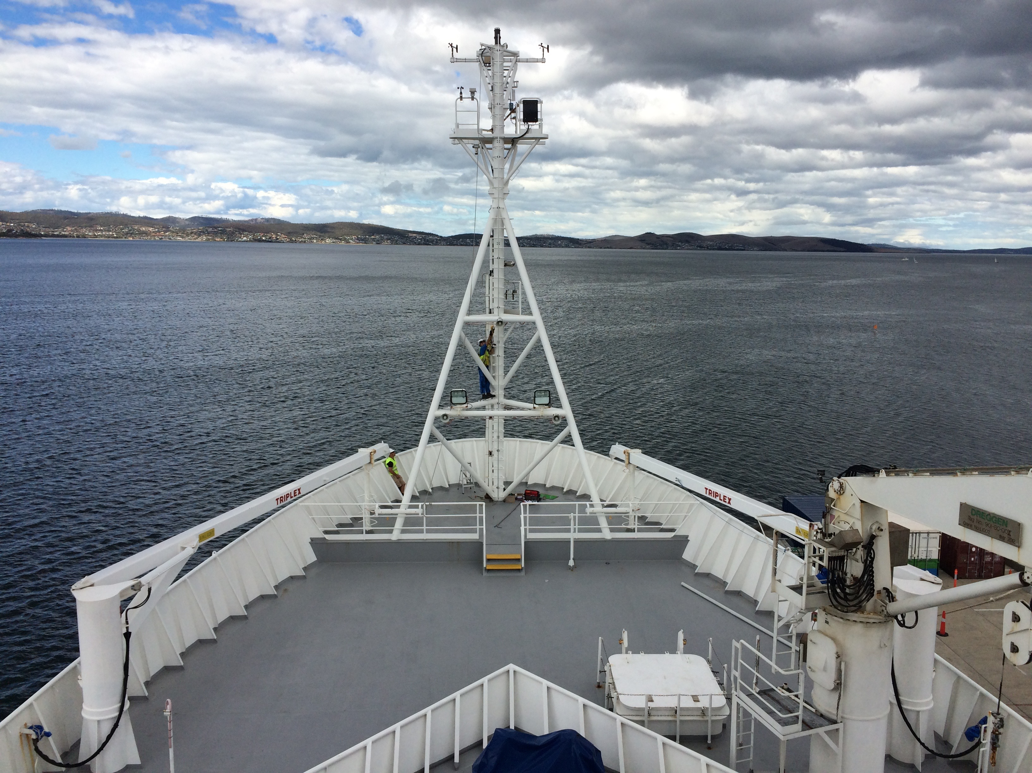

Figure 1. PSD flux instruments on the R/V Investigator jackstaff for CAPRICORN 2016.

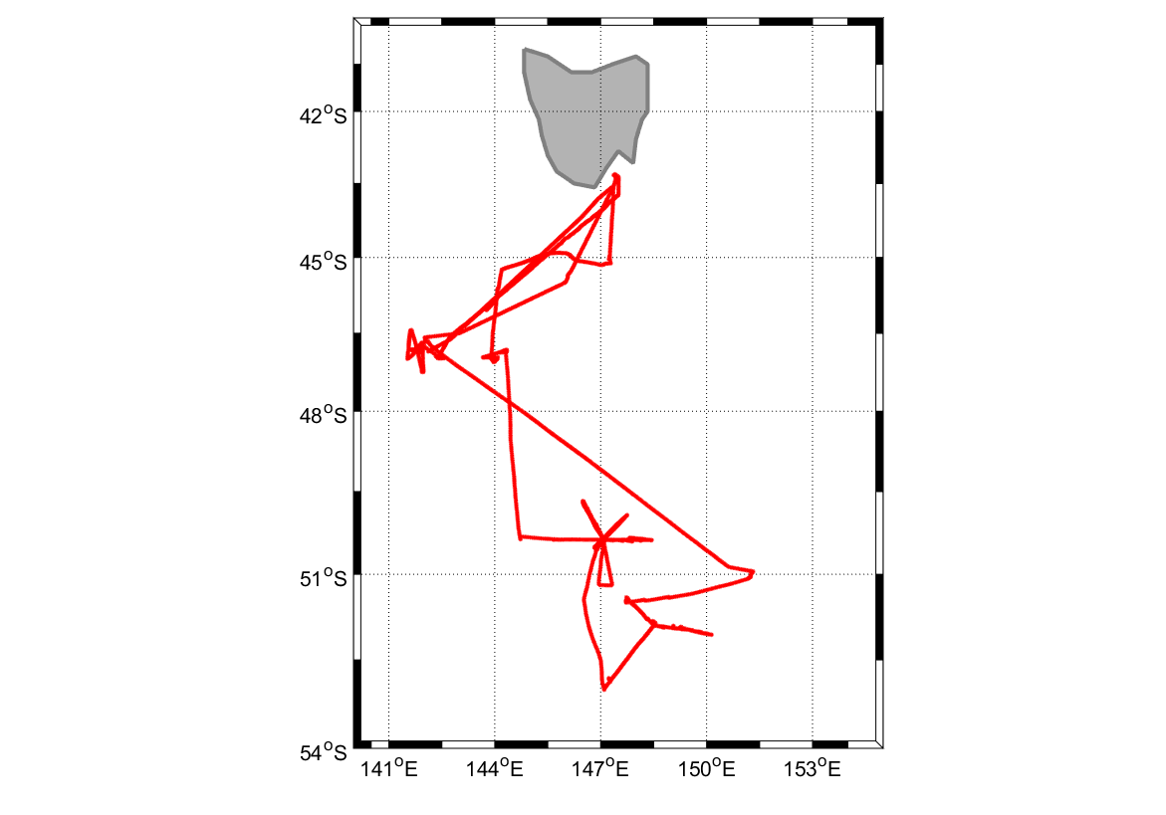

Figure 2. Investigator cruise track for CAPRICORN.

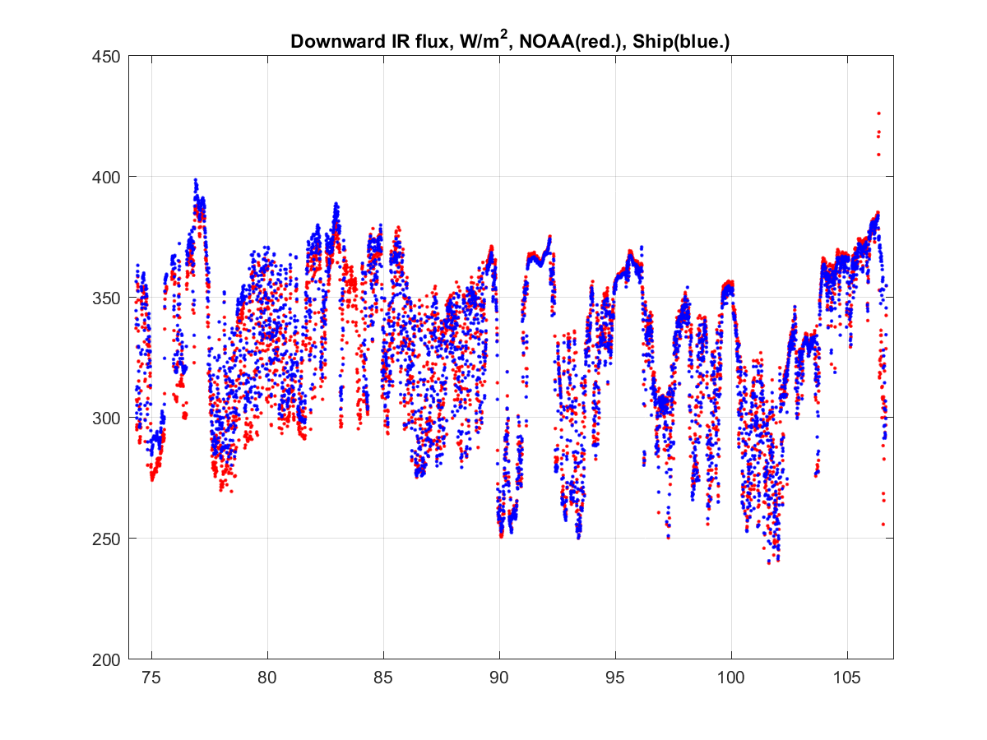
Figure 3. An example of a comparison of direct measurements of downward IR flux (W/m²) from the PSD roving standard (red dots) and the R/V Investigator (blue). In this case, the mean difference is less than 5 W/m² (the SAMOS standard).

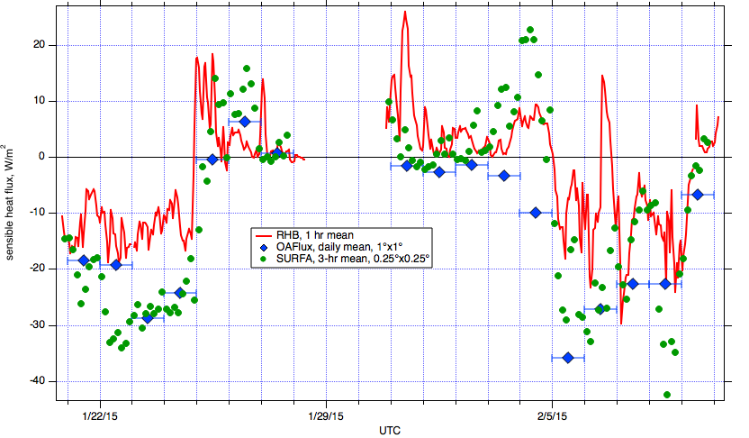
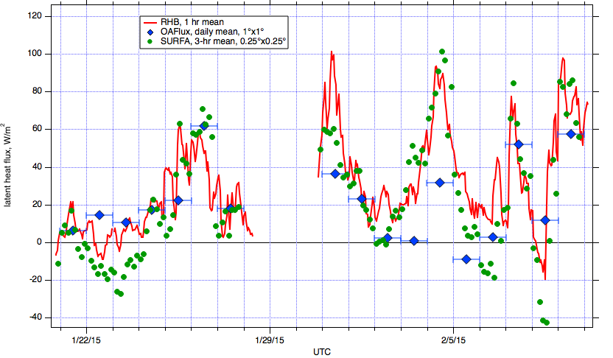

Figure 4. Time series of heat fluxes for the Ronald H. Brown (RHB) and the co-located OAFlux and SURFA/ECMWF gridpoints. Upper panel, sensible heat; lower panel, latent heat. The higher time and space resolution of the SURFA data improves the correlation with the ship observations. Bias is apparent in the very stable conditions in the atmospheric river.

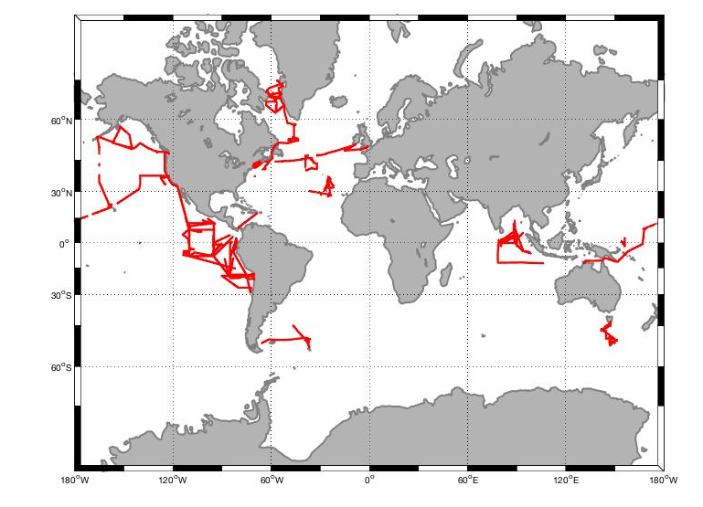
Figure 5. Cruise tracks for data included in the PSD Air-Sea Flux Database Version 2.0. The databased incorporated 60,000 1-hr observations taken between 1991 and 2016.

