PISTON 2019 report on measurements of air-sea fluxes, surface meteorology, clouds, and near-surface seawater

Elizabeth J. Thompson, NOAA ESRL PSD, elizabeth.thompson@noaa.gov

Personnel and Institution:
Elizabeth J. Thompson, Chris W. Fairall, Sergio Pezoa
NOAA ESRL PSD
Earth System Research Lab, Physical Sciences Division, Boulder, CO

Byron Blomquist, Ludovic Bariteau
NOAA ESRL / CIRES
Cooperative Institute for Research in Environmental Sciences at U. of Colorado Boulder

Simon de Szoeke
Oregon State University, Corvallis, OR

Orson Hyde
U. of Notre Dame, South Bend, IN

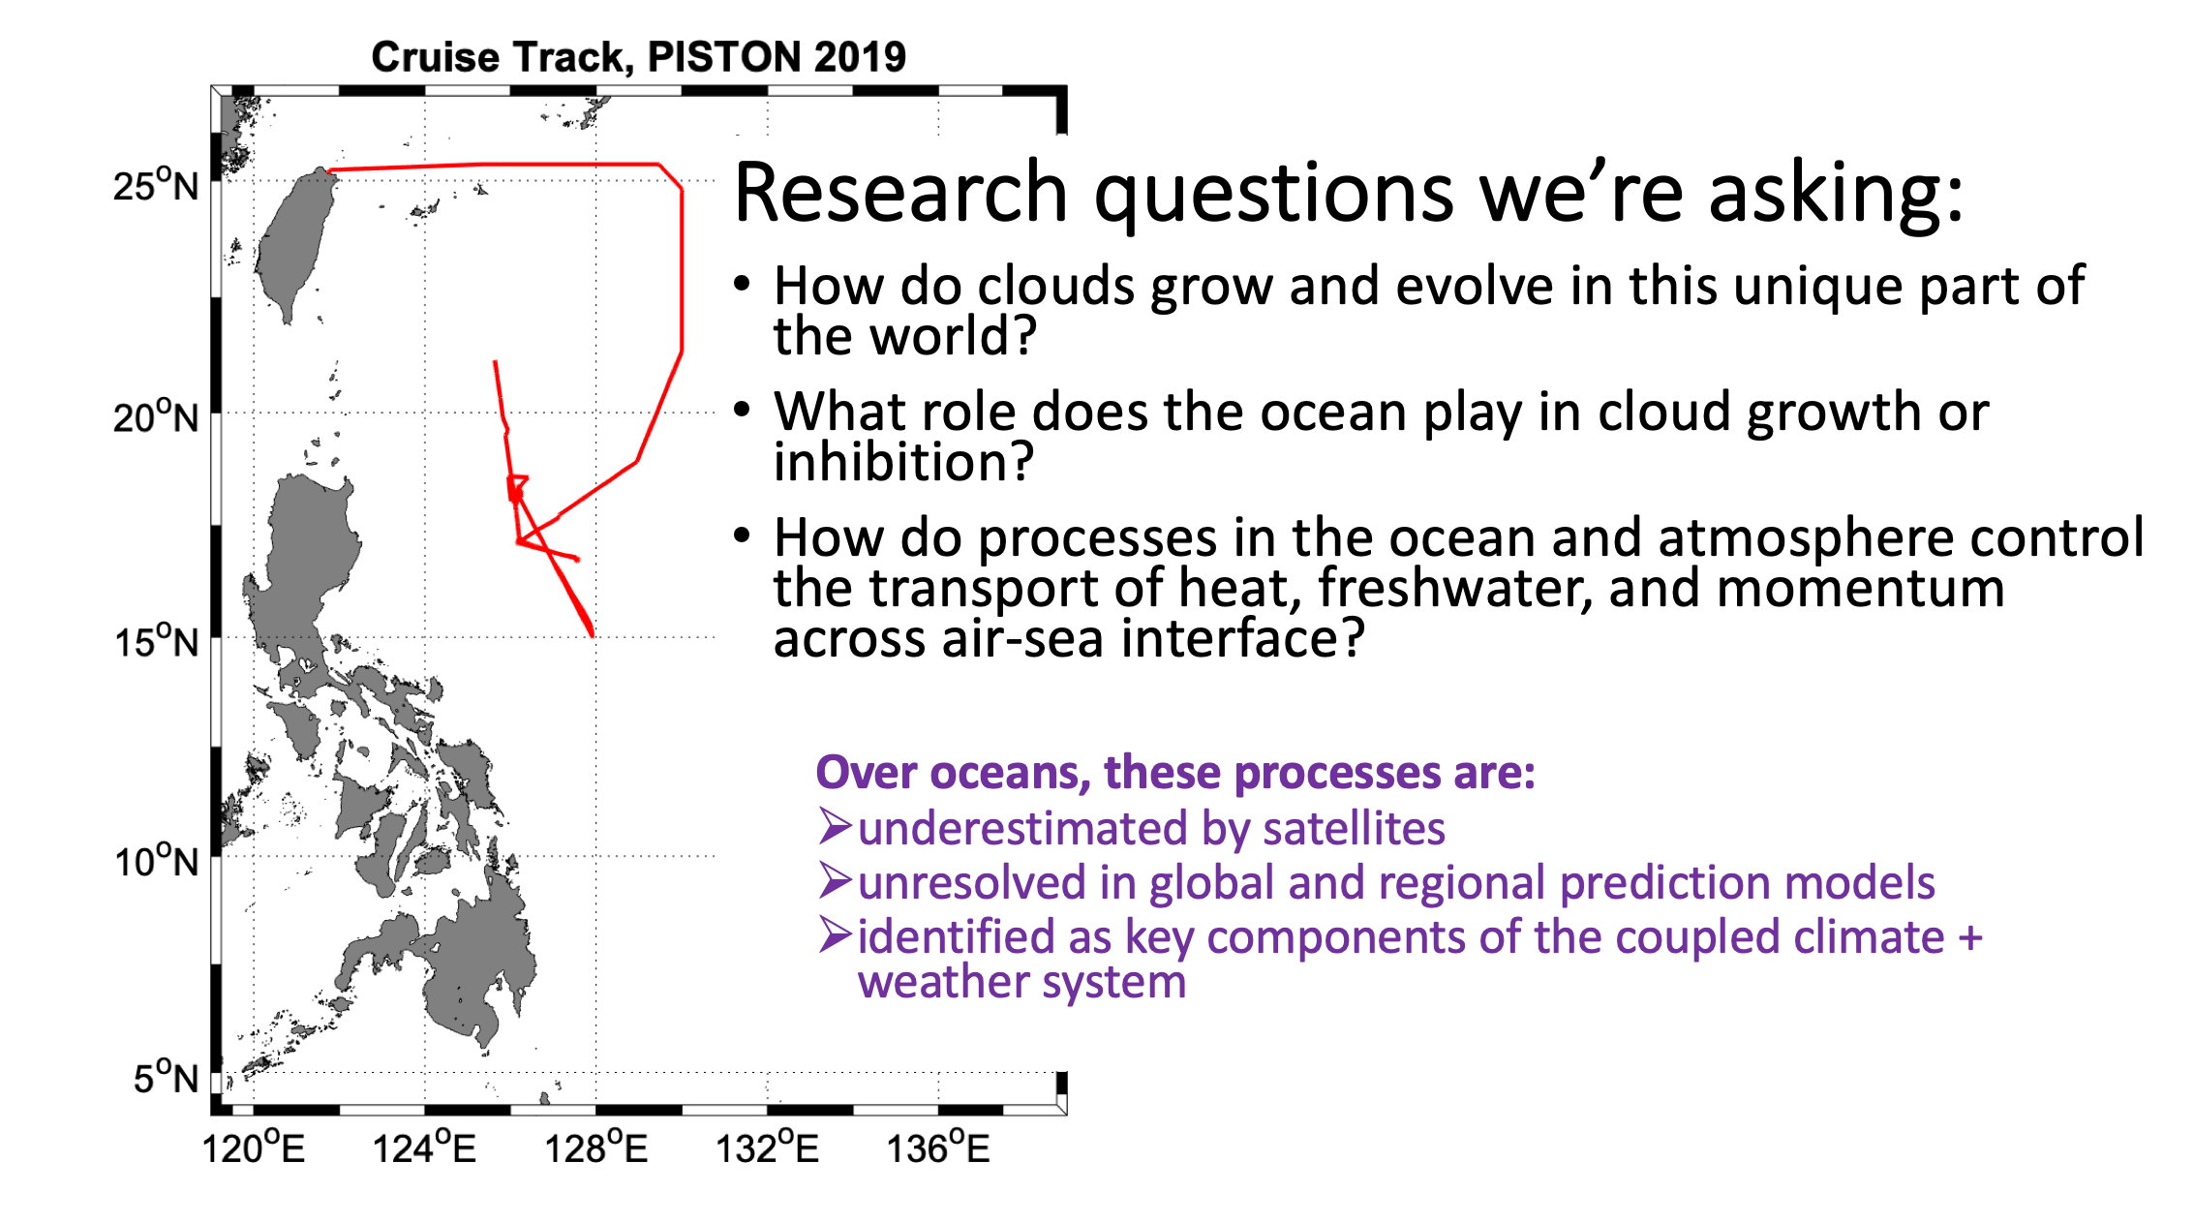

Timeline of ship operations in 2019:
- May 23 - May 27: Port call in Phuket, Thailand. Meteorological and flux instruments were installed on the O2 deck rail and the foremast prior to MISOBOB by B. Blomquist.
- May 27 - June 26 and July 6 - Aug 14: Equipment was operational for 2 cruises of the MISOBOB experiment in Indian Ocean. Port calls in Chennai, India. Data collection and preliminary data processing were run onboard by S. de Szoeke and O. Hyde. Final data processing run post-cruise by S. de Szoeke and B. Blomquist. Several data issues were present by completion of MISOBOB due to water leakage and some instruments being not plugged into UPS.
- Aug 25 - Sept 1: Port call in Keelung, Taiwan. Foremast lowered so that meteorological and flux instruments could be serviced by S. Pezoa. Several ethernet and serial cables were replaced due to water damage during MISOBOB, including for the sea snake and some foremast mast sensors. Configuration files for the heading, GPS, roll, and pitch were corrected. Desicants were replaced in IR and solar radiometers. All equipment was working properly at beginning of PISTON except for the second IR radiation pyrgeometer. The redundant, secondary met measurements made by the WXT system were not expected to be of great quality because of the placement of this unit over the O2 deck. W-band cloud radar and ceilometer were installed by S. Pezoa. Infrared radiometer (ROSR) was installed by E. Thompson
- Sept 2 - Sept 27 (total sailing time); 01 Z Sept 5 – 12 ZSept 25 (time sampling and saving data): Meteorological, flux, radiometer, and cloud instruments were operational for PISTON in Philippine Sea. Operated by E. Thompson. Every day at 01:30 Z, 09:30 LT, the Licor was sprayed with freshwater for about 1 min. Every day between 01:30 - 03:00 Z, the ceilometer lens was wiped with a clean dry paper towel, the radiometers were wiped with a clean wet and then clean dry paper towel, and the same was performed for the ROSR optical rain detector. The color of the desicants was periodically checked during the cruise. It remained purple-ish blue, so was not replaced.
- Sept 27 - Sept 29: Port call in Keelung, Taiwan. E Thompson and L. Bariteau removed all NOAA PSD equipment.
Known data issues during PISTON:
- The W-band radar was not turned on until yearday 253, Sept 10, at 2 Z due to mechanical issues.
- The W-band radar was shut down (data missing) when the P3 aircraft was within about 10 nm range. The P3 had a similar wavelength downward-looking cloud radar; they would have damaged each other if both in transmit/receive mode at the same time. A few other power faults occurred.
- The freshwater hose attached to the Licor on the main mast stopped working properly during PISTON, so the optical sensor was not clean enough to provide good data. Bad data are identified by times when AGC values > 55.
- The sonic anemometer had occasional data dropouts (reason currently unknown). In these cases, the ship’s wind sensor data were used in the provided data file. The consequence of this is that turbulent (covariance) fluxes of heat, moisture, momentum were not computed during these times.
- The W-band radar’s vertical resolution was much smoother and coarser when the automatic motion stabilization system was unable to run, which occurred when ship pitch and/or roll were > 7°. Due to the close proximity of the ship’s smoke stack overhead and just forward of the W-band radar’s field of view, the radar’s motion stabilization system was electronically limited to ≤ 7° pitch and roll. In other words, the radar became immobilized in pitch, roll, or both directions when this limit was met. Typically, when the ship pitched and rolled, the radar will adjust its position in equal magnitude and opposite direction. If the ship rolled or pitched more than 7°, then the radar’s compensated position would have resulted in the transmitted radar pulse being reflected off of the metal smokestack. In this case, an excessively strong returned pulse to the radar would have destroyed its sensitive receiver. At times, the radar’s position would be stuck at the limit switch position but the pitch would keep compensating, or vice versa. When either direction was compromised, the radar would get stuck in that position until this was discovered (no automatic detection or alarm was in place). Then its position was manually reset to vertical relative the ship, fixed in the ship’s reference frame. The auto stabilization process was restarted in calmer conditions.
- One of the pyrgeometers for downwelling IR radiation (PIR1 or PIR2) was not functioning properly prior to PISTON. It was not fully understood why disagreement existed between the radiometers, or which one is correct. The PIR1 values were low compared to PIR2, calculated clear sky solar radiation, and the ship’s PIR (which was also too low and noisy). For now, PIR1 is used in the dataset.
- A warm bias of about 0.12°C was determined to be present in the sea snake T record according to collocated measurements made by the ROSR and SurfOtter (OSU). The bias has been accounted for (corrected) in the provided dataset.
- Since the WXT system (additional met sensors) was not mounted in an ideal location on the ship, its measurements had relatively poor agreement and data quality compared to the foremast measurements made by the ship and NOAA PSD. The WXT measurements show signs of deck heating during the day and flow distortion around the ship. These measurements were not used in the provided dataset. They were collected for redundancy.
- WAMOS waves statistics from the ship’s X-band radar were not correctly computed in the first 2/3 of the cruise because the wrong configuration file was being used by the ship’s automatic processing system. The data will be reprocessed by Tom Cook (UCSD) following the cruise, then added to this dataset.
- The ROSR radiometer for measuring skin T was calibrated in June 2019 in Seattle, WA in a field test and bath calibration test by E. Thompson and the manufacturer, Mike Reynolds, RMR Co. The ROSR does not collect data when it is raining. If rain is detected by the optical sensor, the radiometer’s shutter closes immediately. The shutter reopens 120 sec after rain is no longer detected. A few time periods of ROSR data are also missing due to time spent for in-field tests.
- The ship’s meteorological measurements were of similar magnitude and sign as NOAA PSD, except for rain rate and humidity. Humidity was being calculated with the wrong calibration coefficients prior to day 267, Sept 24. Starting sometime on day 267, Sept 24, the values were in much closer agreement to NOAA’s. Rain rate was calculated cumulatively by the ship. The sampling resolution of the instrument was only 0.2 mm per second, so the effective resolution in mm/hr is only 5 mm/h, relatively coarse. The ship’s long wave radiation measurement was noisier (greater variance) and anomalously low at times, sporadically, but overall this measurement seemed acceptable in most cases. The seawater measurements from the ship were biased by
  - the heating of the ship (sensors are inside the ship, not in the open ocean water)
  - flow distortion around the hull (the extent of which is unknown)
  - temporary dropouts in pump flow rate due to exposure of to air. The portside aft seachest vent’s pump took in air and lost its prime when rolls were high, which was relatively infrequent. The bow pump lost its prime relatively soon in the cruise due to excessive pitching (see below for more details). Data from TSGs was only considered good when 1.75 L/min > flow rate > 3.5 L/min. Values above and below these levels were discarded.

Summary of completed work:
- A 10-min time series was produced of the best meteorological data, seawater data, and computed air-sea fluxes from Sept 5 - Sept 25. The bulk fluxes were computed using the COARE 3.5 algorithm (Fairall et al. 1996a, 1996b, 1997, 2003, Edson et al. 2013).
The raw data was also provided.
- Hourly plots of data from the W-band radar and ceilometer were also produced and posted. These show the evolution of clouds and the atmospheric boundary layer between 0-7.5 km height above sea level.
- All software used on the cruise was posted. The datasets and software will be updated after the cruise to produce the final dataset.

Work to be completed by end of 2019:
- Add time series data of significant wave height, wave period, and wave direction from ship’s X-band radar WAMOS system. The data were collected on the cruise, but were processed initially with the incorrect configuration file. Tom Cook at UCSD will be reprocessing the data after we reach land.
- Add the zonal and meridional components of near-surface ocean current from ship ADCP measurements. Data is currently being processed by OSU. The data are collected from depths of about 15 – 40 m using the 300 KHz ADCP.
- Add zonal and meridional components of wind and wind stress.
- Determine which IR radiation measurement is best. PIR1 is used right now.
- The ship TSG measurements should be corrected to be consistent with the OSU SurfOtter, so that the TSG values relative to SST are consistent before and after the switch between bow and seachest water (see below).
- Determine the precise offset present in the sea snake T relative to Otter and radiometer. Update the dataset accordingly.

List of Instruments:
Table X: Table of NOAA ESRL PSD sensors. temporal sampling frequency and status.
NOAA sensor | Frequency | Status
Anemometer, sonic 3D, Gill | u,v,w winds @ 10 Hz | Functional with occasional dropouts
Motion Pack | accel. & rot. @ 10 HZ | Functional
Fast water vapor, Licor 7500 | H₂O @ 10 Hz | Not functional
Bulk air T & RH, Vaisala | 1 min avg | Functional
Rain rate, OSI ORG optical | 1 min avg | Functional
Air pressure, Vaisala | 1 min avg | Functional
Solar flux, Eppley PSP (2) | 1 min avg | Functional
IR flux, Eppley PIR (1), Kipp Zonen (1) | 1 min avg | Functional, but significant differences noted between sensors
SST, sea snake | 1 min avg, 5 cm depth | Functional
Heading, GPS | 10 Hz | Functional
Ceilometer, Vaisala CL31 | 15 sec avg profiles | Functional
W-band cloud radar | 3 Hz profiles | Functional starting 02 Z, 10 Sept
Skin SST, IR radiometer | 1 min avg, skin level | Functional

The type, purpose, manufacturer, model number, height above water line, and purpose are listed below where applicable

Foremast

Ship: (see SR19B.acq document)
- Aspirated Air T: RM Young, 41342VC, 15.24 m
- Aspirated Air Humidity: EE Elektronic, EE08, 15.24 m
- 2D Ultrasonic Wind Anemometer, RM Young, 86106, 15.24 m
- RM Young self-siphoning rain gauge model #50202, 15.24 m
- barometric pressure, RM Young, 61302V, 15.24 m
- solar and infrared radiometers. Eply PIR and PSP, 15.85 m
- surface PAR, Biospherical Instruments, QSR-2200, QSR-240P, 15.85 m ASL
- GPS, ship speed, heading

NOAA:
- temperature and humidity sensor, Vaisala, HMT 337, 13.75 m
- 3D sonic anemometer: Gill Instruments, Master Pro, 14.75 m
  - Measures turbulent components of air T and 3D components of wind
- open path licor gas analyzer, LI-COR, LI7500, 13.75 m
  - Measures turbulent component air humidity
- optical rain gauge, OSI Inc., ORG-815-DA, 13.75 m
  - Measures rain rate with higher precision than siphons or buckets.
- 6-axis motion detector system, Dystron and Donner, MP-1, 12 m
  - Used for correcting data for ship in roll, pitch, yaw

O2 deck starboard rail
- GPS and heading, 11 m
  - GPS System, Hemisphere GPS, VS-1000
  - GPS Antenna, Hemisphere, MDA30 and MDA10
- pyrgeometer, one Eppley PIR & one Kipp & Zonen IR PIR, 11 m
  - measures downwelling IR radiative flux
- pyranometer, two Eppley solar radiation sensors, PSP, 11 m
  - measures downwelling Solar radiative flux
- upwelling IR flux calculated as function of derived skin T of ocean and downwelling IR flux
- upwelling Solar flux calculated as function of downwelling Solar and assumed albedo = 0.955
- Vaisala WXT520, RM Young aspirator with sensor and fan, 11.31 m
  - aspirated weather station measuring humidity, temperature, rain, wind
- shielded pressure sensor, Vaisala SPH10, 10.39 m
  - Measures barometric pressure, accounts for dynamic P component from motion and wind

Aft:
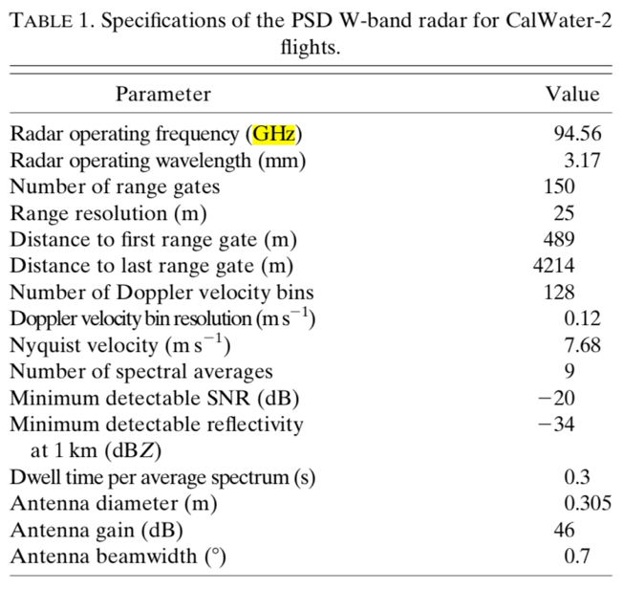
- Motion stabilized vertically-pointing W-band radar on aft main deck. Designed and built by NOAA ESRL PSD (Ken Moran, Sergio Pezoa, Chris Fairall). Reference: Moran et al., 2012 - see specifications of radar listed in table to side. Peak power: 1.75 KHz. Measures cloud vertical structure, drizzle, and light to medium rain < about 10 mm/h between heights of 150 m - 6 km above sea level. 30 m vertical gate spacing. Continuous sampling in time. Motion stabilization is automatically adjusted to true vertical when ship pitch and roll <= 7°. Otherwise, the radar either got locked at a large angle temporarily or reset to vertical relative to the ship, fixed in the ship’s reference frame. The W-band is sensitive to both cloud droplets and drizzle. When clouds are precipitating, it is not simple to determine the height of cloud base because it is difficult to distinguish cloud from precipitation. Radar signal is attenuated in medium to heavy rain > 10 mm/h. Signal gets extinguished above portions of cloud with rain drop characteristics that exceed this level. The motion stabilization system measures the roll, pitch, and heave of the radar platform, and attempts to mechanically redirect the pointing angle of the antenna in real time.
  - Measured variables as function of height and time:
    - Radar reflectivity: Z, dBZ
    - Doppler velocity: V, m/s
    - Spectral Width: SW, m/s
    - Signal to Noise Ratio: SNR, dB
  - Measured variables as function of time:
    - heave of platform (vertical velocity), m/s
    - roll of platform, °
    - pitch of platform, °
  - Known data artifacts:
    - horizontal bands of brighter SNR and SW, potentially due to noise.
    - vertical banding of V due to ship motion. Will be corrected in future.
    - Coarse data resolution when motion stabilization couldn’t be run in high seas

- Vaisala CL31 ceilometer lidar on aft Focsle deck. Measures backscattered reflectivity from 0-6 km above sea level with vertically pointing optical laser (lidar). Sensitive to gradients in refractive index. Data are used to derive time series of cloud base height and cloud fraction. Cloud bases are accurately detected when no rain occurs. Measurement is attenuated in precipitation, so less usable in this case. Ceilometer does not produce a reliable measurement of cloud base top; W-band should be used for that instead. Specifications of ceilometer?
  - Measured variables as function of height and time:
    - backscattered intensity
  - Calculated variable as function of time
    - cloud base heights at multiple levels, if multiple are detected
    - number of cloud layers detected in vertical dimension
    - Fraction of beam width obscured by cloud at each level

Port Rail:
- sea snake on Focsle deck: seawater T at depth of 5 cm, 0.05 m
- ROSR: Remote Ocean Surface Radiometer. A KT-15 infrared radiometer is contained in a system built by RMR, Co. in Seattle, WA. Deployed on port O1 deck. Measures 5 min average of skin T of ocean across a 1 m x 1 m area. Because of the wavelength used by ROSR, this measurement is not affected by atmospheric water vapor or aerosol absorption. Note: skin T of seawater is also derived from COARE 3.5 algorithm using the 10-20 cm depth measurement from sea snake as input.

Ship seawater:
- Surface gravity wave statistics made by WAMOS X-band marine radar system. Contact: Tom Cooke UCSD.
- thermosalinigraph SBE45: seawater T and S taken from both the underside of bow and aft engine room. Exact flow distortion around ship's hull, and subsequent mixing, is unknown. Please see data contained in readme below and figures below.

Readme file for air-sea fluxes near-surface seawater, and surface meteorology

_flux_readme_PISTON_2019.txt

PISTON 2019, Philippine Sea
Preliminary in-field dataset for air-sea fluxes, surface seawater, and meteorology
NOAA Earth System Research Lab Physical Sciences Division (NOAA/ESRL/PSD)
Values are either measured directly or estimated by COARE 3.5 algorithm
Please acknowledge:
NOAA/ESRL/PSD: Chris Fairall, Elizabeth Thompson, Sergio Pezoa
NOAA ESRL / CIRES: Byron Blomquist
Oregon State University: Simon de Szoeke

References for COARE 3.5 algorithm: Fairall et al. 1996, Fairall et al. 2003, Edson et al. 2013

Dataset is subject to change as updates, corrections, and more data become available
Please contact Elizabeth Thompson if errors are found or if changes/additional variables are requested.

Contact: elizabeth.thompson@noaa.gov

Note: * the signs of fluxes are oceanographic convention
negative = out of ocean, cooling the ocean
positive = into the ocean, warming the ocean
* the signs of wind are meteorological convention
direction = the direction wind came from

Fields in Matlab structure called "f", and columns in .txt file

t matlab date and time
yday year day = t - datenum(2019,1,1,0,0,0);
Lat decimal latitude
Lon decimal longitude
sog speed over ground, m/s
cog course over ground, deg
head heading, deg
wspd_15m true wind speed measured on foremast at 14.75 m ~ 15 m, m s^-1
wdir_15m true wind direction measured on foremast at 14.75 m ~ 15 m, m s^-1
wspdrel_15m relative wind speed measured on foremast at 14.75 m ~ 15 m, m s^-1
wdirrel_15m relative wind direction measured on foremast at 14.75 m ~ 15 m, m s^-1
U10N wind speed adjusted to 10 m height and neutral air stability, m s^-1
Psl sea level pressure, mb
skinT skin T of seawater measured by IR radiometer (ROSR), missing in rain
SST sea surface T = snake T - calculated cool skin - 0.12 deg C correction
qs sea surface specific humidity, g kg^-1, calculated from SST
Tsnake snake T at about 0.05 m
dT air-sea T difference = SST - T10N, deg C
dq air-sea q difference = qs - q10N, g kg^{-1}
T10N air T adjusted to 10 m height and neutral air stability, deg C
q10N air q adjusted to 10 m height and neutral air stability, g kg^-1
RH10N relative humidity adjusted to 10 m height and neutral air stability, %
rhoa air density calculated with 10 m values
skin_dT estimated T difference across cool skin, deg C
skin_dz estimated thickness of cool skin, m
hs sensible heat flux, W m^-2
hl latent heat flux, W m^-2
E evaporation rate, mm h^-1
ustar friction velocity in air, m s^-1
tau stress, N m^-2
IRdn downwelling infrared flux, W m^-2
IRup upwelling infrared flux, W m^-2
IRnet net infrared flux = IRdn + IRup, W m^-2
Solardn downwelling solar flux, W m^-2
Solarup upwelling solar flux, W m^-2
Solarnet net solar flux = Solardn + IRup, W m^-2
IRdn_clear calculated downwelling IR flux assuming no cloud cover, W m^-2
Solardn_clear calculated downwelling solar flux assuming no cloud cover, W m^-2
P precipitation rate, mm h^-1
hr rain heat flux due to T difference between rain drops and SST, W m^-2
hnet net heat flux = Solarnet + IRnet + hs + hl + hr
Ttsg seawater T measured by main lab TSG, deg C (see below for details)
Stsg seawater S measured by main lab TSG, PSU (see below for details)
Ftsg seawater flow rate measured by main lab TSG, L/min (see below details)
Ctsg seawater C measured by main lab TSG, mS/cm (see below for details)
Sigtsg seawater sigmaT measured by main lab TSG, mS/cm (see below details)
ID_Ftsg seawater flow rate ID for main lab TSG: 1 = good, 0 = bad
bad = find(F < 1.75 L/min or F > 3.5)
IDtsg 0 = bad tsg data during switch, 1 = before switch, 2 = after switch

Notes about seawater measurements from ship TSG:

ship bow intake = starboard hole at 3.6 m depth, 0.3-0.6 m forward and below bow thruster vent, feeds into bow thruster room.

seachest intake = port vent between 2.3-3.4 m depth, 0.6-0.9 m aft and just above bilge keel, feeds into engine room.

TSG 1 on ship's .MET files = TSG located in bow thruster room (SBE45).
At beginning of cruise, this TSG sampled bow water through a direct line.
After switch, this TSG re-sampled sea chest water after TSG #2.

TSG 2 on ship's .MET files = TSG located in main lab... which is used in this dataset
At beginning of cruise, this TSG re-sampled bow water after TSG #1.
After switch, this TSG sampled seachest water through a direct line.

The switch in plumbing happened between 23:30 Z on 11th and 00:20 Z on 12th because the bow was pitching so much in rough seas that the bow pump was losing its prime and taking in air. For remainder of cruise, we decided to use sea chest water (TSG#2) instead of the bow water (TSG#1).

Only data from TSG#2 are included herein.
9/11/19 23:30 Z when ship's TSG started to change from bow water to seachest water
9/12/19 00:30 Z when ship's TSG completed change from bow water to seachest water

Readme file for ceilometer cloud statistics

_ceilometer_readme.txt

PISTON 2019, Philippine Sea
Preliminary in-field dataset for ceilometer Lidar

Please see readme files in this same folder:
specifications sheet for the Vaisala CL31 Ceilometer Unit.
photos of unit deployed on Sally Ride

Please acknowledge:
NOAA/ESRL/PSD: Chris Fairall, Elizabeth Thompson, Sergio Pezoa
NOAA ESRL / CIRES: Byron Blomquist
Oregon State University: Simon de Szoeke

Dataset is subject to change as updates, corrections, and more data become available
Please contact Elizabeth Thompson if errors are found or if changes/additional variables are requested.

Contact: elizabeth.thompson@noaa.gov

Processed data formats:

PISTON_2019_cloudbase_ddd.txt

raw output at ~ 15 second resolution with the following columns

1 jd_ceil decimal day of year at start of interval
2 cloudcode cloud detection code, as follows:
0 = clear sky
1 = one cloud layer detected
2 = two cloud layers detected
3 = three cloud layers detected
4 = totally obscured
5 = partly obscured but determined transparent
3 cloud1 base height of lowest layer, m
4 cloud2 base height of next highest layer, m
5 cloud3 base height of highest layer, m

PISTON_2019_ceilometer_hr_ddd.txt
PISTON_2019_ceilometer_10min_ddd.txt

stats computed from raw data at 10 min ahd hourly resolution

1 jd_hr/jd_10min decimal day of year at start of interval
2 cloud_cnt count of cloud detections in interval
(codes = 1-3)
3 obscured_cnt count of obscured detections in interval
(code = 4)
4 part_obscured_cnt count of partly obscured detections in interval
(code = 5)
5 cloud_tot count of total cloud detections, sum of
(sum of cloud_cnt and obscured_cnt)
6 frac_cld cloud fraction (codes 1-3), 0-1
7 frac_tot cloud fraction (codes 1-4), 0-1
8 clear_cnt count of clear detections in interval
(code = 0)
9 frac_clear clear sky fraction, 0-1
10 one_layer_cnt count of single layer detections in interval
(code = 1)
11 multi_layer_cnt count of multi-layer detections in interval
(code = 2,3)
12 hgt_median median cloud base height in interval, m
13 hgtsm1 18th percentile of cloud base height, m
14 hgtsm2 64th percentile of cloud base height, m

Figures:
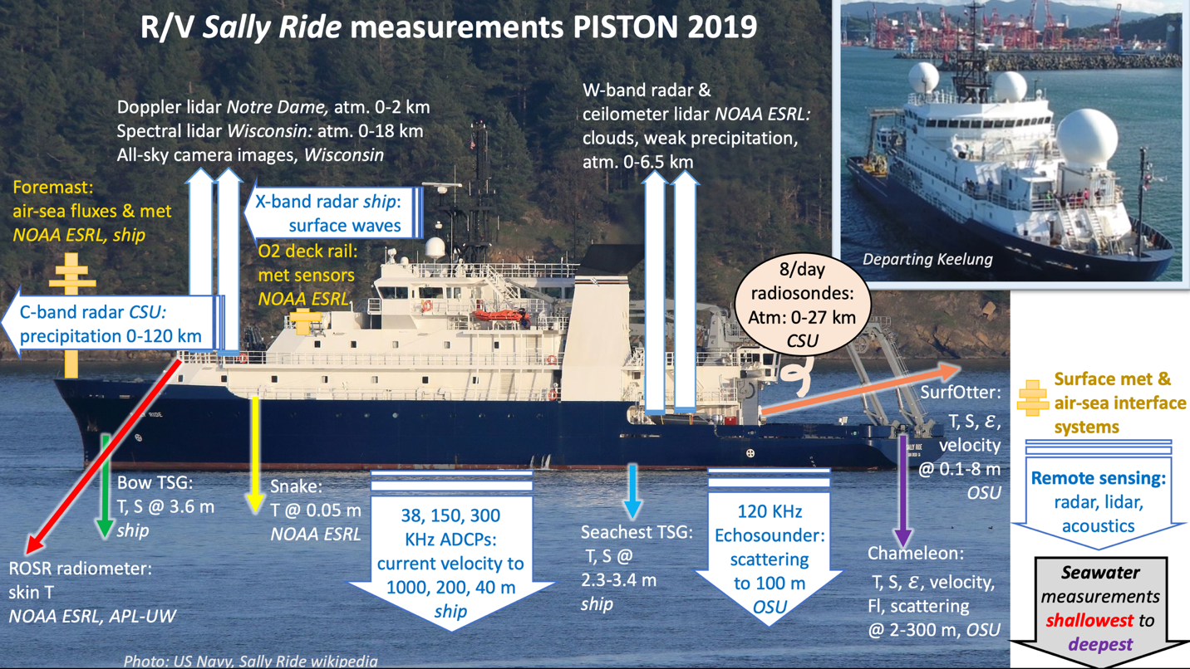

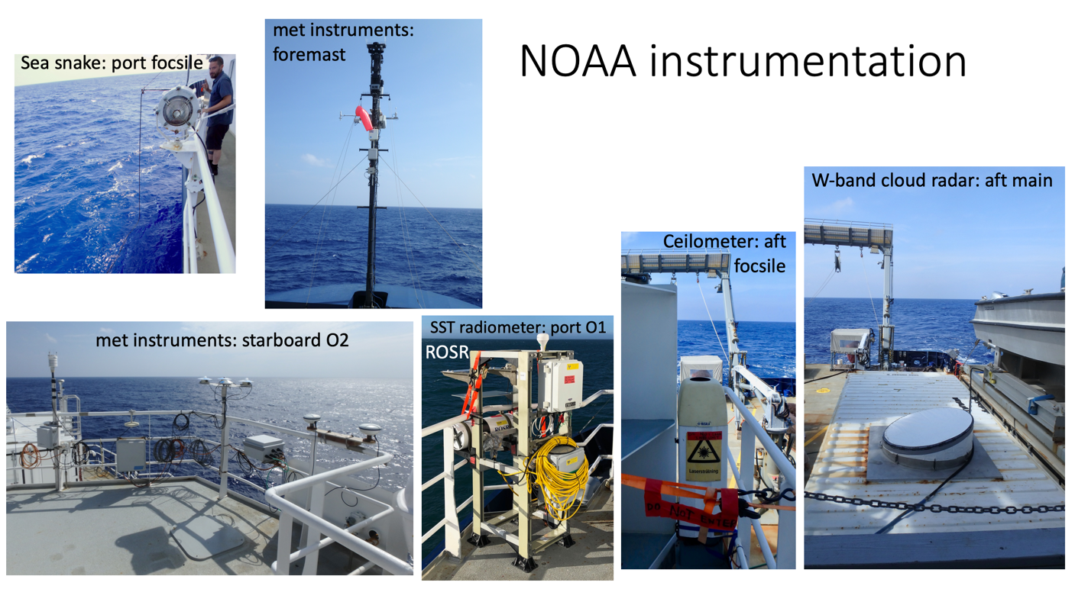
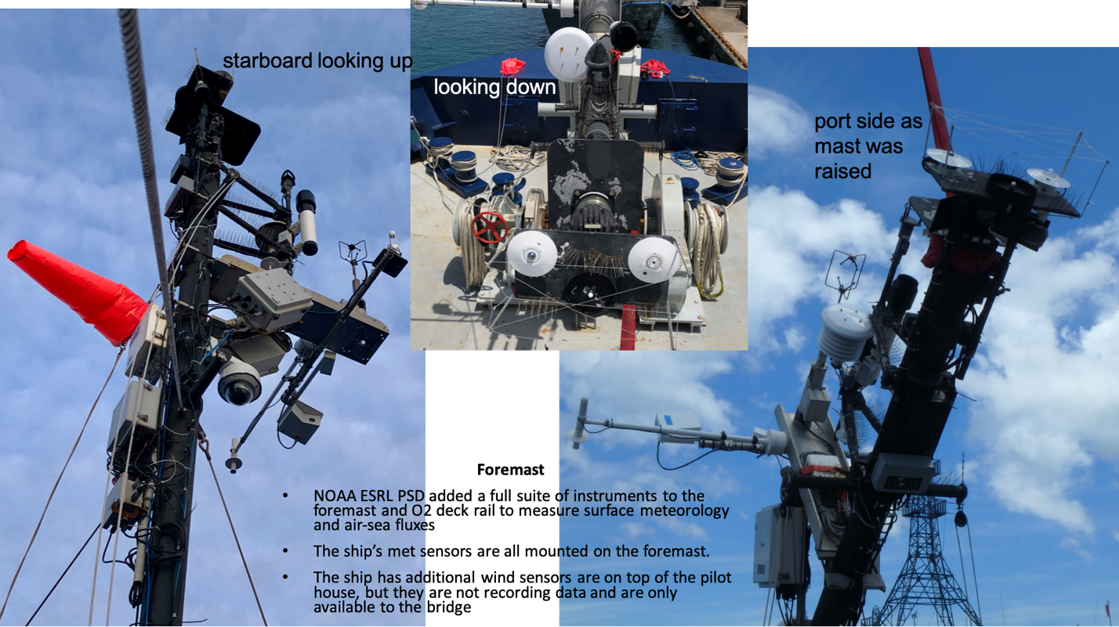

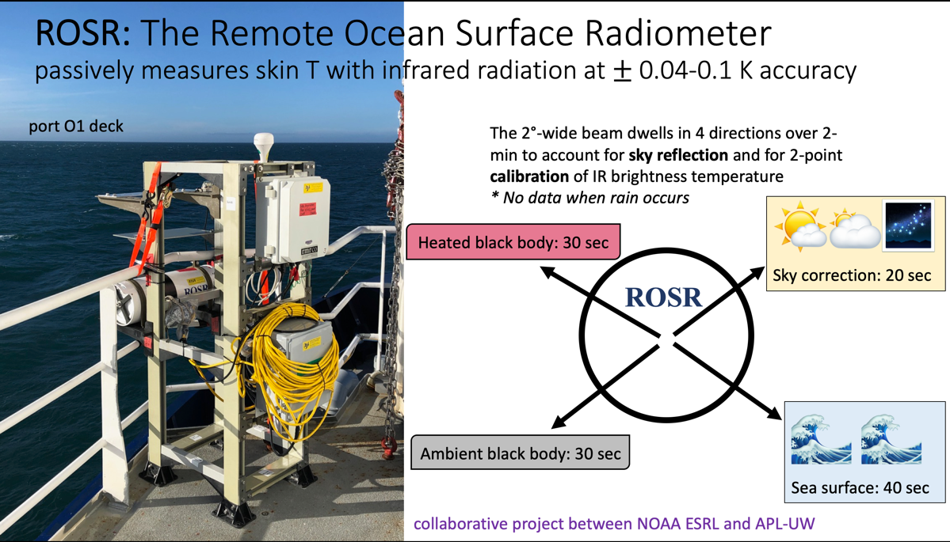
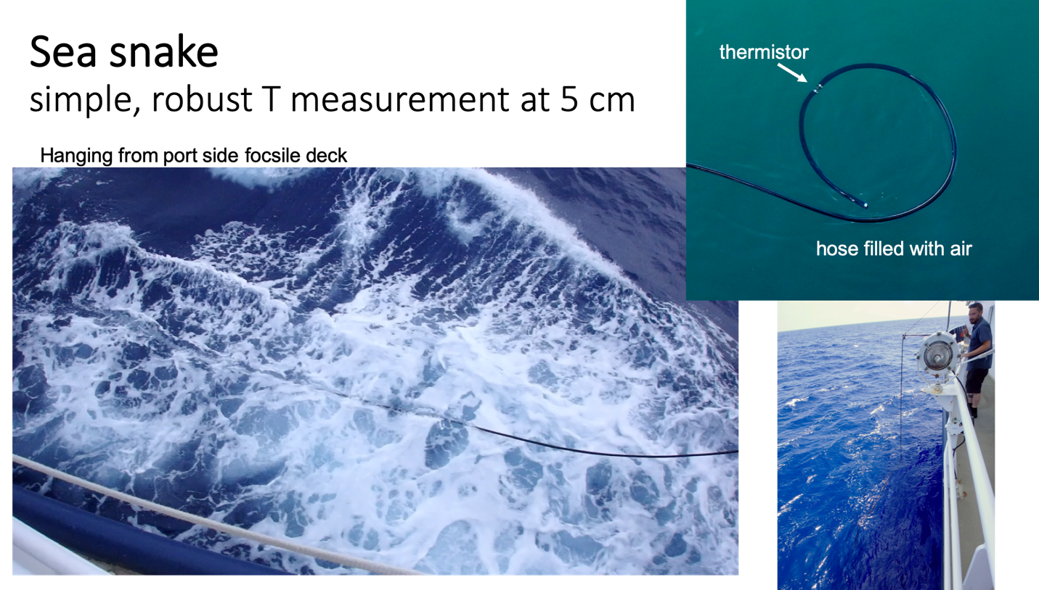
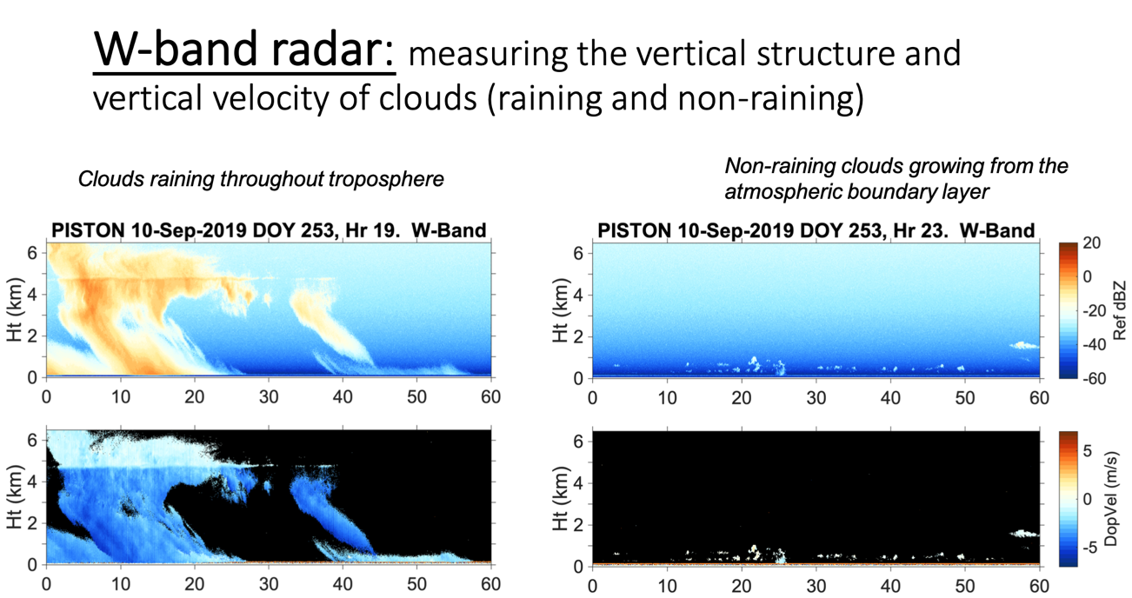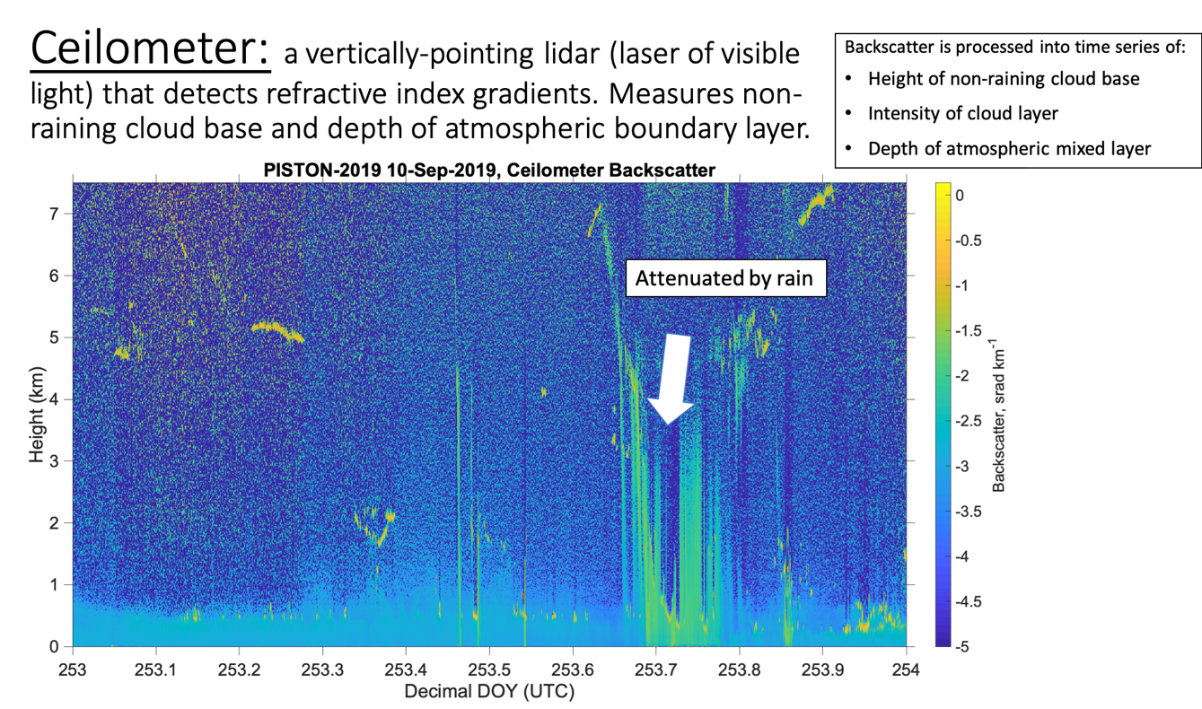
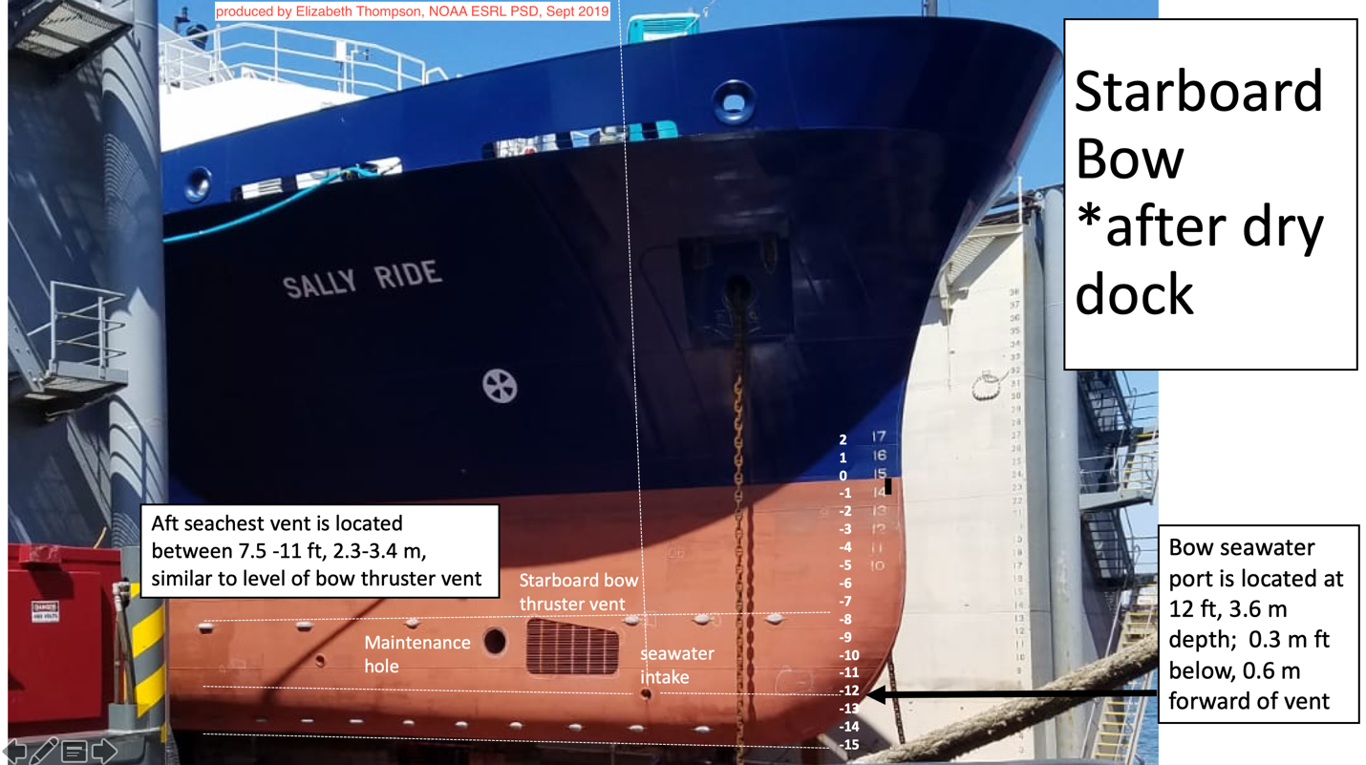

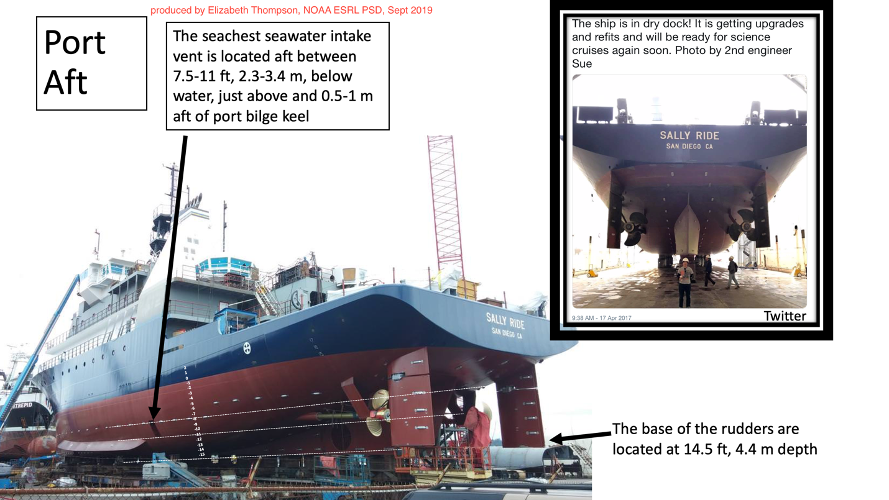

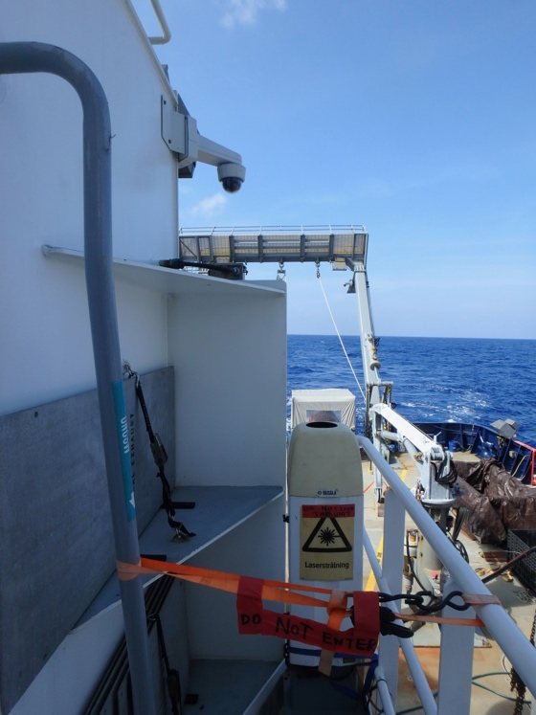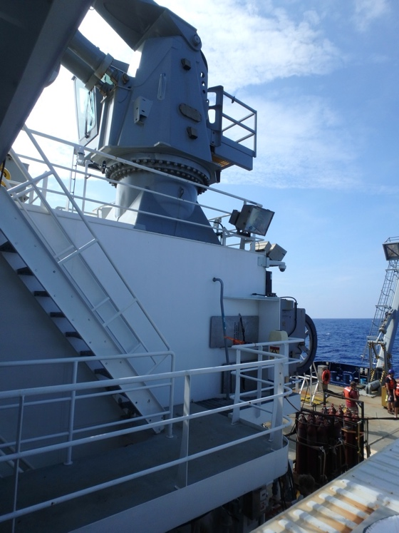
Photos of ceilometer on Sally Ride for PISTON 2019. Aft Focsle Deck.
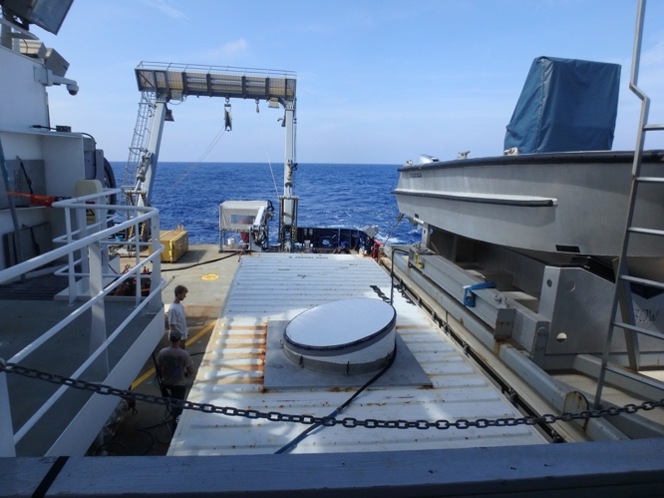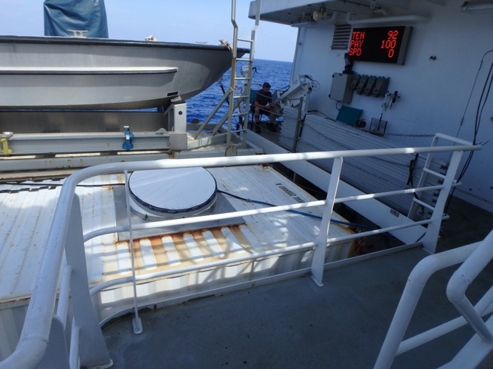
Photos of W-band radar on Sally Ride for PISTON 2019. Aft Focsle Deck. Next to smoking area, work boat, and ceilometer.

Preliminary Scientific Analysis:

The following time series show select output variables from meteorological, seawater, and flux data collection and preliminary processing. Notable to this dataset are the occurrence of several ocean diurnal warm layers, which warmed the sea surface temperature (SST), amplified the air-sea humidity and temperature gradients, and thereby accelerated the latent and sensible heat fluxes into the atmosphere. Despite low wind forcing, the sea surface heated and generated TKE in the atmospheric boundary layer. The strongest event was on 9/23, in which the SST warmed 2.5°C from sunrise to afternoon. During this time, the strongest values of the air-sea humidity gradients, sea surface specific humidity, and SST of the entire cruise occurred. When strong precipitation events occurred, atmospheric cold pools with gust fronts also amplified the air-sea T difference, which caused larger sensible heat fluxes into the atmosphere. Also notable were a few extremely cloudy days that resulted in almost zero values of downwelling solar radiation. This occurred on 9/17 and 9/20. On these two days the net surface heat flux was negative all day (9/17) or only briefly positive (9/20), resulting in ocean cooling that is evident in the SST plots.
Please see readme above for more description of variables plotted below. dT = sea - air temperature difference (SST - T10) and same for dq for specific humidity. 10-m values of U, T, and q are for properties adjusted to 10 m reference height and for neutral atmospheric stability.
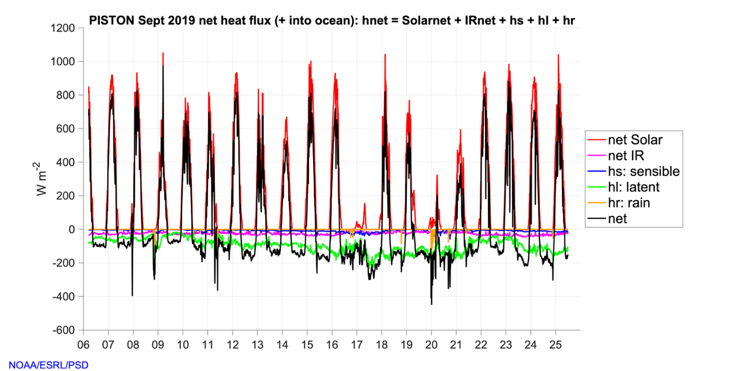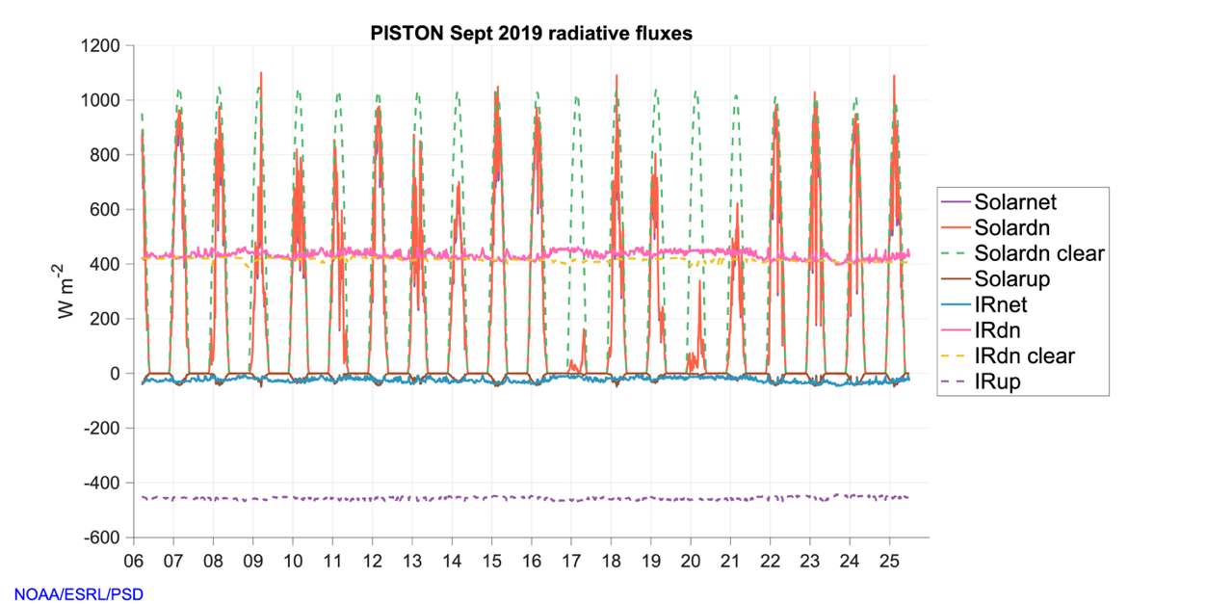
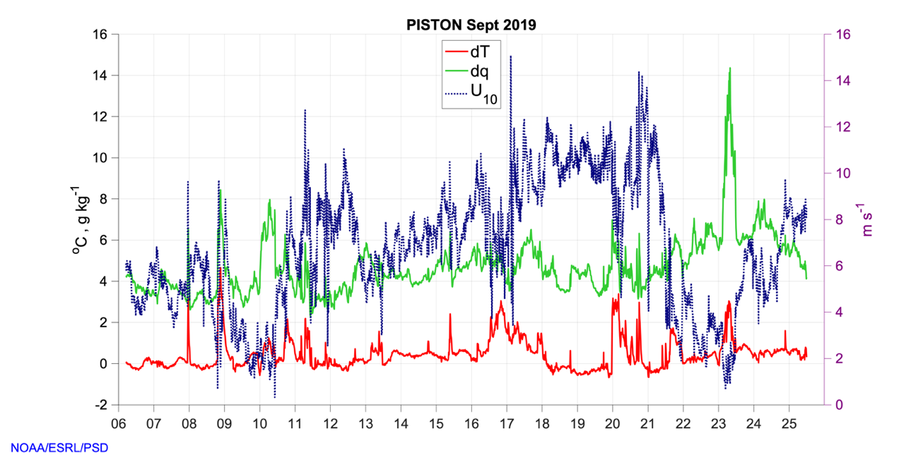
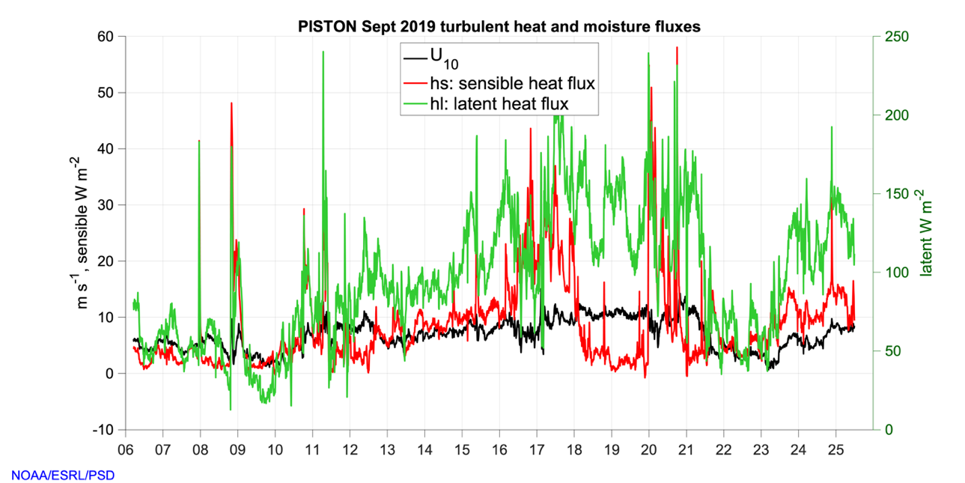
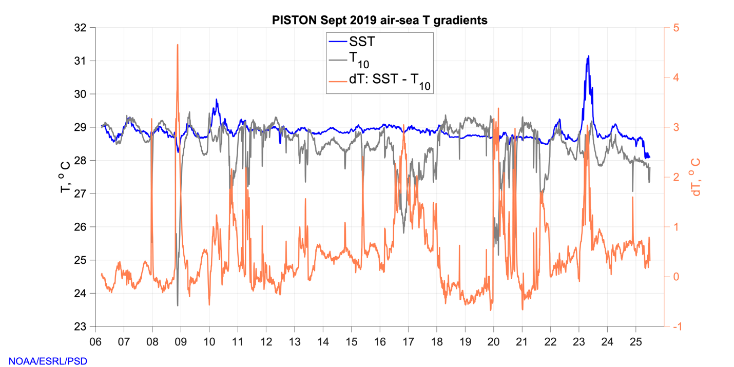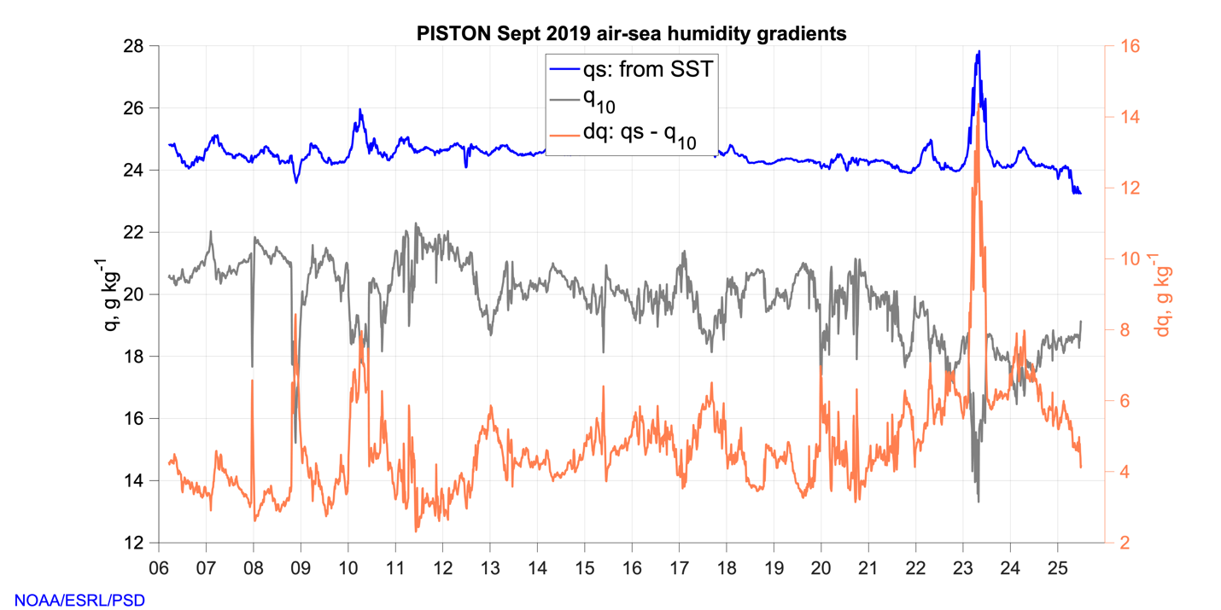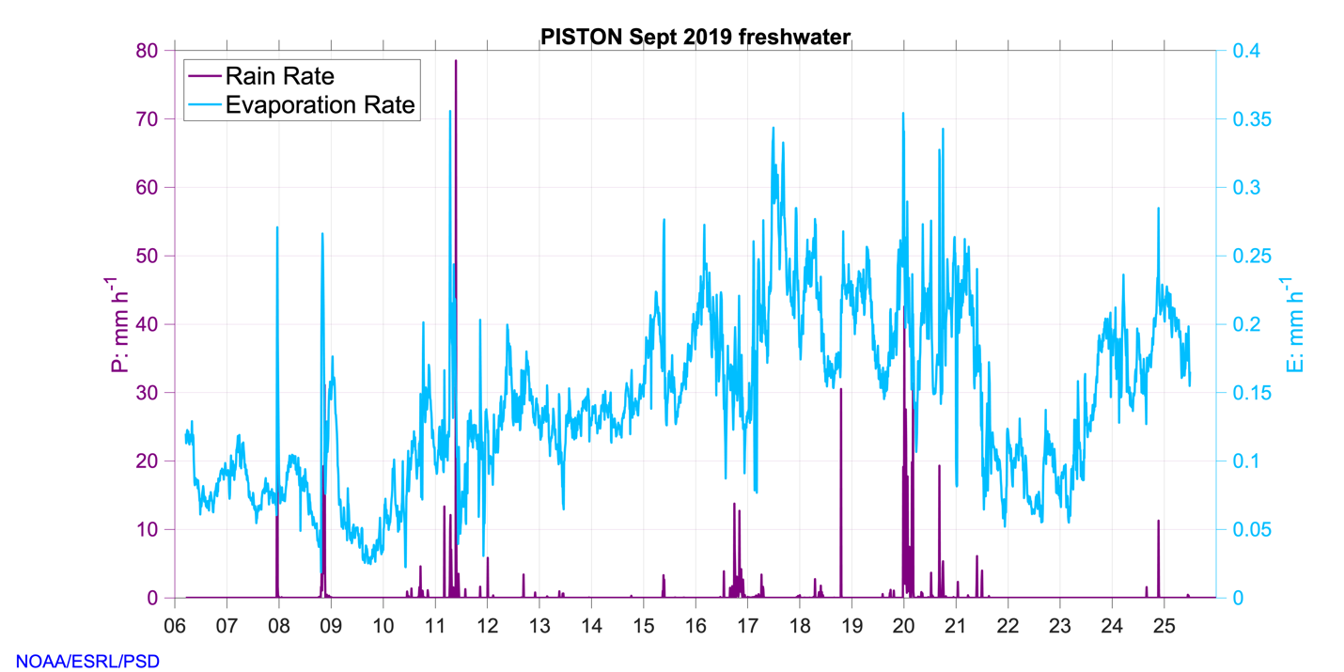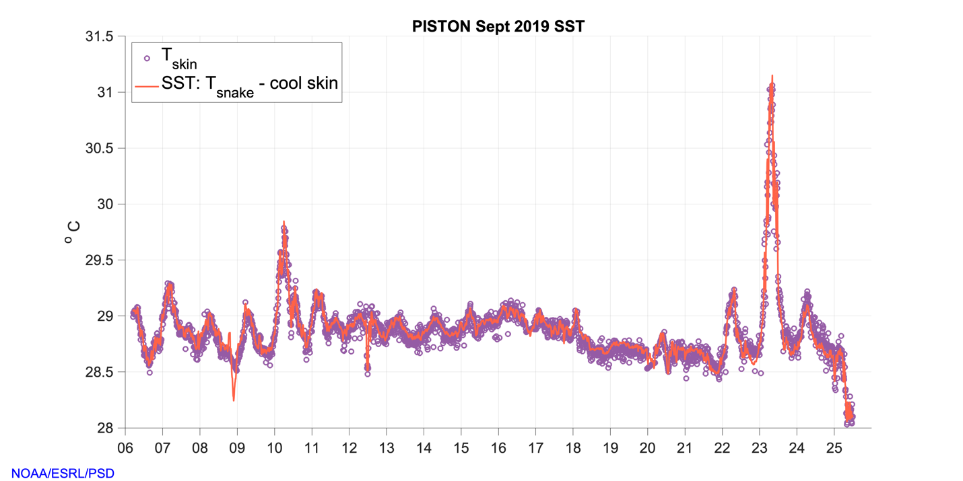
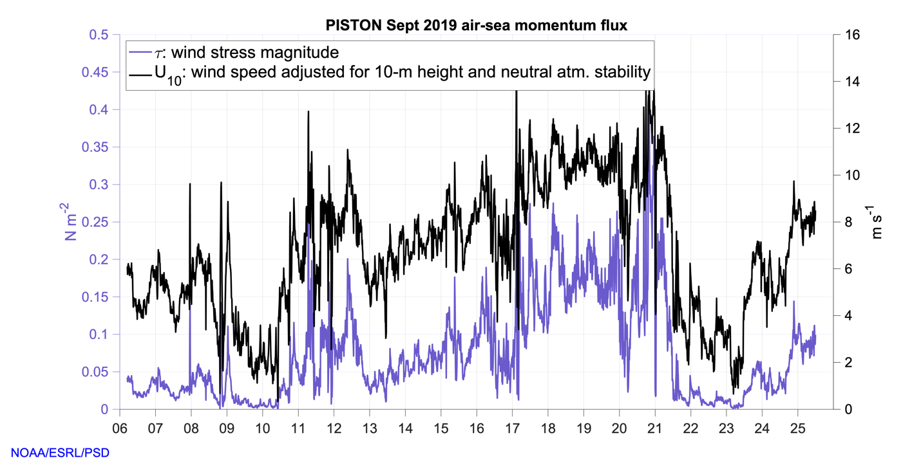

References:

Edson, J. B., Jampana, V., Weller, R. A., Bigorre, S. P., Plueddemann, A. J., Fairall, C. W., Miller, S., Mahrt, D., Vickers, & D., Hersbach, H. (2013). On the exchange of momentum over the open ocean. Journal of Physical Oceanography, 43(8), 1589–1610. https://doi.org/10.1175/JPO-D-12-0173.1

Fairall, C. W., Bradley, E. F., Godfrey, J. S., Wick, G. A., Edson, J. B., & Young, G. S. (1996). Cool-skin and warm-layer effects on sea surface temperature. Journal of Geophysical Research, 101(C1), 1295–1308. https://doi.org/10.1029/95JC03190

Fairall, C. W., White, A. B., Edson, J. B., & Hare, J. E. (1997). Integrated shipboard measurements of the marine boundary layer. Journal of Atmospheric and Oceanic Technology, 14(3), 338–359. https://doi.org/10.1175/1520-0426(1997)014<0338:ISMOTM>2.0.CO;2

Fairall, C. W., Bradley, E. F., Hare, J. E., Grachev, A. A., & Edson, J. B. (2003). Bulk parameterization of air-sea fluxes: Updates and verification for the COARE algorithm. Journal of Climate, 16(4), 571–591. https://doi.org/10.1175/1520-0442(2003)016<0571:BPOASF>2.0.CO;2

Moran, K., Pezoa, S., Fairall, C. W, Williams, C., Ayers, T., Brewer, A., de Szoeke, S. P., & Ghate, V. (2012): A Motion-Stabilized W-Band Radar for Shipboard Observations of Marine Boundary-Layer Clouds. Boundary-Layer Meteorol. (2012) 143: 3. https://doi.org/10.1007/s10546-011-9674-5

