Progress Report
High Resolution Climate Data from
Research and Volunteer Observing Ships
Period of Activity: 01 October 2019 - 30 September 2020
Principal Investigator | Financial Contact
Christopher W. Fairall | David Lee
NOAA ESRL/PSL | NOAA ESRL/PSL
325 Broadway | 325 Broadway
Boulder, CO 80305 | Boulder, CO 80305
Chris.fairall@noaa.gov | david.d.lee@noaa.gov
303-497-3253 | 303-497-6850
C.W. Fairall
Signature Date Signature
Co-Principal Investigator
Elizabeth J. Thompson
NOAA ESRL/PSL 325 Broadway
Boulder, CO 80305
Elizabeth.thompson@noaa.gov
303-497-6930
Budget Summary
FY 2020: $297,518

High Resolution Climate Data from Research and Volunteer Observing Ships
Christopher W. Fairall and Elizabeth J. Thompson
NOAA ESRL/PSL
325 Broadway
Boulder, CO 80305

Table of Contents

1. Project Summary
2. Scientific and Observing System Accomplishments
3. Outreach and Education
4. Publications and Reports
4.1. Publications by Principal Investigators
4.2. Other Relevant Publications
5. Data and Publication Sharing
6. Project Highlight Slides

Project Summary

The coupling of ocean and atmosphere is a critical contributor to variability of weather and climate. This coupling is quantitatively described by air-sea fluxes: the exchange of momentum, mass, moisture, and energy between ocean and air. Examples are: heat flux – solar energy and direct heat transfer; water flux – evaporation and rain; momentum flux – driving of waves and current by the wind; gas flux – absorption of CO2 by the ocean. Fluxes can be measured directly from ships and aircraft but current technology requires a PhD, an engineer, and 0.5 m$ of equipment. Fortunately, fluxes can be estimated with significant accuracy from near-surface meteorology variables obtained from NOAA’s ocean observing system (ships, buoys, drifters, and satellites). Flux estimates are made using so-called bulk flux algorithms – basically parameterizations of fluxes in terms of sea surface temperature, wind speed, air temperature, humidity, etc. The key to this process is obtaining very accurate measurements of those bulk variables plus very accurate bulk flux parameterizations.

ESRL has developed a roving standard air-sea flux measurement system to be deployed on research vessels on several oceanic cruises each year. The purpose is to develop/improve the bulk parameterizations and to promote high-quality climate observations from US research vessel fleet, satellites, and NOAA’s Flux Reference Buoys. This effort is critical to improving the accuracy of fluxes from NOAA’s ocean climate observing system. PSL maintains the NOAA bulk flux algorithm as a community resource. Currently, climate data from 31 research vessels are archived at Florida State University while the Flux Reference Buoy data are available at OceanSITES. Since 2003 PSL has conducted 67 cruise legs for GOMO purposes. We have visited NWS tropical buoys in the Pacific, Atlantic, and Indian Oceans plus Flux Reference Buoys in the N. Atlantic, off Chile and Hawaii, and in the Southern Ocean south of Tasmania.

The project is the result of a NOAA workshop on marine measurements which identified three important needs: 1) a data quality assurance program to ensure the observations meet accuracy requirements, 2) observations at high time resolution and, 3) more efficient utilization of research vessels. An additional aspect involves direct measurement and parameterization of sea-air exchange of heat, momentum, and CO2. The accuracy of buoy and volunteer ship observations must be improved and supplemented with high-quality measurements from the global research vessel fleet. This requires a careful intercomparison program to provide traceability of buoy, VOS, and R/V accuracy to a set of standards.

Scientific and Observing System Accomplishments
This project principally addresses the Climate Observation and Monitoring Program deliverables for improved observations of Air-Sea Exchange and Ocean Carbon Uptake and Content.

All tasks/milestones detailed in the work plan for 2020 were addressed.

* Progress on Milestones
In FY2020 three deployments of the PSL flux system were planned – WHOTS, Stratus, and ATOMIC/NTAS. Stratus was cancelled because of COVID. The roving standard was deployed on NOAA R/V Oscar Sette cruise in October 2019 for the WHOTS 2018 ORS buoy redeployment (Fig. 1). PSL data were shared with WHOI for the buoy calibration check. The full PSL flux system was deployed on the NOAA Ship Ronald H. Brown during the ATOMIC/NTAS project (2 cruise legs 1/7/2020-1/26/2020 and 1/29/2020- 2/13/2020 - see Fig. 2). Co-I Elizabeth Thompson worked closely with the Brown’s Survey Tech on the Brown’s SCS system. Problems with the meteorology and seawater observation system were found and, based on our input, corrected. During ATOMIC the Brown operated within 8 km of the ORS NTAS buoy for 118 hours. Our PSL team measured variables that were recomputed to the measurement heights of the buoy. These are the differences between NTAS and the ship (NTAS-PSL):
Ts (C) Ta (C) U (m/s) qa (g/kg) P (mb) Rs (W/m²) Rl (W/m²)
0.015 0.19 -0.14 0.52 -0.00 4.3 -8.1
An example for specific humidity (qa) is shown in Fig. 3 where it is clear the bias is statistically significant. These results are fairly typical for one of the limited comparisons with two of the variables (air temperature and IR radiative flux) falling slightly outside the accuracy guidelines (0.1 C and 5 W/m²). Part of this mean difference may be inaccuracy in the PSL measurements. These comparisons have led to an improved NTAS dataset on behalf of WHOI Upper Ocean Processes Group, who maintains a multi-decade dataset at this location.

We completed development of a fully automated bulk flux package for ships that reports processed data products daily via Iridium satellite link. The Iridium system was successfully tested in January 2020 during the ATOMIC field program. The automation involves a wireless router that connects to the PSL ftp server. This enables more automatic data reporting and archiving in public archives throughout the cruise, fulfilling our vision of an automated flux processing and data reporting system that all of NOAA can use even if we are not present on the cruise. This is a capacity building milestone for our group.

The PSL COARE Bulk Flux Algorithm was converted to an open-source python computing language and posted to the NOAA PSL Github site: https://github.com/noaa-psd/pyCOARE. This has already been helpful in assisting other groups with using the PSL flux data for the purposes of improving climate observations and performing research activities. PSL will continue to update both the matlab and python versions going forward, which we are told will be useful to a much larger observations and modeling community due to the multiple supporting languages.

We continued our efforts to improve/validate global surface flux products including cooperation with Dr. Huai-Min Zhang of NOAA NCDC on the Surface Flux Analysis (SURFA) project (http://www.ncdc.noaa.gov/oa/rsad/air-sea/surfa.html), with Lisan Yu of WHOI on the OAFlux product, and with the TPOS2020 team. Five papers were published on this work in 2019. We are currently working on a new effort using the massive data obtained from ships, aircraft, wave gliders, Saildrones, and drifters in the ATOMIC field program. Elizabeth Thompson is leading the ATOMIC/EUREC4A flux and sea surface temperature working group to consolidate the data and provide a more ready-to-use product for modeling and reanalysis teams.

Progress was made on data processing from the PISTON 2018 and 2019 cruises. We are following a new paradigm where level-4 data from the cruises are produced in universally formatted, well-documented netcdf format for increased utility by the scientific community. These data are initially stored at the PSL ftp site until being archived at NCEI and assigned a DOI. PISTON 2018 data are available at ftp://ftp1.esrl.noaa.gov/psd3/cruises/PISTON_MISOBOB_2018/TGT/scientific_analysis/updated_July_2020/ . This process will be completed for both PISTON years in calendar year 2020.

* GOMO Required Performance Measures:
- Number of observing days: 45 ship days
- Data availability at DAC: 100%
- Number of newly updated models: 1 python version of COARE flux algorithm https://github.com/noaa-psd/pyCOARE
- 2 metrics regarding number of publications
- Authored/co-authored by PI: 3 in print, 4 submitted
- Publications using data from observing system: too many to track

*Notable observing achievements
In 2020 we saw significant scientific accomplishments as noted through major publications and synthesis efforts:
- Publication of oceanic and atmospheric data on NCEI (with DOIs) obtained from the Ronald H. Brown and WP-3D from ATOMIC field program.
- Scientific advances on parameterization of gas transfer, including a new model of chemical enhancement for CO2 flux.
- A new independent evaluation of the accuracy of air temperature measurement was completed on the ATOMIC field program (see below).

*Scientific advances and significance.
Major progress has been made on the stable of COARE flux algorithms. We have recently made a major step forward in generalizing the COARE met and gas versions so that they can be extended up to 30 m/s wind speed. This has been done by bringing in new data sets and by using numerical simulations from the UNSW (Australia) wave model. This has allowed us to define wave-parameter based parameterizations of surface roughness, drag coefficient, whitecap fraction, and energy dissipated by wave breaking. For example, gas transfer is dependent on whitecap fraction which depends on wind and wave properties. The beta versions of COARE3.6 and COARE3.6G codes are now publicly available with data files and driver programs (ftp://ftp1.esrl.noaa.gov/BLO/Air-Sea/bulkalg/cor3_6/ ).

We have just completed an evaluation of chemical enhancement of CO2 flux that will become part of the COARE flux algorithm (see Fig 4). Chemical enhancement refers to increases in the flux of CO2 that results from carbonate system reactions in the ocean. Thus, CO2 has higher flux than other gases with the same solubility and diffusivity. The enhancement depends on the reaction time scale, which is thought to be on the order of 10 s. Our model results give the chemical enhancement of about 4 cm/hr for a 10-m wind speed of 5 m/s. The enhancement declines with wind speed. We are currently evaluating observations to estimate the enhancement (thus, determining the reaction time scale) and are working with collaborators in Europe on a publication of these advances.

The ATOMIC/NTAS field program provided a unique opportunity to evaluate the accuracy of the PSL air temperature measurements (claimed to be unbiased to 0.1 C) by comparing with the U. Miami (courtesy of P. Minnett) Marine-Atmosphere Emitted Radiance Interferometer (M-AERI). Solar heating of air temperature measurements is difficult to evaluate because of a lack of a standard. The M-AERI is a spectrally resolved IR radiometer that can measure air temperature radiatively to 0.04 C (unaffected by solar heating). It also costs k$350 compared to k$4 for the PSL sensor. This comparison (Fig. 5) showed a 0.1 C solar-induced high bias in the PSL sensor during the day. We were also able to show the modest effects of dynamic heating (proportional to relative wind speed squared) that is normally associated with aircraft measurements. This result shows that our accuracy (averaged over 24 hours) is as claimed and can be improved by applying a daytime bias correction.

*Issues: Stratus cruise cancelled because of COVID.

*Project website: https://www.esrl.noaa.gov/psd/psd3/air-sea/oceanobs/

Outreach and Education

Here are a few examples of public outreach (apologies about the commercials).
*Elizabeth Thompson and Chris Fairall were interviewed in the field by CBS News during ATOMIC
https://www.cbsnews.com/video/study-aims-to-examine-links-between-climate-change-and-clouds/ Both PIs were involved in 5 more published online outreach articles on ATOMIC by NOAA Research News (see links in Outreach section of https://www.psl.noaa.gov/people/elizabeth.thompson/EThompson_CV_website.pdf )
*Chris Fairall was interviewed by Jeff Berardelli for an article in Yale Climate Connections
https://www.yaleclimateconnections.org/2020/07/some-new-climate-models-are-projecting-extreme-warming-are-they-correct/
*Chris Fairall was interviewed on E&E News
https://www.eenews.net/stories/1063713311
*Chris Fairall was just interviewed by Tien Nguyen for a planned video on Science Insider. The video will be educational for children based on the question ‘How would life on earth be different if there were no clouds?’.

Our group is engaged in a variety of outreach/education activities under this project. The range of activities includes lectures for middle and high school science teachers (done through the CIRES outreach office and NOAA PSL). Several are listed on Elizabeth Thompson’s CV in Outreach and Education: https://www.psl.noaa.gov/people/elizabeth.thompson/EThompson_CV_website.pdf.
Currently the PI (C. Fairall) is on the PhD committee of one student at University of Melbourne (Sushma Chen Reddy). Elizabeth Thompson co-mentors a PhD student at the Applied Physics Laboratory at the University of Washington through the ATOMIC project, and another MS student at Colorado State University through our group’s prior DYNAMO project. Check out Ludovic Bariteau’s extensive blog for the HiWinGS project http://cires.colorado.edu/blogs/airseagas/ or Ola Persson’s from the Sea State cruise http://ciresblogs.colorado.edu/iceontheedge/ . In 2011 Dan Wolfe started developing a hands-on short course on methods, techniques, and instruments for meteorological observations from ships (done in cooperation with Shawn Smith at FSU) intended for seagoing MetTechs. The inaugural course was presented at the RVTech meeting in New Orleans in Dec. 2011 and five more have been done since. Course materials are available at ftp://ftp1.esrl.noaa.gov/BLO/Air-Sea/outreach/ . Sergio Pezoa has taken over this work after Dan Wolfe’s retirement. A third aspect of PSL outreach is in the form of technology transfer of our flux observation methods to other research entities (12 so far in 10 different countries). In the past we have transferred designs, methods, and software to other universities and laboratories doing similar work.

Publications and Reports
PSL has been submitting all PSL publications to NOAA’s Public Access to Research Results (PARR) since 2017. Copies of this year’s publications are at ftp://ftp1.esrl.noaa.gov/BLO/Air-Sea/oceanobs/pubs/fy20/ .

Publications by Principal Investigators
*Published
Hagos, S., G.R. Foltz, C. Zhang, E. Thompson, H. Seo, S. Chen, A. Capotondi, K.A. Reed, C. DeMott, and A. Protat, 2020: Atmospheric convection and air-sea interactions over the tropical oceans: Scientific Progress, Challenges and Opportunities. Bull. Amer. Meteor. Soc., 101, E253–E258, https://doi.org/10.1175/BAMS-D-19-0261.1

Norris, Joel R. F. Martin Ralph, Byron Blomquist, Forest Cannon, Reuben Demirdjian, Christopher W. Fairall, Paul J. Neiman, J. Ryan Spackman, Simone Tanelli, and Duane E. Waliser, 2020: An airborne and surface-based study of the complete water vapor budget and associated dynamical processes in an atmospheric river over the Northeast Pacific. J. Hydrometeorol., 21, 2655–2673, https://doi.org/10.1175/JHM-D-20-0048.1

Thompson, Elizabeth and 29 coauthors, 2020. NOAA Physical Sciences Laboratory (2020). The Atlantic Tradewind Ocean-Atmosphere Mesoscale Interaction Campaign (ATOMIC), Barbados, Jan 17 - Feb 12 2020. NOAA National Centers for Environmental Information. Dataset. https://accession.nodc.noaa.gov/ATOMIC-2020 .

*In Press
Bariteau, Ludovic; C.W. Fairall, B. Blomquist, and Sergio Pezoa, 2020: Summary of ship-based air-sea flux observations from 30 PSL field campaigns 1992-2018. NCEI Accession 0170257. Version 1.1. NOAA National Centers for Environmental Information. Dataset. Submitted.

Brizuela, N., S. Johnston, M. H. Alford, O. Asselin, D. L. Rudnick, J. N. Moum, and E. J. Thompson, 2020 submitted: Mixing, upwelling, and internal wave generation beneath Super Typhoon Mangkhut: a vorticity-divergence view of the ocean response to tropical cyclones. J. Phys. Ocean., in press.

PopStefanija, I., C.W. Fairall and E. Walsh, 2020: Mapping of directional wave spectra in hurricanes and other environments. IEEE JRS., in press.

Quinn, P.K., E. J.Thompson, C.W. Fairall and 27 additional coauthors, 2020: Measurements made on the RV Ronald H. Brown and related platforms as part of the Atlantic Tradewind Ocean-Atmosphere Mesoscale Interaction Campaign (ATOMIC). ESSD, submitted.

Stevens, B., and 245 coauthors, 2020: The EUREC4A field program. Advances, submitted.

*Technical Reports
Fairall, C.W., 2020: Regarding trends in the sea-surface temperature and 2-m air temperature difference over the oceans. PSL report requested by lead author for IPCC AR6 and CMIP6 assessment, pp 8.

Cronin, M. and 26 coauthors, 2020: Surface radiation observation best practices. Working group report. Evolving and sustaining OBPS Workshop IV. 18;21-25; 29 Sept., 2020.

Thompson, E. J., 2020: Underway TSG data readme and best practices for R/V Sally Ride. PSL report from PISTON 2019 cruise.

*Data Reports
Pezoa, S., 2020: WHOTS 2019 Bulk Meteorology System Ship-Based (October 2-12, 2019) aboard R/V Oscar Sette. PSL. Informal report.

Thompson, E.J., 2020: Report on NOAA Ship Ronald H. Brown and NTAS Flux Reference buoy during the ATOMIC field program meteorological and seawater measurements. PSL. Informal report.

Thompson, E.J., 2020: Report on R/V Sally Ride measurement systems during the PISTON field program meteorological and seawater measurements. PSL. Informal report.

DeSzoeke, Simon, 2020: Sea surface temperature from multiple in situ sensors on MISO-BOB 2019 research cruise. Oregon State University Report, https://ir.library.oregonstate.edu/concern/datasets/5138jn655 .

Other Relevant Publications
This project has produced 78 refereed publications since beginning in 2003 (see ftp site for cumulative list). These papers have received 7314 citations in Goggle Scholar (cumulative 2003 through Oct 2020). The three basic COARE bulk flux algorithm papers were cited 293 times so far in calendar 2020. One paper (Bulk parameterization of air-sea fluxes: Updates and verification for the COARE algorithm) has received 2027 total citations. In 2016 the 114 citations to that paper can be broken down as modelling - 28, analysis - 36, parameterization – 9, satellite – 9, and engineering – 2. The paper On the Exchange of momentum over the open ocean was cited in Lumpkin et al. 2020: Global Oceans one chapter from the State of the Climate in 2019 annual report https://doi.org/10.1175/BAMS-D-20-0105.1. Thompson also led writing of a White Paper Chapter on Observations as relevant for the recent NOAA Precipitation Prediction Grand Challenge, in which ocean and air-sea flux observations were a heavy focus.

Raw, processed, value-added, and synthesized data from this project are freely available at the ftp site (ftp://ftp1.esrl.noaa.gov/psd3/cruises/ ). The use of the COARE flux algorithms is extensive and difficult to track but the three principal publications have received more than 4500 citations. Furthermore, the use of our data is too extensive to track. Two recent examples include DeSzoke et al. (2017), Cold Pools and Their Influence on the Tropical Marine Boundary Layer, J. Atmos Sci., 74, 1149-1168; Moum et al. (2017), Ocean feedback to pulses of the Madden-Julian Oscillation in the equatorial Indian Ocean, NATURE Comm., 7, DOI: 10.1038/ncomms13203. Below are examples of additional recent papers using PSL data from the PISTON field campaign.

Hughes, K. G., J. N. Moum, and E. L. Shroyer, 2020: Heat Transport through Diurnal Warm Layers. J. Phys. Oceanogr., 50, 2885–2905, https://doi.org/10.1175/JPO-D-20-0079.1.

Hughes, K. G., J. N. Moum, and E. L. Shroyer, 2020: Evolution of the Velocity Structure in the Diurnal Warm Layer. J. Phys. Oceanogr., 50, 615–631, https://doi.org/10.1175/JPO-D-19-0207.1.

Hughes, K. G., J. N. Moum, and E. L. Shroyer, W.D. Smyth, 2020: Stratified shear instabilities in diurnal warm layers. J. Phys. Oceanogr., submitted.

Sobel A. H., J. Sprintall, E. Maloney, Z. Martin, S. Wang, S. de Szoeke, 2020: Large-scale state and evolution of the atmosphere during PISTON 2018.

Data and Publication Sharing

Our PSL Air-Sea Interaction Group website can be found at http://www.esrl.noaa.gov/psd/psd3/air-sea/. A project website has been established (High Resolution Climate Observations http://www.esrl.noaa.gov/psd/psd3/air-sea/oceanobs/ ).
Field processed data summaries for each cruise are transmitted at the end of the day to our ftp site (ftp://ftp1.esrl.noaa.gov/psd3/cruises/ ) with cruise-specific directories – these are publicly available (78 cruises at this writing). The full raw time series is added after the cruise. Updates after post-processing are posted as they become available. High-resolution data undergo thorough review and post-processing, and are made available to the public within one year after system recovery. The data archive maintained at NOAA/ESRL for ship-based measurements is not access restricted, but users of data in publications or presentations are requested to acknowledge the project. Final data products are be completed within one year of the individual cruise and are to be published in a NOAA archive (http://www.ncei.noaa.gov/) with a data DOI, metadata, and documentation as described in the NOAA data management plan (https://geo-ide.noaa.gov/wiki/index.php?title=Category:Data_Management_Plans).

Our PSL flux group has always pursued an open data access policy. After a field program our data go onto the ftp site and are publically available and we do not attempt to track usage. We encourage scientists to contact us about use of the data and this leads to co-authorship on publications (roughly 11 of the 78 publications on the project list). For example: “Which bulk aerodynamic algorithms are least problematic in computing ocean surface turbulent fluxes?” by Brunke et al. (2003) or “Marine boundary layer height over the Eastern Pacific” but Zeng et al. (2004) or “An evaluation of HIRS near-surface air temperature product in in the Arctic” by Peng et al. (2016). Once a particular set of data appears in one of our papers, we consider it to be ‘published’ and we don’t expect co-authorship (acknowledgments are nice) unless we contribute to the paper in other ways. For example, we were acknowledged in “An assessment of the uncertainties in ocean surface turbulent fluxes in 11 re-analysis, satellite-derived, and combined global datasets” by Brunke et al. (2011). In many cases, we open a new paper and see a graph with points labelled “Ship Observations” and that is the first indication we have that someone has used our observations. To get an idea we did a search on one example and located 7 papers in the literature that use the STRATUS Synthesis data set.

6. Project Highlight Slides
Attached separately.

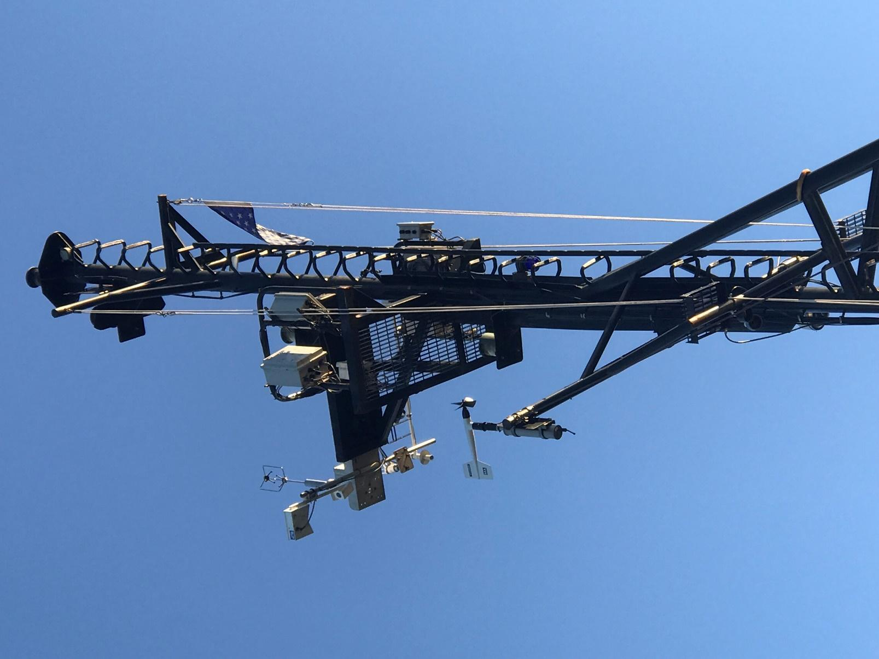

Figure 1. PSL flux sensors installed on the bow mast of NOAA ship Oscar Sette for WHOTS ORS buoy cruise October 2019.

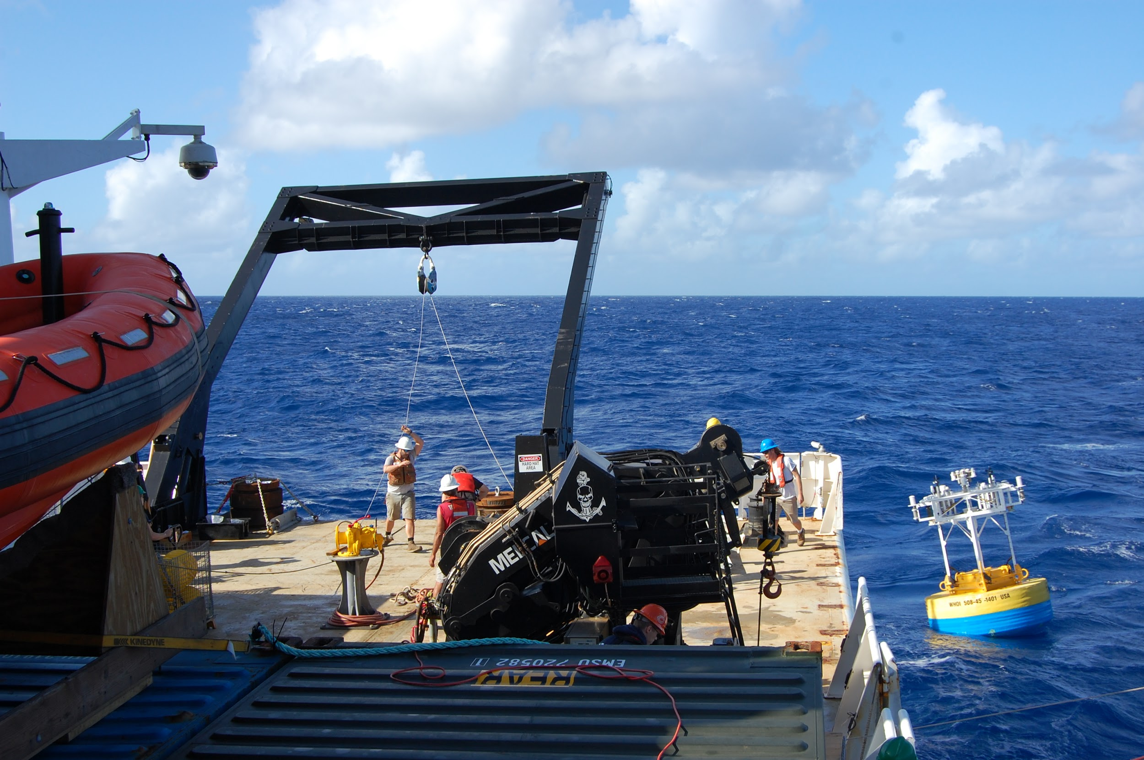
Figure 2. WHOI ORS buoy being deployed from NOAA Ship Ronald H. Brown during the ATOMIC and NTAS turnaround cruise January-February 2020. The PSL flux system was on board for cross calibration as part of this project.

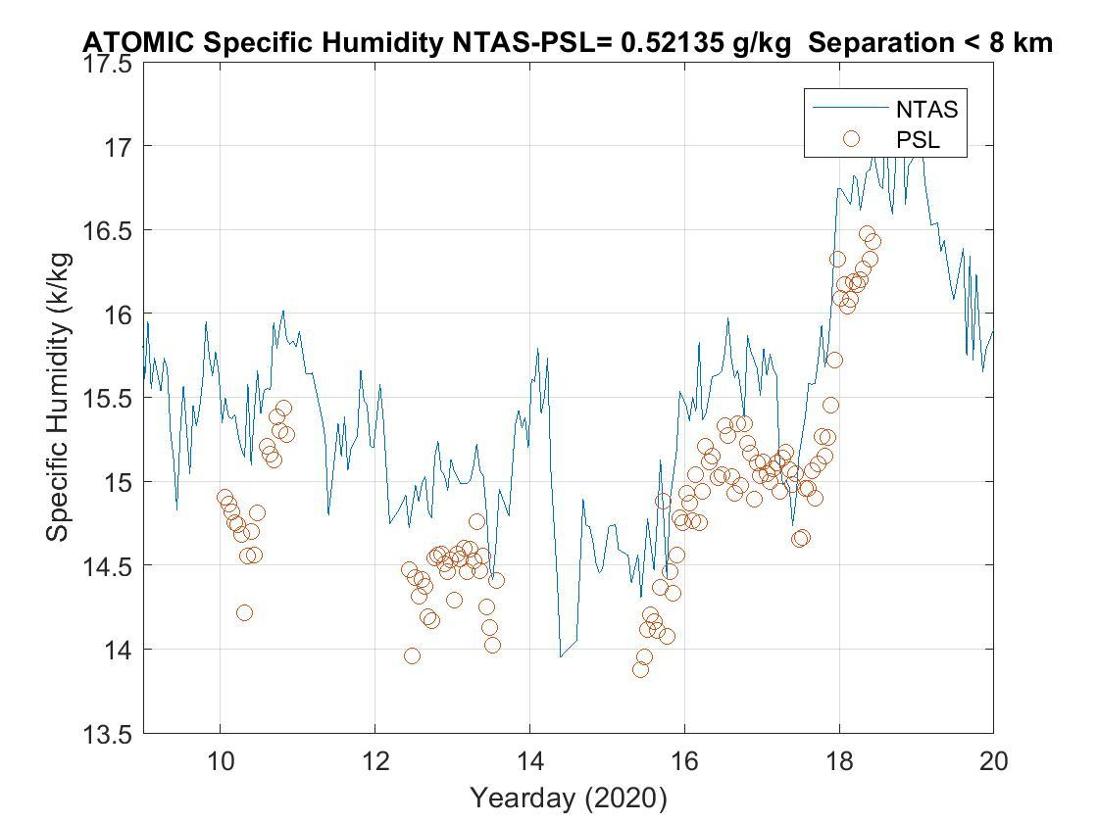
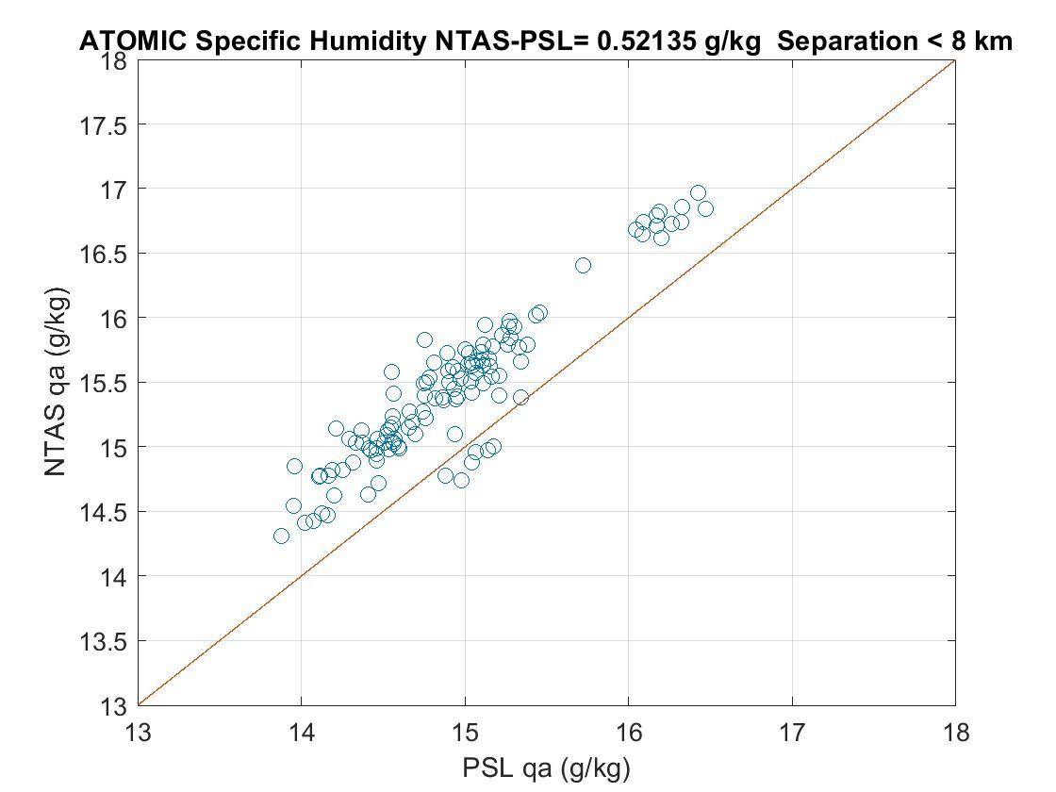
Figure 3. Comparison of PSL standard system and NTAS buoy measurements of specific humidity from the ATOMIC/NTAS cruise on the Ronald H. Brown in January 2020. The PSL data have been corrected to the NTAS sensor height using the COARE algorithm. Upper panel is the time series of NTAS data (line) with circles denoting PSL data where the ship is within 8 km of the buoy. The buoy values are about 3% higher than the standard.

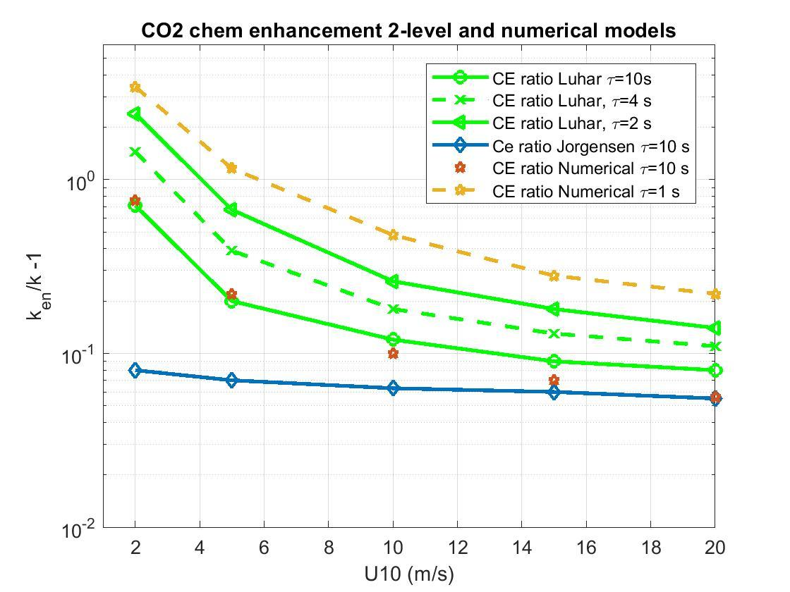
Figure 4. Model computations of carbonate chemical enhancement of CO2 transfer velocity expressed as the ratio of the enhanced velocity, k_{en}, to the inert transfer velocity, k, vs wind speed for different values of the CO2 reaction rate, τ. The air-sea CO2 flux is proportional to k_{en}. k is non-bubble component of the transfer velocity and is approximately linear in wind speed. The stars are an exact numerical computation from the turbulent-molecular chemical reaction budget equation. The green lines are for an analytical approximation to that equation. The blue symbols are from the model of Jorgensen et al. (A simple model of chemistry effects on the air-sea CO2 exchange coefficient. JGR Oceans, 125, e2018JC014808. https://doi.org/10. 1029/2018JC014808 ). Direct observations by the PSL team suggest τ is on the order of 4 s.

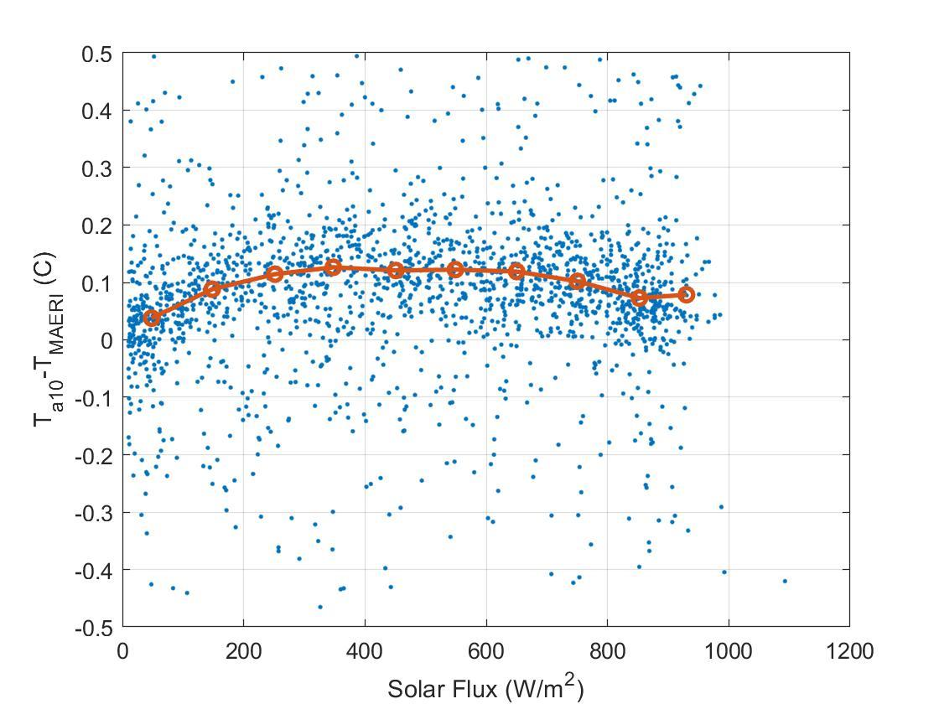
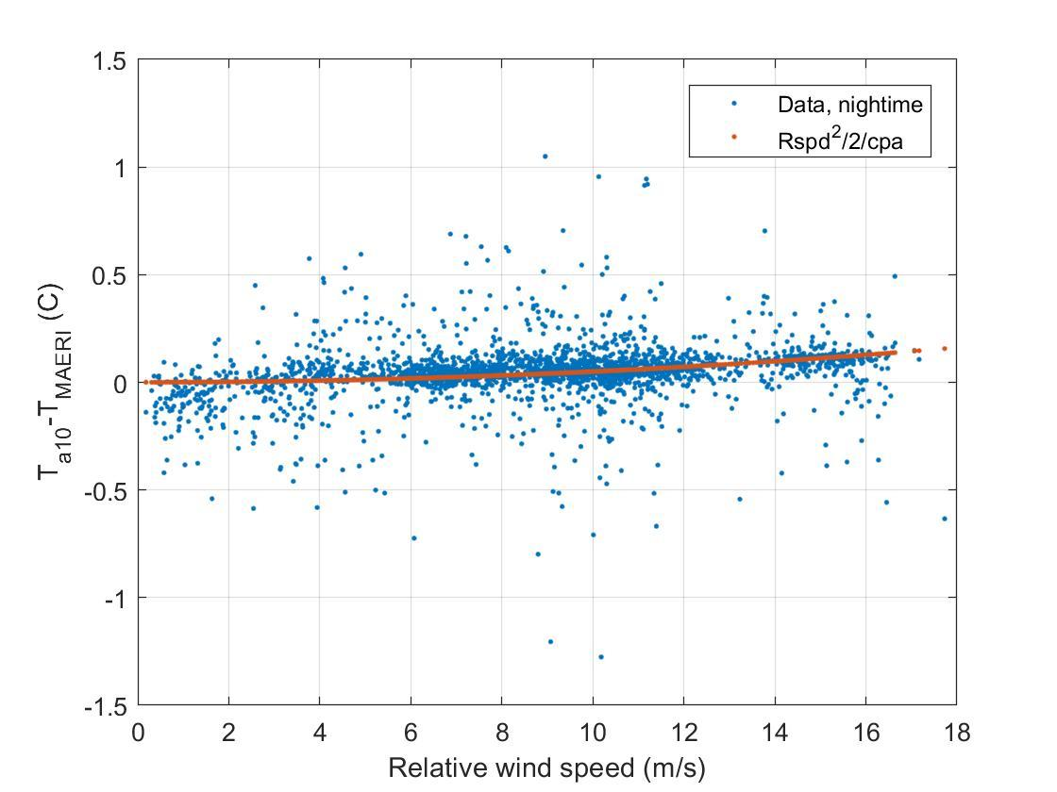
Figure 5. Comparison of PSL aspirated air temperature sensor with U. Miami Marine-Atmosphere Emitted Radiance Interferometer (M-AERI). The M-AERI is a spectrally resolved IR radiometer that can measure air temperature to 0.04 C. We have divided the comparison into daytime (upper panel, difference vs downward solar flux) and night time (lower panel, difference vs wind speed). The upper panel suggests a high bias of the PSL air temperature during daytime of about 0.1 C. The night time bias is negligible but does show the effects of dynamic heating (adiabatic compression) in agreement with the theoretical form where U_{rel} is the relative wind speed and c_{pa} the specific heat of air.

