Progress Report

Project Title

**High Resolution Climate Data from Research and Volunteer Observing Ships**

Period of Activity: 01 October 2021 – 30 September 2022

|  |  |  |
| --- | --- | --- |
| **Principal Investigator**  Christopher Fairall  NOAA PSL  325 Broadway  Boulder, CO 80304  chris.fairall@noaa.gov  Tel: 303 945 5529 | **Financial Contact**  Tina Schiffbauer  NOAA PSL  325 Broadway  Boulder, CO 80304  tina.schiffbauer@noaa.gov |  |
| C.W. Fairall   |  |  | | --- | --- | | Signature | Date | | ________________________  Signature Date |  |

|  |  |  |
| --- | --- | --- |
| **Co-Principal Investigator**  Elizabeth J. Thompson  NOAA PSL  325 Broadway  Boulder, CO 80304  elizabeth.thompson@noaa.gov  Tel: 405 250 5552 |  |  |

**Budget Summary**

FY 2022: $372,518

**High Resolution Climate Data from Research and Volunteer Observing Ships**

Christopher W. Fairall and Elizabeth J. Thompson

NOAA ESRL/PSL

325 Broadway

Boulder, CO 80305

**Table of Contents**

1. Project Summary

2. Scientific and Observing System Accomplishments

3. Outreach and Education

4. Publications and Reports

4.1. Publications by Principal Investigators

4.2. Other Relevant Publications

5. Data and Publication Sharing

6. Project Highlight Slides

# Project Summary

The coupling of ocean and atmosphere is a critical contributor to variability of weather and climate. This coupling is quantitatively described by air-sea fluxes: the exchange of momentum, mass, moisture, and energy between ocean and air. Examples are: heat flux – solar energy and direct heat transfer; water flux – evaporation and rain; momentum flux – driving of waves and current by the wind; gas flux – absorption of CO2 by the ocean. Fluxes can be measured directly from ships and aircraft but current technology requires a PhD, an engineer, and $0.5M of equipment. Fortunately, fluxes can be estimated with significant accuracy from near-surface meteorology variables obtained from NOAA’s ocean observing system (ships, buoys, drifters, and satellites). Flux estimates are made using bulk flux algorithms –parameterizations of fluxes in terms of sea surface temperature, wind speed, air temperature, humidity, etc. The key to this process is obtaining very accurate measurements of the bulk variables plus very accurate bulk flux parameterizations.

PSL has developed a roving standard air-sea flux measurement system to be deployed on research vessels on oceanic cruises. The purpose is to develop/improve the bulk parameterizations and to promote high-quality climate observations from US research vessel fleet, satellites, and NOAA’s Flux Reference Buoys. This effort is critical to improving the accuracy of fluxes from NOAA’s ocean climate observing system. PSL maintains the NOAA bulk flux algorithm as a community resource. Currently, climate data from 31 research vessels are archived at Florida State University and the Flux Reference Buoy data are available at OceanSITES. Since 2003 PSL has conducted 68 flux-observing cruises for GOMO purposes. We have visited NWS tropical buoys in the Pacific, Atlantic, and Indian Oceans plus Flux Reference Buoys in the N. Atlantic, off Chile and Hawaii, and in the Southern Ocean south of Tasmania.

The project is the result of a NOAA workshop on marine measurements which identified three important needs: 1) a data quality assurance program to ensure that observations meet accuracy requirements, 2) observations at high time resolution and, 3) more efficient utilization of research vessels. An additional aspect of the project involves obtaining accurate direct flux measurements to train and improve bulk parameterizations of sea-air exchange of heat, water, momentum, and CO2. The accuracy of buoy and volunteer ship observations must be improved and supplemented with high-quality measurements from the global research vessel fleet. This requires a careful intercomparison program to provide traceability of buoy and ship accuracy so that these datasets can achieve research community standards.

# Scientific and Observing System Accomplishments

1. Progress on the milestones and performance measures.

In FY2022 one deployment of the PSL flux system was planned – WHOTS. The roving standard flux system was deployed on NOAA R/V *Oscar Sette* for the WHOTS 2022 ORS (Ocean Reference Site) buoy redeployment (Figs. 1 and 2). PSL data were shared with WHOI (Woods Hole Oceanographic Institution) for the buoy calibration check. The *Sette* was in the vicinity of the WHOTS ORS buoy from 22 July to 29 July 2022. PSL provided a report comparing the WHOTS-17 and WHOTS-18 buoys plus the ship’s meteorological data.

In 2020 the PSL COARE Bulk Flux Algorithm version 3.5 was converted to an open-source python computing language and posted to the NOAA PSL github site: <https://github.com/noaa-psd/pyCOARE>. In 2021 a fortran version of version 3.5 was produced that is structured to run in NOAA’s operational weather model FV3/UFS. A second version was produced in a form parallel to the matlab and python codes intended for processing data. This has already been helpful in assisting modeling groups with using the PSL flux data for the purposes of improving climate observations, research models, and performing research activities. In 2022 we completed posting of fortran, Matlab, and python versions to github. PSL will continue to update both the matlab, fortran, and python versions going forward, which will be useful to a much larger observations and modeling community due to the multiple supporting languages. After a synthesis of 25 years of theoretical advances, technological development, and observations new versions of the COARE gas transfer codes were completed in 2022 (COAREG36) and two papers were published (Fairall et al. 2022; Yang et al. 2022). An example of the grand ensemble transfer velocity for CO2 from Yang et al is shown in Fig. 3. The codes are now available at https://downloads.psl.noaa.gov/BLO/Air-Sea/bulkalg/cor3_6/

gasflux36/ but will be moved to github next year. Also see the OAR Hot Item at : <https://hub.oar.noaa.gov/Hot-Items/category/physical-sciences-lab/air-sea-trace-gas-fluxes-direct-and-indirect-measurements.aspx> . Considerable work has been done investigating the role of ocean bubbles generated by breaking waves on gas transfer with publication of two papers on bubble observations in high winds (Czerski et al. 2022a and 2022b).

We continued our efforts to improve/validate global surface flux products including cooperation with Lisan Yu of WHOI on the OAFlux product, and with the TPOS2020 team. The PI participates in TPOS2020 working group meetings. The PI and co-I both presented work from this GOMO grant at workshops designed in collaboration with TPOS, or that directly influence TPOS. These are the 2021 US CLIVAR Workshop on Tropical Pacific Ocean Observing Needs for Modeling Advances (TPON), and internal seminars at NOAA ESRL. We are currently working on a new effort using the massive data obtained from ships, aircraft, wave gliders, Saildrones, and drifters in the ATOMIC field program. This is a new separate project funded by GOMO/COM/CVP, however it leverages expertise and experience from this GOMO project. Elizabeth Thompson, co-I of this project, is leading the new separate project. The project formed the ATOMIC + EUREC4A field campaign flux, wave, sea surface temperature working group that will consolidate the data into a synthesized product, and provide a more ready-to-use product for modeling and reanalysis teams.

We have been working with WHOI and University of Hawaii to analyze the long time series (up to 20 years depending on the buoy) of data from the three ORS buoys. Several papers are in progress with one (Weller et al. 2022) just published in BAMS. The BAMS paper compares buoy flux observations to reveal significant biases in reanalysis products and CMIP6 climate models. PSL has been focusing on understanding the role of cloud variability in the forcing of the surface energy budget. We have just completed an analysis of the linkage of tropical surface energy budget components using data from previous PSL ship cruises. This paper (Fairall et al. 2023: Surface energy budgets in tropical organized convection. *J. Clim.*) is currently in internal review. This study shows how tropical convective disturbances have a major influence on oceanic surface energy budgets with the cooling associated with the strong reduction in solar flux during forcing events (such as MJO) being enhanced by 50% by the latent heat flux (see Fig. 4).

We worked with PMEL to complete the first direct covariance flux computations from Saildrone platforms. Our PSL code and expertise was shared directly with PMEL. Saildrones are a major advance in ocean flux observation capability – including hurricanes. The paper (Eyre, J.R., M.F. Cronin, D. Zhang, C.W. Fairall, E. Thompson, 2022: Saildrone direct covariance wind stress in different wind and current regimes of the tropical Pacific. *J. Geophys. Res*.) is in review.

Progress was made on data processing from the PISTON and MISOBOB 2018 and 2019 cruises. We are following a new paradigm where final processed data from the cruises are produced in universally formatted, well-documented netcdf format for increased utility by the scientific community. These data are initially stored at the PSL ftp site until being archived at NASA and NOAA NCEI (depending on the project), and assigned a public DOI. This process was completed for both PISTON years in 2022, and will soon be posted on the NASA and/or NCEI websites with a DOI. These DOIs will soon be active: 10.5067/SUBORBITAL/PISTON2018-ONR-NOAA/RVTHOMPSON/DATA001, 10.5067/SUBORBITAL/PISTON2019-ONR-NOAA/RVSALLYRIDE/DATA001, and data are already here: <https://downloads.psl.noaa.gov/psd3/cruises/> organized by year and cruise.

We have also been working on a combined flux database that will be published at NCEI. It will include both bulk and direct fluxes, near-surface meteorology and seawater properties, as well as ship location and navigation information from all our research cruises over 3 decades. These data are from research field campaigns as well as all GOMO funded cruises. All cruises are formatted in consistent, universal, open-source netcdf format. The data will be submitted to NCEI soon, and a data-paper readme style publication will be submitted soon to ESSD.

Upgrades and replacements of sensors this past year helped improve and maintain our research-quality system of bulk and direct fluxes. We began an effort to build and/or purchase parts for an Iridium satellite based automatic data reporting system that would transfer ship flux data daily from sea to shore. This could allow cruises in the future to require less or no people on board the ship, depending on the needs of the experiment. This could reduce the burden on time and travel for our group members for obtaining needed flux estimates over the ocean. Even when our cruises are still staffed with team members aboard the ship, the automatic reporting system would help share data automatically with team members on land to help troubleshoot, process, and fix data with faster turnaround. After evaluating an Iridium system from AOML, we have now built our own Iridium system and integrated it with our standard bulk flux system and will be field testing it in 2023.

* *GOMO Required Performance Measures: FY2022*

* Number of observing days: 8 ship days
* Data availability at data acquisition system: 100%
* Number of newly updated models: 1 matlab version of COARE gas flux algorithm
* 2 metrics regarding number of publications
* Authored/co-authored by PIs: 8 in print, 5 submitted
* Publications using data from observing system: too many to track

1. Notable observing achievements during FY 2022

In 2022 we saw significant scientific accomplishments as noted through major publications and dataset synthesis efforts, improvements to the COARE bulk flux algorithm, and equipment upgrades:

*Publication of synthesis papers on the air-ocean CO2 transfer velocity (Yang et al. 2022) and parameterization of trace gases (Fairall et al. 2022).

*Scientific advances on parameterization of air-sea fluxes via a new model of the SST cool skin effect, as well as other minor changes that will be released in COARE version 4.0 soon by WHOI.

*Publication of a synthesis paper on ORS mooring flux observations (Weller et al. 2022).

*Flux observing system was improved by upgrading instruments where needed. Construction of an Iridium satellite-based automatic data reporting system to work between the ship and land.

1. Scientific advances and significance of your work

*Continued advancement of COARE flux algorithms for stress, energy, moisture, and trace gases.

*Publication of a paper on modeling the effect of sea spray on hurricanes (Barr et al. 2022)

*Continued advancement in air-sea flux measurements from unattended platforms included buoys (with WHOI) and Saildrones (with PMEL).

1. Instrumental records of [Essential Ocean Variables](http://www.goosocean.org/index.php?option=com_content&view=article&id=14&Itemid=114) , [Essential Climate Variables](https://www.ncdc.noaa.gov/gosic/gcos-essential-climate-variable-ecv-data-access-matrix),

PSL archives essential variables of near-surface atmospheric and oceanic mean properties plus air sea fluxes from routine cruises to ORS buoys and all research cruises.

1. Issues: Stratus cruise cancelled because of COVID19.
2. The PSL Air-Sea Interaction Group website can be found at <http://www.psl.noaa.gov/psd3/air-sea/>. A project website has been established (High Resolution Climate Observations <http://www.psl.noaa.gov/psd3/air-sea/oceanobs/> ).

# Outreach and Education

Our group has been engaged in a variety of outreach/education activities under this project in FY2022. The range of activities includes assisting in creating lectures on fluxes for CU Boulder collaborators, mentoring of several undergraduate and graduate students, and NOAA Research News articles. Several are listed on Elizabeth Thompson’s CV in Outreach and Education: <https://www.psl.noaa.gov/people/elizabeth.thompson/EThompson_CV_website.pdf>.

Currently the PI (C. Fairall) is on the PhD committee of one student at University of Melbourne (Sushma Chen Reddy). Elizabeth Thompson co-mentored a PhD student at the Applied Physics Laboratory at the University of Washington through the ATOMIC project, who graduated in FY22. Elizabeth was the mentor for an undergraduate student this past summer (Alex Penunri). Alex participated in the WHOTS cruise in 2022. Elizabeth is an informal mentor of another MS student at Colorado State University through our group’s prior DYNAMO project. Elizabeth is also mentoring Julio Ceniceros who is working at PSL as a coop PhD student learning about turbulence and air-sea fluxes. In 2011 Dan Wolfe started developing a hands-on short course on methods, techniques, and instruments for meteorological observations from ships (done in cooperation with Shawn Smith at FSU) intended for seagoing MetTechs. The inaugural course was presented at the *RVTech* meeting in New Orleans in Dec. 2011 and five more have been done since. Course materials are available at <https://downloads.psl.noaa.gov/BLO/Air-Sea/outreach/> . A third aspect of PSL outreach is in the form of technology transfer of our flux observation methods to other research entities (12 so far in 10 different countries). In the past we have transferred designs, methods, and software to other universities and laboratories doing similar work.

Another aspect of outreach in the prior year is input to the larger scientific enterprise relevant to GOMO. Using experience and knowledge from this project, Elizabeth and Chris participated in two workshops focused on long term observing systems, research, and the synergy between the two. In May 2021 [US CLIVAR Tropical Pacific Observing Needs to Advance Process Understanding and Representation in Models Workshop](https://usclivar.org/meetings/tpon-2021) (TPON). Elizabeth and Chris both presented research related to this project at the workshop, and Elizabeth was a keynote speaker of the former. Elizabeth co-authored the Session 3 portion of [the workshop report](https://cpo.noaa.gov/Portals/0/Docs/ESSM/Events/2020/NOAA_DOE_PrecipWorkshopReport_July2021.pdf?ver=2021-07-14-160100-057) on interdisciplinary processes (air-sea-land-ice) related to CONUS precipitation processes and predictability. Elizabeth is helped to put on US CLIVAR Gulf Stream air-sea workshop in June 2022, contributing to that workshop report, wrote first-author and co-author newsletter articles on tropical Pacific Observing needs/challenges, and is co-authoring a white paper on Air-Sea Transition Zone as part of multiagency sponsored study group. We are also co-authors of a forthcoming whitepaper (led by Laura Riihimaki, GMDL) on best practices of measurement of radiative fluxes over the ocean.

In the last year, we have also used our expertise gained in this project to support federal interagency ship decision making, planning, and improvement. Byron Blomquist represents our team on the [UNOLS Fleet Improvement Committee](https://www.unols.org/committee/fleet-improvement-committee-fic), Elizabeth and Chris both participate in NOAA calls for input to improve and maintain the NOAA ship fleet. Elizabeth and Chris communicate with the NOAA Ship *Ronald H. Brown* staff on equipment that could be purchased and installed to improve their system. Elizabeth and Chris also have been in discussion with the UNOLS team tasked with starting three new Regional Class Research Vessels. After participating in a workshop in the last year, Science Trials are planned for each of the three ships in the same style that this grant works: the PSL flux system will be deployed alongside the new UNOLS equipment and compared for accuracy in many different ship orientations and steaming speeds. Advice was also given to the UNOLS committee on which equipment to prioritize regarding accurate meteorology, ocean, and flux measurements.

# Publications and Reports

PSL has been submitting all PSL publications to NOAA’s Public Access to Research Results (PARR) since 2017. Copies of this year’s publications are at <https://downloads.psl.noaa.gov/BLO/Air-Sea/oceanobs/pubs/fy22/> which includes paper in press, submitted, internal reports, and white papers.

## Publications by Principal Investigators

***\*Published***

Weller, R.A., Roger Lukas, James Potemra, Albert. J. Plueddemann, C.W. Fairall, and Sebastien Bigorre, 2022: Ocean Reference Stations: Long-term in situ observations of surface meteorology and air-sea fluxes at fixed open ocean locations are essential. *Bull. Amer. Met. Soc*., **103**. <https://doi.org/10.1175/BAMS-D-21-0084.1>.

Yang, Thomas G. Bell, Jean Bidlot, Byron W. Blomquist, Brian J. Butterworth, Yuanxu Dong, C. W. Fairall, Sebastian Landwehr, Christa A. Marandino, Scott D. Miller, Eric S. Saltzman, Alexander Zavarsky, 2022: Global synthesis of air-sea CO2 transfer velocity estimates from ship-based eddy covariance measurements. *Front. Mar. Sci.., Sec. Ocean Observation*, 9:826421 (15p). <https://doi.org/10.3389/fmars.2022.826421>.

Fairall, C.W., Ming-Xi Zhang, S.E. Brumer, B. Blomquist, T. Bell, J.B. Edson, S. Pezoa, E. Saltzmann, Elizabeth Thompson, C.J. Zappa, and L. Bariteau, 2022: Air-sea trace gas fluxes: Direct and indirect measurements*. Front. Mar. Sci.,* *Sec. Ocean Observation* **9:**826606 (16p). <https://doi.org/10.3389/fmars.2022.826606>.

Barr, Benjamin W., Shuyi S. Chen,and C. W. Fairall, 2022: Seastate-dependent sea spray and air-sea heat fluxes in tropical cyclones from a fully coupled atmosphere-wave-ocean model. *J. Atmos. Sci.,* <https://doi.org/10.1175/JAS-D-22-0126.1>.

Czerski, H., I. M. Brooks, S. Gunn, R. Pascal, A. Matei and B. W. Blomquist, 2022: Ocean bubbles under high wind conditions – Part 2: Bubble size distributions and implications for models of bubble dynamics. *Ocean Sci.*, **18** (3), 587–608, <https://doi.org/10.5194/os-2021-104>.

Czerski, H., I. M. Brooks, S. Gunn, R. Pascal, A. Matei and B. W. Blomquist. 2022: Ocean bubbles under high wind conditions. Part 1: Bubble distribution and development. *Ocean Sci.*, **18** (3), 565–586, <https://doi.org/10.5194/os-2021-103>.

Iyer, S., J. Thomson, E. J. Thompson and K. Drushka, 2022: Variations in wave slope and momentum flux from wave-current interactions in the tropical trade winds. *J. Geophys. Res. Oceans*, **127** (3), e2021JC018003, <https://doi.org/10.1029/2021JC018003>.

Iyer, S., Drushka, K., Thompson, E. J., & Thomson, J., 2022. Small-scale spatial variations of air-sea heat, moisture, and buoyancy fluxes in the tropical trade winds. Journal of Geophysical Research: Oceans, 127, <https://doi.org/10.1029/2022JC018972>

Shackelford, K., C. A. DeMott, P. J van Leeuwan, E. J. Thompson, S. Hagos, 2022: Rain-induced stratification of the tropical Indian Ocean and its potential feedbacks to the atmosphere. Journal of Geophysical Research, Oceans, <https://doi.org/10.1029/2021JC018025>

***\*In Review***

Eyre, J.R., M.F. Cronin, D. Zhang, C.W. Fairall, E. Thompson, 2022: Saildrone direct covariance wind stress in different wind and current regimes of the tropical Pacific. *J. Geophys. Res*., in press.

Bariteau, Ludovic; C.W. Fairall, B. Blomquist, and Sergio Pezoa, 2022: Summary of ship-based air-sea flux observations from 30 PSD field campaigns 1992-2020. NCEI Accession 0170257. Version 1.1. NOAA National Centers for Environmental Information. Dataset. Submitted.

Brizuela, N., S. Johnston, M. H. Alford, O. Asselin, D. L. Rudnick, J. N. Moum, and E. J. Thompson, 2020: Mixing, upwelling, and internal wave generation beneath Super Typhoon Mangkhut: a vorticity-divergence view of the ocean response to tropical cyclones. *J. Geophys. Res.*., in press.

CLIVAR *Variations* White Papers / Newsletter Articles: Satellite Observations and Needs for Air Sea Interaction; Tropical Pacific in-situ Observing System (to be released this winter/spring)

Reid, J. and many coauthors including E. J. Thompson: The coupling between tropical meteorology, aerosol science, convection and the energy budget during the Clouds, Aerosol Monsoon Processes Philippines Experiment (CAMP2Ex). *Bull. Am. Met. Soc.*, submitted.

***\*Data Reports***

Blomquist, B., 2022: WHOTS 2022 Bulk Meteorology System Ship-Based (Aug 25 – Sep 2, 2021) aboard *R/V Oscar Sette*. PSD. Informal report.

## Other Relevant Publications

This project has produced 89 refereed publications since beginning in 2003 (see ftp site for cumulative list). These papers have received 8696 citations in Goggle Scholar (cumulative 2003 through Oct 2022). The three basic COARE bulk flux algorithm papers were cited 330 times so far in calendar 2022. One paper *(Bulk parameterization of air-sea fluxes: Updates and verification for the COARE algorithm*) has received 2494 total citations. In 2016 the 114 citations to that paper can be broken down as modelling - 28, analysis - 36, parameterization – 9, satellite – 9, and engineering – 2. The paper *On the Exchange of momentum over the open ocean* was cited in Lumpkin et al. 2020: *Global Oceans* one chapter from the State of the Climate in 2019 annual report <https://doi.org/10.1175/BAMS-D-20-0105.1>. This paper was included on the list of most influence papers in the first 50 years of the *Journal of Physical Oceanography*.

Raw, processed, value-added, and synthesized data from this project are freely available at the ftp site (<https://downloads.psl.noaa.gov/psd3/cruises/> ). The use of the COARE flux algorithms is extensive and difficult to track but the three principal publications have received more than 5200 citations. Furthermore, the use of our data is too extensive to track. Two recent examples include DeSzoke et al. (2017), *Cold Pools and Their Influence on the Tropical Marine Boundary Layer*, J. Atmos Sci., 74, 1149-1168; Moum et al. (2017), *Ocean feedback to pulses of the Madden-Julian Oscillation in the equatorial Indian Ocean*, NATURE Comm., 7, DOI: 10.1038/ncomms13203. Below are examples of additional recent papers using PSL data from the PISTON field campaign:

Hughes, K. G., J. N. Moum, and E. L. Shroyer, 2020: Heat Transport through Diurnal Warm Layers. *J. Phys. Oceanogr.*, **50**, 2885–2905, <https://doi.org/10.1175/JPO-D-20-0079.1>.

Hughes, K. G., J. N. Moum, and E. L. Shroyer, 2020: Evolution of the Velocity Structure in the Diurnal Warm Layer. *J. Phys. Oceanogr.*, **50**, 615–631, <https://doi.org/10.1175/JPO-D-19-0207.1>.

Hughes, K. G., J. N. Moum, and E. L. Shroyer, W.D. Smyth, 2020: Stratified shear instabilities in diurnal warm layers. *J. Phys. Oceanogr.*, submitted.

Sobel A. H., J. Sprintall, E. Maloney, Z. Martin, S. Wang, S. de Szoeke, 2020: Large-scale state and evolution of the atmosphere during PISTON 2018.

# Data and Publication Sharing

Our PSL Air-Sea Interaction Group website can be found at <http://www.psl.noaa.gov/psd3/air-sea/>. A project website has been established (High Resolution Climate Observations <http://www.psl.noaa.gov/psd3/air-sea/oceanobs/> ).

Field processed data summaries for each cruise are transmitted at the end of the day to our ftp site (<https://downloads.psl.noaa.gov/psd3/cruises/> ) with cruise-specific directories – these are publicly available (80 cruises at this writing). The full raw time series is added after the cruise. Updates after post-processing are posted as they become available. High-resolution data undergo thorough review and post-processing, and are made available to the public within one year after system recovery. The data archive maintained at NOAA/ESRL for ship-based measurements is not access restricted, but users of data in publications or presentations are requested to acknowledge the project. Final data products are be completed within one year of the individual cruise and are to be published in a NOAA archive (<http://www.ncei.noaa.gov/>) with a data DOI, metadata, and documentation as described in the NOAA data management plan (<https://geo-ide.noaa.gov/wiki/index.php?title=Category:Data_Management_Plans>).

The PSL flux group has always pursued an open data access policy. After a field program our data go onto the ftp site and are publicly available and we do not attempt to track usage. We encourage scientists to contact us about use of the data and this leads to co-authorship on publications (roughly 11 of the 87 publications on the project list). For example: “Which bulk aerodynamic algorithms are least problematic in computing ocean surface turbulent fluxes?” by Brunke et al. (2003) or “Marine boundary layer height over the Eastern Pacific” but Zeng et al. (2004) or “An evaluation of HIRS near-surface air temperature product in in the Arctic” by Peng et al. (2016). Once a particular set of data appears in one of our papers, we consider it to be ‘published’ and we don’t expect co-authorship (acknowledgments are nice) unless we contribute to the paper in other ways. For example, we were acknowledged in “An assessment of the uncertainties in ocean surface turbulent fluxes in 11 re-analysis, satellite-derived, and combined global datasets” by Brunke et al. (2011). In many cases, we open a new paper and see a graph with points labelled “Ship Observations” and that is the first indication we have that someone has used our observations. To get an idea we did a search on one example and located 7 papers in the literature that use the STRATUS Synthesis data set.

**6. Project Highlight Slides**

Attached separately.

**Figures**

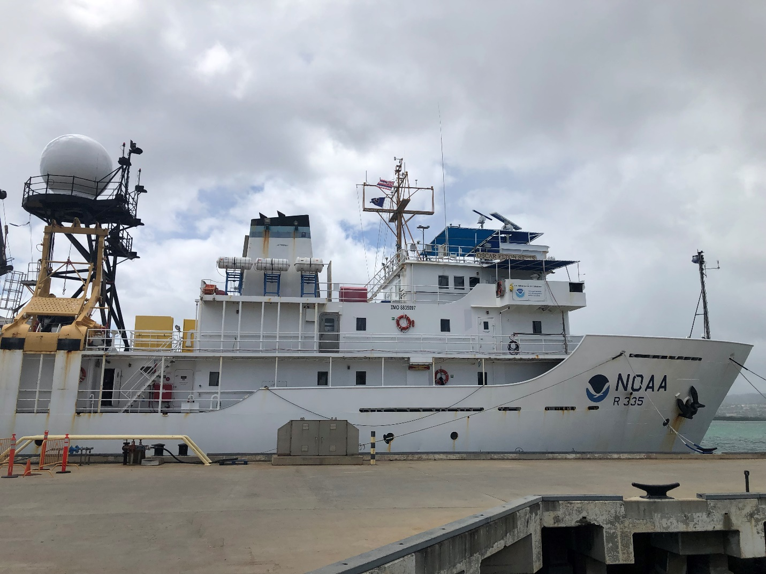

Figure 1: RV *Oscar Elton Sette,* bow and bridge profile for 2022 WHOTS deployment. PSL meteorology sensors are on the bow mast.

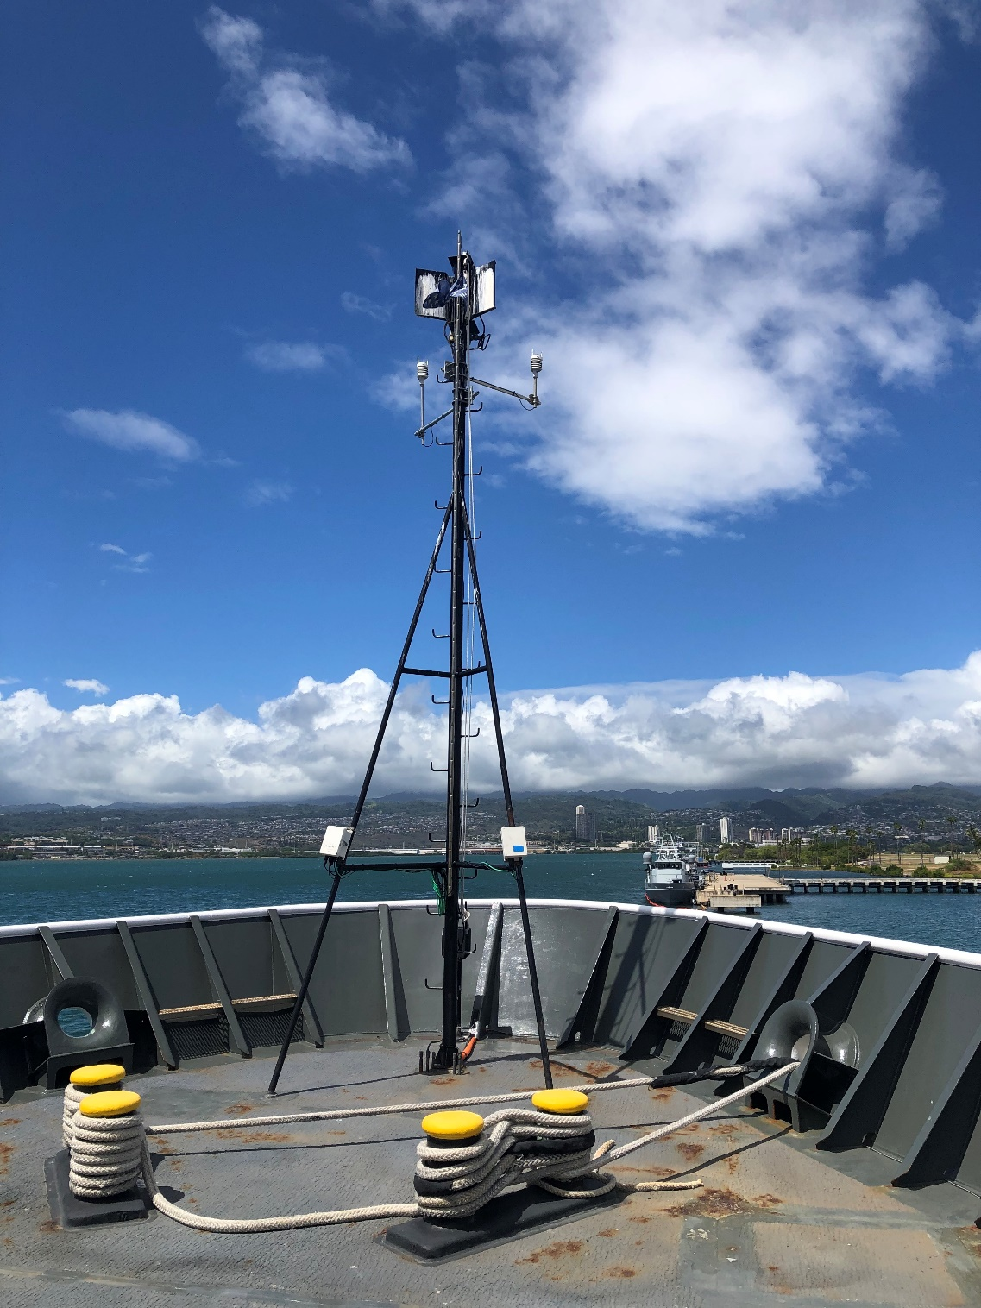

Figure 2. Bow mast meteorological sensor installation 2022 WHOTS deployment.

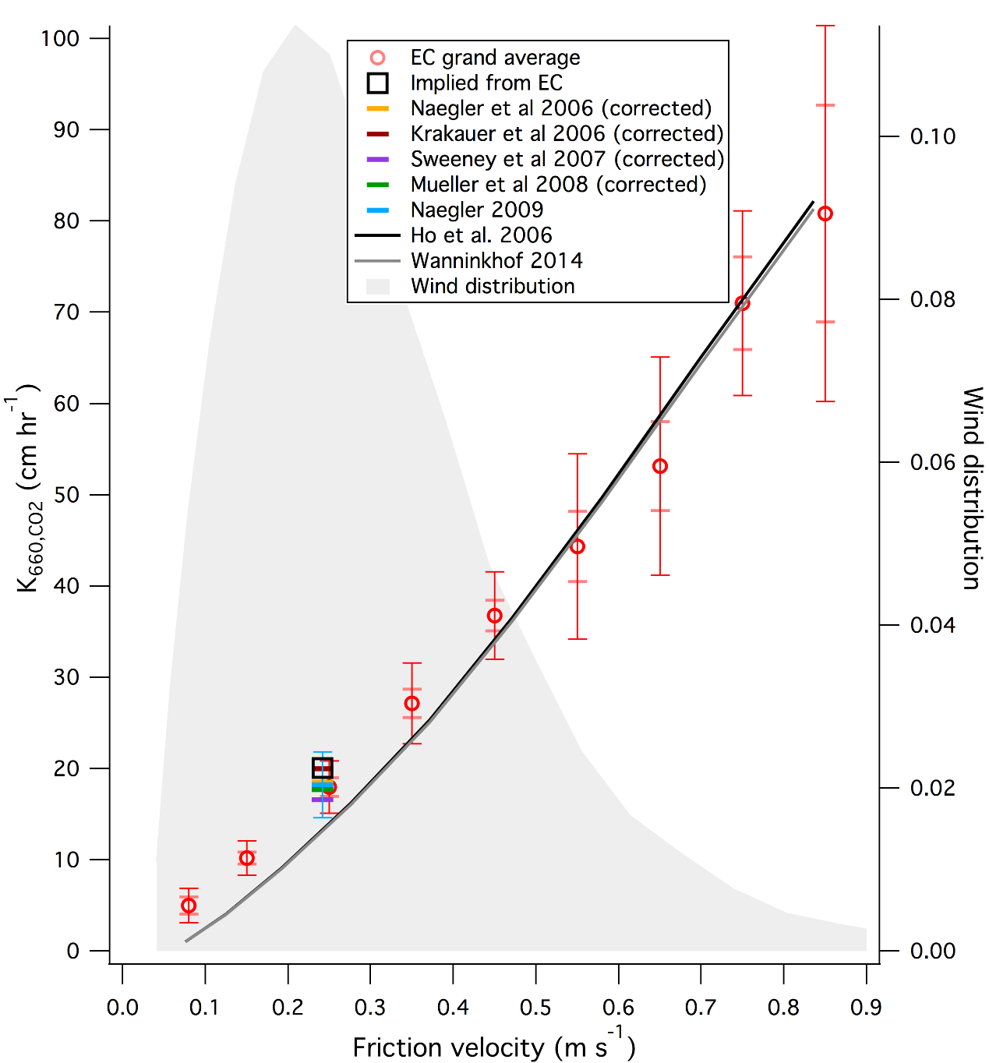

Figure 3. Synthesis of CO2 air-sea transfer velocity direct covariance measurements as a function of friction velocity (square root of surface stress) from Yang et al. 2022. The lines denote various simple parameterizations derived from deliberate tracer experiments from the literature.

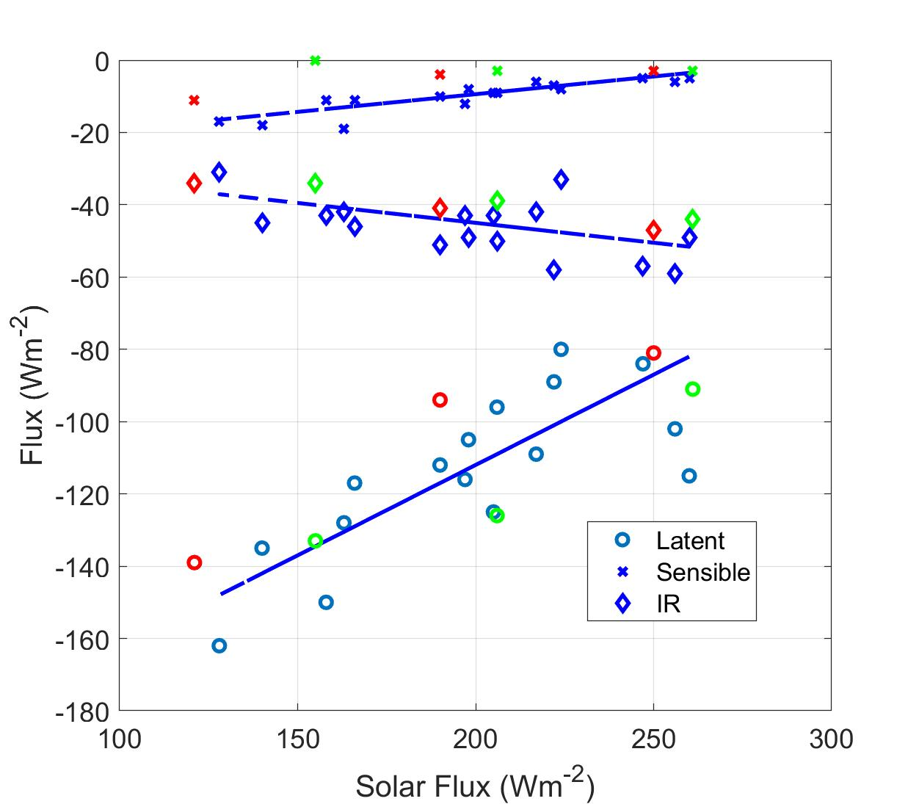

Figure 4. Mean values of sensible, latent, and net longwave heat fluxes for selected conditions (undisturbed, disturbed, MJO, or cruise grand average). The blue symbols are the data from COARE, JASMINE, EPIC, and DYNAMO; red symbols are PISTON; green symbols are MOSOBoB. The lines are fit to the blue points.