Microhard Radios

We have a 2.4 GHz radio at the Polarstern crow’s nest as well as identical radios at each of the ASFS stations. All antennas are omnidirectional.

Turning the system on/off/reset:
Connect/disconnect power source. The radio should not be powered unless it is connected to an antenna!
Wall plug (ship), fused 1A 12 VDC (ASFS)
You can factory reset the radio by using a paperclip (while powered) to hold the reset button on the rear panel down for about 5 s (you will see the LEDs on the front panel start flashing and go off).

Settings:
The ship radio is set to be a Master and ASFS radios are each set to be Slaves in a “point to multipoint” configuration. You can configure the radio using a web browser by navigating to the radio IP. The IP addresses can be found in the IP address spreadsheet. If a radio is reset to factory settings, the default IP is 192.168.1.254.

There are two pages in the Settings menu that need to be configured, the Network Configuration and the Radio Configuration.

- Network Configuration (same for Ship/Master or ASFS/Slave)
  - Use the IP address assigned to the radio you are configuring
  - The Subnet Mask and Gateway are the same for all radios

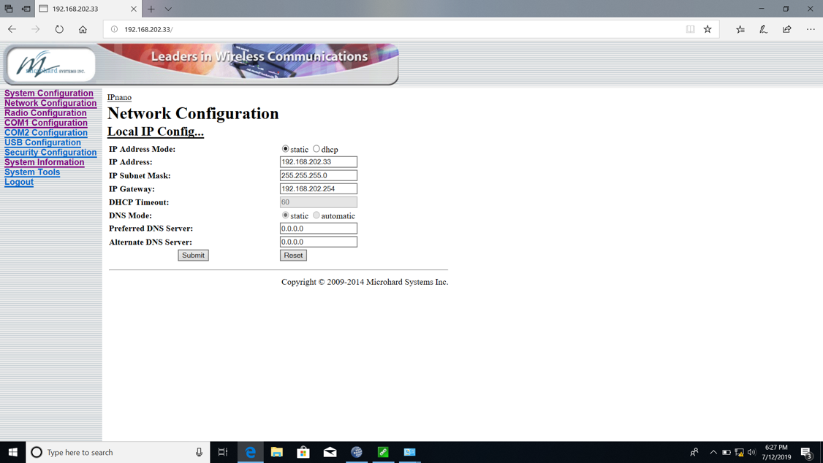

- Radio Configuration for Ship/Master
  - The Operation Mode is set to Master
  - The Network Type is Point to Multipoint

- Radio Configuration for ASFS/Slave
  - The Operation Mode is set to Remote
  - The Network Type is set to Point to Multipoint
  - The Roaming Address is set to 1
    - This is the “unit address” of the Master; i.e., the address of the radio the ASFS stations need to talk to. It will always be 1 because there is only one Master on the network and its address is always 1.
  - The Unit Address is unique!
    - This is the address the Master will use to talk to the radio. It can be any number and you do not need to record this value anywhere else. The only rule is that it must be unique; i.e., it cannot be 1 (the Master) and it cannot be the same as any other radio on the network. For convenience, we are using Unit Addresses 30, 40 and 50 for the ASFS radios, the fourth octet of the ASFS IP address.
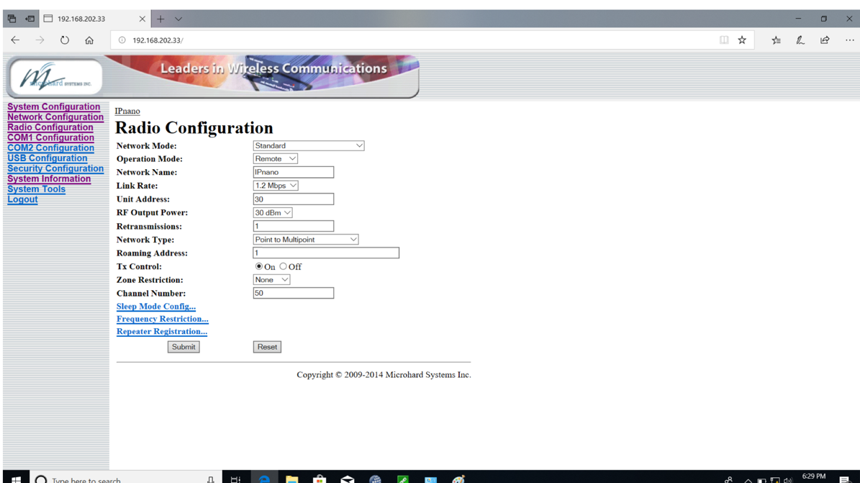

Communications:

All communications are over the network. Each radio has an IP address on the CU VLAN. Once everything is set up, communications between devices through the radio is conceptually the same as if the devices were hard-wired to the network (slower, of course). We expect the data transfer rate to decrease with increasing distance between the ship and ASFS stations, but we were not able test our system at the distances expected at MOSAiC. We did successfully test generic communication between data loggers at a distance of ~ 16 km. We also did more specific tests at short distances (~ 0.25 km) using our full 3-station ASFS system. Over a period of several weeks we consistently collected all of the data archived by the ASFS systems, including the large “fast” files, which are about 98% of the total data volume produced by the ASFS, about 5 mb per hour.
The figure below shows an example of data collections where the traffic over the radio was monitored in bytes/sec using Wireshark. LoggerNet on the ship DAQ initiates a collection every 5 min, collecting all data as yet uncollected; nominally, this means it collects the most recent 5 min of data. The collections are staggered such that the collections from the three stations are not done simultaneously; ASFS 30 is collected at 1/6/11/16… minutes, ASFS 40 at 2/7/12/17… minutes, and ASFS 50 at 3/8/13/18 … minutes. This scheduling is configured in the LoggerNet Setup Screen. The transfer times vary somewhat, but generally 15-45 seconds per station. From hour 12:30 to 12:38 in the figure shows two normal transfers (I). Then (II), the collections were turned off so that a 5 min collection was intentionally skipped followed by turning collections back on at III (12:46). During the period when collections were stopped, the radios exchanged small amounts of information occasionally, but this was internal and not related to LoggerNet. After transmissions were resumed 10 minutes of data was collected from each station (the skipped 5 min + the 5 min after), resulting in larger download times but still not so much as to overlap. This staggering is implemented for efficiency, but is actually not necessary. All packets are addressed and so the Master radio is able to communicate simultaneously with all three ASFS. In other tests we had no trouble collecting from all stations on the same schedule. In the figure, the final test (IV) shows an example of a scheduled 5 min collection occurring while we are logged into one station using LoggerNet and displaying its data collection in real-time. These transfers were also successful.

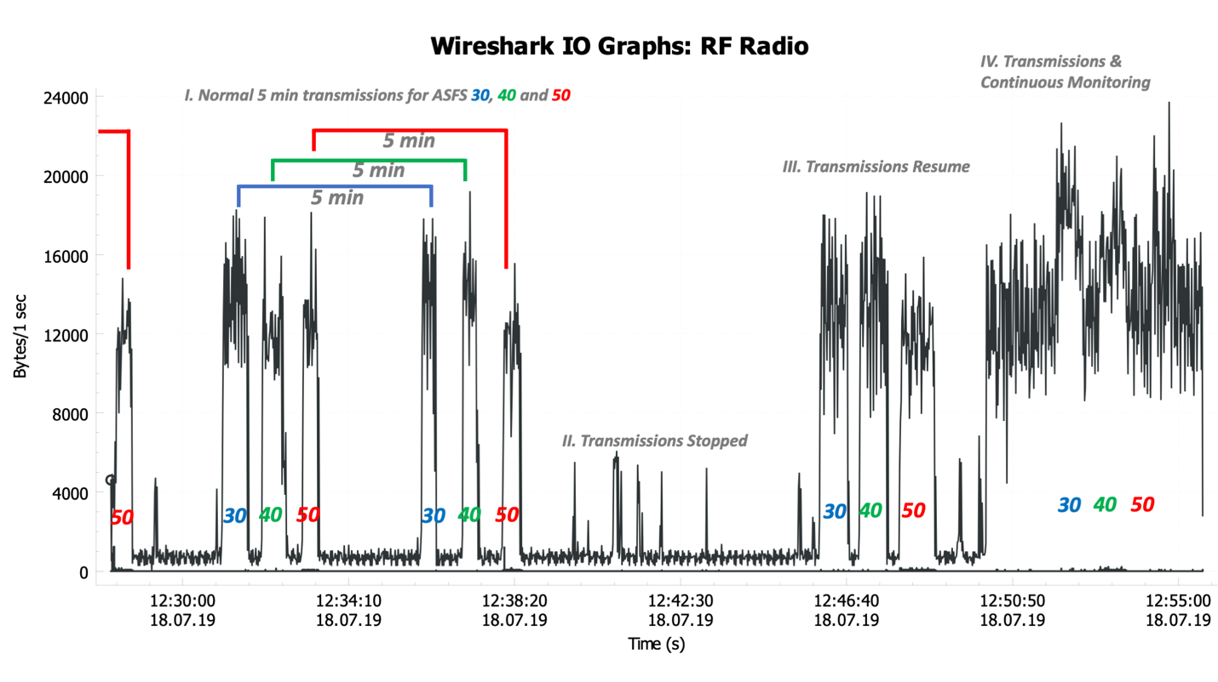

Daily Checks:
- Check the data directories and make sure the file acquisition is up-to-date for all stations.
- Inspect the antenna(ae) on the crow’s nest and clean them of ice if needed. We do not expect icing to interfere with data transmission, but it could create a structural vulnerability for the antenna.

ASFS Visit Checks:
- Inspect the antenna and clean off ice if needed.
- Inspect antenna cable.
- Inspect the connectors at the interface box.
- Inspect the connector at the base of the antenna. This connector is not considered water tight and we have wrapped cold-weather outdoor tape around it to protect it. Inspect the tape and re-tape if needed.

