2. Low-cloud cover measured with infra-red cameras

* 1. *NubiScope*

A NubiScope manufactured by IMK was measuring cloud cover and the cloud base height and temperature during the whole cruise. It was mounted on top of the AERONET container on the Helideck’s portside. This position minimized influences from the ship’s body on the measurements. The instrument consists of an infrared sensor contained in a weather tight metal tube and mounted to a pan and tilt unit programmed for scanning the full sky hemisphere. The sensor

* 1. *MPI Infra-Red Camera (VarioCAM****®)***

During the whole expedition pictures of the sky were taken with an infra-red camera that was mounted on the upper deck, starboard side, next to the aerosol OCEANET container on which a fish-eye cloud camera was mounted.

The camera is a commercial product , VarioCAM**®,** manufactured by Jenoptic, ESW, GmbH and the data acquisition software is provided by InfraTec, GmbH, Dresden.

The sensitive area of the camera consists of a micro bolometer focal plane array with 384 x 288 pixels. With leads to a field of view of 30 x 23**°** or a visible area of about 1000m x 800m at 1km height.

The spectral range covered is 7.5 to 14 μm.

Pictures were taken every 5s from about 18h00 until 10h00 the next day, in order to avoid the exposure to direct sun light. The 5s were a compromise to achieve a good temporal resolution and keeping the data volume manageable,

Due to the good horizontal resolution cloud structures of about 10x8mat 1km height can be resolved.

This provides us information complementary e.g. to large-scale cloud measurements from satellites which are not able to measure temporal development of small scale cloud structures.

* 1. *First results: Comparison of low-cloud cover measured by the two instruments*

The data taken during the two nights were the ship followed the track of the A-Train satellite constellation and was positioned directly under the Calypso satellite were analysed. These dates were the 17/18 March 2014 (02:27UTC overflight) and 20/21 March 2014 (02:55UTC overflight).

Low-cloud cover as a function of time is plotted for these two nights in Figures 2.1 and 2.2 respectively for the two instruments.

Here it must ne noticed that the definition of low clouds in both cases are different. While for the NubiScope low clouds are defined as cloud base lower than 3km, a temperature cut of Tbase > 15°C has been applied. This cut is valid in the tropics and subtropics but has to be adjusted for higher latitudes.

Given this difference and the very preliminary nature of the data treatment the agreement between the two measurements is remarkably good, especially for the first of the two nights. The second night shows reasonable qualitative agreement but quantitatively the NubiScope shows more often overcast situations.

In addition to these comparisons the results of the MPI camera have also been compared to the NOAA ceilometer and W-band radar and to the OCEANET 1064nm Lidar, and a very good qualitative agreement was observed.

Furthermore we could check the consistency of our measurements with the space borne Lidar on Calypso for two points: 18th March 2:27UTC and 21st March 2:55UTC. For the first night both devices measured a clear sky case, while for the second night, the MPI cloud camera found 100% low-cloud cover while the Calypso Lidar signal got fully attenuated at about 10km height and hence no measurement can be made for lower altitudes.

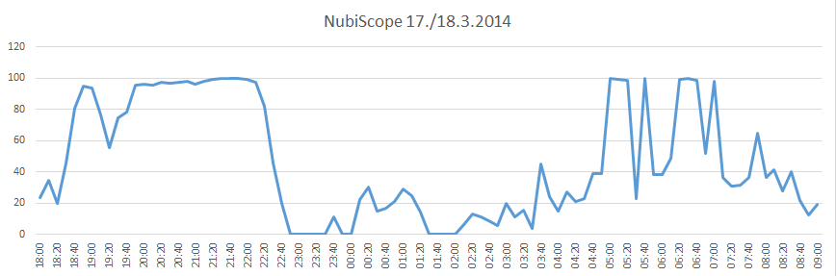

Figure 2.1: Low-cloud cover for the night of 17th March to 18th March measured by the MPI infra-red camera (top) and by the NubiScope (bottom).

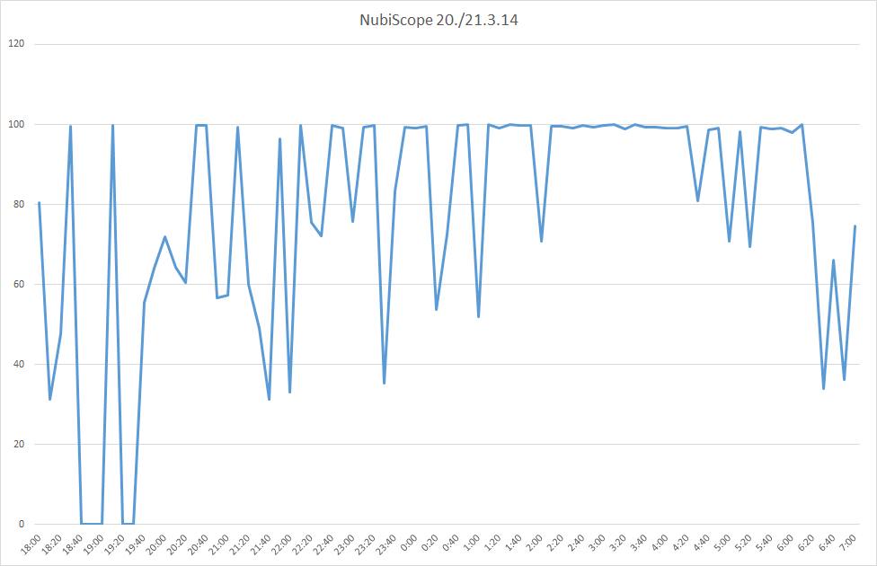

Figure 2.2: Low-cloud cover for the night of 20th March to 21st March measured by the MPI infra-red camera (top) and by the NubiScope (bottom).