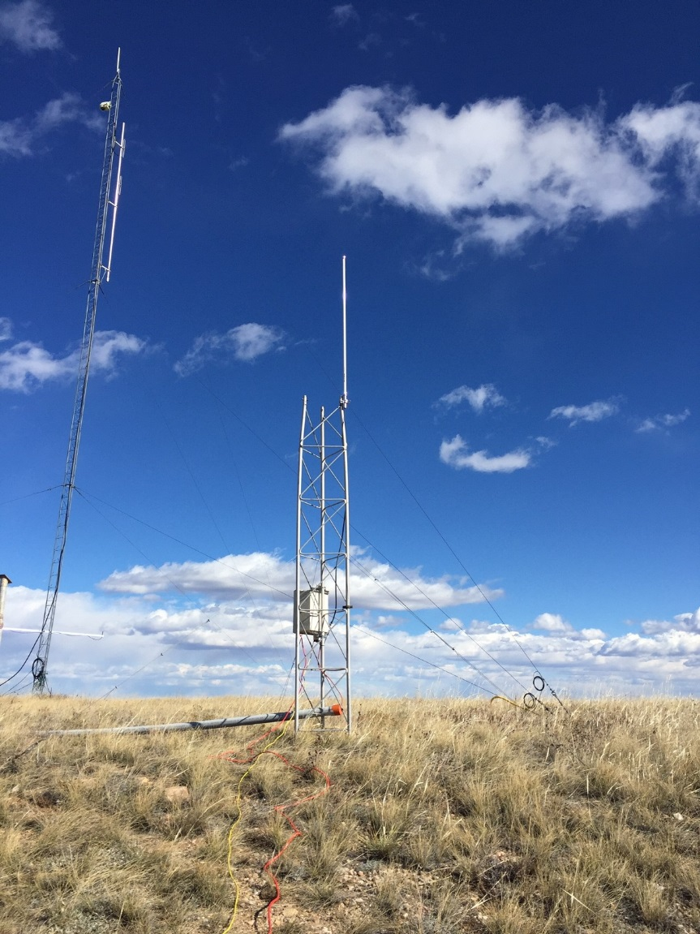

2.4 GHz Radio Modem Propagation Test

Sergio Pezoa | August 2, 2018

Introduction
An attempt to demonstrate and prove the transmission/receiving of data via wireless radio modems from far away locations has been requested within with the purpose to use them as primary communication link between remote observation stations in the artic sea while there is ice.
These radio modems had proved their capability while they were on ship deployments to collect data from flux systems. These modems performed as expected within its limitation, its performance degraded at high sampling data rates. were installed with a separation of
The propagation test will start with a modem separation of 8.9 miles (14.3 kms)- between Table Mountain site B9 and DSRC north roof top of building A, then a second test with a modem separation 14.3 miles (22.8 kms)- between Table Mountain Site B9 and “Luvin Arms” animal shelter located in Erie Colorado.

Table Mountain installation
A Spectra 2420 radio modems (2.4 GHz - 1Watt) from Microhard Systems Inc was installed on site B9-TM area with a Point to Point configuration and Slave mode.
- A datalogger enclosure was used to protect radio modem and datalogger CR1000 from the elements.
- Three antennas were tested:
- Omni FG24005 from Laird Tech, 3 dBi gain.
- Omni TL-ANT2415D from TP-Link, 15 dBi gain.
- Directional HG2409Y from HyperLink Tech,8 dBi gain
- A small weather tower sectional (3 meters) was installed.
Table Mountain coordinates: 40 7 15.52N, 105 15 4.03 W
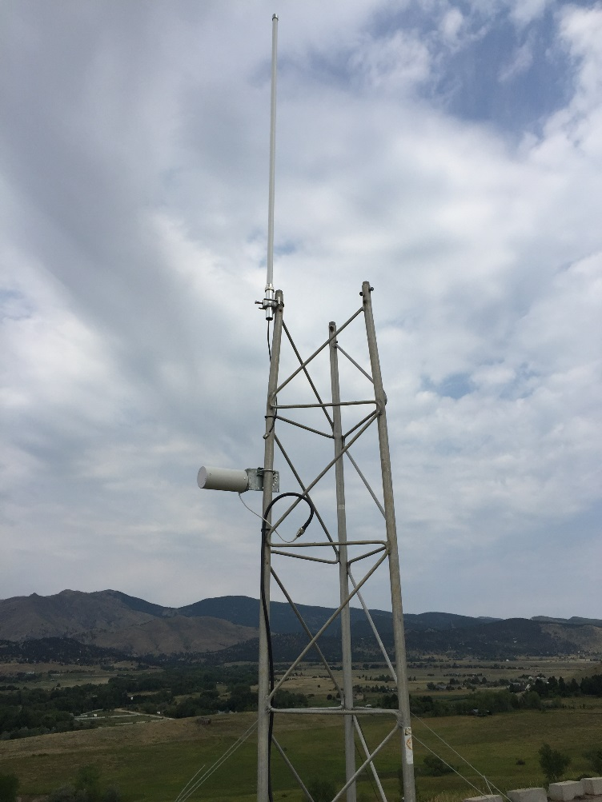

DSRC installation
A Spectra 2420 radio modems (2.4 GHz - 1Watt) from Microhard Systems Inc was used on this site with a Point to Point configuration and a Master mode.
- DSRC unit was installed inside triangular lab at the north end of building A - third floor. The unit interface with the PC via RS232. The PC collected information to test modem communication and CR1000 (dummy data) interface via radio modem.
- Three antennas previously described were installed on the north railing of top roof of building A. Railing is about 68’ from the ground.
DSRC coordinates 39 59 34.68 N, 105 15 42.46 W
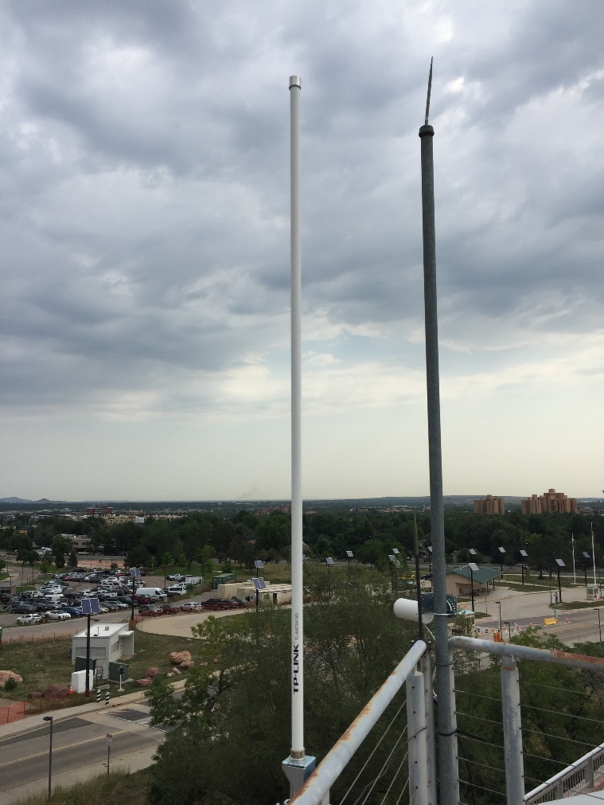

Calculation and Testing procedure

Free Space Path Loss (FSPL) is the loss in signal strength of a signal as it travels through free space between two antennas installed in an ideal situation. This calculation may be used as a reference with the sensitivity of the radio modem.

In these cases

Distance = 14.3 and 22.8 miles Frequency= 2.54 GHz
Gt=Transmitter gain Gr=Receiver Gain

FSPL dB = 20*log(distance)+20*log(frequency)-Gr-Gt
Gain dB= 10 * log (P0/Pi)
G= 10^{dBi/10}
^{G(dBi) = G(dBd) + 2.15}
G(dBd) = power gain of half-wave dipole antenna
Antenna Gain  transmitter | Antenna Gain Receiver | Gain | Frequency | Distance | FSPL
Omni 5dBi | 0 | 3.16-0 | 2.4 GHz | 14.3 Km | 56.52
Omni 5dBi | Omni 5dBi | 3.16-3.16 | 2.4 GHz | 14.3 Km | 59.68
Omni 5dBi | Directional 9dBi | 3.16-7.94 | 2.4 GHz | 14.3 Km | 64.46
Directional 9dBi | Directional 9dBi | 7.94-7.94 | 2.4 GHz | 14.3 Km | 69.24
9 | Omni 15dBi | 7.94-31.6 | 2.4 GHz | 14.3 Km | 92.9
Omni 15dBi | Omni 15dBi | 31.6-31.6 | 2.4 GHz | 14.3 Km | 116.56
Omni 15dBi | Omni 15dBi | 31.6-31.6 | 2.4 GHz | 22.8 Km | 136.86

Fresnel Zone is the ellipsoid intersection between the two or more radio wave transmitted
The radius created stablish the minimum line of sight distance.

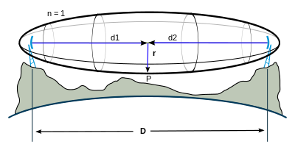

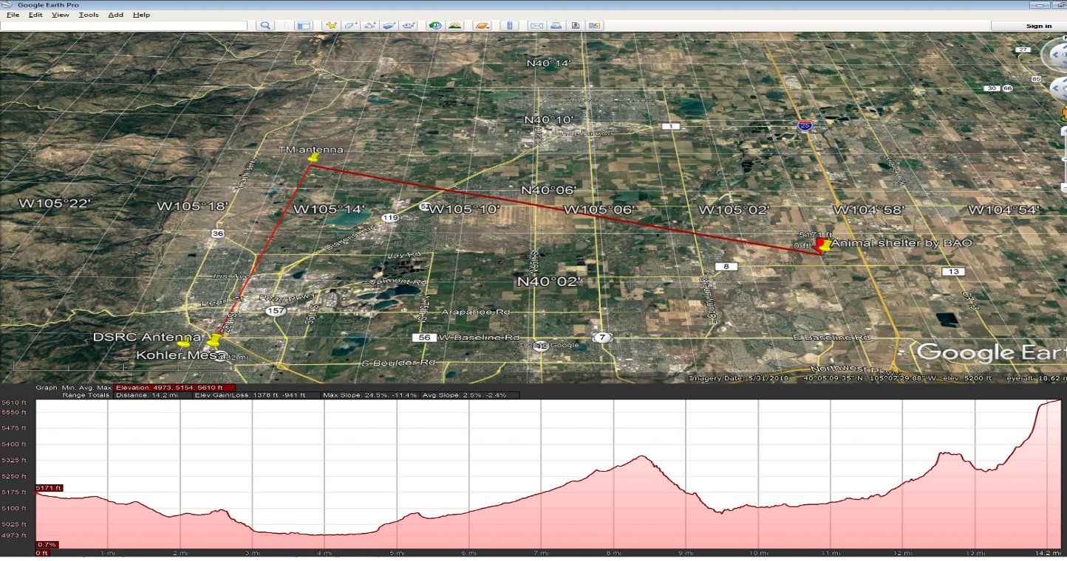
22.8 km the radius is 25 mts
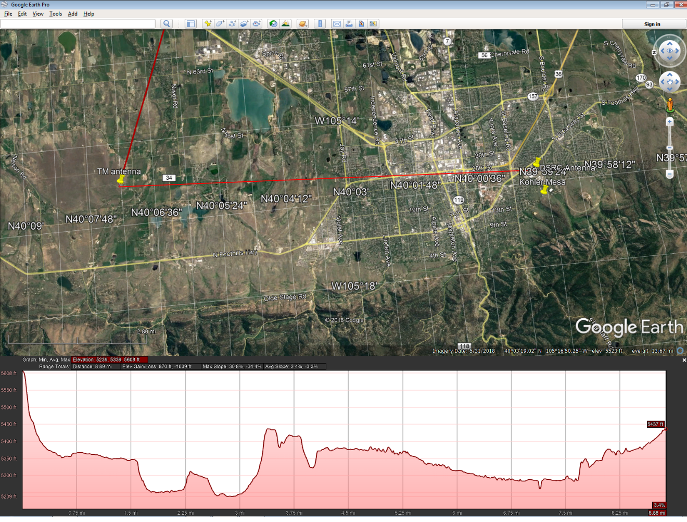
14.3 Km the radius is 20 mts

Vertical Polarization directional
Local RSSI = -97 dBm
Remote RSSi = -95 dBm
Omni Vertical
Local RSSI = -90 dBm
Remote RSSI = -93

Spectra 2420 has the following specs to calculate Max power loss.
TP=30 dB
Sensitivity = = -116
Antenna gain = 5, 9, 15 dBi
Max Power Loss = TP – (sensitivity) +Antenna gain - fade margin (~ 12)

Distance = 10(max power loss-32.44-20 log (2.4 GHz))/20
Antenna Gain | Max Power Lost | Distance
5 dBi | 129 | 27 Km
9 dBi | 133 | 43.55
15 dBi | 139 | 86.89

Radio modem configuration
Master
DSR signaling = data mode ON
DTR signaling = ignored
Slave
DSR signaling = Romote DTR
DTR signaling = ignored
RJ45 | DB9
TX | TX
RX | RX
GND | GND
Not | NC
Not | NC
GND | GND
SYNC B | DTR
SYNC A | CTS
SHIELD GND | GND

