For Blog: First, Long Day
Sunday, 24 Jan 2016, Honolulu (Monday, 25 January 2016, Kiritmati):
This is a quick description of a long day in the field. It is also a quick introduction to Kiritimati (Christmas Island).
We started at the HNL airport at 4 AM. Scott was first customer at Starbucks, opening at 5AM. Plane left 7:10 AM. On way down, there were interesting clouds. There are many layers and cloud types visible.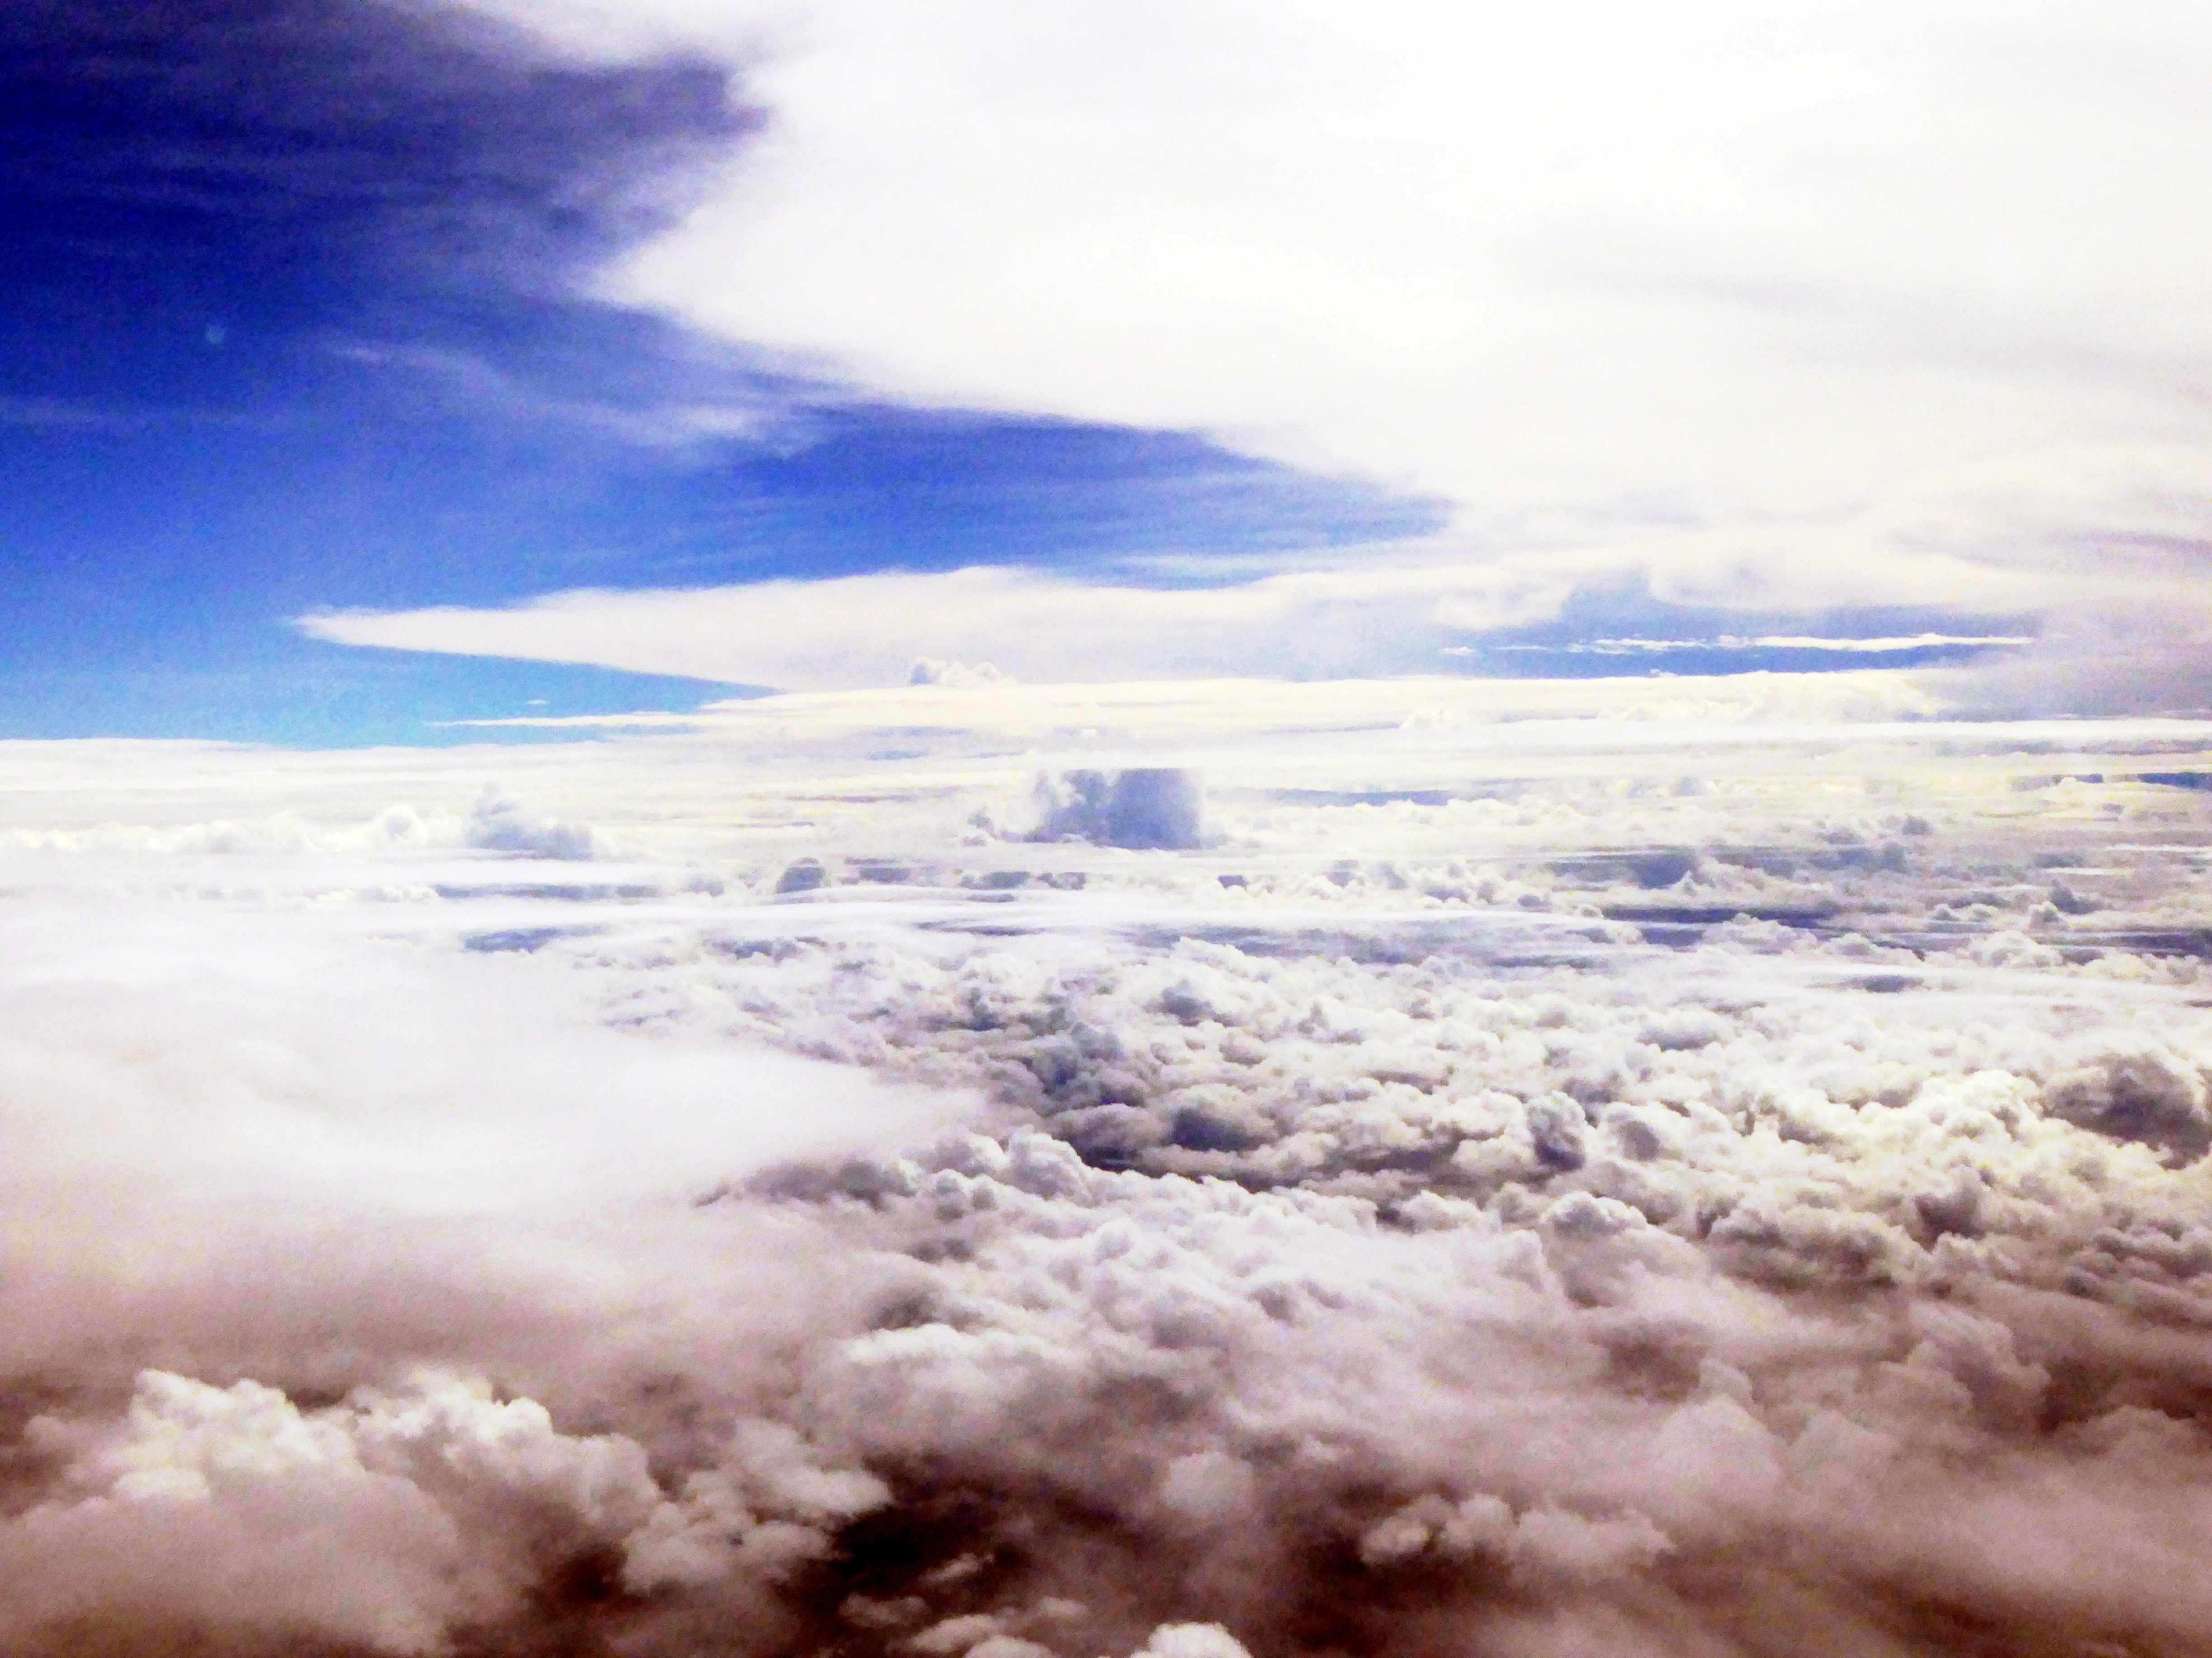
We flew into Kiritbati, so the day became Monday, 25 January 2016. On the way in we flew over the populated end of the island. The photo shows the jetty that was inundated by a surge two weeks ago, washing a pickup off into the sea.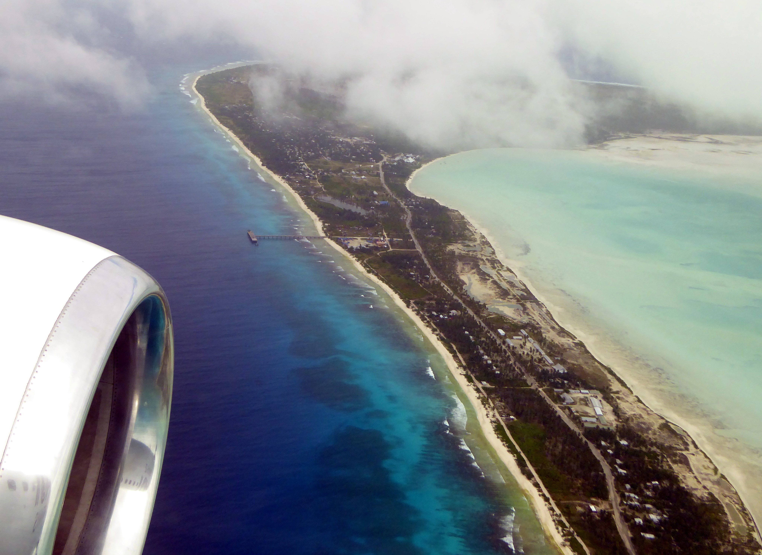
A close up, zoomed from the same photo, shows the jetty. Also, some of the abnormal surface water is visible. During El Niño, Kiritimati gets a lot of flooding.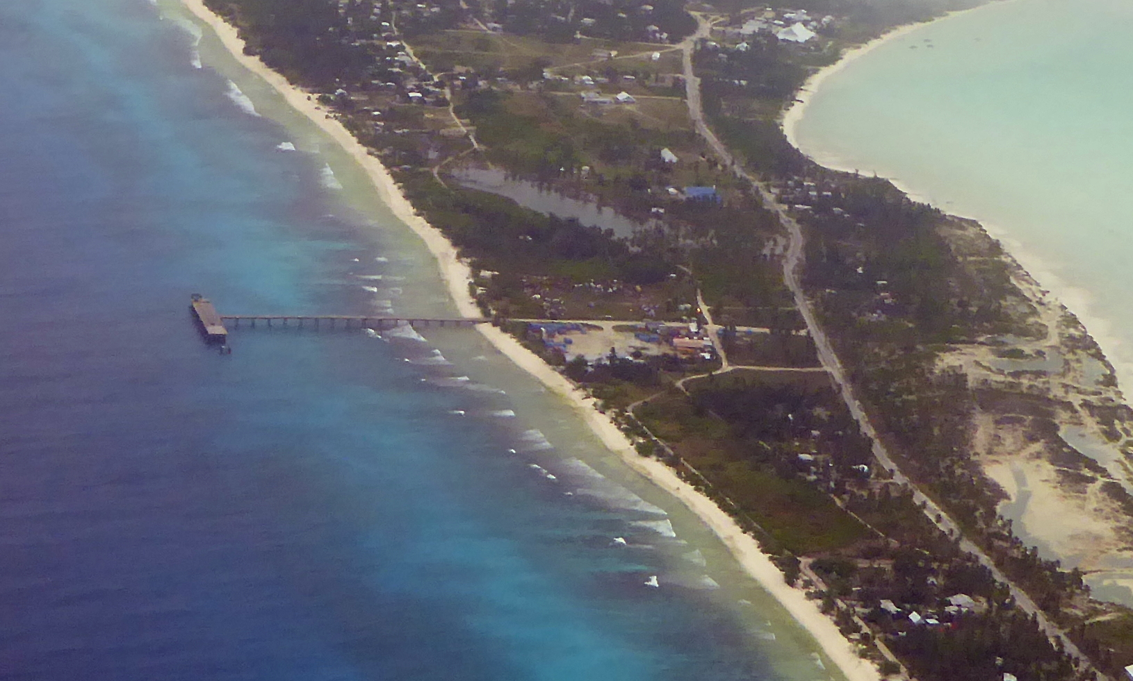
We flew over the lagoon, which is what Kiritimati is famous for. This is where a lot of sport fishermen go to catch bonefish. It has shallow water, and the bonefish come into the lagoon from the ocean to eat shrimp and other creatures on the bottom of the lagoon.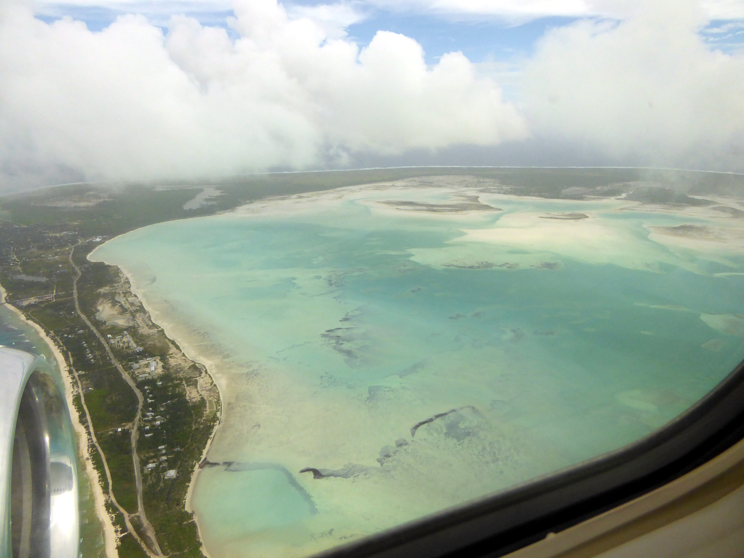
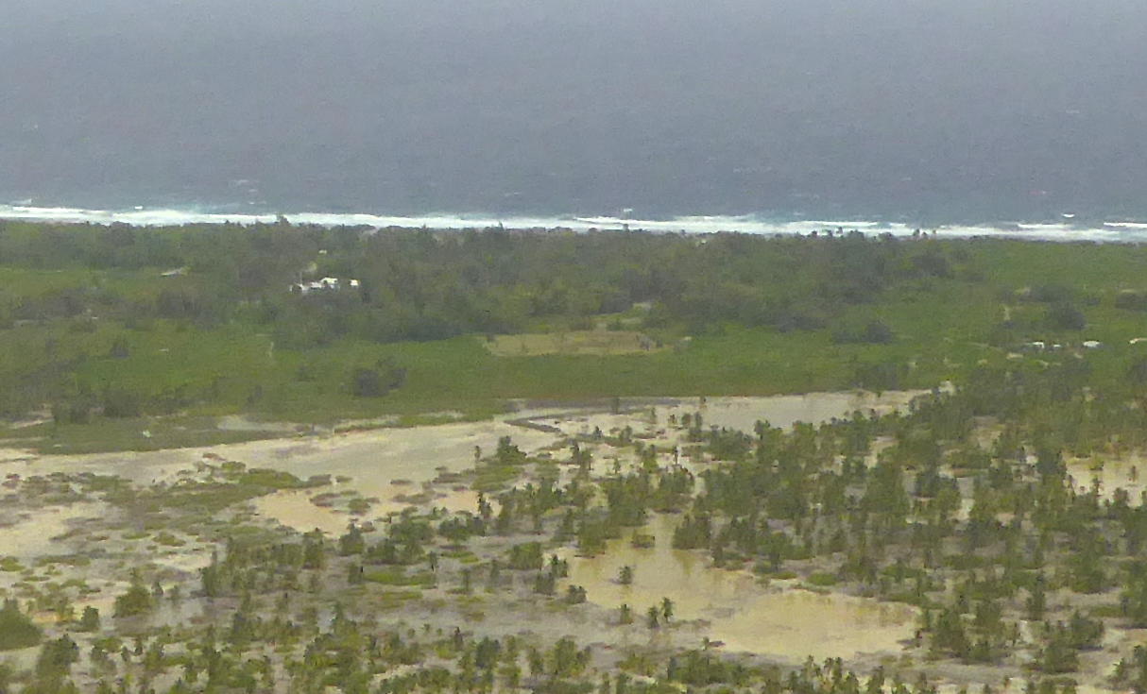
Continuing to fly more or less east, we saw Main Camp, where will have our operations. The large building just left of center is JMB Enterprises, where our freight is stored. JMB is the local car rental and store. Just above center, there is a large square of ground visible. This is where the NOAA 50 MHz radar was located. Along the beach, just above the radar, is where the Captain Cook Hotel is located, where we are living and working.
We checked into our hotel. We have this bungalow. Scotts room is the door on the right. The wind was blowing offshore, and lifting the thatch at the ridgeline!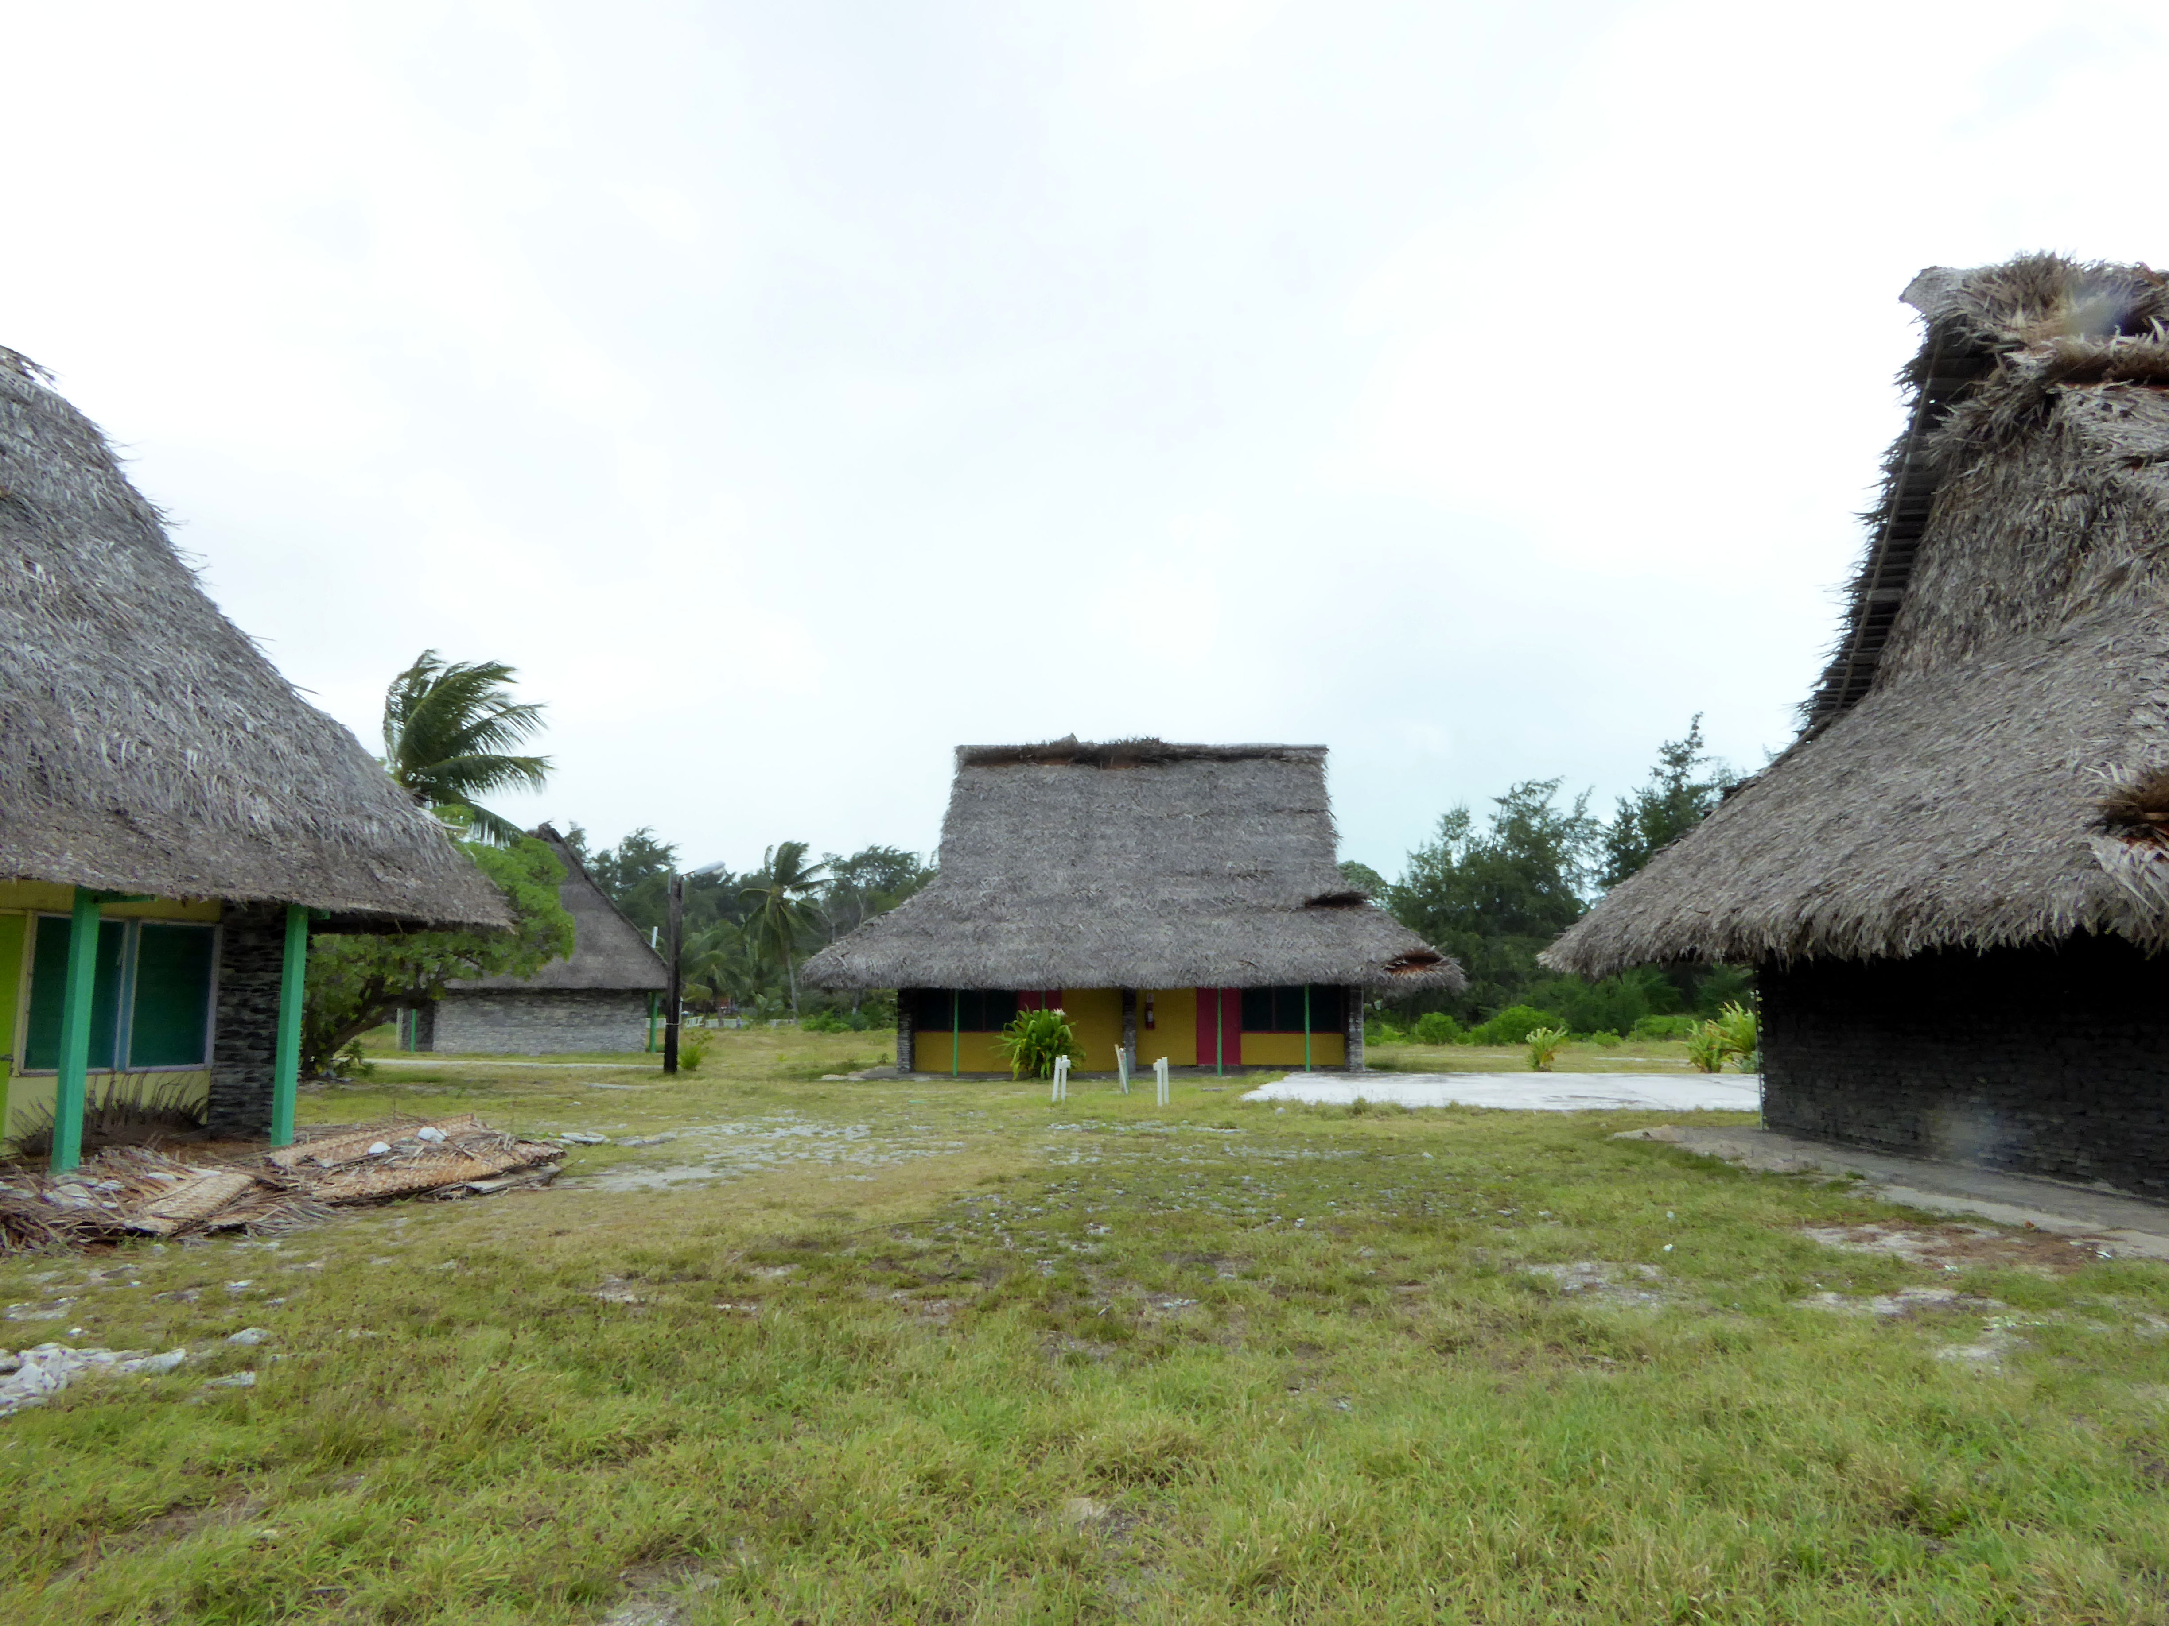
After checking in, we went to find our freight. Here are the four pallets at JMB Enterprises. Scott is making sure that we have all our equipment, which we do! Getting everything to Kiritimati has been an exercise. Thanks to all who helped to get everything here.
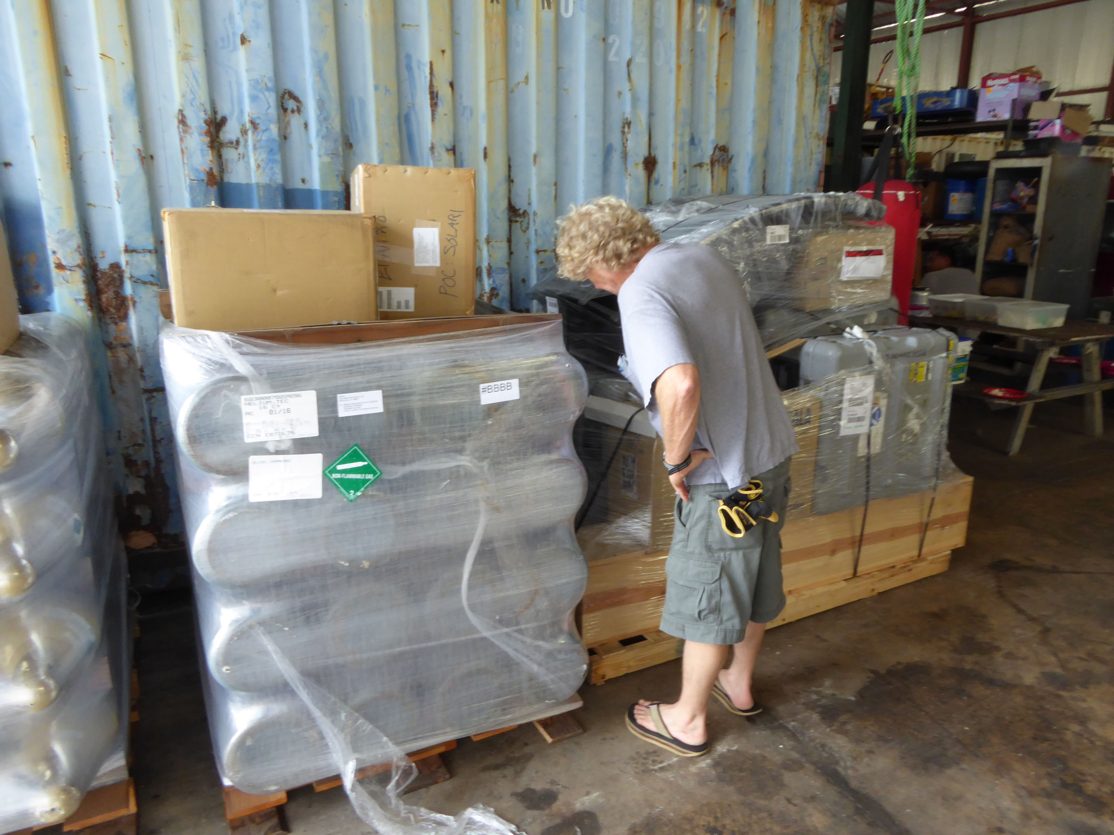
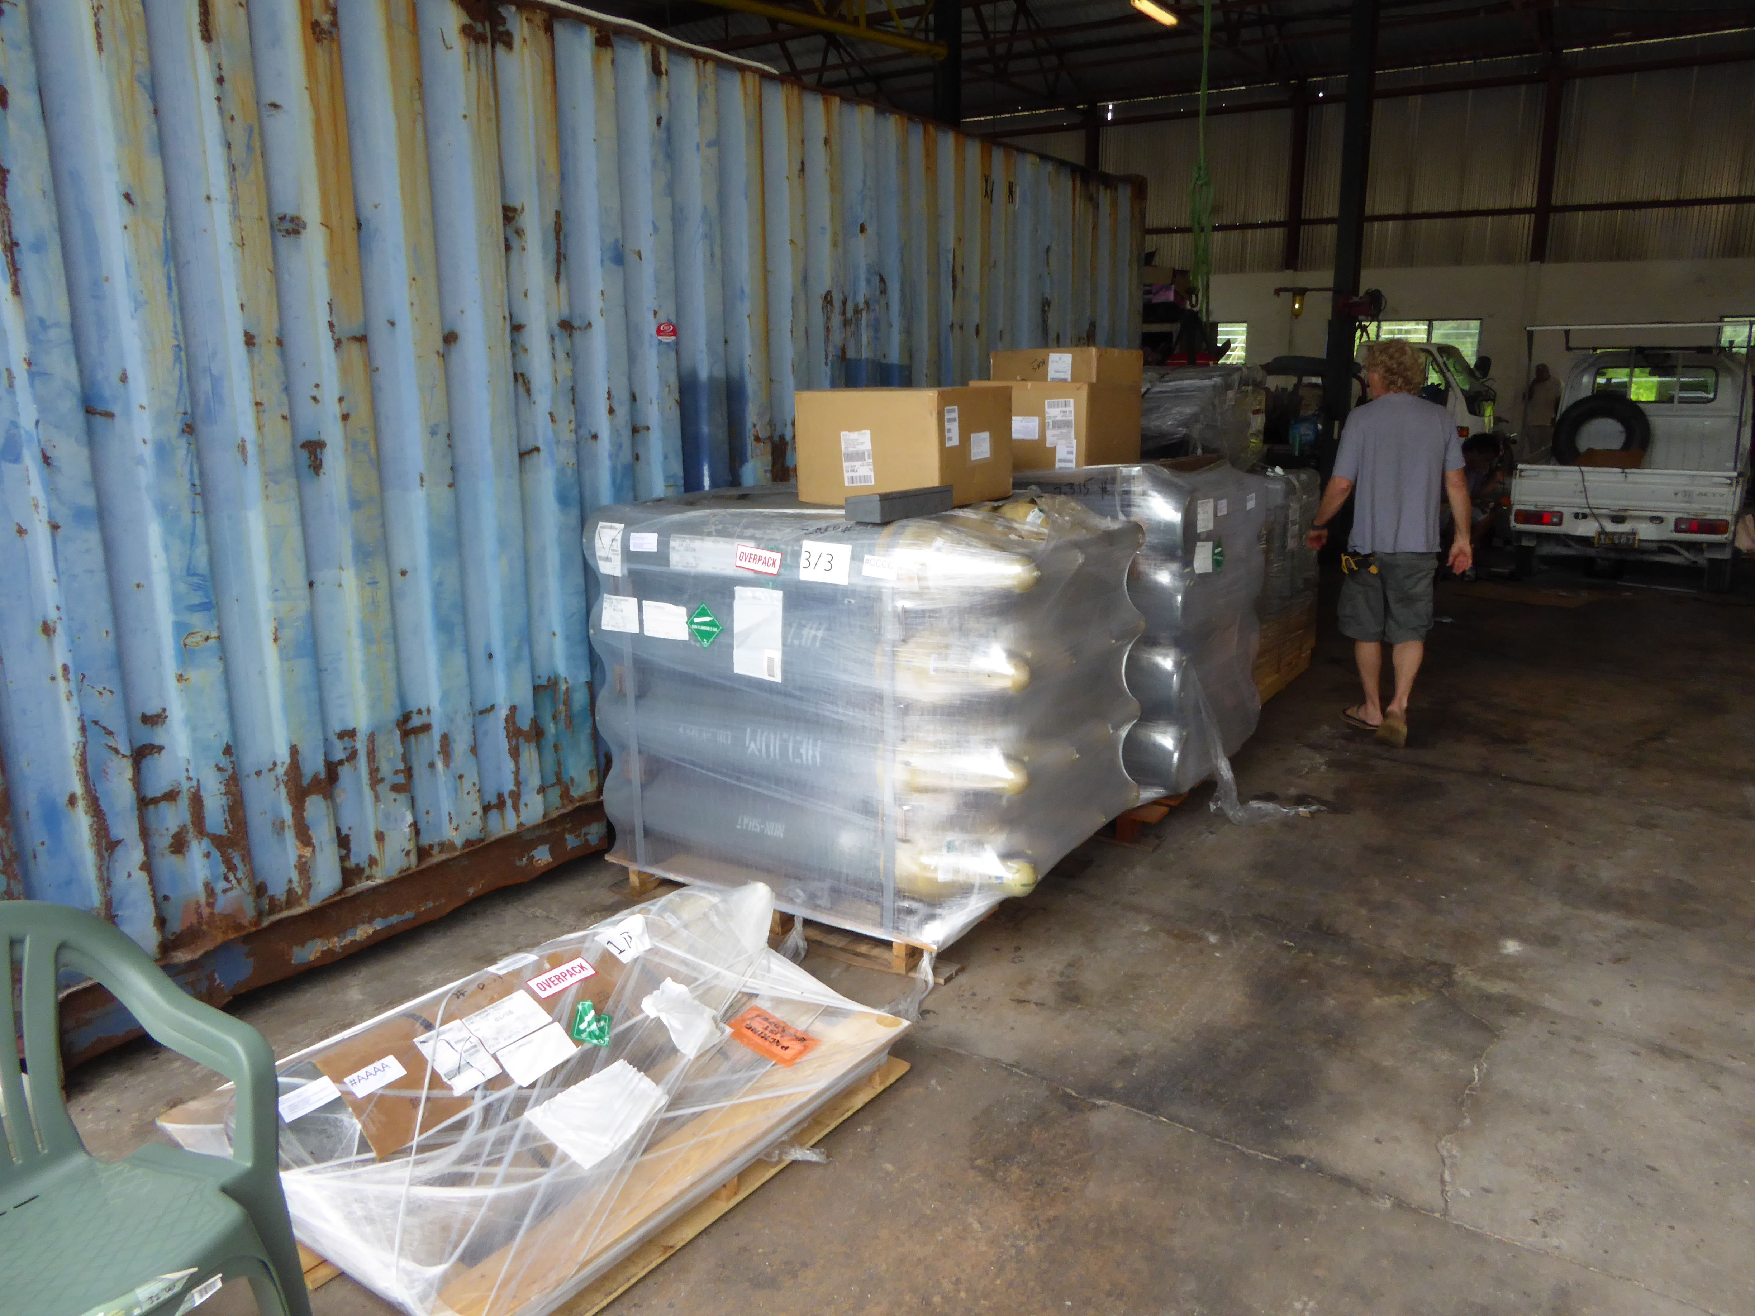
And a more detailed shot of the shipment. Lots of helium and equipment.
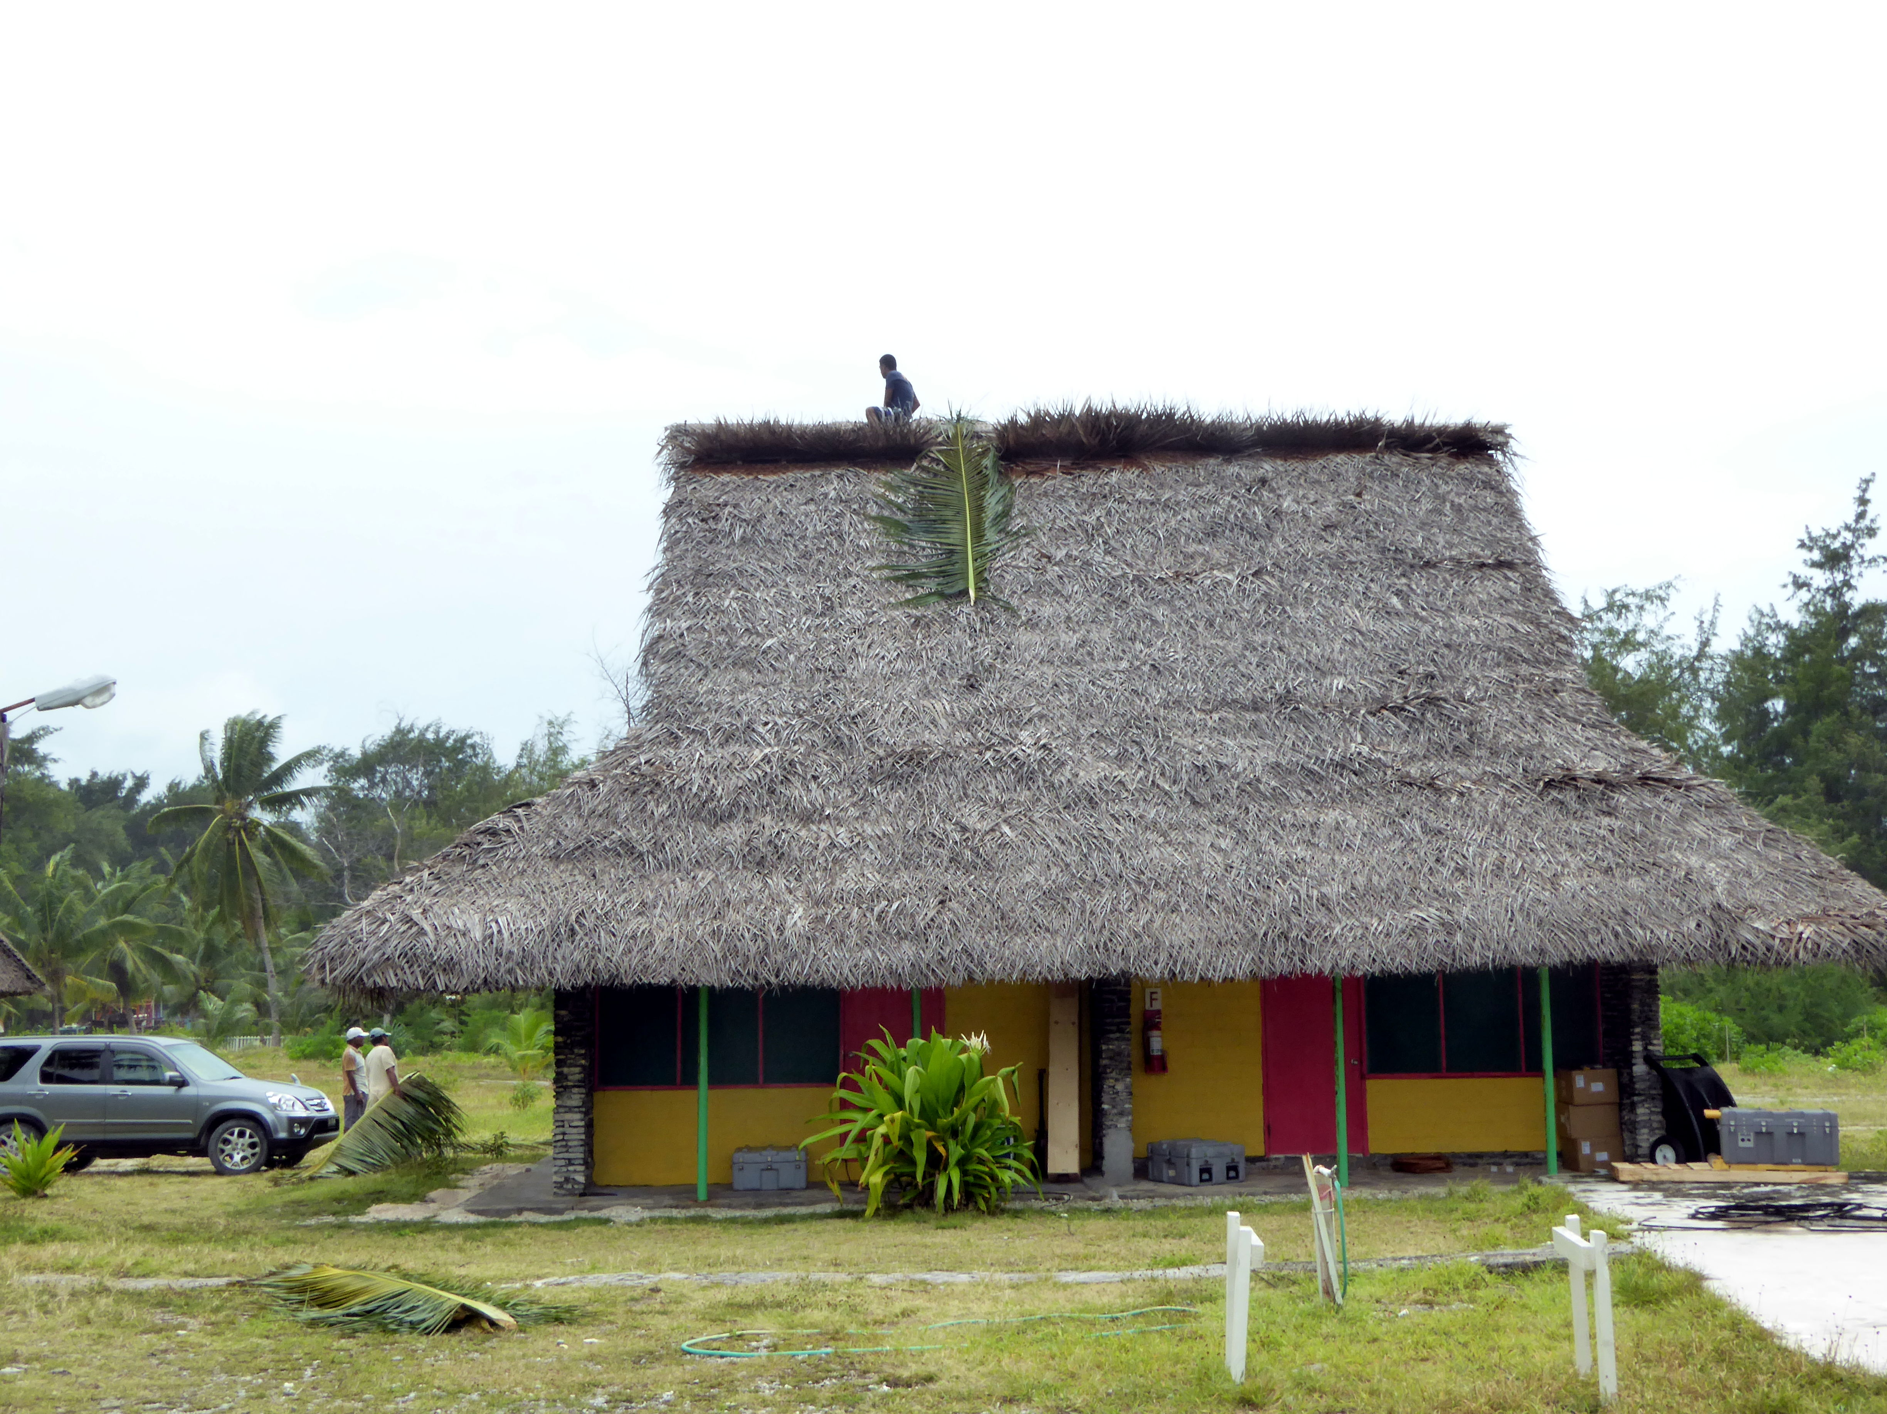
After a very short wait, we had the equipment delivered to our bungalow. We started work, and the hotel crew started to work on our roof. You can see some of the equipment and the workers in this shot. Nice to have a roof made of local materials.

At the end of the day, we have the met station up, but not leveled and fully installed. It is not an ideal location, but given the options we have and the cables we have it is the best we can do. It will give good PTU (Pressure, Temperature, humidity), and the winds will sometimes be okay.
This reads more like a trip repport than a blog, but it is what it is! Signing off from Kiritimati, Paul