Title:

Predicting near-surface atmospheric variables from SSM/I using neural networks with a first guess approach

Authors and Affiliations:

Brent Roberts*, Florida State University, Dept. of Meteorology
*Current Affiliation: Earth Science Office, NASA Marshall Space Flight Center (MSFC)

Carol Anne Clayson, Florida State University, Dept. of Meteorology

Franklin R. Robertson, Earth Science Office, NASA Marshall Space Flight Center (MSFC)

Darren L. Jackson, Cooperative Institute for Research in Environmental Sciences (CIRES)

Abstract:

The turbulent heat fluxes play a pivotal role in the exchange of energy between the atmosphere and ocean. The calculation of these fluxes over the global oceans requires the use of bulk aerodynamic or flux-gradient methods to compute the fluxes requiring estimates of the sea surface temperature, near-surface wind speed, air temperature, and specific humidity. Errors in current methodologies of satellite retrievals of near-surface properties have been shown to be the main sources of error for calculation of the fluxes. A new neural network technique is shown here which significantly improves the error characteristics of the air temperature and specific humidity as compared to previous methods. Improvements in predicting near surface wind speed and sea surface temperature (SST) are also seen. Improvements are also made by accounting for the effects of high cloud liquid water contents, the effects of which can be mitigated through the use of regime specific linear and nonlinear retrieval methods. Also, the use of a first-guess SST is shown to cause significant improvement in retrieval accuracy.

- Introduction/Background
Turbulent latent and sensible heat fluxes over the world oceans are important components of the global energy budget. It is often stated that to perform better climate simulations and estimate climatic trends, these fluxes need to be known within approximately 10 Wm⁻² in the mean [e.g. Curry et al., 2004]. However, there still remains a great deal of uncertainty in these two components as discussed in the intercomparisons of several reanalysis and satellite based heat flux products (Clayson et al., manuscript in preparation, 2009). Because the fluxes need to be estimated on a global scale, the only feasible option for prediction involves the use of bulk aerodynamic or flux-gradient formulas such as

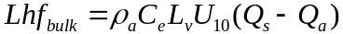 (1)
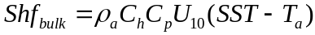 (2)

where ρ_{a} is air density, C_{e} and C_{h} are the bulk exchange coefficients for humidity and heat, L_{v} is the latent heat of vaporization and C_{p} is the specific heat capacity of air.
In the above equations, it is necessary to have an estimate of the near-surface wind speed (U₁₀), sea surface temperature (SST), air temperature (T_{a}), and air specific humidity (Q_{a}). Sea surface specific humidity (Q_{s}) is also necessary but is generally estimated by assuming 100% saturation and applying a standard saturation vapor pressure equation to the SST. Also, a 2% reduction is often applied to account for the effects of salinity [Fairall et al., 1996]. These variables can be obtained from either reanalysis products such as NCEP-2 DOE [Kanamitsu et al., 2002] or from satellite based products. Satellite SST products have generally been obtained through the use of Advanced Very High Resolution Radiometer measurements [Reynolds et al., 2007] or from the Along Track Scanning Radiometer [Merchant et al., 2008]. Wind speed products have been retrieved using passive instruments such as the Special Sensor Microwave/Imager (SSM/I) [Goodberlet et al., 1989 and Wentz, 1997] and from active scatterometers such as QuikScat [Graf et al., 1998].
The application of SSM/I frequencies for retrievals of Qa originated with an indirect approach that evolved into direct multiple linear regressions. In a study by Liu [1986], a functional relationship between monthly averaged columnar precipitable water (PW) and near-surface specific humidity was found. Due to the inclusion of the 22GHz water vapor absorption line onboard the SSM/I, PW can be retrieved with great accuracy from this platform. This relationship is then exploited for the retrieval of Qa. However, the established PW-Qa relationship does not always hold, especially on shorter time scales. Schulz et al. [1993] suggested the use of a 4-channel regression to retrieve a boundary layer moisture estimate (WB) for the lowest 500m that is linearly related to the surface humidity. Using this method, Qa contains errors originating in the WB-Qa relationship as well as from errors in the prediction of WB. This led Schluessel et al. [1995] to use a direct 5-channel regression of Qa to avoid a “propagation of errors,” showing encouraging results. Bentamy et al. [2003] also developed a direct four-channel retrieval of Qa using the same channels as the Schulz study. This was done in hopes of eliminating a possible seasonal bias the authors found in their comparisons. The stated root-mean-square-error (RMSE) of this algorithm is approximately 1.4 g/kg. This is currently the algorithm of choice in the Hamburg Ocean Atmosphere Parameters and fluxes from Satellite (HOAPS) product [Andersson et al., 2007]. In a study by Jackson et al. [2006], a step-wise regression technique using combined instruments was found to improve the accuracy of the retrieval, primarily from the inclusion of the Advanced Microwave Sounding Unit-A (AMSU-A) 52.8 GHz channel that has a peak weighting in the lower troposphere. This study also mentions the impact of high cloud liquid water (CLW) contents on the 37 GHz channels as seen from radiative transfer model simulations. Unfortunately, AMSU-A data only extends from late 1998; for the use of algorithms for longer time scales, SSM/I –only retrievals are necessary. Therefore, comparisons with the Jackson et al. [2006] algorithm in this study will refer strictly to their SSM/I-only retrieval, not the combined instrument retrieval. Their SSM/I-only retrieval is known to be of lesser quality than their combined instrument retrieval, but it is included here for completeness.
Much less work has been directed to the prediction of near-surface air temperature directly from SSM/I data. There is currently no standard approach for estimating Ta from SSM/I only data, given the inherent inaccuracies in all published methods. Jackson et al. [2006] does provide a technique using AMSU-A and SSM/I. Some of the more common approaches use indirect methods to predict air temperature. For example, monthly Ta could be estimated by assuming a constant relative humidity of 80% along with an estimate of Qa [Liu, 1988]. Another methodology is to simply assume a constant one-degree difference in SST and Ta. The HOAPS product uses a combination of these approaches by taking the average of the two estimates. These estimates contain errors due to ad hoc assumptions and errors from imperfect knowledge of the sea surface temperature or specific humidity. Often satellite flux products use NWP-based Ta estimates [e.g. Yu and Weller, 2007] and/or buoys or other in situ products.
Many of the previous approaches that attempt to determine air temperature and specific humidity from satellite products use standard multiple linear regression algorithms to produce the statistical regression coefficients. However, the relationship between the observed microwave radiances and the near surface characteristics is not a strictly linear relationship. The surface characteristics, rather, are only indirectly related to the radiances observed. The multiple linear regressions take advantage implicitly of the strong correlations between Qa and Ta with each other (through the Clausius-Clapeyron relation) and the strong PW-SST-Qa relationship. When these relationships fail or become more nonlinear, perhaps in cases of high CLW content, the linear regressions will have much larger errors. Recently, there have been attempts to use nonlinear regression techniques. Jones et al. [1999] use a simple neural network with 2 inputs, PW and SST, to determine monthly averages of Qa and Ta with RMS errors of 0.77 gkg⁻¹ and 0.72 ºC, respectively. Another approach by Singh et al. [2006] uses genetic algorithms to help determine the proper coefficients of a retrieval using nonlinear regression terms of PW, WB, and SST. The recent work of Meng et al. [2007] uses neural networks for retrieving near surface characteristics as well. In that study, SSM/I radiances are used as inputs to a neural network to retrieve estimates of near surface dewpoint temperature, air temperature, sea surface temperature, and wind speed. However, that study did not take advantage of using multiple associated outputs such as PW and CLW. It also did not include a first guess sea surface temperature as done in this study. The study of Meng et al. [2007] finds retrievals accuracies (RMS) of approximately 1.47 °C, 1.51 °C, 1.54 °C, and 1.48 ms⁻¹ for air temperature, dewpoint temperature, sea surface temperature, and wind speed, respectively.
This study focuses on the retrieval of both Qa and Ta using microwave radiometers, in particular for the frequencies resolved on the SSM/I platform. Details on the use of neural networks for improving wind speed accuracy can be found in Krasnopolsky et al. [1995, 1999, 2000]. Our discussion of wind speed retrieval will be limited to the results of the retrieval; details on the methodology can be found in the above studies. This study will focus on using a standard nonlinear technique, neural networks, in hopes of improving the instantaneous prediction of both air temperature and specific humidity. This study also introduces the use of a first guess SST to allow for the addition of near surface information not taken advantage of in many previous studies. In addition, we will demonstrate the utility of appropriate understanding of the effects of CLW in producing improved Ta and Qa fields.

- Methodology
Nonlinear methods have been applied in previous studies as noted above with varying degrees of success for the prediction of near surface properties. The use of a neural network is really the application of a standard nonlinear regression method. In this section, the neural network structure, its training, and application are described. The datasets in use for preparing training and validation sets are also described. Concluding the section is a description of the possible role of cloud liquid water content in hindering the accuracy of the retrievals.

a) Neural network background:
To properly model the complex nonlinear relationships present in the radiative transfer equations, it is beneficial to use a nonlinear approach. Neural networks (NNET) provide this type of approach. They are used in a wide variety of applications such as pattern classification, data mining, time series prediction, and nonlinear regression [Nabney, 2004 and Samarasinghe, 2006]. They have recently begun to see more use in remote sensing applications, particularly in the area of inverse modeling [Aires et al., 2001 and Atkinson and Tatnall, 1997].
In their simplest form, NNETs represent a series of weighted inputs that produce an output. An example of a multilayer perceptron (MLP) feed-forward network architecture is shown in Figure 1. In this particular example, there are three layers in total: an input layer, a hidden layer, and an output layer. There are two inputs, three hidden neurons, and one output. Each input is connected to each neuron by a series of weights, and each hidden neuron is connected to the output. A neuron acts in two steps. First, all weighted inputs into a neuron are summed. Next, some function is applied to the summed value. This function is typically called the activation function. Choices for the activation function typically are nonlinear and easily differentiable such as the log-sigmoid or hyperbolic tangent. It is through these nonlinear functions that the nonlinear capabilities are introduced into the system. For regression problems in which an output can take on any finite value, often a linear output function is used. In the case of Figure 1, which uses a linear output function, the output is simply the sum of the weighted hidden neurons. The general form of equations for the neural network can be written as

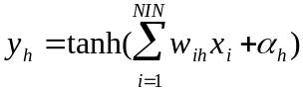 (3)
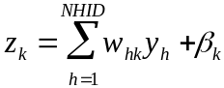 (4)

where y_{h} is the value of a hidden neuron, x_{i} is the input of the i^{th} input neuron, z_{k} is the output of the k^{th} output neuron, NIN is the total number of inputs, NHID is the total number of hidden neurons, w_{ih} is the weight between the i^{th} input and h^{th} hidden neuron, w_{hk} is the weight between the h^{th} hidden neuron and the k^{th} output neuron, and α and β are bias weight parameters.
In remote sensing, the problem typically addressed is one of inverse modeling. Given a set of observed radiances, how can the characteristics of the atmosphere be determined? In general, there are two methodologies that can be applied to this approach - physically based models and empirical models. For physically based models, such as developed by Wentz [1997], often several assumptions must be made. These assumptions effectively remove some of the physics to allow for a simpler, but analytic or numerical solution. An important benefit to these models is that they will be defined well upon the entire range of values. In other words, they will serve well for both interpolation and extrapolation. However, the relationships will only hold to the limits of the assumptions of the model. Also, they can be slow to execute if an iterative solution must be obtained. Alternatively, statistical models do not require simplified physics. If there is a nonlinear relationship between a set of independent and dependent variables, then given enough information, one should be able to model that relationship effectively. The key is to give enough information and degrees of freedom to properly model the functional mapping. Krasnopolsky et al. [2007] provides further details of using neural networks to represent functional mappings.
With neural networks, there are some common pitfalls. First, given enough hidden neurons, one can presumably train the network on a set of data and produce near perfect outputs. However, this may lead to poor generalization abilities. With too many degrees of freedom in the system, overfitting can become an issue. Another problem is that of extrapolation. When presented with independent variables that fall outside the range of values upon which the network was trained, the network will be forced to extrapolate, often with poor ability [Krasnopolsky, 2007]. It is important to train the data with realistic ranges of the independent variables. Often, a lack of empirical data may be supplemented by including synthetic data produced from radiative transfer simulations with specified atmospheric profiles [Aires et al., 2001]. Another problem is associated with the non-uniqueness of the neural network solution and its relationship to sensitivities between inputs and outputs. For given network structures trained using different random initializations, similar retrieval errors may be obtained although the final solution for the weights can vary. To alleviate this problem, regularization techniques including first guess or ensemble methodologies can be employed [Aires et al., 2001] This study uses a simplified first guess approach to help address this problem. Generally, a first guess approach involves using corresponding first guess inputs for all the possible outputs. However, this study is slightly simplified as it uses only a first guess sea surface temperature.

b) Training Data
This study has chosen to construct a neural network that is capable of predicting the near surface characteristics over the ocean using microwave radiometer data. In particular, this study focuses on the use of data from the Special Sensor Microwave/Imager (SSM/I) that has been flown on the Defense Meteorological Satellite Program (DMSP) satellites [Hollinger et al., 1987]. An intercalibrated set of swath level data has been obtained from the Colorado State University repository in association with the Global Precipitation Mission. At the time of this writing, the intercalibrated data extend back until late 1997, and efforts are underway to produce a set from the beginning of the SSM/I record (Wes Berg, personal comm., 2009). As such, all satellite data used in this study covers the period from 1998-2006. There are 7 channels on each SSM/I package: 19GHz (H/V), 22 GHz (V), 37 GHz (H/V), and 85 GHz (H/V) where H stands for horizontal polarization and V stands for vertical polarization.
Near surface measurements are obtained from an extensive set of observations that make up the SeaFlux in situ dataset. This dataset contains observations made from several field campaigns over the period 1988-2006. Information on the SeaFlux in situ dataset can be found in Curry et al. [2004]. The in situ measurements were recorded from several different platform heights, depending on the research vessel or buoy. Measurements consisted of numerous atmospheric parameters such as wind speed, air temperature, specific humidity, and sea surface temperature among others. In an effort to standardize this dataset, log layer profile adjustments are used to adjust all atmospheric parameters to a standard height of 10 meters. Warm-layer/cool-skin adjustments are made to the sea surface temperature so that all SSTs would reflect a true “skin” temperature for purposes of stability calculations. These adjustments are made using the COARE 3.0 algorithm [Fairall et al., 2003]. Table 1 gives an overview of the salient characteristics of the training and validation data set. As discussed in the next section, CLR refers to low cloud liquid water conditions and CLD refers to high cloud liquid water conditions. The range of the observations (max, min) gives the limits at which the neural network may be safely applied. The training (and validation) data have a severe lack of wind speed data greater than 15 ms⁻¹. This will limit the applicability of this neural network in high wind speed conditions. A first guess sea surface temperature is also needed for the approach used in this study. To accommodate this need, the Reynolds daily optimally interpolated SST (OISST) version 1 product is used [Reynolds et al., 2007]. There is a lack of cloud liquid water and precipitable water observations in the SeaFlux in situ database. These values are calculated from the SSM/I data using the Weng and Grody [1994] algorithm and the Petty [1994] algorithm, respectively.
The observed surface measurements are collocated with the swath level SSM/I data using a simple matching procedure. First, all satellite pixels that are within a window of 50km and +/- 3 hours in time of a surface observation are found. Of these matches, the closest match in time and space is kept as a collocated observation. This is done in such a way that a satellite pixel can be matched with only one surface observation and vice-versa. The closest pixel is within 15km of the surface measurement the majority of the time, and the time difference is more evenly spread over a total six-hour period (+/- 3 hours). The distribution of in situ values is heavily skewed due to the inadequate sampling over the ocean. Notably, the fields of air temperature and specific humidity are most unevenly sampled due to their natural dependence on latitude. Most field campaigns and buoy arrays cover a narrow range in latitudes leading to this problem. As discussed in Bauer and Schluessel [1993], it is necessary to have an equal representation of data values across the desired range for the regression. To compensate for the sampling issue, the training subset from the total matched dataset is chosen such that there are an equal number of observations randomly chosen within predetermined bins of the Qa distribution. This methodology is found to improve the performances of both the neural network and multiple linear regression algorithms.

c) Cloud Liquid Water Effects
Cloud liquid water (CLW) obviously plays an important role in affecting the radiances seen at the radiometer [Jackson et al., 2006; Weng and Grody, 1994]. The importance of CLW content on the radiation signal can be seen in Figure 2, where the relationships between observed brightness temperature (TB), specific humidity (Qa), and CLW concurrently are shown. It is clear that the higher CLW amounts effectively cause a warming of the TBs. Tb85 also shows some cooling presumably as a result of scattering by ice particles. This causes the relationship between Qa and each of the corresponding channels to be modified, if not entirely masked. The atmospheric term dominates the signal seen by the satellite, effectively removing surface information contained in the signal. Certain channels are affected more by this interaction than others as discussed in Jackson et al. [2006]. In particular, the 37GHz vertical polarization channel is appreciably altered. Many of the direct regression algorithms use this channel in their retrieval. Under high CLW (or rain) conditions, this interaction can lead to systematic biases. Based on these findings, two separate networks are trained. One is trained for high CLW conditions, hereafter referred to as CLD, and another is trained for low CLW conditions, hereafter referred to as CLR. While CLR and CLD abbreviations are used, this does not necessarily imply that one is looking at a truly clear or cloudy scene but rather low or high cloud liquid water amounts. Therefore, an SSM/I-only retrieval is adequate for determining this separation. It is determined that the 0.025mm threshold value serves as a good point for the demarcation of each algorithm. This threshold value is chosen based on the anticipated accuracy of the Weng and Grody [1994] CLW algorithm as well as the amount of data available to train each network. After appropriately resampling the dataset to equalize the distribution of target values, approximately 9000 matched observations are used in training each network. This leaves approximately 164000 observations for clear-sky (CLR) validation and 45000 for cloudy-sky (CLD) validation. It should also be noted that conditions in which the CLW content was greater than 0.25 mm are excluded as being likely rain contaminated [Wentz and Spencer, 1998]. Many different bin sizes and number of observations in each bin have been used to train different realizations of the neural network. It is shown below that the accuracy of the networks and results shown herein are rather insensitive to this choice. The total number of training observations is roughly 10% of the number of validation observations. In comparison, studies such as Meng et al. [2007] use closer to a 50%-50% split of training and validation data.

d) Network Structure and Training
There appear to be no analytical rules for the choice of network structure. Most studies recommend a trial-and-error type approach when determining the final structure [Jones et al., 1999 and Bourras et al., 2007]. In this study, an 8-10-5 network structure is employed for low cloud liquid water (CLR) conditions, and a 9-10-5 structure is used for high cloud liquid water (CLD) conditions. For CLR conditions, there are 8 neurons in the input layer, 10 hidden neurons, and 5 output units. In CLR conditions, the 8 inputs are the 7 SSM/I channels and the first guess sea surface temperature from the nearest OISST grid point. The five outputs are specific humidity (Qa), air temperature (Ta), wind speed (U), sea surface temperature (SST), and precipitable water (PW). An additional neural network has been trained in which there is no separation in the training set between CLR and CLD conditions. This network uses the same overall structure as the CLD network and is hereafter referred to as the ALL network. This network is trained in hopes that one network can be used to retrieve parameters rather than using two separate networks.
The inclusion of SST and PW in the output are of ancillary importance and are used to take advantage of the ability of NNETs to model covariability between the outputs. For the interested reader, details on this ability can be found in Krasnopolsky [1999]. For CLD conditions, an extra input neuron is the estimated cloud liquid water content. It is found to be more effective as a predictor than including it in the output because it is strongly non-normally distributed and discontinuous as calculated from the Weng and Grody [1994] algorithm. The activation function for the hidden layer is chosen to be the hyperbolic tangent, and a linear activation function is chosen for the output units. The training of a neural network involves randomly initializing the weight layer to small values, propagating the inputs through the network, and calculating a mean-squared error statistic using the predicted outputs and true outputs. The error gradient is then calculated using the error statistic. The weights are then updated in an iterative process by using the negative error gradient direction. There are many different methods to choose for weight optimization. First order methods include standard gradient-descent backpropagation with or without a momentum term. Second order methods use assumptions of quadratic error surfaces and conjugate gradient methods to help improve the speed of training. For this study, a scaled conjugate gradient method is chosen. The training is implemented using a freely available toolbox named NETLAB [Nabney, 2004].
To investigate the sensitivity of the training to network structure and to the number of epochs, or training iterations, for which a given structure needs to be trained, several training runs have been made. The original dataset is sub-sampled randomly to produce several calibration/validation (CAL/VAL) datasets. First, a network structure of 8-15-5 neurons is setup and trained on each of the CAL/VAL sets for up to 30000 epochs. As seen in Figure 3, the final error begins to converge among the different runs within several hundred epochs. The error statistic tends towards a minimum after roughly 10000 epochs. It should be noted that there is the possibility that the error statistic is reaching only a local minimum. However, several runs (not shown) have been made out to several hundred thousand epochs with virtually no improvement. Next, the network structure is varied by changing the number of hidden neurons from 1 to 30, and each is trained for 30000 iterations. Results for training on both the CLR and CLD CAL/VAL sets are shown in Figure 3. Shaded markers refer to the CLR sky runs while open markers refer to the CLD results. It is seen that the root mean square error quickly converges to stable results as more hidden neurons are added. It is also seen that for all but wind speed, the separation of cloudy and clear conditions allows for slightly higher accuracy in the cloud conditions than in the clear sky conditions. Biases (not shown) also converge quite rapidly to near zero values for all but wind speed.

- Results
Based on these sensitivity results, the final network structure is chosen to include 10 hidden neurons and it is trained for 30000 iterations. Two networks were trained, one for clear sky (CLR) and one for cloudy (CLD) conditions. The outputs from these networks are specific humidity, air temperature, wind speed, sea surface temperature, and precipitable water. Since this study is focused on the near surface characteristics, the results below are shown therefore only for all but the latter of above parameters. The validation statistics refer to the entire validation dataset, calculated for both clear and cloudy conditions using the appropriate algorithm, unless otherwise noted.

a) Specific Humidity
Two neural networks have been trained using the aforementioned training data sets. After their training, these networks have been applied to independent data for both clear and cloudy conditions. Figure 4 depicts scatter plots of the combined validation datasets for each of the parameters retrieved using this methodology. The root mean square error of this algorithm for specific humidity is found to be about 1.3 gkg⁻¹ accompanied with a small positive bias of 0.16 gkg⁻¹. Table 2 lists the error characteristics for some other methodologies commonly applied for predicting near surface specific humidity. It should be noted that these error characteristics are representative as calculated for the SeaFlux in situ database and may differ from the stated accuracies of the published algorithms. The total number of points available for comparison from the SeaFlux dataset is ~164000 for clear sky and ~45000 for cloudy conditions. These statistics are also valid for instantaneous matchups while many of the published algorithms have been developed for different applications (e.g. monthly or weekly averaged). In Table 2 it is seen that the neural network generally outperforms all other methodologies in terms of root mean square error (~0.4 g/kg lower) and has a smaller, more consistent bias. Some methodologies also show a near zero bias.
However, non-constant biases of different signs can often offset each other to give a bias statistic that is relatively unrepresentative. In an effort to further investigate the error characteristics, the root mean square (rms) error and biases were calculated for 5 gkg⁻¹ bins covering the full range of Qa values found in the validations dataset. These results are shown in Figure 5. The top panel of Figure 5 shows the neural network maintains the lowest rms statistics across the full range of the Qa distribution. The differences in rms statistics for clear (unshaded) and cloudy (shaded) conditions do not show large deviations between each other except for the 20-25 gkg⁻¹ range of values. For these conditions, all algorithms tend to perform poorly as has been seen in previous studies [Jackson et al., 2006]. In particular, the Jackson (SSM/I-only), Bentamy et al. [2003], and Schulz et al. [1993] algorithms appear to be significantly affected in cloudy conditions, indicative of the CLW effect. The bottom panel of Figure 5 shows that the neural network generally has the smallest bias across the distribution with only small differences between clear and cloudy conditions. The neural network bias is also consistently a small positive bias except for the very high range where it changes sign. This is contrast to most of the other algorithms that show large changes, especially in sign, as one goes from the low range of Qa values to the high range. For the other algorithms clouds seem to play an important factor in determining the bias. It is interesting that for lower values of Qa, CLR conditions are more biased, and for higher values of Qa, CLD conditions appear to be more biased.
Small gains in bias and rms characteristics from the inclusion of a first guess sea surface temperature estimate using OISST are also seen. This is perhaps more evident in Figure 6, which depicts estimates of the probability density function for the error values. The small positive bias is recognized from the offset in maximum density of the error value to the right of the zero error line. In general, the neural network error is more heavily dominated with near zero values and has a much narrower distribution around zero than the other methodologies presented. This is evident for all conditions. Results from the ALL NNET are also shown in Table 2 and Figure 6. While using one network still outperforms other non-neural network methodologies, it is not as good as using two separate networks. ALL bias and RMS error are found to be higher than that found using a proper CLR/CLD separation.

b) Air Temperature
Air temperature retrieval results are also shown in Figure 4. It is found that the root mean square errors are approximately 1.3 ºC with almost no bias. This is in contrast to the other methodologies presented that have significantly higher root-mean-square (rms) errors and biases. The errors are particularly large when a constant relative humidity assumption is made; it should be noted that these errors are optimistic as they were arrived at using a known Qa value, whereas in reality an estimated Qa value will most likely introduce larger errors. Improvement found through proper separation of the CLR/CLD networks versus a single ALL network is modest. Perhaps the most important improvement in prediction of the near-surface air temperature is from the use of an estimate of sea surface temperature. A multiple linear regression (MLR) algorithm using SST as a predictor along with the SSM/I channels outperforms a neural network that is trained without using an SST predictor, highlighting the importance of using the SST as a predictor. The improvement to the Ta algorithm by using SST in the neural net is demonstrated also in Figure 6. Comparing the distribution of errors for clear and cloudy conditions one can see a further improvement of the Ta using the NNET; the NNET approach provides the least difference in error characteristics between clear and cloudy of all the approaches. From the estimated distribution of errors, it appears using a constant relative humidity assumption is a particularly bad approach, with large biases in cloudy conditions. There are pitfalls associated with using SST as a predictor, however, and these will be discussed in Section IV. It should be noted that since neural networks are able to take advantage of covariability in the output parameters, an improved estimate of Ta should, in theory, also lead to improved estimates of the other parameters.
For most situations over the open oceans, there is a strong relationship between the SST and Ta, and some approaches to determination of Ta use a constant SST-Ta difference. Unfortunately, using this would severely restrict the ability to assess near surface stability. From Figure 7, it is evident that an advantage of the neural net over the constant stability assumption is the ability to determine stability over a wide range of surface layers. There is a slight positive bias seen for the neural network; however, it falls away from the mean value in a more realistic fashion than the other methods presented. Better estimating the surface stability should allow for better estimation of the stability-dependent flux exchange coefficients as well.
Examination of Figure 7 reveals the strong relationship between SST and air temperature. While the static stability, SST minus air temperature, remains tightly clustered around 1 ºC, there are times of much higher and lower stabilities. It is important that an air temperature retrieval be able to properly capture these infrequent events. In Table 3, five-degree bins of static stability have been used to estimate how the different retrievals model static stability under different conditions. Table 3 shows that for the most frequently occurring static stability the neural network outperforms the RHTA and MLR methods. There is a slight positive bias of 0.7 ºC in SST-Ta for instances of warmer air temperature than sea surface temperature. For the more infrequent, extreme events the three algorithms do not perform as well. A bias of approximately -4.2 ºC (NNET) for the most extreme cases must be interpreted within the context of 10-15 ºC observed differences. The NNET algorithm is able to produce larger vertical gradients; they are however on average only ~65% of the true static stability. These deficiencies could result from a severe lack of training data in these categories and/or the lack of a detectable influence on the received microwave radiation. It is possible that inclusion of a lower tropospheric channel onboard a microwave sounder could improve determination of the near-surface layer static stability.

c) Wind Speed
Improvements in wind speed retrieval are also seen using the improved neural network algorithm, as seen in Figure 4. The overall rms error is roughly 1.6 ms⁻¹. From Table 2, it appears that the errors associated with the neural network approach are generally smaller than the simple least-squares regression approaches of Goodberlet and Swift (GS) [1992] and Goodberlet et al. (GSW) [1989]. However, the neural net approach is not entirely successful at removing cloudy errors relative to the clear-sky statistics. This is expected as the surface signature associated with wind speed - changes in emissivity due to wave breaking - is quickly masked as the cloud liquid water content increases. Based on the higher RMS and bias for the ALL network, it appears proper treatment of CLR and CLD conditions improves the neural network retrieval. There is also a non-zero bias in wind speed for both the NNET and MLR approaches. This bias is seen as an overestimate in low wind speed conditions and an underestimate in high wind speed conditions. Also, the rms error increases with the wind speed. An improvement to modeling of the wind speed is made by the use of a log transformation applied to the target wind speeds. This transformation effectively normalizes and decreases the dynamic range of the wind speeds, resulting in a more consistent rms error across the whole spectrum of observed wind speeds. The error characteristics seen in this study for the neural network are very similar to those seen in other neural network studies focusing only on wind speed [Krasnopolsky et al., 2000]. The inclusion of SST as a predictor showed only small improvements for the prediction of wind speed in this study.
The older linear regression algorithms for wind speed have generally been replaced by the use of physically based model approaches, in particular that by Wentz [1997]. In an effort to compare the present algorithm with some other available products, the SSM/I data is used to predict the near surface characteristics which are subsequently gridded onto 3 hourly average quarter-degree grids using simple binning and averaging. From this, matches are paired with independent observations at several buoy locations using the nearest pixel of the gridded product. The nearest pixels were also found from the Wentz [1997] version 6 wind speed product, the HOAPS version 3 [Andersson et al., 2007] satellite product, and from the OAflux [Yu and Weller, 2007] product. Due to varying temporal and spatial resolutions among the products, all time series of matches were averaged to a common daily resolution for a more consistent comparison. Scatterplots of these matched observations can be seen in Figure 8. While the bias for the neural net is the same as for the instantaneous matchups, the rms error has decreased slightly, as might be expected with averaging observations together. The neural net appears to do well at low wind speeds for these cases, but scatter increases with increasing wind speed. OAflux appears to do quite well for this set of observations. However, OAflux uses reanalysis products as well which most likely assimilated some of these buoy observations. Therefore, it is hard to judge how independent of the observations the OAflux product is for these comparisons. Nevertheless, this analysis is not meant to be a rigorous comparison of the products but rather a justification that our neural network produces reliable results for wind speed as has been found in previous studies [Meng et al., 2007; Krasnopolsky et al., 2000].

d) Sea Surface Temperature
The frequencies measured by the SSM/I are not strongly sensitive to changes in sea surface temperature [Wentz, 1997]. There have been some attempts to estimate an SST from SSM/I, such as in Langille and Buckley [2002], sometimes in combination with AVHRR data. In the limited survey of Langille and Buckley [2002], small biases (near 0°C) but large rms errors (2.5°C) were possible under clear-sky conditions (with a significant degradation under conditions with higher CLW). Here however we focus on improvements in SST retrievals as a result of the neural net technique with the inclusion of a first-guess SST. Obviously, sea surface temperature retrieval using the SSM/I microwave channels is greatly improved through the use of a first guess SST. In fact, almost a 1.5 degree Celsius improvement is seen through its inclusion. The poor retrieval of SST using the neural network without a first-guess SST is due to a lack of sensitivity to SST for the channels measured by the SSM/I. The output SST from the neural network is almost completely determined by the first-guess SST. This can be seen in direct scatter plots (not shown) between output SST and OISST. What is important, however, is the ability of the neural network to improve the first guess estimate. The OISST fields show a rather consistent bias of almost 0.20 degrees. The neural network is able take this information and effectively remove the bias leaving an estimated output SST that consistently has a smaller RMS and almost no bias in comparison with the Reynolds OISST version 1 product.
It is important to understand the impact of error in the first guess SST on the effectiveness of the neural network retrieval. The first guess SST used to train the neural network contains inherent random and systematic error. Table 4 depicts how random error increases for other parameters as random error is increased in the first guess SST. Zero-mean, Gaussian distributed noise with the given standard deviation is added to all first guess SST inputs. The retrieval is performed and error statistics are determined. Random error in specific humidity and wind speed increases only marginally for a very large increase in error in the first guess SST. However, both air temperature and output sea surface temperature appear to be more sensitive. These results imply that air temperature and SST rely upon the information given by the first guess SST more so than wind speed and specific humidity. This finding agrees with our earlier results as depicted in Figure 6.

- Discussion
The above results suggest that the nonlinear regression neural network method is capable of modeling the inverse retrieval of near surface characteristics more accurately than standard linear regression techniques. Some improvements are likely due to the use of a nonlinear method that is more appropriate considering the inherent nonlinearities of the problem. Improvements gained in the retrieval of different parameters appear to be related to the inclusion of a first guess SST as well. This is most likely due to the inclusion of new information that is strongly correlated with the desired surface parameters. Given only a set of 7 brightness temperatures, there are infinitely many atmospheric and surface characteristic combinations that can produce the same radiance seen by the satellite. This is why the problem is often considered “ill posed.” In a sense, an estimate of SST begins to help regularize the solution.
This regularization can help improve estimates of the surface parameters during times of conflicting information. For example, the summertime North Pacific tends to have numerous inversions in conjunction with ample low-level cloudiness [Norris et al., 1998 and Jackson et al., 2009]. This can act in ways to affect the total radiances seen by the SSM/I radiometer such that many of the multiple linear regression algorithms significantly overestimate the near-surface specific humidity. The neural network technique is able to take information directly related to the surface characteristics (from SST), atmospheric characteristics, and relationships embedded in the empirical training dataset to identify these situations and produce more reliable estimates of the true surface characteristics. In order to demonstrate this feature, the gridded results as described in the previous section are used to calculate the monthly averaged specific humidity field for the North Pacific region during July for the year 2002. The differences in the monthly means are plotted with respect to the neural network mean value (i.e. algorithm minus neural net). The results can be seen in Figure 9. For reference, differences are also plotted with the OAflux product. As seen in Figure 9, there are differences of over 5 gkg⁻¹ between the Bentamy (4-channel retrieval) algorithm and the neural network method on a monthly average. For typical values of the constants in the bulk equations and mean variables of U=8 ms⁻¹, Qs=10 gkg⁻¹, exchange coefficient Ce=1.5x10⁻³, an error in Qa of 5 gkg⁻¹ leads to a latent heat flux error on the order of 150 Wm⁻². Comparatively, the neural network method is in very similar agreement with OAflux that blends reanalysis data that assimilates surface observations. One then might be inclined to lend more credence to the neural network method over the Bentamy algorithm or similar linear regression algorithms.
In an effort to elucidate the primary mechanism for the overestimation in the Bentamy and similar algorithms, the stability of the lower atmosphere is estimated based on the difference of the new NASA Modern Era Retrospective-Analysis for Research and Applications (MERRA) [http://gmao.gsfc.nasa.gov/merra] 10 meter surface temperature with the 950 hPa temperature. This proxy for stability can be seen in the bottom right panel of Figure 9. Also, the difference in the profile of absolute humidity is calculated as the surface to 900 hPa summed absolute humidity minus the summed absolute humidity above 900 hPa. The largest difference between the neural network and Bentamy approach appear to occur in the areas with small to negative lapse rates (inversions) in conjunction with higher amounts of moisture aloft than below 900 hPa. Closer inspection also reveals differences between Bentamy and the neural network method on the order of 1.5-2.5 gkg⁻¹ in the central North Pacific region, the Bentamy algorithm being drier. This area is associated with much higher boundary layer lapse rates and is located in the descending branch of the northern hemisphere summertime Hadley cell. Notice as well the large difference in surface moisture in comparison to that aloft. Both of these scenarios are related by a concept of “mixed signals.” First, in the inversion areas, a drier boundary layer over cool ocean waters, particularly over the California current, is capped by warmer, more moist air above. The simpler regression algorithms sense the higher precipitable water content leading to estimates of higher boundary layer moisture as well. However, the cooler surface conditions act as an important boundary condition in these situations. The neural network is able to distinguish this pattern and effectively model the underlying specific humidity. In the central pacific, warmer sea surface temperature conditions are found in conjunction with dry upper levels being in an area dominated by upper level subsidence. Again, the simpler regressions see less total moisture leading to an underestimate of the boundary layer humidity. The neural network, however, is able to capture this pattern as well. In this way, the neural network retrieval is able to overcome a fundamental issue associated with the previous SSM/I only algorithms; it can effectively predict near surface humidity when the strong linear PW-SST-Qa relationships break down.
Predicting air temperature presents its own challenges when trying to use an SSM/I- only type retrieval. Unlike Qa that is usually strongly related to total columnar water vapor that directly affects the satellite radiances through changes in absorption, surface air temperature is not as directly related. Based on the lapse rate for a particular atmospheric state, the near surface air temperature may or may not be strongly tied to the mean atmospheric temperature or total columnar water vapor. In these situations, information directly related to the near surface air temperature is desired. For example, the Jackson et al. [2006] study shows the combination of the AMSU-A 52.8 GHz channel with SSM/I significantly improves the results of the Ta estimate. This is due to the strong weighting of the 52.8 GHz channel in the lower troposphere. Likewise, inclusion of the SST provides similar information about the boundary condition for the near surface layer.
This leaves a few options for predicting the air temperature. One can use a simple linear regression between Ta and SST. However, changes in Ta then become solely dependent on changes in SST. One can use multiple linear regression in which SST is a predictor along with independent information such as the SSM/I brightness temperatures. This helps alleviate some of the problem, depending on how much weight is put on the SST estimate. However, this could lead to a different problem. Imagine one also uses a similar regression for Qa. Observational evidence overwhelmingly supports a nonlinear relationship between air temperature and specific humidity as might be expected from the Clausius-Clapeyron relationship. This is depicted in Figure 10. Two separate linear regressions to predict Ta and Qa using the same predictors (first guess SST and 7 SSM/I channels) are found, and the effective relationship between these is shown in the bottom panel of the same figure. The relationship has effectively been linearized. This is due to the sharing of the same predictor variables allowing one to rewrite the two separate linear equations into one linear equation relating Qa as a function of Ta. While the slope becomes fixed, the bias is non-constant, depending on the other linear predictors used in the equation; this leads to the spread in the figure from being an exact line. This could be countered with the inclusion of nonlinear terms such as a quadratic dependence on one or more of the regression parameters. In other words, if you used a least squares regression with nonlinear terms, you could possibly find an acceptable model for the relationship. However, the choice of which terms to use could become arbitrary. The neural network avoids this ambiguity by implicitly modeling the nonlinear relationship.
Equations (1) and (2) show wind speed is very important to the calculation of both the sensible and latent heat fluxes. It is very important to have accurate estimates on short, if not instantaneous, time scales. Our results echo others’ [Aires et al., 2001; Jones and Gautier, 1999; Krasnopolsky et al, 1999] that neural networks provide accuracies on par with, and in some cases better than, physically based models that make simplifying assumptions. Unfortunately, cloudy skies appear to remain a substantial hindrance to their prediction using only SSM/I data. As cloud liquid water increases, the atmospheric signal quickly becomes the dominant term in the radiative transfer equation. Information related to surface changes, namely changes in surface emissivity accompanying wave-breaking phenomena, is lost. Specific humidity and air temperature are still strongly tied to sea surface temperature and total columnar water vapor and are able to overcome this issue to an extent. Alleviating this problem and increasing the accuracies in wind speed retrieval may require using additional information that will help to regularize the solution much as the first guess SST improved the neural network SST estimate.
Additional information can be provided by including radiances observed from other satellite instruments. This is the principle behind combined instrument retrievals. Providing additional information may allow for improved estimates of wind speed, air temperature, sea surface temperature, and specific humidity. A drawback of combined instrument retrievals is the need for concurrent, overlapping data. Differing satellite viewing geometries and different instrument/sensor resolutions can severely limit the sampling ability of combined instrument retrievals. Recent investigations into their applicability can be found in Jackson et al. [2006; 2009].

- Conclusion
Determining turbulent latent and sensible heat fluxes over the ocean on a global scale continues to be an important challenge. This requires knowledge of several near surface quantities to employ flux-gradient or bulk aerodynamic formulas. These variables include sea surface temperature, wind speed, air temperature, and specific humidity. However, these variables are not simply related to the radiances observed. This leads to the use of empirical regressions, often of a linear variety, to model the inverse relationship between the radiances. However, the inverse relationship is nonlinear and ill posed. It has been recognized that cloud liquid water can significantly alter the brightness temperatures seen at the satellite. Higher cloud liquid water amounts act in a way that makes the relationships between radiances and atmospheric characteristics more nonlinear. Dealing with these limitations calls for a nonlinear method that also uses additional information to regularize the solution.
This study uses a nonlinear neural network with a first-guess sea surface temperature. To address problems from cloud liquid water, two neural networks have been trained – one for clear sky conditions and one for cloudy conditions. A third network has also been trained which makes no delineation between clear and cloudy conditions. Results showed that using two separate networks results in higher overall accuracies for specific humidity and wind speed retrieval. Negligible improvements were seen using a single network for air temperature and sea surface temperature. Comparisons with other published algorithms show that the neural network approach successfully models the relationship more reliably in both clear and cloudy conditions. This improvement is seen in all variables that were retrieved. Specific humidity is retrieved with an instantaneous root mean square (rms) accuracy of approximately 1.3 g kg⁻¹ with a small positive bias of 0.16 g kg⁻¹. Air temperature shows a drastic improvement compared with other methodologies. Retrieval of air temperature shows an RMS error of 1.31 C with a near zero overall bias. However, there does appear to be a positive bias for temperatures less than freezing. This could partly be due to a severe lack of training data for these situations. Wind speed retrieval is also improved with the neural network. Results are similar to those seen in other algorithms developed for wind speed retrieval. However, accuracy is diminished for very cloudy situations.
This paper introduces the use of a first guess sea surface temperature as an input for the neural network. This addition appears to improve results for all retrieved parameters. The largest impact is on the retrieval of air temperatures and sea surface temperature. Both of these parameters show little direct sensitivity with the channels measured on the DMSP SSM/I. The inclusion of the first guess SST adds direct information about both of these parameters. This additional information is then utilized by the neural network in conjunction with the SSM/I data to predict more reliable estimates of all surface parameters. In addition to better modeling the relationship between inputs and outputs, the neural network is able to inherently model nonlinear covariability of the output parameters. In standard multiple linear regression, only one output can be produced at a time. This means that the training of the empirical coefficients involves averaging over all conditions present in the training dataset. Training a neural network with multiple outputs allows covariability to be taken into account unlike simple regression methods. In essence, the conditional probability density functions of the combined outputs are more correctly modeled. For the purposes of this study, the improvement gained is the ability to better model the true relationship between air temperature and specific humidity, as observed in the data.
The improved accuracies afforded using neural networks will lead to direct improvements in the turbulent heat fluxes over the ocean by reducing the errors in the input parameters. Future work will look to expand validation of this approach to regimes not as prevalent in the training database to examine issues with extrapolation of the network. Future work will also look at the applicability of using synthetic data from model applications to extend the domain used for network training. Combining this neural network method with SSM/I-only data will allow for exemplary records of near-surface parameters over the ocean to extend to the beginning of SSM/I record.

Acknowledgements:

The authors would like to acknowledge the use of the NETLAB software written by Ian T. Nabney and the use of the COARE v3.0 algorithm. The authors also thank and acknowledge the use of intercalibrated SSM/I data obtained from Wes Berg and Chris Kummerow of Colorado State University. The NASA Graduate Student Research Program (GSRP) has supported this work.

References:

Aires, F., C. Prigent, W. B. Rossow, and M. Rothstein (2001), A new neural network approach
including first guess for retrieval of atmospheric water vapor, cloud liquid water path, surface temperature, and emissivities over land from satellite microwave observations, J. Geophys. Res., 106(D14), 14887-14907.

Andersson, Axel, S. Bakan, K. Fennig, H. Grassl, C.-P. Klepp, J. Schulz (2007), Hamburg Ocean
Atmosphere Parameters and Fluxes from Satellite Data - HOAPS-3 - twice daily composite, Electronic publication, World Data Center for Climate, doi:10.1594/WDCC/HOAPS3_DAILY.

Atkinson, P. M., and A. R. L. Tatnall (1997), Neural networks in remote sensing, Int. J. Remote
Sensing, 18(04), 699-709.

Bauer, P. and P. Schluessel (1993), Rainfall, Total Water, Ice Water, and Water Vapor Over Sea
From Polarized Microwave Simulation and Special Sensor Microwave/Imager Data, J. Geophys. Res., 98(D11), 20737-20759.

Bentamy, A., K. B. Katsaros, A. M. Mestas-Nunez, W. M. Drennan, E. B. Forde, and H. Roquet
(2003),Satellite Estimates of Wind Speed and Latent Heat Flux over the Global Oceans, J. Climate, 16, 637-656.

Bourras, D., G. Reverdin, G. Caniaux, and S. Belamari (2007), A Nonlinear Statistical Model of
Turbulent Air-Sea Fluxes, Mon. Weather Rev., 135, 1077-1089.

Curry, J. A., A. Bentamy, M. A. Bourassa, D. Bourras, E. F. Bradley, M. Brunke, S. Castro, S. H.
Chou, C. A. Clayson, W. J. Emery, L. Eymard, C. W. Fairall, M. Kubota, B. Lin, W.
Perrie, R. A. Reeder, I. A. Renfrew, W. B. Rossow, J. Schulz, S. R. Smith, P. J. Webster, G. A. Wick, and X. Zeng (2004), SEAFLUX, Bull. Am. Meteor. Soc., 85, 409-424.

Fairall, C. W., E. F. Bradley, J. S. Godfrey, G. A. Wick, J. B. Edson, and G. S. Young (1996),
Cool-skin and warm-layer effects on sea surface temperature. J. Geophys. Res., 101, 1295–1308.

Fairall, C. W., E. F. Bradley, J. E. Hare, A. A. Grachev, and J. B. Edson (2003), Bulk
Parameterization of air–sea fluxes: Updates and verification for the COARE algorithm. J. Climate, 16, 571–591.

Goodberlet, M. A., C. T. Swift, and J. C. Wilkerson (1989), Remote sensing of ocean surface
winds with the Special Sensor Microwave Imager, J. Geophys. Res., 94, 14547-14555.

Goodberlet, M. A., and C. T. Swift (1992), Improved retrievals from the DMSP wind speed
algorithm under adverse weather conditions. IEEE Transactions on Geoscience and Remote Sensing, 30, 1076-1077.

Graf, J.E., Tsi Wu-yang, and L. Jones (1998), Overview of QuikSCAT
mission-a quick deployment of a high resolution, wide swath scanning scatterometer for ocean wind measurement, Southeastcon 1998 Proceedings. IEEE, 314-317.

Hollinger, J. P., R. Lo, G. Poe, R. Savage, and J. Pierce (1987), Special Sensor
Microwave/Imager user's guide, Naval Research Laboratory, Washington, D. C.

Jackson, D. L., G. A. Wick, and J. J. Bates (2006), Near-surface retrieval of air temperature and
specific humidity using multisensor microwave satellite observations, J. Geophys. Res., 111(D101306), doi:10.1029/2005JD006431.

Jackson, D.L., G.A. Wick, and F.R. Robertson (2009), Improved multi-sensor approach to
satellite-retrieved near-surface specific humidity observations. J Geophys. Res., 114(D16303), doi:10.1029/2008JD011341.
Jones, C., P. Peterson, and C. Gautier (1999), A new method for deriving ocean surface specific humidity and air temperature: An artificial neural network approach, J. Appl. Meteorol., 38, 1229-1245.
Kanamitsu, M., W. Ebisuzaki, J. Woollen, S.-K. Yang, J. J. Hnilo, M. Fiorino, and G. L. Potter (2002), NCEP-DOE AMIP-II Reanalysis (R-2), Bull. Am. Meteor. Soc., 83(11), 1631-1643.

Krasnopolsky, V. M., L. C. Breaker, and W. H. Gemmill (1995), A neural network as a nonlinear
transfer function model for retriving surface wind speeds from the special sensor microwave imager, J. Geophys. Res., 100, 11033-11045.

Krasnopolsky, V. M., W. H. Gemmill, and L. C. Breaker (1999), A Multi-Parameter Empirical
Ocean Algorithm for SSM/I Retrievals, Canadian Journal of Remote Sensing, 25(5), 486-503.

Krasnopolsky, V. M., W. H. Gemmill, and L. C. Breaker (2000), A Neural Network
Multiparameter Algorithm for SSM/I Ocean Retrievals: Comparisons and Validations, Remote Sensing of Environment, 73, 133-142.

Krasnopolsky, V. M. (2007), Neural Network Emulations for Complex Multidimensional Geophysical Mappings: Applications of Neural Network Techniques to Atmospheric and Oceanic Satellite Retrievals and Numerical Modeling”, Reviews of Geophysics, 45(RG3009), doi:10.1029/2006RG000200.
Langille, A. K. and J. R. Buckley (2002), Estimation of sea surface temperature using passive microwave satellite imagery, Geoscience and Remote Sensing Symposium: IGARSS ’02.2002 IEEE International, 4, 2141-2143.
Liu, T. W. (1986), Statistical Relation between Monthly Mean Precipitable Water and Surface-Level Humidity over Global Oceans. Mon. Weather Rev., 114, 1591-1602.
Liu, T. W. (1988), Moisture and latent heat flux variabilities in the tropical Pacific derived from satellite data, J. Geophys. Res. 93, 6749-6760.
Meng, L., Y. He, J. Chen, and Y. Wu (2007), Neural Network Retrieval of Ocean Surface Parameters from SSM/I Data, Mon. Weather Rev., 135, 586-597.

Merchant, C. J., D. L. Jones, R. W. Saunders, N. A. Rayner, E. C. Kent, C. P. Old, D. Berry, A. R. Birks, T. Blackmore, G. K. Corlett, O. Embury, V. L. Jay, J. Kennedy, C. T. Mutlow, T. J. Nightingale, A. G. O'Carroll, M. J. Pritchard, J. J. Remedios, and S. Tett (2008), Deriving a sea surface temperature record suitable for climate change research from the along-track scanning radiometers, Advances in Space Research, 41, 1-11.

Nabney, I. T. (2004), NETLAB: Algorithms for Pattern Recognition, 420 pp., Springer, New York.

Norris, Joel R. (1998), Low Cloud Type over the Ocean from Surface Observations. Part I: Relationship to Surface Meteorology and the Vertical Distribution of Temperature and Moisture, J. Climate, 11, 369-382.

Petty, G. W. (1994), Physical Retrievals of Over-Ocean Rain Rate from Multichannel Microwave Imagery. Part II: Algorithm Implementation, Meteorol. Atmos. Phys., 54, 101-121.

Reynolds, R. W., T. M. Smith, C. Liu, D. B. Chelton, K. S. Casey, and M. G. Schlax (2007), Daily High Resolution Blended Analyses for Sea Surface Temperature, J. Climate, 20, 5473-5496.

Samarasinghe, S. (2006), Neural Networks for Applied Sciences and Engineering, 570 pp., Auerbach Publications, New York.

Schluessel, P., L. Schanz and G. Englisch (1995), Retrieval of Latent Heat Flux and Longwave Irradiance at the Sea Surface from SSM/I and AVHRR Measurements. Adv. Space Research., 16, 10107-10116.

Schulz, J., P. Schluessel and H. Grassl (1993), Water vapour in the atmospheric boundary layer over oceans from SSM/I measurements. Int. J. Remote Sens., 14, 2773-2789.

Singh, R., P. C. Joshi, C. M. Kishtawal, and P. K. Pal (2006), A new method for estimation of near surface specific humidity over global oceans. Meteorol. Atmos. Phys., 94, 1-10.

Weng, F., and Norman C. Grody (1994), Retrieval of cloud liquid water using the special sensor microwave imager (SSM/I). J. Geophys. Res., 94(JD02304), 25535-25551.

Wentz, F. J. (1997), A well-calibrated ocean algorithm for Special Sensor Microwave/Imager, J. Geophys. Res., 102, 8703-8718.

Wentz, F.J., and R.W. Spencer (1998), SSM/I rain retrievals within a unified all-weather ocean algorithm. J. Atmos. Sci., 55, 1613–1627.

Yu, L., and R. A. Weller (2007), Objectively Analyzed air-sea heat Fluxes for the global ice-free oceans (1981–2005). Bull. Ameri. Meteor. Soc., 88, 527–539.

Figure Captions:

Table 1. Standard statistics (mean, standard deviation, minimum, and maximum) are shown for the primary output variables in this study. Together, there are approximately 18000 observations used for training and 209000 observations used for validation.

Table 2. The root mean square error (RMSE) and bias (Algorithm – Observation) statistics computed on the validation data are shown for several methodologies. The clear and cloudy validations sets are combined so that these statistics represent an overall statistic. In all cases, the neural network (NNET) methodology using an SST first guess has the lowest RMS values and in general, the smallest, most consistent bias. Refer to text for details on each algorithm.

Table 3. Errors in prediction of static stability, SST – Ta, computed for different bins of static stability. Bias is computed as algorithm minus observation. Statistics are not computed for static stabilities less than -5 °C due to a severe lack of data.

Table 4. Root-mean-square-errors in the primary output variables are computed as a function of additional random noise added to the input first guess sea surface temperature. The additional noise is zero-mean, Gaussian distributed with a standard deviation given by the values in Stdev. Errors are computed based on the validation set.

Figure 1. This figure shows a topological map of a simple multi-layer perceptron (MLP) neural network. There are 3 layers: Input, Hidden, and Output. Each input is connected to every hidden neuron through weights, which are represented by connecting lines. Each hidden neuron is then connected to the output. A nonlinear activation function is used for hidden layer neurons and a linear function is used for the output neuron.

Figure 2. Scatter plots show the relationship between specific humidity (Qa) and brightness temperature (TB). Shading represents the CLW as calculated by the Weng and Grody (1994) algorithm. Units are in mm. It is apparent that the CLW effectively cause a warming of the TB's and a saturation effect in the Qa-Tb relationship.

Figure 3. The above panels display the training sensitivity for the neural network. The left panel depicts several runs on different calibration/validation data sets. Training proceeded for 30000 epochs in each case. The ordinate is the training error statistic. The right panel depicts the sensitivity to the number of hidden neurons. Shaded pixels are for clear-sky training while open pixels represent cloudy-sky training. For SST, the larger cross is for cloudy conditions. The error statistic is the RMSE computed on the validation dataset.

Figure 4. This figure shows scatter plots of predicted vs. observed parameters for specific humidity (Qa), air temperature (Ta), wind speed (WSPD), and sea surface temperature (SST). The predicted values are the output obtained directly from inversion of satellite brightness temperatures using the neural network. These results are from the neural network applied to the clear and cloudy conditions separately. Observations are from the SeaFlux in situ dataset. Error statistics are also displayed for convenience.

Figure 5. The above figure depicts the root mean square and bias statistics computed across the range of the specific humidity (Qa) distribution for several algorithms. Shaded bars represent cloudy conditions while clear bars represent clear conditions. Notice how several algorithms have biases strongly varying across the distribution leading to a cancellation effect on the overall computed bias statistic given in Table 1.

Figure 6. This figure depicts the estimated probability density function of errors for near surface specific humidity (Qa) and air temperature (Ta) from several methodologies. From left to right, the top row depicts the error characteristics for the networks training only for clear-sky conditions, cloudy conditions, and a network trained making no distinction between clear or cloudy conditions. The bottom row depicts the same as the top panel except for Ta. RHTA refers to the estimate based on assuming a constant relative humidity and MLR refers to a multiple linear regression using the SSM/I channels and the first guess sea surface temperature.
Figure 7. Distributions of sea surface temperature (Ts) minus air temperature (Ta) are shown for clear sky (left) and cloudy sky (right) conditions. Shown are estimates from observations, the neural network method, and estimates using the first guess SST minus air temperature derived from a constant relative humidity (RHTA) assumption and a multiple linear regression approach (MLR).

Figure 8. Scatterplots of daily averaged wind speed observed from buoys and predicted currently available gridded products: NNET (top left), Hoaps version 3 (top right), OAflux (bottom left), and Wentz version 6 (bottom right). Bias is computed as predicted minus observed.

Figure 9. Difference plots of monthly averages of near surface specific humidity for July 2002: Bentamy algorithm minus the neural network algorithm (top left) and OAflux product minus neural network algorithm (top right). The bottom panels show the difference in lower troposphere humidity and upper tropospheric humidity (left) and a proxy for lower tropospheric stability (right).

Figure 10. Relationship between specific humidity and air temperature from observations (top), neural network (middle), and multiple linear regression estimates for Ta and Qa using the same predictor variables (bottom). The observed relationship clearly shows a nonlinear trend as expected from the Clausius-Clapeyron relation. This trend is captured using the neural network method but not using the linear estimates.

Table 1.
 | Training |  |  |  | Validation
 | Mean (CLR/CLD) | Stdev  (CLR/CLD) | Min  (CLR/CLD) | Max  (CLR/CLD) | Mean  (CLR/CLD) | Stdev  (CLR/CLD) | Min  (CLR/CLD) | Max  (CLR/CLD)
Qa (g/kg) | 12.02/12.00 | 6.35/6.37 | 0.81/1.28 | 23.98/23.97 | 14.12/15.00 | 5.17/4.68 | 0.10/1.13 | 24.76/24.38
Ta (degC) | 18.92/17.55 | 9.67/10.32 | -14.6/-11.22 | 31.8/30.70 | 22.57/22.84 | 7.32/6.96 | -15.2/-11.22 | 32.25/32.05
U (m/s) | 6.62/7.75 | 3.24/3.56 | 0.0/0.0 | 21.52/22.00 | 6.14/6.81 | 2.90/2.96 | 0.0/0.0 | 32.03/24.38
SST (degC) | 20.38/18.97 | 8.68/9.50 | 0.19/-0.17 | 34.34/31.92 | 23.52/23.69 | 6.78/6.85 | 0.39/1.21 | 34.6/33.50
Table 1. Standard statistics (mean, standard deviation, minimum, and maximum) are shown for the primary output variables in this study. Together, there are approximately 18000 observations used for training and 209000 observations used for validation.

Table 2.
Qa (g/kg) |  |  |  |  | Ta (deg C) |  |  |  |  | U (m/s) |  |  |  | SST (deg C)
Algorithm |  | RMSE | BIAS |  | Algorithm |  | RMSE | BIAS |  | Algorithm | RMSE | BIAS |  | Algorithm |  | RMSE | Bias
NNET |  | 1.32 | 0.16 |  | NNET |  | 1.32 | -0.03 |  | NNET | 1.58 | -0.16 |  | NNET |  | 0.59 | -0.01
NN ALL |  | 1.40 | 0.25 |  | NN ALL |  | 1.36 | -0.04 |  | NN ALL | 1.66 | -0.23 |  | NN ALL |  | 0.59 | -0.00
Bentamy |  | 1.83 | 0.29 |  | RHTA |  | 2.27 | -0.54 |  | GS | 2.07 | -0.11 |  | OISST |  | 0.66 | 0.22
Jackson |  | 2.07 | 0.85 |  | MLR |  | 1.60 | -0.16 |  | GSW | 2.40 | 1.03
Schluessel |  | 2.00 | 0.55
Schulz |  | 2.14 | 0.28
Singh |  | 1.70 | -0.29
Table 2. The root mean square error (RMSE) and bias (Algorithm – Observation) statistics computed on the validation data are shown for several methodologies. The clear and cloudy validations sets are combined so that these statistics represent an overall statistic. In all cases, the neural network (NNET) methodology using an SST first guess has the lowest RMS values and in general, the smallest, most consistent bias. Refer to text for details on each algorithm.

Table 3.
 |  | RMS (°C) |  |  | BIAS (°C)
SST-Ta (°C) | # Samples | NNET | RHTA | MLR | NNET | RHTA | MLR
{-5 - 0} | 50574 | 1.28 | 1.92 | 1.65 | 0.70 | -0.38 | 0.73
{0 - 5} | 149603 | 1.08 | 2.20 | 1.41 | -0.05 | 0.67 | 0.12
{5 - 10} | 8449 | 2.92 | 4.38 | 2.65 | -1.96 | 3.43 | -1.69
{10 - 15} | 1158 | 4.79 | 3.23 | 5.37 | -4.16 | 2.30 | -4.99
Table 3. Errors in prediction of static stability, SST – Ta, computed for different bins of static stability. Bias is computed as algorithm minus observation. Statistics are not computed for static stabilities less than -5 °C due to a lack of data.

Table 4.
Stdev (degC) | Qa (g/kg) | Ta (degC) | U (m/s) | SST (degC)
0.00 | 1.32 | 1.32 | 1.58 | 0.59
0.50 | 1.32 | 1.36 | 1.59 | 0.74
1.00 | 1.34 | 1.48 | 1.60 | 1.08
1.50 | 1.36 | 1.67 | 1.63 | 1.48
2.00 | 1.40 | 1.90 | 1.66 | 1.90
2.50 | 1.44 | 2.16 | 1.70 | 2.34
3.00 | 1.50 | 2.43 | 1.75 | 2.78
Table 4. Root-mean-square-errors in the primary output variables are computed as a function of additional random noise added to the input first guess sea surface temperature. The additional noise is zero-mean, Gaussian distributed with a standard deviation given by the values in Stdev. Errors are computed based on the validation set.

Figure 1.
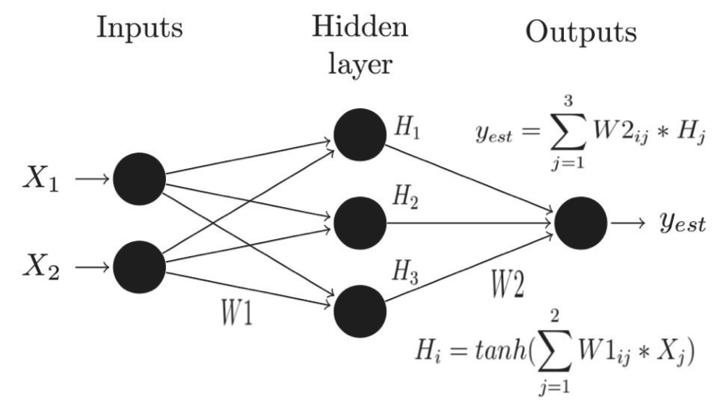

Figure 1. This figure shows a topological map of a simple multi-layer perceptron (MLP) neural network. There are 3 layers: Input, Hidden, and Output. Each input is connected to every hidden neuron through weights, which are represented by connecting lines. Each hidden neuron is then connected to the output. A nonlinear activation function is used for hidden layer neurons and a linear function is used for the output neuron.

Figure 2.
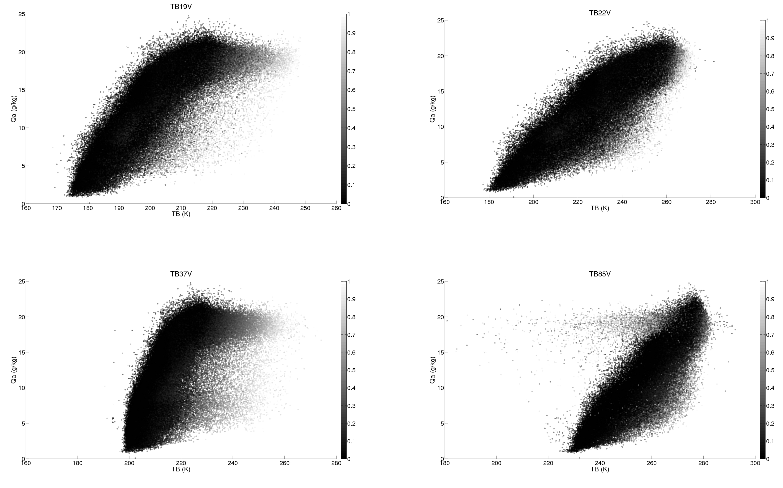

Figure 2. Scatter plots show the relationship between specific humidity (Qa) and brightness temperature (TB). Shading represents the CLW as calculated by the Weng and Grody (1994) algorithm. Units are in mm. It is apparent that the CLW effectively cause a warming of the TB's and a saturation effect in the Qa-Tb relationship.

Figure 3.

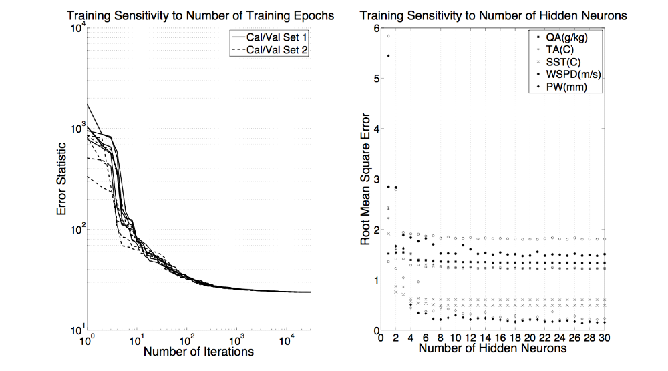

Figure 3. The above panels display the training sensitivity for the neural network. The left panel depicts several runs on different calibration/validation data sets. Training proceeded for 30000 epochs in each case. The ordinate is the training error statistic. The right panel depicts the sensitivity to the number of hidden neurons. Shaded pixels are for clear-sky training while open pixels represent cloudy-sky training. For SST, the larger cross is for cloudy conditions. The error statistic is the RMSE computed on the validation dataset.

Figure 4.
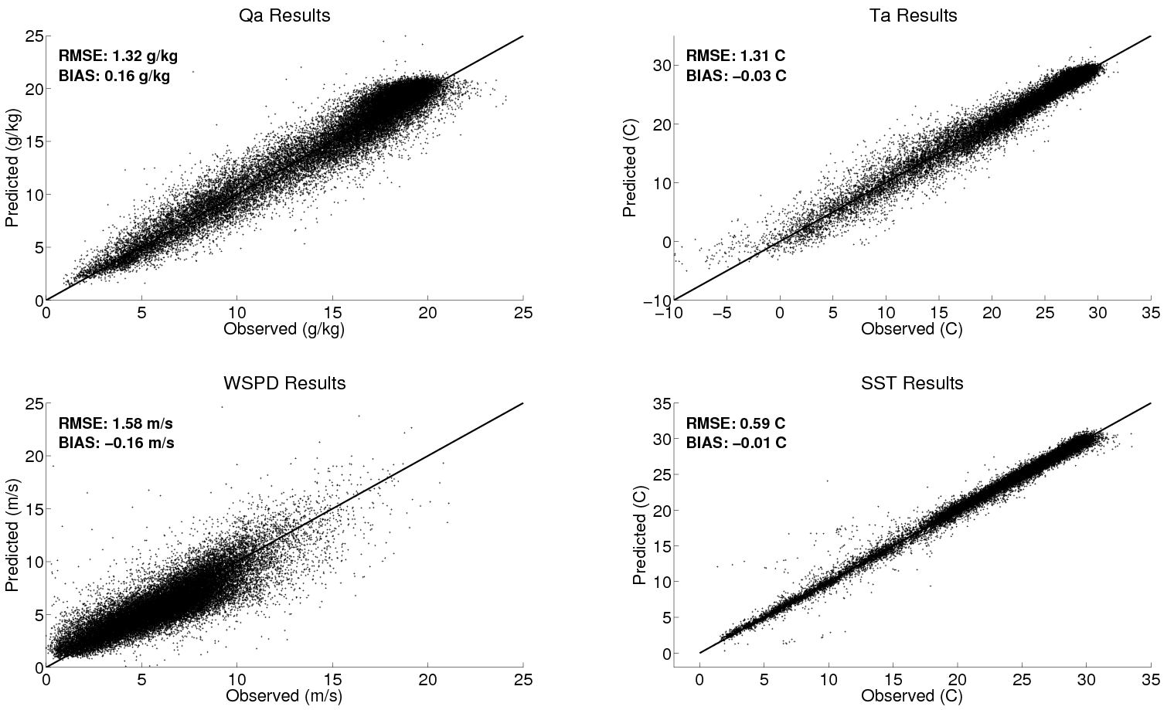

Figure 4. This figure shows scatter plots of predicted vs. observed parameters for specific humidity (Qa), air temperature (Ta), wind speed (WSPD), and sea surface temperature (SST). The predicted values are the output obtained directly from inversion of satellite brightness temperatures using the neural network. These results are from the neural network applied to the clear and cloudy conditions separately. Observations are from the SeaFlux in situ dataset. Error statistics are also displayed for convenience.

Figure 5.
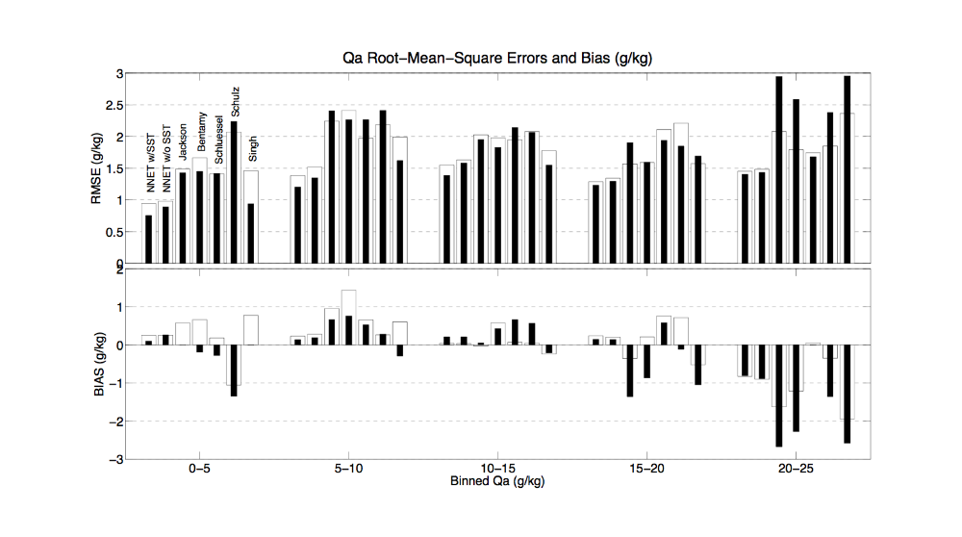
Figure 5. The above figure depicts the root mean square and bias statistics computed across the range of the specific humidity (Qa) distribution for several algorithms. Shaded bars represent cloudy conditions while clear bars represent clear conditions. Notice how several algorithms have biases strongly varying across the distribution leading to a cancellation effect on the overall computed bias statistic given in Table 1.

Figure 6.
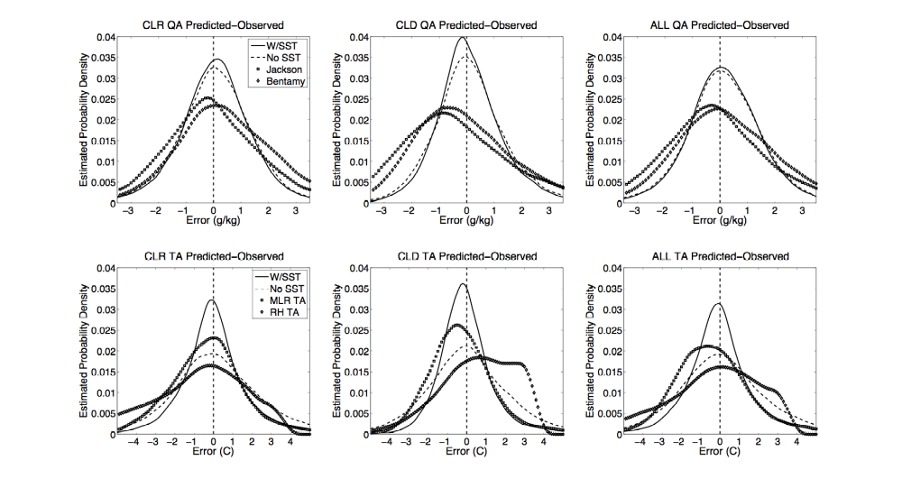
Figure 6. This figure depicts the estimated probability density function of errors for near surface specific humidity (Qa) and air temperature (Ta) from several methodologies. From left to right, the top row depicts the error characteristics for the networks training only for clear-sky conditions, cloudy conditions, and a network trained making no distinction between clear or cloudy conditions. The bottom row depicts the same as the top panel except for Ta. RHTA refers to the estimate based on assuming a constant relative humidity and MLR refers to a multiple linear regression using the SSM/I channels and the first guess sea surface temperature.

Figure 7.

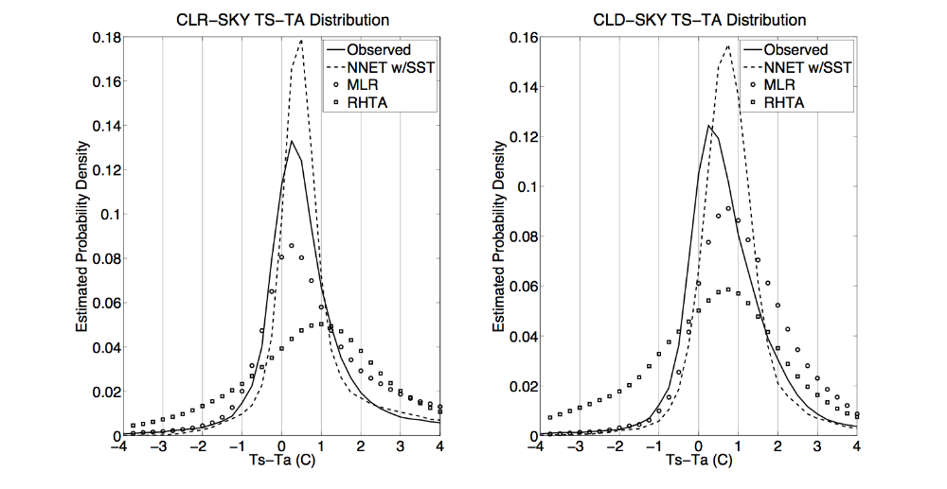

Figure 7. Distributions of sea surface temperature (Ts) minus air temperature (Ta) are shown for clear sky (left) and cloudy sky (right) conditions. Shown are estimates from observations, the neural network method, and estimates using the first guess SST minus air temperature derived from a constant relative humidity (RHTA) assumption and a multiple linear regression approach (MLR).

Figure 8.

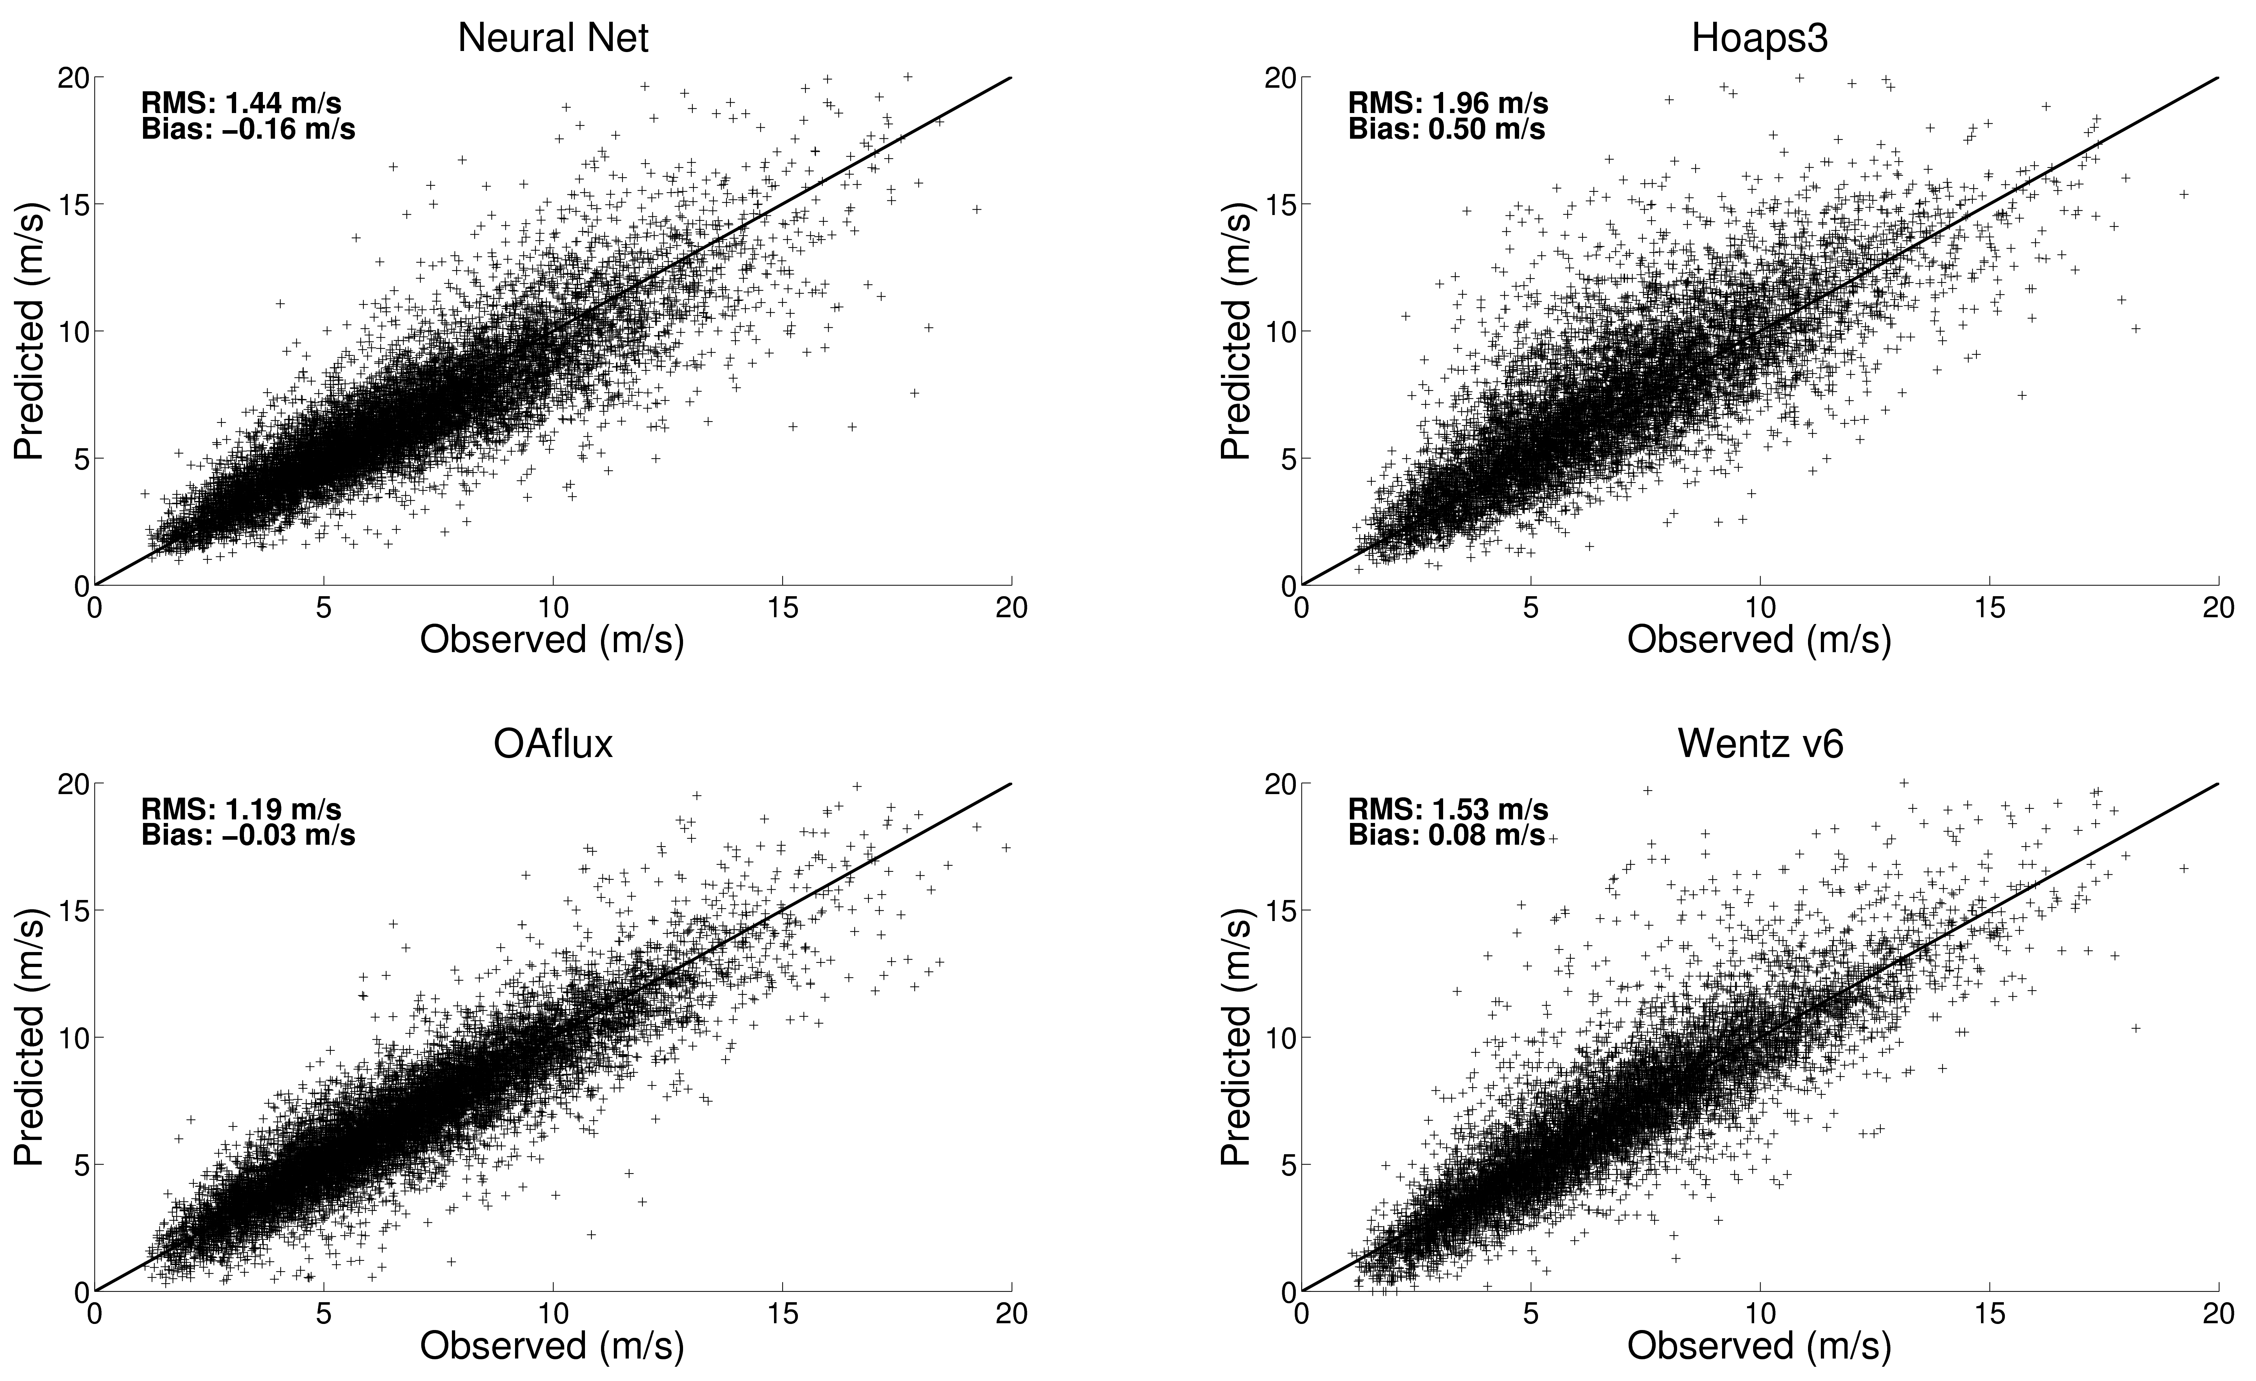

Figure 8. Scatterplots of daily averaged wind speed observed from buoys and predicted currently available gridded products: NNET (top left), Hoaps version 3 (top right), OAflux (bottom left), and Wentz version 6 (bottom right). Bias is computed as predicted minus observed.

Figure 9.

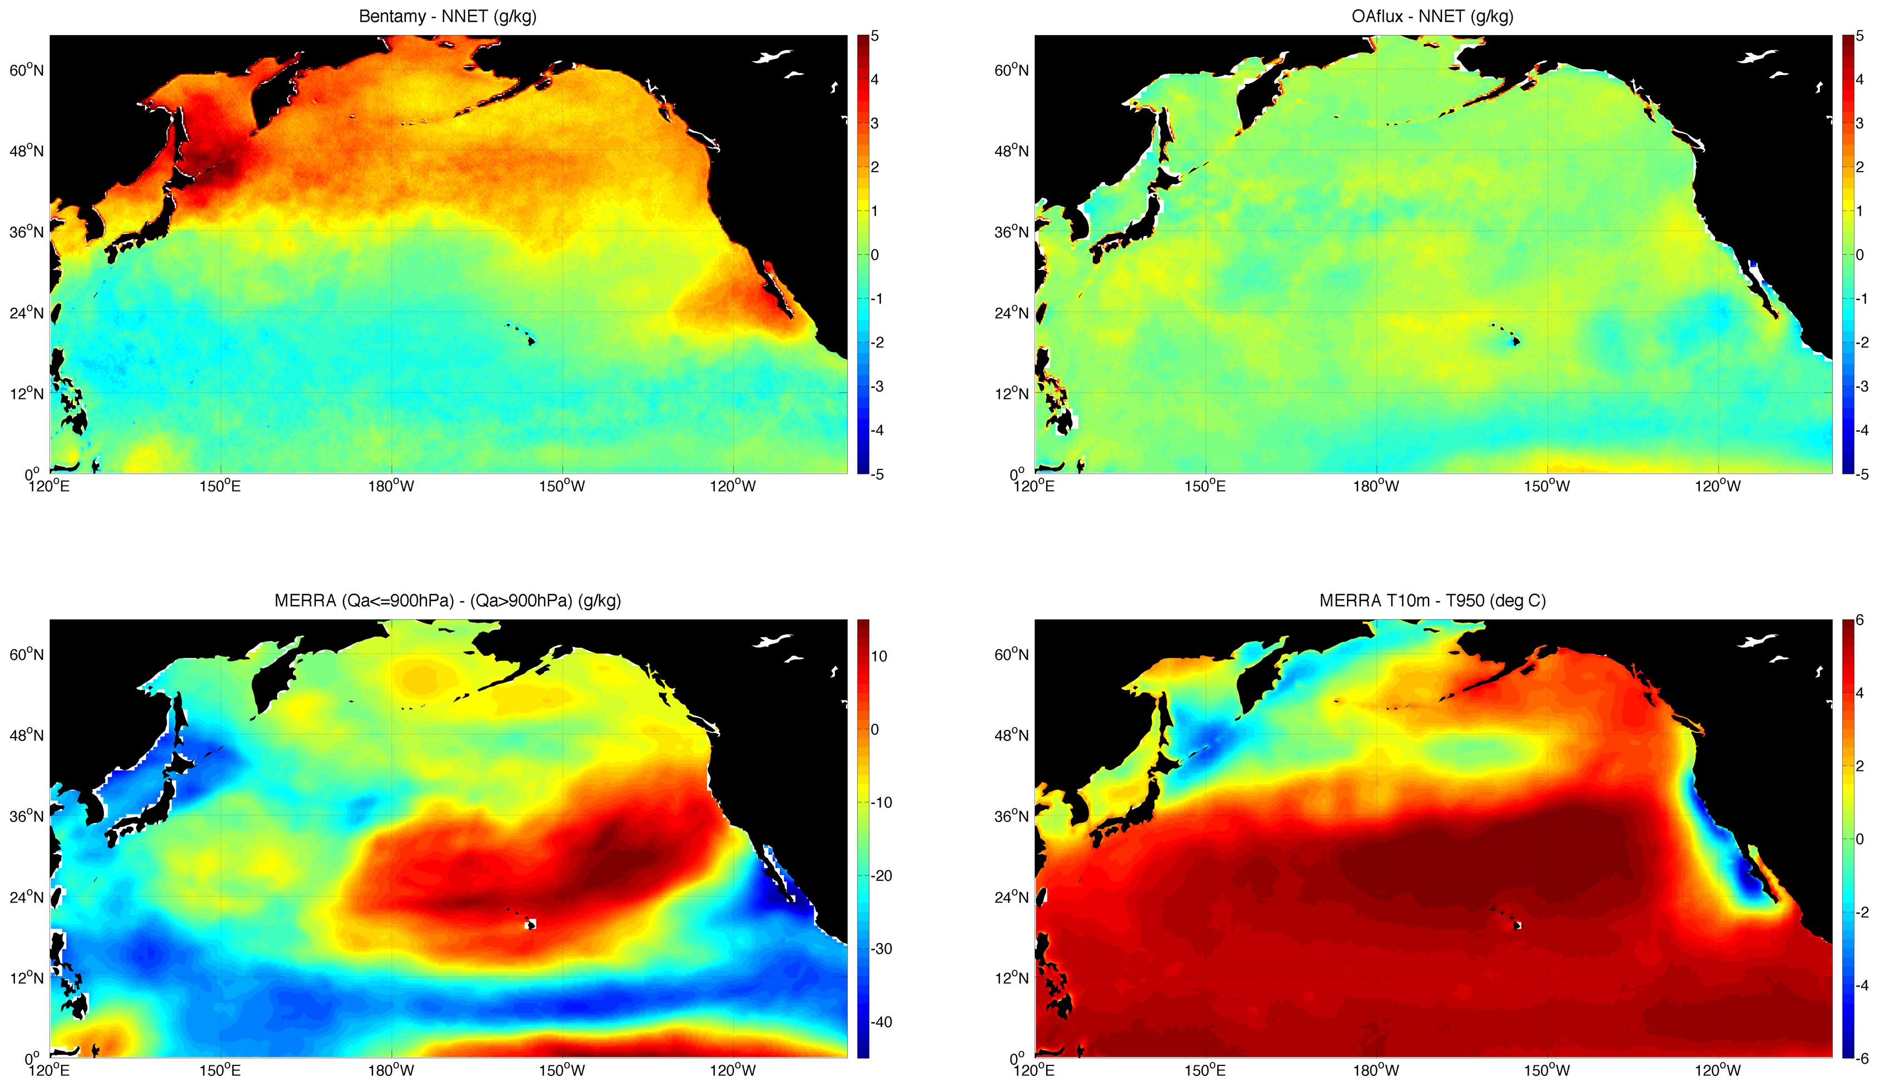

Figure 9. Difference plots of monthly averages of near surface specific humidity for July 2002: Bentamy algorithm minus the neural network algorithm (top left) and OAflux product minus neural network algorithm (top right). The bottom panels show the difference in lower troposphere humidity and upper tropospheric humidity (left) and a proxy for lower tropospheric stability (right).

Figure 10.
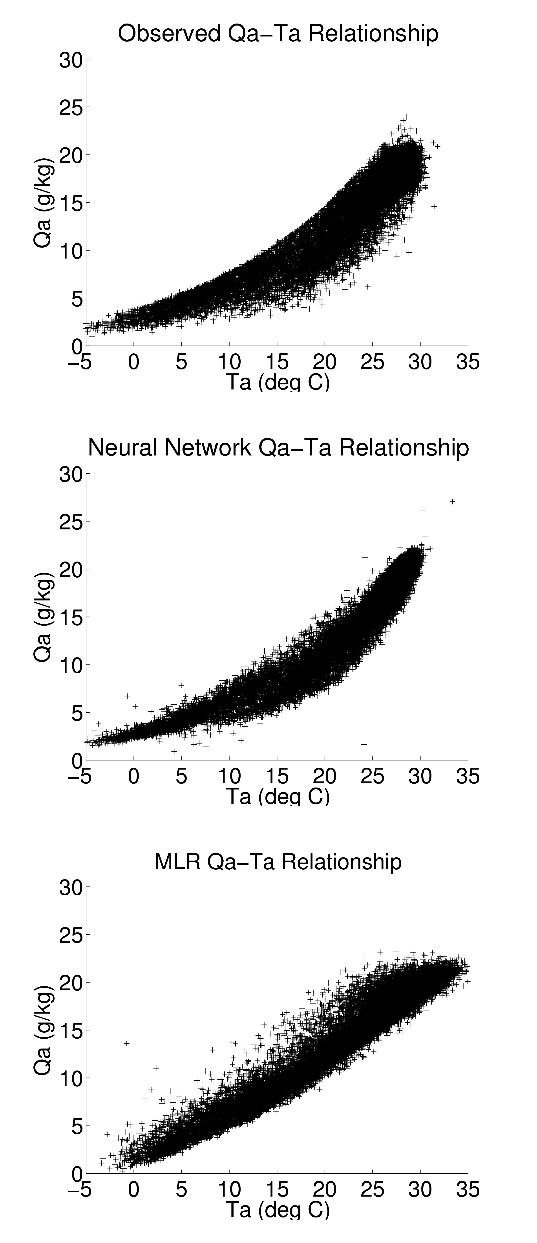

Figure 10. Relationship between specific humidity and air temperature from observations (top), neural network (middle), and multiple linear regression estimates for Ta and Qa using the same predictor variables (bottom). The observed relationship clearly shows a nonlinear trend as expected from the Clausius-Clapeyron relation. This trend is captured using the neural network method but not using the linear estimates.

