Feasibility Assessment of Satellite-Based Tsunami Detection

Prepared by:

Darren L. Jackson and Gary A. Wick
NOAA Environmental Technology Laboratory
325 Broadway R/ET6
Boulder, CO 80305-3328
(303) 497-6180, (303) 497-6322
darren.l.jackson@noaa.gov
gary.a.wick@noaa.gov

November 12, 2004

- INTRODUCTION

Observations of tsunamis have indicated the presence of “shadows” or regions of modified roughness along the wave fronts. Recent work by Godin (2004) provided a theoretical description of this phenomenon and suggested that the corresponding modification of the surface wind field in the presence of the waves could be detected with existing microwave measurements of sea surface roughness. Such a capability would mark a significant advance in the ability to provide early detection of potentially damaging tsunami events. Open ocean detection has been difficult because of the small wave amplitudes and shallow slopes. The most common tsunami detection systems are based on wave gauges or pressure sensors on the sea floor. As such, the systems are significantly limited in their coverage area. Limited open-ocean detection has been reported using satellite altimetry (Okal et al., 1999) but the number of altimeters in orbit is small and their coverage is limited to the sub-satellite point. Wider swath microwave radiometers and scatterometers provide greatly enhanced coverage.
The theoretical work indicated that the horizontal wind velocity immediately above the ocean surface could be perturbed more than 10% over bands of tens of kilometers in width in the presence of a tsunami wave. While relatively small in amplitude, such a signal should be potentially visible in data from existing active or passive microwave sensors used to monitor wind speed. Detection should be further enhanced by the long wave fronts (thousands of kilometers) and high, predictable propagation speed. To this point, however, the tsunami signature has not been conclusively identified in microwave satellite imagery.
This report describes the analyses and results of a study to determine the feasibility of detecting a tsunami in the open ocean with existing microwave satellite sensors. Existing satellite data corresponding to historical tsunami events was used to determine whether any unique signature can be observed in the data. Numerical simulations of tsunami events were used to identify the location of the tsunami events during the overpass of satellites. The second section details the satellite and simulation data incorporated. The third section documents the identification of tsunami events sampled by satellite data. The fourth and fifth sections then describe the analysis techniques utilized and the results obtained from multiple tsunami events. The report concludes with a summary assessment of the feasibility findings.

- DATA

Satellite data from both passive and active microwave sensors were examined for the presence of tsunami signatures. The primary data utilized included passive microwave radiometry from the Special Sensor Microwave Imager (SSM/I) and scatterometer data from the SeaWinds on QuikSCAT. Additional data from the NASA Scatterometer (NSCAT) were also considered but the overpasses exhibited poor coincidence with the tsunami events so the data were not utilized.
The SSM/I instrument onboard the Defense Military Satellite Program (DMSP) satellites senses vertically and horizontally polarized radiation at 19.3, 37.0, and 85.5 GHz and vertically polarized radiation at 22.2 GHz. The SSM/I footprint size is inversely proportional to the frequency of the channel with 19 GHz having the largest footprint of 69x43 km and 37 GHz having the smallest footprint of 37x28 km. The SSM/I scans conically which preserves the footprint size throughout the scan and has a swath width of 1400 km. SSM/I radiometric noise is approximately 0.6 K (Hollinger et al., 1987). Data from multiple DMSP satellites were available from 1992 to the present through an archive maintained at the NOAA Environmental Technology Laboratory.
Analysis to the SSM/I data was applied to both the individual radiometric quantities and derived wind speeds. SSM/I observations are used primarily for retrieval of precipitable water, cloud liquid water, surface wind speed, and precipitation. The SSM/I retrieves wind speed indirectly by observing changes in surface emissivity caused by changes in surface roughness. Increasing surface wind speeds act to increase surface roughness and surface emission. Wind speed retrievals typically have greatest error for high wind speeds (> 10 m/s) where foaming of the ocean surface acts to degrade the relationship between wind speed and surface roughness. This study considered three different wind speed retrievals: Schluessel and Luthardt (1991), Bates (1991), and Goodberlet et al. (1989), but only the Schluessel results are presented here. No significant differences in tsunami signal detection were found between the methods. These retrievals were all developed using a multi-channel regression on matched satellite radiance observations with buoy observations of wind speed. The random errors in the retrieved wind speeds are typically around 1 m/s. The wind speed retrievals were the favored product since variations in wind speed are most directly related to the theoretically predicted effect of the tsunamis, and the retrieval algorithms remove the effect of other influences on the microwave brightness temperatures such as water vapor variations and precipitation. The individual brightness temperatures were also considered since retrieval algorithms can also add noise to the data and mask small anomalies.
QuikSCAT is an active microwave scatterometer functioning at 13.4 GHz with a nominal spatial resolution of 25 km. A 1 m diameter rotating dish using two beams is used to retrieve wind speed and wind direction. The sensor swath width is approximately 1800 km. Analysis of the QuikSCAT data was applied to wind speed and direction retrievals distributed through the Physical Oceanography Distributed Active Archive Center (PO.DAAC) at the NASA Jet Propulsion Laboratory. The sensor was launched in 1999 and the data are available to the present. The rms accuracy of the QuikSCAT wind speed retrieval is approximately 1 m/s (Ebuchi et al., 2002), and the accuracy of wind direction retrieval is ~ 20 degrees.
Along with the sensor radiometric accuracy and spatial resolution, the satellite orbit places a major constraint on the likelihood of being able to detect a tsunami event. Both QuikSCAT and the DMSP satellites are in polar, near sun synchronous orbits. The orbits are approximately 100 min in duration, and, for the swath width of the sensors, sampling of a given spot on the earth is limited to twice daily at most latitudes. Continuous coverage enabled by satellites in geosynchronous orbit would be most desirable for this application, but no suitable sensors are currently in orbit.
Estimates of the position and magnitude of the tsunami waves were obtained from simulations created by the NOAA Pacific Marine Environmental Laboratory (PMEL). The Facility for the Analysis and Comparison of Tsunami Simulations (FACTS) at PMEL has a web site that simulates tsunami events and has detailed results for several historical tsunamis. The primary model output utilized were spatial maps of the tsunami wave height. The data were available at roughly 0.25 degree grid resolution on 75 second time steps. Conversations with Dr. Oleg Godin indicated that the wave characteristic most directly related to a microwave roughness signature would be the vertical velocity of the surface. As a result, estimates of vertical velocity were computed from consecutive maps of wave height using a simple forward differencing method.

- IDENTIFICATION OF TSUNAMI EVENTS WITH SATELLITE COVERAGE

The first step of the analysis was to identify what satellite coverage existed for significant historical tsunami events. Because of the sub-optimal orbits of the existing sensors, it was necessary to determine if any events were sampled soon after their occurrence and if any events were sampled multiple times. A thorough archive of tsunami events containing their magnitude and corresponding runup data was obtained from the National Geophysical Data Center (NGDC). The database was searched for events since 1991 (the start of available ETL satellite data) with significant magnitude and reported runup in multiple locations. Requiring at least one runup measurement to exceed 1 m eliminated many events that would be difficult to detect from satellite data. An additional criterion was for the event to have a detectable propagation over the Pacific basin. For example, an event originating in Peru would need to demonstrate an observable runup at remote location such as Hawaii or Japan. This type of event is more likely to be observed by a satellite observation than a local event only detected in small region of Indonesia. It was important that the matched satellite data were far enough from land so that land contamination did not affect the satellite observation.
Knowledge of the orbital data of SSM/I and QuikSCAT was used to determine if and when overpasses would successfully sample the extracted events. Satellite Tool Kit (STK) version 5.0 orbital propagation software was used with detailed orbital ephemeris data to map potential matching satellite overpasses with tsunami events. Maps giving the satellite ground track were printed and tsunami wave propagation was estimated on the map by assuming a propagation speed of 700 km/hr. A compass was used to mark the location of the tsunami wave front in two hour increments. Matches with satellite data were then identified and compiled in Table 1. Eight tsunami events were found to be sampled by satellite data within 12 hours of the event. An additional 3 events were sampled at later times but these events were not considered. The sampling nearest in time to an event was 40 minutes for the New Guinea tsunami of July 17, 1998. Three additional events were sampled within two hours of the event. Only the Peruvian tsunami on July 23, 2001 was sampled by QuikSCAT data.
Satellite data for each available match were extracted from the archive maintained at ETL. We found a few instances where SSM/I data was missing from the archive due to problems with the tape media. The SSM/I data that did exist were converted from their native format into brightness temperatures for each channel and retrievals were performed to give the selected wind speed products.

- ANALYSIS METHODS

Several different techniques were applied to search for the presence of features in the satellite data corresponding to the presence of tsunami waves. The selected methods were based in large part on discussions with Dr. Oleg Godin. This section details each procedure. The corresponding results are presented in Section 5.

Table 1: Location and time of significant tsunami events and the corresponding SSM/I and QuikSCAT overpass location and time. Time is in UTC and Δt indicates time difference between start of tsunami and satellite overpass. Mg indicates magnitude of earthquake source.

Tsunami Source |  |  |  |  |  | Satellite Matches
Place | Mg | Date | Time | Lon | Lat | Time | Δt | Lon | Lat | Satellite
Nicaragua | 7.2 | 9/2/92 | 0:15 | 87.4W | 11.7N | 2:40 | 2:25 | 85W | 5S | F10
 |  |  |  |  |  | 4:20 | 4:05 | 115W | 15N | F10
Russia | 8.3 | 10/4/94 | 13:23 | 147.3E | 43.8N | 19:40 | 6:17 | 155E | 0N | F11
Mexico | 7.6 | 10/9/95 | 15:35 | 104.1W | 18.9N | 16:48 | 1:13 | 100W | 0N | F10
 |  |  |  |  |  | 18:30 | 2:55 | 125W | 10N | F10
Indonesia | 8.1 | 2/17/96 | 6:00 | 137E | 0.9S | 7:50 | 1:50 | 150E | 0N | F13
 |  |  |  |  |  | 11:45 | 5:45 | 150E | 35N | F10
 |  |  |  |  |  | 17:00 | 11:00 | 160W | 45N | F13
Peru | 6.6 | 2/21/96 | 12:51 | 79.6W | 9.6S | 15:28 | 5:52 | 85W | 30S | F10
 |  |  |  |  |  | 17:07 | 7:31 | 110W | 25S | F10
 |  |  |  |  |  | 18:40 | 9:04 | 125W | 0N | F10
Aleutians | 7.6 | 6/10/96 | 4:03 | 177.6W | 51.6N | 5:18 | 1:15 | 180E | 45N | F13
 |  |  |  |  |  | 7:58 | 3:55 | 150W | 40N | F10
 |  |  |  |  |  | 9:30 | 5:27 | 170W | 15N | F10
 |  |  |  |  |  | 11:10 | 7:07 | 165E | 5N | F10
 |  |  |  |  |  | 12:50 | 8:47 | 140E | 5N | F10
New Guinea | 7.1 | 7/17/98 | 8:50 | 141.9E | 2.9S | 9:30 | 0:40 | 145E | 0N | F11
 |  |  |  |  |  | 17:30 | 8:40 | 170W | 35N | F13
 |  |  |  |  |  | 18:50 | 10:00 | 165W | 40N | F11
Peru | 8.2 | 6/23/01 | 20:33 | 73.6W | 16.3S | 22:40 | 2:07 | 80W | 30S | QS
 |  |  |  |  |  | 23:50 | 3:17 | 80W | 40S | F13
 |  |  |  |  |  | 23:55 | 3:22 | 90W | 0N | F13
 |  |  |  |  |  | 0:22 | 3:47 | 100W | 10S | QS
 |  |  |  |  |  | 1:34 | 5:01 | 110W | 20S | F13
 |  |  |  |  |  | 4:50 | 8:17 | 110W | 55S | F14
 |  |  |  |  |  | 5:12 | 8:39 | 130W | 5N | F14
 |  |  |  |  |  | 6:41 | 10:08 | 145W | 40S | F14
 |  |  |  |  |  | 8:00 | 11:27 | 150W | 40S | F15

4.1 Direct Image Inspection and Feature Extraction

The satellite data products were first searched for direct visual signatures demonstrating coherence with the expected position of the tsunami waves. The products considered included the retrieved QuikSCAT wind speed and direction and both the SSM/I retrieved wind speeds and brightness temperature data. For these analyses, the data were all mapped to a 0.25º grid. This resolution provided the highest possible image resolution with the fewest regions of data gaps. Since signatures in the original data could be masked by large-scale background variations, various filters were applied to the data to enhance any potential features. In the simplest filtering, anomalies from the mean background field were extracted by applying a 5 x 5 median filter to the image and subtracting the result from the original image. Roberts and Sobel edge detection filters were also applied to the data to attempt to highlight any gradients consistent with a tsunami wave front. For the events sampled by SSM/I, the location of the leading edge of the tsunami was estimated by assuming that the leading wave front traveled at 700 km/hr. The PMEL simulations of the 2001 Peruvian tsunami were used for the single event sampled by QuikSCAT.

  - Coincident Image Averaging and Correlation Method

The next analyses focused on trying to identify any apparent average dependence over the tsunami wave fronts. While sensor noise might hinder direct identification of a signal on individual pixels, averaging larger samples of satellite data over a given wave state could reduce the noise and lead to a clearer signal. Wind speed retrievals and SSM/I brightness temperatures were matched with corresponding wave height and vertical velocity values from the available tsunami simulations. While the satellite speed over the ground is rapid, significant time changes occur over the portion of the satellite pass covering the area influenced by a tsunami event. To ensure close correlation in time, the satellite data were blocked into 74 second windows so to match each simulation time step.
Two methods were developed to facilitate matches between satellite and model values. The first method remapped the irregular model data onto 0.25º grid. This resolution was chosen so to minimize averaging of the model data yet not create a grid full of missing data regions. Satellite data at its original resolution are matched to the model grid field by using the satellite observation that most closely matches the center of the model grid. This method intended to eliminate matches between model and satellite data that would have relatively small overlap since SSM/I observations generally have footprints near 0.25º. A second method matched each satellite observation with the closest ungridded model data. Differences in correlation values and averaged data were found to be small.
The matches were first used to compute a correlation coefficient between the satellite product and tsunami characteristic. Correlations were computed both over individual 74 second blocks and over entire satellite passes. The satellite products included both the direct retrievals and the anomaly fields with the mean background removed using median filtering. The matching satellite products were then binned and averaged over areas of equal model wave height and vertical velocity.

4.3 Spectral Analysis Method

The final analyses examined the spatial distribution of the satellite products to determine if the data exhibited any spectral power consistent with the period of the tsunami wave field. Square portions of the satellite swaths were extracted and a 2-dimensional discreet Fourier transform applied to the image. Power spectra were computed from the resulting complex array by computing the logarithm of the square of the modulus. These tests were designed as a compliment to the previous analyses. Evaluating the average product anomaly over a given wave state might not fully identify regular spatial variations in the anomaly that might be expected to result from the wave field, particularly if the simulation is not perfectly aligned with the satellite data. Small errors in the simulation fields or time offsets in the satellite data could completely mask small correlation signals. The spectral analysis does not require a simulation field for evaluation of each satellite product, though sample simulation data helps establish the signal that would be expected.

- RESULTS

The primary event used in the analyses resulted from an 8.4 magnitude earthquake along the southwestern coast of Peru on June 23, 2001. This event will be termed the 2001 Peruvian tsunami. Runup observations at Camana reached 7 m and inundation distance of approximately 1 km from coast. More remote runup observations indicate the tsunami extended over most of the Pacific Basin with observed waves in Hawaii, Alaska, Japan and New Zealand. This was the only event sampled by QuikSCAT and several matches with SSM/I were available. A detailed simulation of the event was also available through PMEL. A second event with existing simulation data and multiple SSM/I matches was the Aleutian Islands tsunami of June 10, 1996. The other identified events were used to lesser degrees in analyses where less detail of the tsunami position was required.

5.1 Visual Inspection of 2001 Peruvian Tsunami

Figure 1 provides the SSM/I orbital data from four overpasses from two different satellites along with grey curves indicate the location of the 2001 Peruvian tsunami wave front during times of satellite overpass. Orbital overpasses occur every 100 minutes and propagate westward with the sun due to the sun-synchronous orbit of the DMSP polar-orbiting satellites. The westward progression of the satellites clearly moves faster than the tsunami, yet more than one overpass can intersect the tsunami wave front. The F13 #1 orbit indicates two intersect points with the tsunami wave front while the remaining three overpasses indicate a more tangential intersection between the satellite overpasses and tsunami wave front. Time coincidence between satellite and tsunami wave front are brief since the satellite coverage is roughly 10 degrees of latitude every 3 minutes. The tsunami wave can travel about 33 km during this time frame which corresponds to the width of the typical SSM/I footprint.
The results of the first analyses applied to the earliest SSM/I match to the 2001 Peruvian event are shown in Figure 2. A circular wave front corresponding to the estimated leading edge of the tsunami wave is superimposed on the SSM/I wind retrieval image while the filtered wind speed data are shown in the other three panels. Similar results for the 19 GHz, vertically polarized brightness temperature for the same match are shown in Figure 3. Neither the retrieved wind speed nor the filtered images show any obvious correlation to the tsunami event. The vertically polarized 19 GHz results show a feature at 25S; however, the wave front has clearly passed through this region at an earlier time, and the curvature of the feature is opposite to the tsunami waves. Results for the QuikSCAT wind speed and direction fields from the orbit closest in time to the event are shown in Figures 4 and 5 respectively. Both figures show the retrieved quantity and anomaly based on application of a median filter to each data field. Contours are of wave height as was determined by FACTS model simulation of the 2001 Peruvian tsunami. The QuikSCAT data also failed to show any direct visual signal. Application of the Roberts and Sobel filters to the QuikSCAT anomalies did not improve the results.
The analyses were applied to other SSM/I orbits for the 2001 Peruvian event and for other tsunamis including the 1996 Aleutians Island event, the Mexico event, New Guinea event, and Nicaragua event. Wind speed fields showed visual correlation to estimated or simulated tsunami wave fields only in one instance. A result from a small portion of the F14 orbit following the Peru event is shown in Figure 6. In this instance, variations in the wind speed do align with the simulated tsunami in the region between 5N and 5S. While intriguing, the results are not conclusive, particularly since similar agreement could not be found in other cases even when wave amplitudes were greater.
Portions of individual brightness temperature images showed potential similarities in a few cases. Extracts of 19V and 37H GHz data and the corresponding simulated wave fields are shown in Figures 7 and 8 respectively. Linear features near 20S and 30S in the brightness temperature anomalies again tend to align with the wave data in these cases. However, linear features also agree with wave patterns over larger portions of the image, and similar features appear in regions where no tsunami waves are present. These features are likely related to atmospheric effects caused by precipitating clouds. It would be difficult to ascribe the features directly to the presence of tsunamis. Even if there were some direct correspondence in the selected regions, unique identification of tsunami fronts would be extremely difficult with this technique.

5.2 Correlation Analysis

Correlation analysis technique was then applied to SSM/I and QuikSCAT data from the 2001 Peruvian tsunami. A sample of the data entering into the analyses is shown in Figure 9 for the F14 #3 orbit. Time difference between satellite and model are zero for the scan line at the center of the image. Vertical and horizontal missing data regions are an artifact of the gridding the model data. Satellite windows exceeding 75 seconds would result in mismatching satellite observations with wave heights due to the high propagation speed of tsunamis. Correlations were filtered by removing all model data below a specified threshold so to remove matched data either not affected by tsunami waves or in regions behind the main wave front where wave amplitudes were very small. Table 2 gives correlation results for multiple windows over one SSM/I F13 orbit. The correlation between wave height and retrieved wind speed remains small for all model realizations. Filtering the matches to include only those matches over significant wave heights does show small improvements in correlation. However, even with such filtering, evaluations with wind product and brightness temperature anomalies against wave heights and vertical velocities failed to produce correlation coefficients greater than 0.3. Noise in the satellite data overwhelmed any correlation present.

Table 2: Correlation results over one SSM/I F13 orbit during 2001 Peruvian tsunami corresponding to consecutive model wave height (wh) realizations. “All points” correlations perform correlation for all locations between matched data sets. The second set of correlations was done for only those matches exceeding wave heights of 1 cm.

Model Time (UTC) | Correlation (all points) | Correlation (|wh| > 1 cm)
23:41:59 | 0.11 | 0.21
23:43:14 | -0.06 | -0.07
23:44:29 | -0.09 | -0.10
23:45:44 | -0.09 | -0.11
23:46:59 | 0.12 | 0.15
23:48:14 | 0.16 | 0.23
23:49:29 | 0.24 | 0.27
23:50:44 | 0.00 | 0.01
23:51:59 | 0.14 | 0.14
23:53:14 | -0.19 | 0.05

Binning the matched data over values of the wave height and vertical velocity, however, did show some hint of a discernable impact. The average SSM/I wind speed anomaly dependence on tsunami wave height derived for one entire SSM/I swath is shown in Figure 10. At the greatest positive and negative wave amplitudes, there does appear to be some mean change to the wind speed anomaly. The results obtained with vertical velocity show an even stronger potential dependence as illustrated in Figure 11. The tendency continues to be apparent when results from several different orbits are combined, despite the fact that small timing differences could overwhelm any signal. A similar analysis applied to the closest matching QuikSCAT orbit (Figure 12) also shows some mean effect on the wind speed at the greatest negative displacements though in the opposite orientation. A change in sign of the effect could potentially be related to differences in the orientation of the wind and wave fields. These are the most positive findings of the study. The results potentially support the assertion that the presence of tsunami waves can perturb the wind field, though only at the largest wave amplitudes.
Despite the suggestion of a possible impact, the results are not statistically significant and are far from conclusive. The number of data points at the greatest displacements and vertical velocities is very small and the random variations observed at lesser displacements are larger than the average offsets. The effect is visible only in the average and it would not be possible to identify a tsunami front in a satellite image with the noise level of the current sensors. Further, the results need to be substantiated with additional coincident satellite and tsunami fields.

5.3 Spectral Analysis of 2001 Peruvian Tsunami

Spectral analysis was then applied to image segments to search for further positive evidence of a tsunami signal. The analysis was first performed on portions of the modeled tsunami wave field coincident with F14 satellite observations of the Peruvian tsunami to identify what, if any, spectral signal might be expected. The results, shown on the left of Figure 13, indicate that enhanced power is visible in both the x and y directions at a wavenumber of 0.4 cycles per degree which corresponds to a wavelength of 275 km. This wavelength is common for tsunami waves. A weak diagonal line is apparent for the model spectral analysis that points perpendicular to the wave front. The corresponding spectral analysis for the SSM/I data indicates its greatest power at low frequencies but the magnitude of the power is reduced (note change in scale between figures). A weak diagonal line corresponding to the model spectral result is evident but is confined to wavenumbers less than 0.6 cycles/degree. Analysis of SSM/I wind speed anomaly data for other locations in this orbit and other orbits for this tsunami event did not show any distinguishable lines within the spectral power image.
Spectra from several different brightness temperature anomaly fields at multiple frequencies did indicate power at periods similar to that of the tsunami waves. Figure 14 shows the results for brightness temperature anomalies at the horizontally polarized 37 GHz channel. Increased power is clearly visible near the same wavenumber as seen in Figure 13 and linear features in the brightness image show coincidence to the tsunami field. Analyses of the corresponding anomaly fields from the days before and after the tsunami, however, show a very similar increase in power when no tsunami is present. The brightness temperature fields are sensitive to variations in factors other than surface roughness such as water vapor and precipitation. In this instance, it would appear that the increase in spectral power could correspond to atmospheric features, such as clouds, that happen to have similar periodicity to the tsunami fields.

5.4 Tsunami Events of 1995-1996

While the 2001 Peruvian tsunami event provided the best opportunity for observing the “tsunami shadowing” effect due to the numerous satellite matches and detailed model simulations, several other tsunami events with coincident SSM/I data were also investigated for the possible detection of this signal. These events generally had fewer matches with tsunami wave fronts and had no corresponding model wave height simulations with the exception of the 1996 Aleutian tsunami.
Figure 15 gives examples of SSM/I overpasses over four separate tsunami events. Brightness temperatures from the vertically polarized 19 GHz channel are shown with the grey arcs indicating the leading edge of the tsunami wave. The 1996 Aleutian and 1996 Indonesian event had overpass times less than two hours following the start of the tsunami event. All four cases show no obvious tsunami signal in the mean brightness temperature field with the possible exception of the Mexican tsunami where a brightness temperature gradient exists along the tsunami wave front. Figure 16 shows the same orbits only displaying the Schluessel wind speed retrieved data. Retrieved data show masking due to precipitation for all four events. The Peruvian and Indonesian tsunamis experience precipitation contamination along the tsunami wave fronts. The Mexican and Aleutian tsunami data both show wind speed features that align themselves with the tsunami wave front; however, these features are considerably wider than the typical tsunami wavelength.
Model simulations of the Aleutian tsunami event did provide opportunity to conduct the correlation analysis described in Section 4.2. Correlations between model wave simulation data and satellite data were again found to be low (< 0.3) and insignificant. A major difference between this event and the 2001 Peruvian event was that the wave amplitudes were an order of magnitude less between model simulations. While the 2001 Peruvian tsunami produced wave heights on the order of 10 cm, the Aleutian tsunami had wave heights less than 1 cm. However, binning successive matches between model wave height and SSM/I wind speed data for the overpass shown in Figure 15 did produce a similar signature as those shown in Figures 11 and 12. Figure 17 shows the relationship between wind speed and vertical velocity over an eight minute period where direct matches were found between model simulations and SSM/I observations. A tail of decreasing wind speed does occur for negative vertical velocities. However, error bars indicate a large degree of uncertainty within each vertical velocity bin, and the subsequent orbit did not show this feature.
A spectral analysis of the 1996 Mexican tsunami shown in Figure 15 was performed with the hopes of finding a tsunami wave signal as was shown in Figures 12 and 13 from the model simulations. Figure 18 shows a 10º x 10º region along the SSM/I orbit and coincident with the tsunami wave front. The 2-D power spectra of the wind anomaly data indicates greatest power at low frequency with a weakly evident region of high power pointing north/south. However, the tsunami wave propagation shown in figure 15 indicates a mostly east/west propagation of the tsunami wave field. Applying the analysis to other location along the overpass or applying the spectral analysis to the wind speed data did not change the result.
While the wind speed data for the Mexican tsunami did not indicate a tsunami signal, Figure 19 does show greater spectral power at low frequencies for the 19H channel brightness temperature field. A wave pattern does emerge in the anomaly field; however, the wave field indicates a more northward direction of propagation to that of the tsunami shown in Figure 15. The spectral analysis shown for the 1995 Mexican tsunami does not conclusively indicate that SSM/I observations can detect the presence of a tsunami.

6. CONCLUSIONS

No signal uniquely related to the presence of tsunami waves has been conclusively identified in existing microwave satellite products. Inspection of SSM/I, QuikScat, and NSCAT data identified eight tsunami events of significant magnitude since 1992 sampled by satellite data. The sampling closest in time to the source event was 73 minutes and in no cases was a tsunami sampled between the source and region of maximum damage. Analyses of the satellite data included visual inspection, basic edge detection, spectral analysis, and compositing the data across constant values of the tsunami wave state. Instances were identified where both raw satellite brightness temperatures and derived wind speeds exhibited linear features in regions near estimated tsunami wave fronts, but the features were not present with regularity and similar features were also observed distant from the tsunamis.
The most promising result was evidence of a perturbation of the wind speed anomaly when averaged over the largest modeled tsunami wave heights and vertical velocities. The perturbation was observed over multiple passes of both the QuikScat and SSM/I satellite sensors. The perturbation was visible, however, only in the average, and was smaller in magnitude than typical scatter in the wind speed retrievals. This significantly hinders potential detectability in real time and conclusive attribution of the feature to the presence of a tsunami.
Satellite detection of tsunami events is currently limited by noise level, orbital geometry, and resolution of the current sensors. The results obtained to date seem inadequate to conclusively evaluate theoretical concepts for detection. The existence of repeatable perturbations suggests the potential for passive microwave satellite detection of tsunami events in support of the theoretical predictions, but, ideally, retrievals with accuracy of better than 1 m/s on scales near 10 km would be required. Detectability would also be enhanced with continuous sampling such as provided from geosynchronous orbit. Further evaluations could be attempted with QuikScat measured backscatter coefficients and additional modeled tsunami fields, but a comprehensive evaluation of detectability would seem to require enhanced or dedicated sensors.

7. REFERENCES

Bates, J.J., High-frequency variability of special sensor microwave/image derived wind speed and moisture during an intraseasonal oscillation, J. Geophys. Res., 96, 3411-3423, 1991.

Ebuchi, Naoto, H. Gruber, and M.Caruso, Evaluation of wind vectors observed by QuikSCAT/SeaWinds using ocean buoy data, J. Atmos. Oceanic Tech., 19, 2049-2062, 2002.

Godin, O. A., Air-sea interaction and feasibility of tsunami detection in the open ocean, J. Geophys. Res., 109, C05002, doi:10.1029/2003JC002030, 2004.

Goodberlet, M.A., C.T. Swift, and J.C. Wilkerson, Remote sensing of ocean surface winds with the special sensor microwave/imager, J. Geophys. Res., 94, 14,547-14,555, 1989.

Hollinger, J.R., R. Lo, G. Poe, R. Savage, and J. Pierce, Special sensor microwave/imager user’s guide, report, Nav. Res. Lab., Washington, D.C., 1987.

Okal, E. A., A. Piatanesi, and P. Heinrich, Tsunami detection by satellite altimetry, J. Geophys. Res., 104, 599-615, 1999.

Schluessel, P., and H. Luthardt, Surface wind speeds over the North Sea from special sensor microwave/imager (SSM/I) observations, J. Geophys. Res., 96, 4845-4853, 1991.

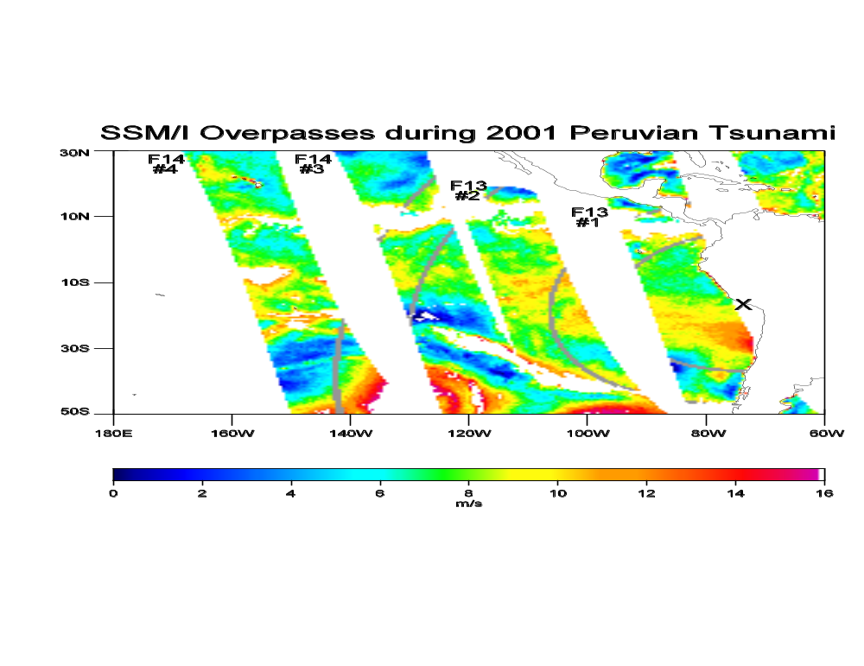
Figure 1: Wind Speed retrieval from four SSM/I overpasses during 2001 Peruvian Tsunami event. Grey arcs indicate location of tsunami wave front during time of overpass. X indicates the epicenter of the earthquake. Labels for each orbit indicate DMSP satellite number (F13,F14) and orbit number used in report.
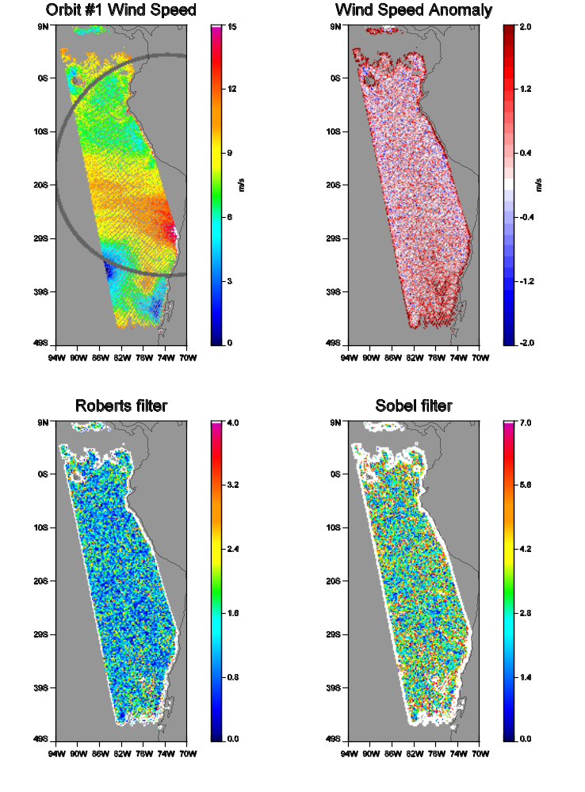
Figure 2: Wind speed retrieval for F13 orbit #1 during 2001 Peruvian Tsunami. Grey area indicates location of tsunami wave front. Wind speed anomaly computed by removing median filter. Roberts and Sobel edge detection filters applied to wind speed data.

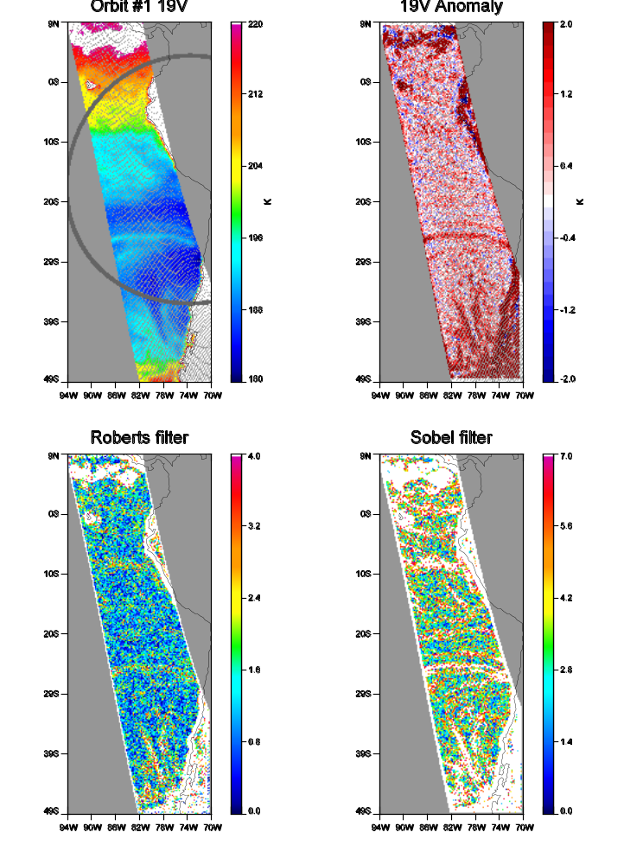
Figure 3: Same as Figure 2 except for 19V brightness temperature field.

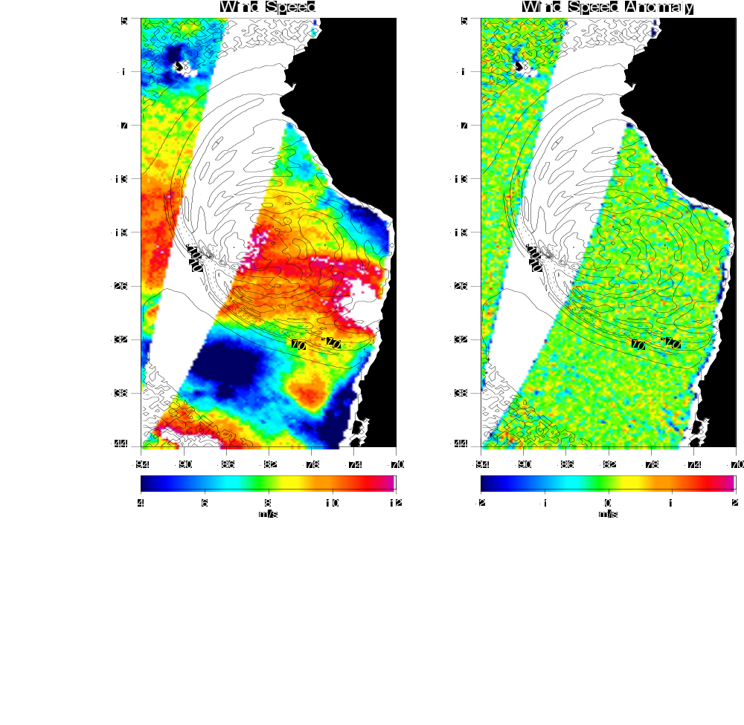
Figure 4: QuikSCAT wind speed retrieval and wind speed anomaly field during the 2001 Peruvian tsunami. Contours indicate tsunami wave height from FACTS model simulation. Wind speed anomaly computed by applying median filter.
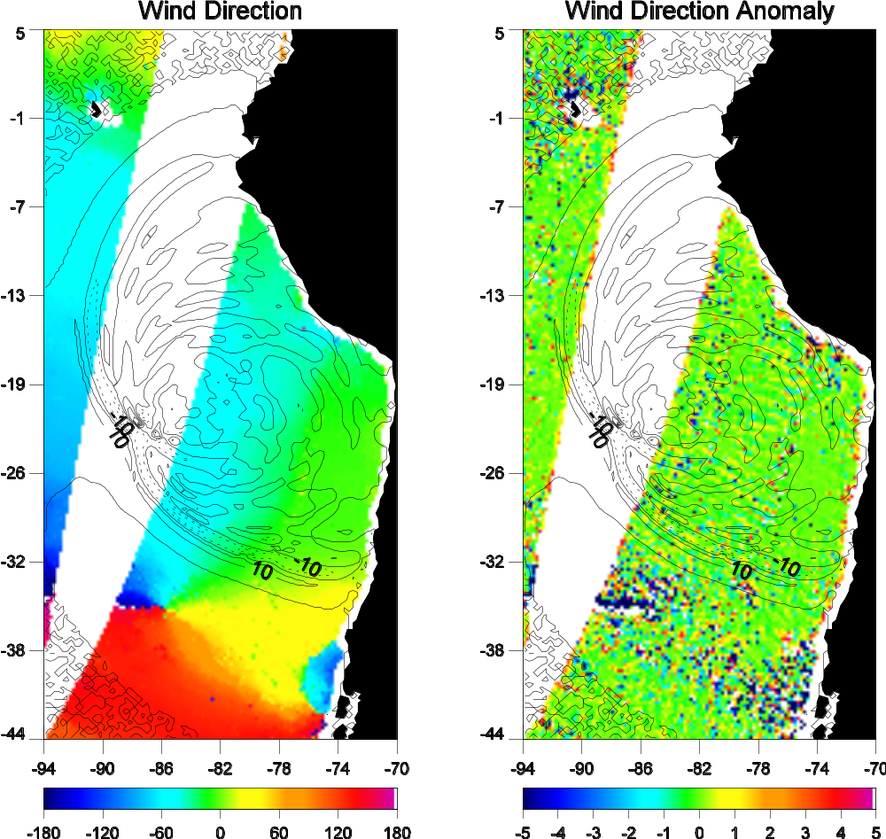

Figure 5: Same as Figure 4 except using wind direction.
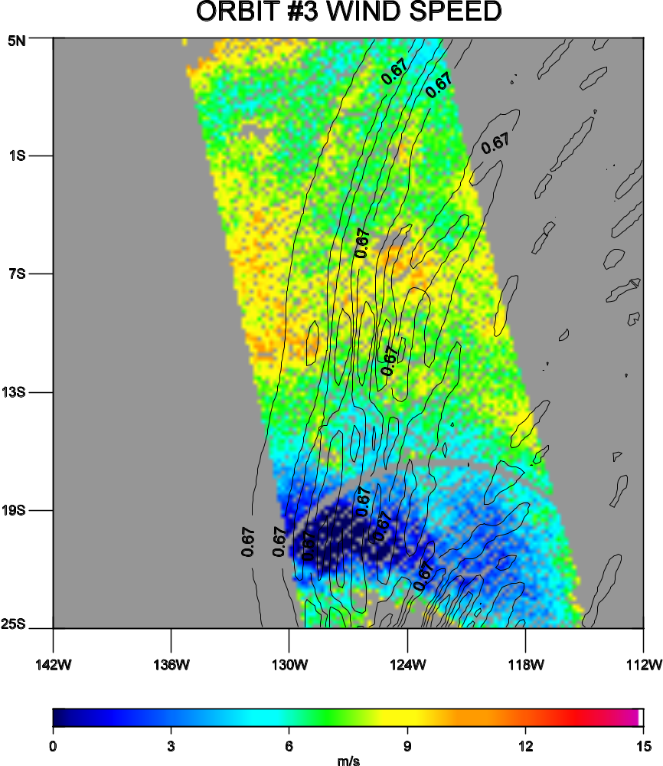
Figure 6: Schluessel and Luthhardt (1991) wind speed for F14 orbit #3 case. Contours indicate wave height data from FACTS model simulation.
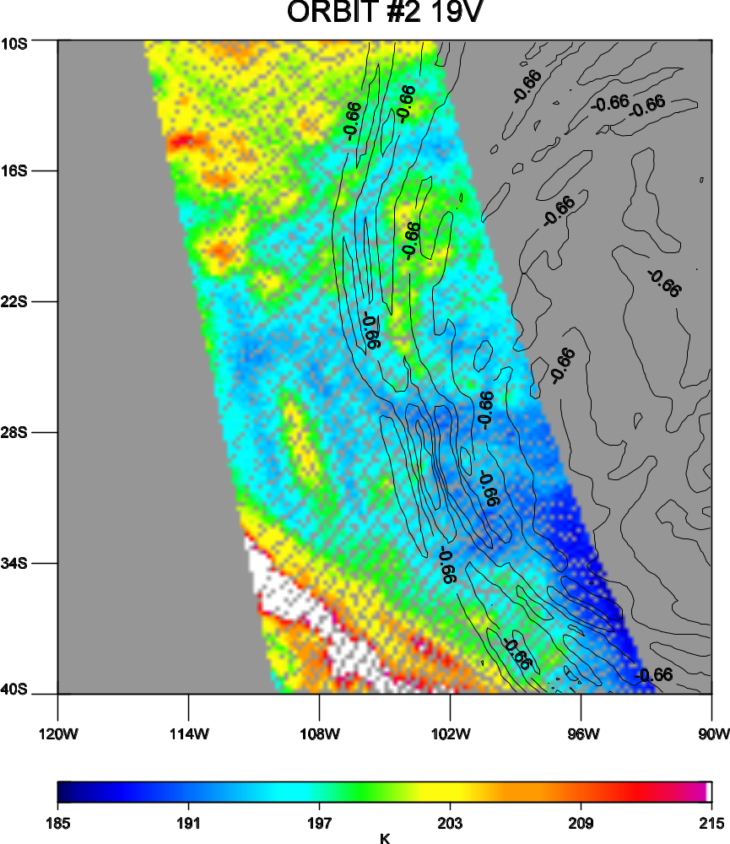
Figure 7: Same as Figure 6 except using 19V brightness temperatures.
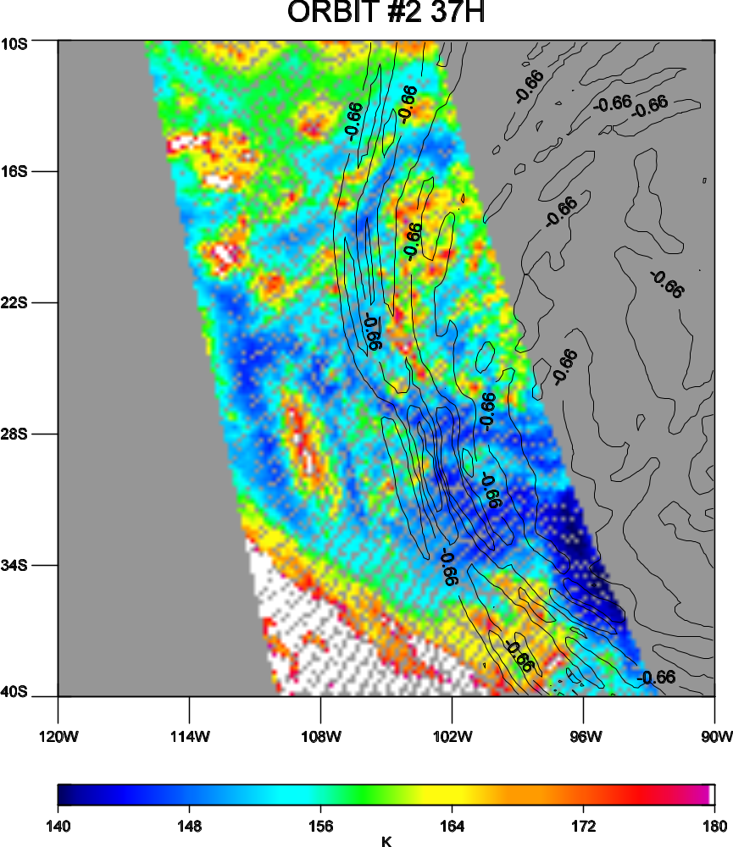
Figure 8: Same as Figure 6 except using 37H brightness temperatures.
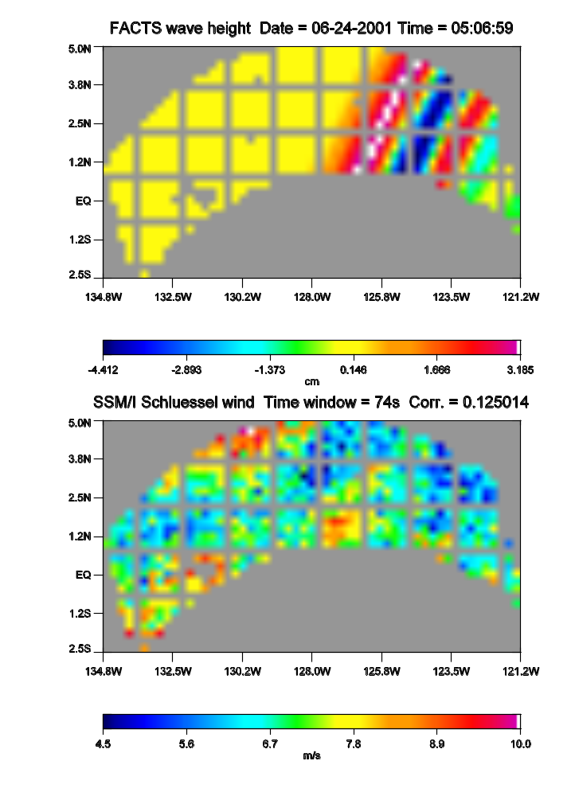
Figure 9: F14 orbit #3 match between FACT wave height simulation and SSM/I wind speed retrieval. The time window indicates the span of time in satellite observations that directly match the model field in time.
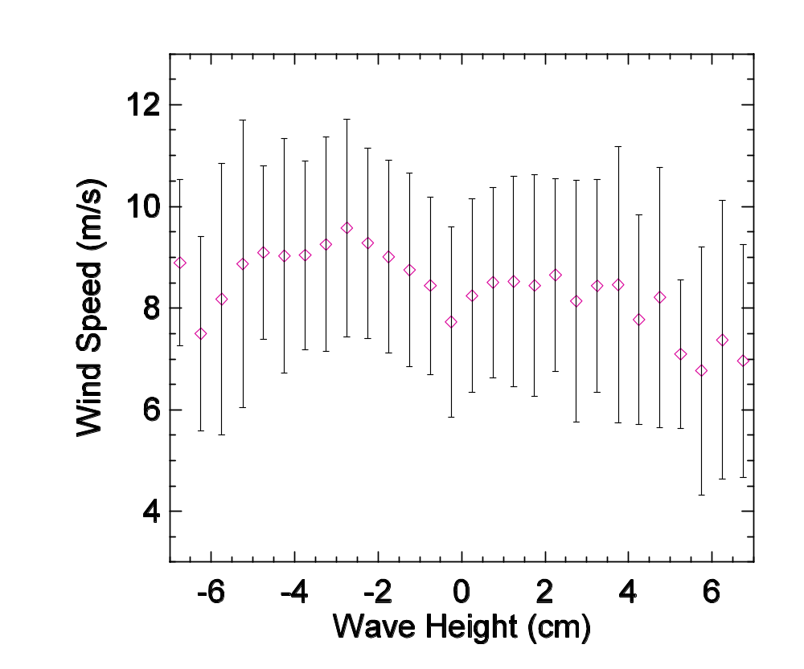
Figure 10: Relationship between model wave height and SSM/I wind speed for a succession of F13 orbit #1 satellite and model matches like those shown in Figure 9. Wave height bin size is 0.5 cm, and error bars indicate standard deviation.

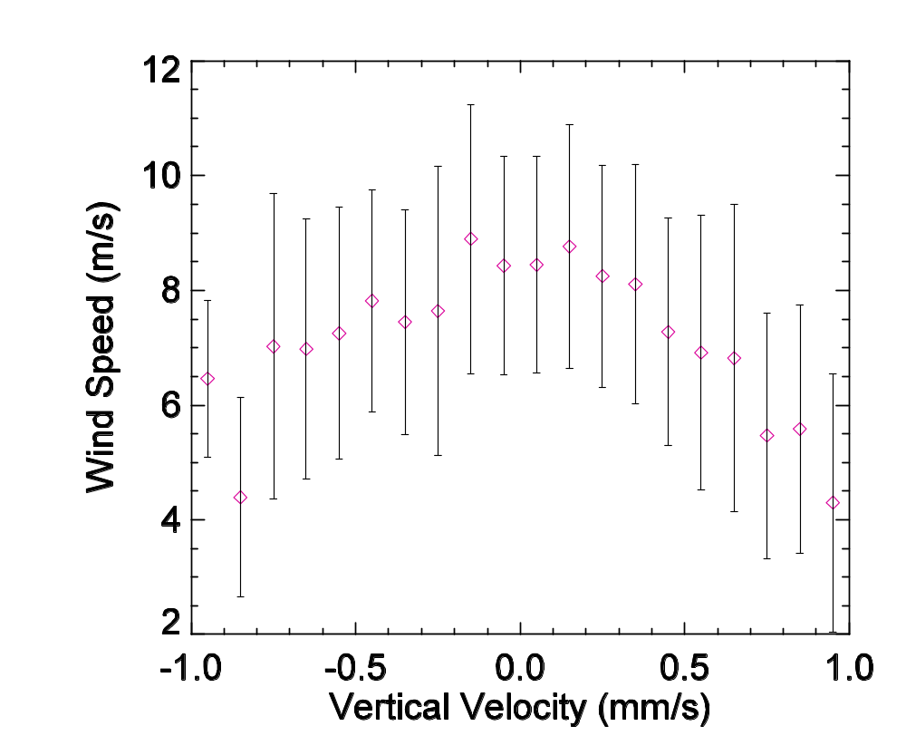
Figure 11: Same as Figure 10 except using vertical velocity.

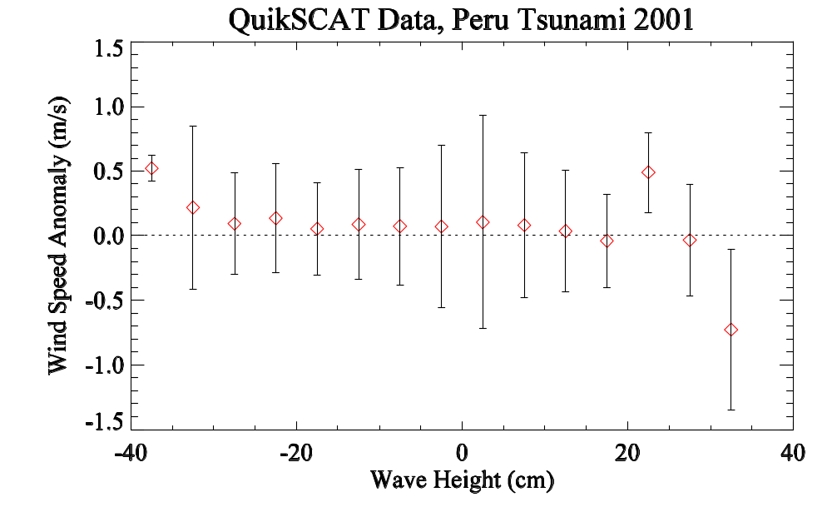
Figure 12: Same as Figure 10 except using QuikSCAT wind anomaly data.

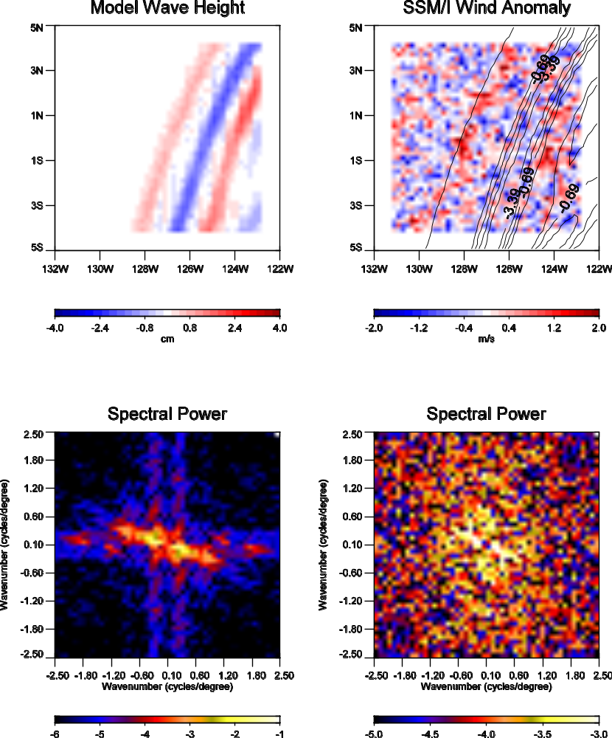

Figure 13: Median-filtered images from F14 orbit #3 model and SSM/I wind speed data and their corresponding 2-D spectral power. Note difference in scale for spectral power for model and satellite data.

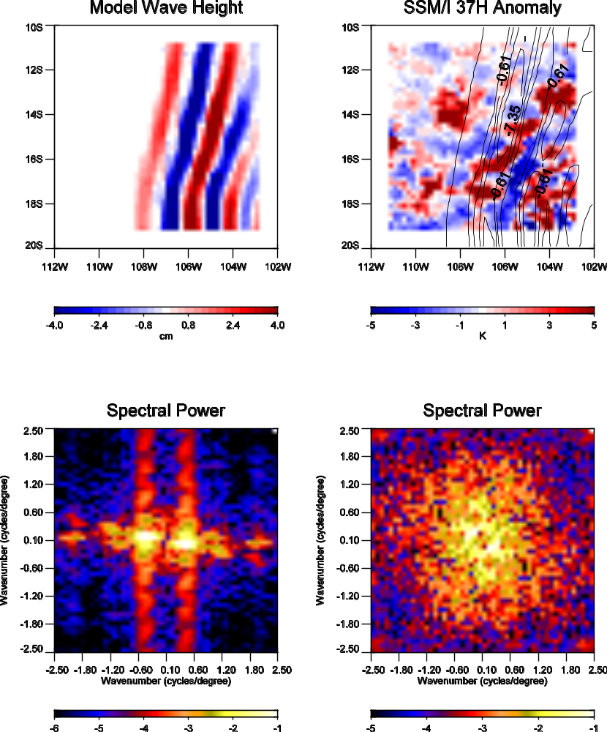

Figure 14: Same as Figure 13 except using 37H brightness temperatures from a F13 orbit #2 location.
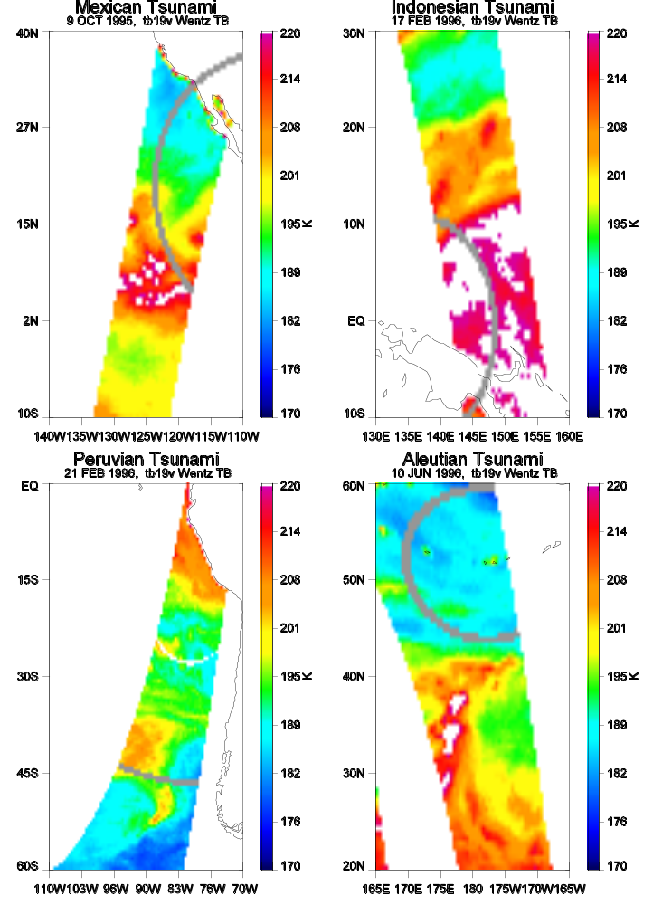
Figure 15: SSM/I 19V brightness temperature observations during four different tsunami events. Grey arcs indicate location of tsunami wave front for each event.
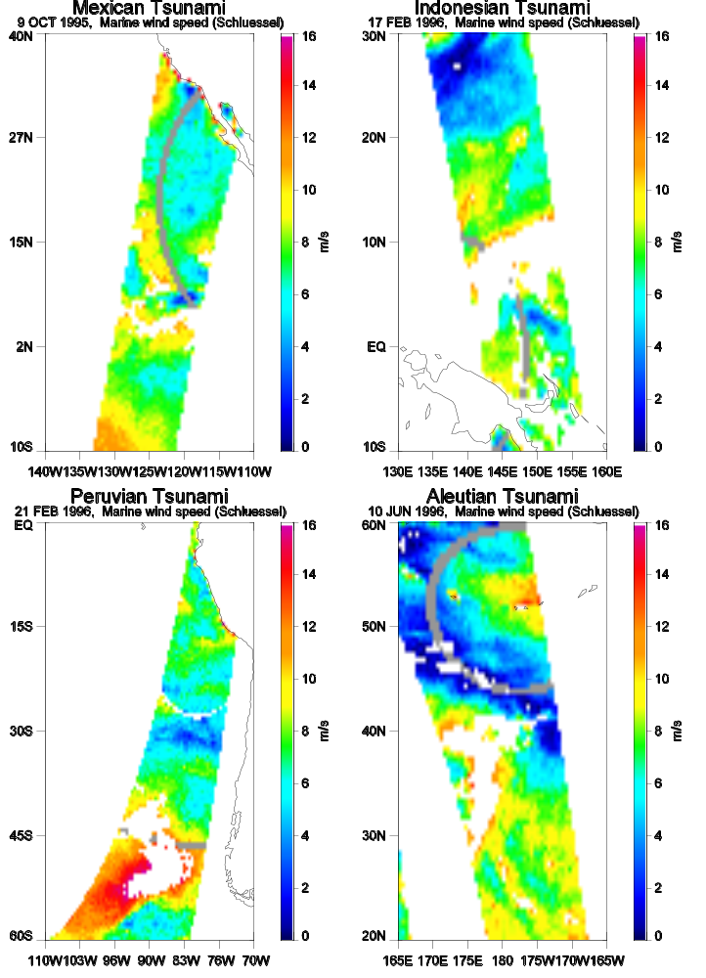
Figure 16: Same as Figure 15 only using SSM/I wind speed data.
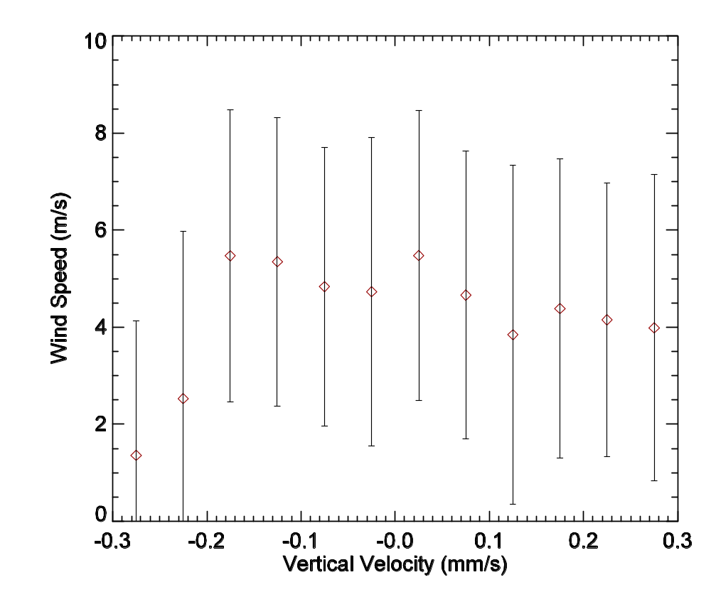
Figure 17: Relationship between model wave height and SSM/I wind speed for 1996 Aleutian tsunami shown in Figure 15. Wave height bin size is 0.05 cm, and error bars indicate standard deviation.

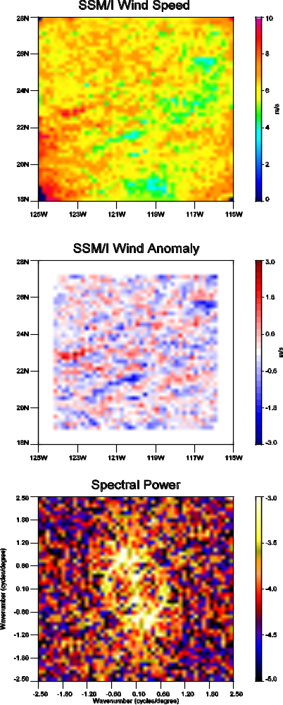

Figure 18: Wind speed, wind anomaly, and 2-D power spectra images from 1996 Mexican tsunami shown in Figure 15.
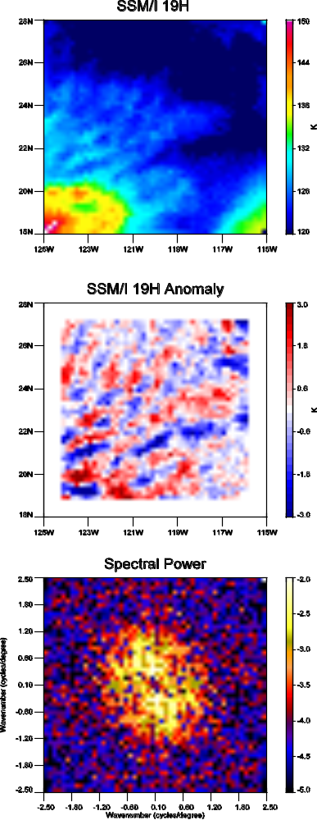

Figure 19: Same as Figure 18 only using 19H brightness temperatures.

