Procedure for Replacing ATI Sonic Anemometer Circuit Board:

Materials needed: new board, shim tool, soldering tools and materials, test cable, (all can be found in box with tracking # EG537092437US) flux computer, silicon sealant

- Unscrew the 4 set screws on the bottom of the mounting arm of the sonic.
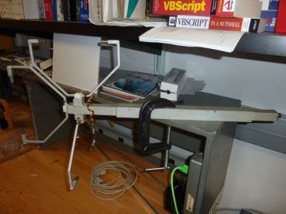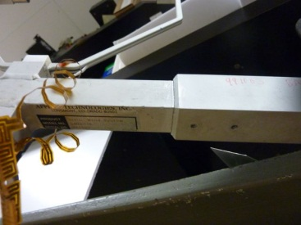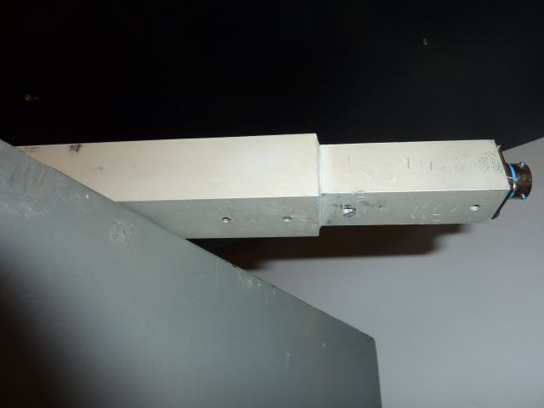
Set screw locations – use a metric allen wrench size 2.

- Use the “shim tool” to cut away the silicon sealant from inside the mounting arm. You may wish to wear gloves or put tape around the shim tool as it has sharp edges. Use the shim on both ends of the arm. Make sure to clean off any
Cut away at both ends of sonic arm
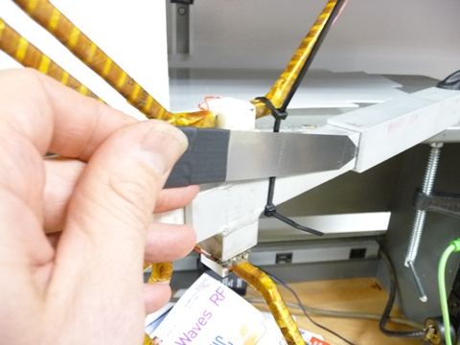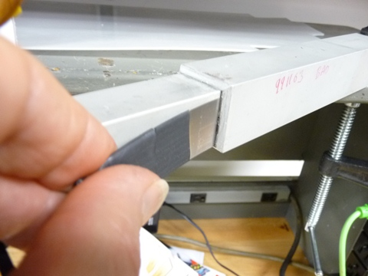

- Once both ends are free to move, push the sonic end toward the connector end and gently pull the connector end out. Unplug the connector end from the board.
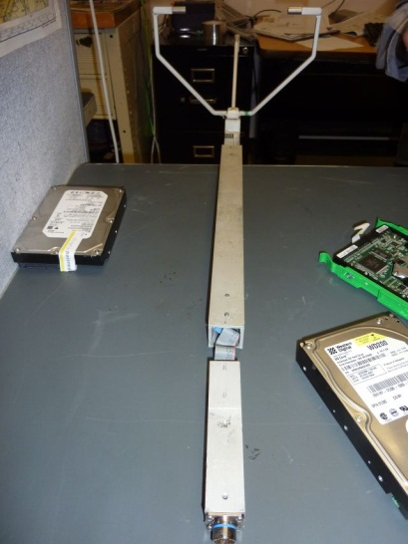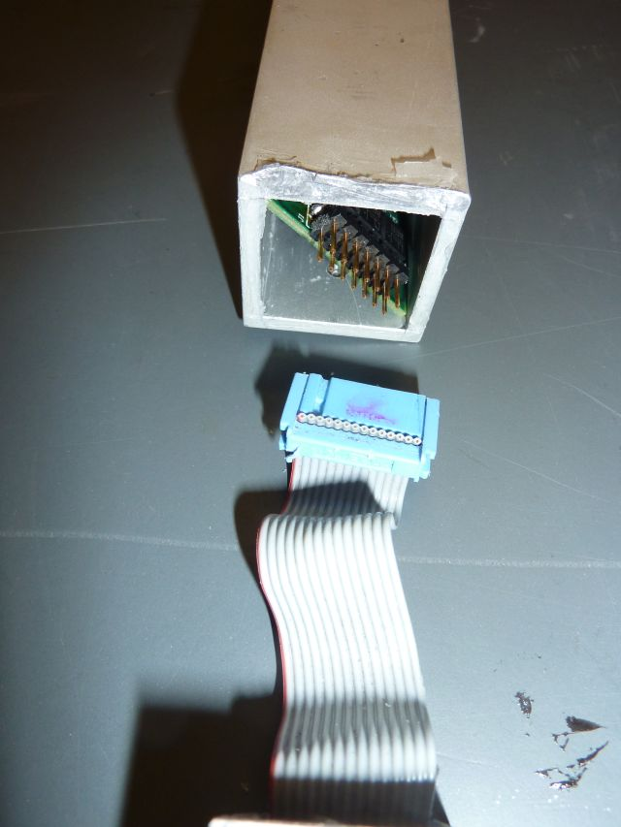
Connector End
Sonic End
Unplug circuit board from connector
Push + gently pull out connector

- Gently pull sonic end out so the circuit board can be removed from the mounting arm. Unsolder the wires one by one. Put a different color piece of shrink tubing on each wire and record which location it came from.
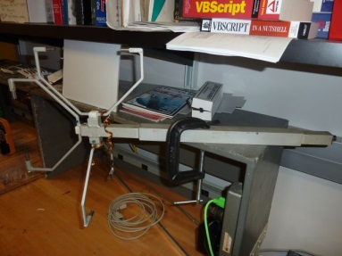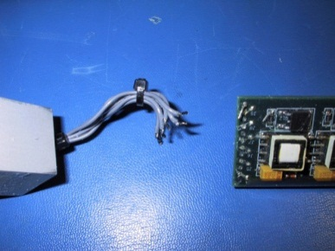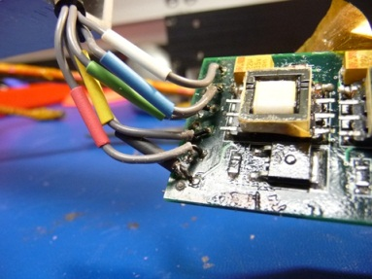
Add color tubing to remember location
Unsolder wires
Gently pull out circuit board

- Solder the wires to the same locations on the new board. Please keep and send the old board back to NOAA.
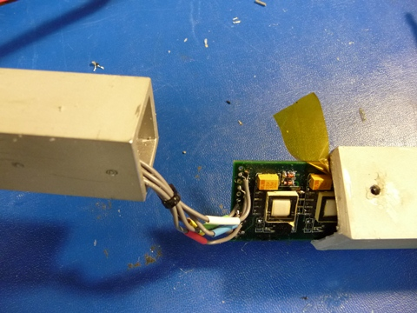
- Once the board is replaced, slide it back into the mounting arm, plug it back into the connector side, and test the operation by using the test cable to plug into the flux computer at the CAF. Connect to COM6
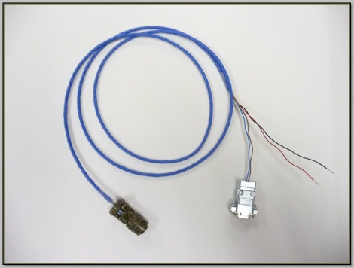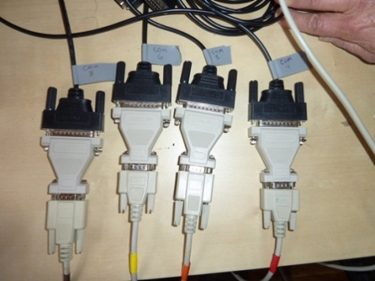
To Computer
To Sonic
To 12V Power Supply

- Use Hyperterminal as in the instructions for resetting the 15m sonic for checking the instrument settings.
- After checking the instrument settings, disconnect from Hyperterminal and connect with NOAA Acquisition service for the 3m sonic test data collection. Allow data to collect for at least a day if possible.
- If everything works properly, disconnect, remove the each end of the mounting arm ends, re-apply silicone sealant, replace arms and set screws. Also put silicone over set screws once they are replace.
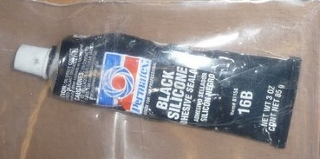
Replace silicon on inside of each arm
and replace set screws

