May- June Tiksi visit report. Bogorodski P.V., Kustov V.Y.
- Troubleshoot Rad1 PIR, (4-8 hours), intermittent noise problem in data. If needed, a replacement pyrgeometer dome/thermistor, soldering tools, wire cutters, were sent to Tiksi.
When we are arrived to Tiksi noticed, that cable from Pyranometer Fan was broken.
Cable was fixed, all wires carefully mounted on the tracker – to avoid entanglement in the future.
Contacts was checked and tightened. Since May 5-th there is no noise at PIR case and dome thermistors.
- 3m Sonic Repair (4-8 hours), replacement circuit board, shim tool, soldering tools, arctic rated cable, connectors.
Sonic was disassembled in accordance with the instruction.
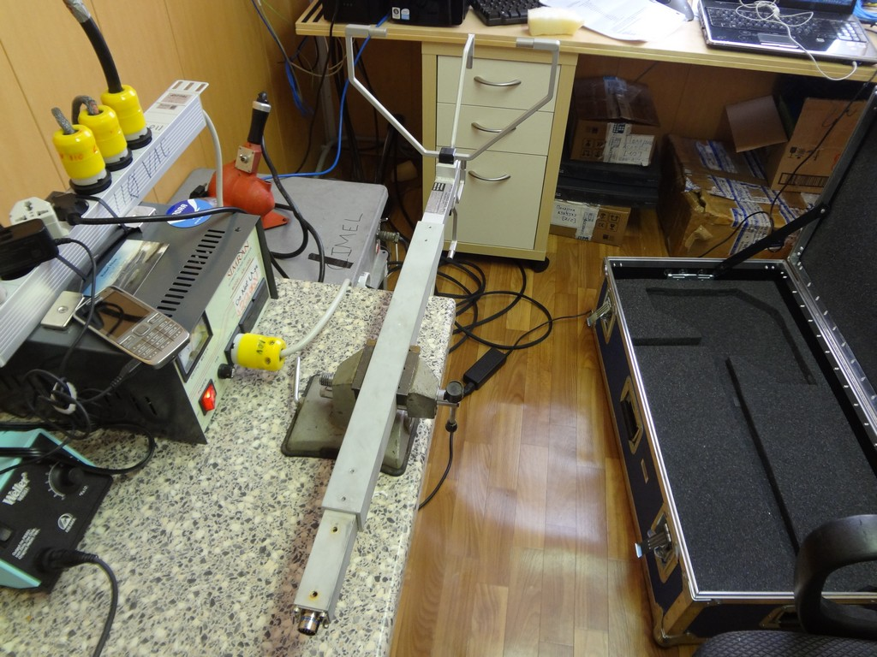
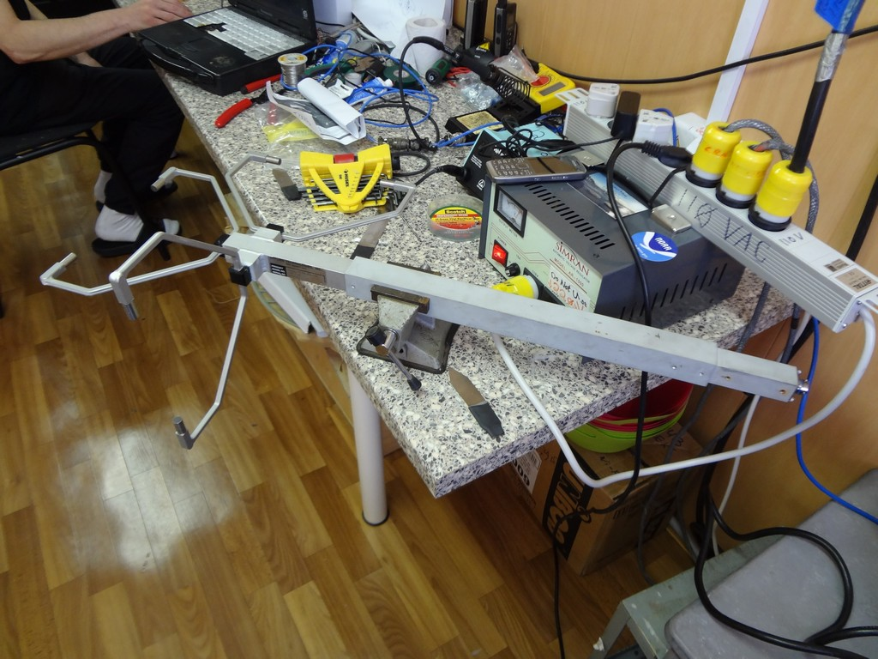
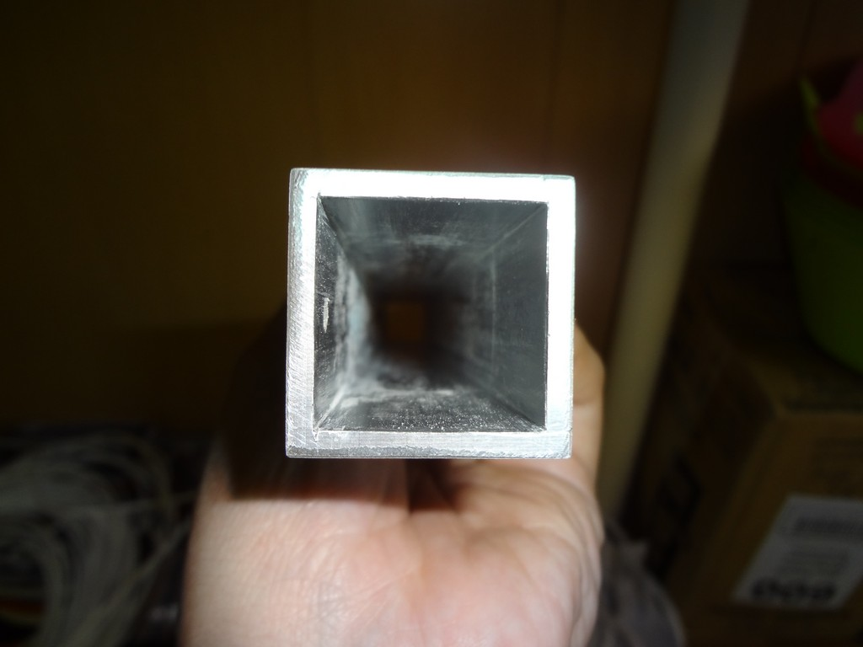
Seems like water was incide.
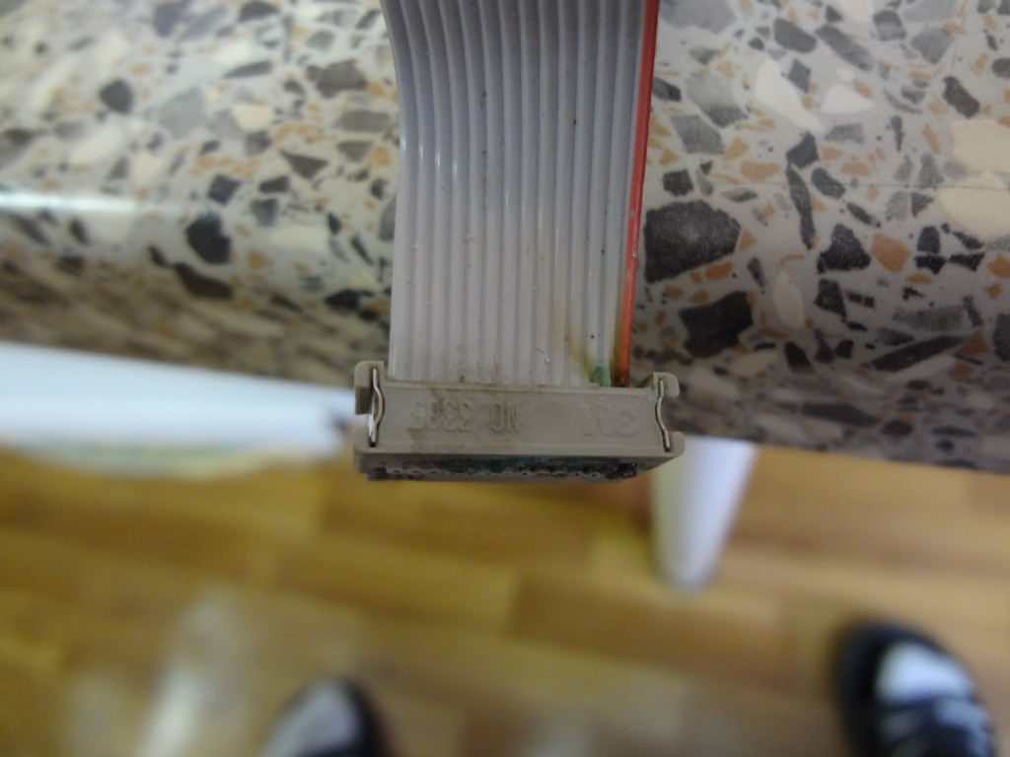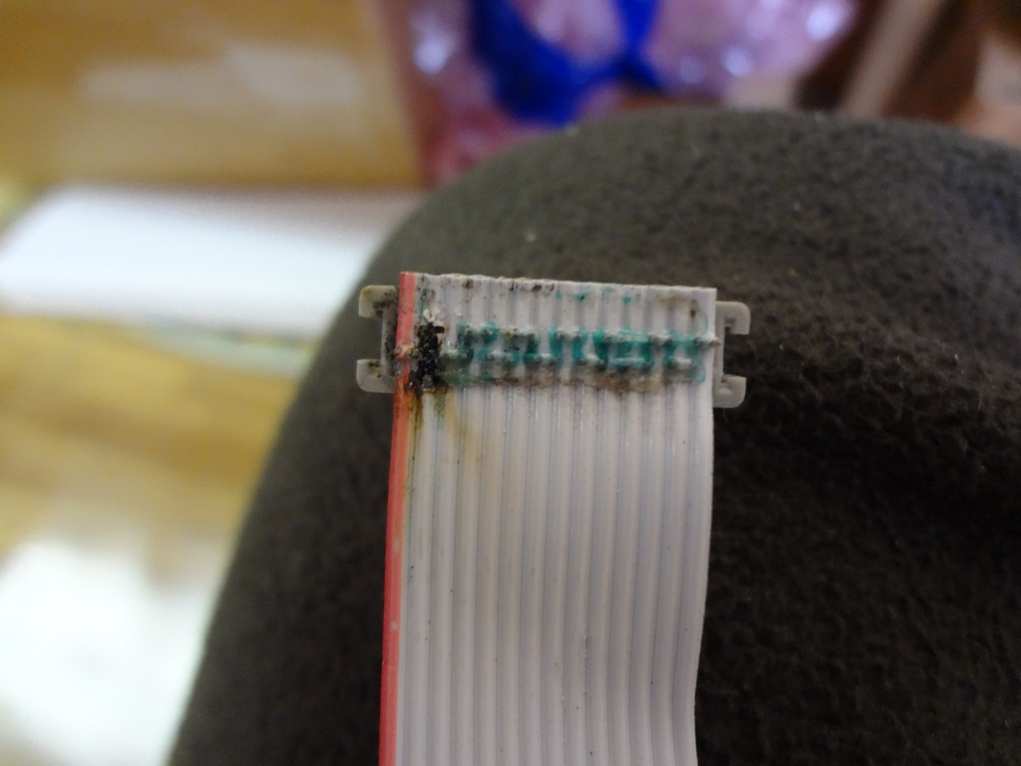
One wire burned.
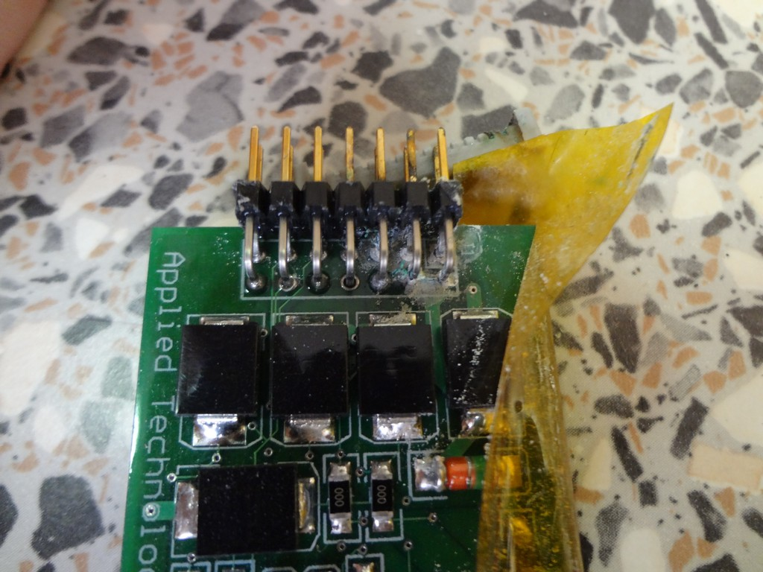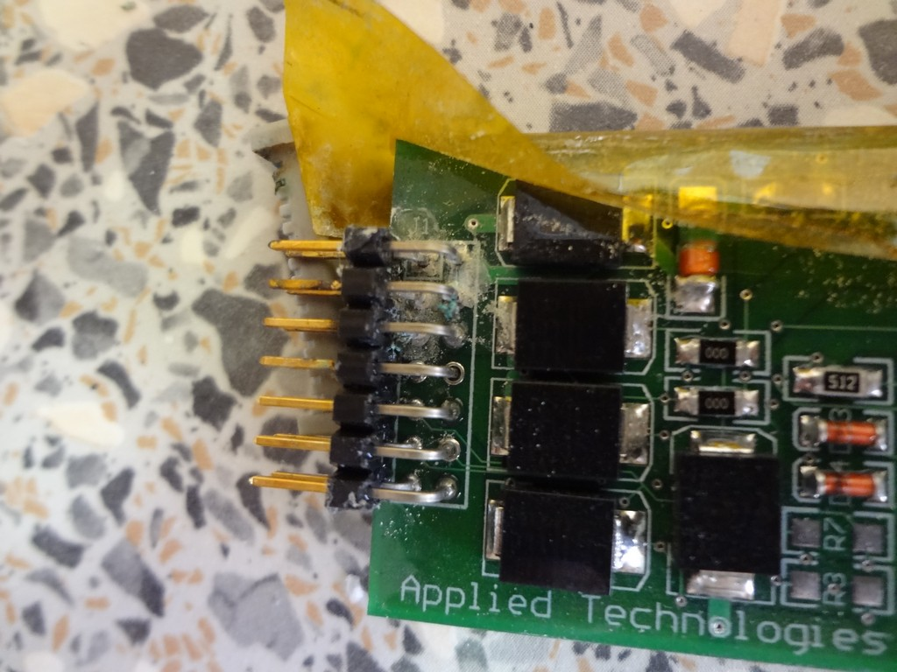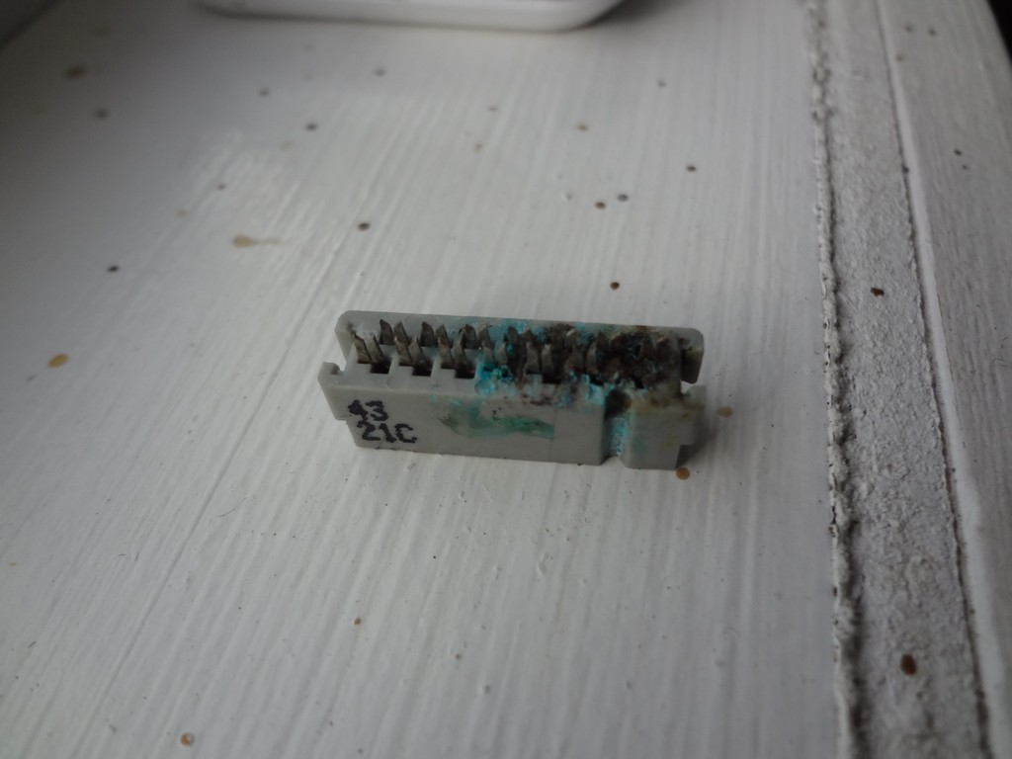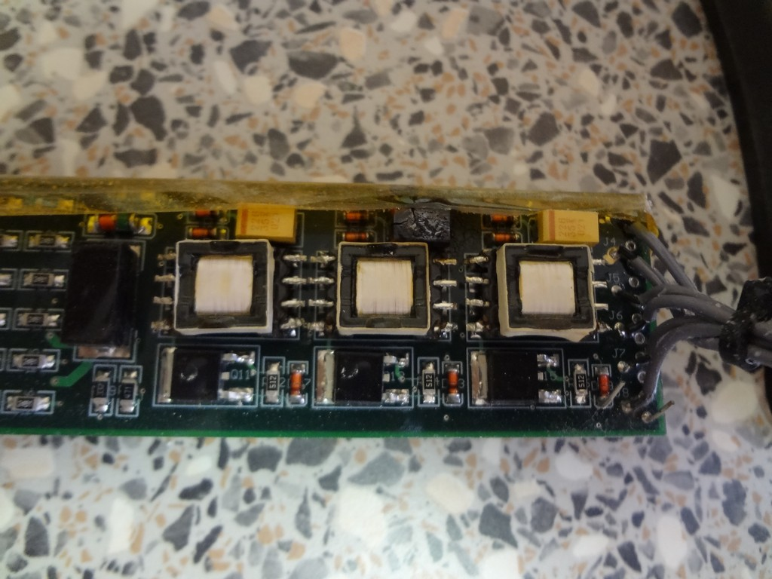
Burned plate.
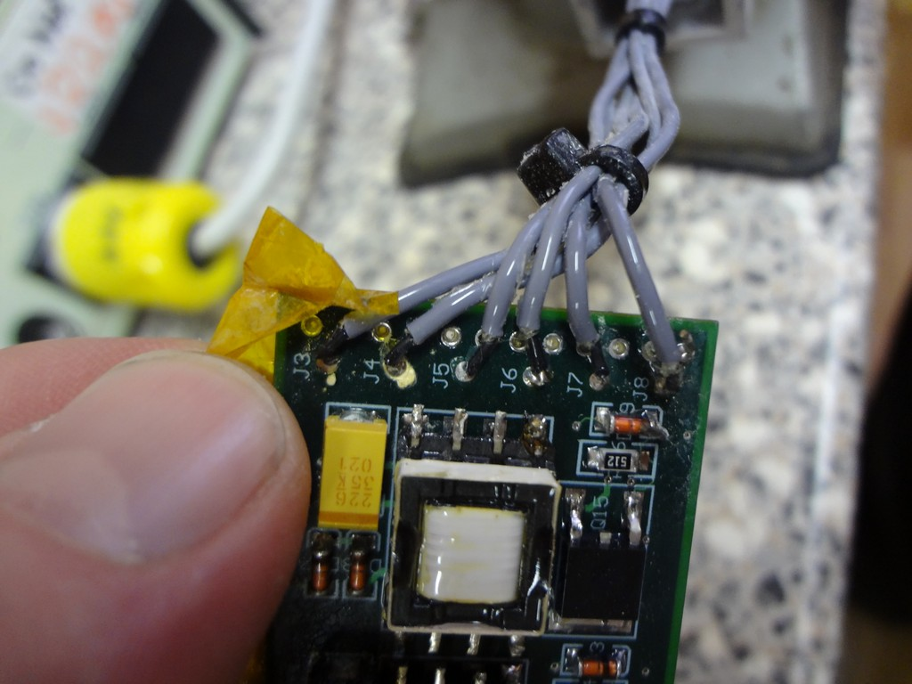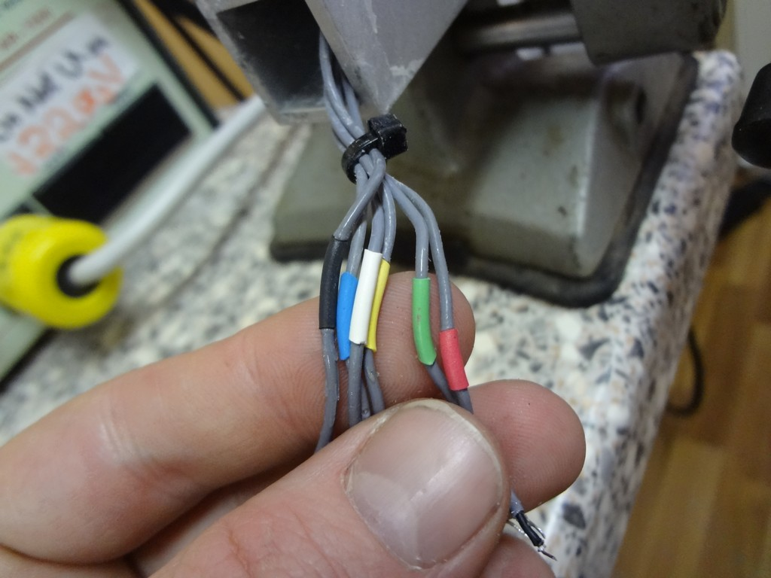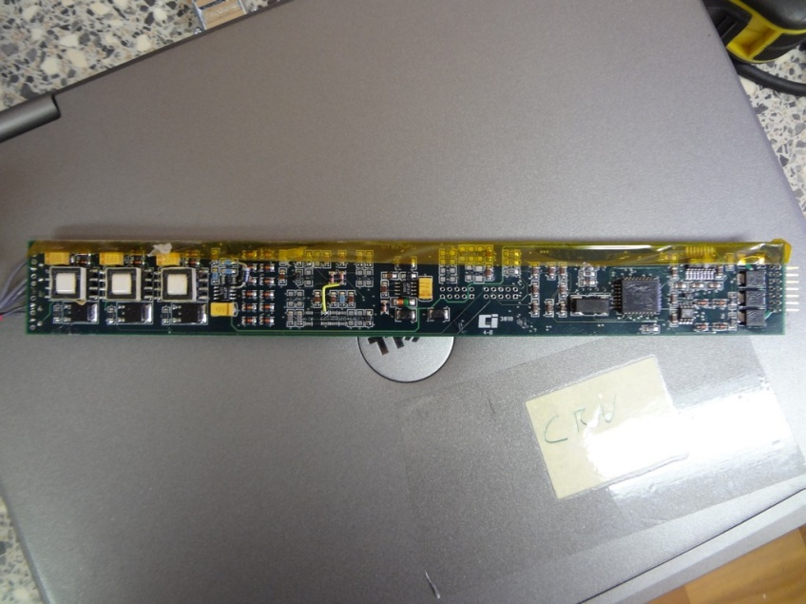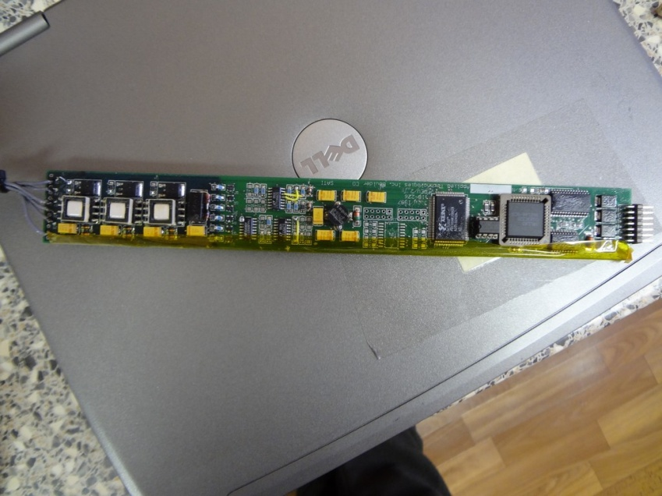
New PCB board installed.

After new PCB board was installed and sonic was connected to Laptop through COM port.
Connection with Hyper terminal with test cable was unsuccessful.
All contacts checked. Sonic don’t work. Packed to the box in CAW.
- 15m Sonic Reset (2 hours), good weather, laptop with hyperterminal and a serial com port or a usb-serial convertor cable, procedure
We tried to connect to 15-m sonic directly from the tower.
There is no respond from the sonic at hyperterminal.
Sonic was removed from the tower, connection with test cable failed, then instrument disassembled. There are no traces of water inside. PCB looks good (sorry forgot to take a picture).
Sonic packed at the box in CAF.

- Sonic Arctic Rate cable fabrication (4-8 hours) , arctic rate cable , connectors for sonic,
Fabricated Arctic rated cables for 9-m sonic and for 15-m sonic.
We have changed 9-m sonic cable at June 4, when wind speed became 5 m per second, after the storm. Noticed, that at June 2 something happened with this sonic. Last two columns become -99999 (the vertical component of wind speed and temperature). After changing the cable sonic still send a bad data with -99999.
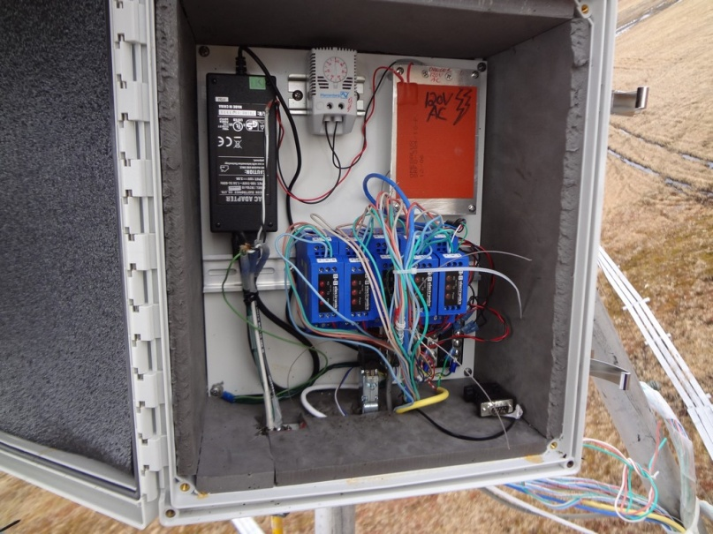
- Remount Licor on tower (2 hours), u-bolts (preferred) or hose clamp (at least 2)
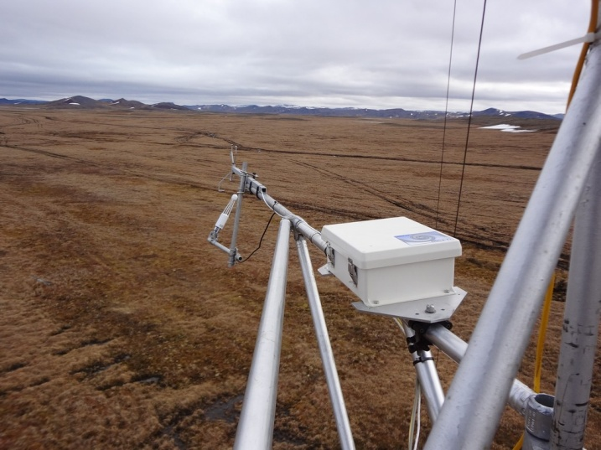
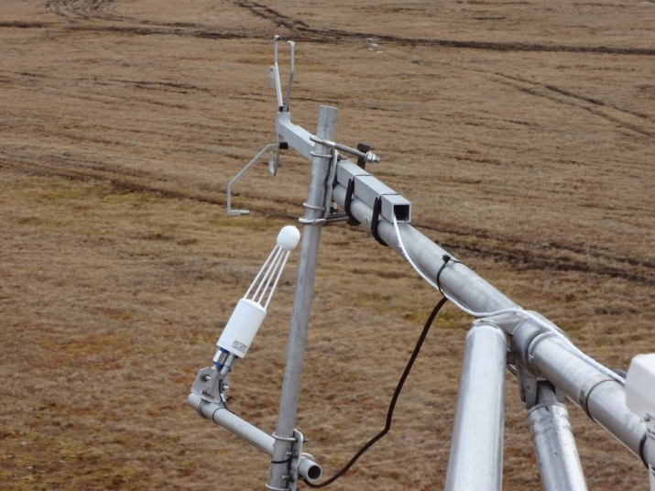
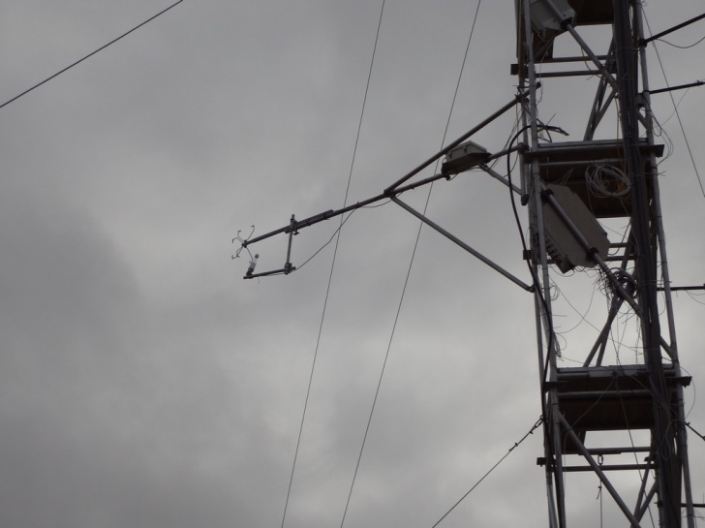
Li-Cor was mounted at the 9-meters level with U bolts.
- Splice tower data cable (4-8 hours), good weather, splice box, connectors, wire strippers/crimpers, wire cutters, tools to strip main data cable (WILL LIKELY WAIT UNTIL AUGUST)
Do not done in case bad weather (strong wind, snow). Need to be fixed during August visit.
- Flux Tower RH and Temp sensor troubleshooting
RH and temperature sensors looks good.
- CAF Wind Bird troubleshooting (2-4 hours), check connections on tower, apply anti-corrosion conducting compound on wind bird wires and data logger.
Program – ok. Wiring – ok.
The reason of malfunction is CR10X logger. Logger need to be changed.
Without wires on the wiring panel logger shows very strong noise from all channels (CAFMET program).
- O3 meter operation/data collection (2-4 hours), install automatic pump switch (if it arrives with Olga), once installed, initiate automatic data downloads using a python script to be supplied by NOAA
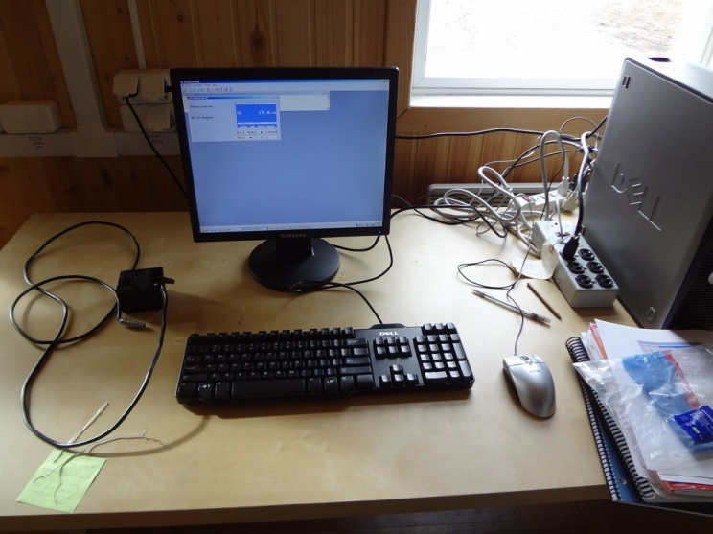
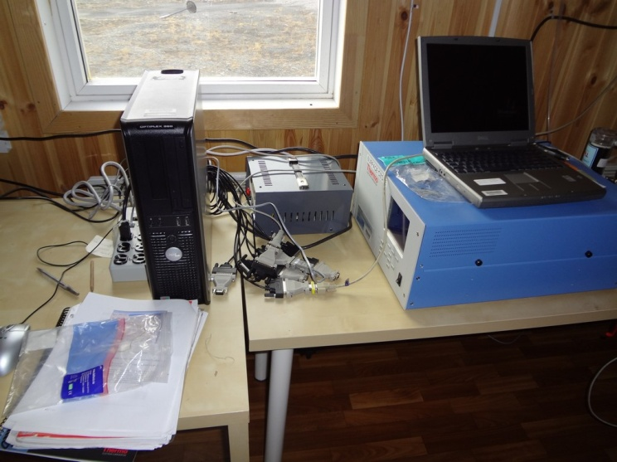

Ozone computer moved nearby the ozonmeter. Ozonmeter connected to th computer (10.31.112.121).
Automatic pump switch connected to Port 2. in accordance with the instruction.
Pump switch should be connected to the outlet after script will be installed remotely(MAO).

- Ensure proper installation, operation and data collection for the CIMEL
Cimel installed at May 24, work properly.

- CRN maintenance (2-4 hours) perform routine maintenance (see checklist) check aspirator fan operation
CRN checked. Aspirator fan working.
Geonor sensor calibrated June 3-rd.
Calibration coefficients applied to CR3000 datalogger.
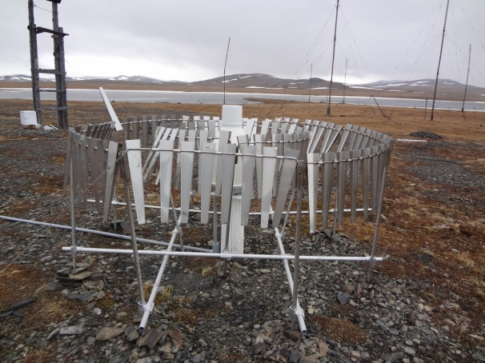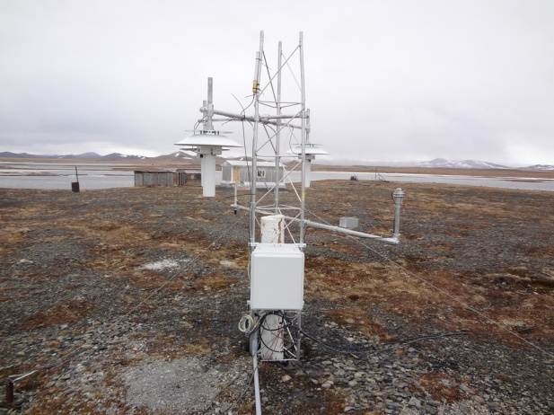
- Report on number of flask boxes which have been shipped to YUGMS/US
There is 20 flasks (NOAA) at the CAF.
- Other:
- Heat flux transducer was installed nearby the albedo rack.
Albedo program corrected, last two columns at data file – data from this device. 1-st value in mV, 2-nd – STD.
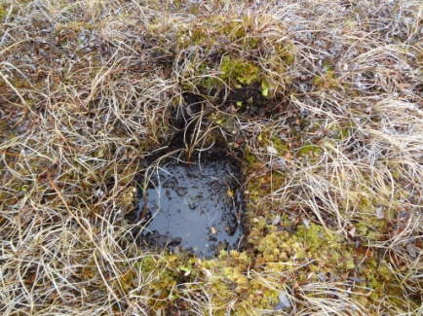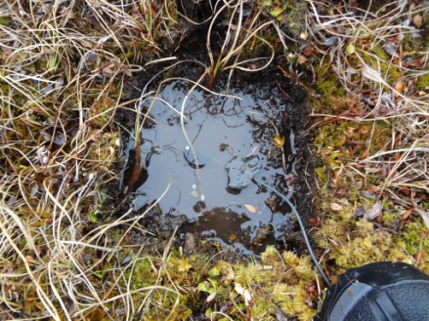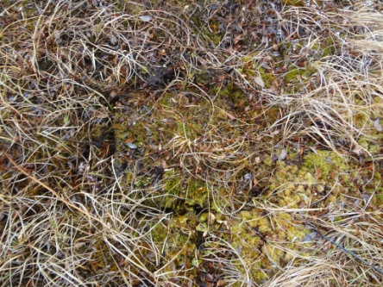

There is big problem with power at the station. There is a misalignment of phases at the COW. 212 - 240-280 volts. UPS fails due to high voltage, an error and shuts down. The batteries are dead.

End of report.

