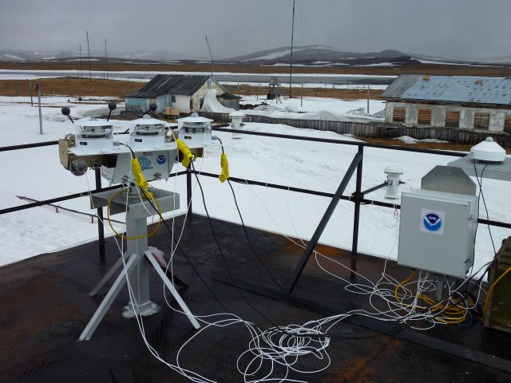

BSRN OPERATION MANUAL
Updated: August 2011

BSRN INSTRUMENTS and COMPONENTS
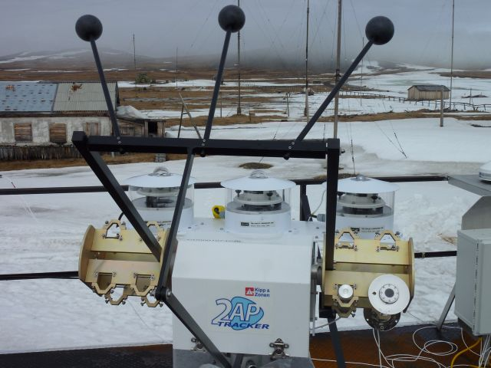
1
2
3
4
6
5
7

1. “2AP” Sun Tracker
2. “B&W PSP” – Eppley Black and White Precision Spectral Pyranometer with aspirator fan below
3. “PSP” – Eppley Precision Spectral Pyranometer with aspirator fan below
4. “PIR” –Eppley Precision Infrared Radiometer (Pyrgeometer) with aspirator fan below
5. “NIP” – Eppley Normal Incidence Pyrheliometer
6. “Sun sensor” – Tracker sun sensing instrument
7. Radiometer Shade Balls
8. BLANK FOR RUSSIAN RADIATION INSTRUMENT

BSRN INSTRUMENTS (CONTINUED)
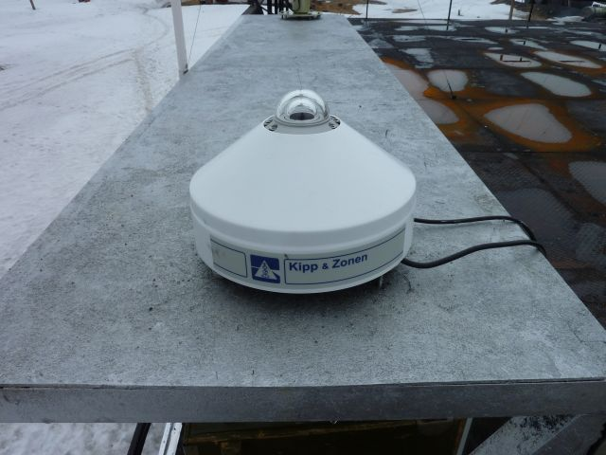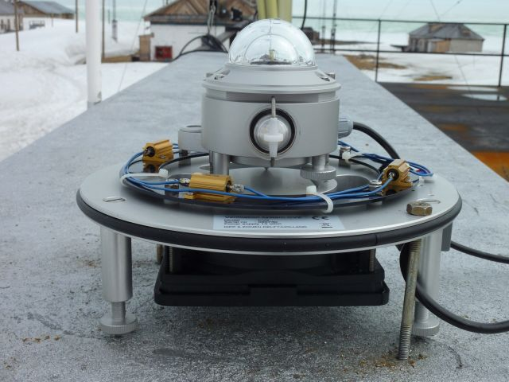
9a
9b
9
9. “K&Z CMP22” – Kipp & Zonen Global Precision Spectral Pyranometer (with cover)
a) Desiccant chamber b) Aspirator fan
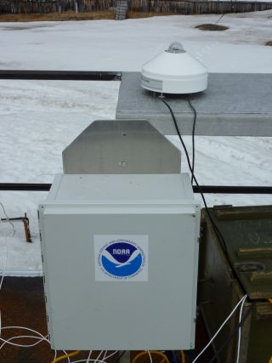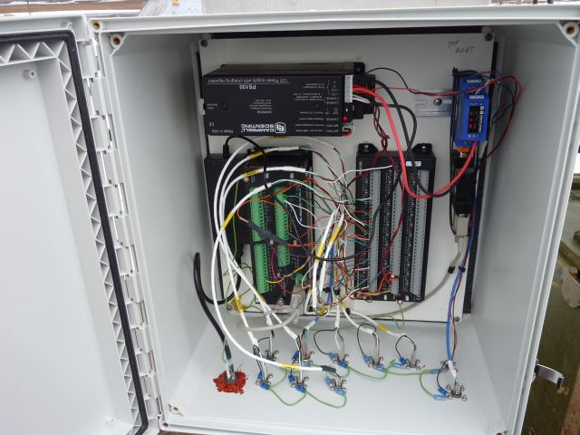
12
13b
13a
13c
13d
12. “Campbell Box” – Campbell Datalogger box (with Global Pyranometer on table above)
13. Campbell Datalogger box inside
a) Power supply with battery
b) CR10X Datalogger
c) Multiplexer
d) RS-232 / RS-485 Convertor
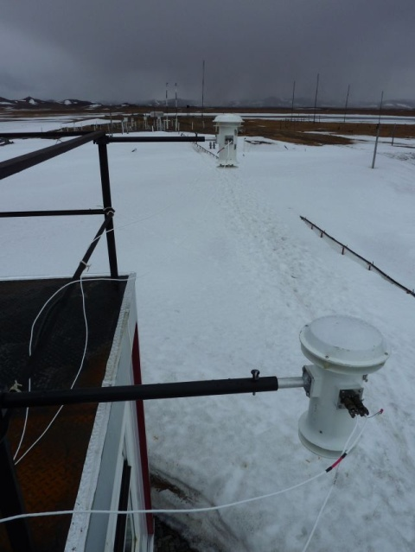
14
14. Aspirated temperature sensors
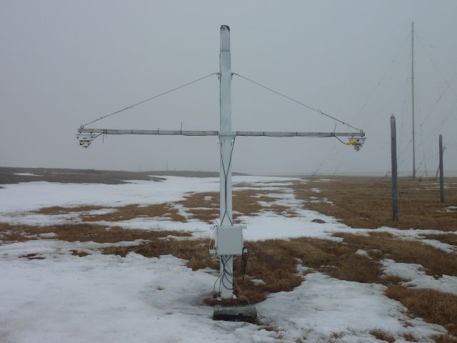
16
17
15
15. BSRN Albedo Rack
16. “PIR” –Eppley Precision Infrared Radiometer (Pyrgeometer) & aspirator fan for upwelling radiation
17. “PSP” – Eppley Precision Spectral Pyranometer & aspirator for upwelling radiation

DAILY INSTRUMENT INSPECTION PROCEDURE
1. Check on the computer that:
a. Data is being written hourly to E:\rad1 (BSRN data – normal files are 12kb) and E:\rad2 (BSRN Albedo data – normal files are 5kb)

2. Instruments to check on the roof and at the albedo rack site:
a. Move service switch out of the MIDDLE position (either UP or DOWN) prior to working around the instruments.
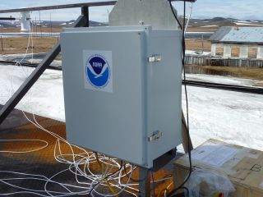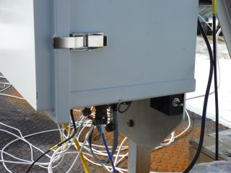
b. Check that all glass domes are free of snow, ice, water and dust. If not, please clean with a tissue and methanol. Please do not scrape glass domes with hard objects.
c. Listen for sun tracker operation to ensure it is working. You should be able to hear it “marching” along (even from inside).
d. Check that sun tracker is on target using the NIP sighting hole and target. (See below – must be a clear day!)
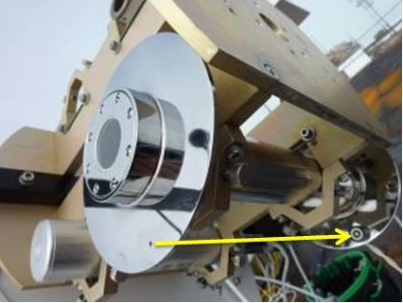
e. Check that the 4 aspirator fans on the radiometers and the 2 fans on the temperature sensors are operating by listening for operation. Please clear snow or frost from the temperature sensor fans if present.
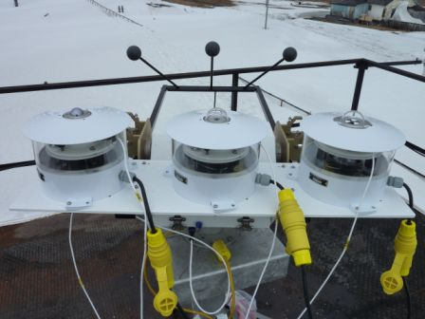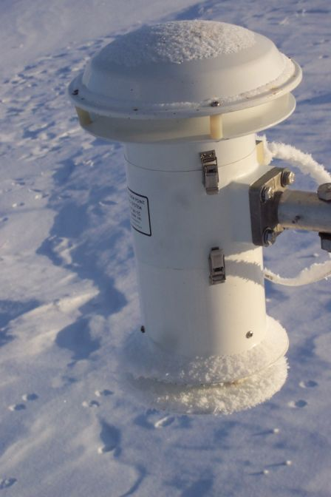
Listen for aspirator fan operation.
Please clear snow or frost
f. Check that cables are not getting caught or tangled on the instruments, tables, or anything else.
g. Move service switch back into MIDDLE position after work around instruments is complete.
h. As weather allows (at least once per week), check the instruments on the albedo rack located near the AARI permafrost sensors. Please do not walk under the sensors or disturb the ground underneath them.
i. If there are any problems, please email the following people:
Vasily Kustov : Василий Кустов kustov@aari.nw.ru
Matt Okraszewski : Мэтт Окражевский matt.okraszewski@noaa.gov

