This file attempts to describe special data sets collected on or at the BAO facility including
type of data, instrumentation, dates, and contact information or references when applicable. Raw data have not been QC’d. Image directories contain MATLB generated plots of data. Program directories contain MATLAB programs to read and plot data.

Tower Instrumentation Data

Lockheed Martin Coherent Technologies
Start 2012-12-21
End 2013-04-08
This experiment involved putting wind energy quality cup and vane wind sensors on the tower. The Lockheed Martin Wind Tracer laser system (http://www.lockheedmartin.com/us/products/windtracer.html) was also deployed with the capability of scanning the tower. The goal was to confirm the accuracy of the Wind Tracer.
Cups on both sides of tower with wind vane on the south boom only.
Keith Barr (keith.barr@aerosys-eng.com)
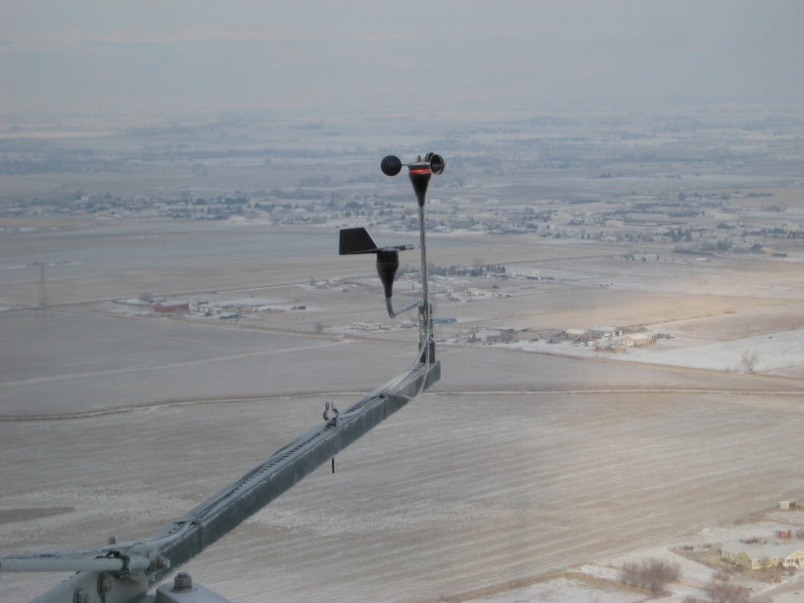\
150 south boom

Second Wind
Start 2008-08
End 2013-03
Second Wind cup and vane sensors put on tower at ??? levels south boom for comparison to Triton sodar (http://www.vaisala.com/en/energy/Weather-Measurement/Remote-Sensing-Systems/Pages/Triton.aspx). We also have some sodar profiles for part of this same time period.
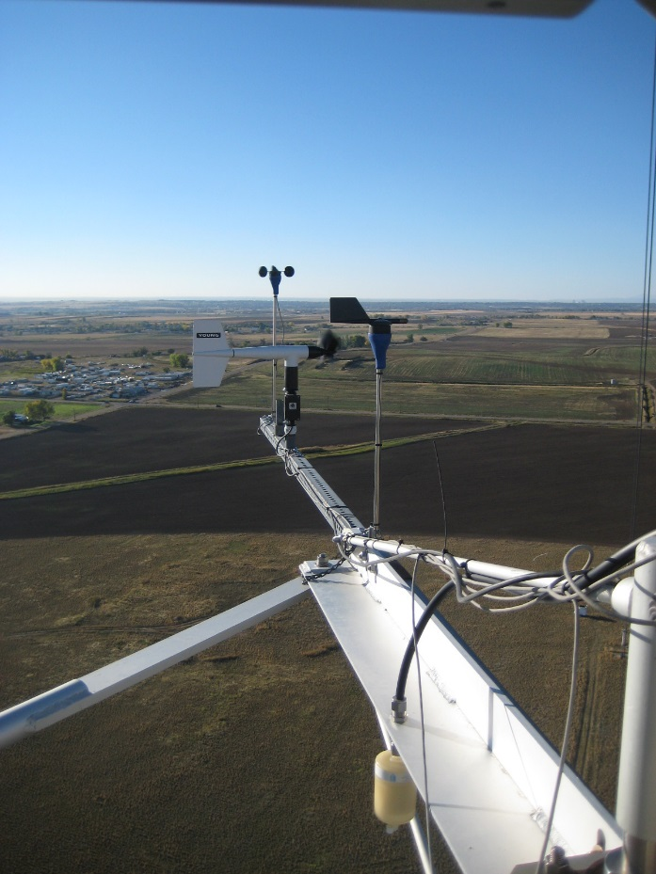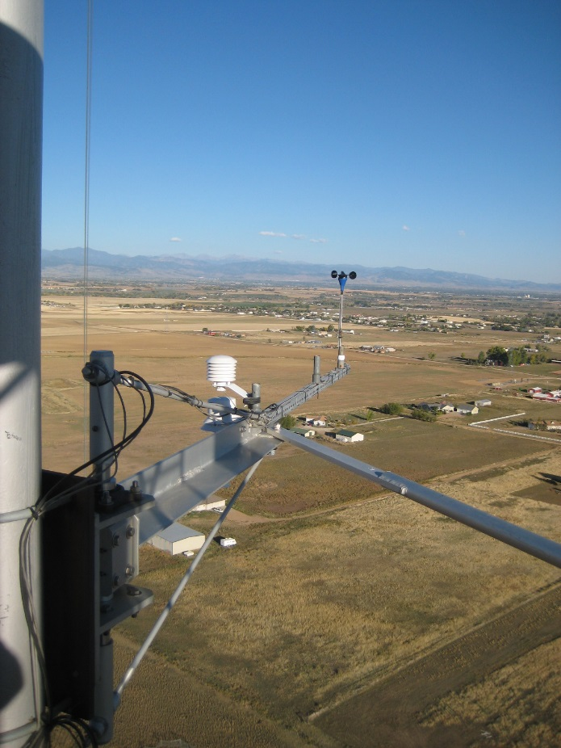
100m level south boom 100m level north boom
Tower carriage sonic comparison
Start 2010-08-13
End 2011-02-04
ATI, RMY, Campbell, Gill, METTEK sonics all mounted on carriage boom. Data collected using DAS software.

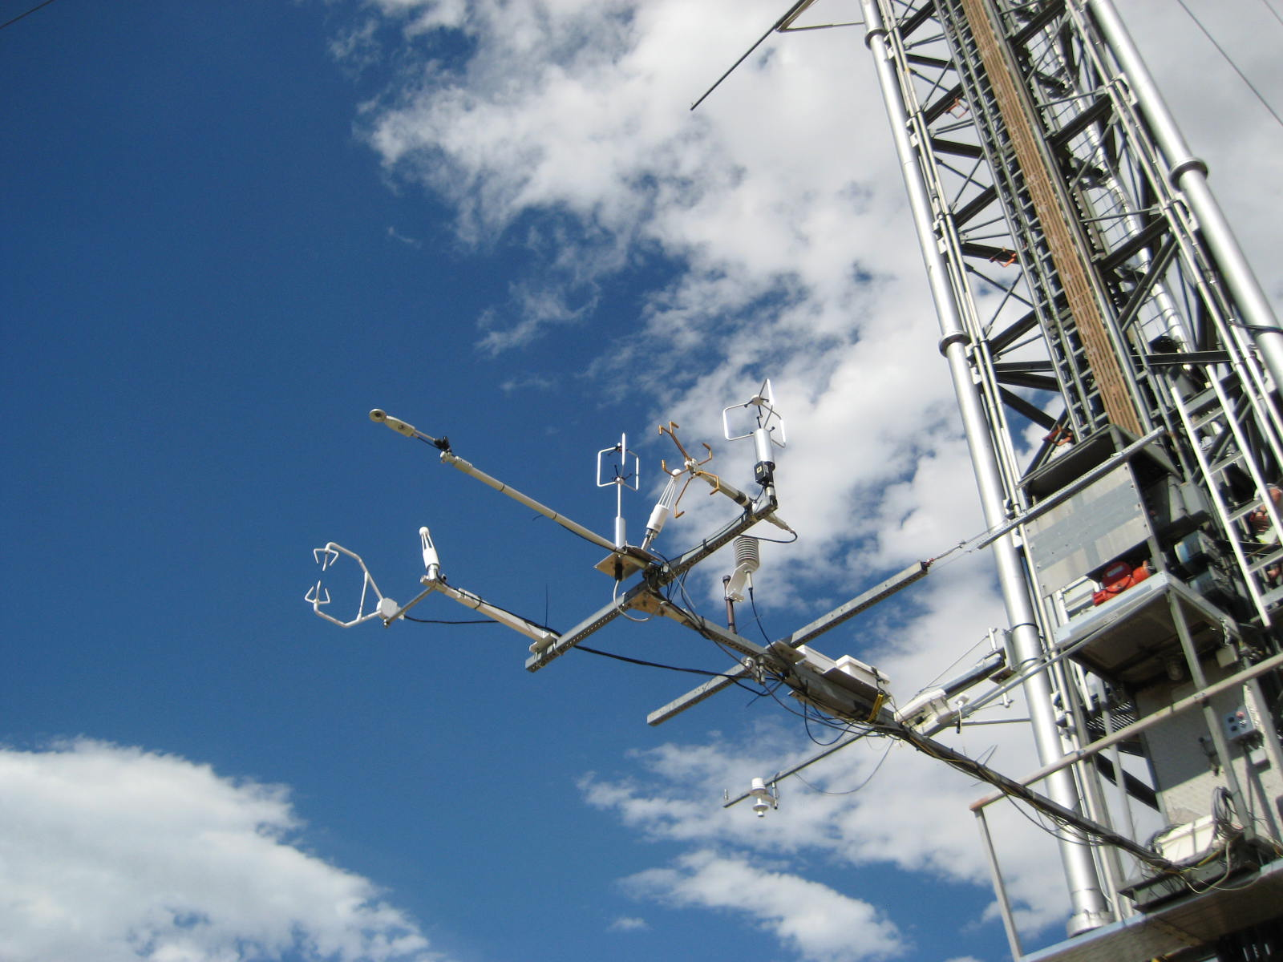

U Mass
Start 2007-08-07
End 2007-08-27
Start 2007-12-15
End 2007-12-31
Start 2008-01-01
End 2008-08-05
RMYoung sonic anemometers (andreas@nwra.com) under the direction of Dr. Andreas Musinski while a professor a Univ. of Mass. Sonics on both sides 50, 100, 150m. At 10, 22, 200, 250, 300 north boom only.
https://www.nwra.com/people/235/
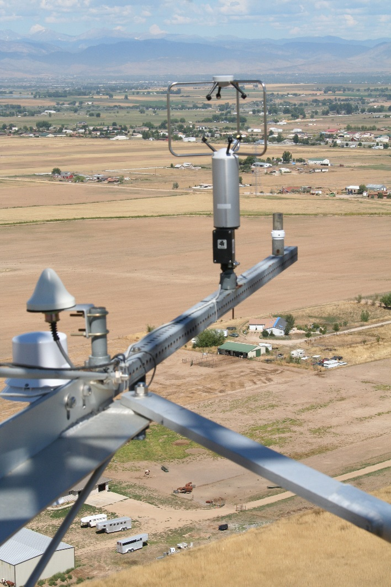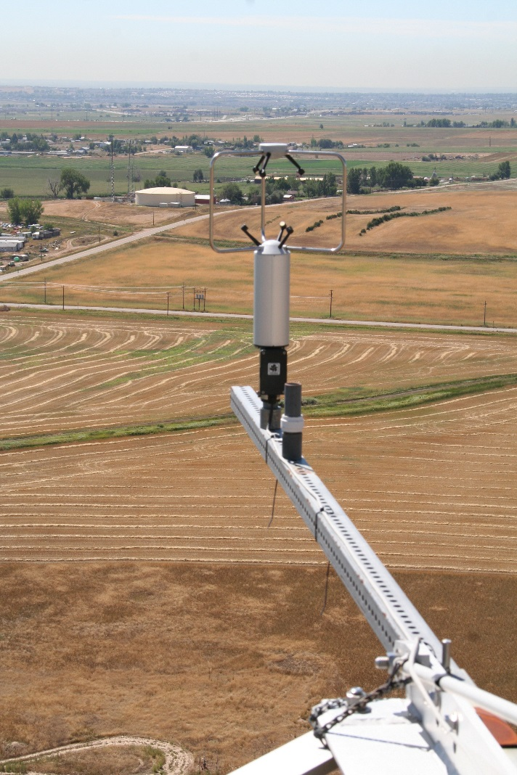
North boom South boom

LATTE (Lower Atmospheric Boundary Layer Turbulence and Thermodynamics Experiment)
Start 2014-02
End 2014
Experiment under the direction of Dr. Phil Chilson (chilson.phillip@gmail.com) with OU/NCAR. Sonic anemometers mounted on the tower at ?? levels on the south boom ???.

FRAPPE (Front Range Air Pollution and Air Chemistry Experiment)
Start 2014-07-31
End 2014-08-08
Campbell IRGASON ((sonic/CO2/H2O) mounted on the instrument carriage in conjunction with the CSD PISA
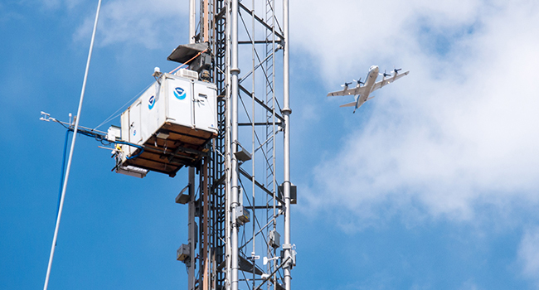
Campbell IRGASON on end of instrument carriage boom

XPIA (Planetary Boundary Layer Instrument Assessment)
Start 2015-03-01
End 2015-06-25
Campbell CSAT sonic anemometers and T/RH sensors mounted on two sides of the tower at ??? levels for comparison to a number of different LIDAR system used in wind energy studies.
Register for the DOE Data Archive and Portal:
https://a2e.energy.gov/auth/register
Then access the data via SFTP:
https://a2e.energy.gov/data/xpia/ecor.z01.00

Other Site Data

Surface Flux
Start 2010-10
End 2011-09
Sfc, 5 cm, 10cm subsurface T and sfc Vol water content (%)
Located near 10m tower

CU
10m Flux tower
Start 2011-04-26
End 2016-05-26
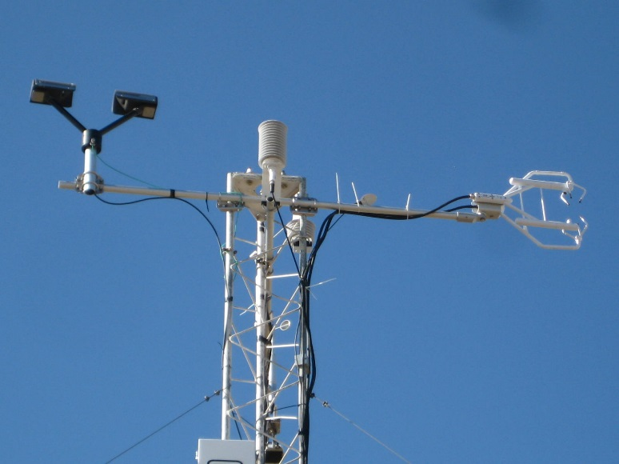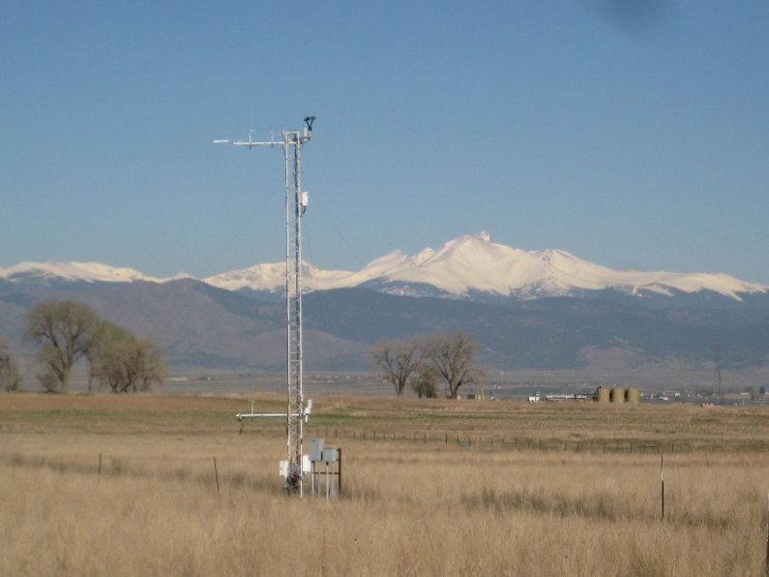

Emily
Start 2010-02-06
End 2011-11-30
Carriage instrumented by CU graduate student Emily Grahm for studying CO2 fluxes.
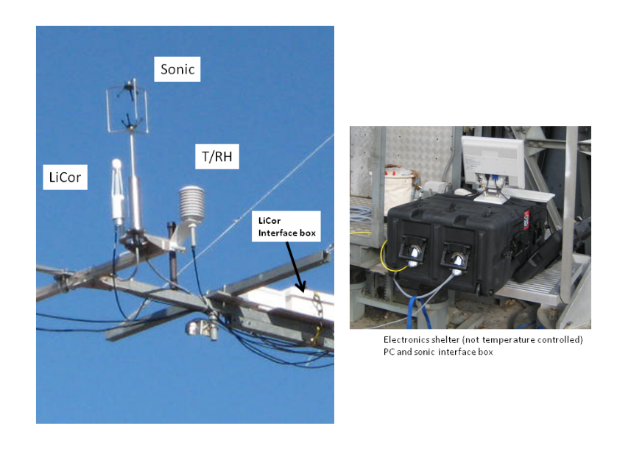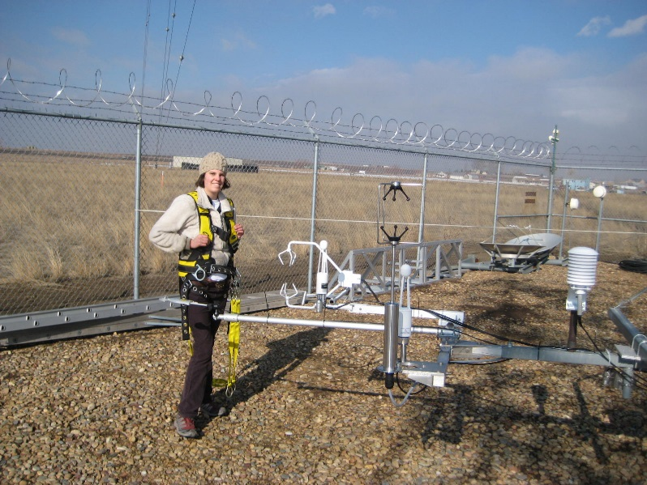
Kipp-Zonen Radiometer too

Micro-wave Radiometer (MP-1100 and MP 3000)
MP-1100
Start 2014-02-13
End 2015-02-10
MP-3000
Start 2015-01-22
End 2015-08-12
Total water vapor and total liquid water
Located on visitor bldg. roof
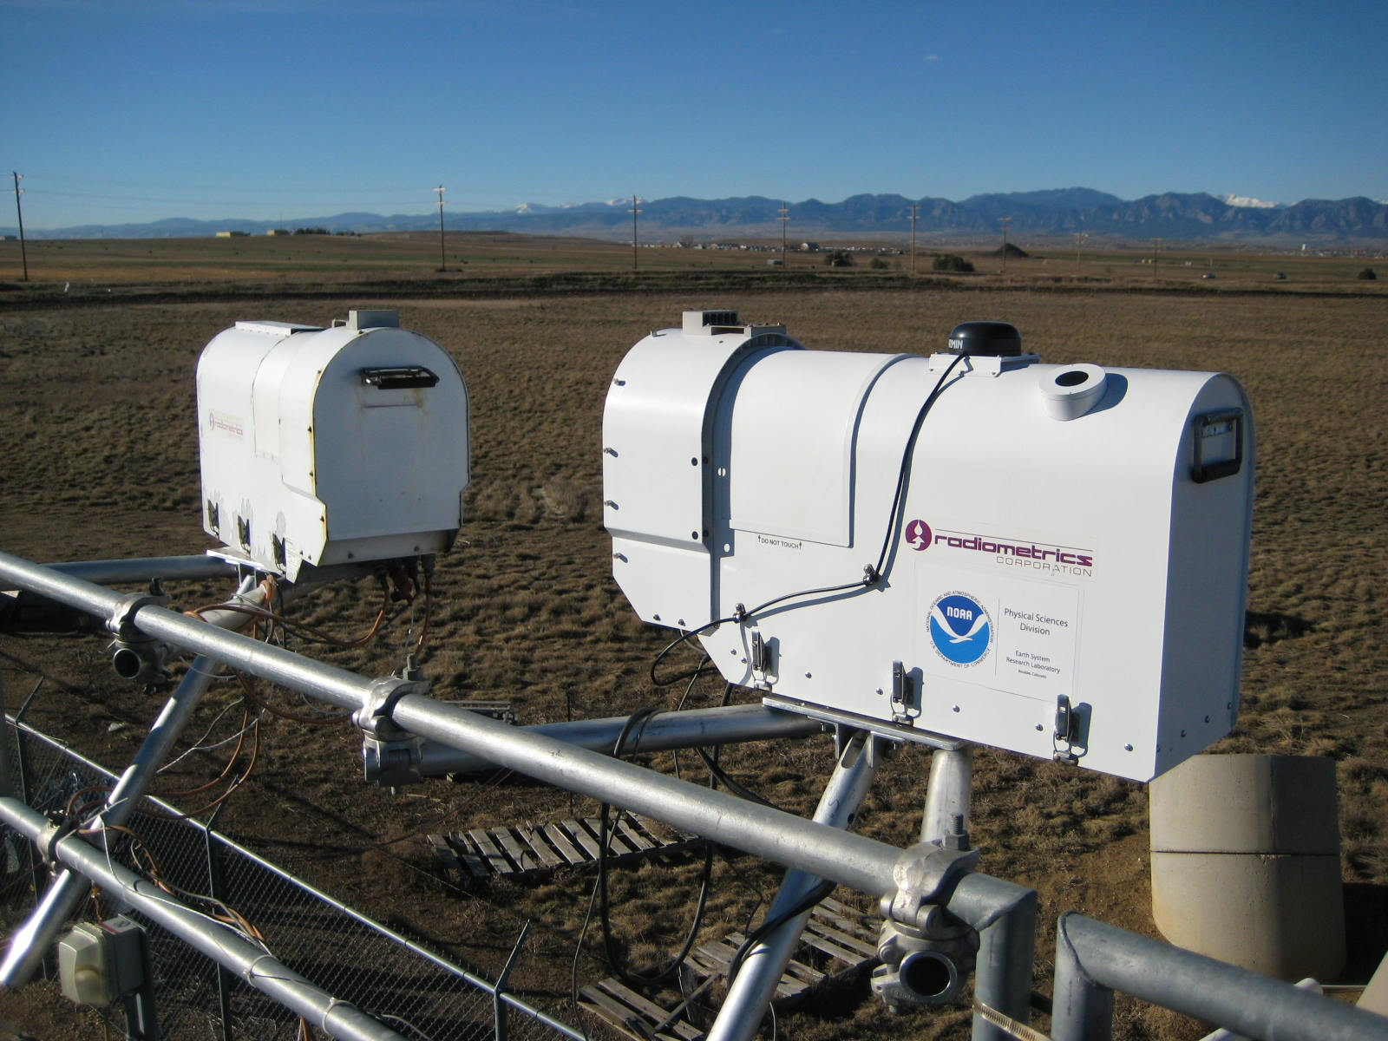
MP-1100 and MP-3000 at BAO

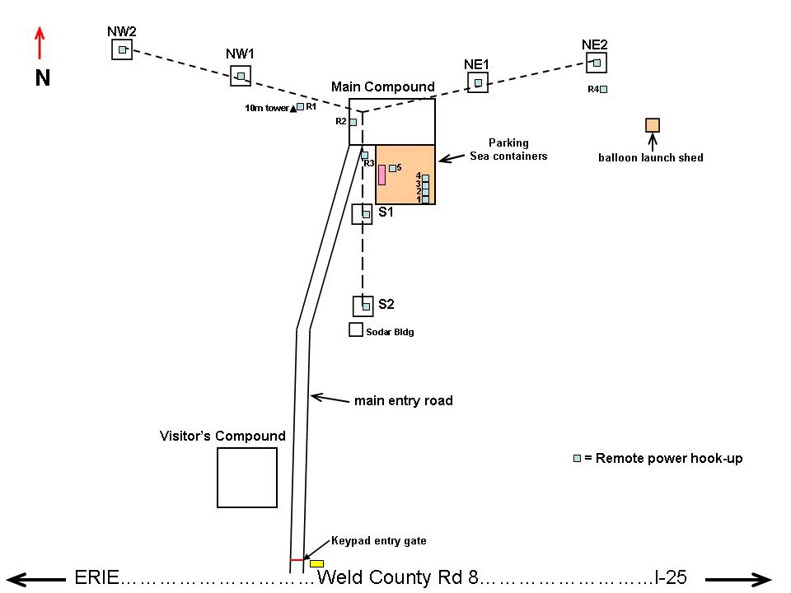
Diagram showing location of main tower, guy wire anchors (NW, S, NE) and 10m tower (CU)

