CRUISE INSTRUCTIONS

NOAA Ship RONALD H. BROWN

30 March 2007

Cruise Number: | RB-07-03
Project: | PIRATA Northeast Extension / AMMA / Sahara Dust
Cruise dates: | 2—31 May 2007
Chief Scientist: | Rick Lumpkin, NOAA/AOML
Working Area: | Tropical Eastern Atlantic Ocean
Itinerary: | Bridgetown, Barbados to Ft. Lauderdale, FL (30 days)

Endorsements:

_______________________ _________________________ __________________________
Dr. Rick Lumpkin Dr. Robert Atlas CAPT Emily Christman
Project Lead Director, AOML Commanding Officer, MOA
NOAA/AOML Miami, FL 33149 Norfolk, VA 23510

CRUISE OVERVIEW

Summary

The PIRATA Northeast Extension

The Pilot Research Moored Array in the Tropical Atlantic (PIRATA) is a three-party project between Brazil, France and the United States that seeks to monitor the upper ocean and near surface atmosphere of the Tropical Atlantic via the deployment and maintenance of an array of moored buoys and automatic meteorological stations. This array is the Atlantic’s analogue of the Pacific Ocean’s TAO array. The PIRATA array consists of a backbone of ten moorings that run along the equator and extends southward along 10ºW to 10ºS, and northward along 38ºW to 15ºN (Fig. 1).

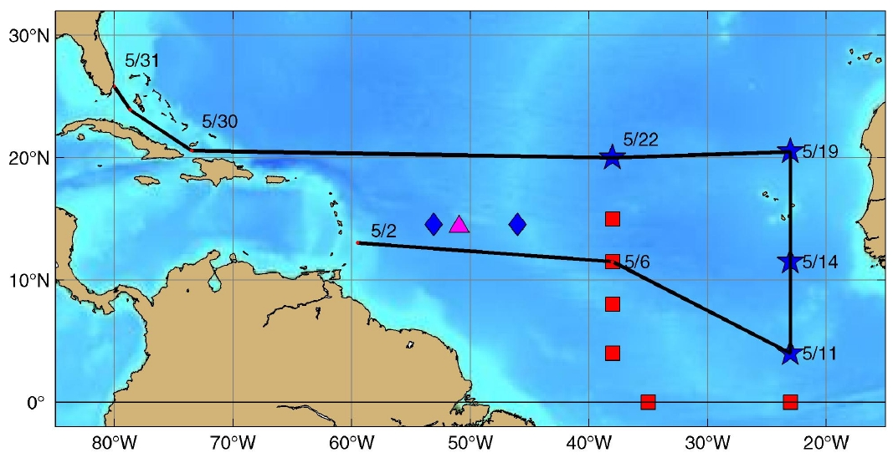
Fig. 1: cruise track of RB-07-03 (black line) and locations of Tropical Atlantic data buoy moorings. Symbols indicate the PIRATA backbone (red squares), the WHOI NTAS buoy (magenta triangle) and the NOAA/NDBC Hurricane buoys (blue diamonds). The PIRATA Northeast Extension is indicated by blue stars.

The northeastern and north central Tropical Atlantic is a region of strong climate variations from intraseasonal to decadal scales, with impacts upon rainfall rates and storm strikes for the surrounding regions of Africa and the Americas. The northeastern Tropical Atlantic includes the southern edge of the North Atlantic subtropical gyre, defined by the westward North Equatorial Current (NEC), and the northern edge of the clockwise tropical/equatorial gyre defined by the North Equatorial Countercurrent (NECC) (Fig. 2). This area is the location of the North Atlantic’s oxygen minimum zone at a depth of 400—600m. The size and intensity of this zone is a potential integrator of long-term North Atlantic circulation changes (Zheng et al., 2000), and the extremely low oxygen values have significant impacts on the biota of the region (Childress and Seibel, 1998). The cyclonic Guinea Dome (c.f., Siedler et al., 1992) is centered near 10ºN, 24ºW (Stramma et al., 2005), between the NECC and NEC in the eastern TA. It is driven by trade wind-driven upwelling, and may play an active role in modulating air-sea fluxes in this region (Yamagata and Iizuka, 1995).

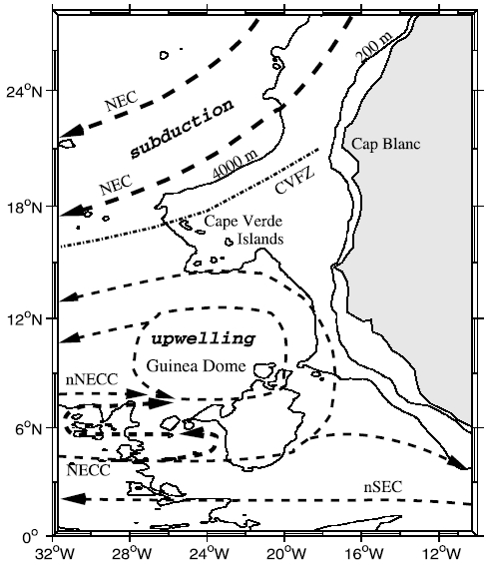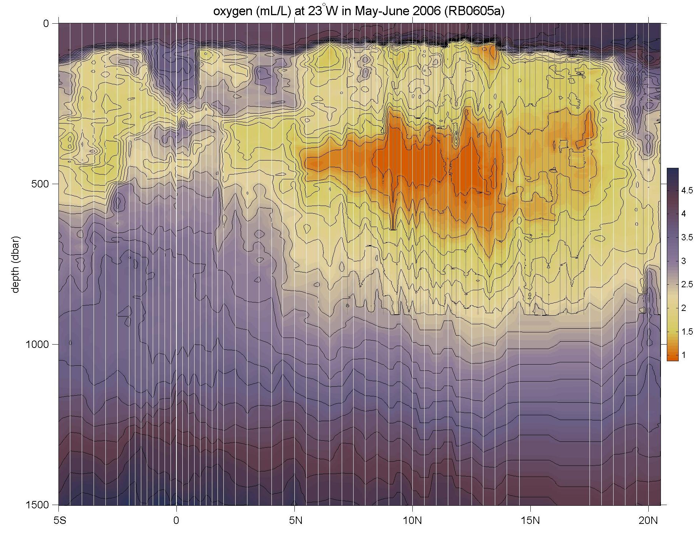
Fig. 2: Left: schematic of surface currents and features in the northeastern TA, from Stramma et al. (2005). Right: oxygen (mL/L) measured during the 2006 PNE cruise of the Ronald H. Brown, showing the pronounced oxygen minimum.

The Tropical North Atlantic is the Main Development Region (MDR) of tropical cyclones. Many major hurricanes that ultimately threaten the eastern United States begin as atmospheric easterly waves that propagate off the African continent. Once over the MDR in the band 10-20ºN, these waves are exposed to convective instability driven by the upper ocean’s heat content. The resulting infusion of energy can result in closed cyclonic circulation and development from tropical depression to tropical storm and hurricane. These hurricanes are known as Cape Verde-type hurricanes, to distinguish them from storms forming further west, and they are often the most powerful storms to strike the US east coast. Prominent examples include Andrew (1992), Floyd (1999) and Ivan (2004). An average season has two Cape Verde hurricanes, but some years have up to five while others have none. There is profound uncertainty regarding the specific atmospheric/oceanic conditions that determine which of the atmospheric waves will develop into tropical cyclones and then hurricanes (on average, one of ten; J. Dunion, personal communication). Specifically, the quantitative effects of the Saharan Aerosol Layer (SAL), sea surface temperature (SST), upper layer oceanic heat content and atmospheric wind shear on this development are unknown.

Seasonal tropical storm and hurricane forecasts are generated annually and based primarily on statistical analyses of historical data that have resulted in predictors (e.g., ENSO index, Atlantic SST, Sahel rainfall, etc.). Recent empirical studies have demonstrated that tropical storm and hurricane activity in the Atlantic Ocean varies on decadal and multi-decadal time-scales and that this variability is correlated with sea-surface temperature anomalies in the MDR (e.g., Shapiro and Goldenberg, 1998). The SST signal in the MDR has been correlated with the North Atlantic Oscillation (NAO) on decadal time-scales. The multi-decadal signal indicates that an extended period of increased hurricane activity is to be expected. Other historical studies have also demonstrated spatial variability in storm formation areas and landfall locations on longer timescales.
Despite the climate and weather significance of the Tropical North Atlantic region, it was not sampled by the PIRATA backbone array apart from the 38°W line of moorings extending north to 15°N (Fig. 1). In 2005, a formal Northeast Extension of PIRATA was proposed as a joint project between NOAA/AOML and PMEL (Rick Lumpkin, Mike McPhaden and Bob Molinari, co-principal investigators). This PIRATA Northeast Extension (PNE) was proposed to consist of four moorings, three creating a northward arm up 23°W (building upon the equatorial backbone mooring there), and a fourth extending the 38°W arm to 20°N.

In June 2006, the first two moorings of this extension were deployed during RB-06-05a. The mooring at 11.5°N, 23°W was deployed on June 7, and the mooring at 4°N, 23°W was deployed on June 11. Both buoys are currently successfully reporting meteorological and oceanographic data onto the Global Telecommunications System for weather and climate forecasting. In the Memorandum of Understanding from the PIRATA-12 meeting (November 2006), the United States agreed that

[I]t is recognized that the Parties are dependent upon year-to-year funding allocations from their governments, and thus commitments for future funding and logistical support can not be guaranteed. Given this proviso, the Parties affirm that PIRATA is a high priority for Brazil, France, and the United States, and that the institutions are making plans for continued support … NOAA will provide ship time for maintenance of four moorings in the North East Extension.

The Ronald H. Brown cruise RB-07-03 serves to honor this commitment for the year 2007.

African Monsoon Multidisciplinary Analysis (AMMA)

African Monsoon Multidisciplinary Analysis (AMMA) is a coordinated international project to improve our knowledge and understanding of the West African monsoon (WAM), its variability and impacts. AMMA will carry out the research needed to improve our ability to monitor and predict the weather and climate of West Africa and downstream tropical Atlantic. Recognizing the needs of society, AMMA also will seek to provide the observations and underpinning science needed to relate variability of the WAM to issues of health, food security and water resources.

AMMA will facilitate the multidisciplinary research required to provide improved predictions of the WAM and its impacts on daily-to-interannual timescales. This will be achieved through international coordination of ongoing activities, promoting necessary basic research, and a multi-year field campaign over West Africa and the tropical Atlantic. During 2003, AMMA received endorsement from the international CLIVAR and GEWEX projects within the WCRP and also has strong linkages with IGBP.

There are multiple scientific and societal reasons why AMMA is needed at this time.

West Africa is a region that experiences marked variability in rainfall. The dramatic change from wet conditions in the 1950s especially and 1960s to much drier conditions in the 1970s, 1980s and 1990s in this region represents one of the strongest climate signals on the planet during the last century. Superimposed on this multidecadal trend, marked interannual variations have resulted in extremely dry years with devastating environmental and socioeconomic impacts. Vulnerability of West African societies to climate variability is likely to increase in the next several decades, as demands on resources increase in association with one of the World’s most rapidly growing populations. The situation also may be exacerbated by regional climate change. There is a strong societal need to develop strategies that reduce the socioeconomic impacts of WAM variability that will benefit from useful predictions of WAM variability and its impacts.

We are currently hindered in providing skilful predictions of WAM variability. This is due to a combination of factors. In addition to the large systematic errors exhibited by dynamical models used for weather and climate prediction and the sparse West African observing network, there are fundamental gaps in our knowledge of the coupled atmosphere-ocean-land system at least partly arising from lack of appropriate observational datasets but also because of the complex scale interactions between the atmosphere, biosphere and hydrosphere that ultimately determine the nature of the WAM.

Variability in West African weather and climate also impacts the rest of the world. Latent heat release in deep cumulonimbus clouds in the ITCZ over tropical Africa represents one of the major heat sources on the planet. Its annual migration and associated regional circulations impact other tropical regions, as exemplified by the known positive correlation between the interannual variability of West African rainfall and Atlantic hurricane frequency. While we know that a majority of tropical cyclones that form in the Atlantic originate from weather systems over West Africa, much less is known about the processes that account for this association and why only a small fraction of these “seedings” actually become tropical cyclones.

West Africa also is part of the world’s major source region of mineral dust aerosol. Given the great uncertainties regarding the impact of dust on weather and climate, there is an important opportunity to address aerosol issues within the AMMA project. Mobilization, transport, and impacts of aerosol on weather and climate in West African and Atlantic regions need to be investigated.

Specific objectives of the RONALD H. BROWN cruise

The objectives of this RHB cruise address NOAA’s Climate Goal and Weather and Water Goal, and are an explicit NOAA contribution to the PIRATA and AMMA programs. Specific goals are in the areas of oceanography, marine meteorology, atmospheric chemistry and satellite validation.

Oceanography: Numerical models that are used to simulate the coupled air-sea system and to forecast atmospheric climate are notoriously inaccurate in the eastern tropical Atlantic. For example, the majority of the models cannot simulate the sign of the equatorial sea surface temperature (SST) gradient. They show cold water in the west and warm water in the east, exactly out of phase with observed conditions. The main objective of the oceanographic component of the RHB is to collect the data needed to evaluate the terms in the heat budget of the upper ocean and to compare the observed results with model results. The comparison should identify areas/processes of model deficiencies. Four ATLAS moorings will be deployed to provide time series of the upper ocean temperature, salinity, current structure and heat fluxes between the ocean and atmosphere. Shipboard observations will include upper ocean and surface heat flux data along 23°W, from 4°N to 20.5°N. These observations will be supplemented by data from surface drifters and profiling floats to be deployed during this and other cruises to the area. Combining the various data will allow estimation of the terms in the heat budget. Data are to be collected over at least 5-years providing a picture of seasonal-to-interannual variability. The evolution of the SST filed will also be compared to the evolution of the West African Monsoon to study the effects of the ocean on this atmospheric phenomenon.
Marine Meteorology: Atmospheric data will be collected to characterize the vertical structure of the Saharan air layer (SAL), including mineral dust aerosol over the Atlantic Ocean. Previous measurements have been collected in March 2004 and June 2006; this cruise track will allow for an transverse analysis of the SAL during the interim between the Spring and Summer peaks in dust. The atmospheric data will also be used to investigate the effect of the SAL on the marine boundary layer, clouds, precipitation, and tropical cyclogenesis.
Atmospheric Chemistry: Atmospheric data will be collected to investigate the linkages between the vertical distribution of tropospheric ozone with Saharan dust outbreaks. Historical data show a seasonal variation in tropospheric ozone that peaks during June-August. The sources of this peak remains uncertain and may be due to anthropogenic sources (e.g., biomass burning in the Congo Basin) or natural sources (e.g., lightning over West Africa). In addition, a suite of trace gas and aerosol ambient measurements, ozonesondes and aerosol sampling will be taken to quantify the microphysical and chemical evolution of the Saharan dust, to analyze the biological and chemical content of size –fractionated aerosol samples and to characterize the density and mass concentrations of aerosols within the SAL.
Satellite validation: Visible, microwave, infrared (hyperspectral and broad-band flux) and in situ measurements will be collected to support the validation and improvement of advanced satellite retrievals and data products including the Aqua Atmospheric Infrared Sounder (AIRS) and Moderate Resolution Imaging Spectroradiometer (MODIS).

B. Operating Area

The operating area is the eastern tropical Atlantic primarily along 23°W. The ship will depart from Bridgetown, Barbados and proceed to 4°N, 23°W. A hydrographic line will be conducted up 23°W, from 4°N to 20.5°N, detouring slightly eastward around the Cape Verde plateau. Along this line, moorings will be recovered and redeployed at 4ºN and 11.5ºN and a new mooring will be deployed at 20ºN. The ship will proceed to 20°N, 38°W for the final hydrographic cast and mooring deployment, then return directly to Ft. Lauderdale, FL.

C. Participating Institutions

United States Department of Commerce
National Oceanic and Atmospheric Administration

a) Atlantic Oceanographic and Meteorological Laboratory (NOAA/AOML)
4301 Rickenbacker Causeway
Miami, FL 33149 USA
Telephone: 001 305 361 4430
Facsimile: 001 305 361 4392

b) Pacific Marine Environmental Laboratory (NOAA/PMEL)
7600 Sand Point Way NE
Seattle, Washington 98115
Telephone: 001 206 526 6239
Facsimile: 001 206 526 6815

c) Earth System Research Laboratory (NOAA/ESRL)
Physical Sciences Division (PSD)
325 Broadway
Boulder, CO 80305-3337

QSS Group (contracting with NOAA/NESDIS)
Alexandria, VA 22302

Howard University (HU)
Program in Atmospheric Sciences
Department of Physics and Astronomy
Room 105 Thirkield Building
2355 Sixth Street NW
Telephone: 001 202 806 5172
Facsimile: 001 202 806 5830

University of Puerto Rico, Mayaguez (UPRM)
Edificio de Diego 205
Mayaguez, Puerto Rico
Telephone: (787) 265-3869

University of Miami (UM)
Rosenstiel School of Marine and Atmospheric Science
Meteorology and Physical Oceanography
4600 Rickenbacker Causeway
Miami, Florida 33149
Telephone: 305 421 4104
Facsimile: 305 421 4622

D. Personnel

Name Sex Nationality Affiliation

- Claude F. (Rick) Lumpkin M USA NOAA/AOML
- Claudia Schmid F USA NOAA/AOML
- Derrick Snowden M USA NOAA/AOML
- Grant Rawson M USA NOAA/AOML
- Claude C. Lumpkin III M USA unaffiliated
- Sandy Snyder F USA unaffiliated
- Steve Kunze M USA NOAA/PMEL
- Jeff Harmon M USA NOAA/PMEL
- Nick Nalli M USA QSS/NESDIS
- Vernon Morris M USA HU
- Everette Joseph M USA HU
- Isha Renta F USA HU
- Juanita Escalera F USA UPRM
- Madelyn Vazquez F USA HU
- Tamil Maldonado F USA HU
- Adrian Flores M Mexico HU
- Samuel Abegaz M Ethiopia HU
- Cassie Stearns F USA HU
- Malgorzata Szczodrak F Canada UM/RSMAS
- Daniel Wolfe M USA NOAA/ESRL

E. Administrative

Project Lead: Dr. Rick Lumpkin
Atlantic Oceanographic and Meteorological Laboratory
4301 Rickenbacker Causeway Miami, FL 33149 USA
Telephone: 305-361-4513 Facsimile: 305-361-4412
Rick.Lumpkin@noaa.gov
Chief Scientists: Dr. Rick Lumpkin (contact above)
co-chief and watch leader: Dr. Claudia Schmid
Atlantic Oceanographic and Meteorological Laboratory
4301 Rickenbacker Causeway Miami, FL 33149 USA
Telephone: 305-361-4313 Facsimile: 305-361-4412
Claudia.Schmid@noaa.gov
Alternate Point of Contact: LCDR Nancy Ash
Atlantic Oceanographic and Meteorological Laboratory
4301 Rickenbacker Causeway Miami, FL 33149 USA
Telephone: 305-361-4544 Facsimile: 305-361-4449
Nancy.Ash@noaa.gov

Clearances: Research clearance is being requested for Grand Bahamas Islands.

F. Foreign National Access and Deemed Export Controls

All foreign national access to the vessel shall be in accordance with NAO 207-12 and RADM De Bow’s March 16, 2006 memo (http://deemedexports.noaa.gov). The foreign national’s sponsor is responsible for obtaining clearances and export licenses required and for providing for required escorts by the NAO. Programs sponsoring foreign nationals should consult with their designated line office personnel to assist with the process (http://deemedexports.noaa.gov/contacts.html).

The following are basic requirements. Full compliance with NAO 207-12 is required.

Responsibilities of the Chief Scientist:

Ensure the following is provided to the Commanding Officer before any foreign national will be allowed on board for any reason:
- Written notification identifying the NOAA Program individual who is responsible for ensuring compliance with NOAA and export regulations for the foreign national (see Foreign National Sponsor responsibilities below).
- A copy of the DOC/OSY clearance authorization for access by the foreign national.
- A copy of Appendix B of NAO 207-12 with NOAA Chief Administrative Officer concurrence endorsement.
- Written notification that the foreign national has been cleared against the State, Commerce and Treasury departments' Lists to Check. http://www.bis.doc.gov/ComplianceAndEnforcement/ListsToCheck.htm
- Provide the NOAA Foreign National List spreadsheet for each foreign national in the scientific party.

Escorts – The Chief Scientist is responsible to provide escorts to comply with NAO 207-12 Section 5.10, or as required by the vessel’s DOC/OSY Regional Security Officer.

Ensure all non-foreign national members of the scientific party receive the briefing on Espionage Indicators (NAO 207-12 Appendix A) at least annually or as required by the servicing Regional Security Officer.

Export Control - The Chief Scientist is responsible for complying with NAO 207-12 and the development of Technology Access Control Plans for items they bring aboard. The Chief Scientist must notify the Commanding Officer of any export controlled items they bring aboard and any access restrictions associated with these items.

The Commanding Officer and the Chief Scientist will work together to implement any access controls necessary to ensure no unlicensed export occurs of any controlled technology onboard regardless of ownership.

Responsibilities of the Commanding Officer:

Ensure only those foreign nationals with DOC/OSY clearance are granted access...

Deny access to OMAO platforms and facilities by foreign nationals from countries controlled for anti-terrorism (AT) reasons and individuals from Cuba or Iran without written NMAO approval and compliance with export and sanction regulations.

Ensure foreign national access is permitted only if unlicensed deemed export is not likely to occur.

Ensure receipt from the Chief Scientist of the NOAA Foreign National List spreadsheet for each foreign national in the scientific party.

Ensure Foreign Port Officials, e.g., Pilots, immigration officials, receive escorted access in accordance with maritime custom to facilitate the vessel’s visit to foreign ports.

Export Control - 8 weeks in advance of the cruise, provide the Chief Scientist with a current inventory of OMAO controlled technology onboard the vessel and a copy of the vessel Technology Access Control Plan (TACP). Also notify the Chief Scientist of any OMAO-sponsored foreign nationals that will be onboard while program equipment is aboard so that the Chief Scientist can take steps to prevent unlicensed export of Program controlled technology.

The Commanding Officer and the Chief Scientist will work together to implement any access controls necessary to ensure no unlicensed export occurs of any controlled technology onboard regardless of ownership.

Ensure all OMAO personnel onboard receive the briefing on Espionage Indicators (NAO 207-12 Appendix A) at least annually or as required by the servicing Regional Security Officer.

Responsibilities of the Foreign National Sponsor

Export Control - The foreign national’s sponsor is responsible for obtaining any required export licenses and complying with any conditions of those licenses prior to the foreign national being provided access to the controlled technology onboard regardless of the technology’s ownership.

The Departmental Sponsor/NOAA of the foreign national shall assign an on-board Program individual, who will be responsible for the foreign national while on board. The identified individual must be a U.S. citizen, NOAA (or DOC) employee. According to DOC/OSY, this requirement cannot be altered.

Ensure completion and submission of Appendix C (Certification of Conditions and Responsibilities for a Foreign National Guest) as required by NAO 207-12 Section 5.03.h.

OPERATIONS

A. Data to be collected and operations
- Deployment of 2 new ATLAS moorings at 20.5°N, 23°W and 20°N, 38°W
- Recovery and deployment of ATLAS moorings at 4°, 23°W and 11.5°N, 23°W
- CTD profiles to 1500m depth along 23°W. Station positions given below.
4. Salinity of the water samples collected with the bottles on the CTD rosette.
5. Dissolved oxygen concentration in the water samples collected with the bottles.
6. Continuous recording of ship mounted ADCP data.
- Heading data from both the MAHRS gyro system and the Seapath GPS system for comparison of heading quality for the MAHRS.
8. Continuous recording of Thermosalinograph (TSG).
9. Continuous recording of Seabeam bathymetry requested (with help from ship science technician)
- Lidar wind observations
- Sun photometers
- Wind profiles from launching of 86 radiosondes
- Ozone profiles from launching of 20-30 ozonesondes
- Laser particle counters
- Launching of 50 XBTs
- Infrafred spectroradiometer to measure SST
- Broadband pyronometer to measure solar radiation
- Trace gas measurements

B. Staging Plan
Staging for the cruise will be conducted in Charleston, South Carolina (prior to RB-07-01) and Bridgetown, Barbados. Equipment characteristics are given in Appendix B. Some equipment (CTD frame, sample bottles, etc.) will be left onboard the ship in a 10-ft container at the end of RB-07-01.

Charleston staging:

Approx. Monday, 19 March:

HUPAS van loaded with ship’s crane if it is less than 14,000 lb; use rented crane if more on port side O-2 deck FWD
17 Surface drifters, 50 XBTs and 10 Argo floats: loaded by crane, stored in hangar, starboard science lab or forward science stores as appropriate.

RSMAS M-AERI to be installed on O2 deck forward, as on the AMMA 2006 cruise RB-06-05. This requires a crane lift. Other RSMAS gear to be installed or stowed for installation in Barbados.

3 ATLAS buoys and mooring systems (reels, anchors, etc.)

Small items (e.g., He cylinders with racks, sondes, etc.) loading needs to be coordinated with the FOO if not included in the HU van.

Any items sent to Bridgetown, Barbados will be reported to the FOO with number of boxes, tracking numbers, expected date of arrival and other pertinent information. The MAERI will require the use of a crane to load on the O-2 deck.

Other AOML equipment such as sensors, oxygen sampling equipment, etc. can be hand carried aboard either in Charleston or Barbados. Scientists will arrive in Bridgetown, Barbardos on Monday, April 30 to complete loading and set up of the CTD package. Scientists arriving before Tuesday, May 1 will have to make lodging arrangements ashore. AOML will require the assistance of the shipboard ET and Survey Technician for 4 hours Monday and 8 hours Tuesday to help install computer systems, complete terminations for the CTD and position other scientific equipment. The science party will stay onboard the ship Tuesday night to allow for maximum time for setup of the scientific gear prior to sailing. We understand that the galley may not be available for meals on Tuesday. Scientists will be allowed to stay onboard the RHB the night of arrival in Ft. Lauderdale.

C. Cruise Plan

The NOAA Ship Ronald H. Brown (RHB) will depart Bridgetown, Barbados on 2 May and steam to the test cast site at 11.5°N, 38°W. The PIRATA backbone mooring at this location is currently not reporting rain rates; if conditions permit, the rain gauge will be replaced via small boat operations from the RHB. The RHB will then proceed to 4°N, 23°W. Atmospheric observations will be taken along the trackline from Barbados to 23°W at positions determined by the atmospheric scientists and based on satellite imagery received on the ship (i.e., pre-cruise positions can not be provided). Changes in speed may be required for sonde launches.

The primary goal of the cruise is to deploy four ATLAS moorings (two new, two recovery/redeploy) and to continuously sample oceanic and atmospheric variables along 23°W longitude from 4°N to 20.5°N. CTD operations will begin at 4°N, 23°W. CTD station locations are given in Table 1. The actual hydrographic stations sampling plan may deviate from this proposed plan in both number of stations and their locations. ATLAS moorings will be recovered and a new one deployed at 4°N and 11.5°N. A new ATLAS mooring will be deployed at 20.5°N.

The RHB will complete the 20.5°N, 23°W mooring deployment on or about 19 May and steam to 20°N, 38°W. There the final CTD cast will be conducted and a new ATLAS mooring will be deployed. This work will be completed on or about 22 May, after which the RHB will steam to Ft. Lauderdale, FL USA to arrive on 31 May. Atmospheric data will be collected throughout the cruise; such data are not subject to restrictions in foreign EEZs. 17 Satellite tracked drifters and 8-10 Argo floats will be deployed along the trackline at locations determined by the Chief Scientist. Pre-cruise deployment locations cannot be provided as final deployment sites will be determined by the locations of floats and drifters previously deployed.

CTD station locations have been planned under the assumption that clearance for Cape Verde’s EEZ will be obtained. Should this not occur, the mooring locations at 11.5°N and 20.5°N have been chosen to fall outside the EEZ; CTD stations planned between these latitudes will in that contingency be abandoned.

D. Waypoints and Schedules

The RHB will steam from Bridgetown, Barbados to the test cast site at 11.5°N, 38°W. It will proceed to 4°N, 23°W, then begin CTD stations every 1/2° of latitude to 20.5°N, 23°W. The ship will proceed to 20°N, 38°W for the final CTD station, then steam to Ft. Lauderdale, FL.

Approximate Station Locations are listed in Table 1. These are subject to change.

Table 1. Station Locations

CTD station | Latitude |  |  | Longitude |  |  | Notes
 | deg | min |  | deg | min
 | 13 | 3 | N | 59 | 30 | W | Bridgetown, Barbados
0 | 11 | 30.6 | N | 38 | 1.2 | W | test cast and buoy repair (small boat)
1 | 4 | 2.4 | N | 22 | 59.4 | W | ATLAS recovery/deployment
2 | 4 | 30 | N | 23 | 0 | W
3 | 5 | 0 | N | 23 | 0 | W
4 | 5 | 30 | N | 23 | 0 | W
5 | 6 | 0 | N | 23 | 0 | W
6 | 6 | 30 | N | 23 | 0 | W
7 | 7 | 0 | N | 23 | 0 | W
8 | 7 | 30 | N | 23 | 0 | W
9 | 8 | 0 | N | 23 | 0 | W
10 | 8 | 30 | N | 23 | 0 | W
11 | 9 | 0 | N | 23 | 0 | W
12 | 9 | 30 | N | 23 | 0 | W
13 | 10 | 0 | N | 23 | 0 | W
14 | 10 | 30 | N | 23 | 0 | W
15 | 11 | 0 | N | 23 | 0 | W
16 | 11 | 30 | N | 23 | 0 | W | ATLAS recovery/deployment
17 | 12 | 0 | N | 23 | 0 | W | First in Cape Verde EEZ
18 | 12 | 30 | N | 23 | 0 | W
19 | 13 | 0 | N | 23 | 0 | W
20 | 13 | 30 | N | 23 | 0 | W
21 | 14 | 0 | N | 23 | 0 | W
22 | 14 | 30 | N | 23 | 0 | W
23 | 15 | 0 | N | 22 | 52 | W | passing E around Cape Verde
24 | 15 | 30 | N | 22 | 44 | W
25 | 16 | 0 | N | 22 | 36 | W
26 | 16 | 30 | N | 22 | 44 | W
27 | 17 | 0 | N | 22 | 49 | W
28 | 17 | 30 | N | 23 | 0 | W
29 | 18 | 0 | N | 23 | 0 | W
30 | 18 | 30 | N | 23 | 0 | W
31 | 19 | 0 | N | 23 | 0 | W
32 | 19 | 30 | N | 23 | 0 | W
33 | 20 | 0 | N | 23 | 0 | W | Last in Cape Verde EEZ
34 | 20 | 30 | N | 23 | 0 | W | Deploy new ATLAS mooring
35 | 20 | 0 | N | 38 | 0 | W | Deploy new ATLAS mooring
 | 20 | 34.9 | N | 73 | 30.6 | W | Waypoint
 | 23 | 55 | N | 78 | 41.4 | W | Waypoint
 | 25 | 50 | N | 80 | 2 | W | Ft. Lauderdale, FL

E. Station Operations

CTD Operations: CTD casts will include the CTD unit and a Rosette sampler. The 35 station locations (36 including test cast) to 1500 m, or shallower in the vicinity of Cape Verde are listed in the Table. We will require a package tracking system and display for the CTD operations (Knudsen/Bathy2000).

ATLAS mooring recoveries will be conducted at 4°N, 23°W and at 11.5°N, 23°W. ATLAS mooring deployments will be conducted at 4°N, 23°W; 11.5°N, 23°W; 20.5°N, 23°W and 20°N, 38°W. A Sea beam swath survey is requested for the mooring site at 20°N, 38°W, and Sea beam monitoring at all four sites is requested. The Chief Scientist will provide areas and coverage parameters for the surveys relative to time available as the cruise progresses. Contoured plots of the mooring site survey will be generated by the Chief Survey Technician. Nominally, the survey will be 5 nm x 5 nm around the sites.
Deploy surface drifters: 17 satellite-tracked surface drifters will be deployed at locations along the trackline specified by the Chief Scientist.

Deploy Argo profiling floats: 8-10 profiling floats will be deployed at locations along the trackline specified by the Chief Scientist.

Deploy radiosondes: \radiosondes will be deployed at locations along the trackline specified by the Chief Scientist

Ozonesondes: ozonesondes will be launched with balloons at locations along the trackline specified by the Chief Scientist

F. Underway Operations

The ship shall continuously ADCP, meteorological, thermosalinograph (TSG), and bathymetric (Seabeam) data while underway. The ship shall also collect heading information from both the MAHRS gyro and SEAPATH GPS system for comparison and testing.

G. Small Boat Operations

Small boat operations will be required for replacing the rain gauge at the 11.5°N, 38°W buoy and during the recovery and deployment of the ATLAS moorings at 4°N, 23°W and at 11.5°N, 23°W. Small boat operations may be required during deployment of new moorings at 20.5°N, 23°W and at 20°N, 38°W. Small boat operations will be conducted at the discretion of the commanding officer.

H. De-staging Plan

De-staging will occur at Fort Lauderdale, Florida on 1 June. All scientific equipment will be off-loaded at that time.

I. Meals and Berthing Plan

Meals are required for up to 22 scientists, 3 times daily beginning one hour before scheduled departure, extending throughout the cruise, and ending two hours after the termination of the cruise. All NOAA Scientists will have proper travel orders when assigned to the NOAA Ship Ronald H. Brown. The Chief Scientist will ensure that all non-NOAA or non-Federal scientists aboard also have proper orders. It is the responsibility of the Chief Scientist to ensure that the entire scientific party has a mechanism in place to provide lodging and food and to be reimbursed for these costs in the event that the ship becomes uninhabitable and/or the galley is closed during any part of the scheduled project.
Since the watch schedule is split between day and night, the night watch may often miss daytime meals and will require adequate food and beverages (for example a variety of sandwich items, cheeses, fruit, milk, juices) during what are not typically meal hours. Special dietary requirements for scientific participants will be made available to the ship’s command at least seven days prior to the survey.

FACILITIES

A. Equipment and Capabilities Provided by the Ship

The following communications devices are currently on board the Ronald H. Brown.
- Hull-mounted transducer for release deckset use
- High Frequency SSB (SEA 330): SEA Inc. 300-watt high frequency transceiver. The transceiver covers a frequency range from 1.6 to 29.9 MHz
- Sperry Global Maritime Distress and Safety System (GMDSS)
- Five fixed VHF radios with eight channels pre programmed with a selection of marine band and NOAA frequencies.
- Cell phones (because of changes in service providers, the OOD phone will not work in San Juan).
- A VSAT for 24/7 Internet capabilities. There will no longer be a charge for e-mail. All scientists will be provided an email address from the ship, but will not have to pay for large messages, etc. A usage policy is being crafted by the ship and will be posted on the RHB web site once complete.
The electronic instrumentation used for navigation includes:
- Magnavox MX-200 GPS
- Northstar 941x differential GPS
- Sperry Mark 37 Gyro Compass
- Sperry Rascar Touch Screen navigational radar. (S-band (10 cm) 30 kW radar and an X-band (3 cm) 25 kW radar)
- Simrad Robertson Dynamic Positioning System
- Raytheon model DSN-450 Doppler Speed/distance log
13. NAVTEX receiving and printing the international automated medium frequency (518 KHz) weather warnings
14. Weather maps: Medium frequency/high frequency
Scientific Equipment requested from the Ship
1. Echo Sounder (Ocean Data Equipment Corporation (ODEC) Bathy 2000 or the Knudsen system) used in 12 kHz mode (to track CTD package to within 10 meters of the bottom) to be used while on CTD station.
2. Continuous Seabeam 2112 (12 kHz) swath bathymetric sonar system sampling while underway between stations.
3. Barometer
4. WOCE IMET sensors
5. Hydrographic Winch system and readouts (using 322 conducting cable for CTD operations).
- Hull mounted acoustic Doppler current profiler (RD Instruments (RDI), 75 kHz Ocean Surveyor acoustic Doppler current profiler) with gyro input.
- MAHRS gyro system for acquisition of heading data used by acoustic Doppler current profiler.
- Seapath GPS system for acquisition of heading data for testing the new MAHRS system.
- Winch and A-frame for ATLAS deployment and recovery .
- Two Guildline 8400B Autosals for processing salinity bottle samples. Also need a temperature controlled room stable to within one degree C.

The above listed scientific equipment provided by the ship are all critical for meeting the objectives of this cruise. However, the hull-mounted tranducer, Seabeam, IMET, sADCP and TSG are particularly important for satisfying the objectives of this cruise.

B. Equipment and Capabilities Provided by the Scientists
In addition to the suite of oceanographic and meteorological instruments on board the Ronald H. Brown, the science party will bring the following instruments and materials on board (see Appendix B for full specifications):

AOML equipment
1. Seabird 911+ CTD to collect profiles of depth. An altimeter will be installed, but it is considered a backup to the shipboard 12kHz tracking of the CTD package.
2. General Oceanics 24 bottle rosette wheel to collect water samples for comparison with the CTD profiles.
3. Salinity sample bottles and standard seawater.
4. One automated oxygen titration system to measure the dissolved oxygen concentration in the water samples.
5. Several computers for data acquisition and initial processing.
- Equipment to support four ATLAS mooring deployments and two mooring recoveries.
- One PC/Laptop running Windows NT or 2000 for SCS feed into wet lab.
- Satellite tracked drifting buoys
- Argo profiling floats
PMEL equipment
- three ATLAS buoy/tower/bridle sets
- five anchors
- five spools Nilspin wire
- five tube boxes with meteorological instruments
- sixe temperature module boxes
- two electronics boxes (laptops, telonics, etc.)
- one hardware box
- two toolboxes
- 18 spools nylon
HUPAS equipment
- Micropulse lidar
- Microtops sun photometers
- Vaisala RS92 radiosondes
- Vaisala ozonesondes
- Cascade impactors
- RAAS high volume sampler
- Laser particle counter
- MFRSR
- Microwave radiometer
- Broadband pyronometer
- Trace gas instruments O3, CO, SO2
- CCN counter
RSMAS/UM equipment: included in Appendix B and Appendix C
NOAA/ESRL included in Appendix B

DISPOSITION OF DATA AND REPORTS

A. Data Responsibilities

The Chief Scientist will be responsible for the disposition, feedback on data quality, and archiving of data and specimens collected on board the ship for the primary project. As representative of the program manager (Director, AOML), the Chief Scientist will also be responsible for the dissemination of copies of these data to participants in the cruise, to any other requesters, and to NESDIS in accordance with NDM 16-11 (ROSCOP within 3 months of cruise completion). The ship may assist in copying data and reports insofar as facilities allow.

The Chief Scientist will receive all original data gathered by the ship for the primary project, and this data transfer will be documented on NOAA Form 61-29 "Letter Transmitting Data". The Chief Scientist in turn will furnish the ship a complete inventory listing all data gathered by the scientific party detailing types and quantities of data.

Individuals in charge of piggyback projects conducted during the cruise have the same responsibilities for their project's data as the Chief Scientist has for primary project data. All requests for data should be made through the Chief Scientist.

The Commanding Officer is responsible for all data collected for ancillary projects until those data have been transferred to the project's principal investigators or their designees. Data transfers will be documented on NOAA Form 61-29. Copies of ancillary project data will be provided to the Chief Scientist when requested. Reporting and sending copies of ancillary project data to NESDIS (ROSCOP) is the responsibility of the program office sponsoring those projects.

DATA REQUIREMENTS
The ship's SCS system should log the following parameters:
MK37-Gyro (Degrees)
GPS positions from Northstar 941 and Furuno G-90 systems
TSG_Unit_Temp (Degrees_C)
TSG_Conductivity (Mega_Mhos)
TSG_Salinity (PPT)
Barometer (MB)
Precip9-trwlhs (mm/hr)
Imet-Rain (mm)
Imet-Rel_Hum (Percent)
Imet-Temp (Degrees_C)
Fluoro-Value (PPM)
Imet-TWind1-Speed-MSEC (M/SEC)
Imet-Twind1-Dir (Degrees)
Imet-Rwind2-Spd-Knts (Knots)
Imet-TWind2-Speed-KNTS (Knots)
Imet-TWind2-Dir (Degrees)
Bottom Depth (meters)
The Chief Survey Technician (CST) will provide an event file logging all of the above variables as two-minute averages. The CST will also provide an additional event file with the parameters needed for LADCP and SADCP processing as will be requested at the time of sailing.

The Chief Survey Technician (CST) will translate the data from thermosalinograph to ASCII and plot the data on a daily basis.

The ship shall record ADCP raw data continuously during the cruise.

The following data products will be produced by the ship and, if requested, will be given to the Chief Scientist at the end of each leg:

a. navigational log sheets (MOAs);
b. salinity determinations;
c. calibration data for Autosals;
d. copy of SEAS data diskettes;
e. CDs of Sea Beam and navigational data, including location and depths of acoustic profile locations;
f. SCS tapes;
g. ADCP raw data on CD
h. CD of two event files: summary data above, and LADCP-SADCP event files

B. Pre- and Post-Cruise Meetings

A pre-cruise meeting between the Commanding Officer and the Chief Scientist will be conducted either the day before or the day of departure, with the express purpose of identifying day-to-day project requirements, in order to best use shipboard resources and identify overtime needs. A brief post-cruise meeting will be held when convenient.

C. Reporting requirements

Within seven days of the completion of the cruise, a Ship Operation Evaluation form is to be completed by the Chief Scientist. The preferred method of transmittal of this form is via email to OMAO.Customer.Satisfation@noaa.gov . If email is not an option, a hard copy may be forwarded to:

Director, NOAA Marine and Aviation Operations
NOAA Office of Marine and Aviation Operations
8403 Colesville Road, Suite 500
Silver Spring, MD 20910

If need be, upon completion of the cruise, a post-cruise meeting will be held and attended by the ship’s officers, the Chief Scientist and members of the scientific party, the Vessel Coordinator and the Port Captain to review the cruise. Concerns regarding safety, efficiency, and suggestions for improvements for future cruises should be discussed. Minutes of the post-cruise meeting will be distributed to all participants with email to the CO.MOC.Atlantic@noaa.gov and ChiefOps.MOA@noaa.gov .

ADDITIONAL PROJECTS

A. MOC Directives

Any additional work will be subordinate to the primary project and will be accomplished only with the concurrence of the Commanding Officer and the Chief Scientist(s).

The following projects will be conducted by ship's personnel in accordance with the general instructions contained in the MOC Directives, and conducted on a not-to-interfere basis with the primary project:

a. SEAS Data Collection and Transmission
b. Marine Mammal Reporting
c. Bathymetric Trackline
d. Weather Forecast Monitoring
e. Sea Turtle Observations
f. Automated Sounding Aerological Program

B. Underway Measurements in support of Global Carbon Cycle Research

The underway sensors on RHB will be used in support of the objectives of the Global Carbon Cycle Research (GCC) to quantify the uptake of carbon by the world's ocean and to understand the bio-geochemical mechanisms responsible for variations of partial pressure of CO2 in surface water (pCO2). This work is a collaborative effort between the CO2 groups at AOML and PMEL.

Principal investigators:
Dr Rik Wanninkhof, AOML 305-361-4379 wanninkhof@aoml.noaa.gov
Dr Richard Feely, PMEL 206-526-6214 feely@pmel.noaa.gov

The semi-automated instruments are installed on a permanent basis in the hydrolab of RHB. All work is performed on a not-to-interfere basis and does not introduce any added ship logistic requirements other than the continuous operation of the bow water pump and thermosalinograph. The chief scientist assumes responsibility of the hazardous materials aboard RHB for this project. A list of the HAZMAT associated with this project is provided in Appendix A.

HAZARDOUS MATERIALS

A. Policy Compliance

RONALD H. BROWN will operate in full compliance with all environmental compliance requirements imposed by NOAA. All hazardous materials and substances needed to carry out the objectives of the embarked science mission, including ancillary tasks, are the direct responsibility of the embarked designated Chief Scientist, whether or not that Chief Scientist is using them directly. The ship's Environmental Compliance Officer (ECO) will work with the Chief Scientist to ensure that this management policy is properly executed, and that any problems are brought promptly to the attention of the Commanding Officer. Scientific HAZMATS will not be left aboard without a trained spill responder from the science party remaining aboard with them.

The scientific party, under supervision of the Chief Scientist, shall be prepared to respond fully to emergencies involving spills of any mission HAZMAT. This includes providing properly trained personnel for response, as well as the necessary neutralizing chemicals and clean-up materials. Ship's personnel are not first responders and will act in a support role only in the event of a spill.

The Chief Scientist is directly responsible for the handling, both administrative and physical, of all scientific party hazardous wastes. No liquid wastes shall be introduced into the ship's drainage system. No solid waste material shall be placed in the ship's garbage.

B. Inventory

The Chief Scientist will provide the Commanding Officer with an inventory indicating the amount, concentrations, and intended storage area of each hazardous material brought onboard, and for which the Chief Scientist is responsible (see Appendix B). This inventory shall be updated at time of offload, accounting for the amount of material being removed, as well as the amount consumed in science operations and the amount being removed in the form of waste.

The ship's dedicated HAZMAT Locker contains two 45-gallon capacity flammable storage cabinets and one 22-gallon capacity flammable storage cabinet. Unless there are dedicated storage lockers (meeting OSHA/NFPA standards) in each van, all HAZMAT, except small amounts for ready use, must be stored in the HAZMAT Locker.

C. MSDS

All hazardous materials require a Material Safety Data Sheet (MSDS). Copies of all MSDSs shall be delivered to the ship at least two weeks prior to sailing. The Chief Scientist shall have copies of each MSDS available when the hazardous materials are loaded aboard. Hazardous material for which the MSDS is not provided will not be loaded aboard.

RADIOACTIVE ISOTOPES

No radioactive isotopes will be used on this cruise.

MISCELLANEOUS

A. Scientific Berthing

The Chief Scientist is responsible for assigning berthing for scientific party within the spaces designated as scientific berthing. The ship will send current stateroom diagrams to the Chief Scientist showing authorized berthing spaces. The Chief Scientist is responsible for ensuring the scientific berthing spaces are left in the condition in which they were received; for stripping bedding and linen return; and for the return of any room keys which were issued.

The Chief Scientist is also responsible for the cleanliness of the laboratory spaces and the storage areas utilized by the scientific party, both during the cruise and its conclusion prior to departing the ship.

All persons boarding NOAA vessels give implied consent to comply with all safety and security policies and regulations which are administered by the Commanding Officer. All spaces and equipment on the vessel are subject to inspection or search at any time. All personnel must comply with OMAO's Drug and Alcohol Policy dated May 7, 1999, which forbids the possession and/or use of illegal drugs and alcohol aboard NOAA Vessels.

B. Medical Forms and Emergency Contacts

The Chief Scientist will provide medical forms for all cruise participants as soon as practicable and no less than four weeks prior to departure. Forms must be provided to the ship's medical officer.

Prior to departure, the Chief Scientist must provide a listing of emergency contacts to the Executive Officer for all members of the scientific party, with the following information: name, address, relationship to member, and telephone number.

C. Shipboard Safety

Wearing open-toed footwear or shoes that do not completely enclose the foot (such as sandals or clogs) outside of private berthing areas is not permitted. Steel-toed shoes are required to participate in any work dealing with suspended loads, including CTD deployments and recovery. The ship does not provide steel-toed boots. Hard hats are also required when working with suspended loads. Work vests are required when working near open railings and during small boat launch and recovery operations. The ship when required will provide hard hats and work vests.

D. Communications
The Chief Scientist or designated representative will have access to ship's telecommunications systems on a cost-reimbursable basis. Where possible, it is requested that direct payment (e.g. by credit card) be used as opposed to after-the-fact reimbursement. Ship's systems include:

1. INMARSAT-B

INMARSAT-B provides high quality voice and fax communications (9600 baud) and high-speed data transmission, including FTP; it is the primary means of transferring email. Cost is $2.60/min for voice and fax; $7.25/min for high speed. INMARSAT-B calls may be made collect or charged to credit card; cost is approximately $2.60/min **.

2. INMARSAT-M

INMARSAT-M (or Mini-M) provides medium quality voice communications. Cost is $2.15/min. INMARSAT-M may be charged to credit card or collect.

**Note: All rates listed are based on direct-dialed business calls to the US. Collect, or calls charged to credit calls are charged higher rates, subject to additional fees, and may have minimum charges.

5. Contacts
Important phone numbers, fax numbers and e-mail addresses: (Up-to-date phone numbers can be found on the MOC web site at www.moc.noaa.gov/phone.htm#RB)

RONALD H. BROWN (to call from US)

- INMARSAT-B VOICE: 011-OAC-336-899-620 (approx $2.60/min)
- INMARSAT-B FAX: 011-OAC-336-899-621
- INMARSAT "M" VOICE: 011-OAC-761-831-360 (approx $2.99/min)
- CELLULAR: 843-693-2082
- OOD CELLULAR: 843-297-1835
Note: Both the Cellular and OOD phones will work in San Juan.

Program contacts
Claude (Rick) Lumpkin rick.lumpkin@noaa.gov 305-361-4513
Claudia Schmid Claudia.Schmid@noaa.gov 305-361-4313

E-mail addresses:
MOP radio room: Radio.Room@noaa.gov
Commanding Officer, RHB CO.Ronald.Brown@noaa.gov
Executive Officer, RHB XO.Ronald.Brown@noaa.gov
Field Operations Officer, RHB FOO.Ronald.Brown@noaa.gov
Medical Officer, RHB Medical.Ronald.Brown@noaa.gov

E. Port Agent Services/Billing
Contractual agreements exist between the port agents and the Commanding Officer for services provided to NOAA Ship RONALD H. BROWN. The costs for any services arranged through the ship's agents by the scientific program, which are considered to be outside the scope of the agent/ship support agreement, will be the responsibility of that program. Where possible, it is requested that direct payment be arranged between the science party and port agent, as opposed to after-the-fact reimbursement to the ship's accounts.

F. Wage Marine Working Hours and Rest Periods
The Chief Scientist shall be cognizant of the reduced capability of RONALD H. BROWN's operating crew to support 24-hour mission activities. Wage marine employees are subject to negotiated work rules contained in the applicable collective bargaining agreement. Dayworkers' hours of duty are a continuous eight-hour day, beginning no earlier than 0600 and ending no later than 1800. It is not permissible to separate such an employee's workday into several short work periods with interspersed non-work periods. Dayworkers called out to work between the hours of 0000 and 0600 are entitled to a rest period of one hour for each such hour worked. Such rest periods begin at 0800 and will result in such a dayworker being unavailable to support science operations until the rest period has ended. All wage marine employees are supervised and assigned work only by the Commanding Officer or his/her designee. The Chief Scientist and the Commanding Officer shall consult regularly to ensure the shipboard resources available to support the science mission are utilized safely, efficiently, and in accordance with the above policies.
APPENDICES

A. List of Hazardous Materials

CHEMICAL REAGENTS USED FOR THE
DETERMINATION OF DISSOLVED OXYGEN IN SEA WATER

NAME OF CHEMICAL AMOUNT OF CHEMICAL COMMENTS

Manganese Chloride 2 Liters, (600gr/Liter) Solution

Alkaline Sodium Iodide 2 Liters, (320gr. Sodium Hy- Solution
droxide + 600gr. Sodium Iodide,
in each liter).

Sulfuric Acid 2 Liters, 280ml/liter Dilute Solution

Sodium Thiosulfate 3 Liters, 10gr/Liter Very Dilute Solution
3 vials of 10gr. Thiosulfate Granular Salt

Potassium Iodate 1 Liter, (0.3567gr/Liter) Std. Very Dilute Solution
Primary Standard

Triton(R) X-100 1 Liter (Polyethylene Glycol Solution
Octylphenyl Ether)

Chemicals used in RSMAS/UM operations

Dilute Nitric Acid (5%) 0.5 liter Solution

Ethanol 0.5 liter Solution

Acetone 0.5 liter Solution

B. Equipment/Van List
1) AOML General Scientific Equipment
WT: 0.75 ton
SIZE: Small miscellaneous equipment
tools, & laptops
SITE: Oceanographic Lab
Oxygen Equipment:
1. Sample bottles- 10 blue plastic cases, 24 x 16 x 12, 20 lb each.
2. Reagents- 2 blue plastic cases, 24 x 18 x 14, 50 lbs each.
3. Titration Equipment- 1 aluminum box, 24 x 24 x 16, 70 lbs.
4. Misc. supplies- 2 cardboard boxes, 16 x 15 x 14, 30 lbs each.
Misc. Equipment
- 5 boxes standard water, 6x6x16, 30 lbs total
- 2 computers, 16x16x10, 20 lbs total
- 2 laptops, 14x2x9, 10 lbs total
- 2 LCD monitors, 16x12x2, 4 lbs total
- 2 tool boxes, 30”x16”x30”, 200 lbs total
- 2 boxes misc. supplies, 16”x16”x36”, 150 lbs total
- 3 crates XBTs
- 2 XBT computers plus hand launchers

2) AOML CTD Rosette with LADCP (1)
WT: 1 ton
SIZE: 4'L x 4'W x 6'H
SITE: Standard CTD Location
- 3- Seabird 9 CTDs, 8”x8”x36”, 90 lbs total
- 1 – RDI LADCP system, 400 lbs
- 1 – “AOML” LADCP 150 kHz system plus batteries, 24”x24”x6’400 lbs
- 2 – “AOML” 300 kHz ADCP workhorses, 12”x16”x20”, 80 lbs total
- 2 – CTD frame, underwater sampling package, 6.5’x48”diameter, 1300 lbs/each
- 2 boxes CTD sensors, 16”x18”16, 30 lbs total

3) ATLAS MOORINGS (3) (NOAA/PMEL)
Total weight approx. 21.2 tons
3X buoy/tower/bridle sets – 3750 lbs
5X 4480 lb. Anchors – 22,4000 lbs
Misc. mooring supplies – 16,000 lbs
5 spools Nilspin wire
5 tube boxes with meteorological equipment
6 temperature module boxes
2 electronics box (laptops, telonics, etc.)
1 hardware box
2 toolboxes
18 spools nylon

4) Satellite tracked surface drifters
Total weight: 750 lbs
Size: 3 boxes of drifting buoys, 42”*42”*42”, 250 lbs each
SITE: Available storage space prior to deployment
Note: drifters can be removed from boxes for individual storage in forward science storage, main lab, etc. if necessary.

5) 10 Argo floats
Total weight: 90 lbs each = 900 lbs total
Size: each box (one float) 18”*18”*96”
SITE: Available storage space prior to deployment
6) HUPAS He cylinders: racks for 35-40 cylinders

7) HUPAS radiation measurements
Site: radiometers mounted on railing O1 deck

8) HUPAS sonde launches
Site: Hangar and fantail, larger space needed for ozonesondes

9) HUPAS general laboratory requirements
Site: Main laboratory; 12-foot contiguous bench space, storage space,
4 tables, 4 tables, 8 seats
Refrigerator; space for chemical storage
Chemical stores; modest space for chemical storage

10) UM/RSMAS equipment
The RSMAS equipment is described in more detail in Appendix C

Instrument | Preferred Location | Power
Marine-Atmospheric Emitted Radiance Interferometer | O2 deck to view sea surface ahead of the bow wave. | 120 V A/C, 2 kW maximum, 800W normal.
Weather station | Forward railing O2, O3 deck or above bridge | 120 V A/C, 1 W
Surface temperature float | Deployed by hand from the foredeck, computer in the hangar | 120 V A/C, 20 W
All-sky camera | O2, O3 deck or above bridge | 120 V A/C, 15 W
Microwave radiometer | O2, O3 deck or above bridge | 120 V A/C, 1 kW max
Optical Rain Gauge | O2, O3 deck or above bridge | 120 V A/C, 25 W

Site: Main laboratory; 6-foot contiguous bench space, storage space, 1 seat

C: RSMAS Sea-going Equipment (AMMA-PIRATA 2007)

Point of Contact:

Peter J. Minnett
Meteorology and Physical Oceanography
Rosenstiel School of Marine and Atmospheric Science
University of Miami
4600 Rickenbacker Causeway
Miami, FL 33149-1098
Tel: +1 (305) 421-4104 Fax: +1 (305) 421-4622
email: pminnett@rsmas.miami.edu

Alternate:

Malgorzata Szczodrak (same address)
Tel: +1 (305) 421-4996 Fax: +1 (305) 421-4622
email: goshka@rsmas.miami.edu

Table C1. Measured and derived variables and sensors.

Variable | Ship-based Sensor
Skin sea-surface temperature | M-AERI, ISAR
Bulk sea-surface temperature | Surface-following float
Infrared spectra of surface emitted radiation | M-AERI
Infrared spectra of atmosphere emitted radiation | M-AERI
Direct/diffuse SW↓; aerosol optical thickness | PRP (MFRSR)
Cloud type and cover | All-sky camera
Insolation (SW↓) | Gimbaled Eppley pyrometer
Incident thermal radiation (LW↓) | Gimbaled Eppley pyrgeometer
Aerosol / cloud layers | Micropulse LIDAR#
Aerosol size distributions | MOUDI, APS#
Columnar water vapor | Microwave radiometer
Rainfall | Optical rain gauge
Air Temperature | Thermistor*
Relative humidity* | Vaisala “Humicap” *
Wind speed* | R. M. Young anemometer*
Wind direction* | R. M. Young anemometer*
Barometric pressure* | Digital barometer*
*Part of Coastal Environmental System’s “Weatherpak”
# To be confirmed

Table C2 Summary of instruments, preferred location and power requirements.
Instrument | Preferred Location | Power
Marine-Atmospheric Emitted Radiance Interferometer | Starboard side railing. Deck O2 ahead of the Bridge | 120 V A/C, 2 kW maximum, 800W normal.
LIDAR | Starboard side railing. Deck O2 ahead of the Bridge | 120 V A/C, < 1500 W
Weather station | Forward railing above Deck O2 or O3 | 120 V A/C, 1 W
Aerosol samplers | Forward railing above Deck O2 or O3 | 120 V A/C, 50 W
Surface temperature float | Deployed by hand from the foredeck, computer in Main Lab | 120 V A/C, 20 W
All-sky camera | Starboard side railing. Deck O2 ahead of the Bridge | 120 V A/C, 15 W
Microwave radiometer | Starboard side railing. Deck O3 ahead of the Bridge | 120 V A/C, 1 kW max
PRP | Forward railing above Deck O2 or O3 | 120 V A/C, 10 W
Optical Rain Gauge | Starboard side railing. Deck O3 ahead of the Bridge | 120 V A/C, 25 W

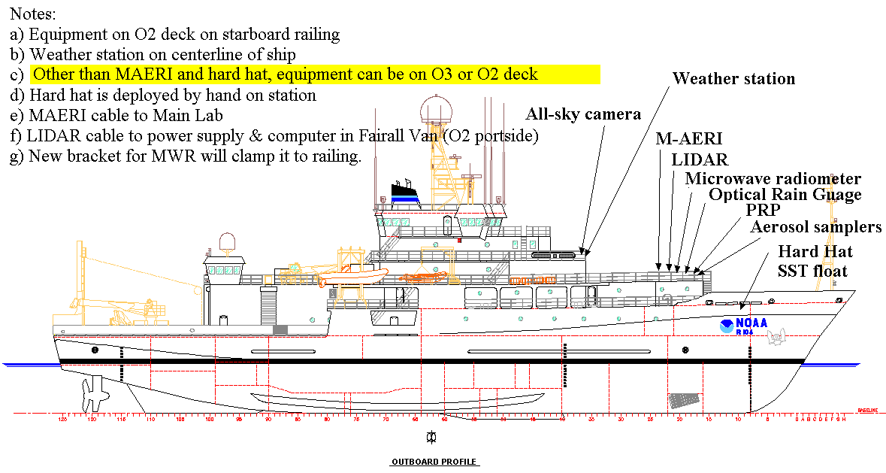
Figure C1. Suggested layout of Minnett equipment for AMMA
The layout suggested in Figure C1 is a compromise between the measurements being made with a minimum of influence from the ship, cable lengths, and access for maintenance. The M-AERI cable length is such that the external unit can be mounted to give a clear view of the sea ahead of the bow-wave, and have the electronic rack in the Main Lab. The rack has to be close (within 10ft) of the main aft doors of the Lab. Other computers, electronics components and printer require about 12 linear feet of bench space and it would be more convenient for this bench space to be allocated close to the M-AERI electronics rack. Other than the M-AERI and hard hat float, the instruments can be mounted on railings on the O2 or O3 deck, a choice that will be made dependent on the layout of other senor sans vans, with the objective of obtaining as clear a view of the sky as possible while still permitting access during the cruise.

Access to the instruments is required for:

- M-AERI: covering the instrument for heavy rain of sea-spray
- PRP: cleaning the radiometer domes
- All-sky camera: cleaning the mirror and lens
- Weather station: cleaning radiometer domes
- LIDAR: covering the zenith window close to noon to avoid sunlight entering the optics; , cleaning lenses
- Aerosol samplers: changing filters (daily), cleaning
- Hard-hat float: deployment and recovery

A – The M-AERI

Our main piece of equipment is the M-AERI (Marine-Atmosphere Emitted Radiance Interferometer – see Minnett, P. J., R. O. Knuteson, F. A. Best, B. J. Osborne, J. A. Hanafin, and O. B. Brown (2001), The Marine-Atmospheric Emitted Radiance Interferometer (M-AERI), a high-accuracy, sea-going infrared spectroradiometer, Journal of Atmospheric and Oceanic Technology, 18, 994-1013). It is a bulky piece of equipment which sits on a table that mounts on the railing where it can view the surface of the sea ahead of the bow wave, at an angle of about 55º to the vertical. On the Ronald H Brown, this is on the O2 deck (Figure C2a). The M-AERI electronics rack is usually installed in the Main Lab. The cable connecting the M-AERI to the electronics rack is a thick ‘umbilical’ bundle (about 5 cm diameter). We provide all of the mounting structure for the MAERI, so there are no special requirements from the ship for this, only that the area where we install it be available. In order to get the MAERI components to the appropriate deck we require a crane – the weight is 280kg. Power for the M-AERI is provided via cables to the interior lab. We provide an isolation transformer as well as a UPS unit. Power requirements are maximum ~2 KW.

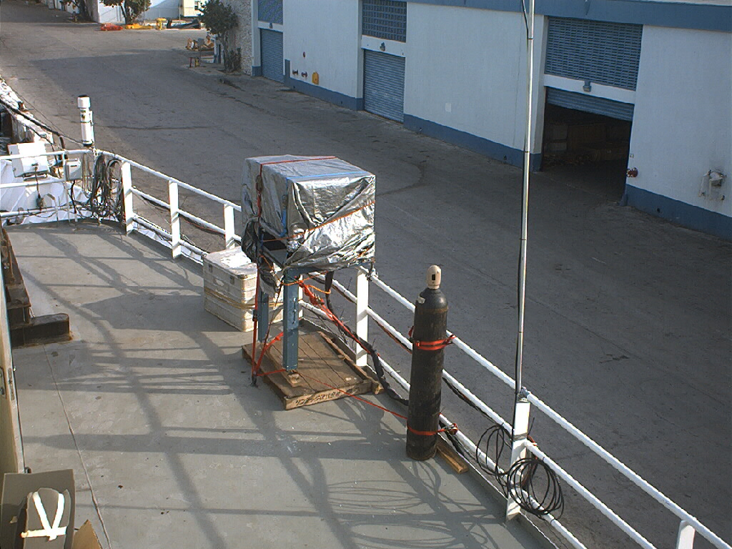
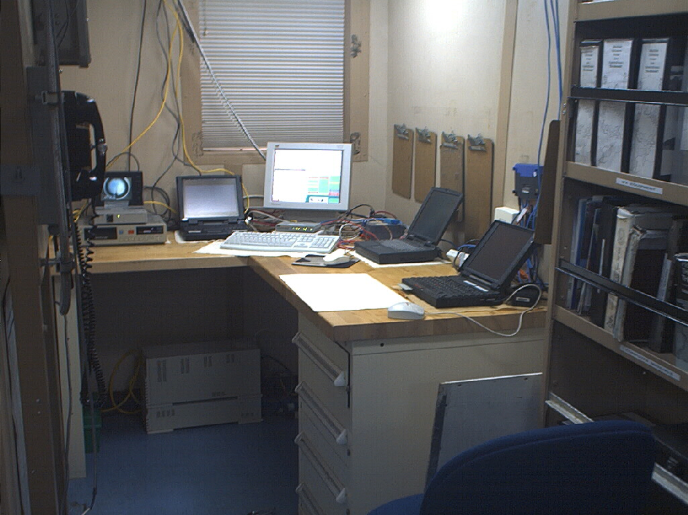
Figure C2a. M-AERI mounted on starboard side railing on the O2 deck of the Ronald H Brown. The instrument is covered by a tarpaulin, which is the case when there is heavy rain or sea-spray. Measurements are not taken while covered.

Figure C2b shows the interior equipment in the Met Lab on the USCGC Polar Star (keyboard, flat-panel display, laptop computers and video monitors) on the far bench in the lab. (A printer was mounted on another shelf off the photograph.)

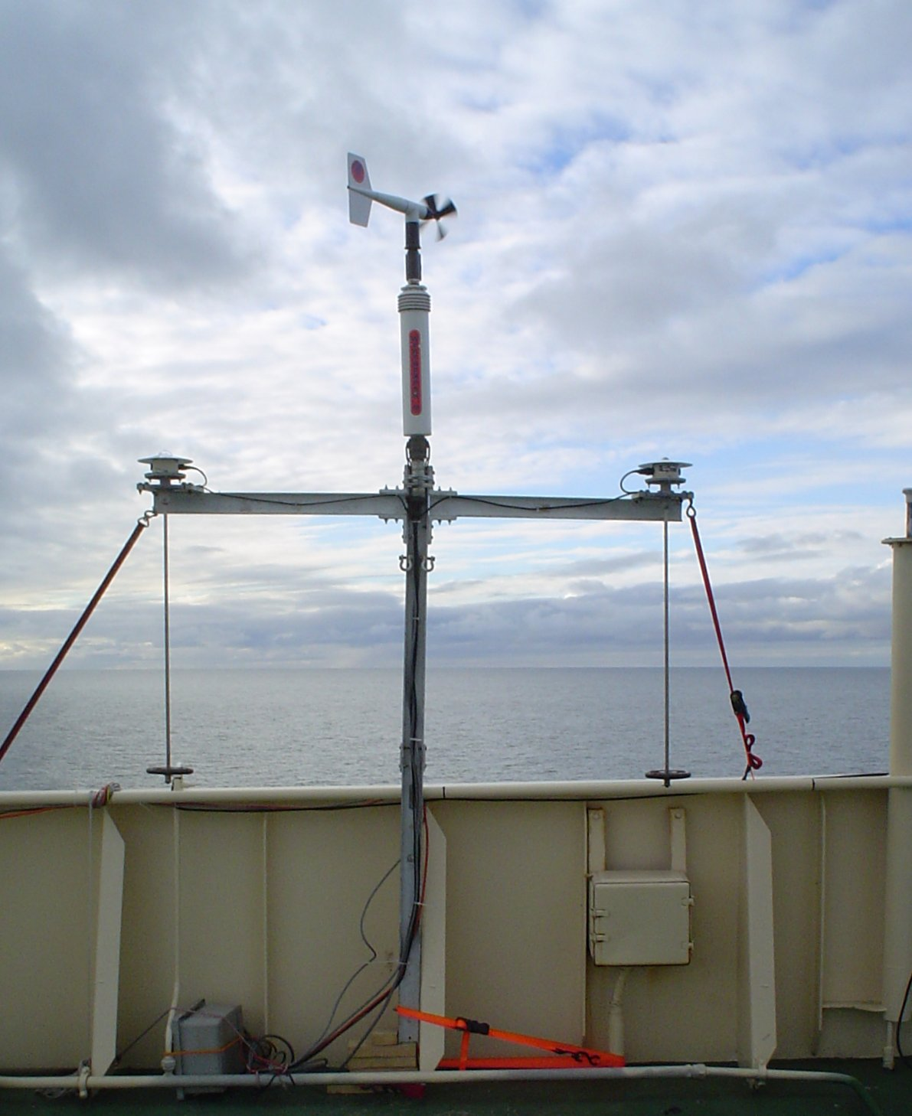
B- Meteorology and incident radiation
Figure C3. Weather station mounted above the bridge of the I/B Kapitan Dranitsyn.

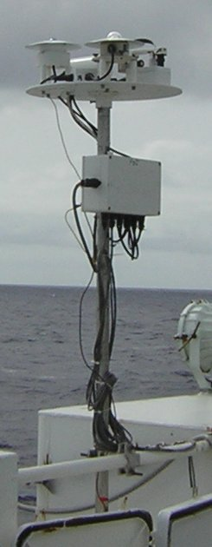
We set up a Met package on the forward railing of the O2 deck or above the bridge. Parameters measured are wind speed and direction, air temperature and humidity, surface air pressure and incident long and short wave radiation (Eppley radiometers mounted on gimbals with pendulums (Figure C3). Power is provided via cables to the Lab. Power requirements are 120 V A/C, 0.2 amps.
Figure C4. Portable Radiation Package on RHB during the AMMA 2006 cruise.

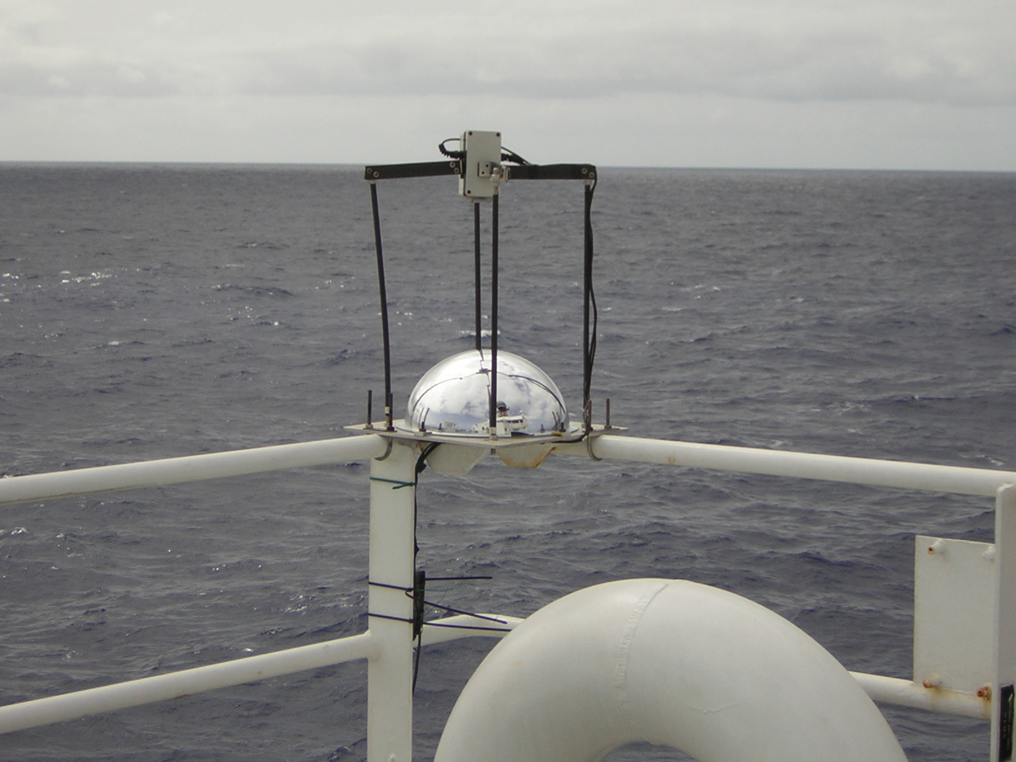
We also set up a set of instruments called a PRP (Portable Radiation Package) which measures spectrally resolved incident solar radiation, for the determination of aerosol parameters. This usually is mounted on the flying bridge (Figure C4). Power is supplied via cables to the Lab. We provide a D/C power supply.
Figure C5. Sky camera setup on the bridge top of the RHB during the AMMA 2006 cruise.

C - All-sky camera

We mount a sky camera system where as unobstructed as possible view of the dome of the sky is available such as on the bridge top (Figure C5). All of the mounting structure is provided by us, there are no additional requirements from the ship. Power is supplied from to the Lab where the images are acquired by a laptop computer 120 V A/C, 50 watts.

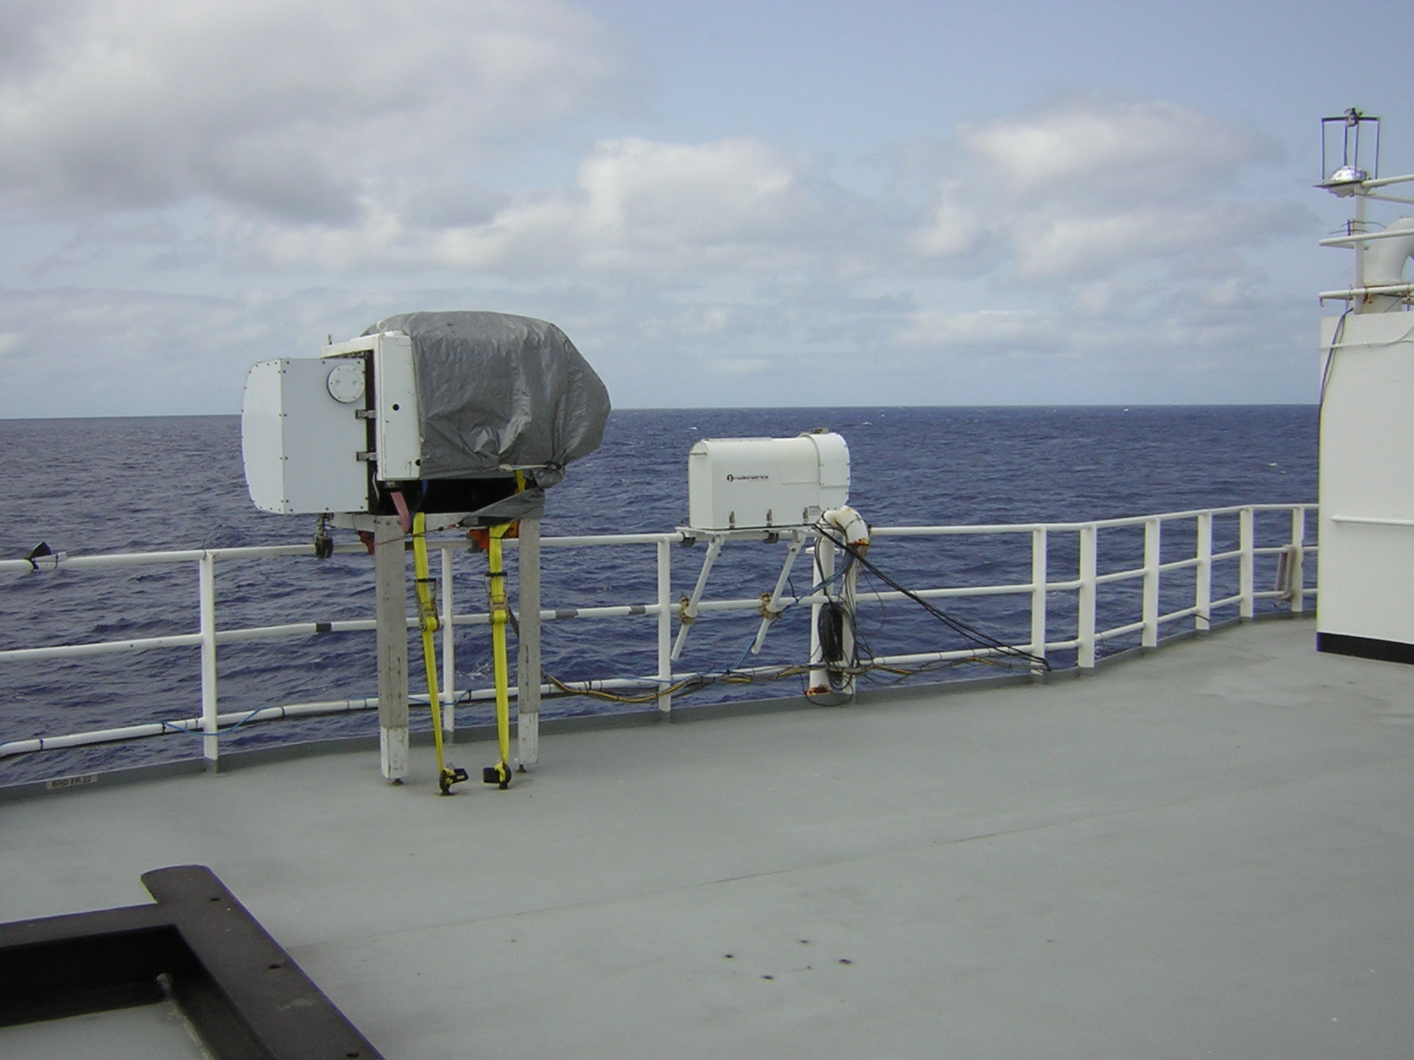
D - Microwave radiometer
Figure C6. Microwave radiometer next to the M-AERI on the RMB during the AMMA 2006 cruise

We set up a Microwave Radiometer where ir has a clear view from zenith to the horizon. It measures atmospheric precipitable water, and cloud liquid water content, (Figure C6). The instrument mounts conveniently on the stand shown in the photo, but can be adapted to mount without the stand if there is a more suitable location. Power for this instrument is provided via cables into the Lab. Power requirements for the radiometer are 120 V A/C, 1 amp. The instrument also has an air blower fan which requires 120 V A/C, 1000 watts, 4 amps.

E – Near surface bulk temperature.
The near surface bulk sea temperature is measured by a precision thermistor mounted in a small surface-following float constructed from a “hard hat” (Figure C7). This is deployed by hand when the ship is on station, drifting or making way at less than a few knots (dependent on sea state). The thermometer is at a nominal depth of 5cm and is sampled every second, and 20-s averages are logged by a laptop computer.
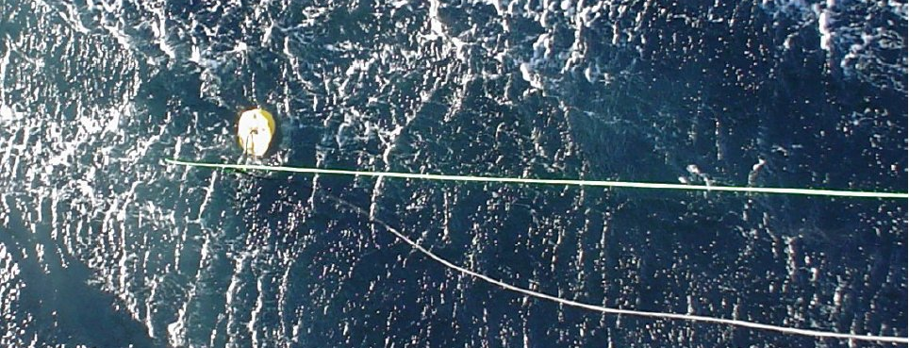
Figure C7. The Hard–Hat float of the port bow of the R/V Tangaroa, when seen from above.

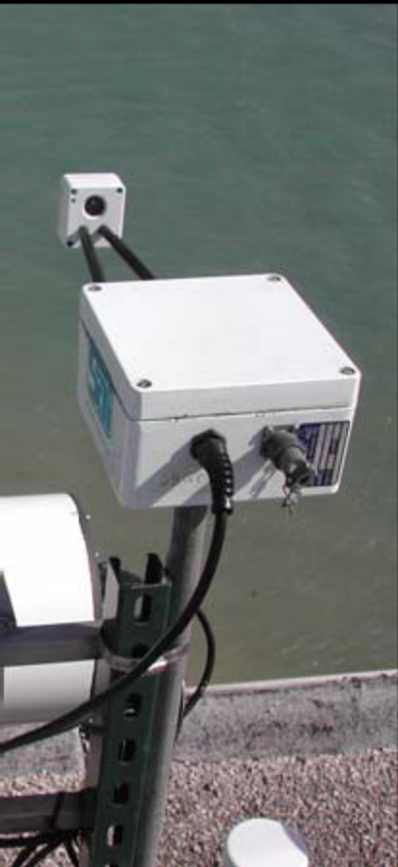
F - Optical rain gauge

Figure C8. The optical rain gauge measures liquid precipitation. The data are logged by a laptop computer in the lab.
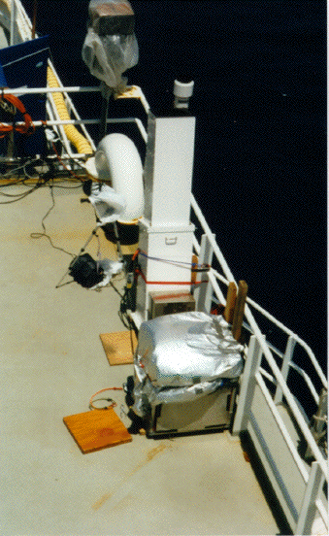
Figure C9. The Micropulse LIDAR on the RHB.

G- LIDAR

The eye-safe micropulse LIDAR will be mounted on the O2 deck. The limiting factor is a ~30ft power and fiber-optics cable that lead to a lab unit. This will be housed in the van of ESRL (Chris Fairall) which is anticipated to be installed on the O2 deck, port side. Access is required to cover the zenith window of the LIDAR close to local noon to avoid the risk of direct sunlight entering the instrument. This instrument was deployed on the RHB for the Aerosols99 cruise (January 14 to February 8, 1999) between Norfolk,
Virginia, and Cape Town, South Africa, and for all of INDOEX.
H- Aerosol samplers.

These will be mounted on the O2 deck forward to sample uncontaminated air. Two instruments are planned: an Aerodynamic Particle Sizer (APS; currently being refurbished), and a Micro-Orifice, Uniform-Deposit Impactor (MOUDI). Access, on at least a daily basis, is required to change filters and clean optics.

The replacement of the filters in the MOUDI requires access to a “clean hood” to avoid contamination. If such a hood is not available on the RHB, a portable one can be brought from RSMAS, and set up on a bench. It requires about 3 feet of bench space.
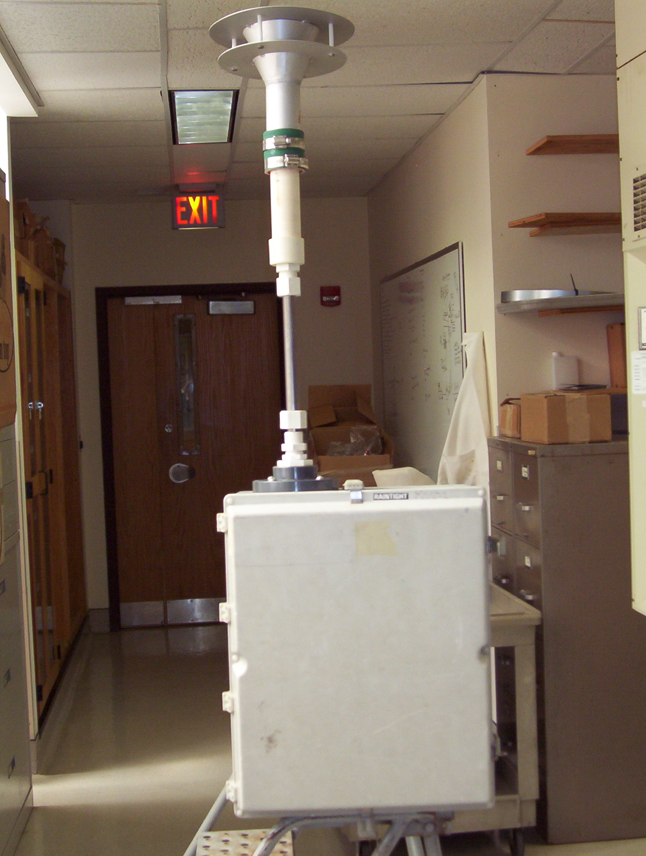
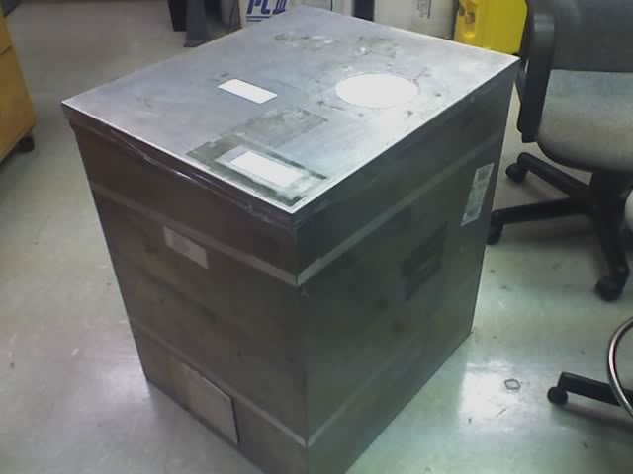
Figure 10. The MOUDI (left) and APS (right, without the inlet tube) in the lab.

