NOAA DAS setup and operation
The NOAA Services suite consists of Data Acquisition and Clock Sync. Data Acquisition (DAS) is the application we use to log serial data streams. For ASTRAL, DAS is logging 7 separate serial feeds from a variety of sources at a variety of rates. Each acquisition session is programmed as a service in Windows OS, which means data continues to be saved even if you close the DAS app. In theory the acquisition restarts automatically if the computer is rebooted but that wasn’t found true for all feeds on that particular computer during the tests in Boulder. Thus we recommend keeping an eye on it frequently to make sure things are running properly. To halt a session in the Data Acquisition Setup window, highlight the line and press the Stop button.
The normal state of the acquisition window is shown below. Each acquisition session is listed showing status, instrument, data port, samples received per minute, and last time the sample total was reported. A Green icon indicates samples have been received within the last minute.
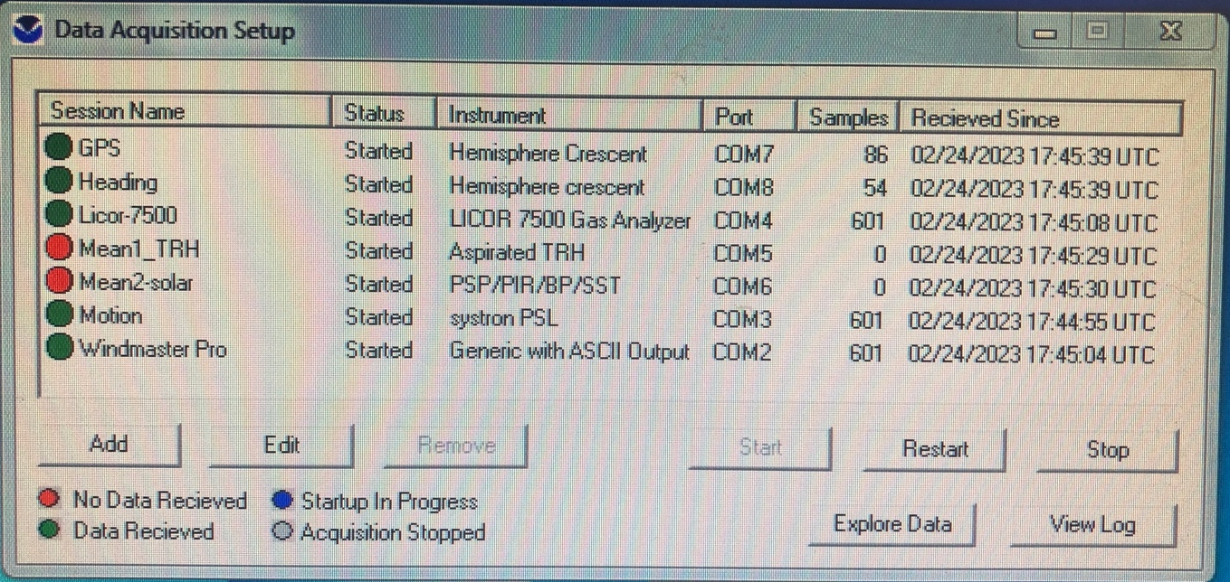
In this example the Mean1 and Mean2 feeds are red because it doesn’t always send a record at the exact 1min time interval but will send it on the consecutive one. So once very 1 to 2 minutes those 2 channels will cycle between red and green as shown below.
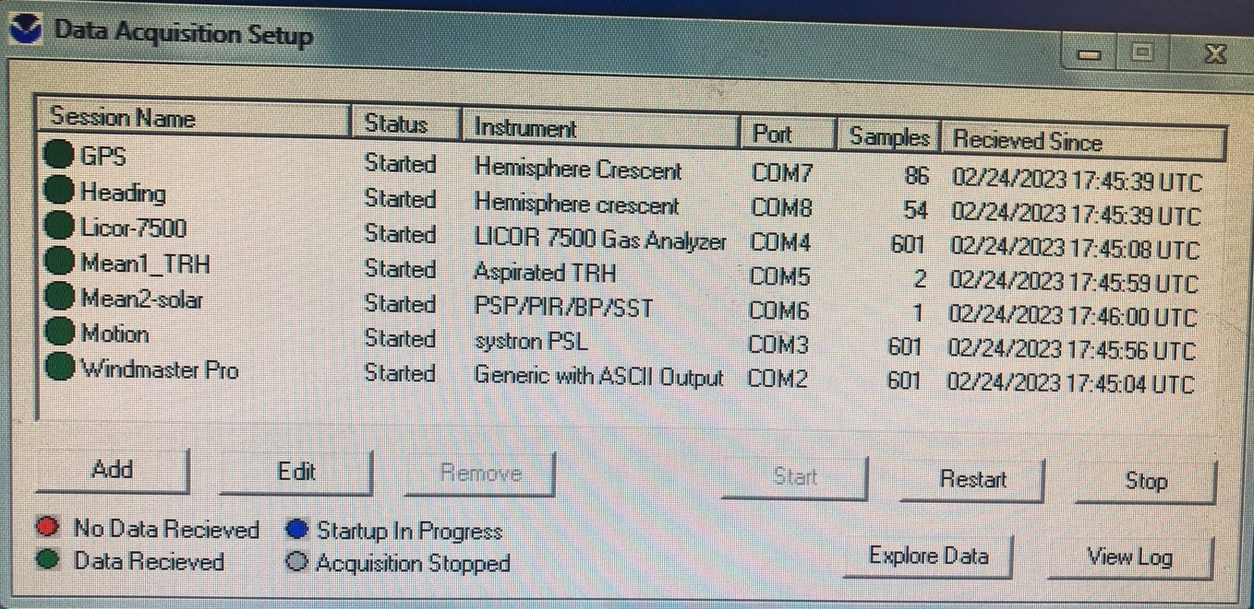
A stopped session is shown with a Gray icon. To edit an existing session double click on the line or highlight the line and hit the Edit button (shouldn’t be needed for Astral as pre-configured at Boulder).
Clock Sync setup
The NOAA Clock Sync service provides a more flexible and precise way to control clock synchronization compared to the Windows OS internet time server option. This can be used when you have access to a $GPRMC serial message from a GPS unit or other serial feed which can be logged through a COM port. Currently a GPS feed from the heading system is used and acquired on COM13 as shown below. It is set to run once a day around midnight UTC.

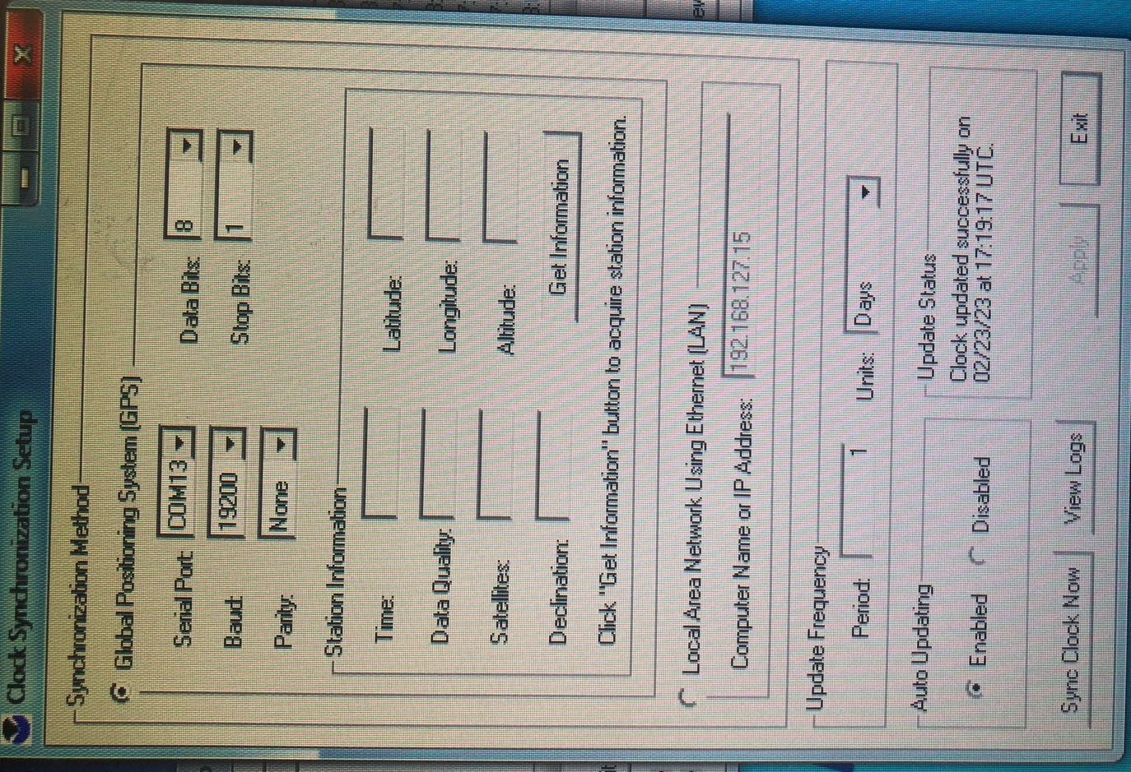

MOXA configuration and associated COM ports on DAS
Name | IP address | COM port on DAS | Baud rate | Parity | Data bits | Stop bits | Flow control | FIFO | Data type
DAS | 192.168.127.101 | N/A | N/A | N/A | N/A | N/A | N/A | N/A | N/A
Mean2 (PSP/PIR/BP/SST) | 192.168.127.11 | 6 | 9600 | None | 8 | 1 | None | Enabled | RS232
Sonic | 192.168.127.21 | 2 | 19200 | None | 8 | 1 | None | Enabled | RS232
Motion | 192.168.127.22 | 3 | 38400 | None | 8 | 1 | None | Enabled | RS232
Licor | 192.168.127.20 | 4 | 19200 | None | 8 | 1 | RTS+CTS | Enabled | RS232
Mean1 (T/RH aspirated) | 192.168.127.18 | 5 | 9600 | None | 8 | 1 | None | Enabled | RS232
GPS | 192.168.127.15 | 7 | 19200 | None | 8 | 1 | None | Enabled | RS232
Heading | 192.168.127.16 | 8 | 19200 | None | 8 | 1 | None | Enabled | RS232

PSL mean offsets from lab comparison with standards in Boulder

Variable | Observed offset WRT standard | Comments
Barometric pressure | +1.5mb | Compared outdoor to local barometric measurements
RH | +0.2% | Compared to HMT337 outdoor (~50% humidity)
Tair | +0.02C | Comapred to RBR probe
Seasnake (black tube) | +0.5C | New offset after datalogger swap. Might need to reavulate Rref and check offset again after cruise.
Seasnake spare (transparent tube) | +0.5C | Offset before datalogger swap. Hard to evaluate as datalogger issue during test. Might need to reavulate Rref and check offset again after cruise.

