**Description of airborne dropsonde data processing from NOAA P3 aircraft during ATOMIC**

**Version 1**

C. Fairall, S. Pezoa, Mason Leandro

2020 March 21

NOAA deployed the P-3 aircraft during the ATOMIC 2020 field program (Jan-Feb). The P-3 dropped dropsondes and AXBT’s. In this document we will briefly describe the processing that has been done to produce summary files. The sondes and AXBT’s generate raw data files. These can be found as follows:

Data from all P-3 systems are archived at <ftp://ftp1.esrl.noaa.gov/psd3/cruises/ATOMIC/P3/>

Individual flights are given in directories with the names 2020MMDDI1, with flights on

01 17 20200117I1 17

01 19 20200119I1 19

01 23 20200123I1 23

01 24 20200124I1 24

01 31 20200131I1 31

02 03 20200203I1 34

02 04 20200204I1 35

02 05 20200205I1 36

02 09 20200209I1 40

02 10 20200210I1 41

02 11 20200211I1 42

Within each flight directory are subdirectories:

AVAPS Dropsonde raw files

DMT Cloud/precipitation microphysics from DMT probes.

FLT LVL Data from P3 flight level measurements

SFMR Stepped frequency microwave radiometer

WSRA Wide Swath Radar Altimeter

AXBT Raw AXBT files

The dropsondes in the AVAPS data were raw in the first flight. Later flights included files from ASPEN processing. A complete set of .frd (txt) files are available under the same flight file naming convention at <https://seb.noaa.gov/pub/flight/ASPEN_Data/> The AXBT files are in text form and do not give geolocation. We processed them to provide more complete files.

P-3 Dropsondes in individual daily files (matlab .mat files) indexed by day number (17 is January 17, 2020) under

<ftp://ftp1.esrl.noaa.gov/psd3/cruises/ATOMIC_2020/P3/sonde/>

P-3 AXBT (matlab .mat files) indexed by day number (18 is January 18, 2020) will be available under

<ftp://ftp1.esrl.noaa.gov/psd3/cruises/ATOMIC_2020/P3/axbt/data/>

The dropsondes data are abstracted from the *.frd* files using the MATLAB script *read_atomic_Dropsonde_raw_P3.m*. Individual files are read in, the valid data lines are pulled out and remapped into a grid with the first line corresponding to the surface. A new mat file is written for each day with all sondes on that day in one matrix. A single *all* cruise file that contains all of the sonde data is created.

<ftp://ftp.etl.noaa.gov/psd3/cruises/ATOMIC_2020/P3/sonde/ATOMIC_P3_sonde_all.mat>

The files take the form

'jdxh' Year day

'zhh' Height (m) above the surface

'Uhh' Wind speed (m/s)

'rhahh' Relative humidity (%, relative to ice if T<0 C)

'tahh' Temperture (C )

'lathh' Latitude (deg)

'lonhh' Longitude (deg)

'Phh' Pressure (mb)

'qahh' Specific humidity (g/kg)

'udirhh' Wind direction (deg)

jdxh, lathh, lonhh have one value per sonde; the other variables have 4000 values per sonde with NaN’s in the invalid locations. For example, the entire P3 dataset can be read in using

way_raw_files='Z:\ATOMIC\P3\sonde\';

sondex=load([way_raw_files 'ATOMIC_P3_sonde_all.mat']);

rhahh=sondex.rhahh;

zhh=sondex.zhh;

Uhh=sondex.Uhh;

tahh=sondex.tahh;

lathh=sondex.lathh;

lonhh=sondex.lonhh;

Phh=sondex.Phh;

qahh=sondex.qahh;

udirhh=sondex.udirhh;

jdxhG=sondex.jdxh;

jk=length(lathh);

[yr mon dttn hr mn sec]=datevec(jdxh);

Also, for example, the matlab line

i=1;figure;plot(Uhh(:,i),zhh(:,i),'.');xlim([0 20]);xlabel('U (m/s)');ylabel('Alt (m)');title(['ATOMIC P3: ' num2str(mon(i)) '/' num2str(dttn(i)) '/' num2str(hr(i)) ' lat=' num2str(lathh(i)) ' lon=' num2str(lonhh(i))])

will produce Fig. 1 which is a plot of wind speed vs altitude for the first sonde in the file. Nominal vertical spacing of the profiles is 6 m so a typical P3 sonde from 7.5 km will have about 1200 levels.

A similar procedure was followed to process the AXBT data. The depth-temperature series was read in and matched with the aircraft location series using the MATLAB script *read_axbt_raw_P3_calwater.m*. A file for each day was written with the ocean temperature profile from 0-800 m depth for all AXBT for that day (*ATOMIC_AXBT_MM_DD_data2.mat*). A sample profile is shown in Fig. 2. An *all cruise* file was also written. A second file (ATOMIC_SST_data.mat) was written that has the SST from each AXBT. Similarly to reading the sonde data, you can read the SST data

way_raw_filesA='Z:\ATOMIC\P3\axbt\';

axbt=load([way_raw_filesA '\ATOMIC_SST_data.mat']);

sstA=axbt.tazh;

lathhA=axbt.latzh;

lonhhA=axbt.lonzh;

jdxhA=axbt.jdzh;

jkA=length(lathhA);

[i mona dttna hra mna seca]=datevec(jdxhA);

This gives the time/space series of SST computed from the near-surface values (we used the 3rd value in the profile) of AXBT data. There are 122 SST values.

The locations are all are shown in Fig. 3; locations of AXBTs (color-coded with SST) are shown in Fig. 4.

The MATLAB codes used are at <ftp://ftp.etl.noaa.gov/psd3/cruises/ATOMIC_2020/P3/matlab/>

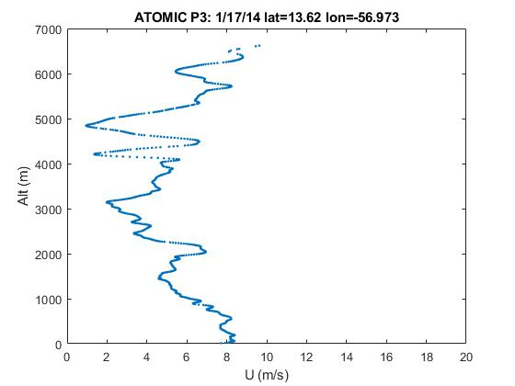

Figure 1. Sample wind speed profile from a P3 dropsonde in ATOMIC January 17, 2020.

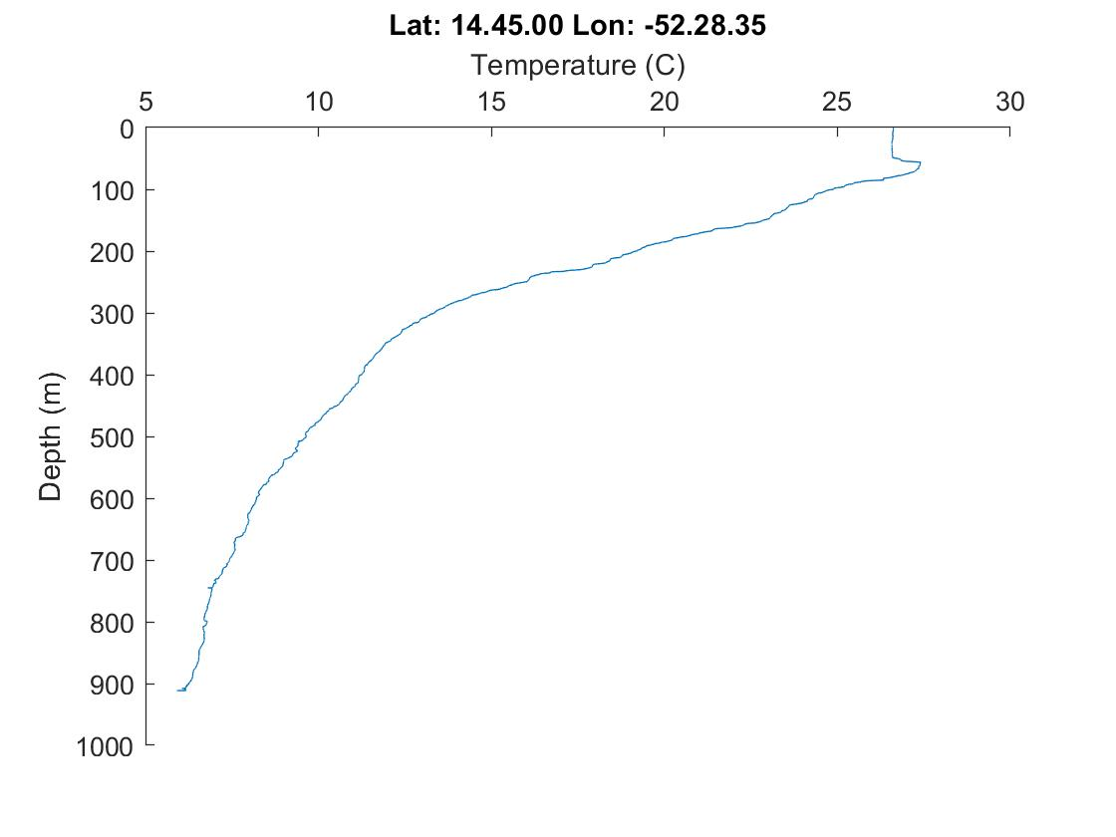

Figure 2. Sample ocean temperature profile from a P3 AXBT in CALWATER2 January 28, 2015.

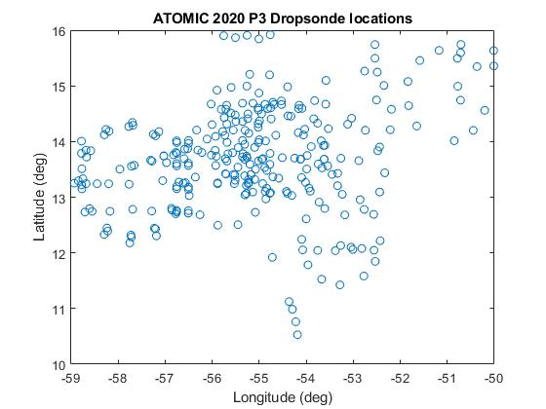

Figure 3. Locations of dropsondes for ATOMIC.



Figure 4. SST values from the ATOMIC AXBT’s on a lat-lon grid.