Setup of Vaisala Radiosonde for Release from RV Investigator

Note:

- GC25 refers to the radiosonde groundcheck station that contains desiccant for zeroing the sonde humidity sensor.
- MW21 refers to the hardware for radiosonde telemetry (actually a collection of subsystems with names that will occasionally be referred to by the Digicora software).
- Digicora refers to the complete sounding system, but here it is used for the software component of that system.

Procedure

- Fire up computer, GC25 and MW21
- Start Digicora on desktop

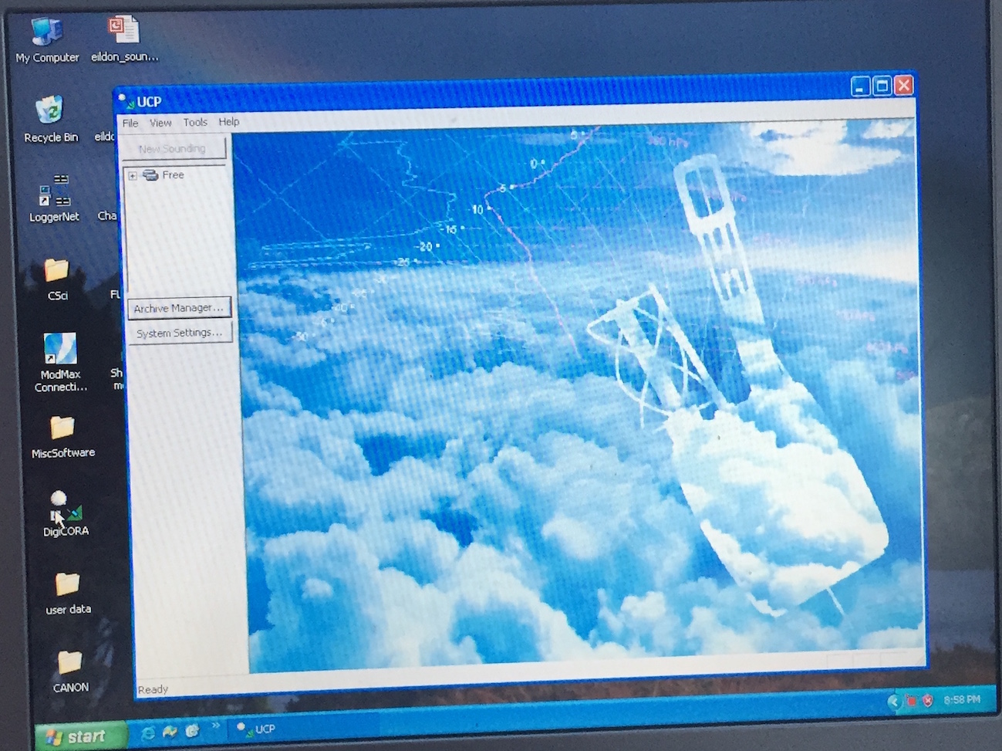
Figure 1

- “No Item Found” warnings should be dismissed
- Under dropdown menu File, click new sounding (Fig. 1). Screen on Fig 2 should appear …
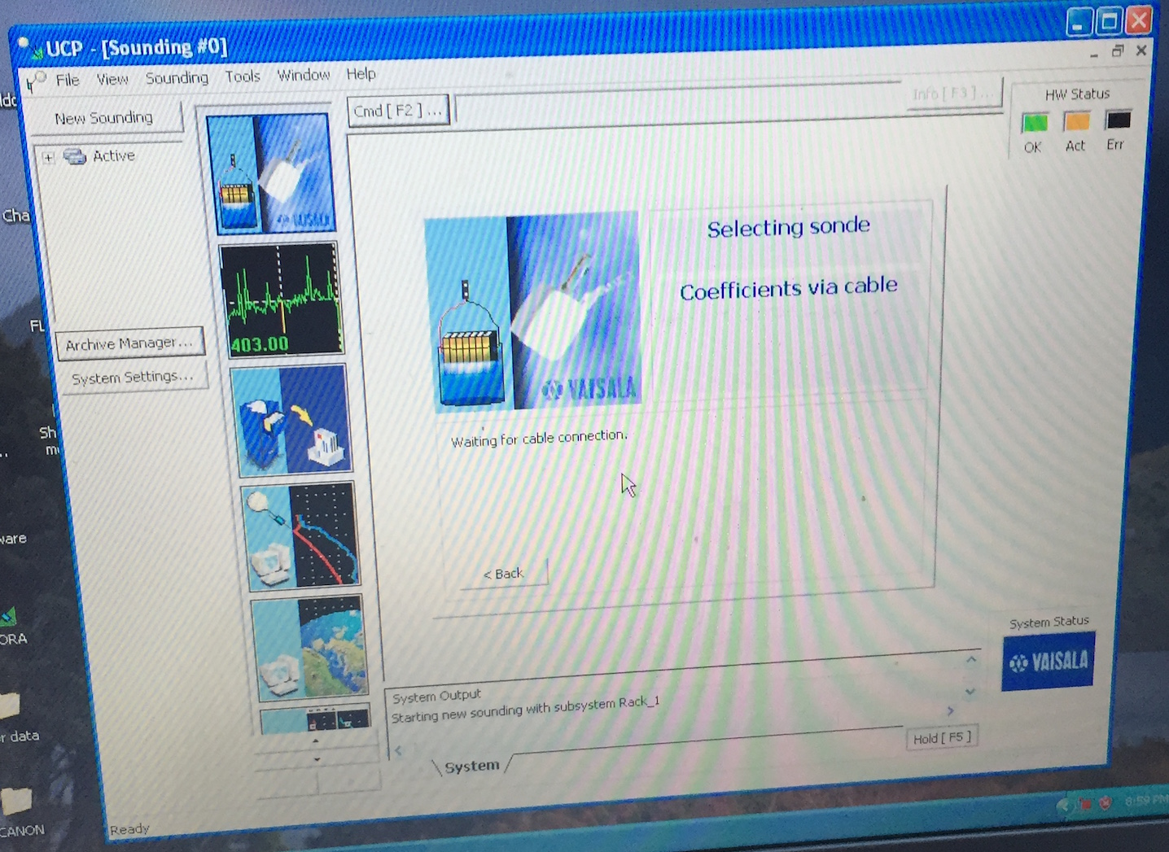
Figure 2

- Put the sonde on the GC25 with the sensor boom covered by the lid of the dessicant chamber (latched down)
- Connect the GC25 to the sonde with the blue connector on ribbon cable (Note “UP” on the connector)
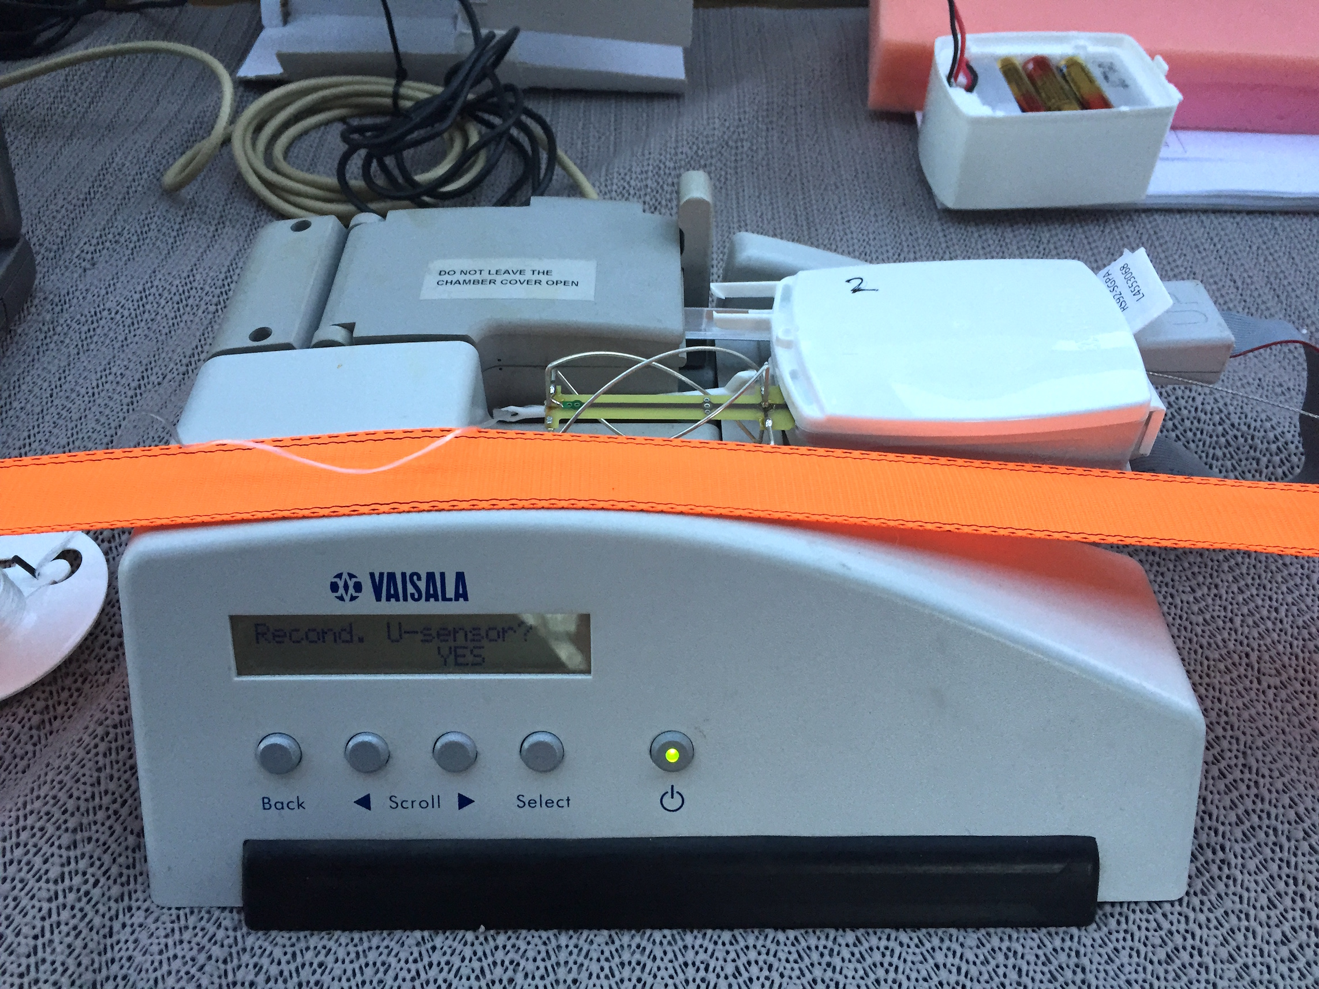
Figure 3

- The Digicora will read the sonde serial number and display that. Click “Next” on the active Digicora window

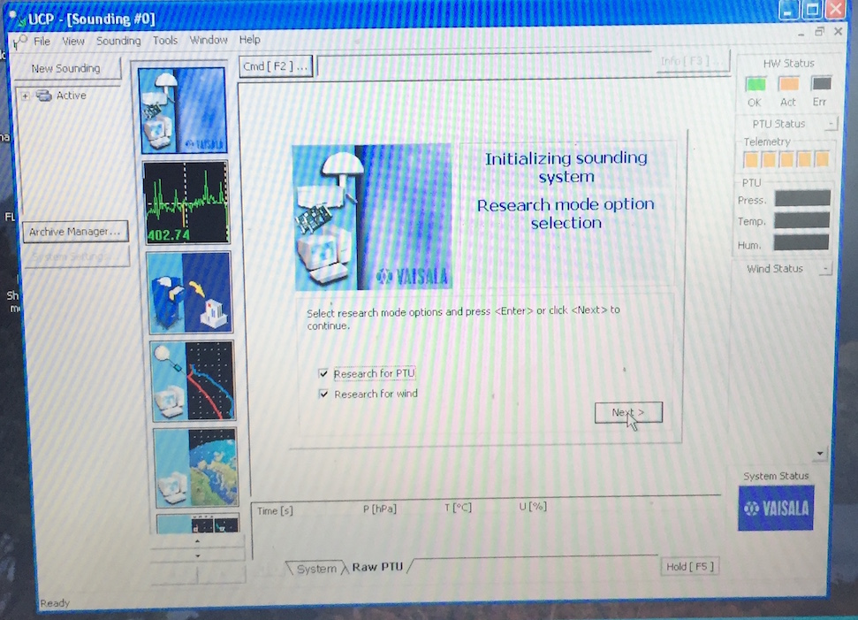
Figure 4

- Select “research for PTU” and “research for wind” , then click “Next”

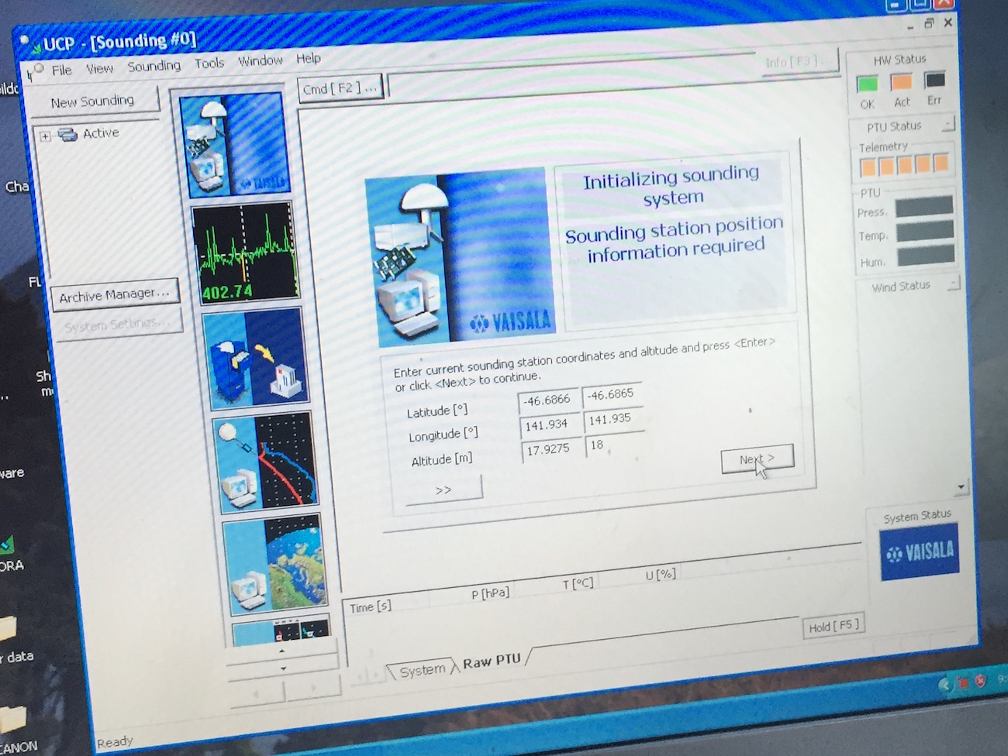
Figure 5

- Now displaying screen as in Fig. 5, and looking for lat/lon from GPS (in Digicora, not sonde!)
- When system has found lat/lon/alt confirm or correct these – note that the bridge is 26 m above sea level, so we add 3m for the bench in the observation deck, but I think that we should also add 1.5 m to include the height of the GPS antenna above the bench)
- (For launches 1 & 2 we have confirmed these by typing the GPS lat/lon in the right hand column of textboxes – unless actually correcting, this may not be necessary.)
- Click “Next”

- On next window leave “manual” ticked, and click “Next”

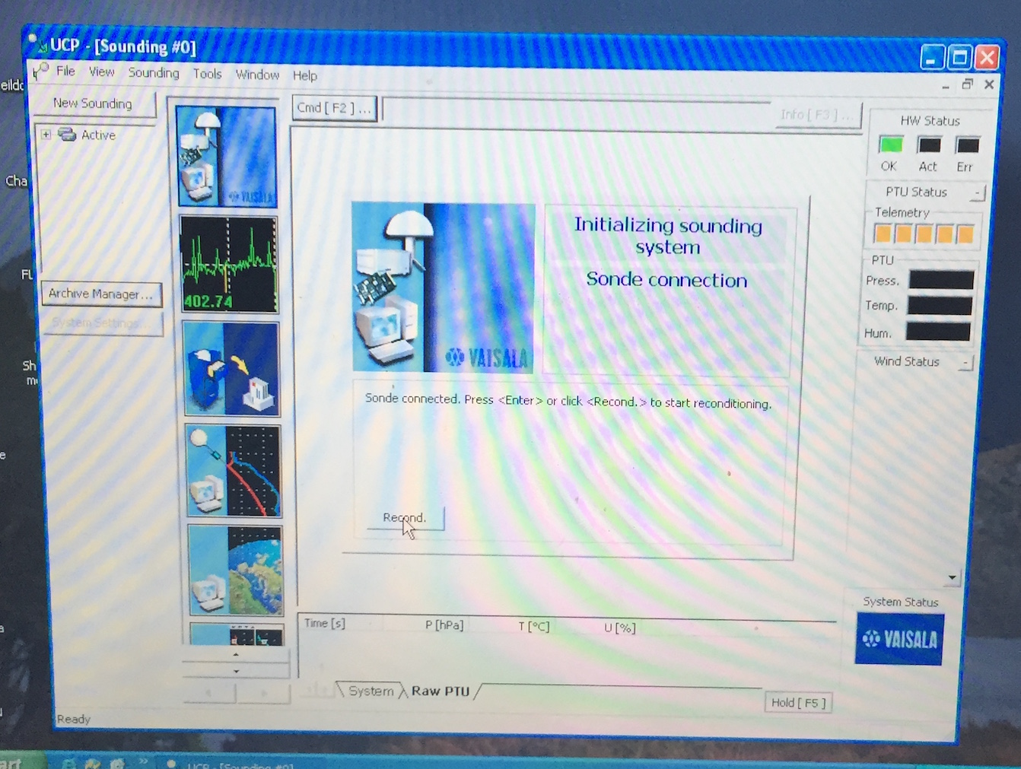

Figure 6

- On next window click “recond” – the system will respond with “sonde connected” – just click “recond” again.
- Wait 3 min for reconditioning and then 2 min for stabilization – both stages display a countdown – see Figs 7 and 8.

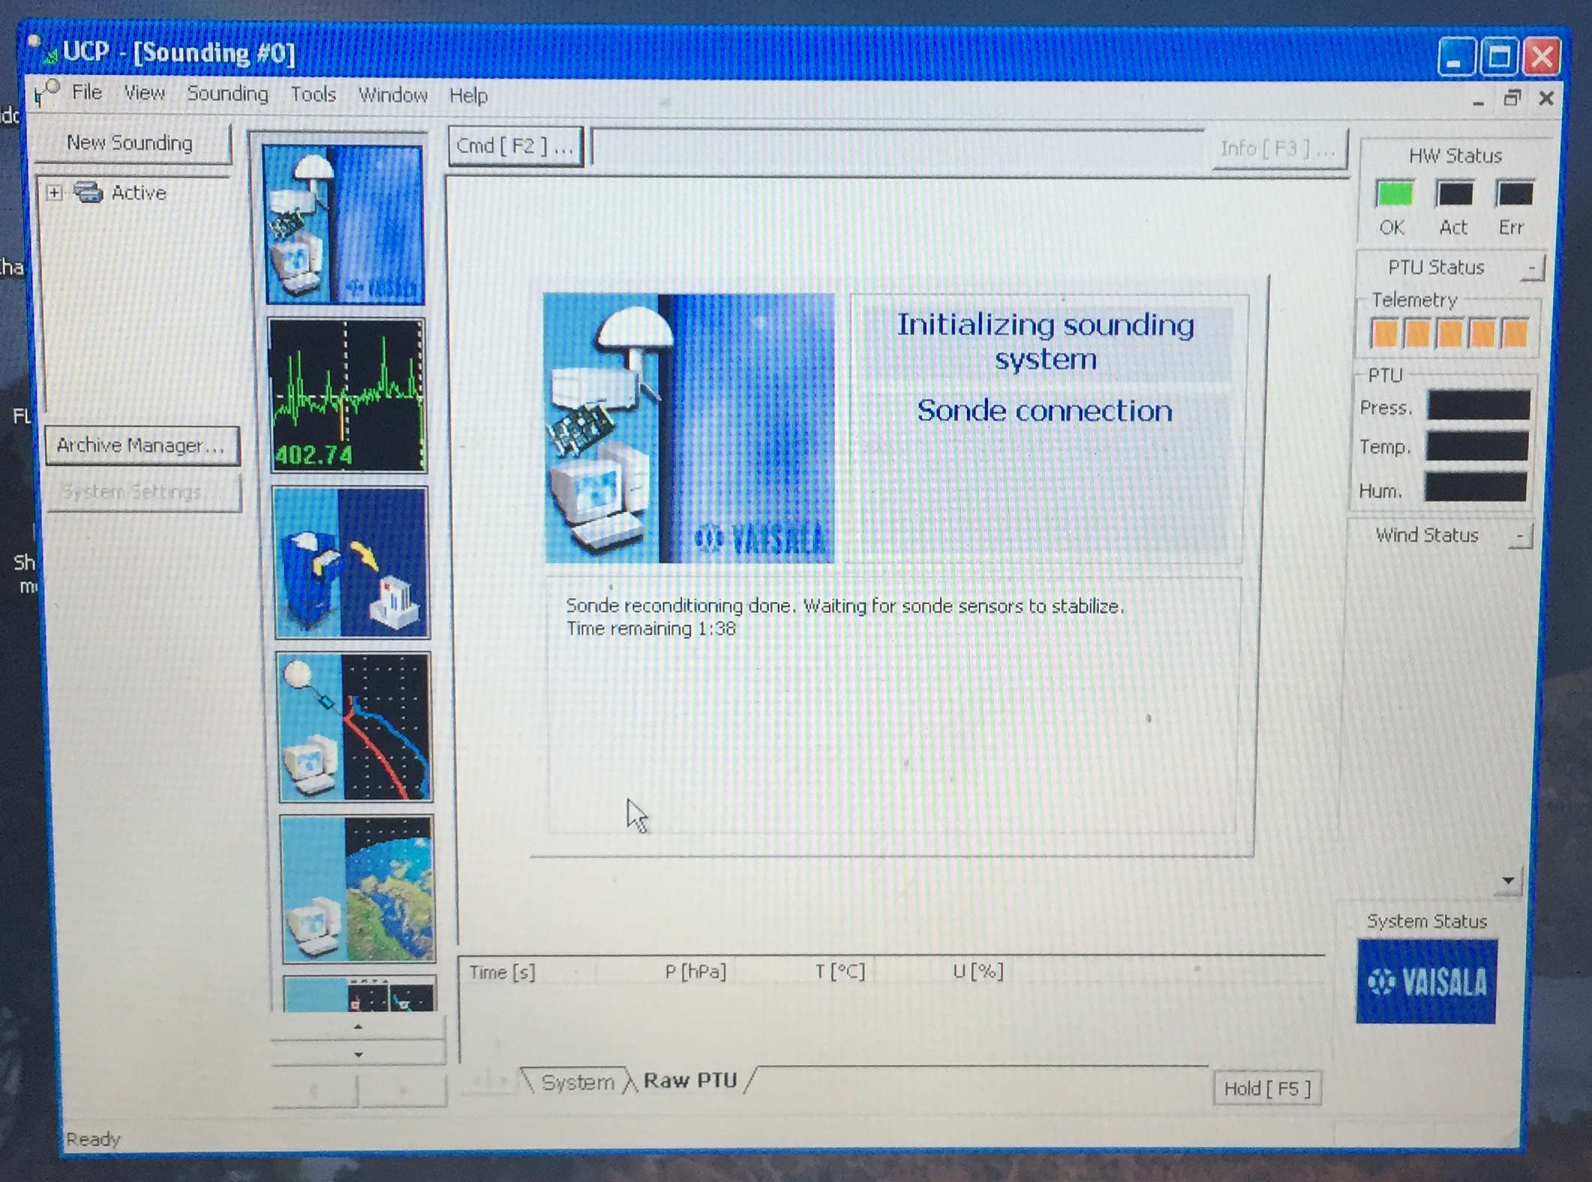
Figure 7

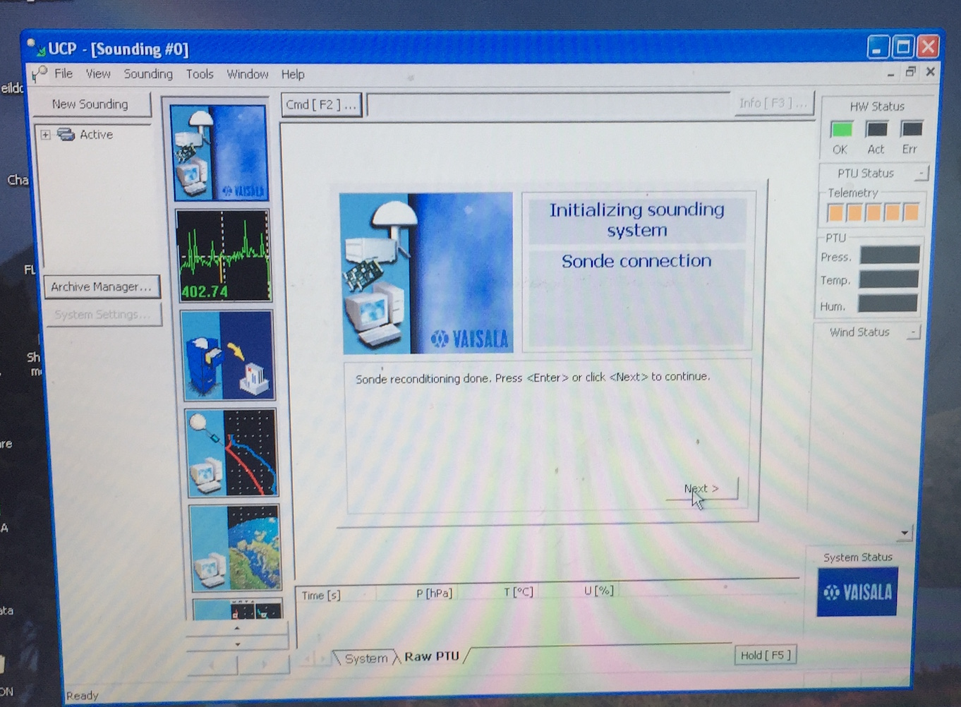
Figure 8

- When this is finished, click “Next”
- Sonde initialization takes place now – wait …

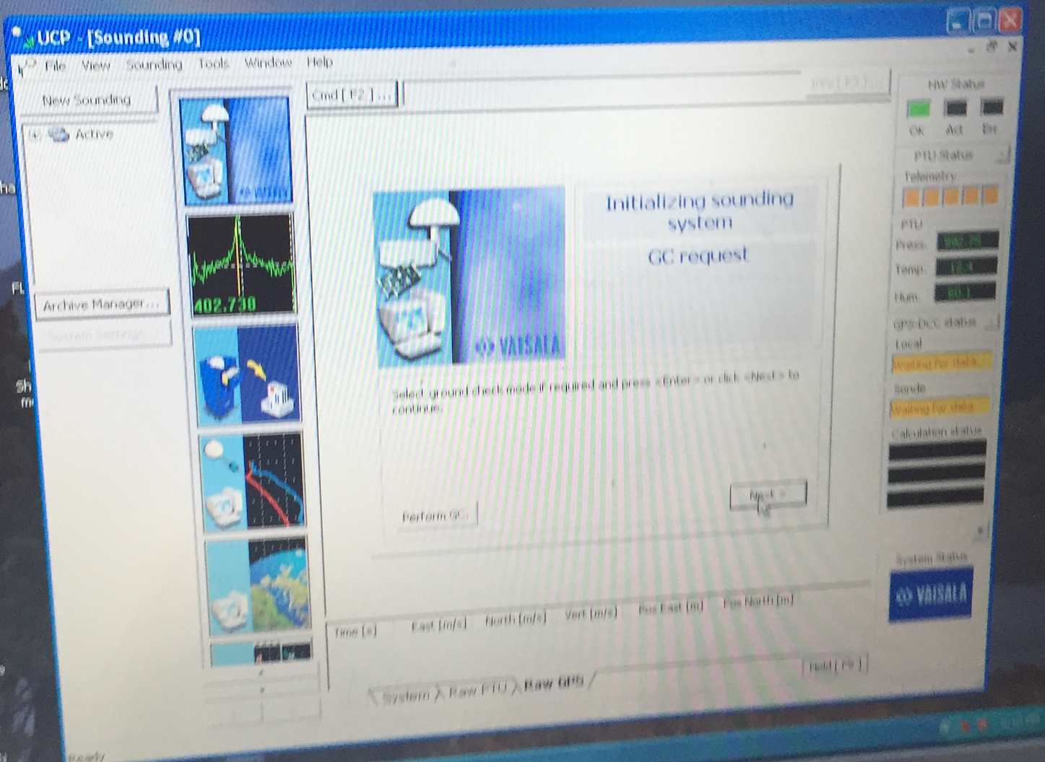
Figure 9

- When the Digicora window says “Select ground check if required” (see Figure 9) just click “Next” – ground check has happened already.
- System will say ready for sonde release – click on “surface obs”
- enter surface observations and click “Next” – see Fig 10.

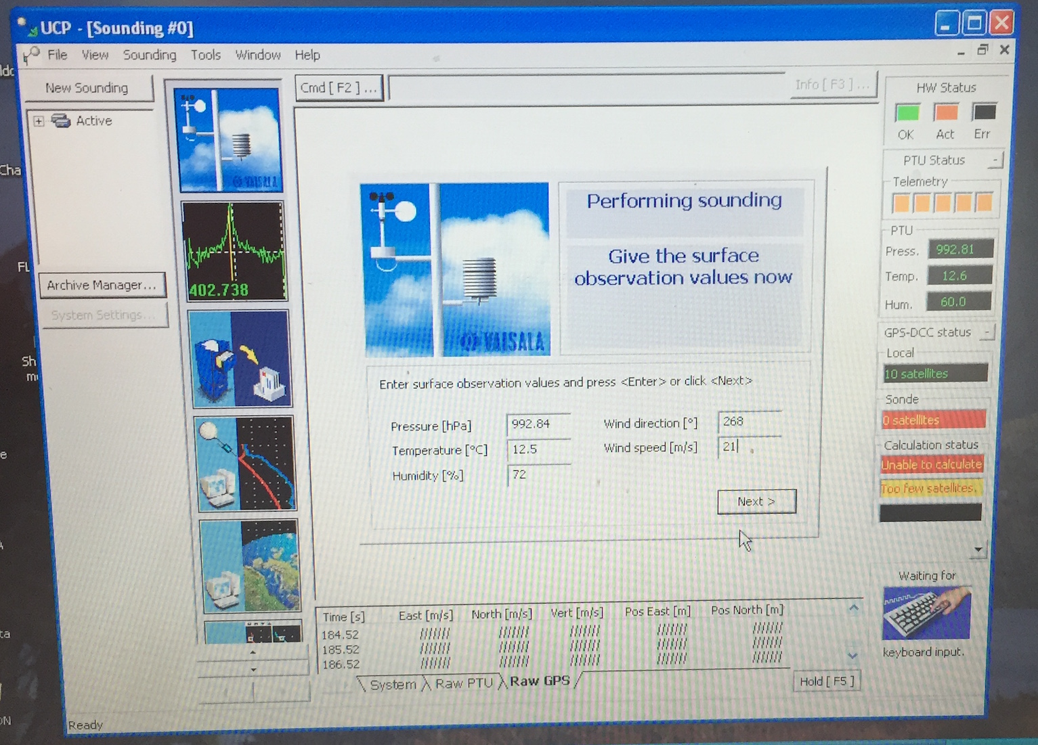
Figure 10

- Click “Next”

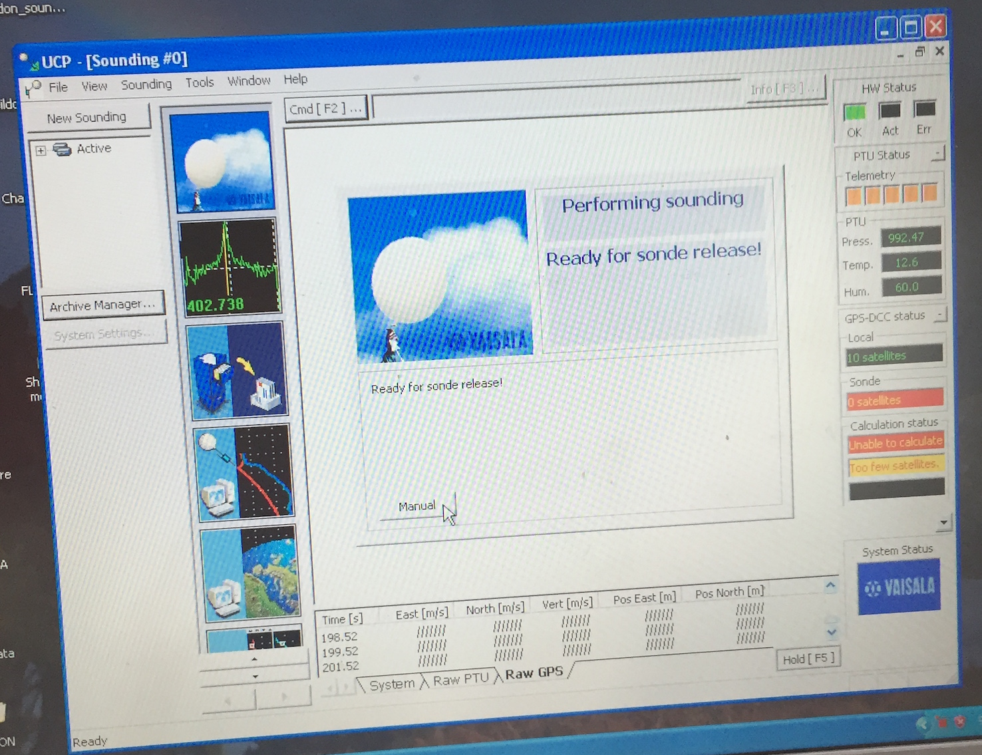
Figure 11

- Click “Manual on next screen (Figure 11)

- Remove sonde from GC25, and connect Battery Pack.
- If battery pack has red button, push it to turn on battery power to sonde – green light should appear.
- Place sonde on window sill – preferably propped up so that the GPS antenna is pointing at least somewhat upward.
- Monitor the telemetry signal strength (should have 5 orange squares), and whether the sonde can see GPS satellites – from this position at least one satellite should be “visible”

- When these conditions are met, sonde can be taken down to the Sheltered Science Area for attachment to balloon.

