Setup of Vaisala Radiosonde for Release from RV Investigator

These notes are for operation of the Monash University Digicora system

Note:

- GC25 refers to the radiosonde groundcheck station that contains desiccant for zeroing the sonde humidity sensor.
- MW21 refers to the hardware for radiosonde telemetry (actually a collection of subsystems with names that will occasionally be referred to by the Digicora software).
- Digicora refers to the complete sounding system, but here it is used for the software component of that system.

Procedure

- Fire up computer, GC25 and MW21
- Start Digicora on desktop

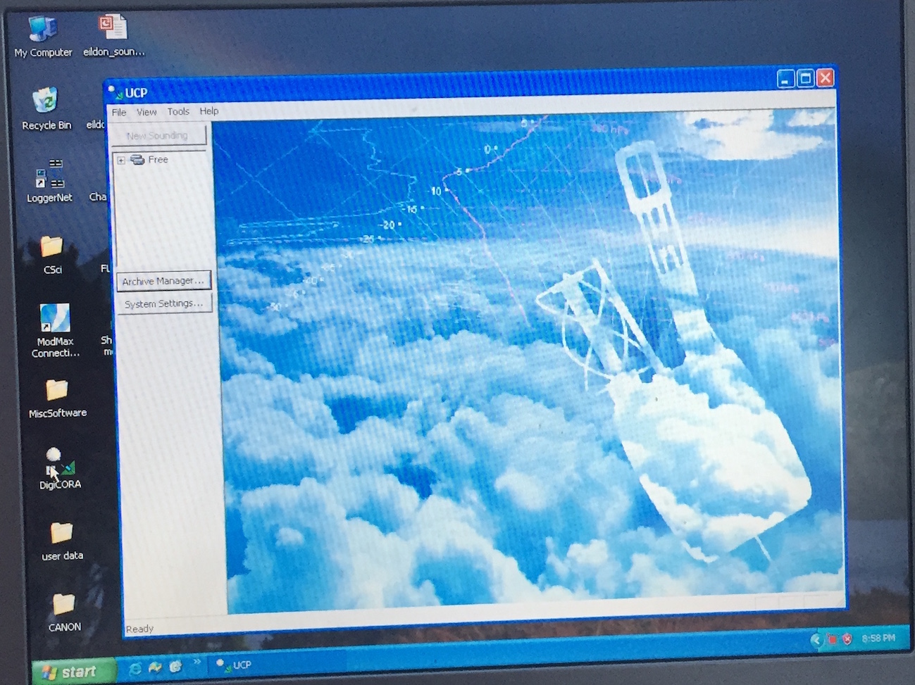
Figure 1

- “No Item Found” warnings should be dismissed
- Under dropdown menu File, click new sounding (Fig. 1). Screen on Fig 2 should appear …
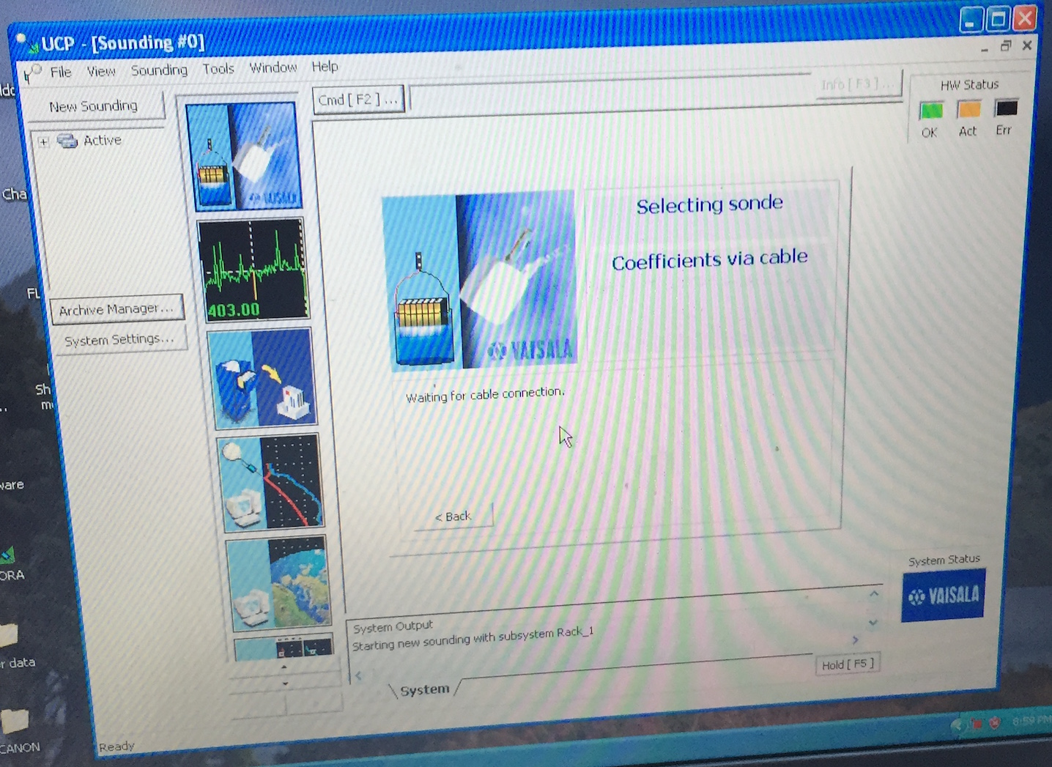
Figure 2

- Put the sonde on the GC25 with the sensor boom covered by the lid of the dessicant chamber (latched down)
- Connect the GC25 to the sonde with the blue connector on ribbon cable (Note “UP” on the connector)
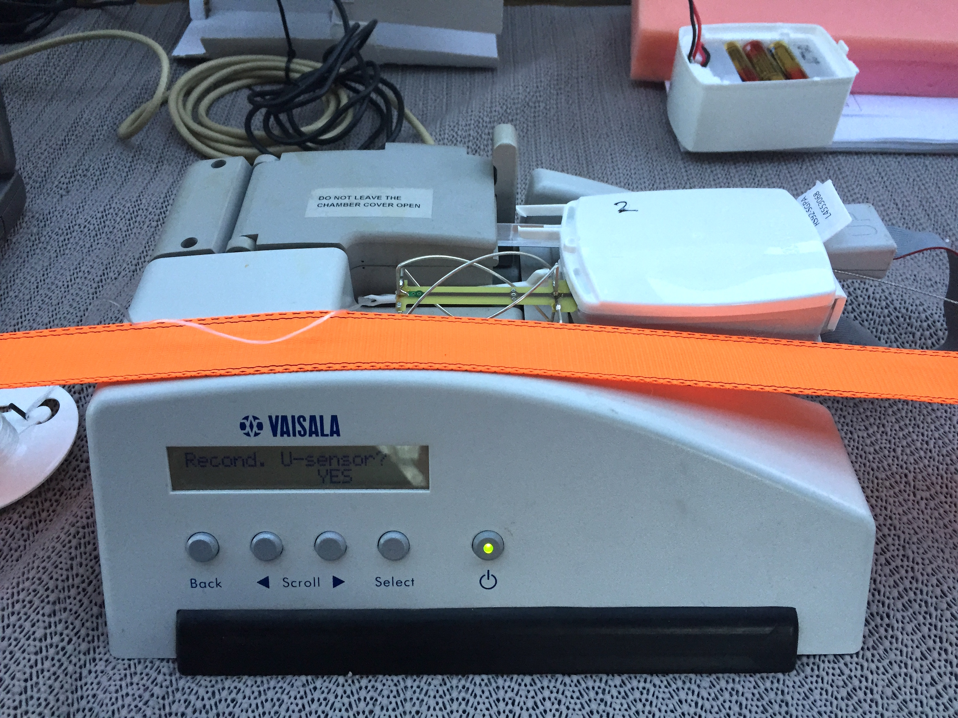
Figure 3

- The Digicora will read the sonde serial number and display that as in figure 4. Click “Next” on the active Digicora window

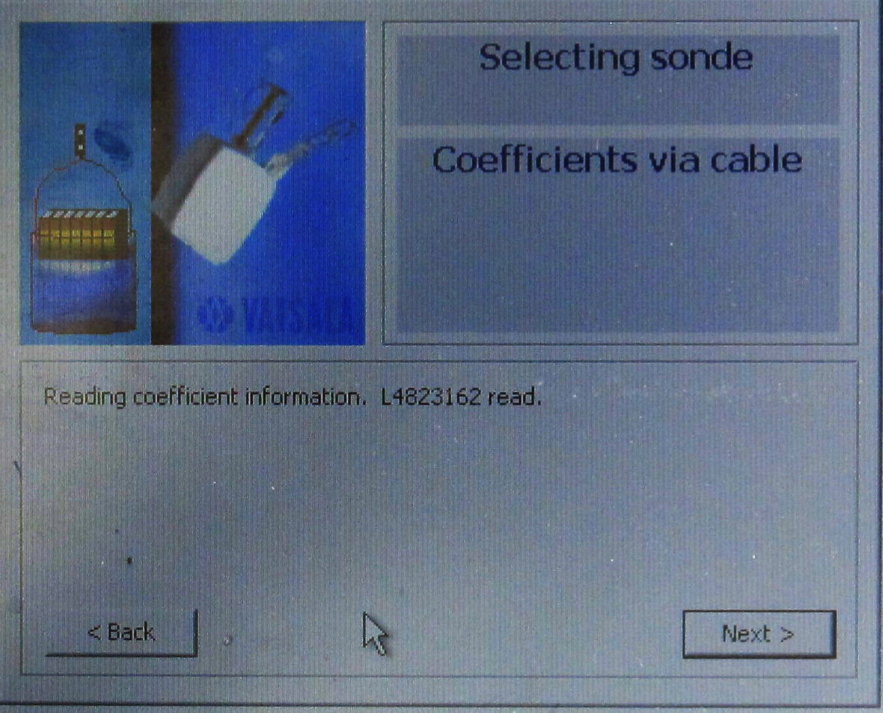
Figure 4

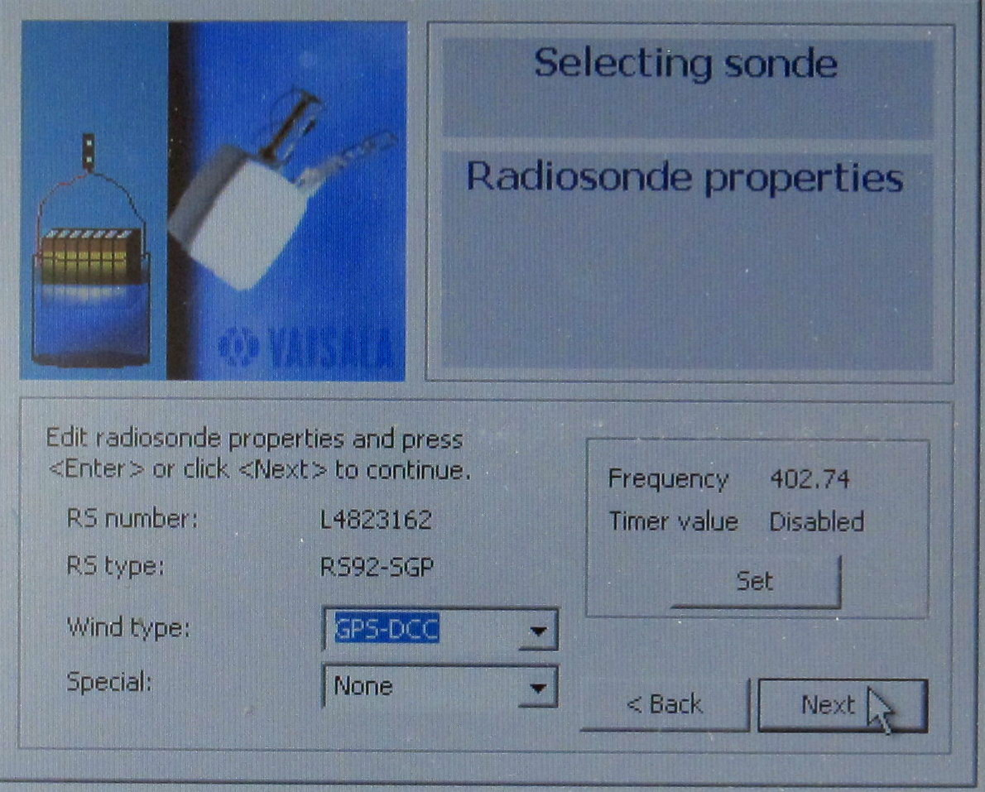
Figure 5

The Digicora will display the sonde properties as shown in figure 5. The frequency shown is a default telemetry frequency which may vary from sonde to sonde. Unless the launch is happening a long way (ca 300 km) from a land-based met station, the frequency should be edited (click Set). The timer value should be left at “disabled” which in the next window (figure 6) is the same as “0”.

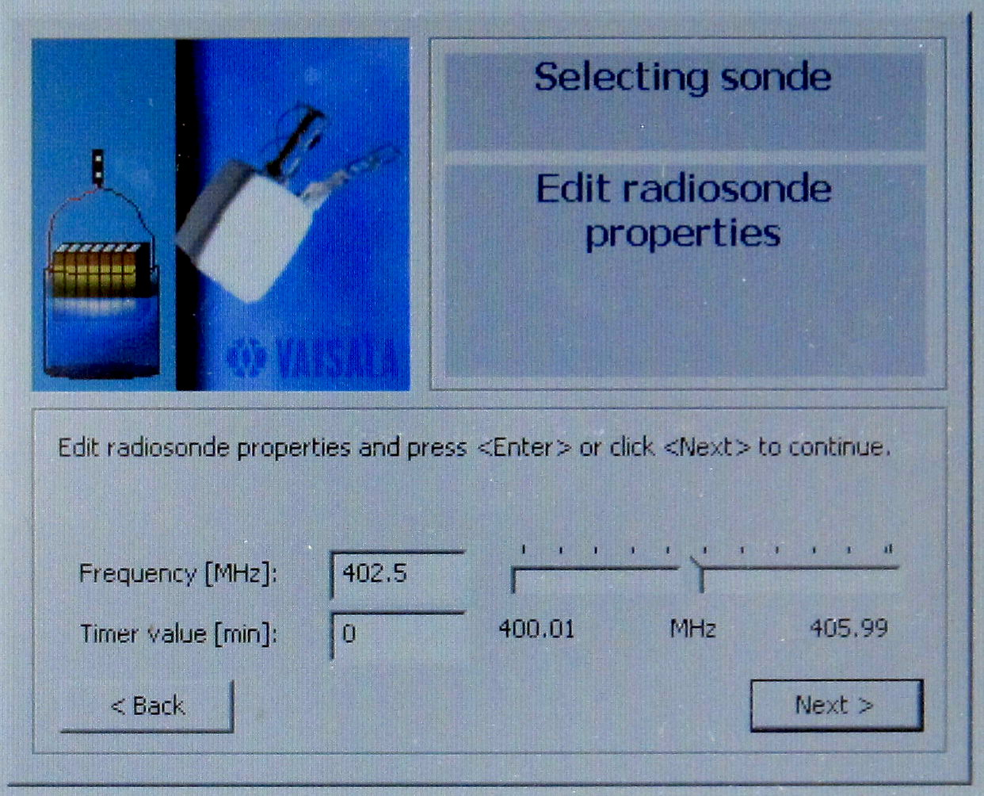
Figure 6

A suitable frequency for Australian waters is 402.5 MHz as this is a standard one used by the BoM, but is not often used, being the third of three standard frequencies, and is used when multiple sonde launches happen, or as a last resort when launches are aborted and re-launches occur. Note that frequencies above 403 MHz should not be used, as 403 – 406 MHz is a band used by emergency services in Australia.
After clicking Next in the screen shown by figure 6, the same screen as in figure 5 appears, but showing the reset frequency. Now click “Next”.

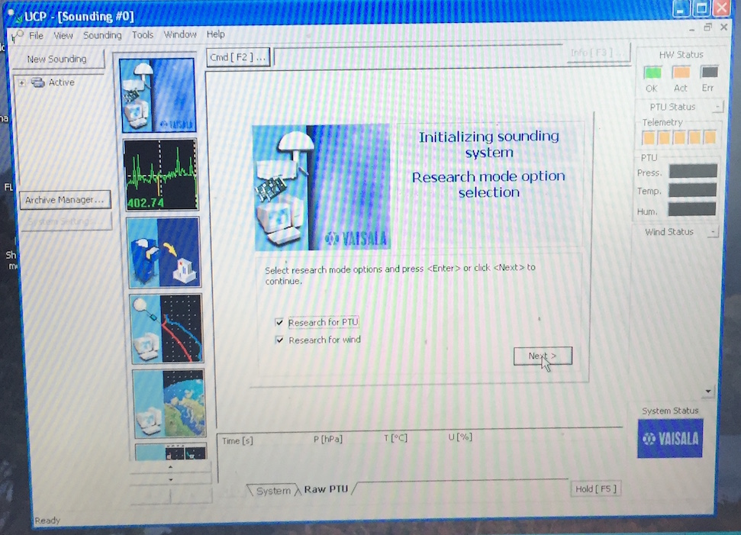
Figure 7

- Select “research for PTU” and “research for wind” , then click “Next” as in figure 7

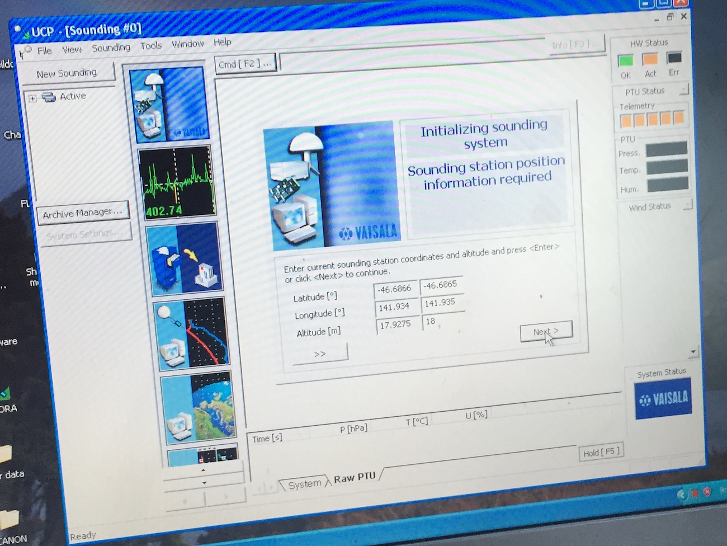
Figure 8

- Now the displayed screen is as in Fig. 8, and looking for lat/lon from GPS (in Digicora, not sonde!)
- When system has found lat/lon/alt confirm or correct these – note that the bridge is 26 m above sea level, so we add 3m for the bench in the observation deck, but I think that we should also add 1.5 m to include the height of the GPS antenna above the bench)
- Click “Next”

- On next window leave “manual” ticked, and click “Next”

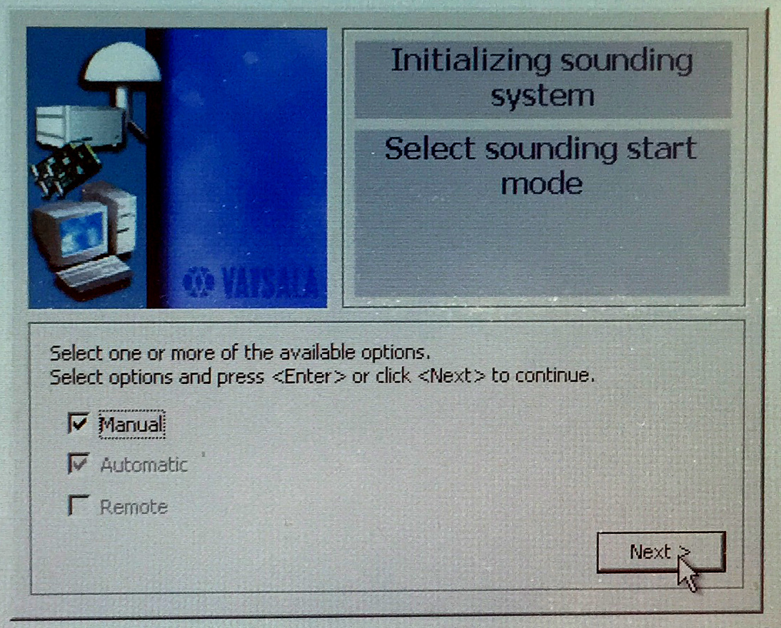
Figure 9

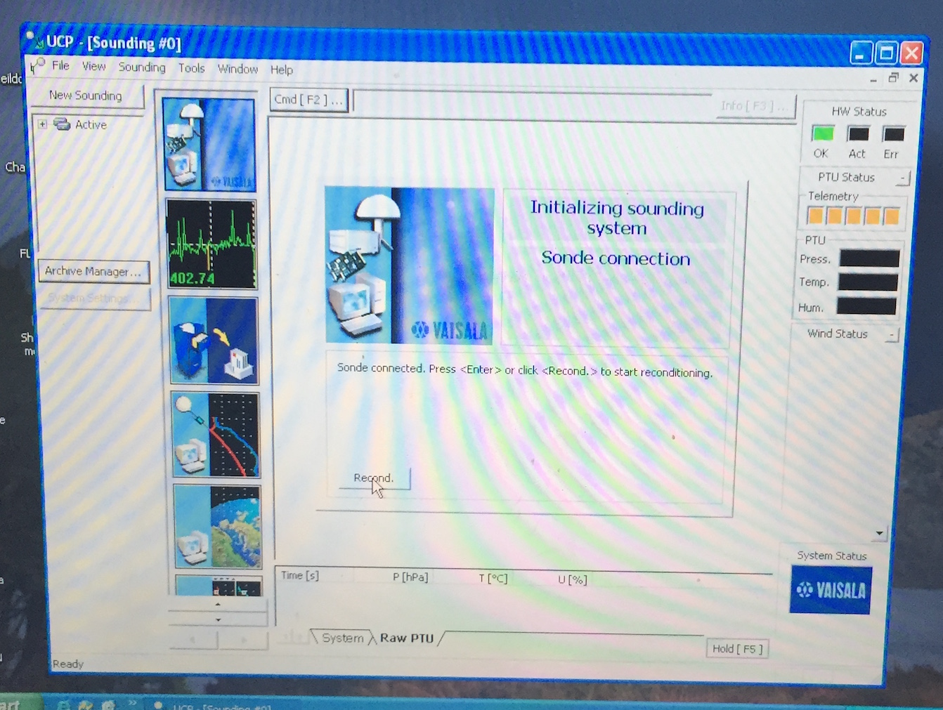
Figure 10

- On next window click “recond” – the system will respond with “sonde connected” – just click “recond” again.
- Wait 3 min for reconditioning and then 2 min for stabilization – both stages display a countdown – see Figs 7 and 8.

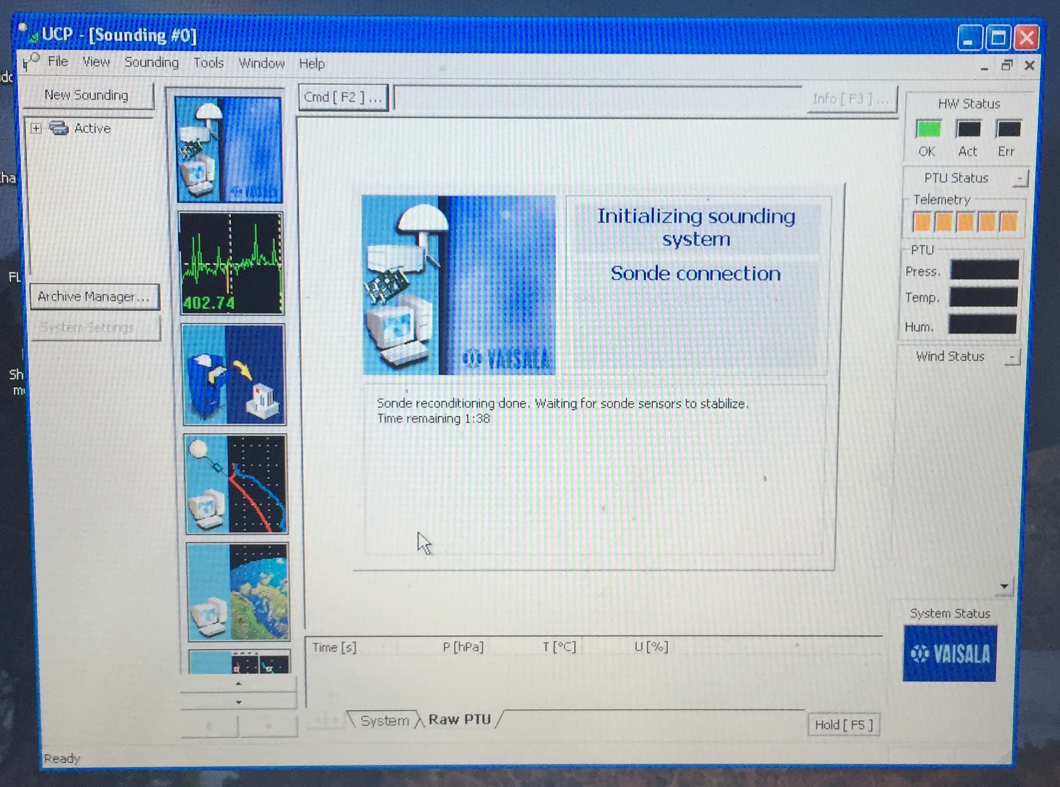
Figure 11

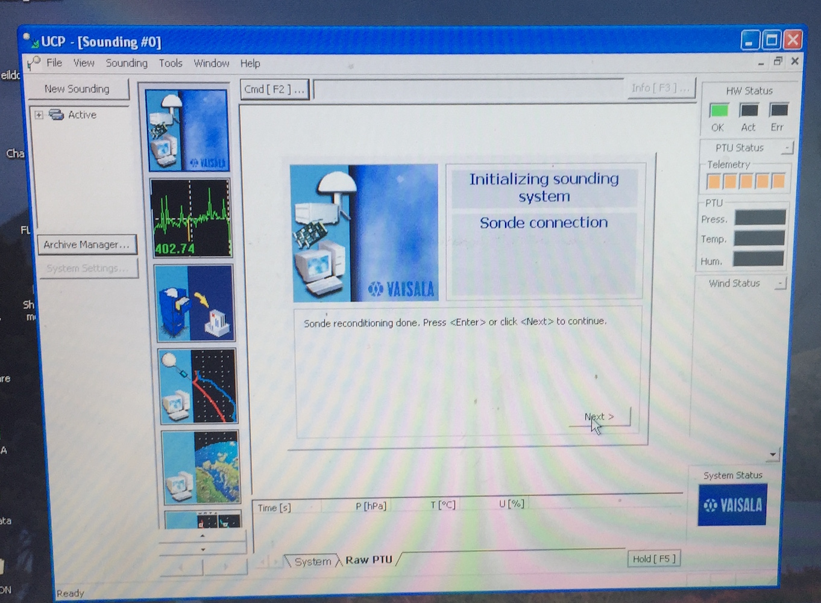
Figure 12

- When this is finished, click “Next”
- Sonde initialization takes place now – wait …

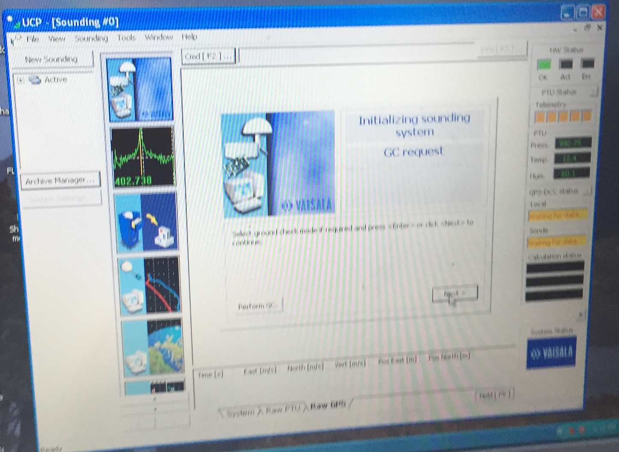
Figure 13

- When the Digicora window says “Select ground check if required” (see Figure 9) click “perform GC”.
- The window will display raw data from the sensors, initially with two humidity values U1 and U2. Wait for a short while until this changes to just one humidity value. Then enter the numbers shown in the window into the boxes provided.
- Then “Next”.

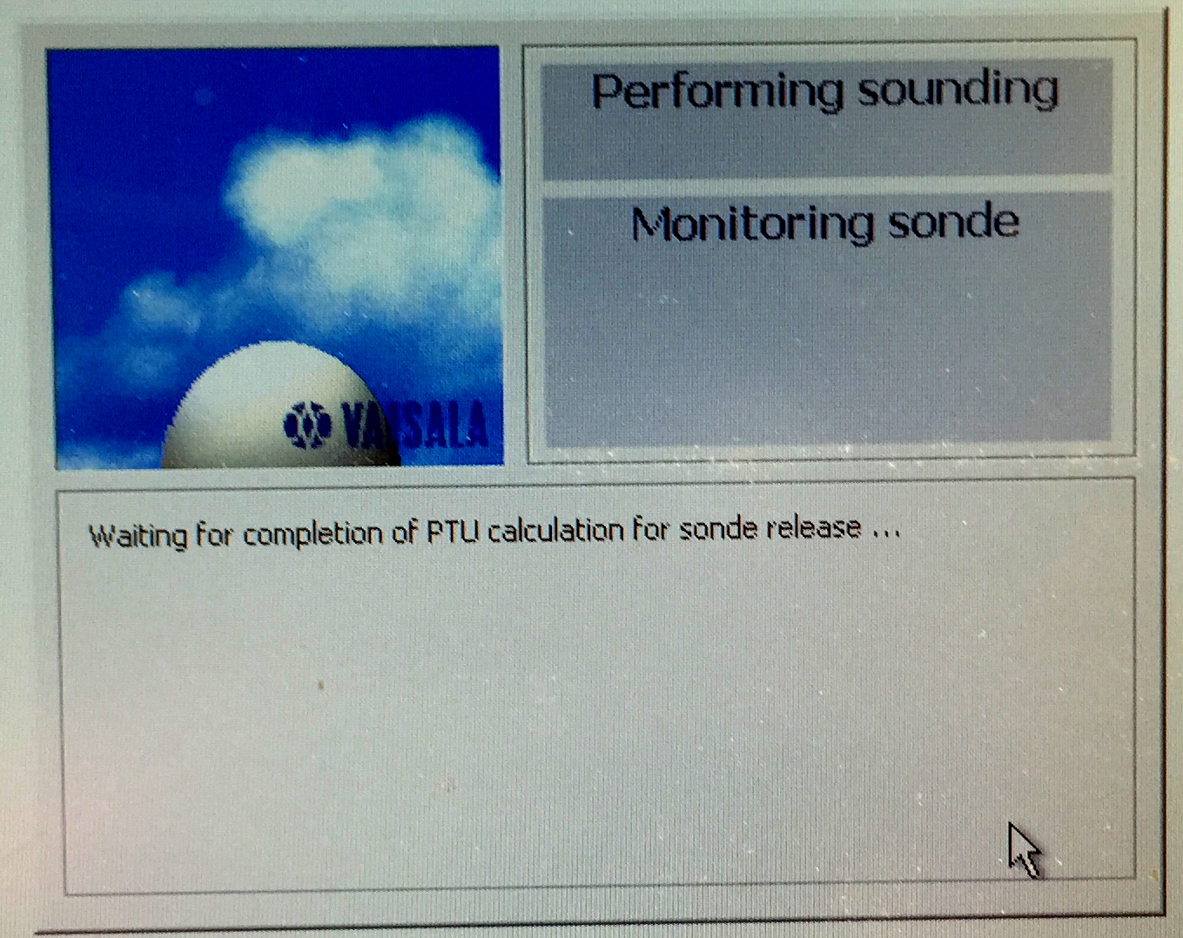
Figure 14

- System will say ready for sonde release – click on “surface obs”

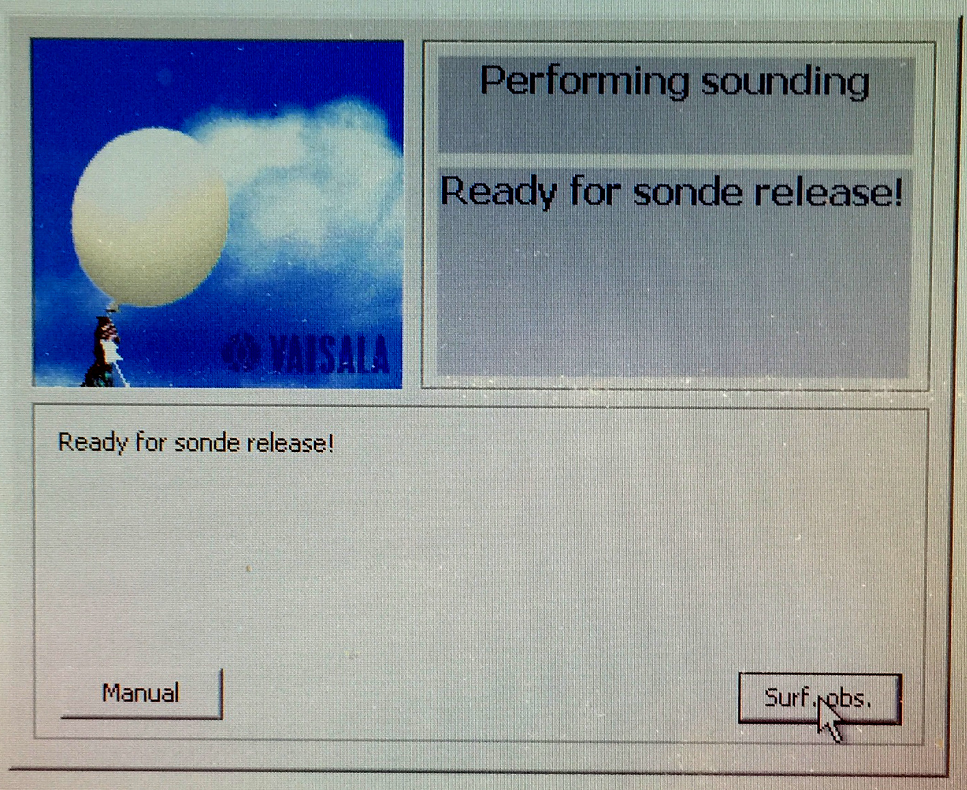
Figure 15

- enter surface observations and click “Next” – see Fig 10.

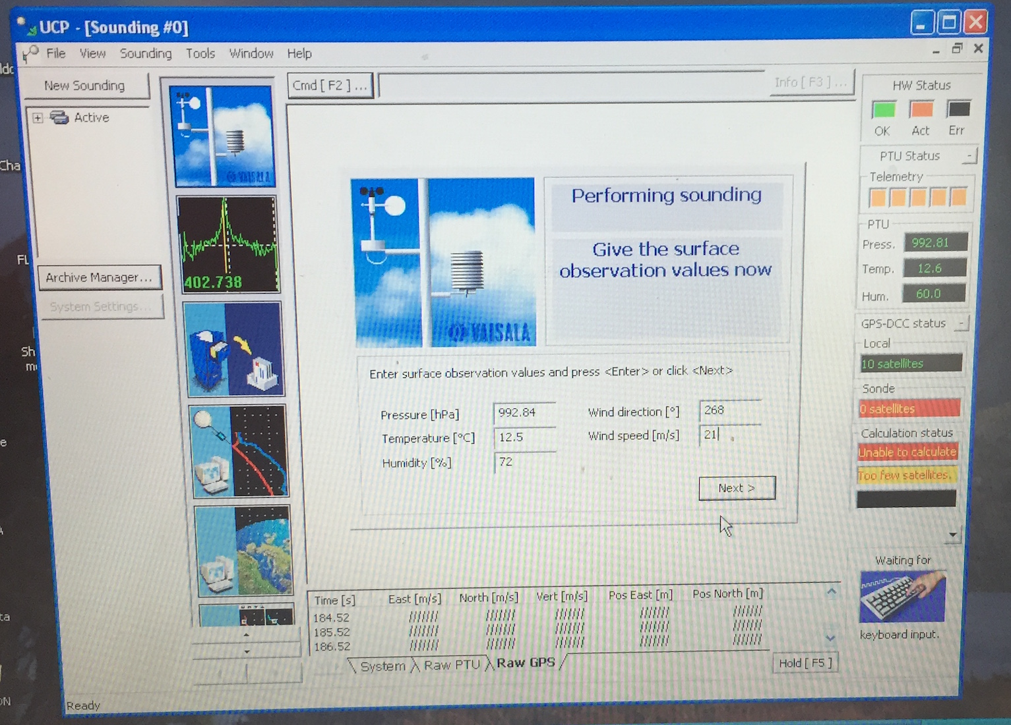
Figure 16

- Click “Next”

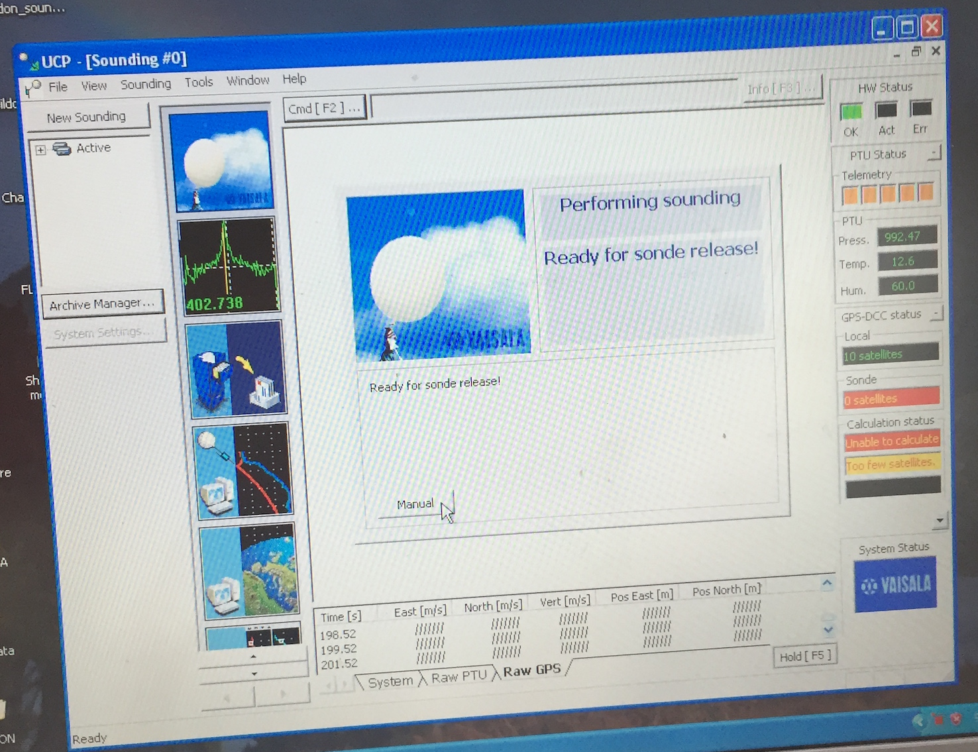
Figure 17

- Click “Manual on next screen (Figure 11)

- Remove sonde from GC25, and connect Battery Pack.
- If battery pack has red button, push it to turn on battery power to sonde – green light should appear.
- Place sonde on window sill – preferably propped up so that the GPS antenna is pointing at least somewhat upward.
- Monitor the telemetry signal strength (should have 5 orange squares), and whether the sonde can see GPS satellites – from this position at least one satellite should be “visible”

- When these conditions are met, sonde can be taken down to the Sheltered Science Area for attachment to balloon.

Termination of the sounding

This is done manually.
Click on button Cmd[F2] at top left.
Then Manual stop.
Termination will take some time, involving a couple of confirmatory clicks of the “Next” button

