**Computation of Air-sea fluxes in Six Atmospheric Rivers over the Northeast Pacific using Dropsonde Observations**

C.W. Fairall1, B. Blomquist2, Chelle Gentemann3, F. M. Ralph4, R. Spackman5, J. Intrieri1, and A.B. White1

Atmospheric Rivers (AR’s) play a dominant role in variability of precipitation on the US W. Coast. A major AR study field effort with three research aircraft and the ship RV Ron Brown are committed to a campaign in January–February 2015. In this paper we report on an ”early-start” deployment of the NOAA G-IV aircraft to evaluate observation strategies. In February 2014 the NOAA G-IV research aircraft sampled 10 ARs over the northeast Pacific Ocean. On six of these flights (Feb 08, 11, 12, 13, 18, 21) dropsondes were deployed in a line crossing an AR. The sonde profiles yield gradients of wind speed, potential temperature, and water vapor mixing ratio in the surface layer over the ocean. Surface fluxes can be estimated from these gradients. If sea surface temperature (SST) is available, fluxes can also be computed using a bulk-flux algorithm. Conventional atmospheric sondes do not measure SST, but we developed a method to estimate SST by extrapolating the gradient to the surface. This was effective for temperature and water vapor profiles. A short iteration yielded reasonable estimates of SST and fluxes of momentum, sensible, and latent heat. The SST values were compared to satellite values. Five different satellite products were used; a single satellite estimate was created as the median of these five. Standard deviation (std) of the five satellite estimates at each location is about 0.5 C. A grand comparison of satellite and sonde SST estimates for the six flights was made. For a total of 134 locations, the mean of Sonde-Satellite SST is about 0.10 C (std 0.76 C, correlation coefficient 0.983). For SST deduced from the humidity profile, the mean difference is -0.08 C (std 1.26, correlation 0.953). Surface fluxes were small: sensible heat flux was typically negative (mean -9.0 W/m2) and latent heat flux positive or negative (mean 17 W/m2). This implies that the bottom of the AR loses some heat to the surface and gains water vapor only modestly as it goes from the tropics to the W. Coast. Because of the stratified surface layer, the AR is decoupled from the surface.

In this paper we report on an early-start deployment of the NOAA G-IV aircraft conducted in February 2014. The NOAA G-IV research aircraft sampled 10 ARs over the northeast Pacific Ocean. On six of these flights (Feb 08, 11, 12, 13, 18, 21) dropsondes were deployed in a line crossing the AR so as to robustly sample the atmospheric structure. An example of an AR is shown in model precipitation output in Fig. 1; the footprint of sonde drops on this day is shown in Fig. 2. A cross section of meteorological parameters as a function of latitude is shown in Fig. 3. The peak water vapor transport in the AR is at about 40 deg latitude.; the surface wind maximum is about 20 m/s at 46 deg. The sonde profiles yield gradients of wind speed, potential temperature, and water vapor mixing ratio in the surface layer over the ocean (see Fig. 4 for an example of profiles in the 100 m closest to the ocean).

Surface fluxes can be estimated from these gradients. If sea surface temperature (SST) is available, fluxes can also be computed using a bulk-flux algorithm. Conventional atmospheric sondes do not measure SST, but we developed a method to estimate SST by extrapolating the gradient to the surface. This was effective for temperature and water vapor profiles. A short iteration yielded reasonable estimates of SST and fluxes of momentum, sensible, and latent heat. The SST values were compared to satellite values. Five different satellite products were used: microwave, AMSR, wsat, TMI, and MODIS. A single satellite estimate was created as the median of these five. Standard deviation (std) of the five satellite estimates at each location is about 0.5 C. Details follow.

Surface turbulent fluxes in the surface layer are related to profiles of the mean variables through standard Monin-Obukhov (MO) similarity theory via

 (1)

Here *x* denotes the variable *u*, θ, *q*; *X(z)* is the height-dependent mean of *x*, *x\** is the scaling parameter for *x*, *z0x* the surface roughness length, ψ the MO profile function, and L the MO stability length. The scaling parameters are related to the surface values of the turbulent fluxes

 (2)

where  is the friction velocity and  is the turbulent stress on the sea surface. The sensible and latent heat fluxes are given by

 (3)

Equation (1) forms the basis for bulk-flux computation methods

 (4)

Where *Cx* is the bulk transfer coefficient for *x*, *S* is the mean wind speed, *Xs* the value of *X* at the air-ocean interface, and *zr* a reference height where a measurement of *X* is obtained. For temperature, *Xs* is the sea surface temperature (SST); for humidity *Xs*=*qsat*(SST) where *qsat* is the saturation vapor pressure for seawater. Comparing (1) and (4) it is clear that *Cx* is related to the roughness length, *zr*, and stability.

We use the COARE flux parameterization (version 3.0, Fairall et al. 2003) for specification of *Cx*. For x=u, *Cx* is conventially designated as *Cd* and is referred to as the drag coefficient. The drag coefficient has a wind-speed dependence – increasing from 1E-3 at *U10*=5 ms/ to about 2.0E-3 at *U10*=20 m/s; the coefficients for heat and mositure are roughly 1E-3. Computation of fluxes via (4) requires specification of wind speed, potential temperature, and specific humidity at the reference level and the surface. However, the surface current is usually negligible compared to the wind speed so and the surface specific humidity can be calculated from SST. Thus, SST is the critical surface value that is required to compute surface fluxes via (4). Equation (1) suggests that near the surface the profile of *X* will have a log-dependence on *z*. Thus, we can fit *X* to the form

 (5)

where Γ is *dX/dlog(z)*. In Fig. 4 we can see such a linear fit to the profile in the lowest 50 m (note, in Fig. 4 the parameters of the fit are done with *log10(z)*). From the coefficients given, it is simple to estimate the surface value using an estimate of the surface roughness. For moisture and temperature, *z0* is on the order of 1E-4 m, so

 (6)

where the 10 implies the gradient is computed in log10(z).

MO theory also allows us to compute the fluxes without determining a value for SST. This is done by taking the vertical derivative of (1) to eliminate *Xs*:

 (7)

Here φ is the MO gradient function (related to the derivative of the ψ function). Thus, the flux is

 (8)

Finally, (6) provides a reasonable estimate of SST in near-neutral conditions but there may be stability effects that cause a bias. So, a more accurate estimate of SST from the gradient can be obtained combining (8) and (1)

 (9)

Here the factor 0.4343 is log10(e) and

 (10)

with the values being provided from the COARE algorithm.

The procedure for estimating the flux from a given profile involves 4 steps.

1: Equation (6) is used to estimate θs=SST and *qs* and the bulk fluxes are computed with the COARE algorithm via (4) with mean values at *zr*=20 m computed from the linear fit. This provides values for *u\**, *z/L*, etc.

2: Gradient fluxes are computed via (8). New estimates of SST and *qs* are computed via (9).

3: Bulk fluxes are re-computed with the new SST’s.

4: Gradient fluxes are re-computed via (8). New estimates of SST and *qs* are computed via (9).

Notice that this yields an estimate of SST from the temperature profile and from the humidity profile, SSTq=Tdew(*qs*) and estimates of the flux from the gradient and the bulk methods.

In Fig. 5 the results for the SST determination are shown for the data from Feb 13, 2014. Values from SST, SSTq, and satellite SST are given. In Fig. 6 the sensible and latent heat fluxes from bulk and gradient methods are compared. Because SST from the temperature gradient is used in the bulk calculation, the comparison for sensible heat flux is very good. This just shows the consistency of the MO similarity relationships. The greater scatter for latent heat occurs because the surface values deduced from the moisture profile are inconsistent with those deduced from the temperature profile – a result principally of the inherent uncertainty in the temperature and humidity sensors on the sonde and the limited similarity mositure and temperature profiles.

A grand comparison of satellite and sonde SST estimates for the six flights is shown in Figs. 7 and 8. For a total of 134 locations, the mean of SST- SSTsat is about 0.10 C and the standard deviation (STD) of SST-SSTsat is about 0.76 C; the correlation coefficient is 0.983. For SST deduced from the humidity profile, the mean of SST-SSTq is -0.08 C, the STD is 1.26 C, and the correlation is 0.953. The comparison with satellite SST suggest that a single sonde gradient SST has a random uncertainty of about 0.6 C white SSTq is uncertain by 1.1 C (with perhaps a small bias). The uncertainty in air-sea fluxes is more difficult to estimate. The COARE3.0 algorithm is considered unbiased to about 5% for *Hs* and *Hl* in the wind speed range 0-20 m/s (Fairall et al. 2003) but the uncertainty in the derived fluxes depends on the errors in the mean values input to the algorithm. A 1 m/s error in wind speed changes mean sensible heat flux by 1 W/m2 and mean latent heat flux by 2 W/m2. A 0.5 C error in SST changes *Hs* by 6 W/m2 and *Hl* by 10 W/m2. An error of 0.25 C air temperature (sonde specification) changes *Hs* by 3 W/m2 and a 2.5% error in humidity (sonde specification) changes *Hl* by 8 W/m2. Combining these errors yields an uncertainty of *Hs* of 7 W/m2 and *Hl* by 13 W/m2 – dominated by the error in SST.

Scatter between gradient and bulk methods for each sonde is 2.2 W/m2 compared to a mean value of -9 W/m2 for sensible and 27 W/m2 compared to a mean of 17 W/m2 for latent heat. Mean bias between gradient and bulk methods is small for sensible heat flux. Because the gradient method is less sensitive offsets in humidity, it is likely the gradient latent heat flux is better estimate than the bulk, but this cannot be quantified without more information or comparison with direct surface observations. The large disagreement between gradient and bulk latent heat fluxes cannot be reconciled with the expected accuracy of the sondes. Perhaps relative humidity accuracy is not 2.5% or there are other sources of error. For example, the response time of the sensors may affect the gradient estimates. So for now, we are treating the gradient and bulk estimates as equally valid and have computed a final flux estimate as the mean of both. Summary values are given in Table 1. An example for the flight on Feb 13, 2014 is shown in Fig. 9. Wind speed peaks at close to 20 m/s. Air temperature is slightly warmer than SST and air humidity is slightly less than SSq. In the heart of the AR sensible is about -35 W/m2 and latent heat flux is 0-20 W/m2.

The sonde data are available at <ftp://ftp1.esrl.noaa.gov/psd3/cruises/CalWater2/GIV/> ; the analysis discussed in this report is available at <ftp://ftp1.esrl.noaa.gov/psd3/cruises/CalWater2/GIV/Analysis/> .

REFERENCES

Fairall, C. W., E. F. Bradley, J. E. Hare, A. A. Grachev, and J. B. Edson, 2003: Bulk parameterization of air-sea fluxes: Updates and verification for the COARE algorithm. *J. Clim.*, **16**, 571-591.

Gentemann, Chelle L., 2014: Three way validartion of MODIS and AMSR-E sea surface tempreatures. *J. Geophys. Res. Oceans*, **119**, 2583–2598, doi:10.1002/

2013JC009716.

|  |  |  |  |  |  |  |
| --- | --- | --- | --- | --- | --- | --- |
| Table 1. Catalog mean values of meteorological data from six Pre-Calwater2 NOAA G-IV flights analyzed in this paper. | | | | | | |
| **Flight** | Feb08 | Feb11 | Feb 12 | Feb13 | Feb18 | Feb21 |
| **#Sondes** | 29 | 36 | 15 | 23 | 14 | 17 |
| **Min Lat (deg)** | 28.0 | 37.3 | 37.0 | 34.1 | 24.46 | 27.94 |
| **Max Lat (deg)** | 37.14 | 47.55 | 45.07 | 49.1 | 30.50 | 53.15 |
| **Min Lon (deg)** | -140.62 | -134.27 | -125.66 | -138.98 | -164.93 | -160.08 |
| **Max Lon (deg)** | -131.79 | -129.58 | -123.84 | -129.37 | -142.90 | -146.92 |
| **SST (C )** | 17.37 | 12.53 | 10.29 | 12.54 | 20.14 | 13.21 |
| **SST Sat (C )** | 17.57 | 12.41 | 10.68 | 12.63 | 20.38 | 13.00 |
| **U10 (m/s)** | 8.9 | 14.3 | 7.1 | 11.4 | 6.5 | 9.1 |
| **TH10 (C )** | 17.69 | 13.24 | 11.12 | 13.13 | 20.08 | 13.87 |
| **Q10(g/kg)** | 11.26 | 8.84 | 7.85 | 8.75 | 12.78 | 9.65 |
| **Hs (W/m2)** | -8.9 | -27.7 | -17.6 | -18.0 | -0.1 | -16.2 |
| **Hl (W/m2)** | 24.8 | 13.2 | -1.8 | 11.9 | 32.8 | 7.0 |
| **u* (m/s)** | 0.31 | 0.57 | 0.25 | 0.44 | 0.20 | 0.31 |

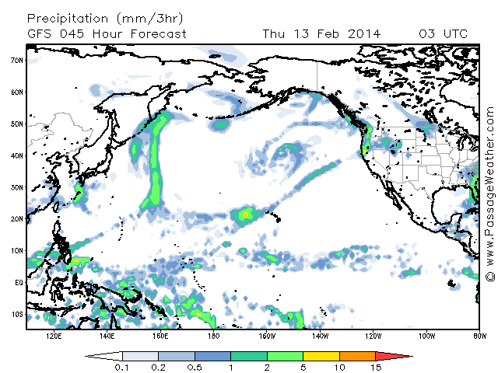

Figure 1. Sample structure of AR indicated by map of forecast precipitation. In this case an AR is present from Hawaii to N. California.

48

46

44

42

40

38

36

-138

-136

-134

-132

-130

Figure 2. Dropsonde locations for Feb. 13, 2014.

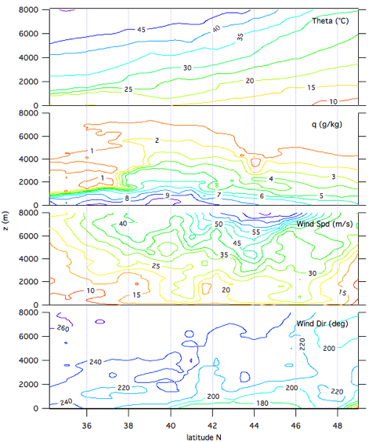

Figure 3. Latitude –height cross section of potential temperature (top panel), specific humidity (2nd panel), wind speed (3rd panel), and wind direction (bottom panel) for Feb 13, 20014 flight.

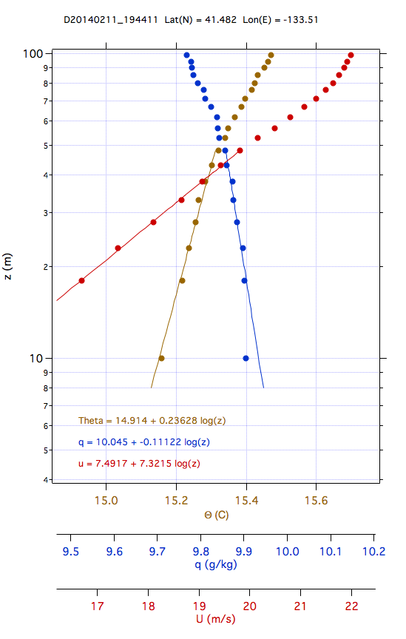

Figure 4. Sample profile from one dropsonde on Feb. 11, 2014: 41.482 latitude and -133.51 longitude. Profiles of potential temperature (Theta), specific humidity (q), and wind speed (u) are shown. Regression fits to log10(altitude) are indicated by the lines. The bottom of the graph shows the coefficients for the linear fits of the varibles to log10(z).



Figure 5. Sample grapgh of SST as a function of Latitude on Feb. 13, 2014. SST as deduced from the sonde temperature gradient (solid line), the moisture gradient (dashed line), satellite observations (diamond), and a combined bulk algortihm/gradient value.

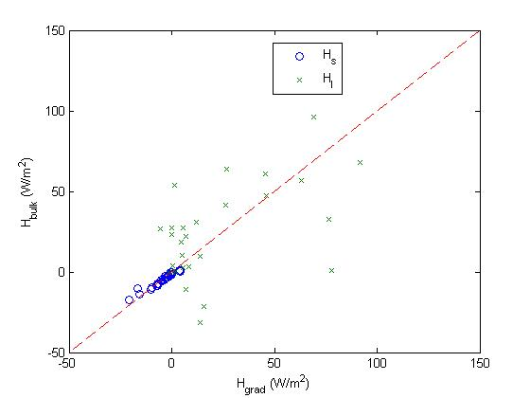

Figure 6. Comparison of heat fluxes computed via the bulk vs the gradient methods for Feb. 8, 2014. In this case SST is from the temperature profile.



Figure 7. Ensemble graph of SST vs latitude from all six flights.



Figure 8. Linear fit of ensemble SST data (satellite vs sonde values) from all six flights.

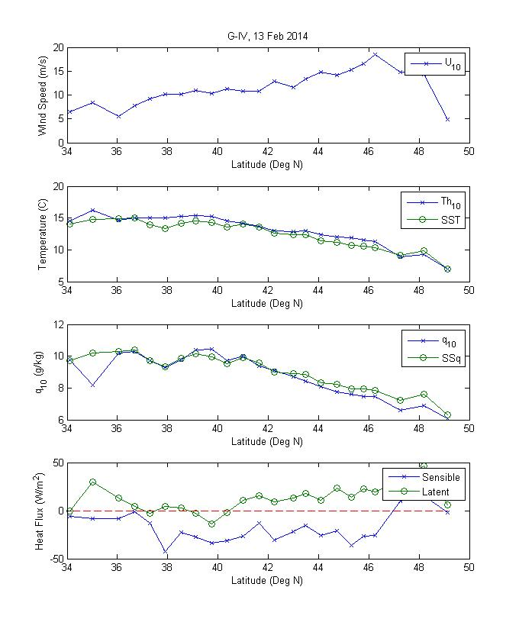

Figure 9. Bulk meteorology and heat fluxes as a function of latitude from sondes dropped on Feb 13, 2014. Wind speed (upper panel), air temperature and SST (2nd panel), air specific humidity and SSq (3rd panel), sensible and latent heat flux (bottom panel).