2008 SO GaxEx cruise report
Field Program on the NOAA Research Vessel Ronald H. Brown
February 29 – April 10, 2008
Results from the PSD Flux Group

Ludovic Bariteau, C. W. Fairall, Sergio Pezoa, Daniel E. Wolfe
NOAA Earth System Research Laboratory
Boulder, CO USA
April 10, 2008

The Physical Science Division (PSD) air-sea flux group conducted measurements of fluxes and near-surface bulk meteorology in the Southern Ocean at 50 S Latitude 40 W Longitude. The flux system was installed initially on the Ronald H. Brown (RHB) in Charleston, SC, in early October 2007. Then it was used during the fall for STRATUS 2007 off the coast of South America (20S, 85W). Finally, it was tested and brought back into full operation in Punta Arenas, Chile, in late February, 2008. The official start of the GASEX III experiment and data collection was around 1600 UTC February 29, 2008 (JD 61). We arrived on the study site station on day65 (March 5, 2008). The first tracer patch survey was from JD 68 to 73 (March 8 to March 13, 2008), and the second patch period was from JD 81 to 96 (March 21 to April 5, 2008). At about 1400 UTC on day 96 (April 5, 2008), the RHB departed the site to begin its transit to Montevideo, Uruguay.

1. Background on Measurement Systems 3
1.1. Flux system 3
1.2. CO2 flux measurements 4
1.3. Aerosol and sea spray measurements 5
1.4. Fast ozone system 5
1.5. SeaSpace system 5
2. Selected Samples 6
2.1. Basic Flux Data 6
2.2. Remote Sensing Data 7
2.3. CO2 data 7
3. Cruise Summary Results 8
3.1. Basic Time Series 8
3.2. Aerosol 9
3.3. Ozone data 9
4. Intercomparisons 9
4.1. PSD-Ship Comparisons 10
4.2. CO2 Comparisons 10
5. PSD Data Cruise Archive 11
6. Contact 11

Figures 12 to 27

- Background on Measurement Systems

  - Flux system

The PSD air-sea flux system consists of six components: (1) a fast turbulence system with ship motion corrections mounted on the jackstaff. The jackstaff sensors are: GILL Sonic anemometer, Fast Ozone Sensor’s inlet, LiCors LI-7500 fast CO₂/hygrometer, and a Systron-Donner motion-pak. (2) A mean T/RH sensor in an aspirator on the jackstaff. (3) Solar and IR radiometers (Eppley pyranometers and pyrgeometers) mounted on top of wood pole on the 02 deck. (4) A near surface sea surface temperature sensor consisting of a floating thermistor deployed off port side with outrigger. (5) A Riegl laser rangefinder wave gauge mounted on the bow tower. (6) An optical rain gauge mounted on the bow tower.
Slow mean data (T/RH, PIR/PSP, etc) are digitized on a Campbell 23x datalogger and transmitted via RS-232 as 1-minute averages. A central data acquisition computer logs continuously all sources of data via RS-232 digital transmission and wireless radio modem network:
- Sonic Anemometer
- 5 Licors 7500, CO2/H2O (3 from university of Connecticut, see section 1.2)
- Slow means (Campbell 23x)
- Laser wave sensor
- Fast ozone sensor
- Systron-Donner Motion-Pak
- Ship’s Computer System
- GPS
- Heading system (Crescent VS100)
- CLASP from University of Leeds

The 14 data sources are archived at full time resolution. At sea we run a set of programs each day for preliminary data analysis and quality control. As part of this process, we produce a quick-look ASCII file that is a summary of fluxes and means. The data in this file come from three sources: The PSD sonic anemometer (acquired at 10 Hz), the Ship’s Computer System (SCS) (acquired at 0.5 Hz), and the PSD mean measurement systems (sampled at 0.1 Hz and averaged to 1 min). The sonic is 5 channels of data; the SCS file is 17 channels, and the PSD mean system is 77 channels. A series of programs are run that read these data files, decode them, and write daily text files at 1 min time resolution. A second set of programs reads the daily 1-min text files; time matches the three data sources, averages them to 5 and 30 minutes, computes fluxes, and writes new daily flux files. The 5 and 30-min daily flux files have been combined into files flux_5hf_GasexIII_08.txt and flux_30hf_GasexIII_08.txt. The 1-min daily ASCII files are also concatenated as proc_nam_DDD.txt (nam=’pc’, ‘scs’, or ‘son’; DDD=yearday where 000 GMT January 1, 2008 =1.00). File structure is described in the readme accompanying these files.

  - CO2 flux measurements

In collaboration with University of Connecticut (UConn) and Lamont-Doherty Earth Observatory (LDEO), numerous atmospheric CO2 measurements have been done on this cruise. There are five LI-7500’s up on the foremast: three of them are open (two are attached together and one is sleeved in a metal frame to reduce the vibration effects). One Licor is the sample (in a tube with strong ventilation), and one is the null (in a tube with weak ventilation through a mixing volume). All the units, except the null one, are washed regularly in order to remove any sources of contaminations.
Three Licors 6262 from LDEO are also deployed for this experiment. These sensors are setup in the University of Hawaii’s seatainer on the 02 deck. The sampling inlets are located on the foremast at the same location as the 7500 Licors.
Our central data acquisition computer was logging the three opened Licors from University of Connecticut through a signal splitting box.

  - Aerosol and sea spray measurements

Atmospheric aerosols were measured with a Particle Measurement Systems (PMS) Lasair-II aerosol spectrometer. The Lasair-II draws air through an intake and uses scatter of laser light from individual particles to determine the size. Particles are counted in six size bins: 0.1-0.2, 0.2-0.3, 0.3-0.5, 0.5-1, 1-5, and greater than 5.0 μm diameters. The PSD system was mounted in the University of Hawaii’s seatainer on the 02 deck with the intake on the upwind side of the container. The system ran at 1.0 cfm (0.028 m³/min) sample volume flow rate with a count deconcentrator that reduces the counts a factor of 10 (to prevent coincidence errors).
Another aerosol instrument from University of Leeds was deployed on the foremast, near the sonic anemometer. This Compact Lightweight Aerosol Spectrometer Probe (CLASP) is used to make high frequency measurements of aerosol spectra suitable for direct eddy correlation determination of the sea spray particle flux. This device is capable of measuring 8-channel size spectra for mean radii between 0.15 and 3.5 µm at 10 Hz.

  - Fast ozone system

Ozone concentration was also present in the standard ESRL flux package. The first-ever direct eddy correlation (EC) measurements of ozone flux from the ship. This fast ozone sensor was designed in Boulder as a collaborative effort between NOAA and INSTAAR to help understand more about the destruction of ozone at the oceans surface. This sensor was setup in the University of Hawaii’s seatainer on the 02 deck. A sampling line runs to the jackstaff with the sampling inlet near the sonic anemometer. Two additional slow ozone monitors were used as well for calibration purposes and low frequency measurement.

  - SeaSpace system

A SeaSpace satellite receiver was operational for GasExIII 2008 and collected Quicklook images from NOAA’s polar orbiting satellites (15, 17, and 18) were archived along with the flux data (Fig. 24).
- Selected Samples

  - Basic Flux Data

Preliminary flux data is shown for Julian Day = 85 (March 25, 2008) as the RHB remains on the study site to survey the patch at 51.3 S 37.7 W (Fig. 1). During this day, a series of light rain events occurred (Fig. 2). These were accompanied by increasing humidity (Fig.3) and wind speed (Fig. 5). The time series of ocean and air temperature is given in Fig. 4. The water temperature is constant over the day around 5.1C, while the air temperature increases significantly from 3.5C to 6.5C. The air-sea temperature difference varies considerably, reflected in variability of the turbulent heat fluxes (Fig.9). True wind direction (Fig. 6) suggests some most air coming from the North-West. The effect of clouds on the downward solar flux is shown in Fig. 7 and on the IR flux in Fig. 8 from both the flux and ship sensors. Modeled clear sky values are shown in each figure for reference. The solar trace indicates considerable cloudiness during the day. The solar energy peaks only at 100 Wm⁻² whereas the clear sky modal suggest a peak value around 600 Wm⁻² (values measured during sunny days). For IR flux, the cloudy skies values ranges from 310 Wm⁻² to 350 Wm⁻² over the day. Clear skies values range from 240 Wm⁻² to 265 Wm⁻².
Fig. 9 shows the time series of four of the five primary components of the surface heat balance of the ocean (solar flux is left out). The largest term is the latent heat (evaporation) flux, followed by the net IR flux (downward minus upward plus), the sensible heat flux and the precipitation flux. We are using the oceanographic sign convention (+ for warming of the ocean) for the turbulent fluxes so in that case all three fluxes actually cool the interface over the night and warm it up during the rest of the day. The time series of net heat flux to the ocean is shown in Fig. 10. The sum of the components in Fig. 9 is about -141 Wm⁻², which can be seen in the night time trace of the net heat flux; the positive peak during the day is due to the solar flux, which was low during this cloudy day. The integral over the entire day gives an average flux of 17 Wm⁻², indicating warming of the ocean mixed layer.

  - Remote Sensing Data

A sample time series from the laser wave gauge is shown in Fig. 11. This device measures the range from a point on the mast to a point on the ocean. The distance includes the motions of the sea surface (waves) plus motion of the ship up and down relative to mean sea level. A simple motion correction (heave) has been applied to the time series on Fig. 11. Comparison with the TSKA Wave Height Sensor and the WaMoS® II from LDEO have been attempted but no conclusions yet This comparison shows that all systems seem to match during periods when the ship is stationary and heading into the wind. A closer look to this wave correction must be done.

  - CO2 data

The sample/null system is an approach for a more robust and weatherproof CO2 measurements. To illustrate this system, figures 12 and 13 show comparisons of CO2 and H2O from the different sensors on Julian Day 86 (March 26, 2008), hour 12. Through the day, we experienced diverse rain events. The three open path Licors were totally out of range, whereas the sample unit was still performing reasonably. On the other hand, when the weather conditions are better, we can get fine agreement with the open path units. As an example, figures 14 and 15 present 28min time series of CO2 and H2O for Julian Day 87 (March 27, 2008), hour 23.
On figure 14, we can observe that each unit has a different reading for CO2. The zero and span on the Licors 6262 have been controlled regularly, but at the end they always seem to read different CO2 concentrations. On the contrary, the water vapor reading of the 6262 is in good agreement with our Vaisala sensor (Fig. 15). The same observation can be made for the three open Licors 7500, even though their water vapor mean is a bit lower than the 6262. The sample and null units give also reasonable values. Nevertheless, the sample CO2 measurement is a bit to low compare to the underway system of the ship (Fig. 14), and both water vapor readings are a bit too high (Fig. 15).
All of this illustrates that rigorous analysis on each sensor will be needed in order to get good CO2 and H2O fluxes.

- Cruise Summary Results

  - Basic Time Series

The ship track for the entire cruise is shown in Fig. 16. A closer look on the ship track around the patches is presented in Fig 17. The first tracer patch was created at about 50˚ 40’ S Latitude, whereas the second patch was created around 51˚ 10’ S Latitude.
The 5-min average time series of true wind speed, true wind direction (relative to N), air temperature, sea surface temperature, incident shortwave and longwave, relative humidity and atmospheric pressure are shown for March 2nd to April 6th, 2008, in Fig. 18. On this plot, we can see that the sea temperature has been very constant during the two patch surveys. The water temperature is constant around 5.9C for the first patch, while it averaged about 5.2C for the second patch. The decrease in air and sea temperatures between these two periods corresponds to ship’s run near South Georgia Island. The two other drops in air temperatures during the second patch survey were associated with ice (JD 84) and snow (JD 90) events. The change in conditions at the end of the plots is due to the transit to Montevideo.
The resulting bulk air-sea fluxes for March 2nd to April 6th, 2008 are illustrated in Fig. 19. Momentum, sensible and latent heat fluxes are computed using the COARE bulk algorithm version 3.0. The mean net surface heat gain during the studied period was about 42 Wm⁻² (Table 1)

Variable | Mean | Max | Min | Standard deviation
WS (m/s) | 9.46 | 19.86 | 0.03 | 3.50
Tair (C) | 5.53 | 14.58 | 0.01 | 2.48
SST (C) | 5.93 | 14.24 | 2.41 | 1.89
RH (%) | 89.29 | 99.31 | 46.40 | 9.60
Atm Pressure (mb) | 1004.22 | 1023.26 | 980.56 | 10.17
Stress (N. m-2) | 0.16 | 0.83 | 0.00 | 0.13
Hnet (W. m-2) | 41.60 | 708.00 | -414.20 | 166.70
Rs (W. m-2) | 91.48 | 744.07 | -0.30 | 151.81
Rnl (W. m-2) | -27.58 | 28.16 | -116.88 | 32.82
Hsb (W. m-2) | -4.00 | 79.88 | -116.32 | 24.34
Hlb (W. m-2) | -19.50 | 89.68 | -201.55 | 38.19
Table 1. Mean conditions during GasExIII.
  - Aerosol

Data from the PMS Lasair-II aerosol spectrometer is shown in Fig. 20. The instrument size range includes most of the so-called accumulation-mode aerosols that represent most of the particles activated to form droplets in clouds. Thus, the total number of aerosols counted by this device is expected to correlate with cloud condensation nuclei and the number of cloud drops. The Lasair-II only observes the large particle size mode. The concentration varies with a time scale of several days. This is the result of the complex interaction between entrainment, advection, production and scavenging of aerosols. Spikes in the graph are caused by the ship’s exhaust. We can observe that most of the aerosol concentration variation correlates with the variations in the heat fluxes (Fig. 19), especially with the net longwave radiation which is connected to energy emitted from aerosols.

  - Ozone data

Time series of ozone concentration is shown on Fig. 21 for March 2nd to April 6th, 2008. As for the aerosol systems, most of the drops in the signal are caused by the ship’s exhaust. The NO released by the ship interacts with ozone. Some drops are due to lag time testing on the system. All of these bad data points will be removed later during post-processing.
The ambient level of ozone has been pretty low in this part of the ocean. The maximum ozone peak encountered was about 27ppbv on Julian Day 81. An interesting feature is the difference in concentration between the two surveys. During the first patch, the mean ozone concentration was about 15.5 ppbv, whereas it reached a mean level of 20 ppbv for the second survey. A closer look to other parameters will be done in order to understand why.

- Intercomparisons

Intercomparisons are a key strategy in data quality assurance for the climate reference buoys and the use of research vessel measurements for climate-quality data archives. The PSD flux system is intended to produce measurements of turbulent flux bulk variables and radiative fluxes that have the required accuracy for climate research. For this cruise, a set of Intercomparisons were done.
*As our flux system acquired all relevant ship IMET-based measurements, bulk meteorology and radiative fluxes from PSD and ship were compared.
*Sample/null CO2 sensors were compared with the underway system from NOAA AOML and with the systems from University of Connecticut and LDEO.

  - PSD-Ship Comparisons

We compared PSD and ship measurements for wind speed and direction, sea surface and air temperature, relative humidity, and solar and IR downward radiative flux. All measurements agreed within the accuracy required for flux evaluations. The ship wind system does experience flow blockage by the jackstaff for relative winds from the starboard side.

  - CO2 Comparisons

As previously shown on figures 14 and 15, CO2 and H2O from different systems are in reasonable agreement. To verify the coherence between the various systems, we also made some spectral analyses on the CO2 and H2O signals. Figure 22 shows the variance spectra of the water vapor signals. At high frequency, the sample unit spectrum is reduced showing the filter effect of the ventilation. The null spectrum shows that the high frequency atmospheric variations have been removed by the mixing volume. Besides the peak present in the null spectrum is correlated to the ship’s motion. We are planning to use the null signal to correct any other Licors affected by the motion. The coherence spectrum has also been plotted on figure 23. The green lines show that the sample unit signal is consistent with the open path measurements, until the signals drop due to the filtering effect of the ventilation. This filter for the sample sensor has a characteristic frequency of about 1 Hz.

- PSD Data Cruise Archive

Selected data products and raw data were made available at the end of the cruise for the joint cruise archive. No direct turbulent flux information is provided as more quality control is required; however, bulk meteorological variables and fluxes are available in the flux summary file. After post processing, direct covariance, inertial-dissipation and bulk turbulent flux will be produced at 10 min and hourly average. This will include mainly momentum, sensible and latent heat, ozone, and CO2 fluxes. All data for this project will be put on an ftp site back in Boulder.
For access to the FTP site:
ftp voodoo.etl.noaa.gov
username anonymous
password (email address)
cd et6/cruises/ GASEX_2008

- Contact

L. Bariteau or C.Fairall
NOAA Earth System Research Laboratory
325 Broadway
Boulder, CO USA 80305
303-497-4482 ludovic.bariteau@noaa.gov
303-497-3253 chris.fairall@noaa.gov
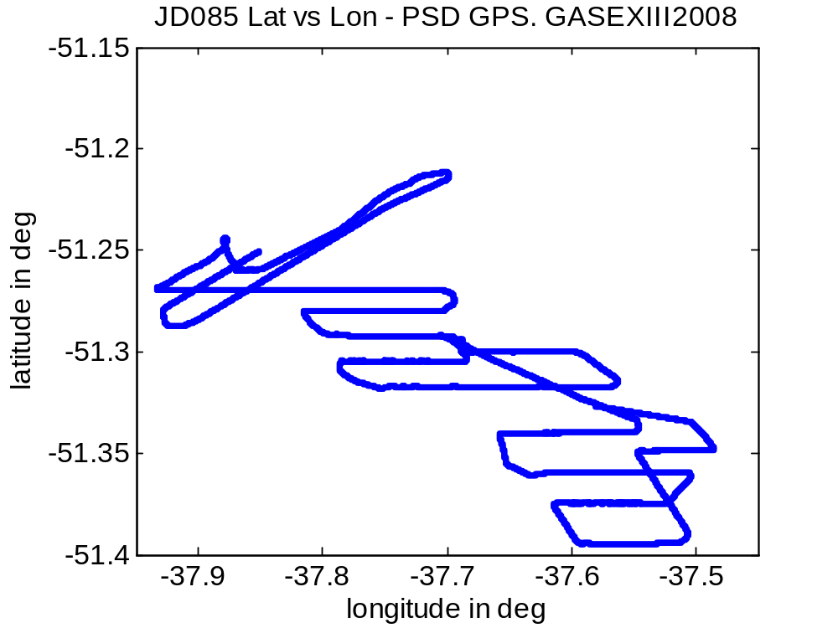
Figure 1. Cruise track for RBH on March 25, 2008 (JD 85).
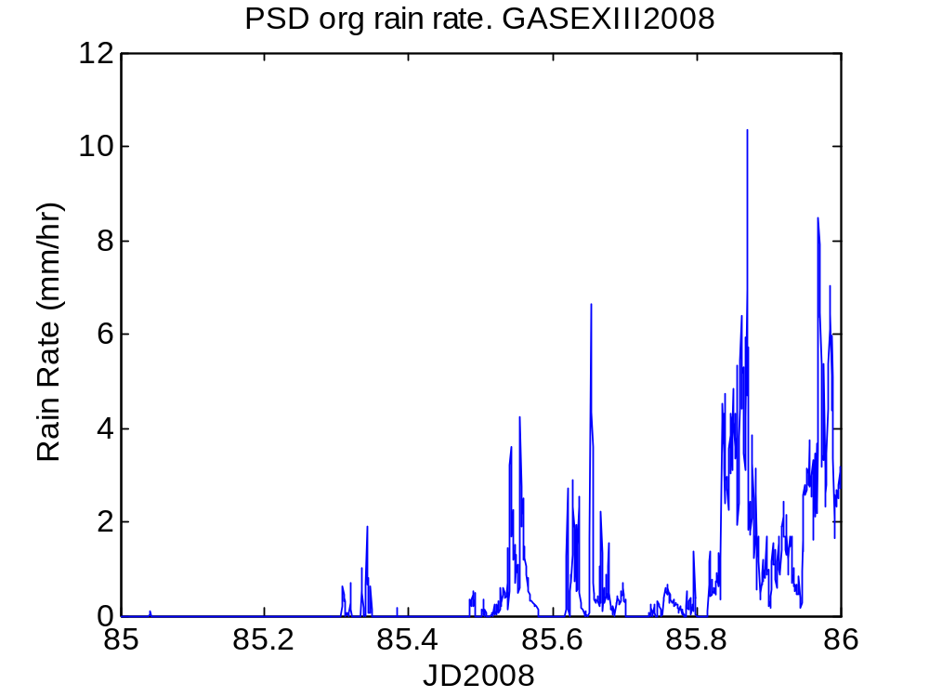
Figure 2. Time series of rain rate on March 25, 2008 (JD 85).
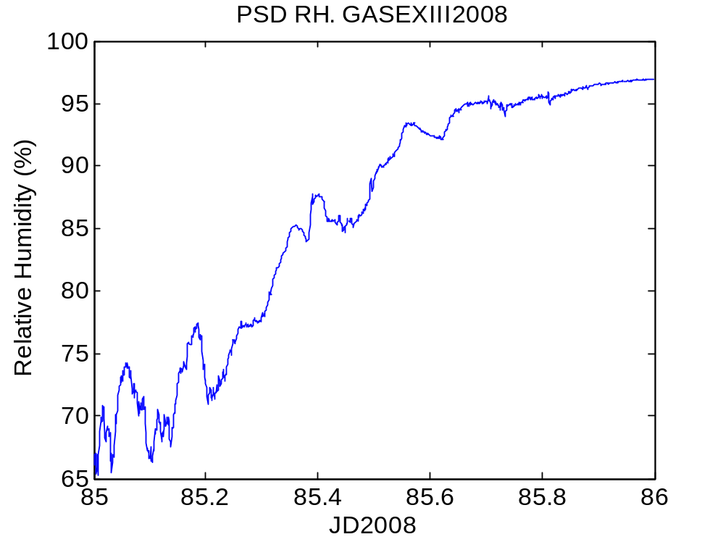
Figure 3. Time series of relative humidity on March 25, 2008 (JD 85).

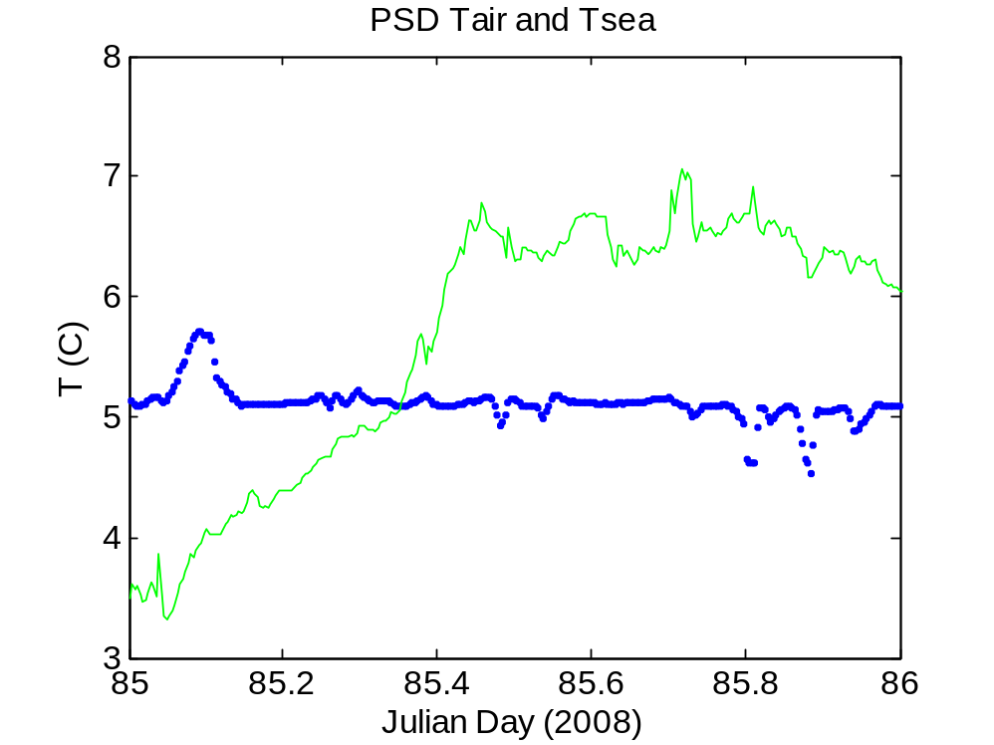
Figure 4. Time series of near-surface ocean temperature (blue) and 15-m air temperature (green).
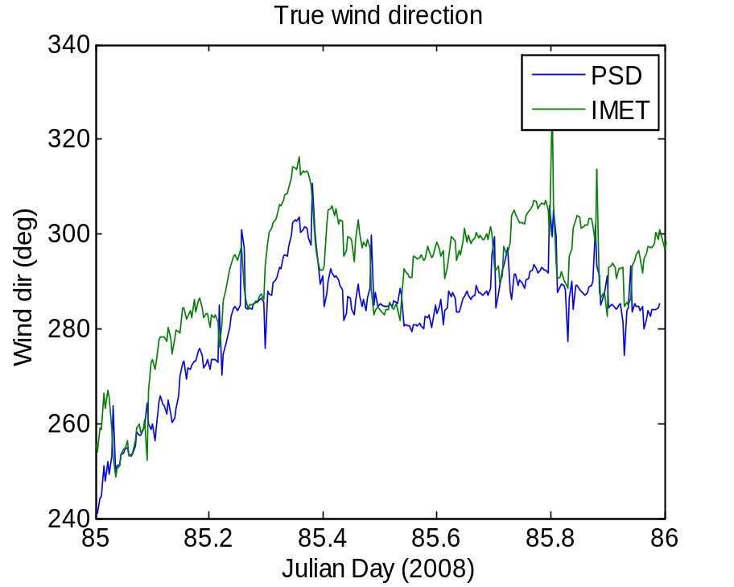
Figure 5. True wind direction from the PSD sonic anemometer (18 m) and the IMET propvane (15 m).
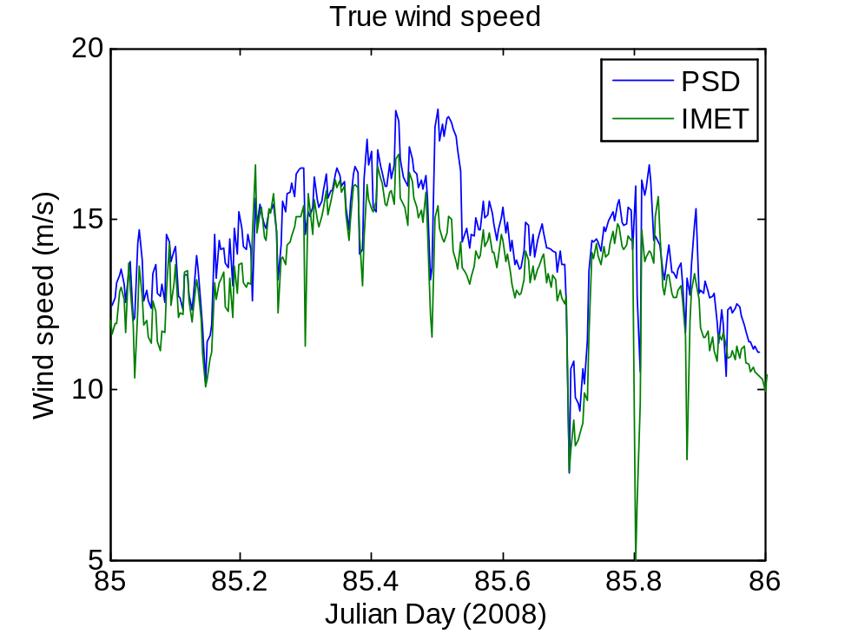
Figure 6. True wind speed from the PSD sonic anemometer (18 m) and the ship’s propvane (15 m).
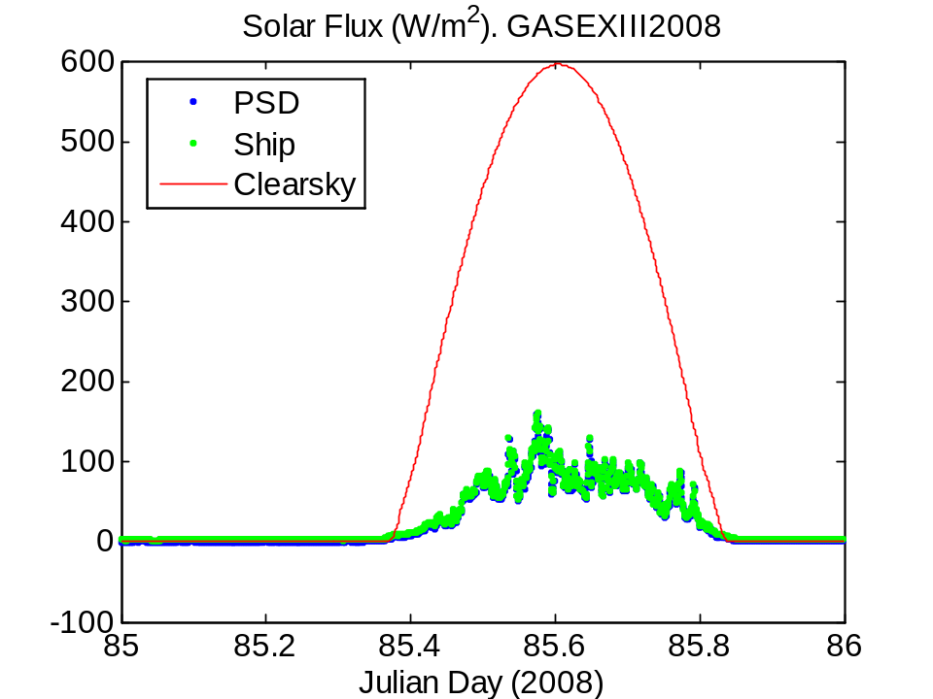
Figure 7. Time series of downward solar flux from PSD and ship Eppley sensors. The green line is a model of the expected clear sky value.
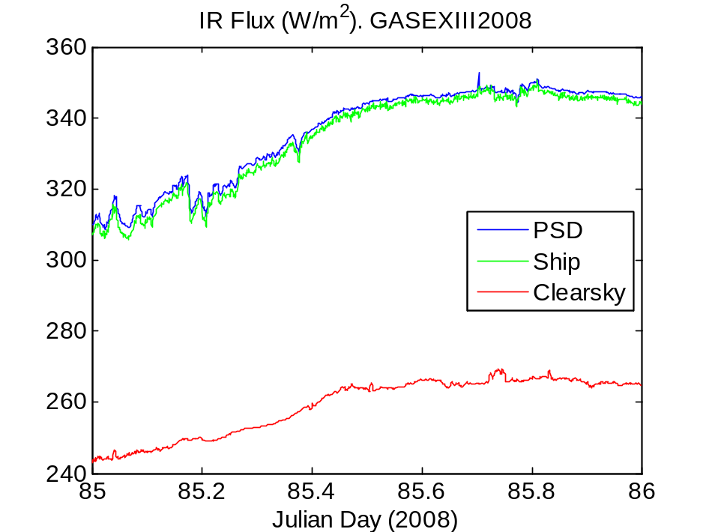
Figure 8. Time series of downward IR flux from PSD and ship Eppley sensors. The red line is a model of the expected clear sky value.
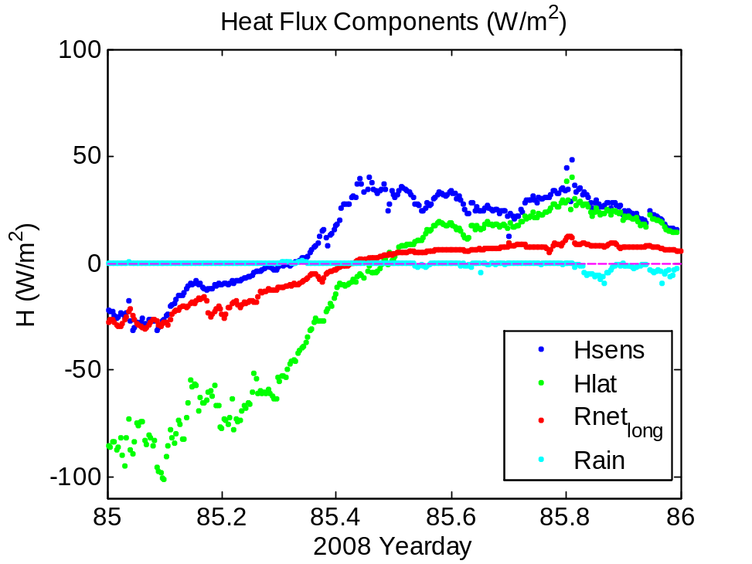
Figure 9. Time series of non-solar surface heat flux components: sensible (blue), latent (green), and net IR (red).
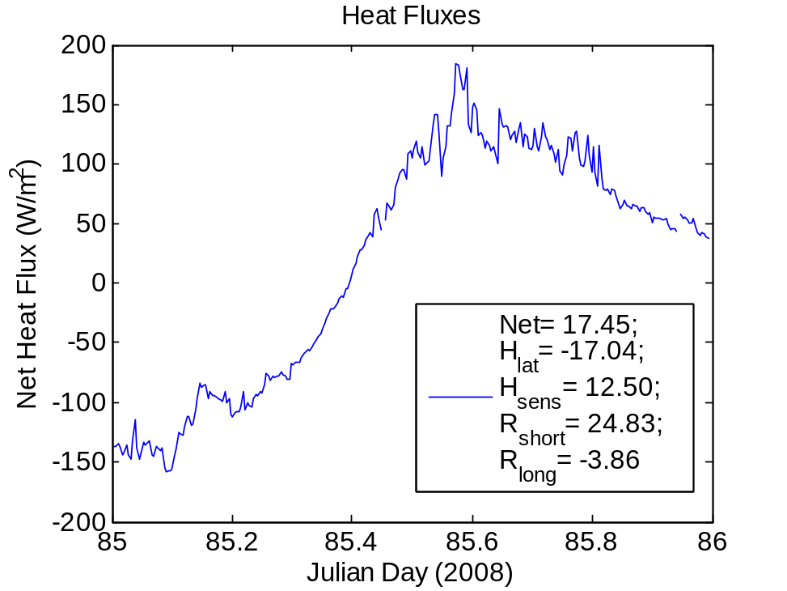
Figure 10. Time series of net heat flux to the ocean surface. The values at the top of the graph are the average for the day for each component of the flux.
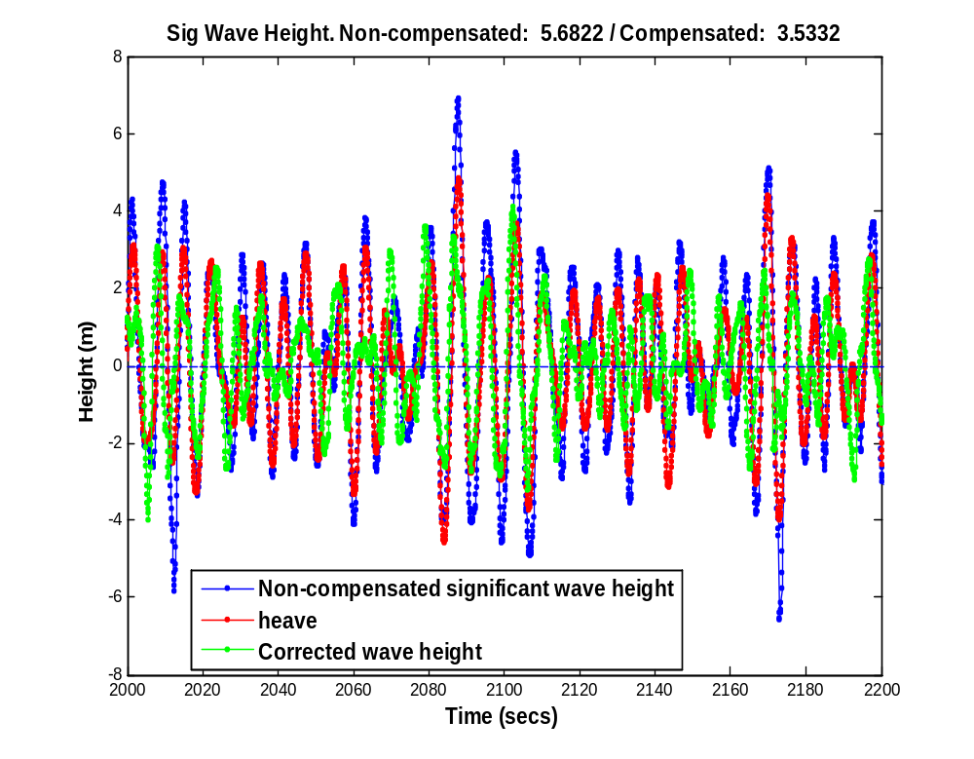
Figure 11. Sample wave time series from 0000 UTC on day 85 (March 25) from the laser rangefinder. The blue trace shows elevation of the sea surface relative to the bow of the ship, while the green line represents the motion corrected wave height.

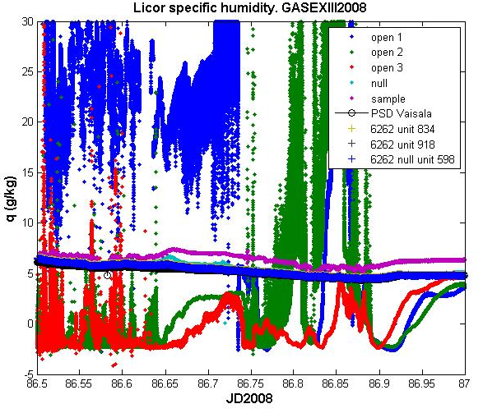
Figure 12. Time series of specific humidity from Licors-7500 (dots), Licors-6262 (plus) and Vaisala HMP325 (black line). Hour 12 to 23 of Julian Day 86.

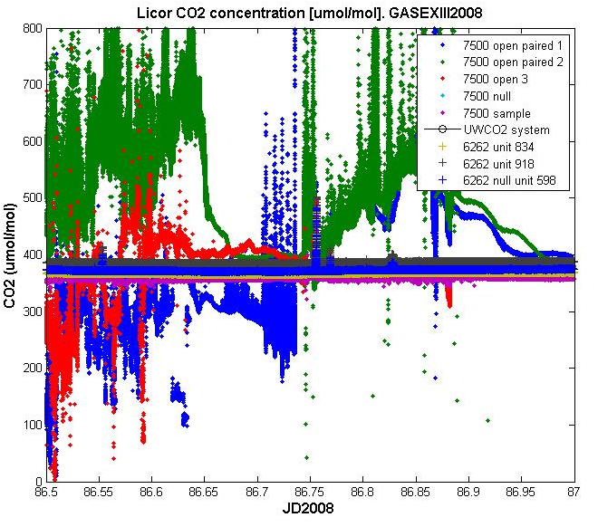
Figure 13. Time series of CO2 from Licors-7500 (dots), Licors-6262 (plus) and Underway system from NOAA AOML. Hour 12 to 23 of Julian Day 86.
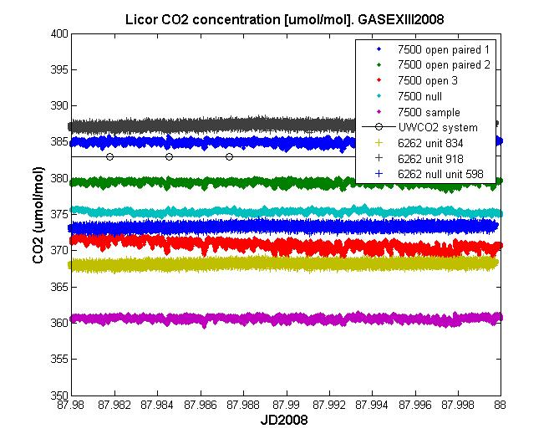
Figure 14. Time series of CO2 from Licors-7500 (dots), Licors-6262 (plus) and Underway system from NOAA AOML (black line). Julian Day 87, 28 minutes of hour 23.

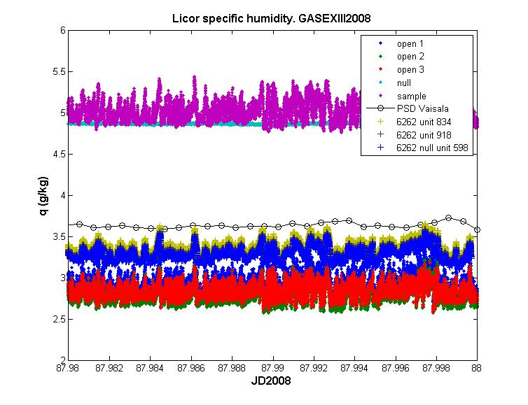
Figure 15. Time series of specific humidity from Licors-7500 (dots), Licors-6262 (plus) and PSDVaisala HMP325. Julian Day 87, 28 minutes of hour 23.

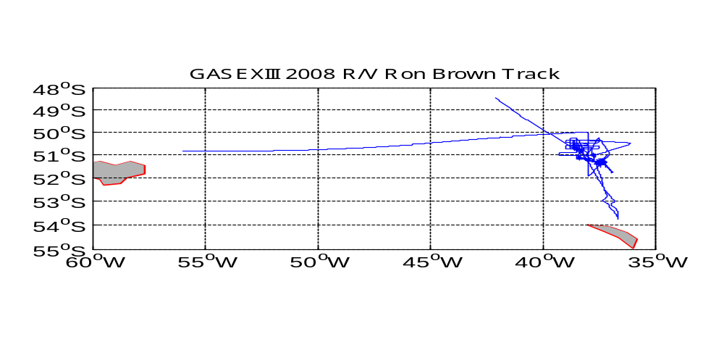
Figure 16. Cruise track for GasExIII 2008 cruise. Solid blue line is data collection period.

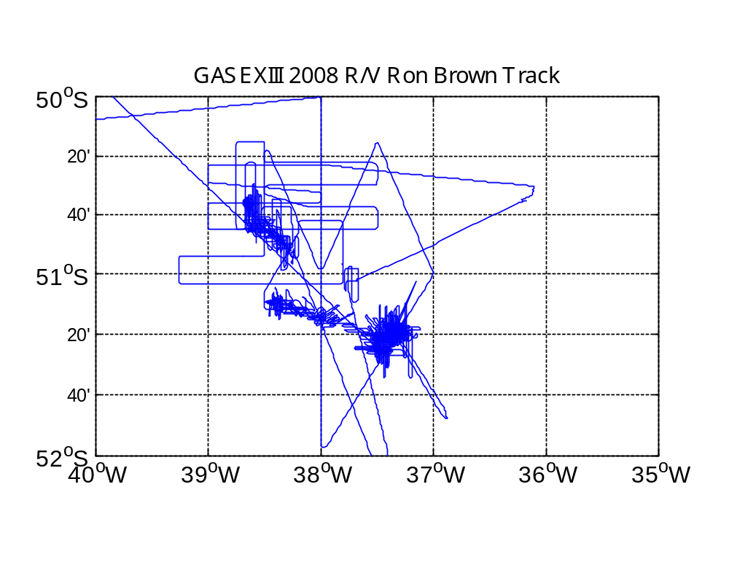
Figure 17. Same as figure 16, but a close up on the two patch surveys.

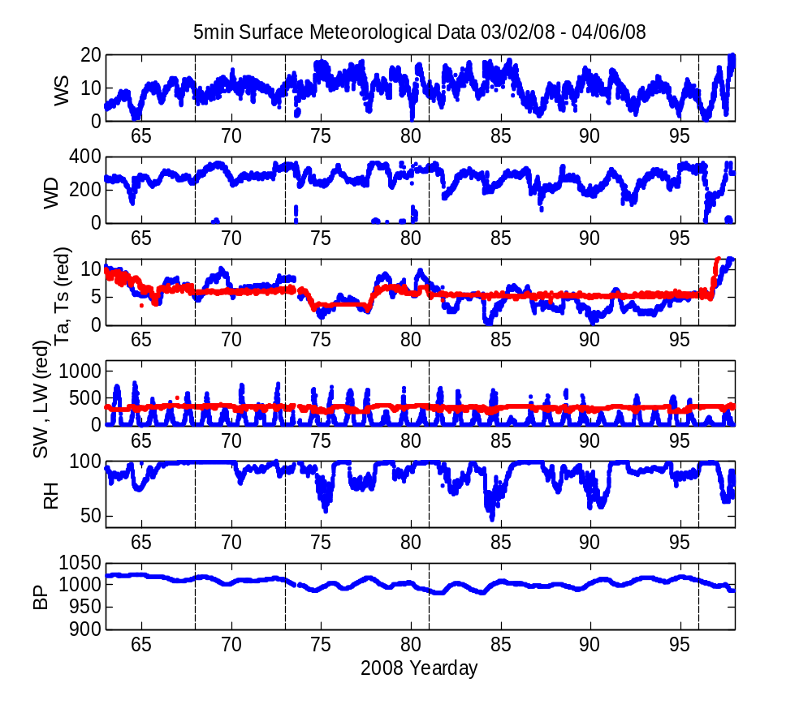
Figure 18. Meteorological conditions during GasExIII from JD 62 to JD 97 (March 2nd to April 6th, 2008). From the top, the panels show the wind speed (m/s), the wind direction in degrees relative to N, the air temperature and SST (red) (degC), the incident shortwave and longwave (red) radiations (W/m2), the relative humidity (%) and the barometric pressure (mb).

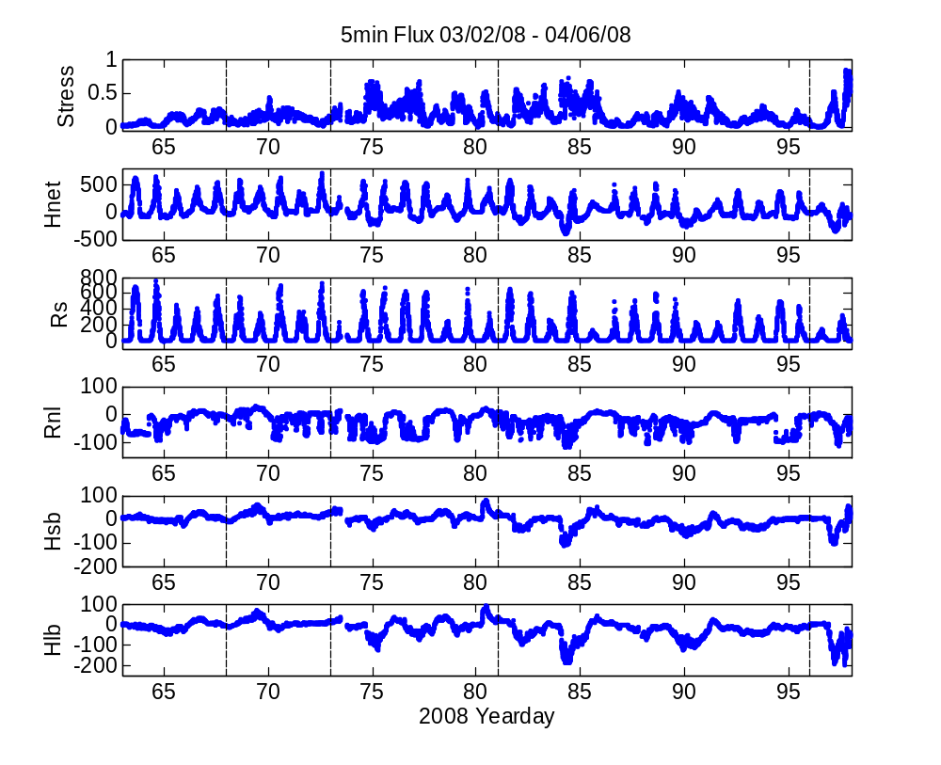

Figure 19. Surface fluxes during GasExIII from JD 62 to JD 97 (March 2nd to April 6th, 2008). From the top, the panels show the longitudinal component of the wind stress (N.m⁻²), the net heat flux (W.m⁻²), the solar flux (W.m⁻²), the net longwave radiation flux (W. m⁻²), the sensible heat flux (W. m⁻²) and the latent heat flux (W. m⁻²).
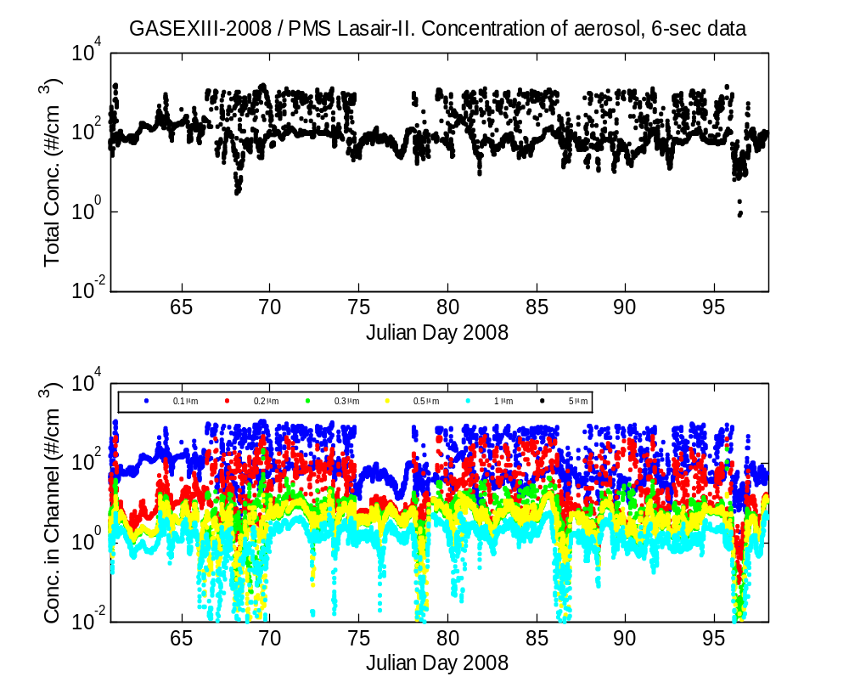
Figure 20. Aerosol concentrations from Lasair-II spectrometer from JD 62 to JD 97 (March 2nd to April 6th, 2008). Upper panel: total number concentration for aerosols larger than 0.1 micron diameter. Spikes are caused by the ship’s exhaust. Upper panel: aerosol concentrations for 0.1-0.2 (blue), 0.2-0.3 (red), 0.3-0.5 (green), 0.5-1.0 (yellow), and 1.0-5.0 (cyan).

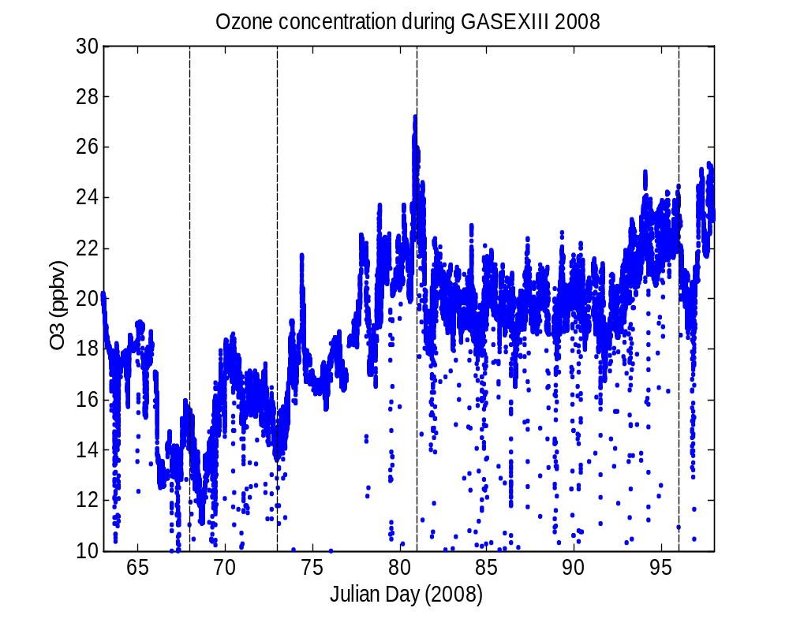
Figure 21. Ozone concentration from the fast ozone instrument, from JD 62 to JD 97 (March 2nd to April 6th, 2008).
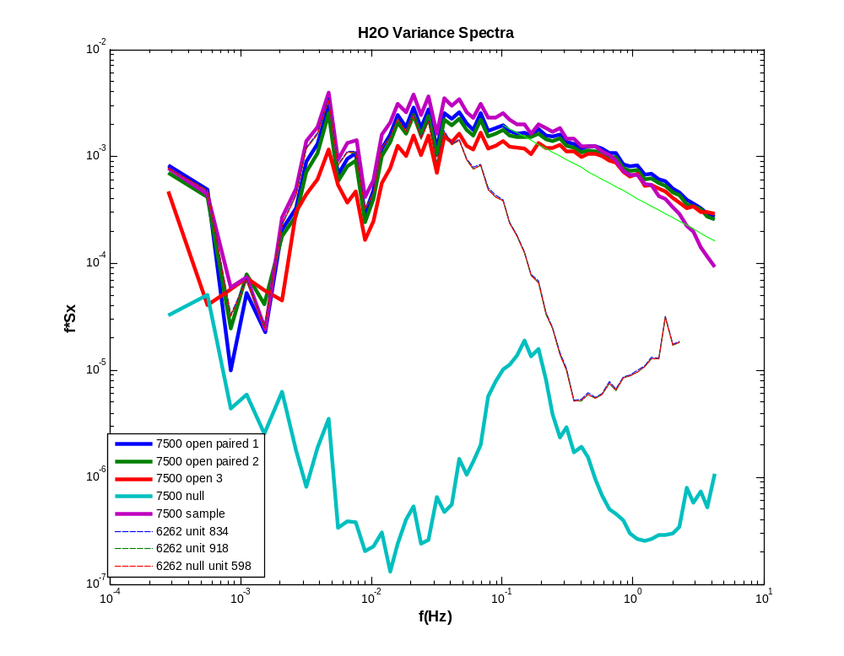
Figure 22. Power spectra for the water vapor signals for Julian Day 87, hour 23. The short green straight line is the -5/3 inertial subrange slope.
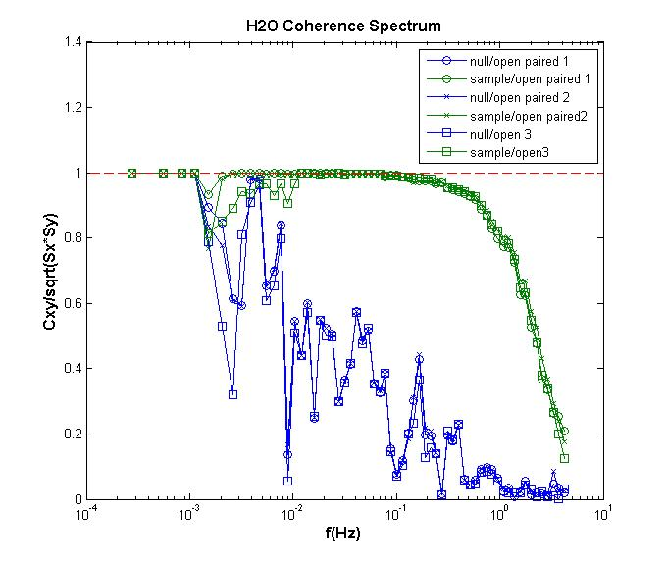
Figure 23. Ratio of cross correlation of null (blue) and sample (green) with the open signals divided by the square root of the variance spectra product. x is the open signal and y are the other signals. Hour 23 of Julian Day 87.

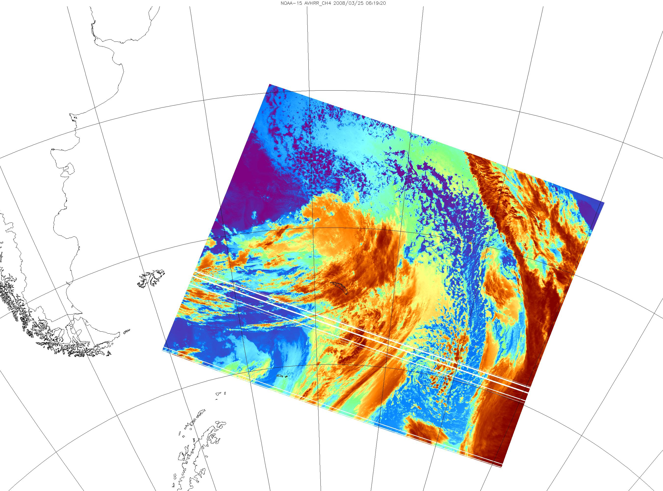
Figure 24. Terascan satellite visible image NOAA-15 0619 UTC March 25, 2008. Red circle is the approximate location of the study site at that time (51.3 S, 37.7W)

