Background

Researchers from the Univ. of Miami (UM), the Univ. of Colorado (CU) and the Environmental Technology Laboratory (ETL) collaborated to address several questions on trade-wind cumuli and PBL studies for RICO. In the first year, this work involved equipment preparation on the cloud radars (UMDCR and NOAA-K), the installation of these radar systems along with the flux/PBL system, the ETL lidar, and the microwave radiometer system, on the R/V Seward Johnson (SJ), and deployment of the ship to the RICO field program near Barbuda Island. The SJ was positioned in areas scanned by the island-based S-POL radar and provided detailed observations of trade-wind cumuli with evolving high reflectivity cores. We were able to sample ‘pure’ clouds over undisturbed marine conditions away from island topography.

Specific scientific questions addressed in this project include:
- What is the range of the dynamical and microphysical structures in trade-wind cumuli, and how do these structures affect the lifecycle of clouds under varying wind shear, stability, and aerosol conditions?
- What microphysical / dynamical factors and time scales are involved in the production of large-drop concentrations in fair-weather cumulus clouds?
- How do the raindrop size distributions evolve from the initial to mature precipitating stages of shallow cumuli?
- How is the marine boundary layer altered by precipitation from trade-wind cumuli?
- What are the statistical properties of precipitating trade-wind cumuli from the cloud to mesoscale scale?
- Can we find evidence for cloud processing of aerosol in the aerosol size distributions?
- Can we detect changes in cloud microphysics under different aerosol loadings?

Pre-Cruise Preparations:

The ETL Ka-band radar had several components hardened for operation at sea. The SJ was visited on two occasions at Ft. Pierce, Fla, to measure, compare with drawings, and talk with ship people about logistics and deployment locations. Two meetings were held in Boulder to discuss the ship setup and decide on locations for the lidar, NOAA Ka-band, and UMiami W-Band and X-band radars. A seatainer-laboratory was shipped from ETL to UMiami for the installation of the Miami observing systems. The lidar seatainer laboratory and two NOAA K-band packages where shipped to Ft. Pierce.

Cruise Information
Following the lengthy preparations described above, the observing systems (Table 1) were installed on the SJ in two periods (early and late December 2004). The ship departed Florida on December 29. Rough seas were immediately encountered. The ship made a 2-day unscheduled stop in Puerto Rico to repair a failed engine and arrived at the experimental site at the end of 1/8.The ship was manned by personnel from ETL, CU, U. of Miami, and a teacher from a middle school in Denver.

The cruise was conducted in two legs: leg1, 12/29-1/14 and leg2, 1/16-1/28. Intensive observing periods in the vicinity of the island were 1/9-1/14 and 1/16-1/24 (see Fig. 1).

Personnel on Cruises

Leg 1

Pavlos Kollias Chief Scientist (UM radars)
Bruce Bartram NOAA K
Scott Abbott Flux/profiler Engineer
2 persons ETL lidar
4 UM grad & 2 undergrad students (1 REU) UM radars/Sondes

Leg 2

Paquita Zuidema Chief Scientist (Cloud/precip Scientist)
Bruce Bartram NOAA K
Sergio Pezoa Flux/profiler Engineer
2 persons ETL lidar
3 UM graduate students UM radars/Sondes
Judy Malley Teacher-at-sea

Several instruments were stressed by the rough seas encountered during transit to the experimental area, but most performed as expected and data recovery was excellent. The exception was the Lasair II aerosol spectrometer, which ingested water and was a total loss. A unit was rented from PMS and installed for the second leg. Rawinsondes were launched at a rate varying from 2 to 6 per day depending on requests from the Operation Center. The sonde data were processed and transmitted via IRIDIUM to an ETL ftp site where they were available for pickup and transfer to GTS.

Cloud Conditions and Meteorology During the Cruise:

A wide range of cloud and precipitation conditions were sampled during the cruise and were clearly within the range of conditions expected and needed to accomplish the scientific objectives. Cruise means for selected variables from the flux system are given in Table 2. Winds during the cruise were typical of the trades with an average speed of about 8 ms⁻¹ from the east-northeast and SSTs of about 26 ºC. The ceilometer cloud base heights shown in Figure 2 illustrate the amount of cloud and the type of clouds that were observed. Typical trade wind cumuli were observed frequently during cruise with frequent observations of drizzle and precipitation associated with these clouds.

Data Processing:

Items 1-5 in Table 1 are processed and written into a single data file. The first version was released May 25, 2005. Raw ceilometer data, raw wind profiler data, and microwave radiometer data were released right after RICO. The ceilometer data have been processed to 10-min and 1-hr average time series and released also. The NOAA ETL Mailbox radiometer operated during both legs of the RICO project and data from it are being processed. The wind profiler data are being processed to remove ship motion and will be released in June 2005. W and X-Band radar data collected on the cruise are being calibrated and processed to provide moments data that will also be subjected to motion removal processing. The sonde data were sent to GTS in real time; they are being quality controlled and reprocessed by NCAR. The production of a more integrated and quality controlled data set is planned for late 2005. A more detailed description of the analysis completed to date and samples of initial data are shown below.

Initial Results from the Major Observing Systems:

Air-Sea Fluxes:

The flux system performed normally with no equipment problems uncovered to date. The time series has been processed for basic mean parameters; turbulent fluxes have been computed using the COARE algorithm version 3.0. These data are available at the ETL ftp site at 5 and 30 minute time resolution (ftp://ftp.etl.noaa.gov/user/cfairall/RICO/flux/). Cruise means for selected variables are given in Table 2. Direct turbulent flux computations are in progress.

The wind time series shown in Fig. 3 indicates winds were typically from the NE. The air and water time series is shown in Fig. 4. The passage of precipitating clouds is apparent as indicated by the strong drops (about 3 K) in air temperature. Most of the variations in the ocean temperature depicted in the graph are probably not real but caused by ship maneuvers. Conditions in the first week were stronger winds (10.5 m/s versus 5.9 m/s after January 16) and smaller sea-air temperature difference (0.7 ºC versus 1.04 ºC after January 16) The daily mean surface fluxes are shown in Fig. 5. From the radiative fluxes we can see that January 9,13,14,18, and 19 were cloudy at the ship; the 9th was very cloudy. The dip in latent heat fluxes seen on 17-19 is associated with the lighter winds in that period.

Diurnal variations were weak (with the obvious exception of solar flux). The air temperature varied less than 0.5 on average, peaking about 1800 local time. The SST temperature varied even less, peaking about 1500 local time. Thus, the sea-air temperature difference was about 1.0 ºC at night and 0.8 during the day. In the tropics it is normal for the SST diurnal variation to be larger than the air temperature and for the sea-air temperature difference to peak in the afternoon. The slightly larger diurnal variation of air (versus SST) for RICO implies surface fluxes are not dominating the air temperature variations. However, the differences are small enough that measurement errors could be a contributing factor. This bears further investigation. There is also a weak diurnal cycle in IR cloud forcing (about 10 W/m² amplitude) implying more cloudiness at night and a minimum about 1500 local time. Again, this variation is near the measurement accuracy. The ceilometer will give more definitive information on this issue.

NOAA Ka-band Radar

The NOAA ETL 34.6 GHz radar was operated on the RV Seward Johnson during the RICO project. Data were collected during the first leg from Jan 9 through 14, and on the second leg Jan 16 - 24. A typical operations day was to start the radar before the aircraft arrived and to shut down after the aircraft left the area.

The radar usually operated scanning in the vertical plane to the starboard side of the ship from 0 to 60 degrees elevation. The scan was NOT corrected for ship motion, and many times the roll rate exceeded the scan rate so the beam "back tracked" for a moment. There were a few short period when the radar was operated pointing up (relative to the ship, not the earth), and also there was a bit of vertical plan scans from 60 degrees elevation starboard to 120 degrees elevation (beyond vertical) when the cloud was passing directly over the ship.

The radar samples at 8 Hz. The NOAA ETL LIDAR's motion reporting system data was captured at 12 Hertz, and the ship's INS/GPS "PosMV" data stream was captured at 20 Hz during the times the radar was operating. With this information, the actual radar pointing angle can be calculated and the radar data can be translated into earth co-ordinates.

A sample of an RHI for a precipitating cell is shown in Fig. 6.

W-Band and X-Band Radar Observations

The X-Band radar operated continuously during both Legs 1 and 2. Unfortunately, the W-Band radar failed during the first leg of the cruise. Both radars were operated in an upward facing mode with 1-2 second temporal resolution and 30 m vertical resolution. A detailed comparison of the W-Band and the X-Band is in progress and initial results show very good agreement between the two radars as indicated by the reflectivity comparison shown in Fig. 7. The X-band data will be used to provide extensive observations of the clouds observed over the ship and will be used in conjunction with the other ship-borne (e.g ceilometer, microwave radiometer, and wind profiler) and island-based remote sensing systems (S-POL) to provide statistical descriptions of the clouds sampled. Comparisons with aircraft observations will be used to evaluate the retrieval techniques developed for the X-Band.

Mini-MOPA Lidar:

Data from the Mini-MOPA lidar instrument aboard the RVSJ during the 2005 RICO experiment were obtained using different scan modes. Typical data collection entailed repeated sequences of four types of scans using a motion-compensated full-hemispherical scanner. The scan sequence consisted of short, full 360º PPI scans (repeated 3 times every hour and in between all other scans) to calculate horizontal mean winds versus altitude, sector scans at two levels and RHI scans to observe rain shafts, outflows, and other below-cloud wind activity. At the end of each hour, zenith stares allowed for measurement of vertical wind velocities. Fig. 8 shows a color-coded display of the actual scan schedule used during the ship-board portion of the experiment.

The baseline data products from the mini-MOPA lidar include wideband SNR (signal to noise ratio) and line-of-sight velocity estimates. Fig. 9 shows images of the wideband SNR and velocity estimates taken during a vertical stare scan. For the vertical stare scans, the laser pulse width was shortened from 1 μs to 450 ns, resulting in improved vertical resolution. Data “stripes” prevalent near the end of the data set are due to an increase in the ship’s vertical velocities after the ship turned to head into the wind (and waves!). Data from this and similar vertical stare files will be analyzed to gain improved understanding of vertical wind structures, especially in below-cloud situations.

Other potential data products include high vertical resolution mean-wind profiles updated every 20 minutes, and RHI residual wind fields. As post-processing continues, a collection of images for the intensity and wind-fields of interest is being compiled. An example of the intensity and residual wind fields from a VAD scan that captured a rain shaft and corresponding outflow is shown in Figure 10. The lidar group is currently creating a web-site for the RICO lidar products. This site is expected to be available, with preliminary products, starting June 1, 2005.

Plans for FY05:

Year 1 activities of this project focused on field campaign planning/logistics, and data collection efforts. Year 2 will focus on QC of the instrument data and development of integrated data sets, followed by analysis of those data together with relevant ancillary datasets. Integrated data sets will include both case studies and statistical descriptions and will involve collaborative efforts involving NOAA ETL, University of Miami, and University of Colorado. Additional efforts will be made to integrate these data sets with the radar, rawinsonde, and aircraft observations made during RICO.

Table 1. Instruments and measurements for the ship-based cloud microphysics and PBL properties in precipitating trade cumulus clouds during the RICO study.
Item | System | Measurement
1 | Motion/navigation package | Motion correction for turbulence
2 | Sonic anemometer/thermometer | Direct covariance turbulent fluxes
3 | IR fast H₂O/CO₂ sensor | Direct covariance moisture/CO₂ fluxes
4 | Mean SST, air temperature/RH | Bulk turbulent fluxes
5 | Pyranometer/Pyrgeometer | Downward solar and IR radiative flux
6 | Ceilometer | Cloud-base height
7 | Lasair-II | Aerosol size spectrum
8 | Vaisala rawinsonde system | Profiles wind, temperature, and humidity
9 | 915-MHz wind profiler | PBL 3-D winds, inversion height, clouds
10 | 94-GHz Doppler radar (UMDCR) | High resolution Doppler spectra, cloud and precipitation microphysics and dynamics
11 | 9.4 GHz (X-Band) Doppler Radar (UM) | Cloud dynamics and precipitation physics
12 | 23 and 31 GHz  microwave radiometer | Integrated cloud liquid water  Integrated total water vapor
13 | 35 GHz Doppler cloud radar (NOAA/K) | Cloud microphysical properties
14 | Doppler lidar (NOAA ETL) | High resolution Doppler spectra around and below clouds

Table 2. Estimates of mean (or median) variables from the Seward Johnson deployment in RICO. Wind and temperature are measured at a nominal height of 14 m above the sea surface.

Variable | Mean (or Median)
Latitude | 17.9 N
Longitude | 61.7 W
Wind Speed | 7.71 m/s
Wind Direction | 71.7º
SST (snake) | 26.1 ºC
SST (Interface) | 25.9 ºC
Air Temperature | 25.3 ºC
Specific Humidity | 15.4 g/kg
Sat. Specific Humidity (SST) | 20.5 g/kg
Relative Humidity | 76.3 %
Downward Solar | 179 Wm⁻²
Downward IR | 392 Wm⁻²
Net Solar Flux | 169 Wm⁻²
Net IR Flux | -62 Wm⁻²
Rainfall Rate | 0.1 mm/hr
Bulk Wind Stress | 0.091 Nm⁻²
Sensible Heat Flux | 4.7 Wm⁻²
Latent Heat Flux | 141 Wm⁻²

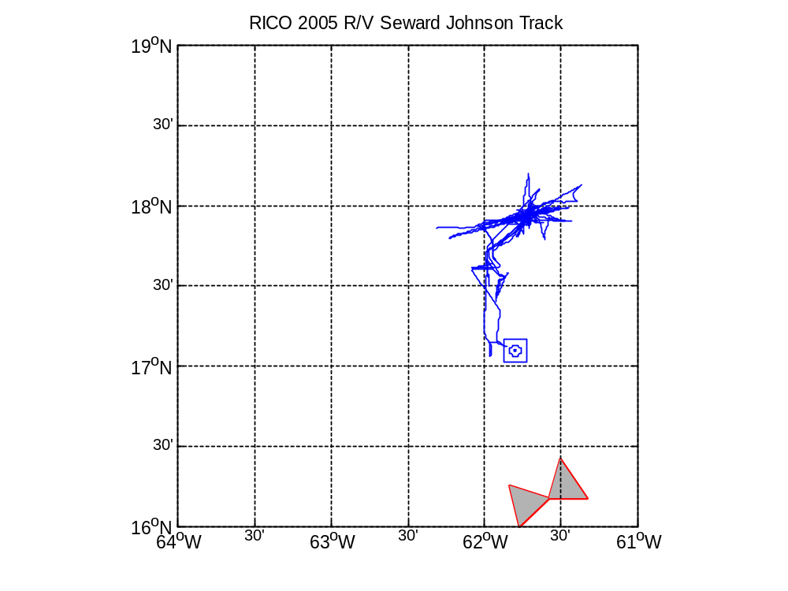

Figure 1. Cruise track of R/V Seward Johnson between 1/9 and 1/15/ 2005 during the RICO field campaign. The land at the bottom is Antigua Island; the circle-in-a-square symbol denotes the approximate location of Barbuda Island.

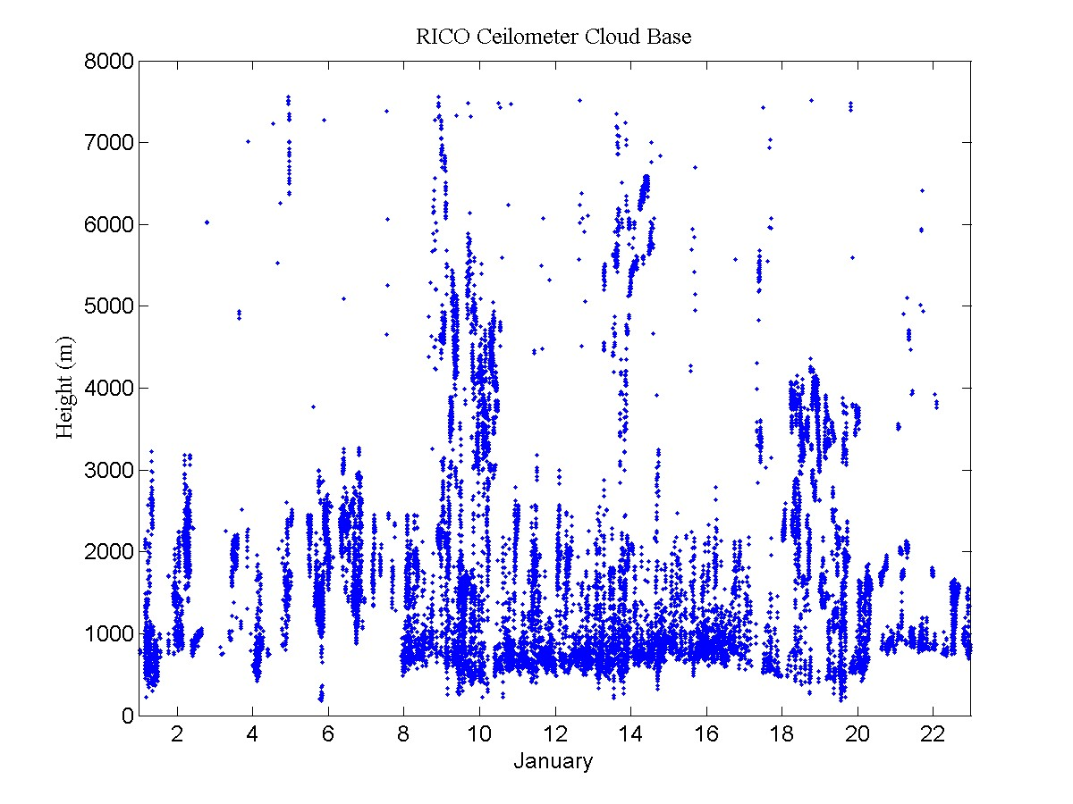

Figure 2. Cloud base height from the ceilometer on the R/V Seward Johnson during the RICO cruise.

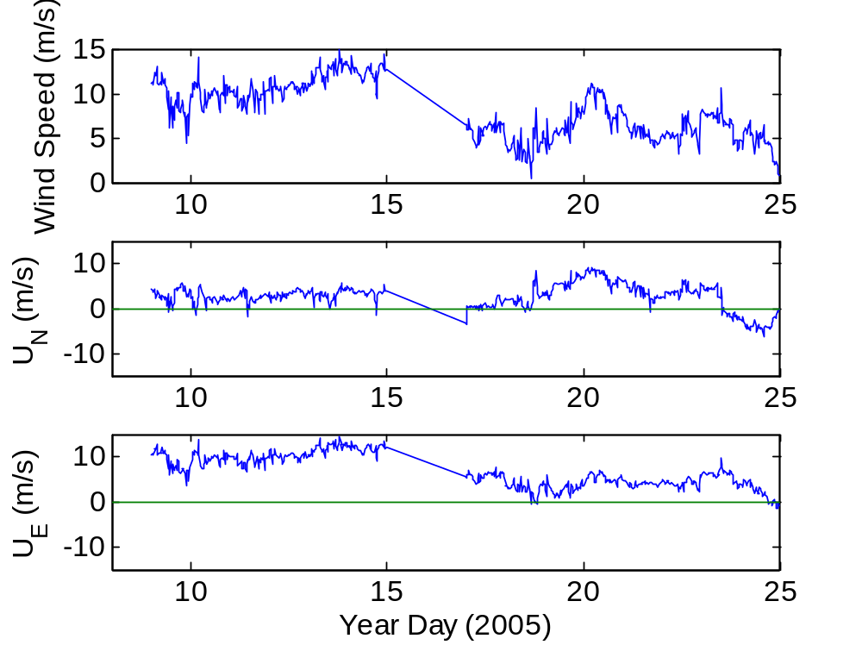

Figure 3. Time series of true wind speed and components for the RICO field program.

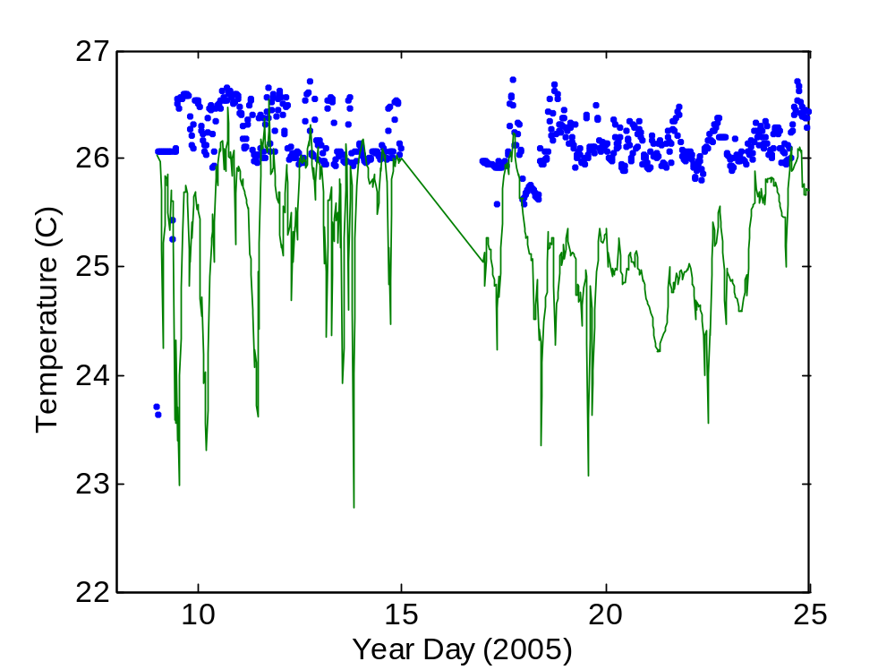

Figure 4. Time series of the near-surface ocean temperature (blue dots) and the 14-m air temperature (green line) from the RICO field program.

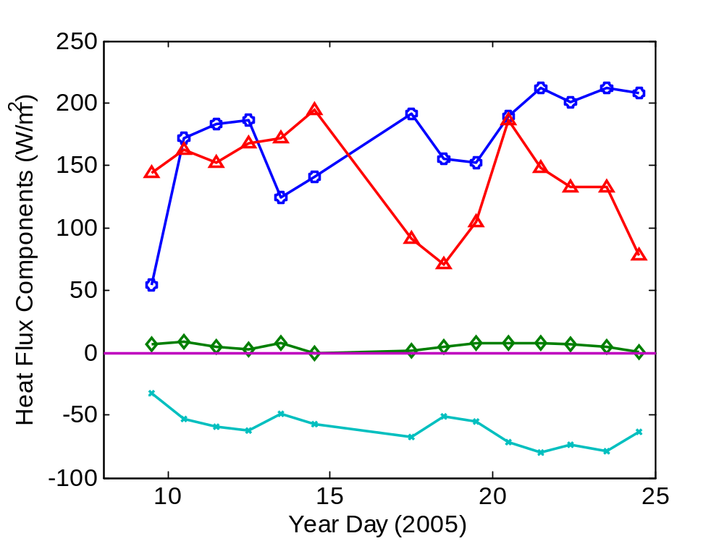

Figure 5. Time series of daily-averaged surface fluxes from the RICO field program: sensible heat flux (green diamonds); latent heat flux (red triangles); net solar flux (blue circles); and net IR flux (light blue x’s).

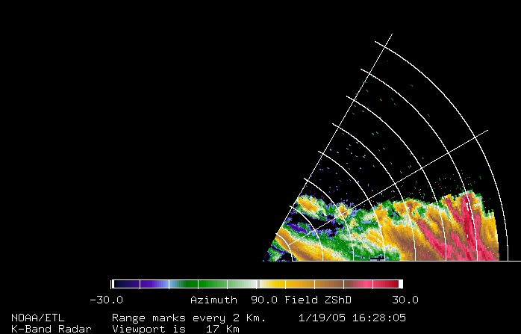

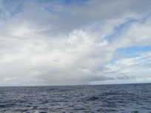

Figure 6. Sample data on precipitating cloud from 1/19/05 during RICO: upper panel - NOAA Ka-Band RHI scan; lower panel - photograph.
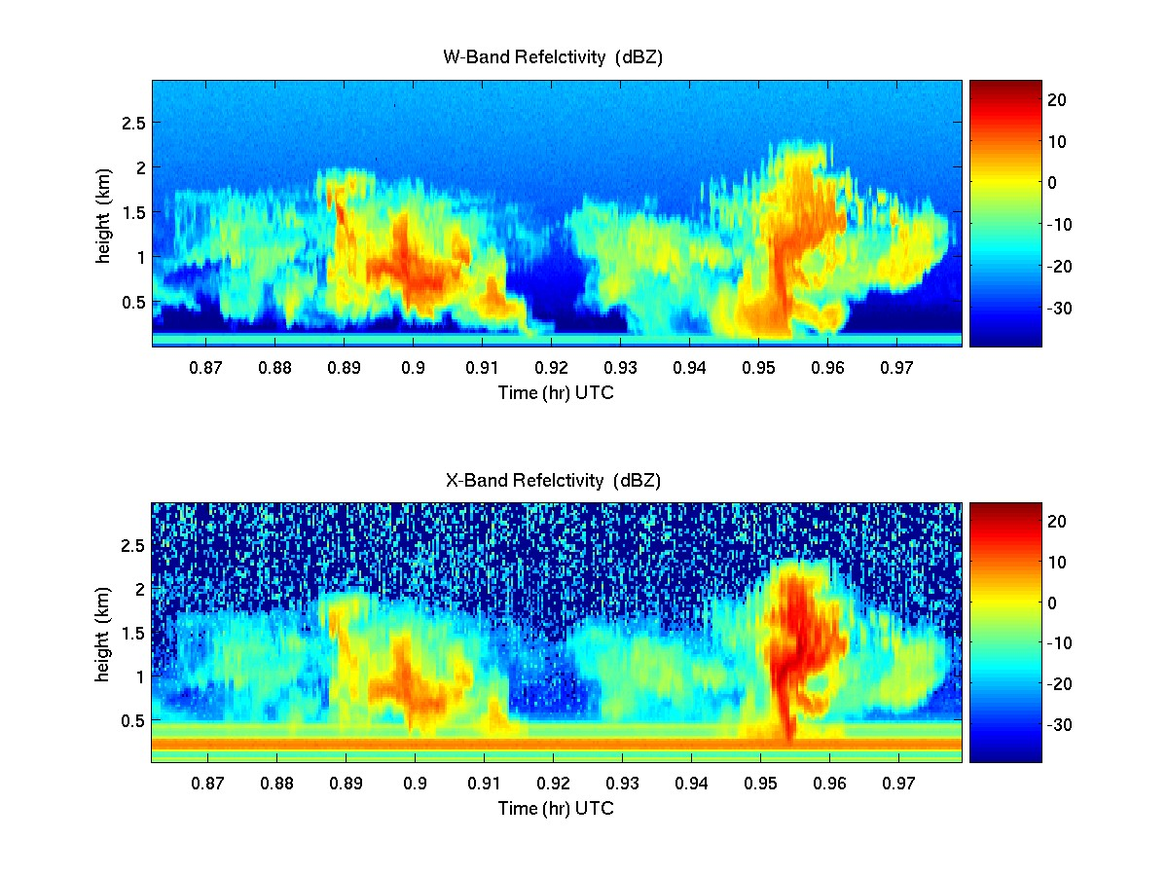

Figure 7. Reflectivity from UM W-band and X-band radars for shallow convection observe during RICO. Time scale is in hours.
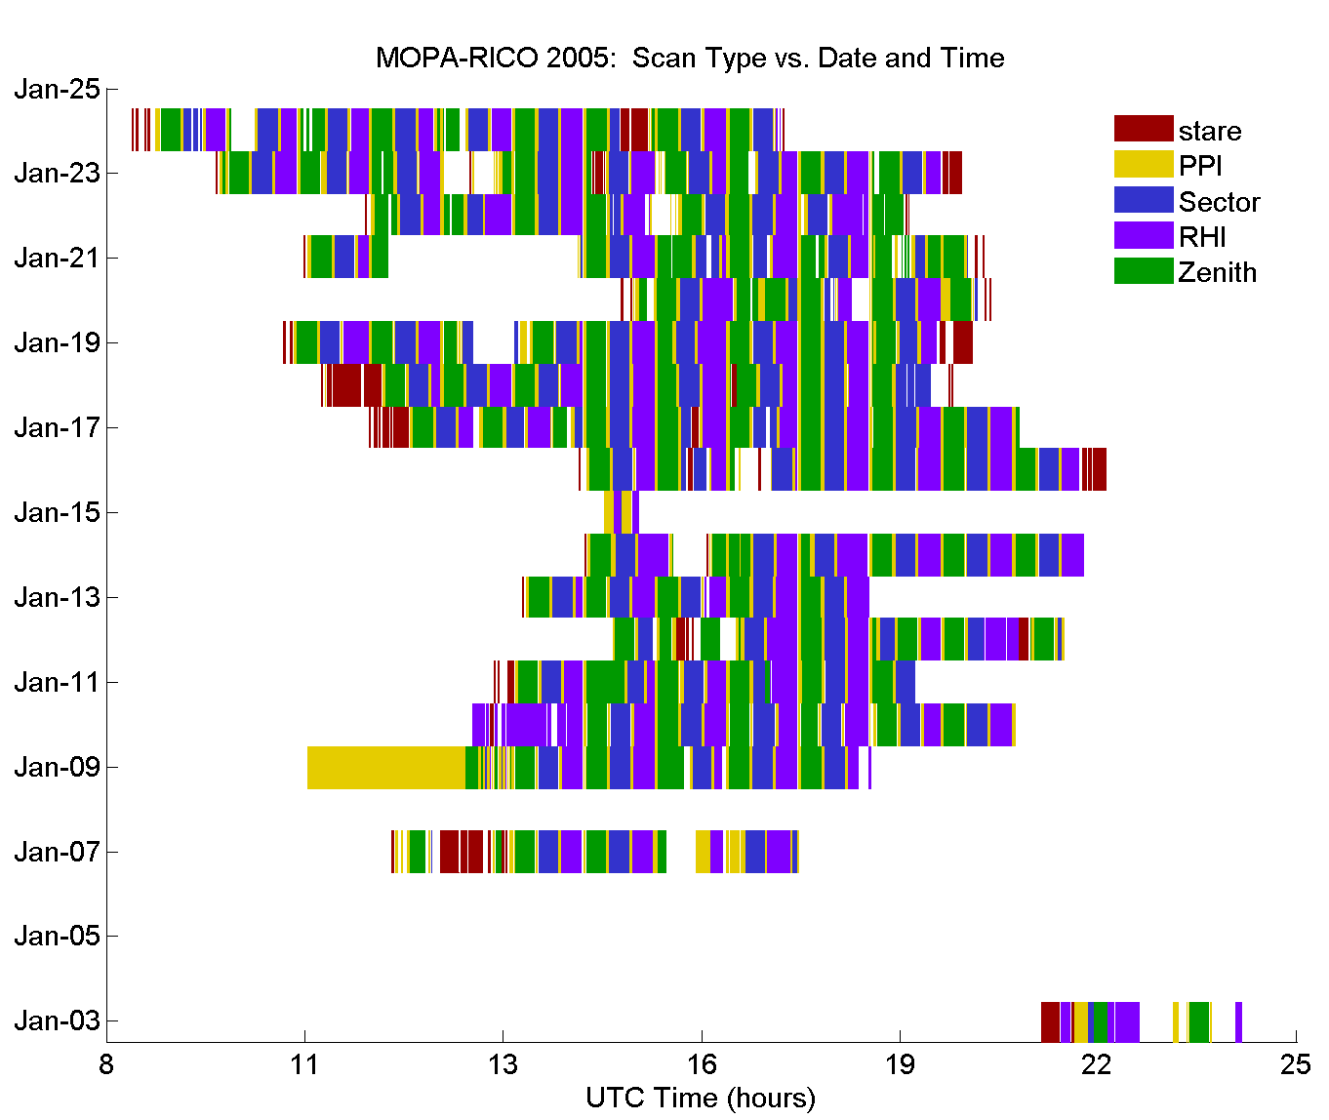

Figure 8. Lidar scan types and schedule during RICO 2005 experiment.
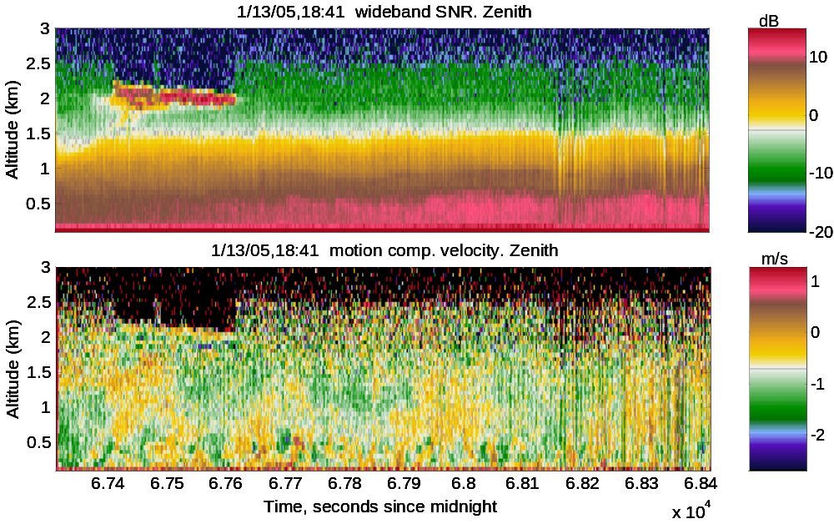

Figure 9. Examples of vertically staring lidar wideband SNR (top) and velocity (bottom) data. In this case, the return signal extends up to the top of the boundary layer at about 2.5 km altitude. Negative values (cooler colors) indicate wind toward the lidar (down) and positive values (warmer colors) indicate winds away from the lidar (up).

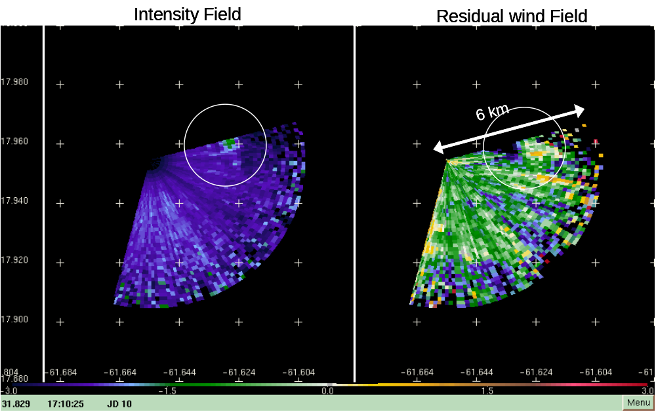

Figure 10. Intensity and residual wind fields from a 1 degree VAD scan that captured a rain shaft and corresponding outflow. The color scale at the bottom of the images applies to the residual wind field. X and Y axes labels represent longitude and latitude, respectively. Negative (positive) values or cooler (wamer) colors indicate radial wind toward (away from) the lidar.

Publications
Hill, R. J., 2005: Motion compensation for shipborne radars and lidars. ETL Tech. Memo, pp18, in press.

