ESRL/PSD Flux Group

The Earth System Research Laboratory (ESRL) Physical Science Division (PSD) air-sea flux group collected surface meteorological observations during the Woods Hole Oceanographic Institution (WHOI) Hawaii Ocean Time-series Station (WHOTS) research cruise on board the NOAA Research Vessel Hi’ialakai. Instruments were deployed and tested on the ship several days prior the departure date. Cruise dates were July 9-16, 2013.

a. Flux system
A 10m triangular tower was setup on the 02 deck of the ship (Figure 1). The fast turbulence system installed on the bow tower is composed of a GILL Sonic anemometer, a Li-Cor LI-7500 fast CO₂/hygrometer, and a Systron-Donner motion-pak. A Vaisala T/RH sensor in an aspirator and an OCI optical rain gauge were also mounted on the bow tower. To complete the PSD air-sea flux system, Pairs of Eppley pyranometers and pyrgeometers were mounted on top of a pole on the flying bridge port side (Fig. 2). A Vaisala pressure sensor with dynamic pressure port was also mounted aft on the flying bridge. Two Crescant GPS antenna for heading were mounted on the ship’s decompression container on the O2 deck beneath the large radome. Finally, a near surface sea surface temperature sensor (‘sea snake’) consisting of a floating thermistor was deployed from a portside mounted boom.

Slow mean data (T/RH, PIR/PSP, P, and SST) are digitized on two Campbell dataloggers and transmitted via wireless as 1-minute averages. Inside the dry lab on the 01 deck (Fig. 3), a central data acquisition computer logged continuously all sources of data via RS-232 digital transmission and wireless radio modem network.
- Gill Sonic Anemometer
- Licor 7500, CO2/H2O
- Slow means (two Campbell dataloggers)
- Systron-Donner Motion-Pak
- Crescant GPS Heading and pitch systems

The 8 data sources are archived at full time resolution. At sea, an ESRL data acquisition system (DAS) program is run continuously collecting sonic anemometer, LiCor, and motion data at 10 Hz and the mean measurement systems sampled at 0.1 Hz and averaged to 1 min. The DAS writes daily text files at 1 min time resolution. The 1-min daily ASCII files are named as proc_nam_DDD.txt (nam=’pc’, or ‘son’; DDD=yearday where 000 UTC January 1, 2011 =1.00). File structure is described in the readme accompanying these files. Further data analysis includes time matching the PSD met data creating 5 and 30-min daily flux files in order to compare with the ship’s various systems.

Table 1 contains information on sensors and Table 2 contains height of sensors above water and location.

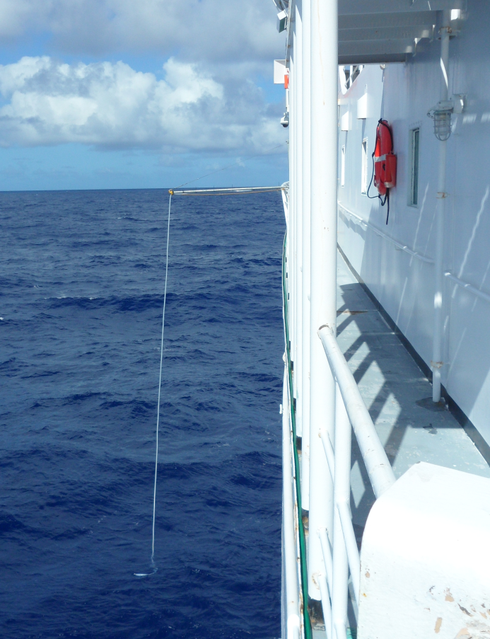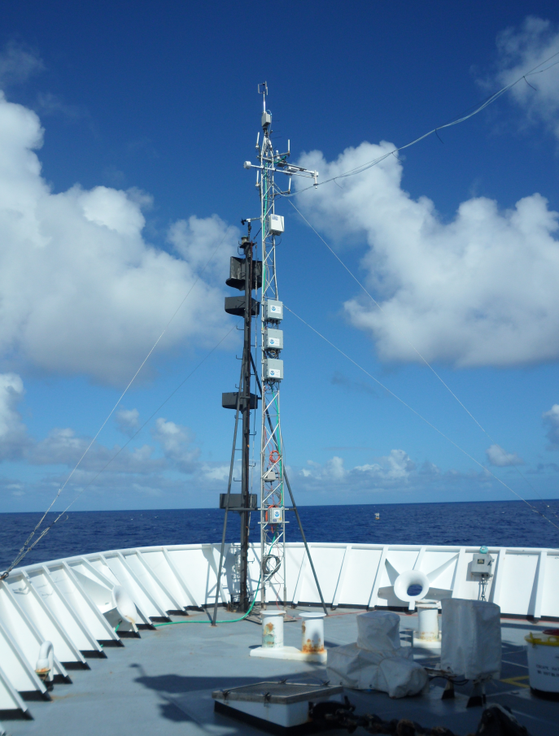
Figure 1: Left: Flux tower deployed on the bow. Right: The sea surface thermistor, i.e. “sea snake”, can be seen on port side of the ship.
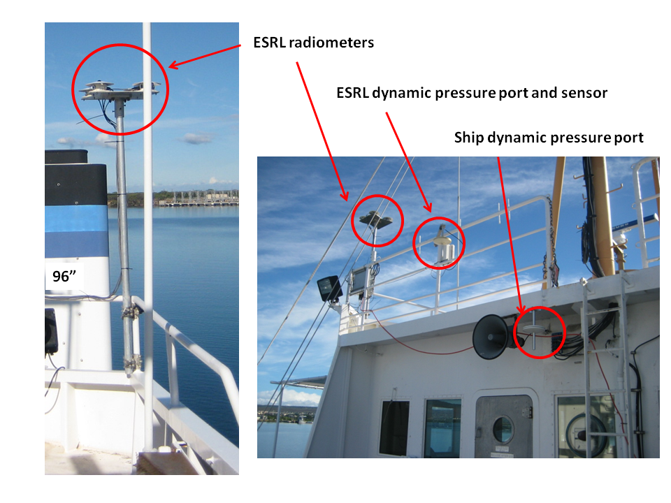
Figure 2. ESRL radiometers and pressure sensor on flying bridge. Alos shown ship dynamic pressure port.

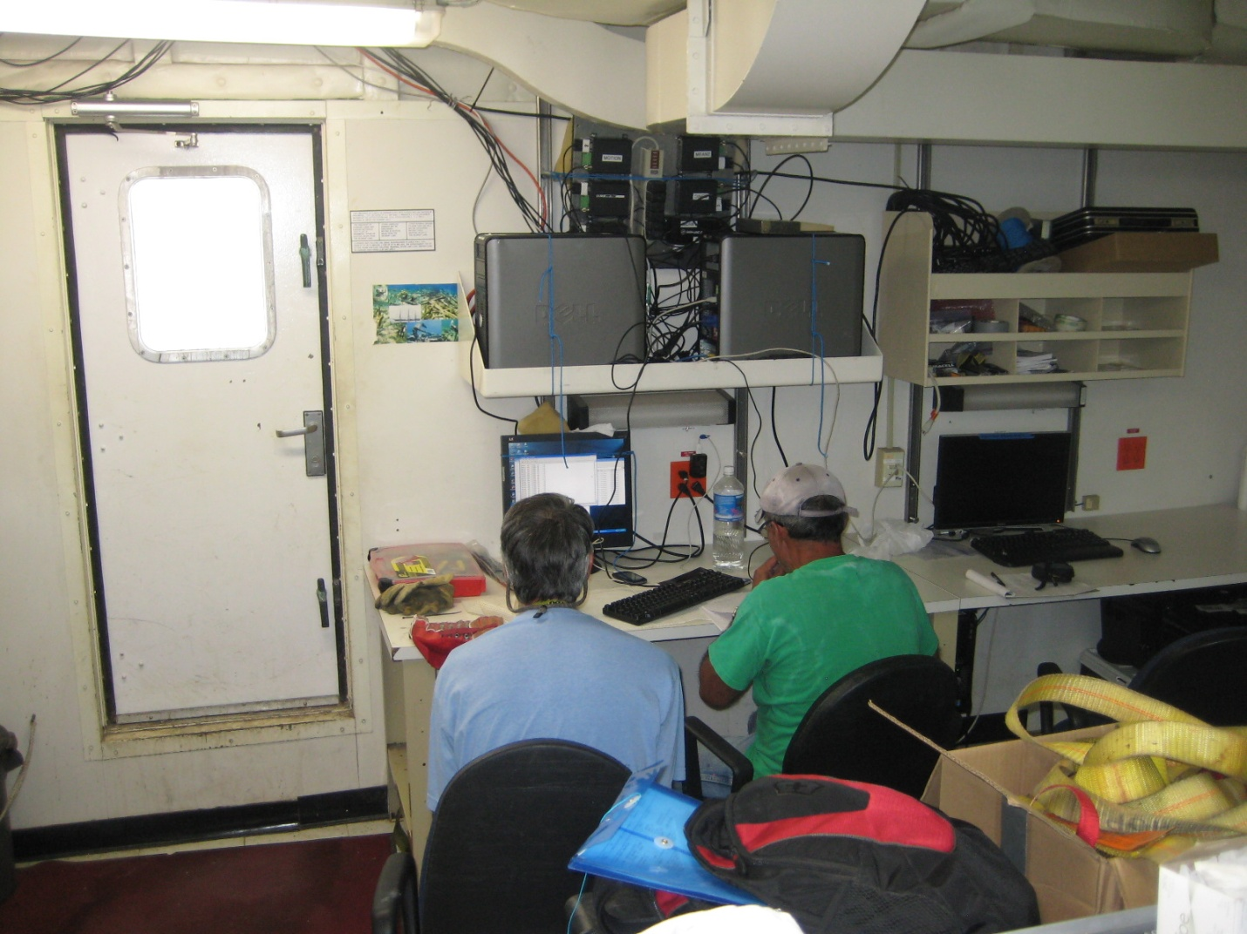
Figure 3: Wireless modems and Data Acquisition and processing computers

b. ESRL Data Archive
Selected data products were made available at the end of the cruise for the joint cruise archive. Further analysis will be done in order create the 5-min and 30-min daily flux files. After post processing, direct covariance, inertial-dissipation and bulk turbulent flux will be produced at 10 min and hourly average. This will include mainly momentum, sensible and latent heat fluxes. All data for this project will be put on an ftp site back in Boulder.

NOAA Research Vessel Hi’ialakai Meteorological Sensors
The following information was gathered in cooperation with the ship’s survey technician to document the meteorological sensors and data being collected on the ship. The ship’s sensors include a prop-vane anemometer mounted on the main mast, a digital pressure sensor mount in the aft portion of the bridge on the 03 Deck, and a T/RH sensor mounted on the forward portion of the flying bridge (Fig. 3). The sea surface temperature is measured using a Sea Bird Electronic-38 located near the bow starboard side at a depth of ~4 m (Fig. 4). Calibration for the ship sensors is not known. Location of T/RH is poor and subject to influence by deck heating.
The Hi’ialakai uses the NOAA Ship Computer System (SCS) for data acquisition. A list of sensors was loaded into an SCS event template (WHOTS). Each day at 00 UTC the Event from the previous day was stopped and a new Event was started therefore creating daily data files similar to the ESRL daily files. Events are incremented automatically by SCS. Table 3 is a list of the instrumentation, heights, and the variable name of each data type found in the Event file. Additional metadata on the ship’s sensor can be found on the Shipboard Automated Meteorological Oceanographic System (SAMOS) web site (http://samos.coaps.fsu.edu/html/).

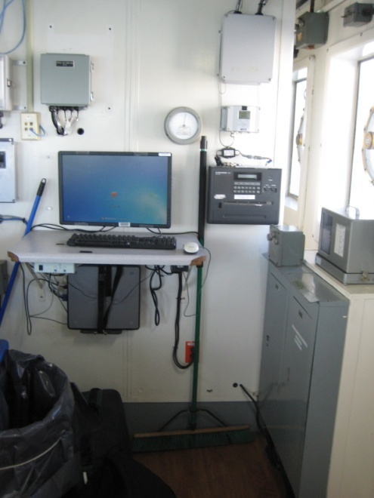
Figure 4: Left: prop-vane anemometer mounted on main forward mast, middle: pressure sensor mounted aft bridge, right: T/RH sensor.
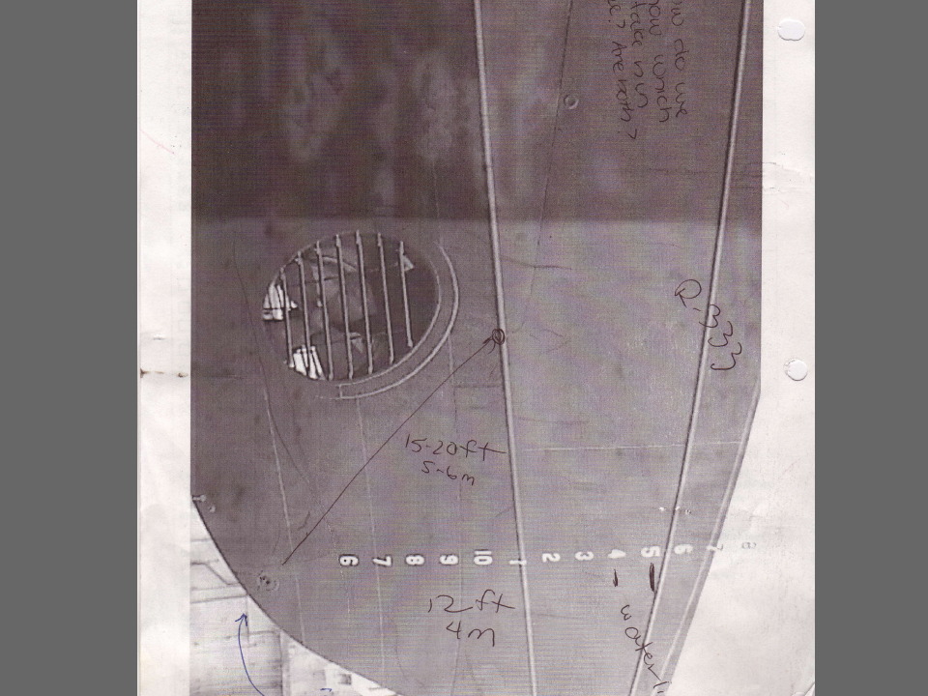
Figure 5: Location of ship SST sensor on starboard side near bow. Lower right in picture

Appendix A contains time series plots of various data from both the ESRL and ship sensors along with preliminary fluxes calculations and direct comparisons.

For access to the ESRL FTP site:
ftp://ftp1.esrl.noaa.gov/psd3/cruises/WHOTS_2013/
username anonymous
password (email address)
Contacts:
Daniel Wolfe/ Ludovic Bariteau / C. W. Fairall / Sergio Pezoa
NOAA Earth System Research Laboratory
325 Broadway
Boulder, CO USA 80305
303-497-4482 Ludovic.Bariteau@noaa.gov
303-497-6204 Daniel.wolfe@noaa.gov
303-497-3253 Chris.Fairall@noaa.gov
303-497-6441 Sergio.Pezoa@noaa.gov

Table1: ESRL Sensor Information

Sensor | Calibration coefficient | Make / Model | Serial No. | Date of calibration
Precision Spectral Pyranometer | 0.00882 | Eppley / PSP 1 | 30593F3 | July 5, 2012
Precision Spectral Pyranometer | 0.00795 | Eppley / PSP 2 | 30434F3 | Feb 15, 2012
Precision Infrared Radiometer | 0.00387 | Eppley / PIR 1 | 34302F3 | Mar 14, 2012
Precision Infrared Radiometer | 0.00426 | Eppley / PIR 2 | 30432F3 | Feb 15, 2012
Rain Gauge | Offset=0.057mV | OSI/ORG815DA | 08060282 | Apr 30, 2012
Motion Pak ZERO xrate | 0.00828 | Sundstrand | n/a | May 15,2012
Motion Pak ZERO yrate | 0.01728 | Sundstrand | n/a | May 15,2012
Motion Pak ZERO zrate | 0.03569 | Sundstrand | n/a | May 15,2012
Motion Pak Zero xaccel | 0.009 | Systron & Donner | n/a | May 15,2012
Motion Pak ZERO yaccel | -0.0064 | Systron & Donner | n/a | May 15,2012
Motion Pak ZERO zaccel | -0.008 | Systron & Donner | n/a | May 15,2012
Sea Snake thermistor -5C to 40C | C4=0.001399937 | YSI 46040 series |  | May 9, 2012
Sea Snake thermistor -5C to 40C | C5=0.00237854 | YSI 46040 series
Sea Snake thermistor -5C to 40C | C6=0.000000097 | YSI 46040 series
Temperature / Humidity | n/a | Vaisala/HMT335 | CT10008 | Feb 22, 2012
Class A Digital Barometer | n/a | Vaisala/ PTB220 | A2710003 | checked OK June16, 2013
CO2/H2O Analyzer | Available | Licor / LI-7500 | 75H-0027 | Zeroed for:  CO2 Sep 9, 2012  H2O Sep 9, 2012

Table 2: ESRL Sensor Heights and Location
ESRL Sensor | Ht above water (m) | Location
Sonic anemometer | 18.13 | 10m mast on bow
T/RH | 16.20 | 10m mast on bow
LiCor CO₂/H₂0 | 16.99 | 10m mast on bow
Optical ran gauge | 16.66 | 10m mast on bow
Pressure | 14.38 | Aft flying bridge

Table 3: NOAA Research Vessel Hi’ialakai Sensor Information
Ship Sensor | Make/Model | Ht above water (m) | SCS variable name
Prop-Vane  Spd/Dir | RM Young 5103 | 15.6 forward mast | SAMOS-TrueWind-Dir-Value  SAMOS-TrueWind-Spd-Value
T  RH | RM Young 41372 | 15.27 forward flying bridge | SAMOS-AirTemp-Value  SAMOS-RelHumidity-Value
Barometer | Vaisala PTB330 | 12.02 aft bridge | Vaisala-Barometer-
SST | SBE38 | -4 m | SAMOS-TSG-Temp-Value

Appendix A:
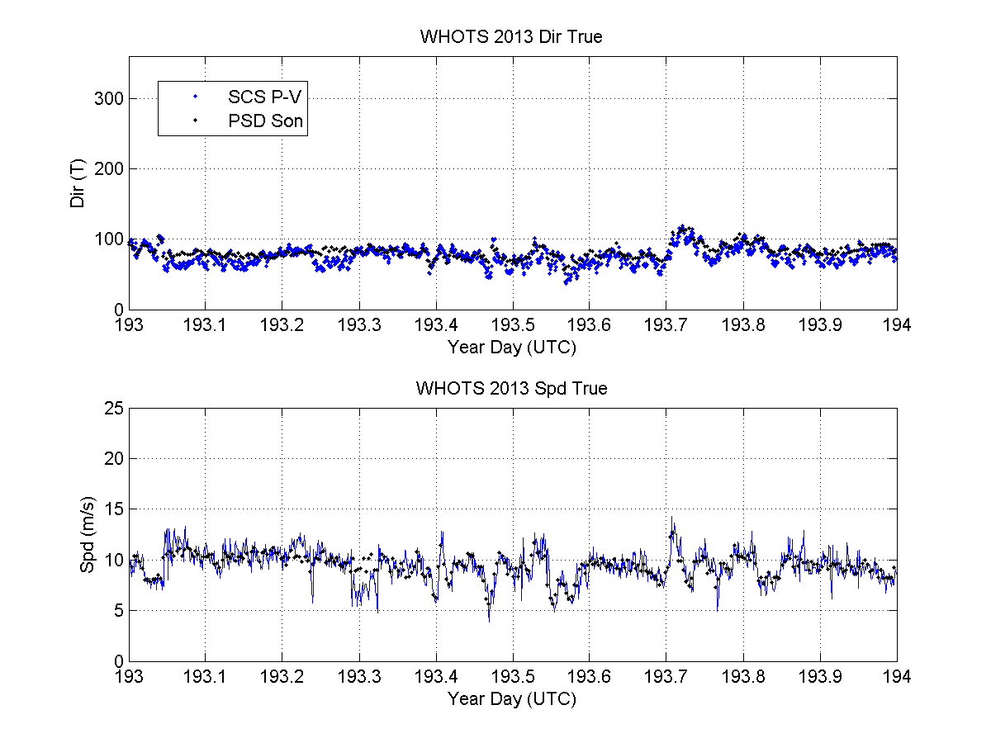
Comparison of ESRL sonic and ship prop-vane anemometer true wind speed and direction.
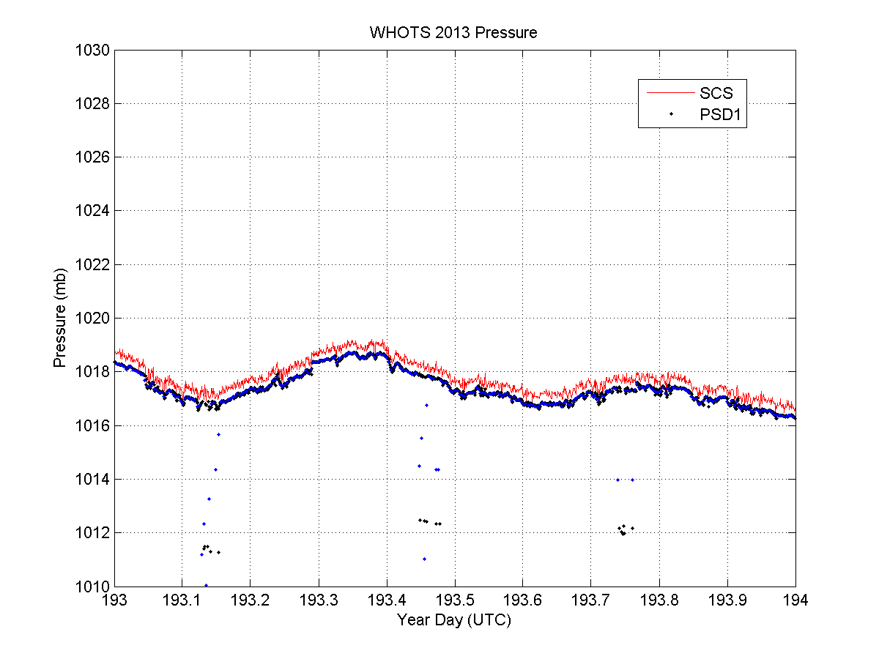
Comparison of ESRL and ship pressure sensors. Both sensors use a Vaisala dynamic pressure port to eliminate dynamic wind effects. Sensor heights are 14.38m and 12.02m respectively. Sea level pressure correction shows very good agreement.

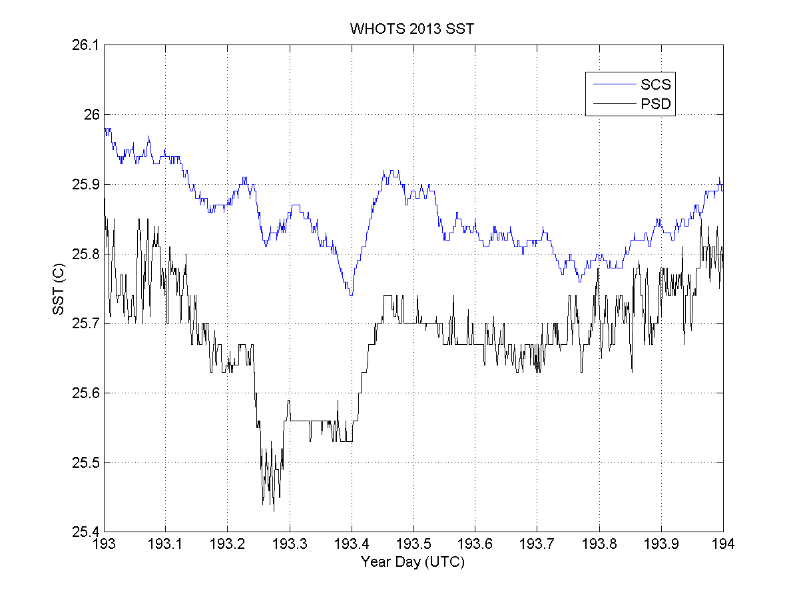
Comparison of ESRL seasnake sea surface temperature and ship TSG sea surface temperature (SBE-38). ESRL sensor is thermal couple encased in a hose that floats on the surface and the TSG sensor is located forward portside at a depth of ~? M.
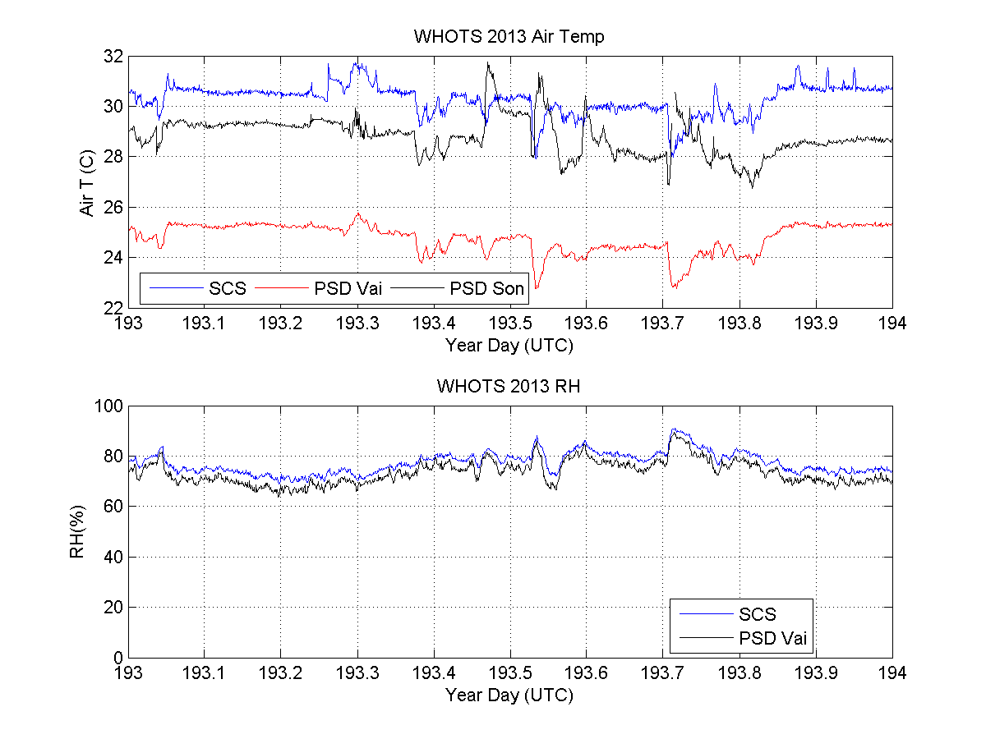
Comparison of ESRL and ship air temperature and relative humidity sensors. The ESRL sensors (PSD Vai and PSD Son) are located on the bow tower. PSD Vai is a Vaisala T/RH sensor in an aspirated shield and the ship’s sensors are located of the forward side of the flying bridge in a non-aspirated shield. ESRL temperature not corrected height corrected.
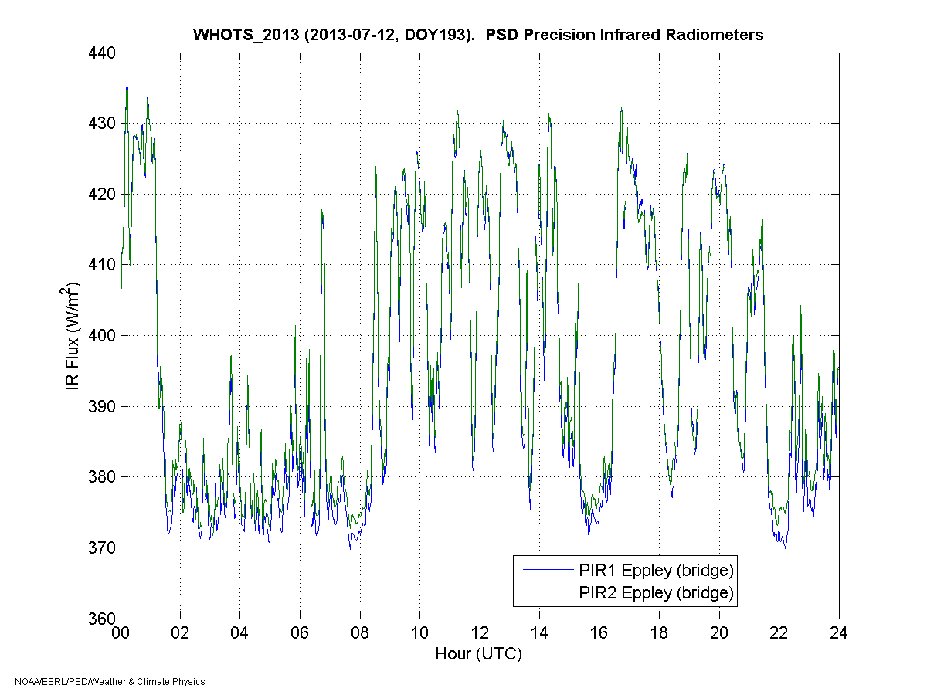
Time series of ESRL short-wave radiation. July 12, 2013 YD 193.

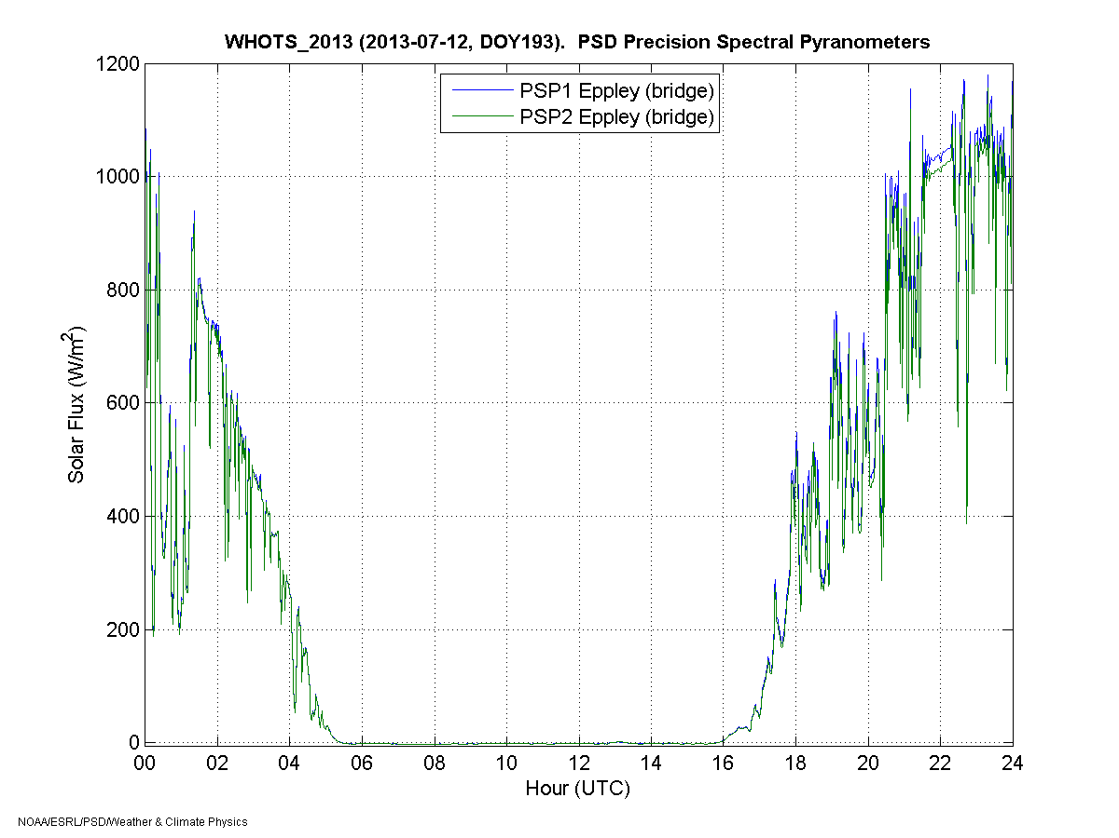
Time series of ESRL long-wave radiation. July 12, 2013 YD 193.
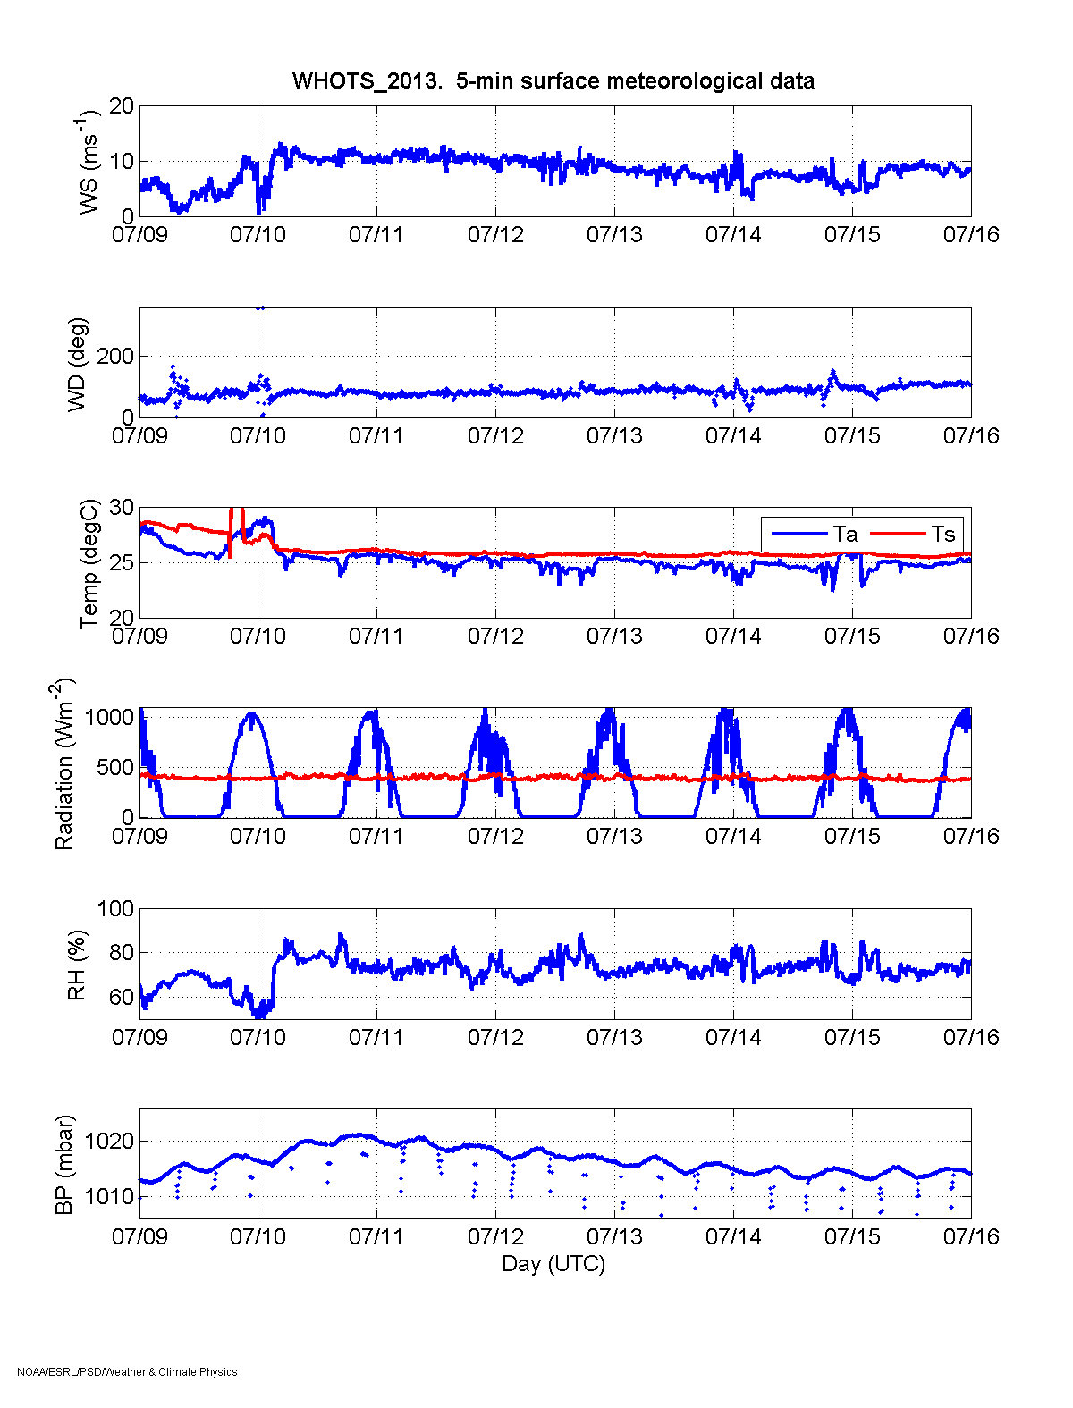
Time series of from top to bottom wind speed, wind direction (T), Air blue) and sea surface (red) temperatures, long (blue) and short(red)-wave incoming radiation, relative humidity, and station pressure from YD 190-196 (UTC).
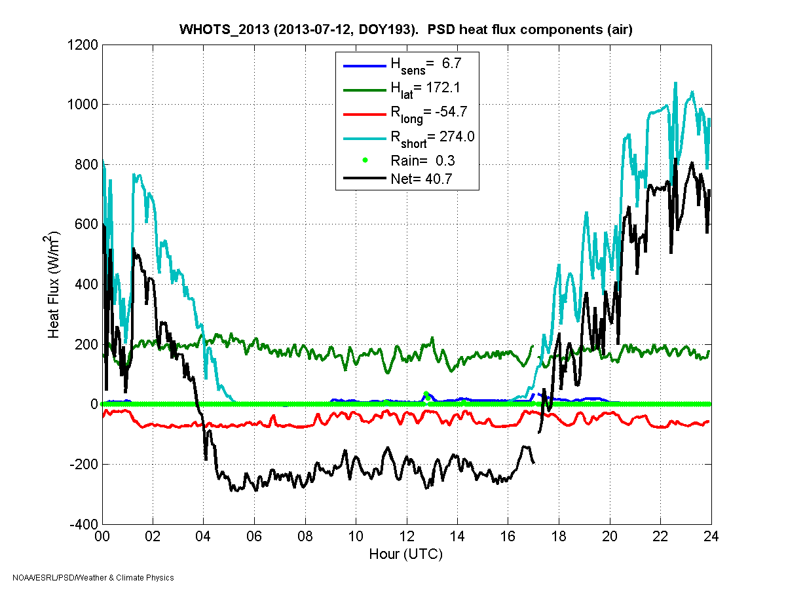
Time series of flux calculations July 12, 2013 YD 193. H_{sens} is sensible heat flux, H_{lat} is latent heat flux, R_{long} is long-wave flux, R_{short} is short-wave flux, Rain is flux due to rain, Net is sum of fluxes.
.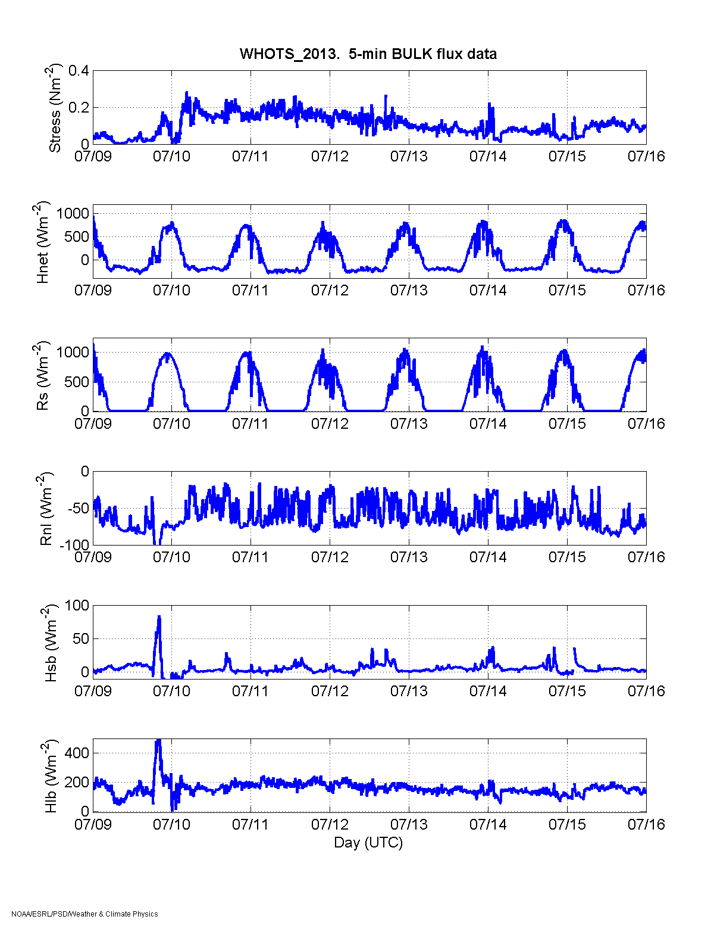
Time series of flux calculations July 9-15, 2013 YD 190-196. From top to bottom are stress, net, long-wave, short-wave, sensible, and latent fluxes from YD 190-196 (UTC)

Time series comparison of ESRL and ship temperature (top) and relative humidity (bottom) measurements July, 12, 2013 YD 193. Temperatures not height corrected.
Time series comparison of ESRL and ship sea surface temperature measurements July, 12, 2013 YD 193.

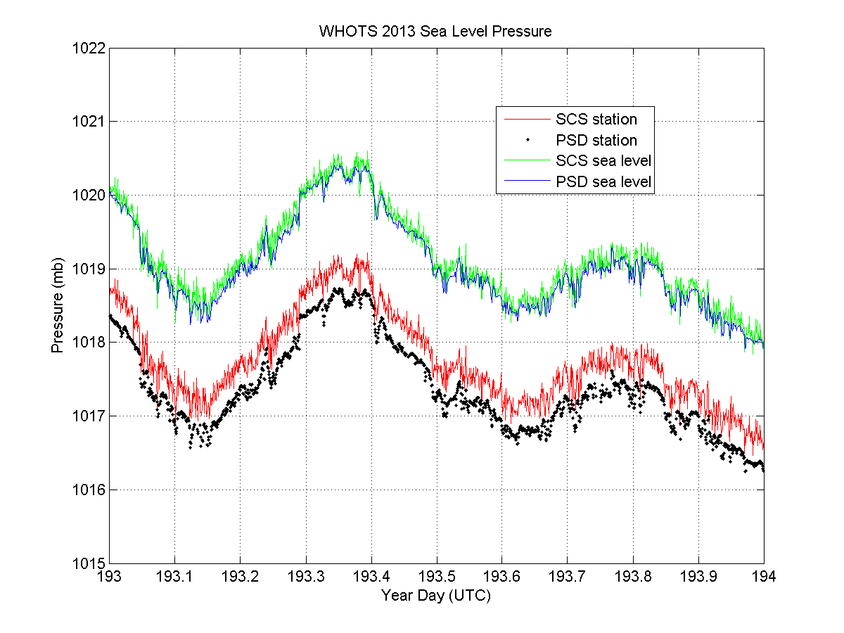
Time series comparison of ESRL and ship pressure measurements July, 12, 2013 YD 193. Sea level pressure calculated from station pressure using measure heights (Table 2 and 3).
Time series comparison of ESRL and ship True wind direction (top) and wind speed (bottom) measurements July, 12, 2013 YD 193. Wind speeds not height corrected.
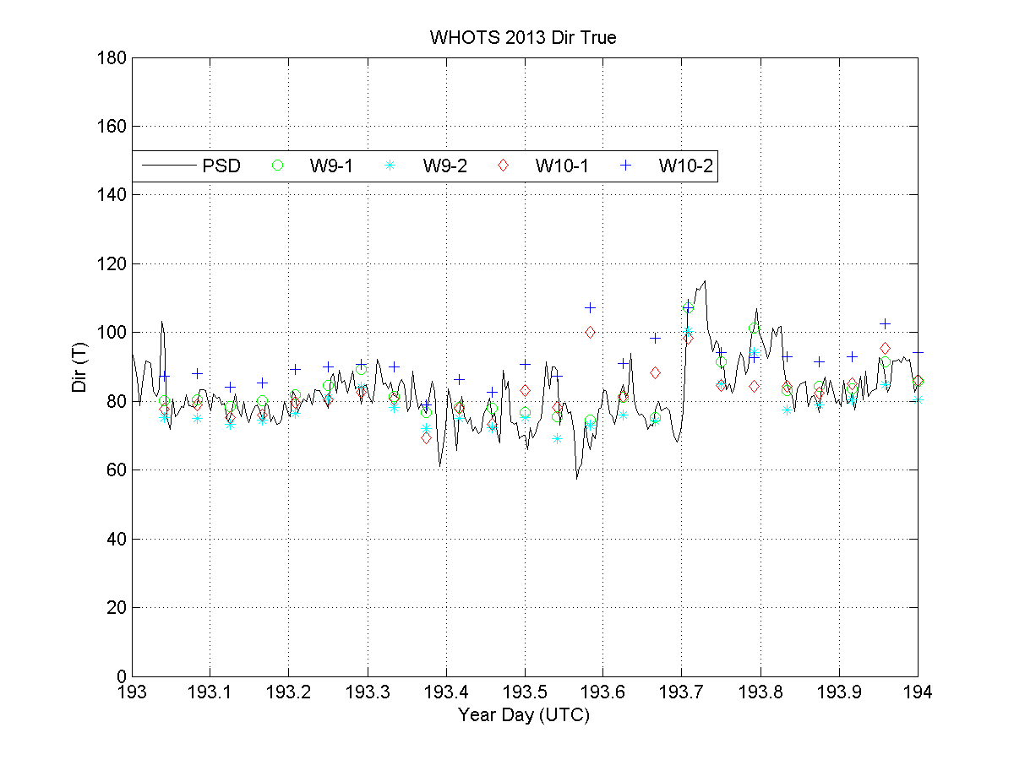
Time series comparison of ESRL and WHOI buoy True wind direction July, 12, 2013 YD 193. W9-1 and W9-2 are 2012 buoy. W10-1 and 2 are 2013 buoy. 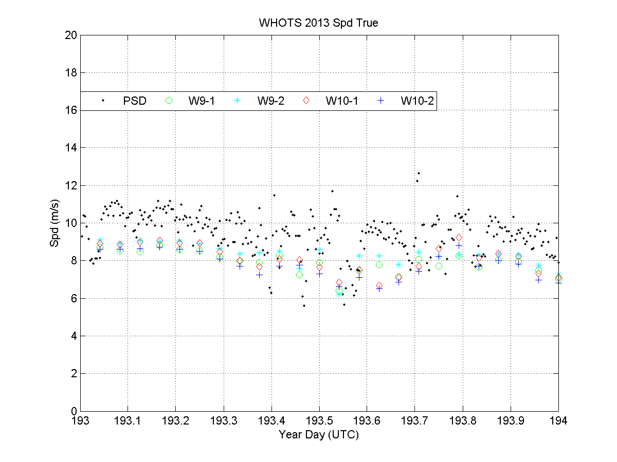Time series comparison of ESRL and WHOI buoy True wind direction July, 12, 2013 YD 193. W9-1 and W9-2 are 2012 buoy both sensors. W10-1 and 2 are 2013 buoy both sensors.
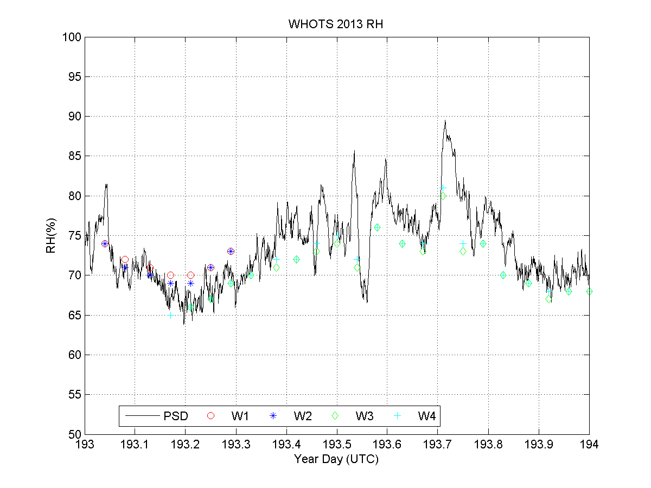
Time series comparison of ESRL and WHOI buoy relative humidity July, 12, 2013 YD 193. W1 and W2 are 2013 buoy both sensors. W3 and W4 are 2012 buoy both sensors.
Time series comparison of ESRL and WHOI buoy wind speed July, 12, 2013 YD 193. W1 and W2 are 2013 buoy both sensors. W3 and W4 are 2012 buoy both sensors. ESRL wind speeds not height corrected.
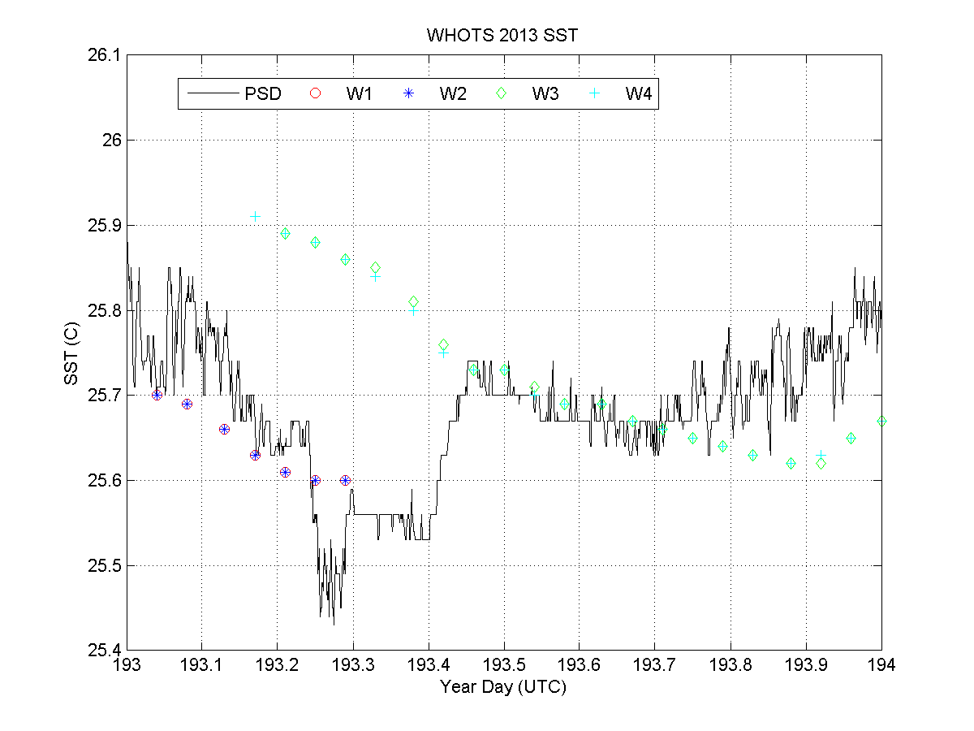
Time series comparison of ESRL and WHOI buoy sea surface temperature July, 12, 2013 YD 193. W1 and W2 are 2013 buoy both sensors. W3 and W4 are 2012 buoy both sensors.
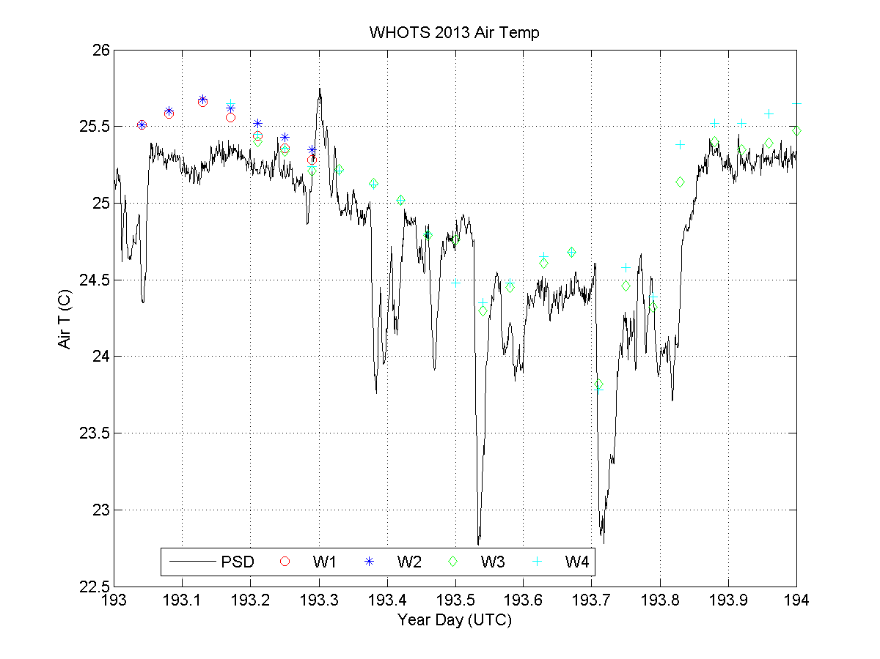
Time series comparison of ESRL and WHOI buoy air temperature July, 12, 2013 YD 193. W1 and W2 are 2013 buoy both sensors. W3 and W4 are 2012 buoy both sensors. ESRL temperature not height corrected.
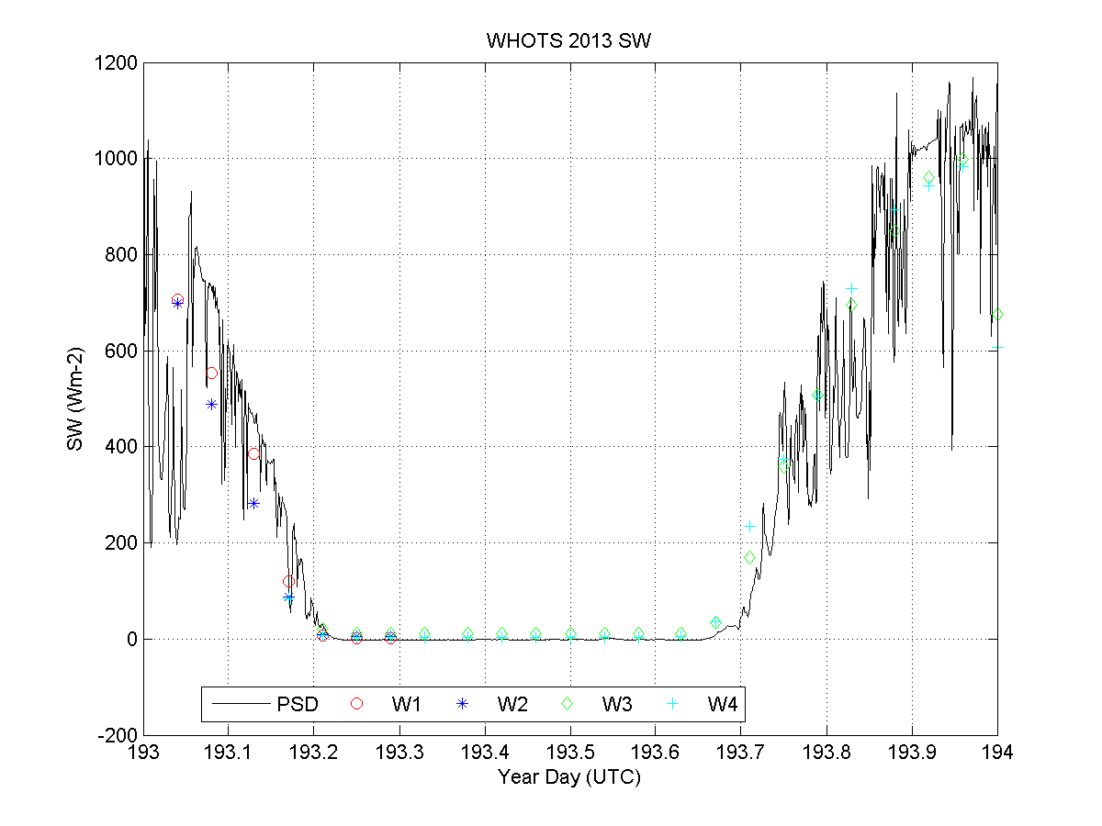
Time series comparison of ESRL and WHOI buoy incoming short-wave radiation July, 12, 2013 YD 193. W1 and W2 are 2013 buoy both sensors. W3 and W4 are 2012 buoy both sensors.
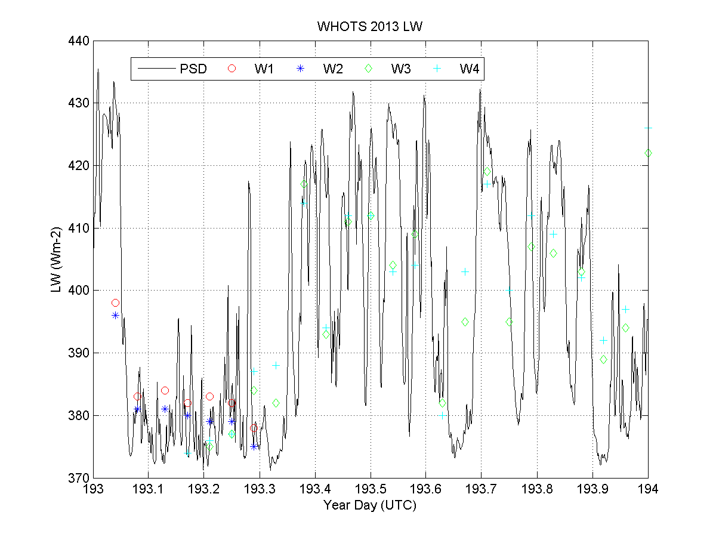
Time series comparison of ESRL and WHOI buoy incoming long-wave radiation July, 12, 2013 YD 193. W1 and W2 are 2013 buoy both sensors. W3 and W4 are 2012 buoy both sensors.

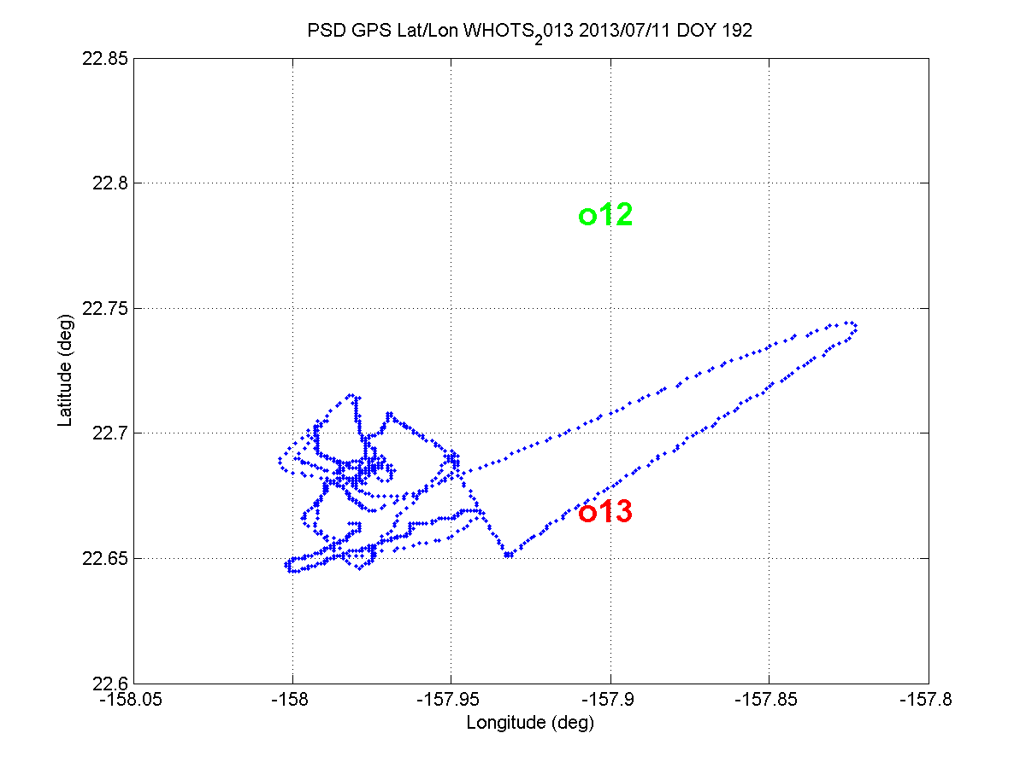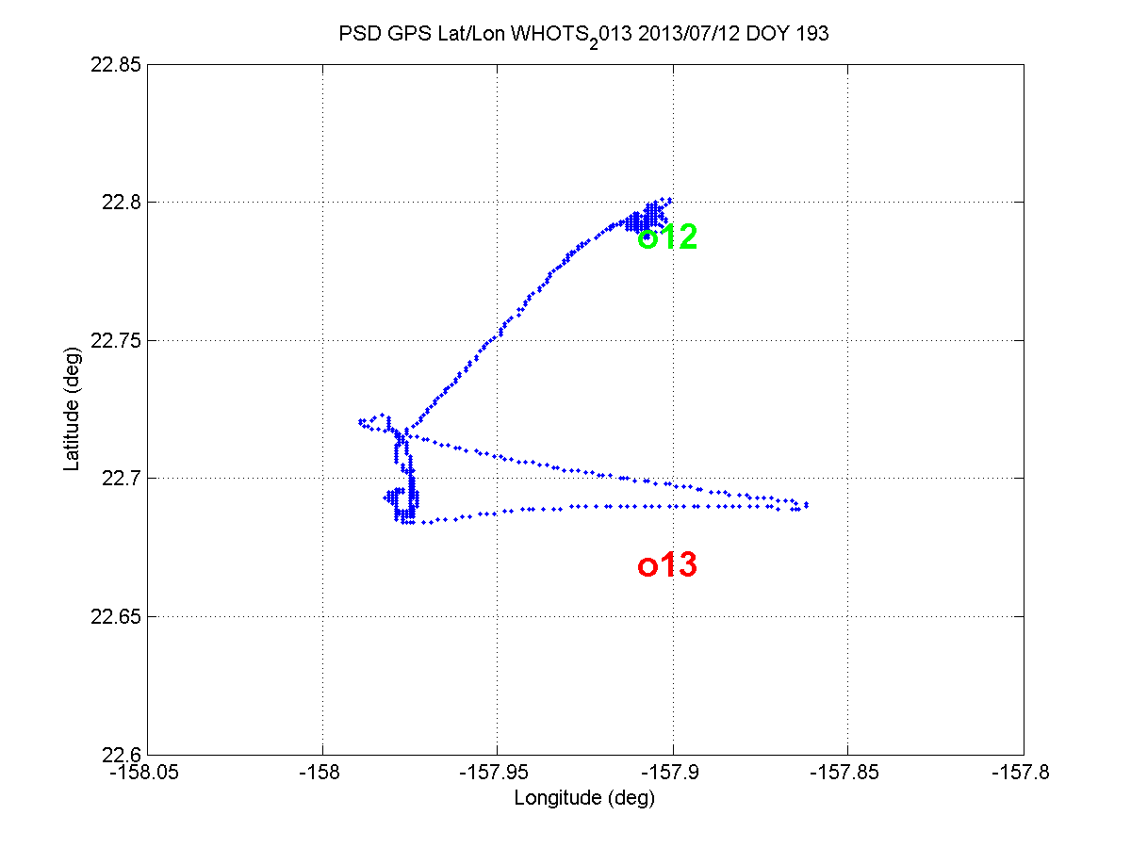

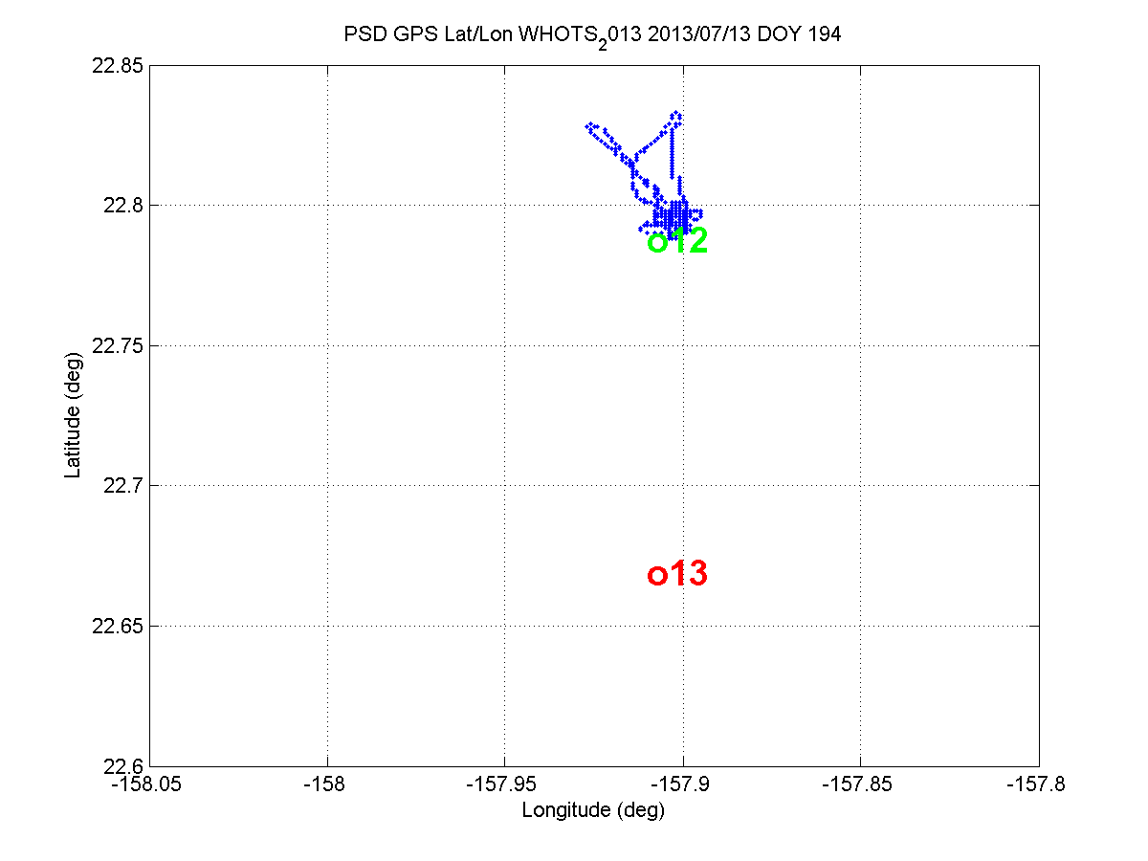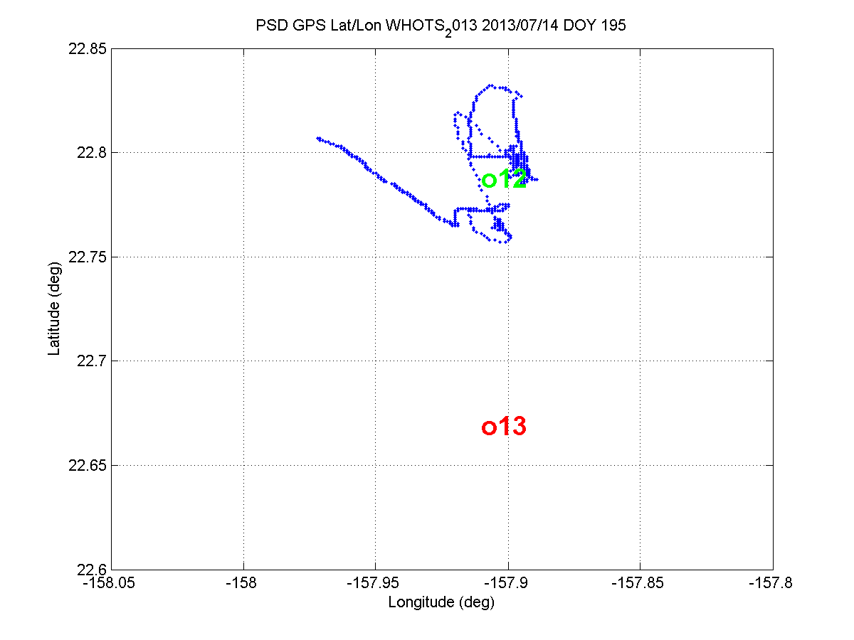
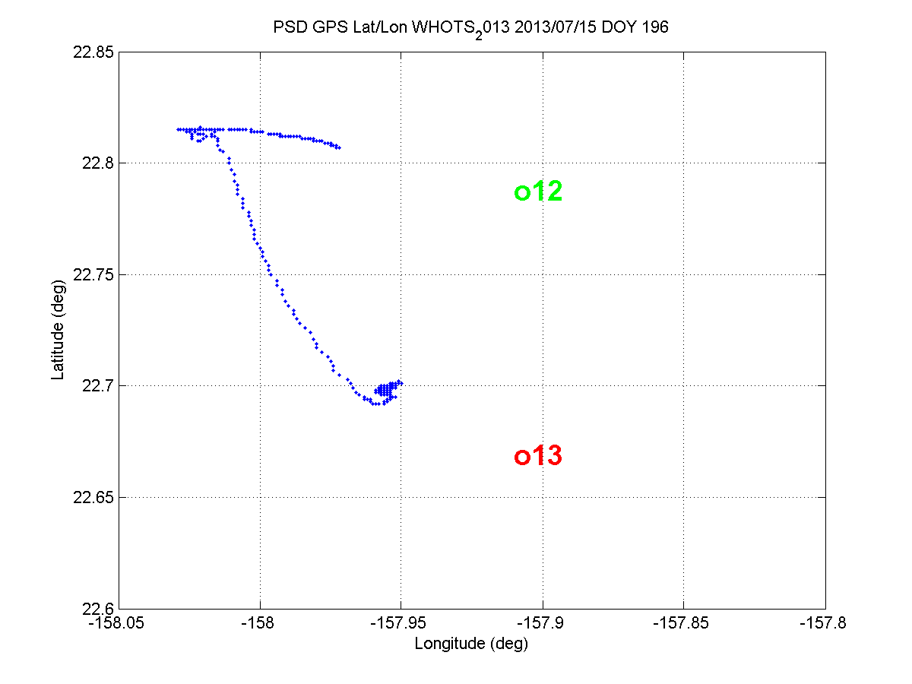
Buoy positions relative to ship track 12 (green) is 2012 W09 deployment and 13 (red) is 2013 W10 deployment. July 11-15, 2013 (Yd 192-196).

YD 189-190 transect from Pearl Harbor to new buoy location.
YD 191 ~1900 UTC new buoy in water
YD 192 ~ 0425 UTC anchor in water
YD 193 transect to old buoy (night of July 11, 2013)
YD 195 recovering old buoy 1616 UTC acoustic release triggered
YD 195 ~1706 UTC glass balls on surface.
YD 196 transect to new buoy (night of July 14, 2013).

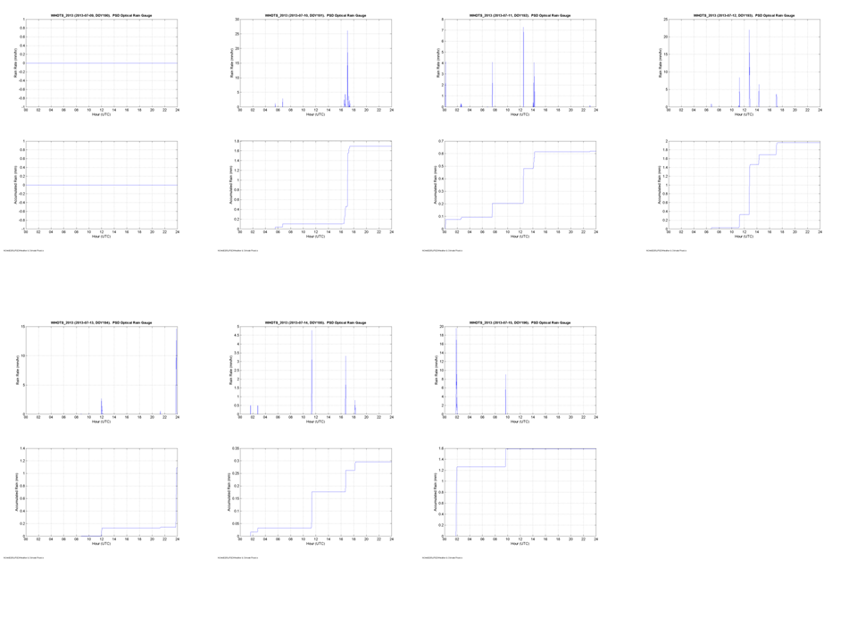
Rain rate and total accumulation on each day from July 9-15, 2013 UTC (YD 190-196).
(0mm, 1.7mm, .62mm. 1.95mm, 1.1mm, 2.99mm, 1.6mm)

