Budget Calculations using G4 Dropsondes.

C. Fairall 3 March 2016

Following Yanai et al. (1973) and Johnson et al. (2015)

Two basic temperature and moisture budget quantities are computed from a network of soundings:





Here θ is potential temperature, q specific humidity, QR the radiative flux divergence, cp the specific heat of air, c the rate of liquid water condensation, e the rate of evaporation, n and e subscripts denote the north and east horizontal coordinates, z the vertical coordinate, u the horizontal wind components, and w the vertical wind component. You can think of the right hand side of these equations as the convective forcing and the left side as the large-scale (measured) response.

If you add these two equations,



Where h is the moisture static energy (or, total enthalpy or equivalent potential temperature). This represents the subgridscale vertical eddy transport by turbulence and convective mixing. If we let the symbol <x> represent the integral of x from the surface to the tropopause, then





And



Here P is the precipitation rate, S the sensible heat flux, E the evaporation rate, and ‘0’ denotes the value at the surface. To compute  we have to assume a profile of QR, which is on the order of -1 K/day.



where R is the net radiative flux (+ downward). In the tropics, RTOA is about 45 W/m2 and R0 is about 150 W/m2, and .

The precipitation rate at the surface in mm/day is given by



The G4 dropsondes provide us profiles of T, RH, un, ue, and P. A given flight has 20-35 dropsondes. I have processed each drop:

1. Computed q from T, RH, P.
2. Remapped from top down to bottom up.
3. Interpolated to a common height grid.
4. Smoothed the profiles in the vertical.
5. Recomputed a new RH with respect to ice if T<0 C.

Processing of the profiles for thermodynamic quantities followed standard practice except we did not attempt to integrate around closed polygons to determine the budgets. Instead, we fit a lat-lon linear regression to an ensemble of drops. The ensemble may be a set of drops from one flight or from many flights, typically restricted to some latitude range where convection is active. This simplified the computations and allowed us to easily combine observations from multiple flights. Lat-lon fits were also done by Yanai et al. (1973).

The linear regression is of the form



yielding  ,  , etc. This allows us to compute the advection terms in Q1 and Q2. Also, we can use the wind component regression coefficients to compute divergence and vorticity





The vertical velocity is obtained from the integral of divergence



An example of a few derived profiles for flight 01 are shown on the next page. Average profiles of Q1, Q2 and moist static energy flux are shown on the next page. Notice that Q1 peaks much higher than Q2; this was observed in the original Yanai analysis. The separation of the peaks implies relatively weak contribution from stratiform precipitation (Johnson et al., 2015). The integral of the Q2 profiles yields a surface precipitation rate of about 24 mm/d. Another amusing reference to check out is Luo and Tung’s evaluation of atmospheric rivers using YOTC data. The moist static energy flux is about 10% of the moisture convergence.

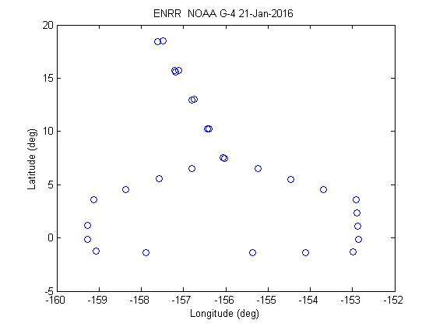

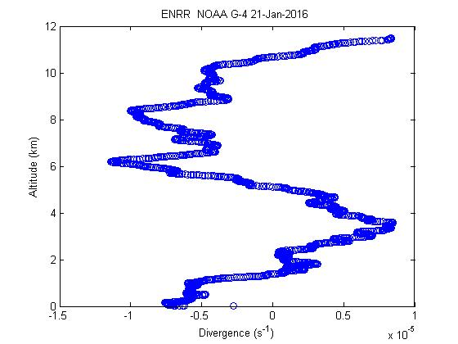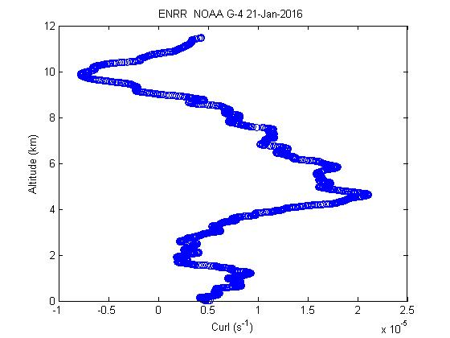

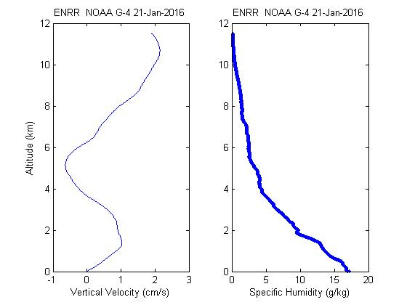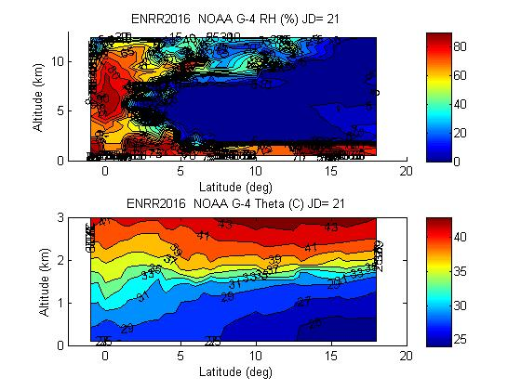

Sample profiles from Flight 01; divergence, etc, computer for data south of 6 N..

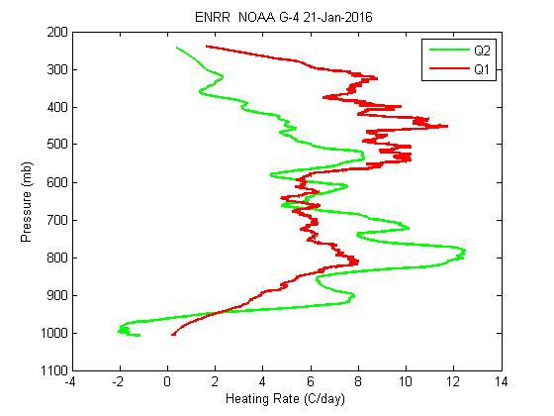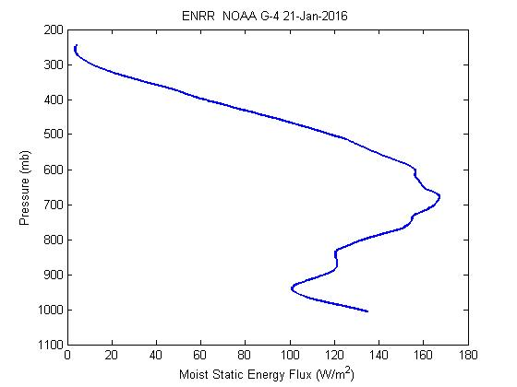



Example derived profiles from flights 01-15 for latitude < 6 deg.

Johnson, R.H., P.E. Ciesielski, H.H. Ruppert, and M. Katsumata, 2015: Sounding-based thermodynamic budgets for DYNAMO. J. Atmos. Sci., 72, 598- 622.

Luo, Q., and W.-W. Tung, 2015: Case study of moisture and heat budgets within atmospheric rivers. Mon. Wea. Rev., 143, 4145-4161.

Yanai, M., S. Esbensen, and J.-H. Chu, 1973: Determination of bulk properties of tropical cloud clusters from large-scale heat and moisture budgets. J. Atmos. Sci., 30, 611-627.