Direct/bulk fluxes from the 2013 HiWinGS Cruise – Version 1

PSD Air-Sea Interaction Group
Ludovic Bariteau, Chris Fairall, Sergio Pezoa, Byron Blomquist
NOAA/ESRL
Boulder, CO USA
July 11, 2014
Chris.Fairall@noaa.gov
Ludovic.Bariteau@noaa.gov

This document is the Readme for HiWinGS2013_flux_10_v1.txt and HiWinGS2013_flux_hr_v1.txt. The _hr refers to hourly averages and the _10 refers to the 10-minute averages. Both direct (covariance) and inertial-dissipation (ID) turbulent flux calculations are included in this present data. The period covered is DOY 283 (October 10, 2013) through DOY 317 (November 13, 2014). The graph below gives the ship tracks for the data period.
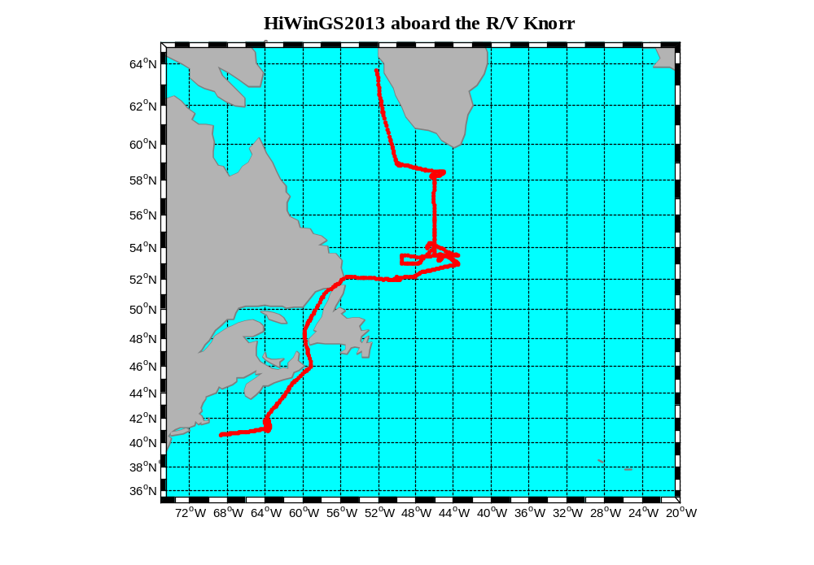
Figure 1. Tracks of R/V Knorr during HiWinGS2013

The PSD turbulent flux system was mounted on the ship’s foremast seen on Figure 2. Reference heights (with respect to water line) and sampling rates of the sensors used in the HiWinGS2013 experiment can be found in table 1.
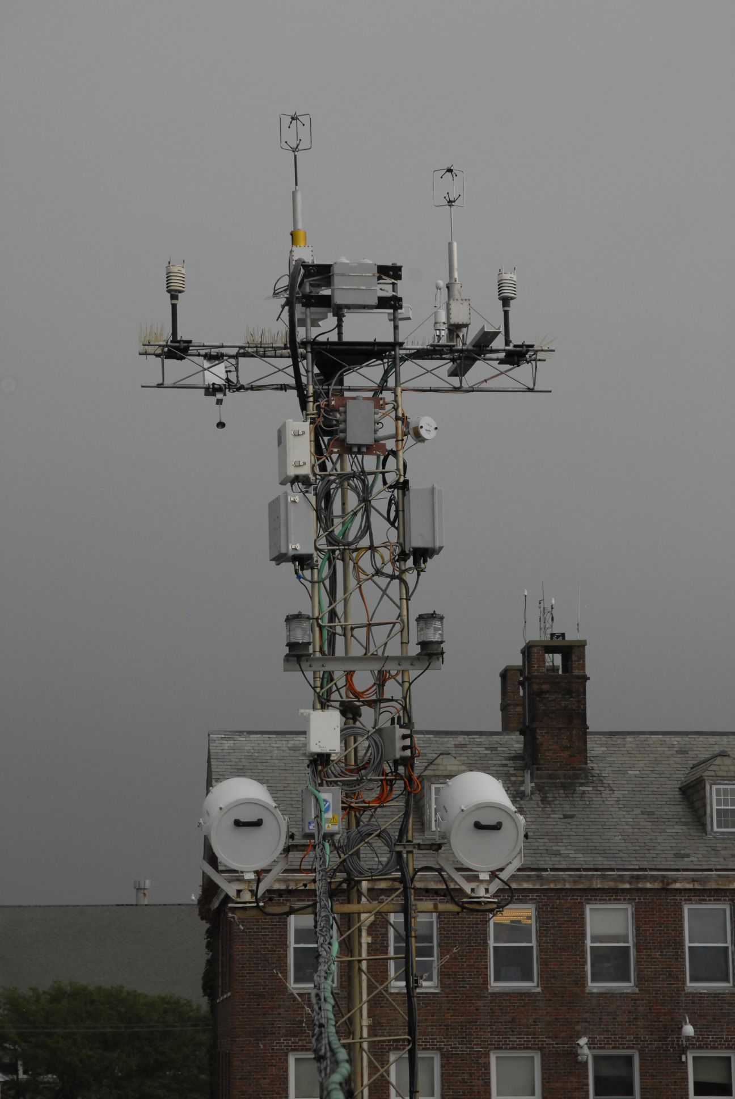
Figure 2. Views of the flux tower during HiWinGS 2013.

Sensor | Sampling rate | Height (m)
PSD sonic | 10 Hz | 15.9
Motion Pack | 10 Hz | 15.1
ORG | 0.1Hz, averaged to 1 sample/min | 15
T/RH | 1Hz | 14
Licor7500 (CO2&H2O) | 10 Hz | 15
Radiometers (top PSD van) | 0.1Hz, averaged to 1 sample/min | 11.5
Barometer | 0.1Hz, averaged to 1 sample/min | 11
SST | 0.1Hz, averaged to 1 sample/min | -0.05 to -0.10
Table 1. PSD sensor heights and sampling rates.

- Column assignment for HiWinGS2013_flux_10_v1.txt and HiWinGS2013_flux_hr_v1.txt files

The files are 56 columns:
• First column is the decimal day-of-year date
• Columns 3 to 11 are mean variables from the PSD system
• Columns 12 to 21 are turbulent fluxes (covariance, ID, and bulk)
• Columns 22 to 23 are the radiative fluxes
• Columns 24 is the rain rate
• Columns 25 to 27 are turbulence data quality indicators
• Columns 28 to 31 are the turbulent structure function parameters (indices of small-scale turbulence in the inertial subrange).
• Columns 32 to 33 are the minor (rain and Webb) heat flux components;
• Columns 34 to 35 are latitude and longitude;
• Columns 36 to 38 are the heights of the PSD wind, temperature, and humidity mean sensors.
• Columns 39 to 48 are mean variables from the ships sensors. As no data from the ship were available, these variables were setup to Not-a-Number (NaN)
• Columns 49 to 53 are data computed from the LICOR-7500 open path IR sensor.
• Column 54 is the atmospheric pressure
• Columns 55 and 56 are the true wind speed and direction (from) relative to earth

The files can be directly acquired with a MATLAB ‘load’ statement. For instance:
x=load('your_local_directory\ HiWinGS2013_flux_10_v1.txt ');%read file with 10-min average data; set your local directory. The columns assignment is as follows:
jdy=x(:,1);%day-of-year at beginning of time average
ushp=x(:,2)%doppler log, SCS (m/s) →not available, replaced by SOG
U=x(:,3);%true wind PSD sonic relative to water (m/s)
dir=x(:,4);%true wind direction from relative to water, PSD sonic (deg)
urel=x(:,5);%relative wind speed, PSD (m/s)
reldir=x(:,6);%relative wind dir (from),clockwise rel ship's bow, PSD sonic (deg)
head=x(:,7);%ship heading, deg clockwise rel north, PSD GPS
tsnk=x(:,8);%sea snake temperature, PSD (C)
ta=x(:,9);%air temperature (C)%
qse=x(:,10);%sea surface specific humidity from snake (g/kg)
qa=x(:,11);%air specific humidity (g/kg)
hsc=x(:,12);%sensible heat flux, covariance, PSD sonic anemometer(W/m^2)
hsib=x(:,13);%sensible heat flux, ID, PSD sonic anemometer(W/m^2)
hsb=x(:,14);%bulk sensible heat flux, (W/m^2)
hlc=x(:,15);%latent heat flux, covariance, (W/m^2)
hlib=x(:,16);%latent heat flux, ID, (W/m^2)
hlb=x(:,17);%bulk latent heat flux, W/m^2 (includes Webb et al. correction)
taucx=x(:,18);%covariance streamwise stress, PSD sonic anemometer (N/m^2)
taucy=x(:,19);%covariance cross-stream stress, PSD sonic anemometer (N/m^2)
tauib=x(:,20);%ID streamwise stress, PSD sonic anemometer (N/m^2)
taub=x(:,21);%bulk wind stress along mean wind, (N/m^2)
rs=x(:,22);%downward solar flux, PSD units (W/m^2)
rl=x(:,23);%downward IR flux, PSD units (W/m^2)
org=x(:,24);%rainrate, PSD STI optical rain gauge (mm/hr)
J=x(:,25);%ship plume contamination index
tiltx=x(:,26);%flow tilt at PSD sonic anemometer
Jm=x(:,27);%ship maneuver index
ct=x(:,28);%ct^2 (K^2/m^.667)
cq=x(:,29);%cq^2 ((g/kg)^2/m^.667)
cu=x(:,30);%cu^2 ((m/s)^2/m^.667)
cw=x(:,31);%cw^2 ((m/s)^2/m^.667)
hrain=x(:,32);%rain heat flux, Gosnell et al 1995, JGR, 18437-18442 (W/m^2)
hlwebb=x(:,33);%correction to measured latent heat flux, Webb et al.
lat=x(:,34);%latitude, deg (PSD pcode)
lon=x(:,35);%longitude, deg (PSD pcode)
zu_psd=x(:,36);%height of mean wind sensor, 17.75 m
zt_psd=x(:,37);%height of mean air temperature sensor, 15.6 m
zq_psd=x(:,38);%height of mean air humidity sensor, 15.6 m
%***** ships imet and scs data
sog=x(:,39);%speed over ground, SCS gps, (m/s)
U_scs=x(:,40); %true wind speed relative to earth m/s) – 19.6m
dir_scs=x(:,41);%true wind direction from relative to earth, clockwise rel north (deg)
cog=x(:,42);%%course over ground, SCS gps, (m/s)
tsg=x(:,43);%tsg water temperature (C)
ta_im=x(:,44);%imet air temperature (C)
qs_tsg=x(:,45);%imet bulk water specific humidity (g/kg)
qa_im=x(:,46);%imet air specific humidity, (g/kg)
rs_im=x(:,47);%imet solar flux, (W/m^2)
rl_im=x(:,48);%imet IR flux (W/m^2)
wco2_lic=x(:,49);%LICOR 7500 CO2 flux, (micatm m/s)
q_lic=x(:,50);%Specific humidity from LICOR (g/kg)
sgq_lic=x(:,51);%Standard deviation of specific humidity from LICOR (g/kg)
co2_lic=x(:,52); %CO2 concentration from Licor (umol/mol)
sgC_lic=x(:,53);%Standard deviation of CO2 concentration from LICOR (microatm)
press=x(:,54); %Atmospheric pressure (mb)
Uearth=x(:,55); %True wind speed (m/s) relative to earth
direarth=x(:,56); % True wind direction (deg) from relative to earth

Notes:

• True wind speed is computed from the sonic anemometer using PSD GPS system and the surface currents measured by the ship's ADCP; thus, U is interpreted as the speed relative to water. Some modest corrections have also been used to minimize flow distortion due to the ship’s structure. The wind speed components relative to water have then been used to compute the fluxes.

• On DOY 301, power to the flux tower was lost and was restored on DOY309. During that time period, some instruments were off and some did not come back afterward. This includes the laser altimeter and the PSD motion pack. To motion correct the PSD sonic after DOY 309, the UH motion pack was used instead.

• SST is from the PSD seasnake which has some suspicious behavior during high winds when it was found to be flying out in the air.

• Following post-calibration, the PSD air temperature, humidity and atmospheric pressure were adjusted to match the best available QC mean data available at: ftp://ftp1.esrl.noaa.gov/psd3/cruises/HIWINGS_2013/Knorr/Scientific_analysis/MeanNBulkfluxes/

• Bulk estimates of air sea fluxes were computed using the COARE bulk algorithm version 3.5.

• In processing the 10-min data to one-hr averages, only the filtered data were used in averaging the turbulence variables. If there were no valid values in the 1-hr interval, the turbulence variables were set to NaN. The quality criteria were subdivided in two parts:
- A value of J=0 implies no ship contamination.
- A value of Jm<3 implies no significant maneuver during the average.

• Because the IR hygrometer detects water vapor mass concentration (ρv in kg/m3), the water vapor -velocity correlation must be corrected as per Webb et al (Hlatent = Le <w’ ρv’> + hl_webb). The values given for covariance and ID latent heat fluxes in the file are Le<w’ ρv’>. Values for hl_webb are included in column 33. This should be applied to the covariance and ID values. It is already included in the bulk values given here.

• Both latent and CO2 fluxes are computed from the LICOR-7500 open path IR sensor. The CO2 fluxes have been corrected for the humidity Webb effect but not for the temperature Webb effect.

• Sensible heat flux was computed from vertical velocity -sonic temperature covariance and Inertial-dissipation (ID) methods. The humidity contribution to sonic temperature was removed using the bulk latent heat flux.

- Time series

Figures 3, 4 and 5 show the time series for stress, sensible heat, and latent heat for that cruise.

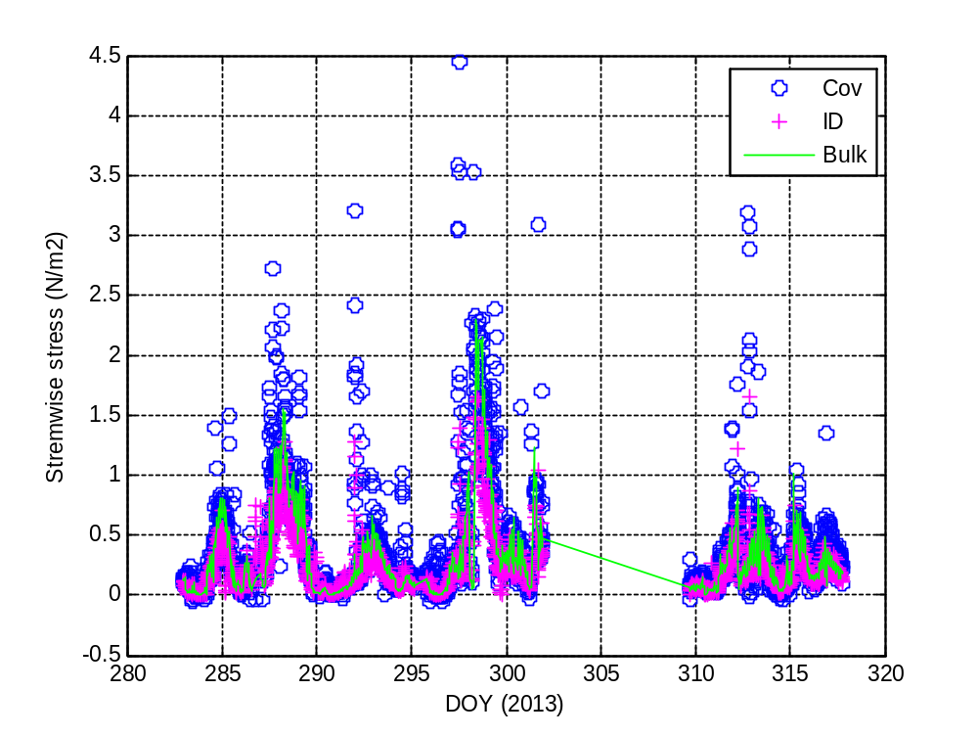
Figure 3. Time series of turbulent surface stress in HiWinGS 2013: green line - bulk estimate; magenta ‘+’ - ID; blue circles - covariance measurement.
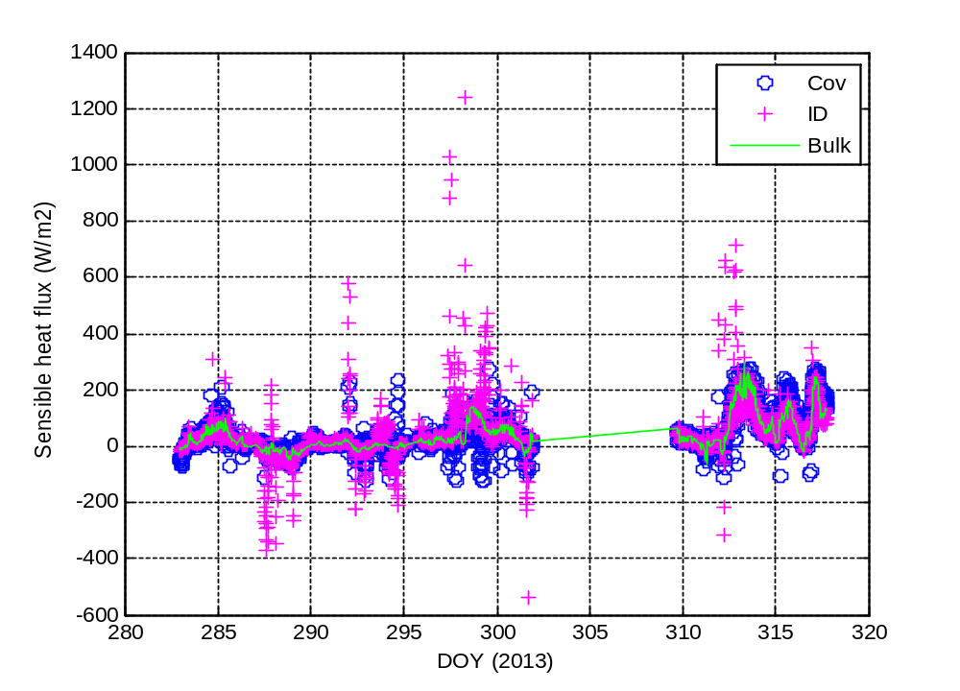
Figure 4. Time series of sensible heat flux in HiWinGS2013: green line - bulk estimate; magenta ‘+’ - ID; blue circles - covariance measurement.
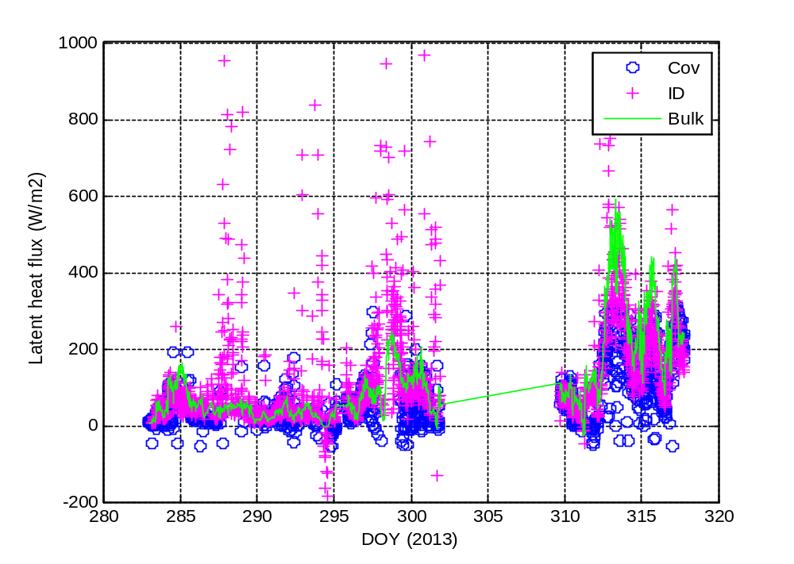
Figure 5. Time series of latent heat flux in HiWinGS 2013: green line - bulk estimate; magenta ‘+’ - ID; blue circles - covariance measurement.

