NOAA/PSD

Primary Turbulent Flux Data Acquisition System Ship-based

Rev 1.9

Technical Reference Guide for Turbulent Flux System

HiWings Campaign 2013

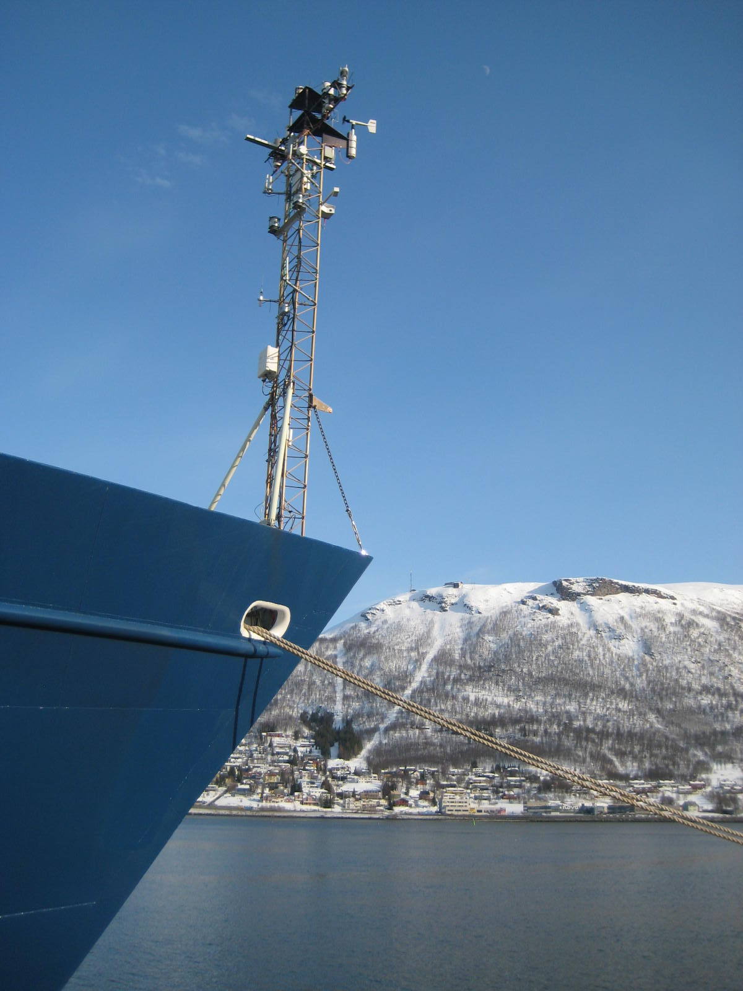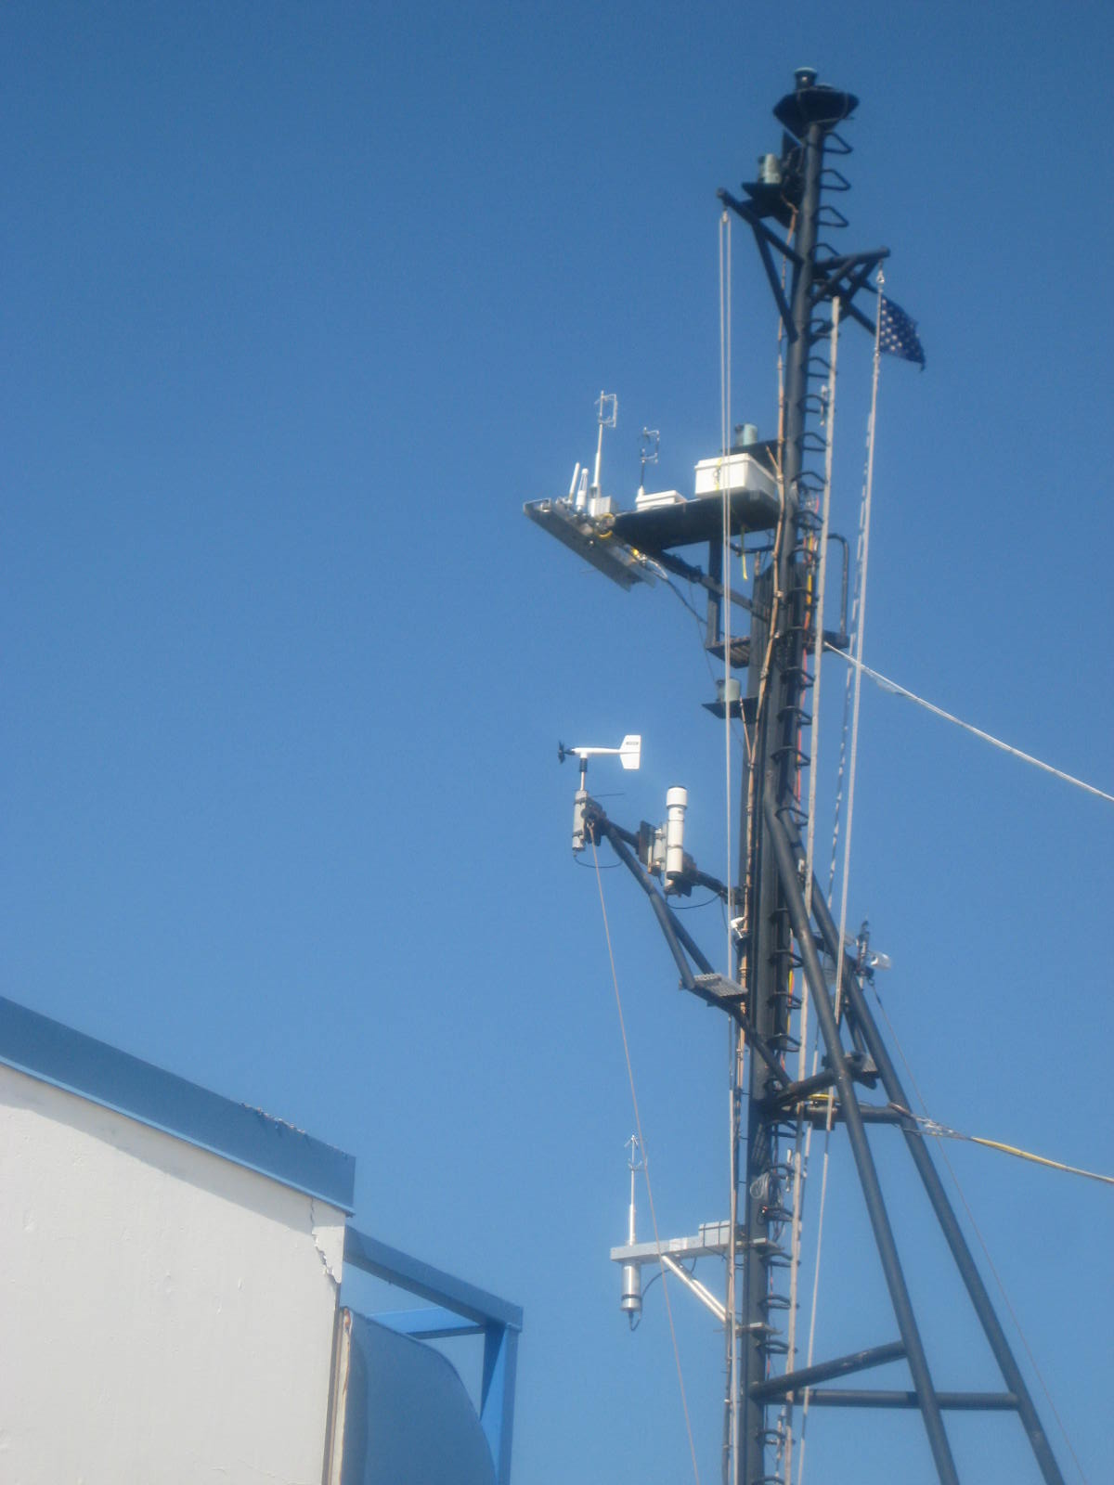
Turbulence Flux System setup Turbulence Flux System setup on
on R/V Knorr main mast of R/V Ronald Brown

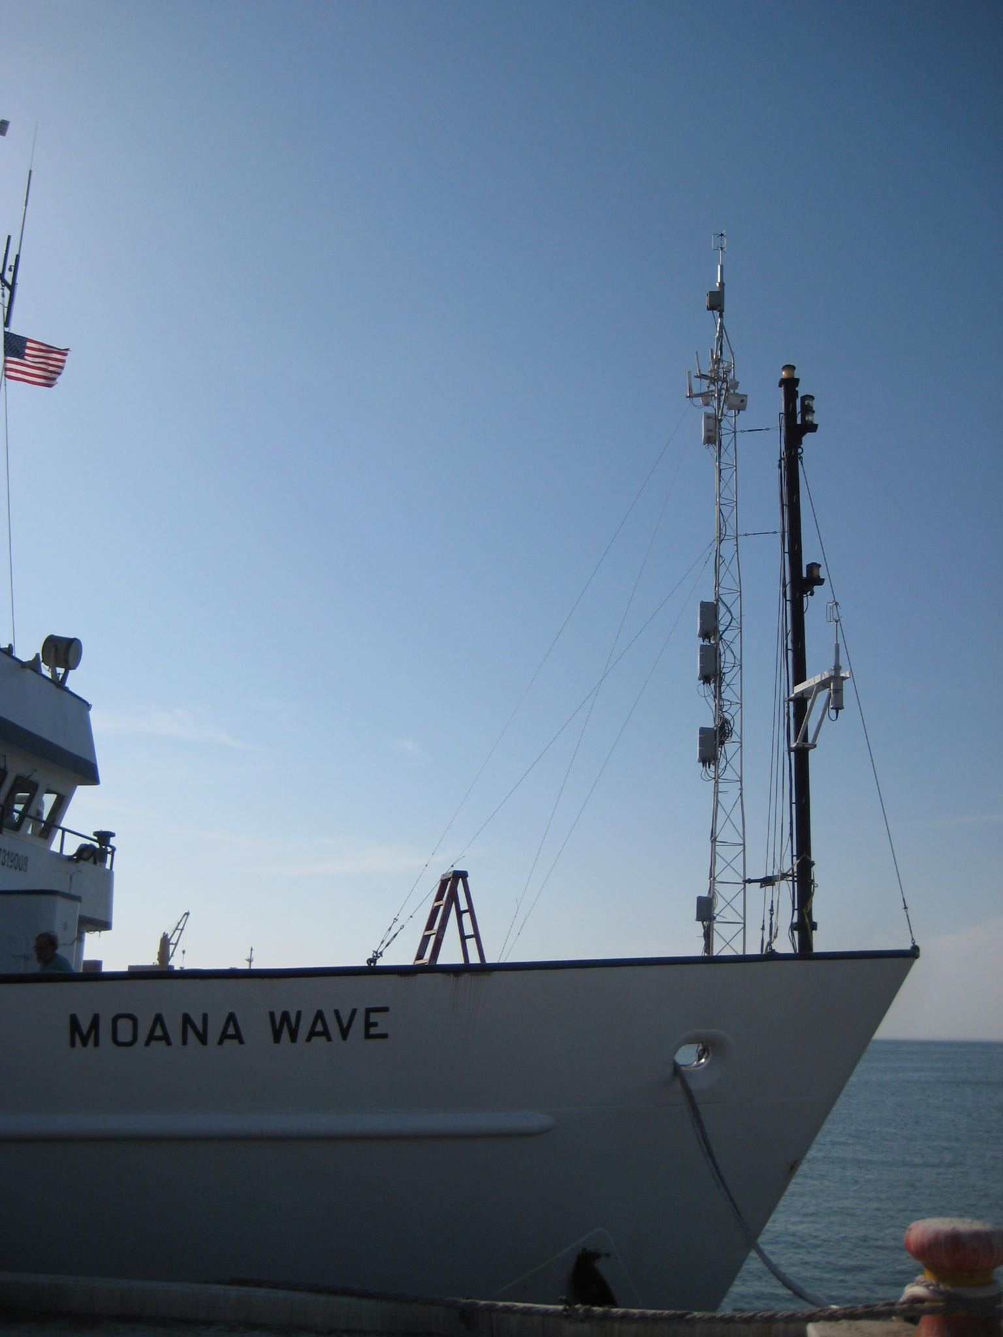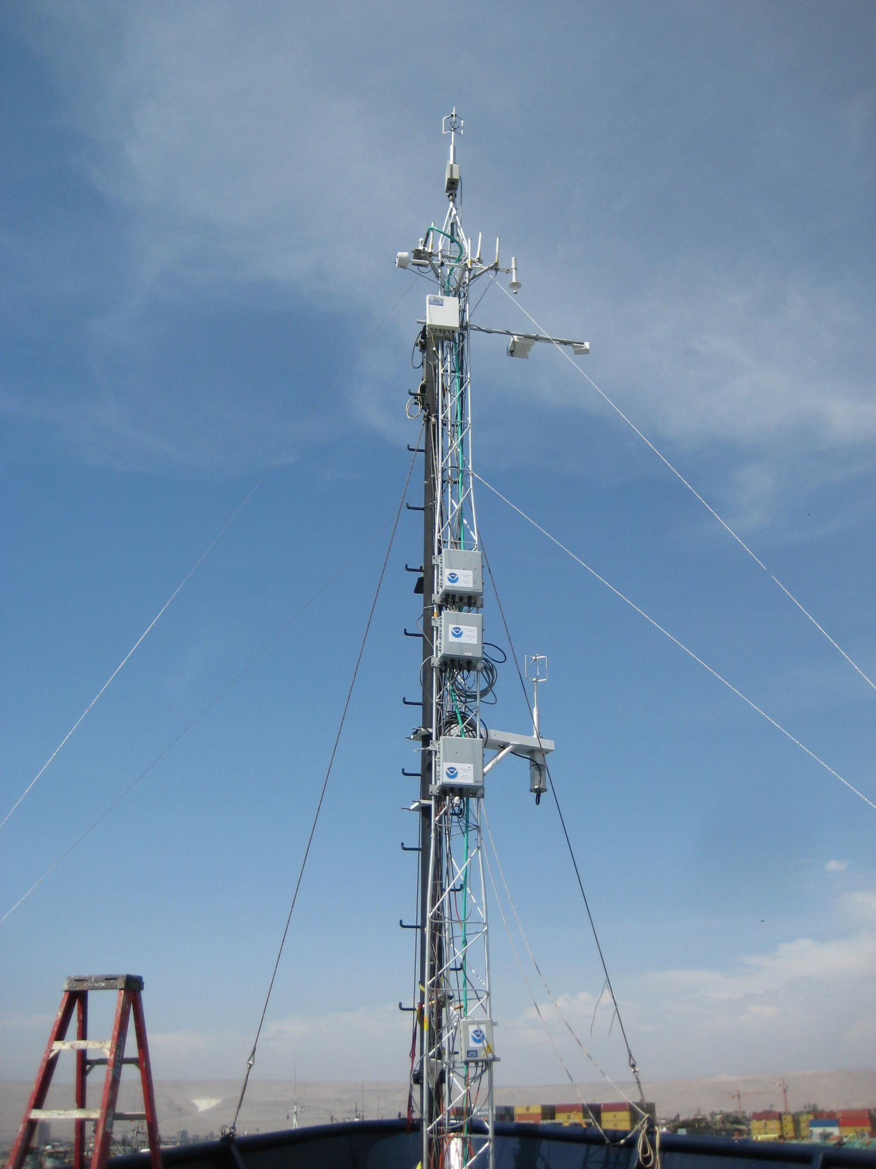
Turbulence Flux System set up on R/V Moana Wave

The PSD Turbulent Flux System

The PSD Turbulent Flux Measurement System consists of six components:

- A fast turbulence system with ship motion corrections mounted on the jack staff.

The sensors are:
- Ultrasonic anemometer, Gill Wind Master model R3A.
- Systron Donner Inertia Div. Motion-pak unit with serial number 0681.

- Solar and IR radiation sensors are:
- Radiometers from The Eppley Lab, two pyranometers and two pyrgeometers mounted on the top of bridge or highest and unobstructed sky-see location.

- Bulk Meteorology-sensor are:
- Mean Vaisala T/RH (sensor s/n)sensor in aspirator,
- Near-Skin Surface Temperature (SST), SST measurement is made with a floating (YSI 46040) thermistor deployed off port side with outrigger.
- Optical Scientific Inc.-Optical Precipitation Sensor model ORG-815 DA.

- Li-COR 7500 fast CO2/H2Ogas analyzer - mounted on the top of bow tower.
- Two differential GPS heading, pitch and roll information.

- A Riegl laser rangefinder wave gauge – mounted at a high point on the bow mast.

Item | System | Measurement
1 | Air-sea flux system | Motion corrected turbulent fluxes
2 | 3 Axis Motion system | Motion correcting for turbulent fluxes
3 | Pyranometer & Pyrgeometer | Downward solar radiative, IR flux
4 | Bulk meteorology | Tair, Relative Humidity, wind speed
5 | Optical Rain gauges | Rain rate
6 | Open Path LI-7500 Analyzer | CO2/H2O
7 | Sea Snake | Sea surface temperature

Table 1. Instruments used for air-sea interaction, cloud, and precipitation studies.

Acquisition System Structure

Two computes are used to log, archive and display instruments data sets; one computer is used solely as the data acquisition system while the other computer serves as real time display data and as the platform for daily diagnostics.

The instruments data is transmitted to the acquisition computer via a selected serial communication ports or via a selected wireless radio modems. The Data Acquisition System consist of two data loggers, six self contained instruments and two Microsoft Windows XP professional computer.
- Campbell CR1000 data logger, slow mean data MEAN1(1Hz)
- Campbell CR1000 data logger, fast data Ship Motion(10Hz)
- Wind Master Pro Ultrasonic Anemometer Gill (10Hz)
- Open Path CO2/H2O Analyzer- LI-COR 7500 (10Hz)
- Motion Pak Systron & Donner model MP-GDDDQBBB-100 (10Hz)
- Two of Crescent Hemisphere GPS-VS100 Heading, pitch/roll (10Hz)
- Distance Meter Riegl LD90 3100VHS-FLP (10Hz)
- PS3DAS01 Microsoft Windows XP professional computer.
- PS3DAS02 Microsoft Windows XP professional computer.

PS3DAS01 computer collects real time data using a 16 serial port interface PCI device and a PSD developed sophisticated data acquisition software.
Ports COM3 thru COM10 are used for flux data acquisition instruments.
COM11 thru COM18 are available for other instruments to be included in the present study.

Data Files

All logged and archived data file names are formatted as follows:
aaabYYJJJHH_raw.txt

aaa: Instrument identification
b: Index , default is 0 for one instrument
YY: last two digits of year
JJJ: julian day
HH: hour

Time stamp structure is as follows:

Timestamp: mmssmmm
mm: minutes
ss: seconds
mmm: milliseconds

The data files are logged initially on folder D:\Data. The daily files are moved to a daily folder of the form of D:\Data\<YYJJJ> at the end of the UTC day.

Archived files have the following format:

- Combined Ship Data - scs0YYJJJhh_raw.txt (optional, depending on ship data logging system)
- Ship Motion data – mot0YYJJJhh_raw.txt

- Met Data logger – met0YYJJJhh_raw.txt

- 7500 Licor gas analyzer – lic0YYJJJhh_raw.txt

- GPS Cresent VS100 – gps0YYJJJhh_raw.txt

- Ship Heading& pitch - Crescent VS100– hed0YYJJJhh_raw.txt

- Sonic anemometer – son0YYJJJhh_raw.txt

- Laser Wave sensor – lsr0YYJJJhh_raw.txt

- 7200 Licor gas analyzer – li00YYJJJhh_raw.txt

- Picarro gas analyzer – pic0YYJJJhh_raw.txt

- MFS serial frick – mfs0YYJJJhh_raw.txt

- CLAP1 particle analyzer – clp1YYJJJhh_raw.txt

- CLAP2 particle analyzer – clp2YYJJJhh_raw.txt

- Aspirated Vaisala Temperature and Humidity – trh0YYJJJhh_raw.txt

Serial port assignments and data descriptions:

- Serial Port COM1 reserved

- Serial Port COM2 reserved.
- Serial Port COM3-Gill Sonic Anemometer.
Data is acquired at 19200 baud rate and a sampling rate of 10Hz.

Data parameters are separated by a comma and file name format is:
son0YYJJJhh_raw.txt

See bellow an example of the first and second lines of an hourly Anemometer raw data file.
First line shows: Date, Hour, Instrument Description.

10/07/2008 17:00 GILL ANEMOMETER-1210R3 (SN: 0137)
0000029 04,00,-00.51,-13.00,+02.42,+33.94,0B

- Timestamp
- Status Address
- Status Data
- U (m/s)
- V (m/s)
- W (m/s)
- Sonic Temperature (deg C°)
- Check sum

- Serial Port COM4- LI-7500 Gas Analyzer.
Data are acquired at 19200 baud rate and a sampling rate of 10Hz.

Data parameters are separated by space and the file name format is:
lic0yyjjjhh_raw.txt
See bellow an example of the first and second lines of an hourly Licor 7500 raw data file.
First line shows: Date, Hour, Instrument Description.

10/18/2008 02:00 LI-7500 (SN: 0772)
0000048 250 9.7144 765.788 30.02 101.0

- Timestamp
- Diagnostic code
- CO2 (mmol/m3)
- HO2 ( mmol/m3)
- Temperature (deg C°)
- Pressure (kPa)

Temperature is in C, and Pressure is in kPa.
In some instances Absorptances are not recorded

- Serial Port COM5- Mean data logger-, Surface Water Temperature,Rain Rate, Solar radiation, IR radiation and Ambient Pressure.
Data is acquired at 9600 baud rate and a sampling rate of 1Hz.
Data parameters are separated by commas the file name format is:
met0yyjjjhh_raw.txt
See bellow an example of the first and second lines of an hourly Mean raw data file.
First line shows: Date, Hour, Instrument Description.

10/18/2008 14:00 CR1000-CAMPBELL (SN: 3649)
0006901 176,2008,292,1359,7267.4,7099.3,7118.5,6881.3,2631,1.1867,4.0956,-.29308,-.25627,4.4952,4.3684,5.0893,.03931,33.172,33.79,33.719,34.617,29.898,27.469,81.913,-47.5,-70.598,506.79,502.11,-.02703,13.022,240.48,3.4752,1011.5, 22.025,16.659,26.541, 15.699,2.0023,.00046,.002,.00738,.01465,.0285,.02852,.00005,.00009,.07978,.06209,.09849,.06062,.01792,.0184,.03998,1.196,4.0365,3.213,3.2782,.00035,.00252,2.1563,.0018,.10828

- Timestamp
- Case Resistance PIR1-average
- Case Temperature PIR1-avearage
- Dome Resistance PIR1-average
- Dome Temperature PIR1-average
- Case Resistance PIR2-average
- Case temperature PIR2-average
- Dome Resistance PIR2-average
- Dome Temperature PIR2-average
- PIR1 voltage
- PIR1 w/m2
- PIR2 voltage
- PIR2 w/m2
- PSP1 voltage -average
- PSP1 w/m2 -average
- PSP2 voltage -average
- PSP2 w/m2 -average
- ORG Rain Gauge Carrier Voltage -average
- ORG Rain Gauge Sensing Voltage –average
- ORG1 mm/hr – average
- Sea snake 2 wire resistance - average
- Sea snake 2 wire temperature in Celsius –average
- Sea snake 4 wire resistance – average
- Sea snake 4 wire temperature – average
- Atmospheric pressure hpa
- Aspirator air flow >0 flow is on -average

Note : after parameter 26, standard deviation measurements are made between parameters 2 and 26.

- Serial Port COM6- Ship Heading Crescent VS100s/n VS 072235040014
Data are acquired at 19200 baud rate and a sampling rate of 10Hz.

Data parameters are separated by commas and the file name format is: hed0yyjjjhh_raw.txt.
See bellow an example of the first two lines of an hourly Crescent VS100 raw data file.
First line shows: Date, Hour, Instrument Description.

10/15/2008 06:00 VS100/072235040014 (SN: 1234)
0000045 $PSAT,HPR,060002.65,298.17,-0.39,,N*19

1 Timestamp
2 $PSAT,HPR identifier
3 time UTC time (HHMMSS.SS)
4 heading in degrees
5 pitch in degrees
6 roll in degrees
7 type N for GPS, G for gyro

Note: This instrument measures heading or pitch.

- Serial Port COM7 – Wave Measurement RIEGL
Data are acquired at 9600 baud rate and a sampling rate of 20 Hz
Data parameters are separated by commas and the file name format is: lsr0yyjjjhh_raw.txt
See bellow an example of the first two lines of an hourly Riegl raw data file.
First line shows: Date, Hour, Instrument Description.

10/15/2008 01:00 LD90-3100VHS-FLP (SN: 12)
0000017 r7.389;a37;q27

- timestamp
- range in meters
- amplitud signal strength
- measurement quality

- Serial Port COM8-Ship pitch, roll and yaw motion with
Motion-pak data logger.
Data are acquired at 19200 baud rate and a sampling rate of 10Hz.
Data parameters are separated by commas and the file name format is:
mot0yyjjjhh_raw.txt
See bellow an example of the first two lines of an houly Systron and Donner raw data file.
First line shows: Date, Hour, Instrument Description.

10/07/2008 21:00 SYSTRON AND DONNER-100 (SN: 1124)
4814609 0.0122128,0.00814187,0.00814187,-0.1818351,-0.189977,-3.70226,-3.703194

- Timestamp
- Rate-x
- Rate-y
- Rate-z
- Acceleration-x
- Acceleration-y
- Acceleration-z
- Acceleration –z with divider for overflow

Rates and Accelerations are in Volts. It is normal for A-z to be -3.3 V

- Serial Port COM9- All Ship instruments-SCS data to be determent
Data are acquired at 9600 baud rate and a sampling rate of 1Hz.
Data parameters are separated by commas and the file name format is:
scs0yyjjjhh_raw.txt
See bellow an example of the first two lines of an hourly Ship raw data file.

First line shows: Date, Hour, Instrument Description.

10/15/2008 02:00 SHIP DATA (SN: 123)
0001728 020004.00,0701.2580N,08005.7242W,220.1,11.4,27.547,30.673, 85.37, 27.48, 4.7,18.78,224.5, 5.92,12.09,245.73,412.8

- Timestamp
- Ship timestamp (hhmmss.msms)
- Latitude (*100)
- Longitude (*100)
- Course-Over-Ground
- Speed-Over-Ground
- Sea water temperature (TSG)
- Salinity
- IMET RH (%)
- IMET Tair (C)
- IMET solar (W/m2)
- IMET rain
- Gyrocompass heading
- ODEC speed log (wrt water)
- IMET wind speed
- IMET wind direction
- IMET PIR (W/m2)

- Serial Port COM10- Ship position GPS Cresent VS100
Data are acquired at 19200 baud rate and a sampling rate of 10Hz.

There are two kind of GPS file format that will be seen on GPS files, with 3 different GPS codes ($GPRMC), ($GPGGA), ($GPVTG)

file name format: gps0yyjjjhh_raw.txt
Date, hour, instrument name and serial number are showed on every hourly file.

08/27/2007 18:00 Generic with ASCII Output (SN: 0013)
2514518$GPRMC,182512.10,A,3959.55406252,N,10515.73178677,W,0.01,15.97,2708,9.6,E,D*1D
2514578 $GPGGA,182512.20,3959.55406400,N,10515.73170,W,2,08,1.2,1665.0,M,20.7,M,5.2,
0138*49

06/12/2009 06:00 Generic with ASCII Output (SN: 12345)
0000077 $GPRMC,060000.40,A,3251.15194534,N,07956.64350164,W,0.01, 207.50, 120609, 7.3,W,D*3E
0000671 $GPVTG,145.12,T,152.46,M,0.01,N,0.02,K,D*22

$GPRMC coding
- Timestamp
- GPS code $GPRMC
- GPS time (HHMMSS.SS)
- Status ('A' = valid, 'V' = warning)
- Latitude in degrees, minutes and decimal minutes (DDMM.MMMMM)
- N or S latitude
- Longitude in degrees, minutes and decimal minutes(DDDMM.MMMMM)
- W or E longitude
- Speed-over-ground Z.Z in knots
- Track made good, reference to true north
- UTC date DDMMYY
- Magnetic Variation in degrees D.D
- Variation Sense v=E ;V=W
- *CC check sum

$GPGGA coding
- Timestamp
- GPS code $GPGGA
- GPS time (HHMMSS.SS)
- Latitude in degrees, minutes and decimal minutes (DDMM.MMMMM)
- s=N or S=S latitude
- Longitude in degrees, minutes and decimal minutes(DDDMM.MMMMM)
- s=W or S=E longitude
- N quality indicator 0= no pos, 1=un-differentially corrected position, 2=diff corrected position
- QQ = number of satellites
- PP.P = HDOT = 0.0 to 9.9
- Antenna altitude SAAAA.AA
- M altitude, M=meters
- +/- XXXXX.XX geoidal separation
- M geoidal separation units, M= meters
- SSS= age of differential correction
- AAA= ref station
- *CC check sum

$GPVTG coding
- Timestamp
- GPS code $GPVTG
- T
- True course over ground, 000 to 359 degrees
- Magnetic course over ground, 000 to 359 degrees
- M
- Speed over ground, 00.0 to 99.9 knots
- N
- Speed over ground, 00.0 to 99.9 kilometers per hour
- K
- Check sum
- Serial Port COM16- Vaisala Temperature and Relative Humidity.
Data is acquired at 9600 baud rate and a sampling rate of 1Hz.
Data parameters are separated by space and the file name format is:
trh0yyjjjhh_raw.txt
See bellow an example of the first two lines of an hourly Ship raw data file.

First line shows: Date, Hour, Instrument Description.

09/08/2013 17:00 Vaisala model HMP230 (SN: 12222)
0000189 100.300, 6.906, 6.907

- Timestamp
- Humidity
- Temperature Celsius
- Dew Point

Data Processing Computers are:

- Computer PS03DAS01 Data Archive
Computer Description: OptiPlex 330 Minitower, Pentium Dual Core E2180/2.0GHz,1M 800FSB
Main used Software in this computer are:
- Data Acquisition Setup software, this is a windows XP service that allows to setup RS232 serial ports, set up archiving location, folder and files archiving names and archive the data with time stamp.
- File Manager software, this is a Windows XP service allows to manage files as they are been archived.
- Clock synchronization Windows XP service allows sync computer clock with GPS or Network.

- Computer PS03DAS02 Data Analysis
Computer Description: OptiPlex 330 Minitower, Pentium Dual Core E2180/2.0GHz,1M 800FSB
Main used Software in this computer are:
- File Manager software, this is a Windows XP service allows to manage files as they are been archived.
- MathWorks used as mathematical computation, analysis, visualization, and algorithm developmental programs.
- Labview is s a graphical programming environment used to display real time data.

Wireless communication Devices Setup

Four pairs of wireless radio modems are setup to send/receive data between instruments and acquisition computer. They are Sonic1 anemometer, Laser distance meter, Licor gas analyzer, and Motion Pak ship motion. All modems are paired and configured on a point to point interface.
Each of these four sensors communicate with the acquisition computer via a pair of radio modems by Microhard System, model Spectra 2420 with a transmitter frequency of 2.4 GHz., refer to Operating manual for Spectra 2420. Table below shows modems configurations.
Parameter | Radio15 | Radio16 | Radio17 | Radio18 | Radio21 | Radio22 | Radio | Radio
System | System 1 | System 1 | System 1 | System 1 | System 1 | System 1 | System 1 | System 1
Serial # | 010-0015918 | 010-0015118 | 010-0015899 | 010-0015959 | 010-0015083 | 010-0015090 | 010-1011434 | 010-1011413
S101 | 0=master | 2=slave | 0 | 2 | 2 | 0 | 0 | 2
S102 | 19200 | 19200 | 38400 | 38400 | 9600 | 9600 | 9600 | 9600
S103 | 230400 | 230400 | 230400 | 230400 | 230400 | 230400 | 172000 | 172000
S104 | 1220 | 1220 | 5899 | 5899 | 1234 | 1234 | 6666 | 6666
S105 | 1 | 30 | 1 | 40 | 20 | 1 | 1 | 27
S107 | spyder7 | spyde7 | spyder5 | spyder5 | spyder8 | spyder8 | spyder69 | spyder69
S118 | 1 | 1 | 1 | 1 | 1 | 1 | 1 | 1
S133 | 1 | 1 | 1 | 1 | 1 | 1 | 1 | 1
S140 | 30 | 1 | 40 | 1 | 1 | 20 | 27 | 1
S112 | 60 | 120 | 120 | 120 | 70 | 70 | 60 | 60
S113 | 1 | 1 | 1 | 1 | 5 | 1 | 1 | 1
S116 | 10 | 10 | 10 | 10 | 5 | 5 | 10 | 10
Frequency | 2.4GHz | 2.4GHz | 2.4GHz | 2.4GHz | 2.4GHz | 2.4GHz | 2.4GHz | 2.4GHz
Connected to | Sonic of PC | Sonic Interface | Motion Pak | Motion Pak | LicorPC | Licor | LaserPC | Laser
Restrictions | None | None | none | none | none | None | None | None

GPS Crescent VS100

The Crescent VS100 is a high precision GPS heading system that provides pitch or roll and also GPS NMEA sentences. This system has two independent serial outputs that provide information for serial port COM6 (heading) and COM10.
The system has two GPS antennas that connect to primary and secondary inputs thru BNC cables.
Instrument baud rate for terminal A and B are setup with the instrument configuration option. Terminal A should be set up to communicate with COM6 and terminal B should be set up to communicate with COM10.
To setup heading and PITCH use HyperTerminal.
- Primary and secondary antenna need to be in line between the bow and the stern of the ship with the primary antenna on the bow side.
- The following command need to be send to the crescent unit
“$JATT,ROLL,NO <CR><LF>” (default)

To setup heading and ROLL use HyperTerminal
- Primary and secondary antenna need to be in line between the port and starboard of the ship with the primary antenna on the port side.
2. The following command need to be send to the crescent unit
“$JATT,ROLL,YES <CR><LF>”

The “$JASC” command allows the GPS data messages to be turned on at a
particular update rate, or to turn message off.
This command has the following layout:
$JASC,MSG,R[,OTHER]<CR><LF>
Where “MSG” is the name of the data message and “R” is the message
rate, as shown in the table below. Sending the command without the
optional “,OTHER” data field (without the brackets) will enact a change
on the current port.
Sending a command with a zero value for the “R” field turns off a
message.
When the “,OTHER” data field (without the brackets) is specified, this
command will enact a change on the other port.
The receiver will reply with the following response:
$>
To change baud (make sure HyperTerminal is connected to desired port ( A or B)
- Type $JBAUD,19200
- Type $JSAVE
- Repeat for port B
To change message on PORT A
- Type $JASC,GPRMC,10
- Type $JASC,GPGGA,10
- Type $JSAVE
- $>SAVE COMPLETE response

To change message on PORT B
- Type JASC,PSAT,HPR,10
- Type $JSAVE
- $>SAVE COMPLETE response

Troubleshooting Heading :
- Reduce antenna separation below 2 meters for accuracy
- Antenna separation measurement should agree within 1 centimeter between measured (MSEP) and calculated (CSEP) values
- GYROAID is enabled
- TILTAID is enabled
- Verify antenna connectors are facing in the same direction

Please consult Hemisphere GPS Technical Reference manual before making any changes.

Laser Distance Sensor Riegl LD90-3100VHS-FLP

The LD90-3100VHS-FLP is a Laser Distance sensor that emits a wavelength of 905nm laser beam at a programmable rate, it is a class 1M product.
This instrument is connected to COM7 on Data Acquisition Computer, normally it does send incomplete sentence due to the water reflectivity, in calm water the reflectivity is very poor.
To access programming mode

- Type ^P (Ctrl + P)
- The instrument is in programming mode if the response is a *.
- LASER0 turns laser off, LASER1 turns laser ON.
- To exit programming mode type Q <Cr>.
Data should stream thought the com port

Check manual for command definitions.

Motion Pak Sensor

The motion Pak is a six degrees of freedom inertial sensing system used to measuring linear accelerations and angular. Data is acquired at 19200 baud rate and a sampling rate of 10Hz with a CR1000 Campbell data logger. To connect to data logger.

- To establish direct communication with instrument, stop data acquisition on Data Acquisition Setup for this COM port (COM8).
- Open Logger Net and click on “Connect” button.
- Find predefined station setup for Motion Pak
- Click Connect button.
- Click Numeric “1…” to see data on each of the six channels
- Notice that Program loaded on data logger is “KMotion9.cr1”
- Copy of program running on data logger will be found on Data Acquisition Computer.
- Click on “CR Basic” button on LoggerNet to access / edit desired data logger program.
- Click on Send button to load program on Datalogger, notice that buffer will be erase.
- Create notes on program if changes have been made for future reference.

Gill Windmaster Pro Ultrasonic Anemometer

The Wind Master measures the times taken for an ultrasonic pulse of sound to travel from an upper transducer to the opposite lower transducer, and compares it with the time for a pulse to travel from lower to upper transducer. Same measurement is done to other transducer resulting in the measurement of U,V,W. A manufacturer’s software is available to interface with the instrument to modify communication and configuration parameters.

- Stop data acquisition on Data Acquisition Setup for this COM port (COM3).
- Click on Wind Icon, as windows open select serial port, i.e. COM3.
- Communication should be establish and data strings should be scrolling down as fast as they have been setup.
- Click on “Tools” then “Wizard”.
- Make changes as required and save

Check manual before making any configuration changes.

Most recent configuration parameters on instrument.
- Report mode UVW cal
- Speed of sound mode Sonic Temp C
- Absolute Temp mode OFF
- String format ASCII pad
- ASCII terminator CR LF
- Echo ON
- Message mode CONT

LI7500 Open Path Gas Analyzer

LI7500 is an Open Path Gas Analyzer has it own windows program to configure communication and to modify and calibrate the sensor, this software is installed on the computer (version 3.0 or greater).

- Turn off “Data Acquisition Setup” to free the serial communication ports used by this instrument to acquire data (COM4).
- Click on LI7500 3.0 icon, the window shows a Connect window with a Connect button, select COM Port ( in this case COM4) , set baud rate to 9200 and Data Acquisition Freq no greater than 5,… then click Connect button...(this baud is only to communicate with sensor)
- Connection has been made after seeing number in CO2 and HO2 boxes, then click on RS232 window
- Mark with a check “Configuration RS232 Port of LI-7500 when disconnecting from the PC” .
- Baud Rate should be 19200 and Freq 10 HZ (this is the data baud rate)
- In Output should be check:
Temperature, Pressure, CO2 Absorptance, CO2 (mmol/m3), HO2
Absorptance, HO2 (mmol/m3) and Diag.
- In “Options” check nothing
- In “End of Line” check Both
- After done with setting up RS232 communication, click on Connect Window then click on Disconnect button.

For other changes please consult the manual

Serial Communication on the system

There are two types of serial communication link between instruments and Data Acquisition Computer.
By a direct connection between the instrument and/or a data logger to the computer, i.e. Met dataloggers for Bulk meteorology, Temperature and humidity, solar radiation, IR flux, rain gauge, sea surface temperature and wave meter.

By a set of multiple wireless radio modem, these are RF Spectra 2420 radio modem from Microhard Systems. These modems are used with Sonic, Licor, and Motion Pak data streams.

Spectra 2420

Spectra 2420 is a 2.4 GHz RS232 radio modem configured for point to point communication with the LI7500 Gas Analyzer. The unit connected to the acquisition computer is defined as master and the radio modem connected to instrument is defined as remote. Changing configuration parameters on Spectra 2420 can be done by two methods.
- By connecting an open serial port on PC directly to “Serial Diag” port on radio modem in question and using the manufacturer’s software Radio Network.
It is not necessary to turn Data Acquisition Setup off in this case to talk to radio modem and it is also possible to talk to the remote radio modem with this connection.
- Click on Radio Network icon, click on File, click on Open and select previously saved setup for this pair of radio modems. Or, add a Master box to the window, as shown below.

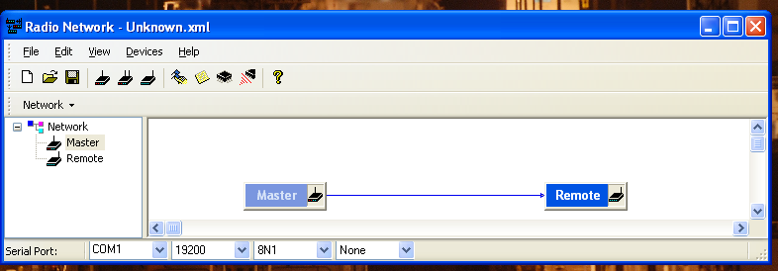

- Click on Master or Remote, right click on properties
- Click on “Read All before attempting to make changes
- Make sure serial number on screen match serial number on radio modem.
- Click on Write button after configuration changes have been made

- The serial acquisition port for this instrument will be used, it is necessary to Turn off “Data Acquisition Setup” to free the serial communication ports used by this instrument to acquire data (COM4).
- Open Hyper Terminal, select appropriate COM port and set baud rate to 9600.
- Press reset button and hold, plug power to radio modem then release reset button.
- NO CARRIER <CRLF> OK <CRLF> will appear on screen is connection to modem has been made.
- Type AT&V to see all modem configuration
- Type “ATA” after done making changes to configuration parameters. The modem will be place in Data mode.

Consult the manual for AT commands to access all configuration parameters.

Data Acquisition and File Manager

PS3DAS01

The Serial Acquisition Setup service is used to timestamp and archive the incoming data from instruments and data loggers. It is setup to create hourly data files for each of the instruments on the flux system and save them on D:\Data.
The Data Acquisition Setup window shows session, name, status, instrument, port, samples per min and received since.
File Manager Setup creates daily folder (YYJJJ) on D:\Data, the daily set of data files will be move to this daily folder after two days to create the first set of backup data (this is on PS3DAS01).
PS3DAS02 will pull all the hourly data files at the end of the hour to create the second set of backup data that will be shared with the ship network.
The D:\Data partition, on PS3DAS01 is shared only with PS3DAS02. It is not shared with the ship network to prevent data file corruption.

PS3DAS02

The Serial Acquisition Setup service is not setup to be running on PS3DAS02.
File Manager Setup for PS3DAS02 is set up to pull the hourly data files been created on PS3DAS01 after the end of an hour.
To access configuration parameters on PS3DAS02’s File Manager.

- Click on icon Shortcut to FileManagerSetup.
- File Manager Setup window will show two sessions:
  - Copy Data to Lacie…..(Disabled)
  - DAS Data Copy………(Enabled)
  - Highlight Das Data Copy, then click on Edit button

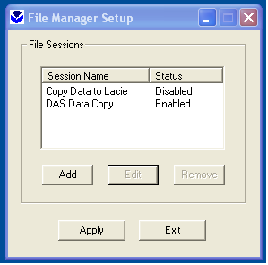

- File Session Properties window will open, showing the file settings for the instruments and data loggers as:
- Licor Today’s Data and Licor Yesterday’s Data
- Mean Today’s Data and Mean Yesterday’s Data
- Sonic Today’s Data and Sonic Yesterday’s Data
- Motion Pak Today’s Data and Motion Pak Yesterday’s Data
- Laser Today’s Data and Laser Yesterday’s Data
- Heading today’s Data and Heading Yesterday’s Data
- Ship today’s Data and Ship Yesterday’s Data
- GPS today’s Data and GPS Yesterday’s Data

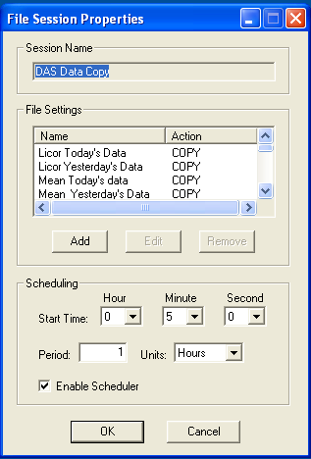

- Highlight a file setting name and press Edit

Licor Today’s Data window is showed as an example

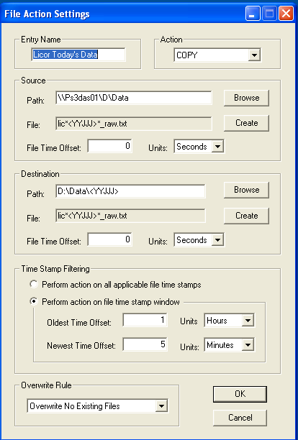

- Source path is \\Ps3das01\D\Data

- File is lic*<YYJJJ>*_raw.txt

- File Time offset is 0 seconds, meaning the latest files been created

- Destination path is D:\Data\<YYJJJ> meaning that latest files will be copy to the latest folder created

- Destination File is lic*<YYJJJ>*_raw.txt

- File Time offset is 0 seconds, meaning the latest files been created. Note: this offset must be equal to time offset on Source

- Time Stamp Filtering is set to Perform action on file stamp window

- Oldest Time Offset set to 1 Hours

- Newest time Offset set to 5 Minutes
Meaning file are been written will not be moved/copied until they are closed since this operation is repeated every 1 hour.

Licor Yesterday’s Data File Action Setting is setup as shown on window below

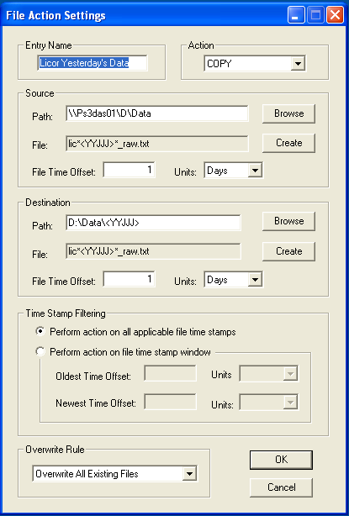

The settings for Licor Yesterday’s Data File are showed on the above window.
This file action setting will copy the hourly files to folder YYJJJ one day after they had been created in case that files had not been copied previously.
It is important to address that file timestamp parameter determent when files are copied to folder and not the file name.
The File Action Setting parameters for mean, sonic ,motion pak, laser, heading, ship SCS and GPS are similar to Licor with the exception of file names on source and destination.

Hard Drive Failure

Both the Data Acquisition and Data Analysis computers have each a backup up hard drive with the latest versions of all programs used for the current even. There will be always last minute changes to programs and directories but hopefully the main integrity of these back up will allow you to continue with your work.
Hard Drive 0 or (SAT0) will be ON and hard drive 1 or SAT1 will be off on both computers when the systems are delivered to site.
Now, go to the BIOS by pressing F2 after turning ON the computer or rebooting. Turn OFF SAT0 and ON SAT1, save setting and reboot. Good luck!

Sensor Coefficient Table

Sensor | Calibration coefficient | Make / Model | Serial Number | Date of calibration
Precision Spectral Pyranometer | 0.00857 | Eppley / PSP 1 | 34290F3 | Feb 15, 2012
Precision Spectral Pyranometer | 0.00875 | Eppley / PSP 2 | 28110F3 | Apr 2, 2012
Precision Infrared Radiometer | 0.00320 | Eppley / PIR 1 | 30433F3 | Apr 2, 2012
Precision Infrared Radiometer | 0.00412 | Eppley / PIR 2 | 30558F3 | Feb 15, 2012
Rain Gauge | Offset=0.093mV | OSI/ORG815DA | 00010149 | Apr 30, 2012
Rain Gauge SPARE | Offset= | OSI/ORG815DA
Motion Pak ZERO xrate | 0.00828 | Sundstrand | n/a | May 15,2012
Motion Pak ZERO yrate | 0.01728 | Sundstrand | n/a | May 15,2012
Motion Pak ZERO zrate | 0.03569 | Sundstrand | n/a | May 15,2012
Motion Pak Zero xaccel | 0.009 | Systron & Donner | n/a | May 15,2012
Motion Pak ZERO yaccel | -0.0064 | Systron & Donner | n/a | May 15,2012
Motion Pak ZERO zaccel | -0.008 | Systron & Donner | n/a | May 15,2012
Sea Snake thermistor -5C to 40C | C4=0.001399937 | YSI 46040 series |  | May 9, 2012
Sea Snake thermistor -5C to 40C | C5=0.00237854 | YSI 46040 series
Sea Snake thermistor -5C to 40C | C6=0.000000097 | YSI 46040 series
Temp / Humidity | n/a | Vaisala/HMT335 | CT10008 | Feb 22, 2012
Class A Barometer | n/a | Vaisala/ PTB220 | A2710003 | June16, 2013
CO2/H2O Analyzer | Available | Licor / LI-7500  In use | 75H-00772 | Zeroed Jul 19,2013  CO2 Zero=0.8122  H2O Zero=0.7041
CO2/H2O  Analyzer | Available | Licor / LI-7500  spare | 75H-1749 | Zeroed Jul 16,2013  CO2 Zero=0.9190  H2O Zero=0.9023
Met Datalogger Program

Note: Lines starting with a single apostrophes (‘) are comments.

'First System Met Program Sep 04,2013
'by Spezoa
'Program name: First Met Sep_4_2013.CR1
' Based on old program from CR23
'Use aspirator 4350F on this setup
'AIRFLOW UNITS ARE HZ.
'Pressure changed from Analog to Digital-RS232 serial communication 8/12/2013
'--------------------------------------------
'First "check" voltage sensitivity for radiometers
Dim L1,L2,L3
Public TimeValue As String * 25
Public Outputdata
Public Rpir1(2),Rpir2(2)
Public seatemp_r,seatempC
Public Snake_r4w,Snake_C4w
Public caseRpir1_,caseRpir2_
Public domeRpir1_,domeRpir2_
Public caseCpir1,caseCpir2
Public domeCpir1,domeCpir2
Public pir_volt(2)
Public psp_volt(2)
Public pir1_wm2,pir2_wm2,psp1_wm2,psp2_wm2
Public ORG1_volt(2)
Public ORG1_mmhr,ORG1S_OFF
Public bv_v,PTemp
Public airflow
Public hpa As String * 4
Public Flag(1) As Boolean
Public AvgDat(52)
Public OutS1 As String * 150
Public OutS2 As String * 150
Public OutS3 As String * 150
Public OutS4 As String * 100

Alias Rpir1(1)=caseRpir1
Alias Rpir1(2)=domeRpir1
Alias Rpir2(1)=caseRpir2
Alias Rpir2(2)=domeRpir2
Alias pir_volt(1)=pir1_volt
Alias pir_volt(2)=pir2_volt
Alias psp_volt(1)=psp1_volt
Alias psp_volt(2)=psp2_volt
Alias ORG1_volt(1)=ORG1C_volt
Alias ORG1_volt(2)=ORG1S_volt
'Constants
' s/n 30433 as Apr/02/2012 cal coeff for PIR-1
Const pir1cte = 0.0032
' s/n 30558 Feb/15/2012 cal coeff for PIR-2
Const pir2cte = 0.00412
' s/n 34290 Feb/15/2012 cal factor for PSP-1
Const psp1cte = 0.00857
' s/n 28110 Apr/02/2012 cal factor for PSP-2
Const psp2cte = 0.00875
'PSP and PIR constants requiested by Jeff Hare document 10/23/97
'Campbell Scientifics Inc. App. Note Code: 2RA-H
' using YSI 44031 c1,c2,c3
Const c1=0.0010295
Const c2=0.0002391
Const c3=0.0000001568
'Sea Snake Constants for ysi serie 46040 c4,c5,c6 -20 to 50 C
Const c4=0.001398809
Const c5=0.000238061
Const c6=0.000000096
Const high=true
Const low=false

'PipeLineMode

'\\\\\\\\\\\\\\\\\\\\\\\\ OUTPUT SECTION ////////////////////////

DataTable(Table07,Outputdata,-1)
DataInterval(0,1,Min,-1)
'Samples
Sample(1,bv_v,FP2)
Sample(1,PTemp,FP2)
'Averages 25 values
Average(1,caseRpir1,IEEE4,0)
Average(1,caseCpir1,FP2,0)
Average(1,domeRpir1,IEEE4,0)
Average(1,domeCpir1,FP2,0)
Average(1,caseRpir2,IEEE4,0)
Average(1,caseCpir2,FP2,0)
Average(1,domeRpir2,IEEE4,0)
Average(1,domeCpir2,FP2,0)
Average(1,pir1_volt,FP2,0)
Average(1,pir1_wm2,IEEE4,0)
Average(1,pir2_volt,FP2,0)
Average(1,pir2_wm2,IEEE4,0)
Average(1,psp1_volt,FP2,0)
Average(1,psp1_wm2,IEEE4,0)
Average(1,psp2_volt,FP2,0)
Average(1,psp2_wm2,IEEE4,0)
Average(1,ORG1C_volt,FP2,0)
Average(1,ORG1S_volt,FP2,0)
Average(1,ORG1_mmhr,FP2,0)
Average(1,seatemp_r,IEEE4,0)
Average(1,seatempC,FP2,0)
Average(1,Snake_r4w,IEEE4,0)
Average(1,Snake_C4w,IEEE4,0)
Sample(1,hpa,IEEE4)
Average(1,airflow,FP2,0)
'Standard deviation 25 values
StdDev (1,caseRpir1,FP2,0)
StdDev(1,caseCpir1,FP2,0)
StdDev(1,domeRpir1,FP2,0)
StdDev(1,domeCpir1,FP2,0)
StdDev(1,caseRpir2,FP2,0)
StdDev(1,caseCpir2,FP2,0)
StdDev(1,domeRpir2,FP2,0)
StdDev(1,domeCpir2,FP2,0)
StdDev(1,pir1_volt,FP2,0)
StdDev(1,pir1_wm2,FP2,0)
StdDev(1,pir2_volt,FP2,0)
StdDev(1,pir2_wm2,FP2,0)
StdDev(1,psp1_volt,FP2,0)
StdDev(1,psp1_wm2,FP2,0)
StdDev(1,psp2_volt,FP2,0)
StdDev(1,psp2_wm2,FP2,0)
StdDev(1,ORG1C_volt,FP2,0)
StdDev(1,ORG1S_volt,FP2,0)
StdDev(1,ORG1_mmhr,FP2,0)
StdDev(1,seatemp_r,FP2,0)
StdDev(1,seatempC,FP2,0)
StdDev(1,Snake_r4w,FP2,0)
StdDev(1,Snake_C4w,FP2,0)
StdDev(1,hpa,FP2,0)
StdDev(1,airflow,FP2,0)
EndTable

'\\\\\\\\\\\\\\\\\\\\\\\\\ SUBROUTINES //////////////////////////
‘no subroutines

'\\\\\\\\\\\\\\\\\\\\\\\\\\\ PROGRAM ////////////////////////////

BeginProg
SerialOpen (ComRS232,9600,0,0,1000)

SerialOpen (Com2,9600,10,0,100)
Scan(1,Sec,1, 0)
TimeValue=Table07.Timestamp(1,1)
Battery(bv_v)
PanelTemp(PTemp,250)
If TimeIntoInterval (0,60,sec)Then Flag(1)= high

'**Measurements made on AM16/32A**
'Turn AM16/32 ON
PortSet (2, 1)'Set mux reset line high
Delay(0,100,mSec)
'************
L3=1
SubScan (0,usec,2)
PulsePort(1,30000)
'Measurement of PIR1 and PIR2 voltages on diff ch 5 and 6 of multiplexer
VoltDiff(pir_volt(L3), 1,mV2_5,1,False, 0, _60Hz, 1, 0)

L3=L3+1
' thermopile (W/m**2) for PIR-1
pir1_wm2 = pir1_volt / pir1cte
' thermopile W/m**2) for PIR-2
pir2_wm2 = pir2_volt / pir2cte
NextSubScan
'**********
' Modified on Sep 4 2013 by Sp to use CH2 and CH8 for PSP1 and 2 thermopile measurement
' L2=1
'SubScan (0,usec,2)
' PulsePort(1,30000)
'Measurement of PSP1 and PSP2 on diff ch 3 and 4 of multiplexer
'VoltDiff(psp_volt(L2), 1,mV7_5,1,False, 0, _60Hz, 1, 0)
'L2=L2+1
' *** Begin calculations for units (C) and (W/m**2)
' solar rad (W/m**2) for PSP-1
' psp1_wm2 = psp1_volt / psp1cte
' solar rad (W/m**2) for PSP-2
' psp2_wm2 = psp2_volt / psp2cte
' NextSubScan
'*************
L1=1
SubScan (0,mSec,2)
'Switch to next AM416 Multiplexer channel
PulsePort(1,30000)'Clock Mux
'Measurement of ORG1C,ORGS on diff ch 1 and 2 of multiplexer
VoltDiff(ORG1_volt(L1), 1,mv5000,1,False, 0, _60Hz, 0.001, 0)
L1=L1+1
' *** Convert ORG output to rain rate mm/hr ***
ORG1_mmhr = 0
ORG1S_OFF = ORG1S_volt + 0
'ORG1S_OFF is a correction added due to cable, changed to 0 on Oct 28,2011
If (ORG1S_OFF >= 0.085) Then
' rain rate (mm/hr) ORG 1
ORG1_mmhr = 25 *(ORG1S_OFF ^ 1.87) + -0.15

EndIf
NextSubScan

' Turn AM16/32 Off
PortSet(2, 0) 'Set Mux Reset low
Delay(0,150,mSec)
'**Measurements made on CR1000**

'Measurement of PSP1 and PSP2 on diff ch 2 and 8 of CR1000
VoltDiff(psp_volt(1), 1,mV25,2,False, 0, _60Hz, 1, 0)
' *** Begin calculations for units (C) and (W/m**2)
' solar rad (W/m**2) for PSP-1
psp1_wm2 = psp1_volt / psp1cte
'******************************************************
VoltDiff(psp_volt(2), 1,mV25,8,False, 0, _60Hz, 1, 0)
' solar rad (W/m**2) for PSP-2
psp2_wm2 = psp2_volt / psp2cte
'*******************************************************
' case, dome resistance PIR-1, single ended
BrHalf(Rpir1, 2,mV2500, 5,Vx1, 3, 500, True, 0, 250, 1, 0)
' case-temp (C) PIR-1
caseRpir1_ = 10000*(caseRpir1/(1.0-caseRpir1))
'caseCpir1 = 3563/(2.74+LN(caseRpir1_)) + -273.16 (old formula)
caseCpir1 = 1/(c1+c2*LN(caseRpir1_)+c3*PWR(LN(caseRpir1_),3))+(-273.16)
' dome-temp (C) PIR-1
domeRpir1_ = 10000*(domeRpir1/(1.0-domeRpir1))
'domeCpir1 = 3563/(2.74+LN(domeRpir1_)) + -273.16 (old formula)
domeCpir1 = 1/(c1+c2*LN(domeRpir1_)+c3*PWR(LN(domeRpir1_),3))+(-273.16)
' case,dome resistance PIR-2, single ended
BrHalf(Rpir2, 2,mV2500, 7,Vx2, 4, 500, True, 0, 250, 1, 0)
' case-temp (C) PIR-2
caseRpir2_ = 9990*(caseRpir2/(1.0-caseRpir2))
'caseCpir2 = 3563/(2.74+LN(caseRpir2_)) + -273.16 (old formula)
caseCpir2 = 1/(c1+c2*LN(caseRpir2_)+c3*PWR(LN(caseRpir2_),3))+(-273.16)
' dome-temp (C) PIR-2
domeRpir2_ = 10010*(domeRpir2/(1.0-domeRpir2))
'domeCpir2 = 3563/(2.74+LN(domeRpir2_)) + -273.16 (old formula)
domeCpir2 = 1/(c1+c2*LN(domeRpir2_)+c3*PWR(LN(domeRpir2_),3))+(-273.16)
' sea-temp resistance, single ended
BrHalf(seatemp_r, 1,mV5000, 9,Vx3, 1, 1000, True, 0, _60Hz, 1, 0)
seatemp_r = 9990*(seatemp_r/(1.0-seatemp_r))
' sea-temp (C)
seatempC = 3915.9/(5.127+LN(seatemp_r - 10)) + -273.16

'Sea snake Half Bridge, 4 Wire measurements Seatemp_r4W:
'6H & 6L ,7H & 7L ,E3
'(wire1,2) ==/\/\/\/\/\== (wire3,4)
'CH5- wire1(yellow)to 5H/10k resistor between 5H and 5L/5L to E3
'wire3(green)to GND
'CH6- wire2(red)to 6H/wire4(blue)to 6L
BrHalf4W(Snake_r4w,1,mV2500,mV2500,6,Vx3,1,2500,False,False,0,_60Hz,7510,0)
If StrComp(Snake_r4w,"INF") = 0 Then
Snake_C4w=-9999
Else
Snake_C4W = 1/(c4+c5*LN(Snake_r4w)+c6*PWR(LN(Snake_r4W),3))+(-273.16)
EndIf

' Airflow monitor for t/rh aspirator******************
PulseCount(airflow, 1, 1, 1,1,1,0)

' Ambient Relative Pressure voltage*******************
'rs232,9600,7,even,1 stop
'com2 of cr1000
SerialInBlock(com2,hpa,50)

'Call Data Tables and send Data via RS232
If TimeIntoInterval(0,60,Sec) Then Outputdata= high
If Flag(1)=high Then
TimeValue=Table07.Timestamp(1,1)
GetRecord (AvgDat(),Table07,1)
OutS1=TimeValue+","+AvgDat(1)+","+AvgDat(2)+","+AvgDat(3)+","+AvgDat(4)+","+AvgDat(5)+","+AvgDat(6)+","+AvgDat(7)+","+AvgDat(8)+","+AvgDat(9)+","+AvgDat(10)+","+AvgDat(11)+","+AvgDat(12)+","+AvgDat(13)+","+AvgDat(14)+","+AvgDat(15)+","
OutS2=AvgDat(16)+","+AvgDat(17)+","+AvgDat(18)+","+AvgDat(19)+","+AvgDat(20)+","+AvgDat(21)+","+AvgDat(22)+","+AvgDat(23)+","+AvgDat(24)+","+AvgDat(25)+","+AvgDat(26)+","+AvgDat(27)+","+AvgDat(28)+","+AvgDat(29)+","+AvgDat(30)+","

OutS3=AvgDat(31)+","+AvgDat(32)+","+AvgDat(33)+","+AvgDat(34)+","+AvgDat(35)+","+AvgDat(36)+","+AvgDat(37)+","+AvgDat(38)+","+AvgDat(39)+","+AvgDat(40)+","+AvgDat(41)+","+AvgDat(42)+","+AvgDat(43)+","+AvgDat(44)+","+AvgDat(45)+","
OutS4=AvgDat(46)+","+AvgDat(47)+","+AvgDat(48)+","+AvgDat(49)+","+AvgDat(50)+","+AvgDat(51)+","+AvgDat(52)+CHR(13)+CHR(10)

SerialOut (ComRS232,OutS1+OutS2+OutS3+OutS4,"",1,0.01)
Flag(1)=false
SerialFlush (Com2)

EndIf
CallTable Table07
NextScan
EndProg

Motion Pak Program

'CR1000 Series Datalogger

'offsets reset September 3, 2010 by SP

'September 3, 2010 added routine to control water jets for Licor

'Program modified on : July 31, 2012

'Program: C:\campbellsci\programs\Brown_Motion_Zoffset_07312012 for cr1000

'zaccel is measured with a voltage divider...result is x 0.0019973

'rawz is raw measurement without divider

'Declare Public Variables

PipeLineMode
Public PortOn
Public Meas(7)
Public OutString As String * 1000
Alias Meas(1)= xrate
Alias Meas(2)= yrate
Alias Meas(3)= zrate
Alias Meas(4)= xaccel
Alias Meas(5)= yaccel
Alias Meas(6)= zaccel
Alias Meas(7)= rawzaccel

'Define Data Tables

DataTable (Motion,1,6)
Sample (7,Meas(),FP2)
Sample (1,PortOn,FP2)

EndTable

'Main Program

BeginProg
SerialOpen (ComRS232,9600,0,0,10)
Scan (200,mSec,10,0)

'Sprayer contoller
If TimeIntoInterval(0,3600,Sec) Then PortOn=1 'set PortOn to 0 , close for 60 min
PortSet(9, PortOn) 'Set port 1 low for time interval
If TimeIntoInterval(5,3600,Sec) Then PortOn=0 'set PortOn to 1 , open for 5 sec
PortSet(9, PortOn) 'Set port 1 high for time interval

'Motion pak voltages readings

'VoltSe (Meas(1),1,mV5000,1,0,0,250,0.001,-0.008)
VoltDiff (Meas(1),1,mV5000,1,True ,0,250,0.001,-0.0082)
'VoltSe (Meas(2),1,mV5000,2,0,0,250,0.001,-0.003)
VoltDiff (Meas(2),1,mV5000,2,True ,0,250,0.001,-0.003)
'VoltSe (Meas(3),1,mV5000,3,0,0,250,0.001,-0.004)
VoltDiff (Meas(3),1,mV5000,3,True ,0,250,0.001,-0.004)
'VoltSe (Meas(4),1,mV5000,4,0,0,250,0.001,-0.018)
VoltDiff (Meas(4),1,mV5000,4,True ,0,250,0.001,-0.018)
'VoltSe (Meas(5),1,mV5000,5,0,0,250,0.001,-0.031)
VoltDiff (Meas(5),1,mV5000,5,True ,0,250,0.001,-0.031)
'VoltSe (Meas(6),1,mV5000,6,0,0,250,0.0019973,0)
VoltDiff (Meas(6),1,mV5000,6,True ,0,250,0.00199999,0.005)
'VoltSe (Meas(7),1,mV5000,7,0,0,250,0.001,0)
VoltDiff (Meas(7),1,mV5000,7,True ,0,250,0.001,0)

OutString=Meas(1)+","+Meas(2)+","+Meas(3)+","+Meas(4)+","+Meas(5)+","+Meas(6)+","+PortOn+CHR(13)+CHR(10)

SerialOut (ComRS232,OutString,"",0,0)
CallTable Motion
NextScan
EndProg

