Fast ozone instrument #2 operation guide

(MOSAIC version 1.0, 10/12/2019)

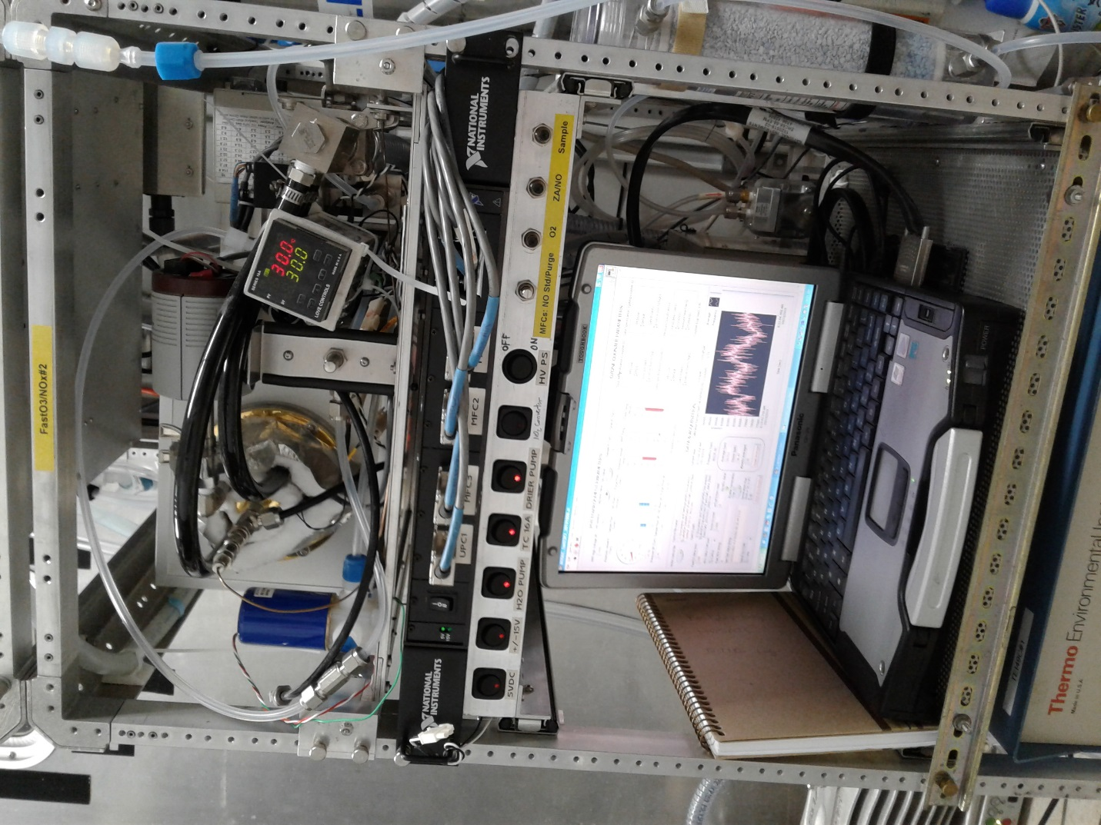

Pic 1: general view of the instrument

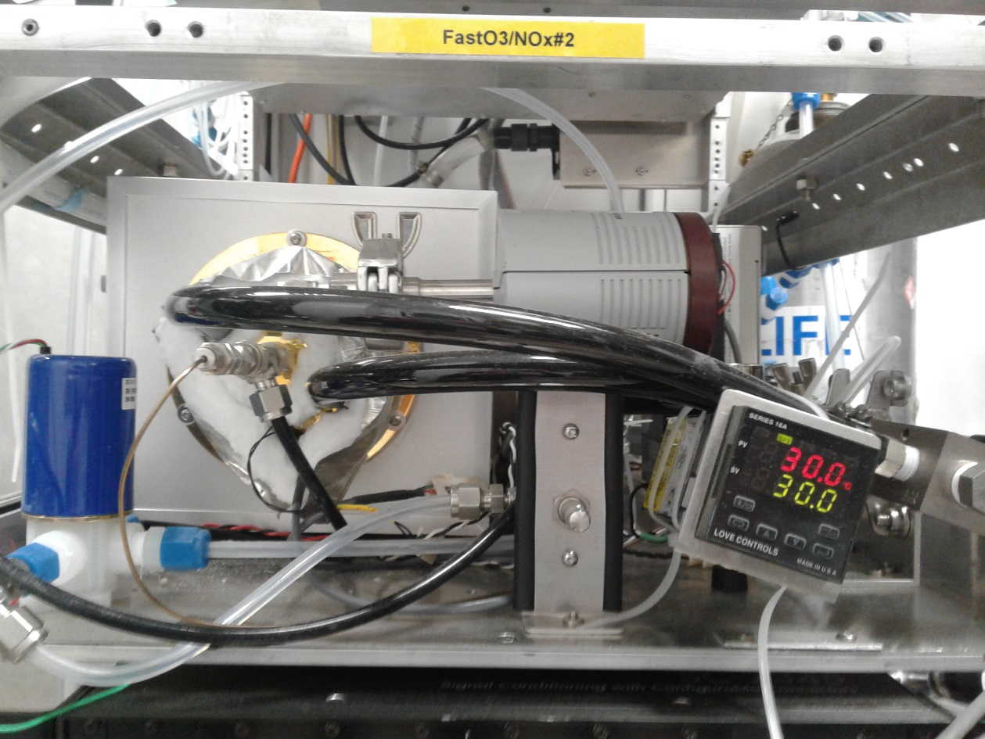
Pic 2: Front of the top drawer : Temp controller, Pressure transducer, Reaction vessel.

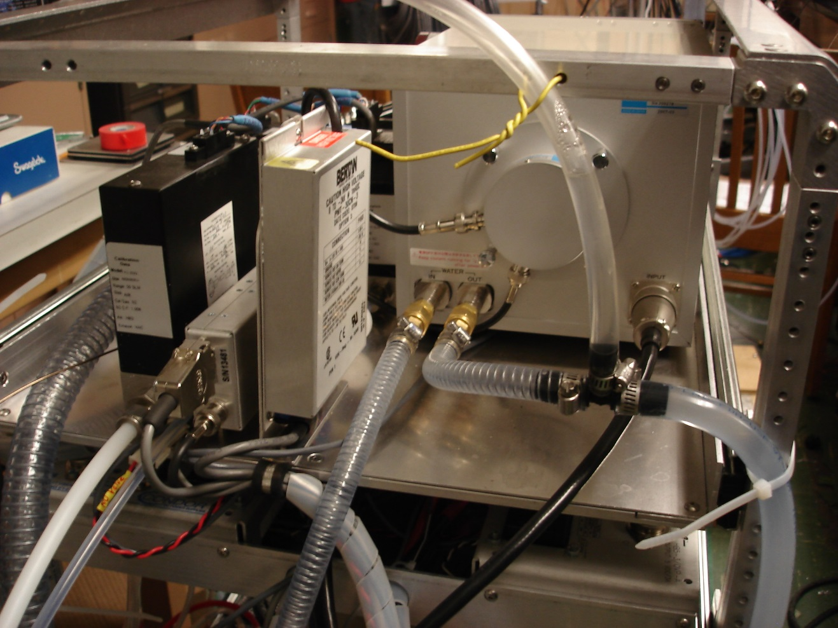
Pic 3: Back of the top drawer: PMT enclosure, PMT power supply, A/D, MFC
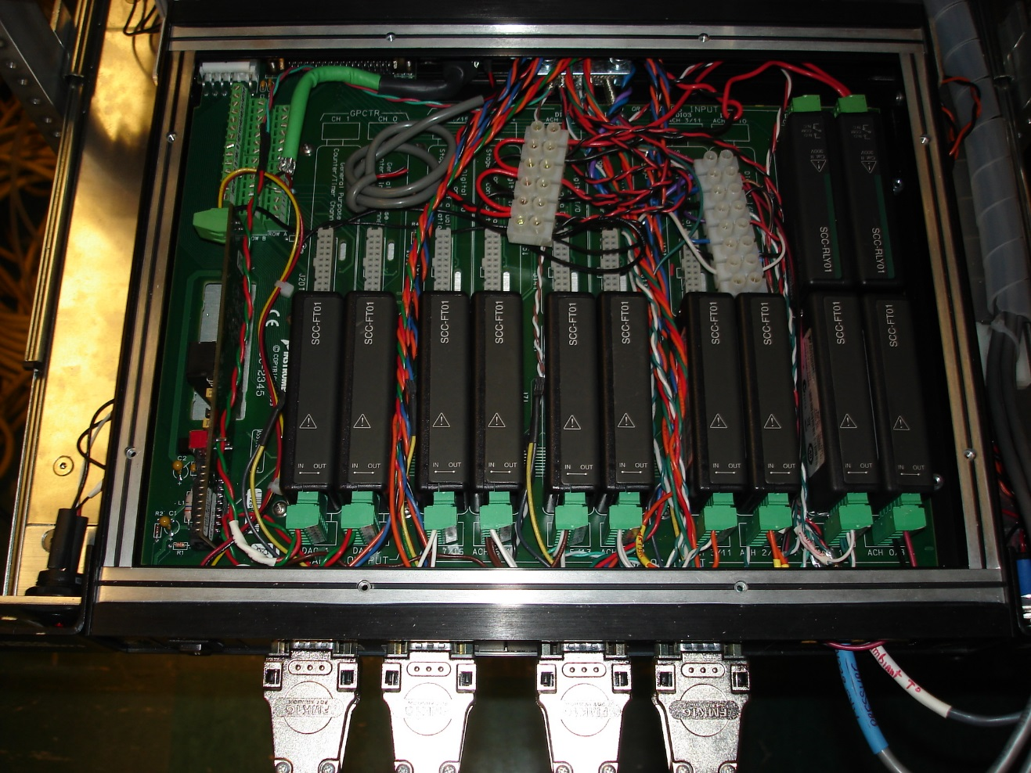
Pic 4: Second drawer: Signal conditioning box.

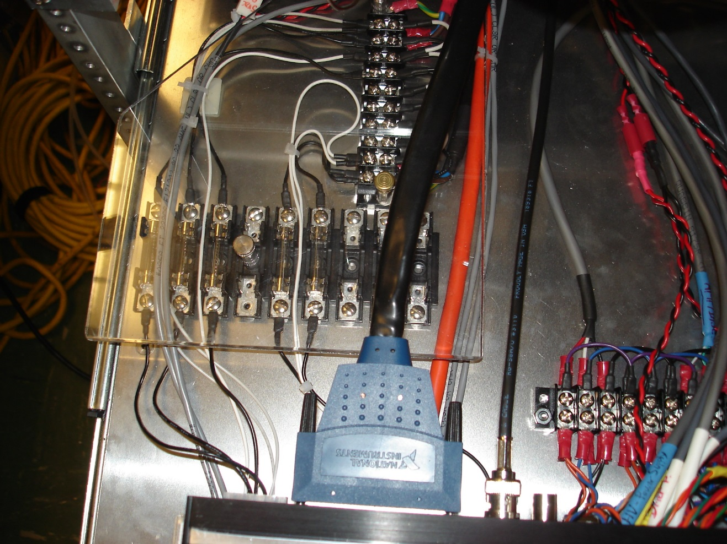
Pic 5: Second drawer: DAQ card cable connection, fuses.
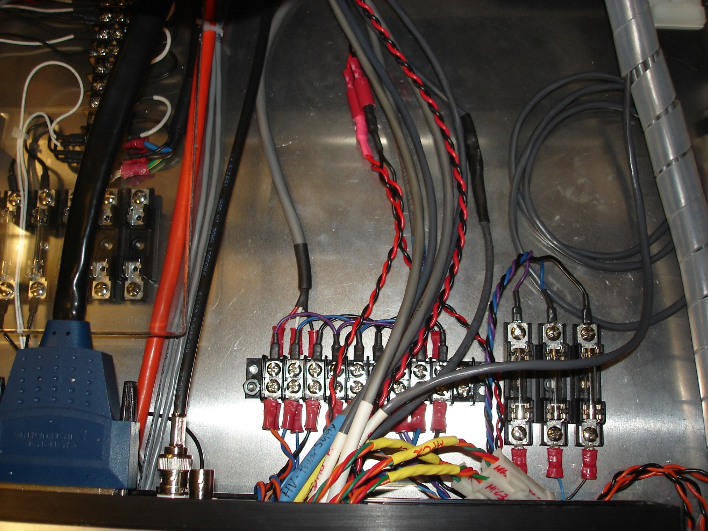
Pic 6: Second drawer: +/-15VDC distribution and fuses for the PMT power supply

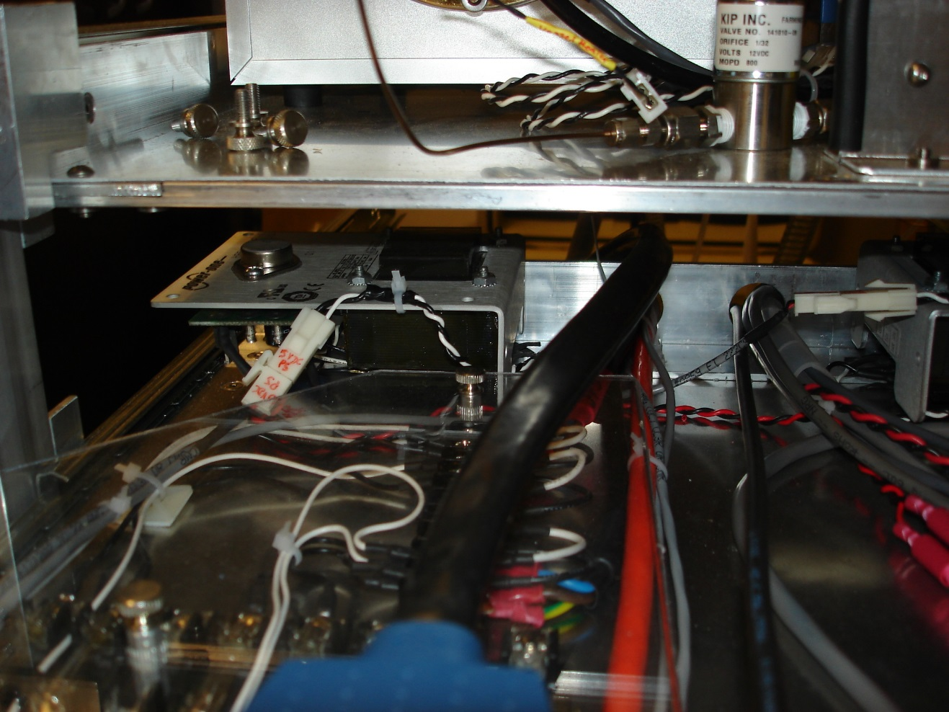
Pic 7: Second drawer: +5VDC power supply (on the back to the left)
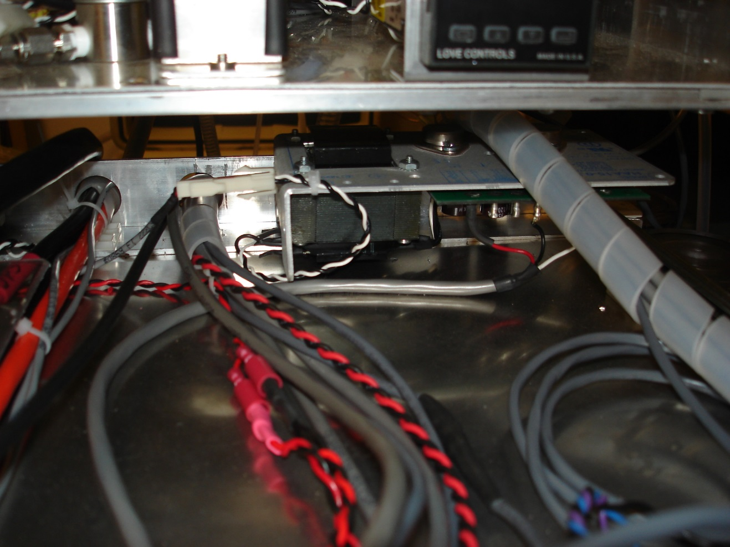
Pic 8: Second drawer: +/-15VDC power supply (on the back right)

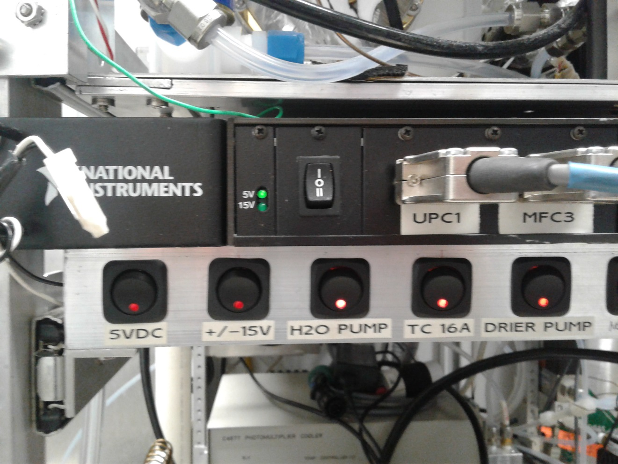
Pic 9: Second drawer: Main switches.
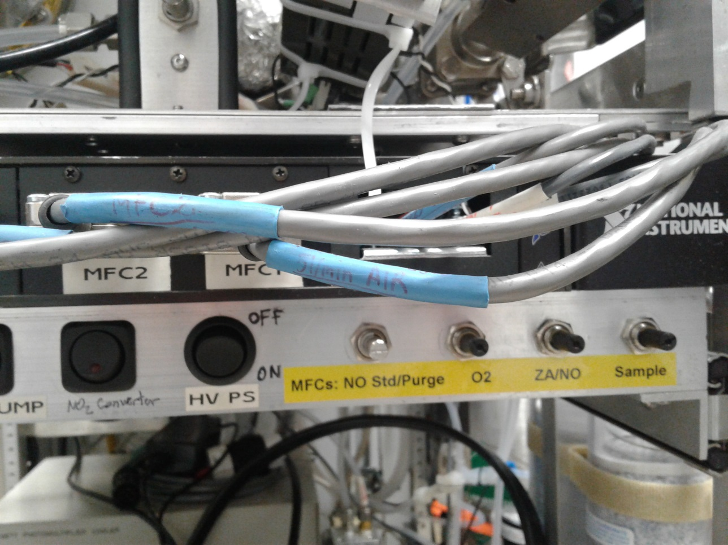
Pic 10: Second drawer: Main switches and potentiometers for MFC flows setpoint.

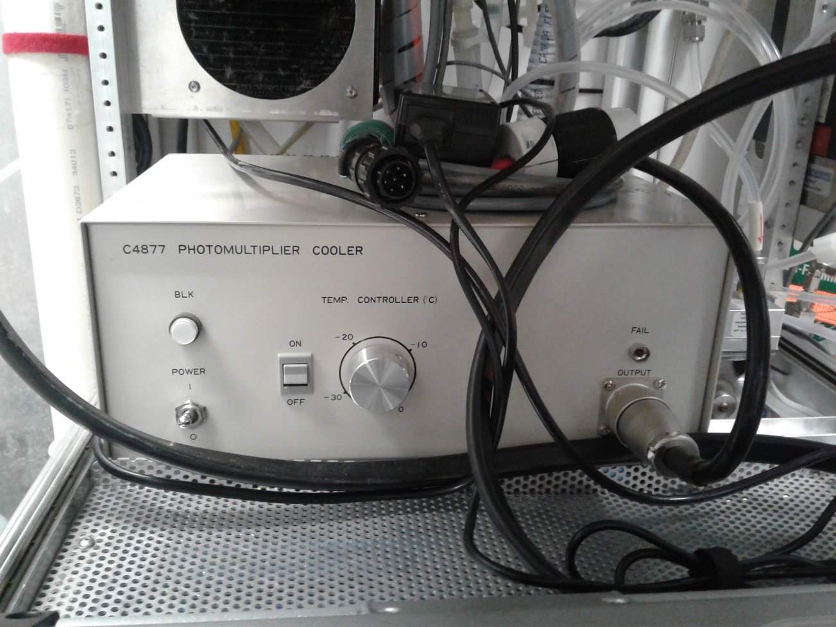
Pic 11: Third drawer: PMT Cooler controller, drier pump and computer

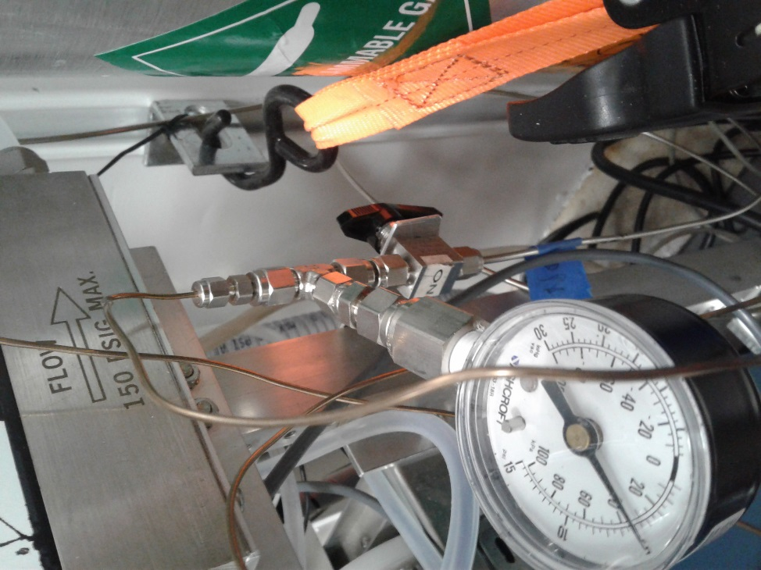
Pic 12: NO Shut off valve + NO pressure gauge
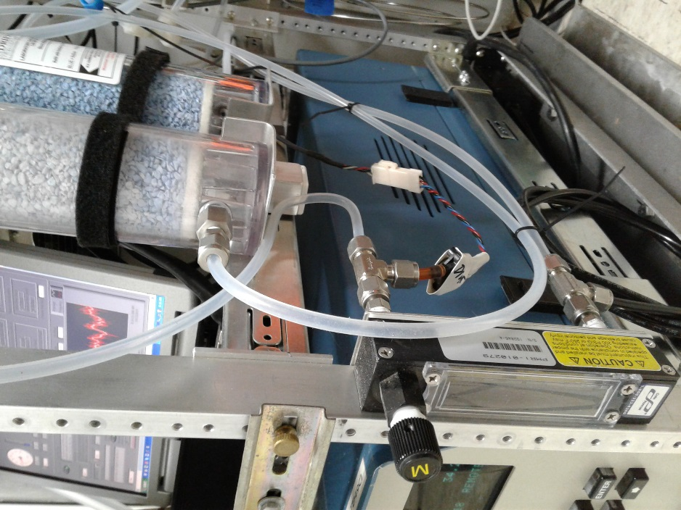
Pic 13: Drier Cycle is attached to the right side of the frame: Drierite columns, flow meter with needle valve, pressure sensor.

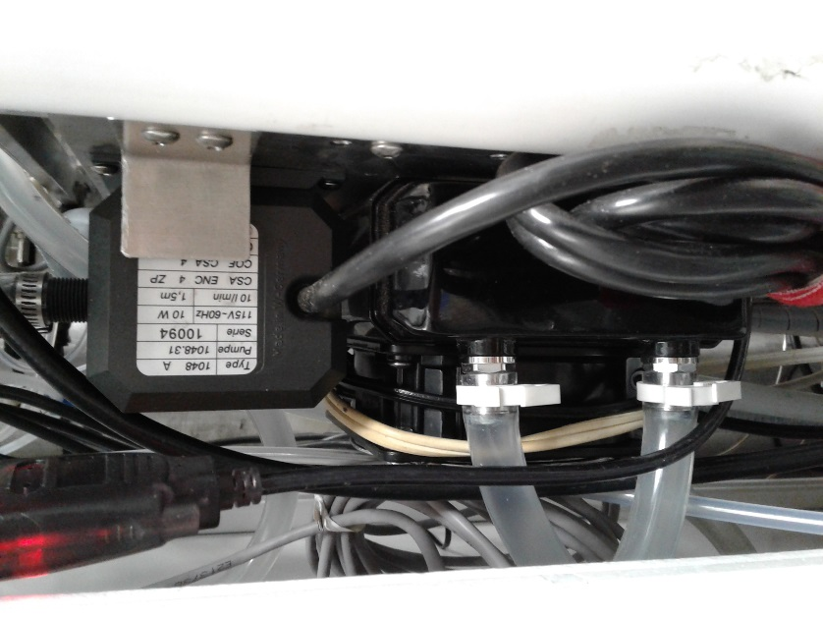
Pic 14: Water pump and fan+radiator.

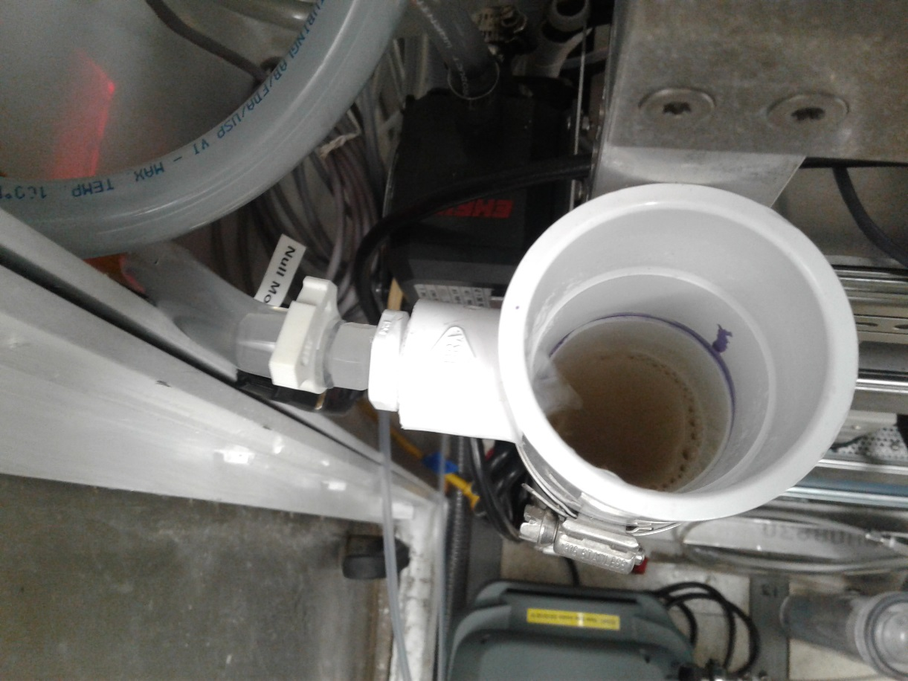
Pic 15: Water reservoir input
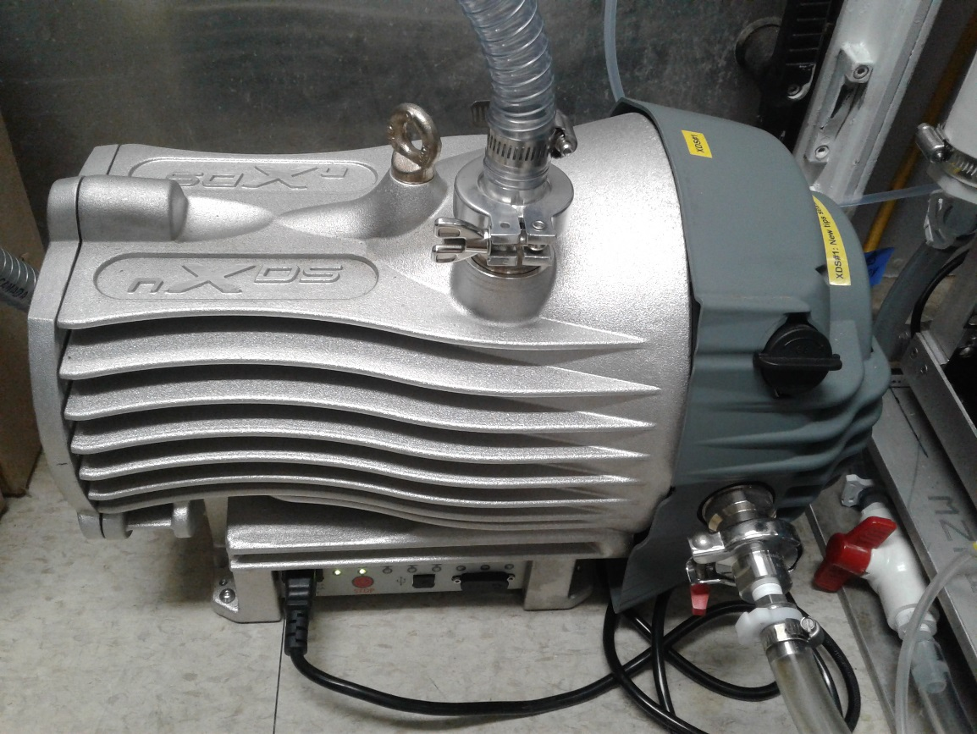
Pic 16: Scroll pump.

Pic 17: Line purge pump (pump inside the pump cabinet).
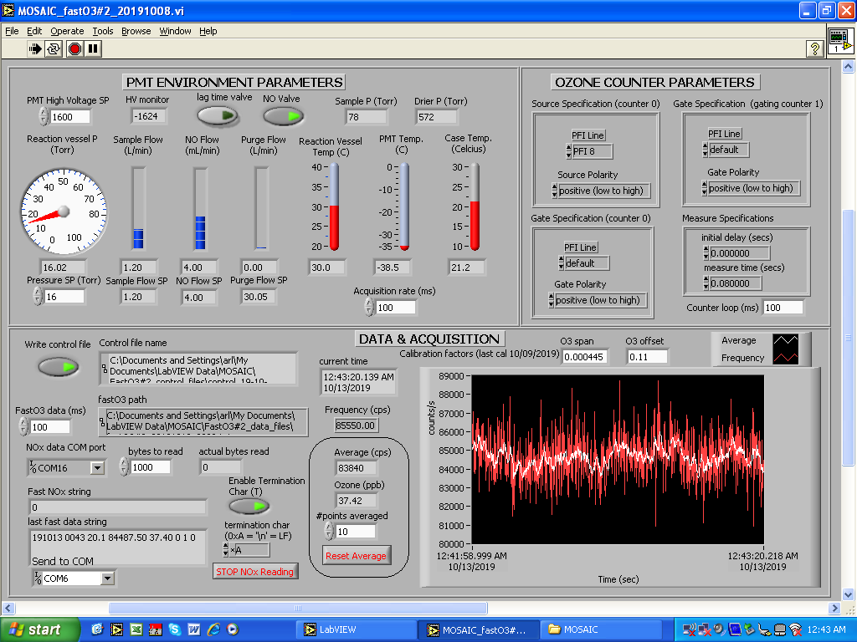
Pic18: Labview VI front panel.

Turning off the instrument:

- Turn OFF the Line Pump in the pump cabinet (unplug the pump from the orange cord). In the VI, the purge flow reading should drop to 0.
- Turn OFF the NO shut off valve and watch the NO flow reading on the VI. When the flow drops to 0, proceed to next step.
- Slowly turn down the PMT High Voltage SP in the VI (steps of 100V), all the way to 0.
- Switch OFF the PMT cooler (toggle switch on the left side, pic. 11)
- On the switch panel, turn the HV PS switch OFF (pic. 10)
- On the switch panel, turn OFF Drier Pump switch and TC 16A switch (pic. 9)
- Close the vacuum isolation valve and watch the Reaction Vessel pressure in the VI go to 100.
- If the system will stay off for an extended period of time (days), turn off the scroll pump. Since the exhaust of the scroll pump is shared with the Fast NOx instrument, turn off the O3 generator on the FastNOx system, wait for a couple minutes and then disconnect the output of the FastO3 scroll pump and cap the tubing. This will prevent back flow of FastNOx exhaust through the FastO3 pump. Then, turn the O3 generator back on on the FastNOx system.
- On the switch panel, turn OFF the +/-15V and 5VDC switches (pic. 9)
- If the system will stay off for several days, shut OFF the H2O pump switch on the switch panel (pic. 9)
- Stop the Labview VI on the laptop (stop button on the top left)

Turning on the instrument:

- Turn ON the H2O Pump switch on the switch panel (pic.9)
- Turn ON the computer and launch the Labview VI (shortcut on the desktop: MOSAIC_fastO3#2_191008.vi)
- In the VI, change the PMT High Voltage SP to 0.
- Turn ON the 5VDC and +/-15V switches on the switch panel (pic 9)
- Turn ON the temperature controller: TC 16A switch on switch panel (pic. 9). On the VI, the Reaction vessel temperature should start rising and will settle at 30C.
- Switch ON the PMT cooler (toggle switch on the left side, pic. 11). Also make sure that the temperature knob is set to -35C (all the way count-clockwise) and that the grey button next to it is on the ON position.
- Turn ON the scroll pump (green button on the side of the pump)
- Open the vacuum isolation valve. On the VI, you should see the sample flow reading go to 1.2L/min and the Reaction Vessel pressure settle at 16 Torr. If you have disconnected the pump output when you turned off the system, reconnect the exhaust tube to the output of the pump. Make sure to turn off the O3 generator on the FastNOx system before uncapping the exhaust tube.
- On the switch panel, turn ON the Drier Pump. Check that the ball on the flowmeter is between 30 and 40. If necessary, adjust it with the valve on the flowmeter.
- Turn ON the NO shut off valve and watch the NO flow reading on the VI. It should go to 4mL/min. Also make sure that the cylinder of NO is open and that the delivery valve on the regulator is open as well.
- Turn on the Line pump in the pump cabinet (reconnect the pump to the orange cord). If the wind conditions are good, pump should come on and the purge flow reading in the VI should go up to 30L/min
- When the PMT temperature is below 0C, turn the HV PS switch ON (pic. 10). Then, in the VI slowly increment the PMT High Voltage SP to 1600. You should start seeing counts on the VI now.
- Let the instrument equilibrate for a while and check that control files and data files are being recorded. Also check that data is being recorded in the DAS.

REGULAR CHECKS/MAINTENANCE:

  - Daily:

- Check the Drierite status. If first column is all purple/pink, replace with a spare one (replace before the second one starts turning purple/pink). Turn off the drier pump during the replacement and turn it back on right after.
- Check the NO cylinder pressure and log it in the gas logbook on the GCMS inlet computer.
- Check the water level in the water reservoir. Should be 1-2” (3-5cm) below the tee where the water cycles back in.
- Check the VI to see if all parameters and readings are ok:

PMT High Voltage SP: 1600
PMT reading: -1624V (+/-20V)
Reaction Vessel Pressure SP: 16 Torr
Reaction Vessel Pressure reading: 16 Torr (+/-0.02)
Sample Flow SP: 1.20 L/min
Sample Flow reading: 1.20 L/min (+/-0.02)
NO Flow SP: 4.00 mL/min
NO Flow reading: 4.00 mL/min (+/-0.01)
Purge Flow SP: 30 L/min
Purge Flow reading: 30.0 L/min (+/-0.1)
Reaction Vessel Temperature: 30.0C (+/-0.5C)
PMT Temperature: below -34C
Case Temperature: 20-25C
Drier Pressure: 570 Torr (+/-50)
Sample Pressure: disregard this reading, the pressure sensor is not present.
Acquisition Rate: 100ms
- Check that the control file and the data file are getting written:
Control File: My Documents/LabVIEW Data/MOSAIC/FastO#2_control_files/control_DATE_TIME.lvm
Data File: My Documents/LabVIEW Data/MOSAIC/FastO#2_data_files/ fastO3#2_DATE_TIME.lvm
- Transfer data to a USB stick or drive and transfer to the ship’s data archive

  - Weekly, or when necessary:
- Refill the water reservoir to about 1-2” (3-5cm) below the tee where water comes in. Use the small bottle with the green cap and a funnel if necessary. Be careful to pour very slowly! It fills up fast!
- Regenerate the used Drierite in the oven in Wet Lab1 (Nasslab 1). Lay the Drierite in a thin layer on an aluminum boat. Set the oven at 190C and bake the Drierite for 1h. Make sure to take the Drierite out of the oven while it’s still hot. Pour into a glass jar to let it cool and then transfer back into the Drierite column.
NOTE: As drierite is reused, it tends to get dustier and stick to the walls of the plastic column, so before refilling a column always wipe the inside with a damp paper towel or completely remove the felt bottom and rinse with water and dry.
- Replace the NO cylinder. This should be done very carefully. Contact Jacques and Detlev when cylinder pressure gets below 50PSI for further instructions.

