Manual for the GCMS system during MOSAIC (Version 1.0, 10/14/2019)

Regular operation of the GCMS system
The GCMS system is composed of 2 independent systems that need to be coordinated: on one side the Inlet system, controlled by the Labview VI on the Labview computer and on the other side the Agilent GCMS, controlled by the Mass Hunter software on the Agilent computer.
Both systems are running a sequence that need to match in order to make sense of the data later.
On the inlet side, the sequence table can be viewed in the Labview VI, in the Autosample tab.
On the GCMS side, the sequence can be viewed from the top menu bar (Sequence > Edit Sequence…) or when the sequence is running, by clicking on Edit in the yellow bar that replaces the usual menu.
A fixed sequence of 49 runs has been established on both computers. Once initiated, a sequence will run for about 3 days. The advance of the sequence should be watched every day (see Regular checks and maintenance at the end of this document). When a sequence is done, the current sample# in the Labview VI will be 49 and the Run Status in Mass Hunter will be Idle. At that point a new sequence should be started, identical to the previous one.
IMPORTANT NOTE: For this to work properly, Labview and Mass Hunter need to always be “in sync”. One program can’t be stopped without pausing or stopping the program on the other computer too. So, follow the instructions closely and if you are in doubt, contact Jacques (jhueber@colorado.edu) or Detlev (detlev@colorado.edu).
Running Samples (regular sampling sequence)

This is the procedure to follow when a sequence is ready to be started and the system is idle (Autosample OFF in Lavbiew, Run Status Idle in Mass Hunter).
- On the Agilent computer, in Mass Hunter, check that the Run Status shows: Idle.
- in the top menu bar, click on Sequence, then Save sequence as…
- Save the new sequence using the following this format: GCMS_MOSAIC_YYYYMMDD, where YYYYMMDD is the current date.
- Go to the Sequence menu again and choose Load Sequence
- Select the file that you just saved.
- Go to the Sequence menu again and choose Edit Sequence…
- Check that all the lines in the sequence have a white background. (If they are greyed, go back to step 4 to load the sequence again).
- In the first line of the sequence, select the Data File cell and change the Data File name to MOSAIC_YYYYMMDD_01, where YYYYMMDD is the current date.
- Then select all the cells in the Data File column, right click on one of the selected cell and choose Fill Increment.
- Now, all the file names in the Data File column should go from MOSAIC_YYYYMMDD_01 to MOSAIC_YYYYMMDD_49. If it’s not the case, check again to make sure you started at the first line (line1) and went all the way down to the last line (line 49).
- Click OK to close the sequence window.
- Go to the Sequence menu again and choose Save Sequence
- Go to the Sequence menu again and choose Run Sequence…
- In the pop up window, enter your initials in the Operator Name, then click on the big Run Sequence button (don’t click on OK, it will just close the window but nothing will happen!) , (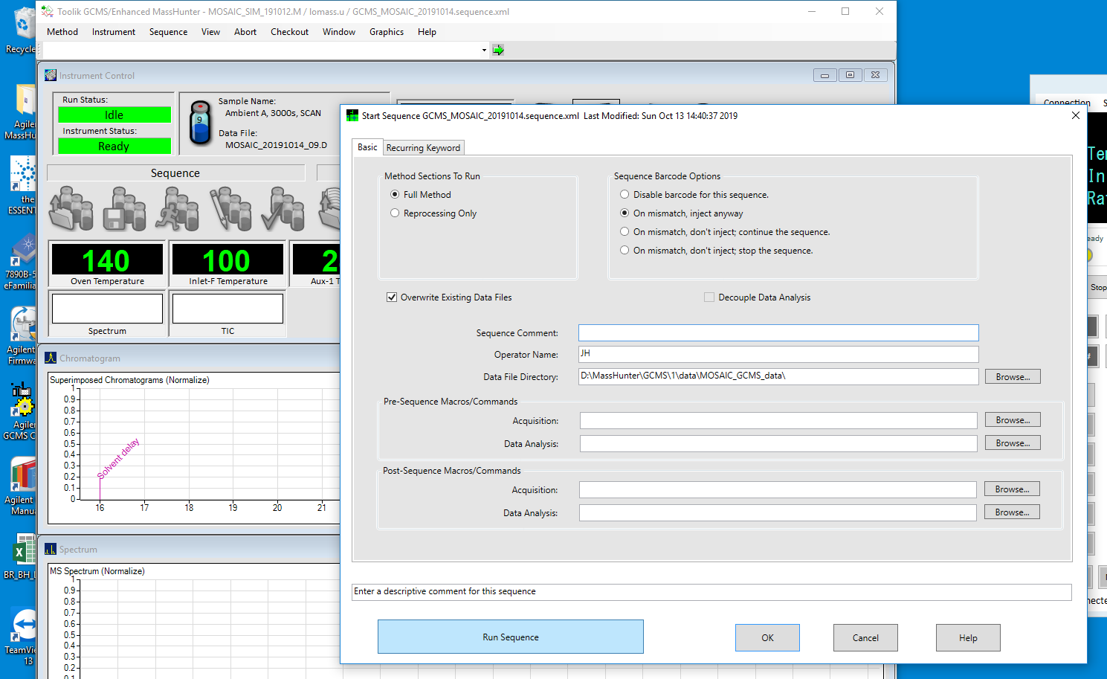
- Wait for a few seconds that the software does all the necessary checks (don’t worry about windows that pop up for a few seconds). After 10-20s, the GCMS should be ready for acquiring the first sample. Check the following items: a yellow line should appear where the menu bar used to be, the Run Status should be PreRun, the Instrument Status should be Ready and the Data File should be the first file name of the sequence (MOSAIC_YYYYMMDD_01)
- Now, the GCMS is all set. Go to the Labview computer.
- In the Labview VI, go to the Autosample tab and click on the Reset Sample# button so that the current sample# gets reset to 0.
- Check that the current Sample# has been updated to 0 and then click on the Autosample button.
- The first sample should get started right away. Go to the Indicators tab and check that the Sample button is on.
- You are good to go!!
Pausing/resuming a sequence

If you want to pause a sequence (stop sampling for a little while), go to the Labview computer, in the Autosample tab and turn OFF the Autosample button. The current run will finish and no new run will start.
Don’t change anything on the Agilent computer. The sequence in Mass Hunter should not be interrupted.
When you want to resume sampling, simply turn ON the Autosample button again. The system will continue through its current sequence, it won’t start over from the beginning.
Interrupting a sequence

If a sequence needs to be interrupted completely, then follow this procedure.
- On the Labview computer, in the Autosample tab, turn off the Autosample button.
- Wait for the current run to finish (could take up to 2h if a run just started). To make sure a run a finished, look in the Indicators tab: the Sample button will turn itself off at the end of the run. Also look on the Agilent computer: the Run status should be in PreRun and the current Data File name should be the one for the next run. For example: if the in the Labview VI, the Current Sample# is 7 at the end of the run, the Data File name displayed on the Agilent computer should be MOSAIC_YYYYMMDD_08.D
- Once the run is finished, the sequence can be interrupted on the Agilent computer by clicking on the STOP sign in the Mass Hunter window.
- Click Yes in the pop up window.
- Wait for a few seconds as the software is getting the GCMS in idle mode.
- At this point, the whole system is idle, both on the inlet side and on the GCMS side.

Restarting a sequence after it has been interrupted

After a sequence has been interrupted completely (not just paused), best is to start a new sequence from scratch. Follow the Running Samples Procedure at the beginning of this manual.

Restarting the Labview computer

Once every 2 months or so, it’s a good idea to restart the Labview computer. Best is to do that between 2 sequences so that no interruption is needed. At that point, restart the Agilent computer as well.

- If you are in the middle of a sequence, follow the Interrupting a sequence procedure first, then proceed to step 2. If the last sequence finished and you haven’t started a new one yet, proceed to step 2.
- On the Labview computer, in the Heaters & Coolers tab, turn off all the heaters control (Heat WT should already be off).
- In the Indicators tab, wait for all heaters toggle switches to go to the off position (= down).
- Stop the VI by clicking on in top menu bar
- Also stop the O3 monitor VI (O3_MOSAIC_ship_190920.vi)
- Close the VIs and all other windows, then go to the Windows power menu, and select Restart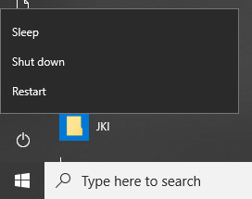
- Wait a minute to let the system reboot
- Enter login for Windows (ARLlab) and wait for system to finish booting.
- Open the LabView VI for the O3 monitor: O3_MOSAIC_ship_190920.vi (shortcut on the desktop or directly in the Labview VIs folder on the desktop). The VI runs automatically. If not, click on the run button
- Open the LabView VI named 190924_MOSAIC_GCMS.vi (shortcut on the desktop or directly in the Labview VIs folder on the desktop)
- Run the VI by clicking on the run button
- In the Heaters & Coolers tab, turn on Heat Valves, Heat GC X-fer, Heat AdsA Xfer and Heat AdsB Xfer. (leave Heat WT OFF!)
- In the Indicators tab, ensure MFC1 is reading the same value as MFC1 SP (currently 0.8 V) and MFC2 is reading the same value as MFC2 SP (currently 0.3V)
The system is now idle. To start sampling, follow the Running Samples (regular sampling sequence) procedure.
Restarting the Agilent computer

Once every 2 months or so, it’s a good idea to restart the Agilent computer. Best is to do that between 2 sequences so that no interruption is needed. At that point, restart the Labview computer as well.
All you need to do is close the programs that are currently running (no need to save anything) and launch Mass Hunter again once the computer rebooted (shortcut on the desktop)
Turning the inlet system off

The system shouldn’t be turned off unless instructed by Jacques or Detlev or if there are safety concerns.
- On the Labview computer, in the Autosample tab, turn off the Autosample button.
- Wait for the current run to finish (could take up to 2h if a run just started). To make sure a run a finished, look in the Indicators tab: the Sample button will turn itself off at the end of the run.
- On the Labview computer, in the Heaters & Coolers tab, turn off all the heaters control (Heat WT should already be off).
- In the Indicators tab, wait for all heaters toggle switches to go to the off position (= down).
- Stop the VI by clicking on in top menu bar
- On the back of the electronics drawer, turn off the SW2 and SW1 switch.
- Unplug the NetBooter power cord from the back of it (left rack, under the electronics drawer)
- Shut off the He IN and He OUT shut off valves at the back of the Plumbing drawer (right rack)
- Shut off the Helium tank valve (unless Steve’s GC is still running)
- Turn off the computer if the ozone monitor is OFF. Otherwise keep the computer ON so that the data acquisition is not interrupted for the 49C ozone monitor.
Turning the inlet system on

- If the Labview computer is off, turn it ON. Enter login for Windows (ARLlab) and wait for system to finish booting.
- If the He tank is off, open the tank and regulator delivery valve and check that the pressure is set at 50PSI.
- Plug the NetBooter power cord in the back of it (left rack, under the electronics drawer). In the front panel of the NetBooter, lights from 1 to 7 should turn on.
- On the back of the electronics drawer, turn ON the SW1 switch.
- On the Labview computer, open the LabView VI for the O3 monitor: O3_MOSAIC_ship_190920.vi (shortcut on the desktop or directly in the Labview VIs folder on the desktop). The VI runs automatically. If not, click on the run button
- Open the LabView VI named 190924_MOSAIC_GCMS.vi (shortcut on the desktop or directly in the Labview VIs folder on the desktop)
- Run the VI by clicking on the run button
- On the back of the electronics drawer, turn ON the SW2 switch.
- Turn ON the He IN and He OUT shut off valves at the back of the Plumbing drawer (right rack).
- On the Labview computer, in the Heaters & Coolers tab, turn on Heat Valves, Heat GC X-fer, Heat AdsA Xfer and Heat AdsB Xfer. (leave Heat WT OFF!)
- In the Indicators tab, ensure MFC1 is reading the same value as MFC1 SP (currently 0.8 V) and MFC2 is reading the same value as MFC2 SP (currently 0.3V)
- The system is now idle. To start sampling, follow the Running Samples (regular sampling sequence) procedure.

Recovering after a power outage

Regular checks and maintenance

Daily:
- Check the current sample# on the Labview computer. If at 49, check that the last run is done on the GCMS computer too and start a new sequence (follow the Running Samples (regular sampling sequence) procedure).
- Check the water level on the bottom of the right rack and refill if necessary.
- Check on the He scrubber at the back of the plumbing drawer. O2 indicator should be green, H2O indicator should be orange. If bad, O2 indicator turns grey and H2O indicator turns clear.
- Check the He cylinder pressure and log it into the gas log on the Labview computer.
- Check that no warning lights are red on the Labview VI Indicator tab (green is normal)
- Check that Power supply voltages and temperatures are good:
Valves T, GC Xfer T, AdsA Xfer T and AdsB Xfer T : 80C (+/-1C)
Catalyst T: 380C (+/-2C)
E-box: below 30C
5V, 12V,15V, 24V should be within 0.1V
Battery voltage: 11.8-13.7V
He P: 50-60PSI.
- Copy the last day’s log files (refer to the log file’s name to select the files for that particular day) and transfer them to the ship’s archive
Every 3 days:
- Integrate 1 BH A, 3000s SIM run, 1 NPL A, 1000s SIM, 1 Zero air A, 3000s SIM and 2 Ambient A, 3000s, SIM runs and send the integration files to Dean (dean.howard@colorado.edu) and Jacques (jhueber@colorado.edu).
Every 2 months:
- Restart Labview and Agilent computer. Check on clock and adjust if necessary before rebooting.
When needed:
Change the He cylinder when cylinder pressure goes below 200PSI. Before changing it, pause the sequence (refer to the Pausing/resuming a sequence procedure). Once the system is in idle mode, shut OFF the He IN and He OUT valves on the back of the Plumbing Drawer (right rack). Then proceed with the cylinder swap. After the line is pressurized again, open the He IN and He OUT valves and resume the sequence (refer to the Pausing/resuming a sequence procedure).

Integrating a chromatogram with the Agilent Data Analysis software

This is a guide to help with the integration of the chromatograms that have been recorded by Mass Hunter. The goal is to produce a small text file (integration file) that contains the peak areas of all the compounds that are currently in the analysis method. As of 10/15/2019, the analysis method is called MOSAIC_SIM_Analysis_20191012.M
- On the Agilent computer, open the data analysis software (shortcut on the desktop) and check that you are using the method that you want: it is displayed on the top left of the window. If the method is not the one you want, go to Method > Load Method and choose the one you want.
- Then, open a chromatogram file: in the top menu bar, click on or go to File > Open. In the pop up window, scroll down to the file that you want to open and click OK. NOTE: All the files should be in D:\MassHunter\GCMS\1\data\MOSAIC_GCMS_data. By default, it should take you to this directory.
- Go to the top menu and click on Method > Run Method…
- Go to the top menu and click on View > QEdit Quant Result. A window pops up (Quick QEdit)on the left side with a list of all the compounds in the method. On the right side, the current compound peak and its information is displayed. To select a compound, double click on the compound name in the Quick QEdit window. 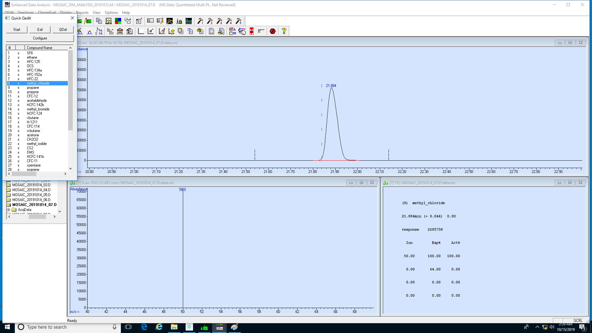
- Review all the compounds one by one to make sure that they are integrated properly by the software (the red integration line should represent the baseline of the peak). To scroll through the peaks, you can use the Start/Stop button on the Quick QEdit window. The time it spends on each peak can be adjusted by clicking on Configure and entering the time in seconds.
- When you see a peak that is not well integrated. Hit the Stop button or double click on that compound name. Below is an example of a bad integration:
- To fix it, point to the base of the peak, hold the right click and draw a line that goes to the other side of the peak. It should go from the left side to the right side of the peak and follow the signal base line. Once fixed, it looks like this:
- Some peaks also don’t get integrated because they fall below the detection limit of the software. In this case, integrate them manually as well unless there is really no peak at all.
- Once all the peaks have been reviewed/corrected, click Exit on the Quick QEdit window.
- In the pop up window that asks you to save the results, click on Yes
- Then, go to top menu bar and click on Quantitate > Generate Report…
- In the window that pops up, enter the name of the file that you want to save the integration results to, then click OK.
Here is the file naming format that should be used:
- BH standards ran in SIM mode : integration_BH_SIM_YYYYMMDD_##
- BH standards ran in SCAN mode : integration_BH_SCAN_YYYYMMDD_##
- NPL standards ran in SIM mode : integration_NPL_SIM_YYYYMMDD_##
- NPL standards ran in SCAN mode : integration_NPL_SCAN_YYYYMMDD_##
- Ambient ran in SIM mode : integration_Ambient_SIM_YYYYMMDD_##
- Ambient ran in SCAN mode : integration_Ambient_SCAN_YYYYMMDD_##
- 0-Air ran in SIM mode : integration_0-air_SIM_YYYYMMDD_##
- 0-Air ran in SCAN mode : integration_0-air_SCAN_YYYYMMDD_##
Where YYYYMMDD_## is the same as the file that you integrated.

