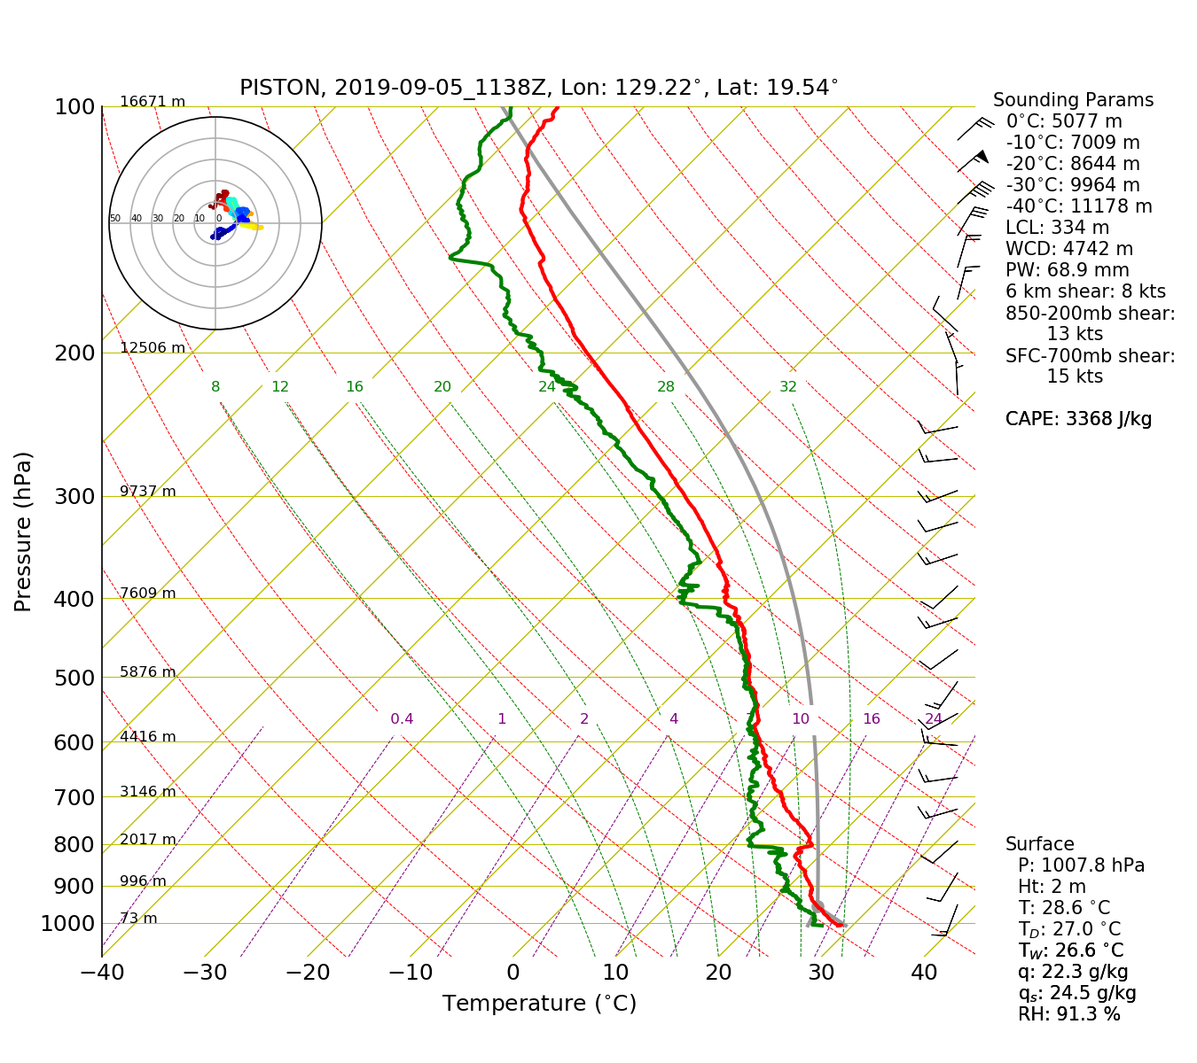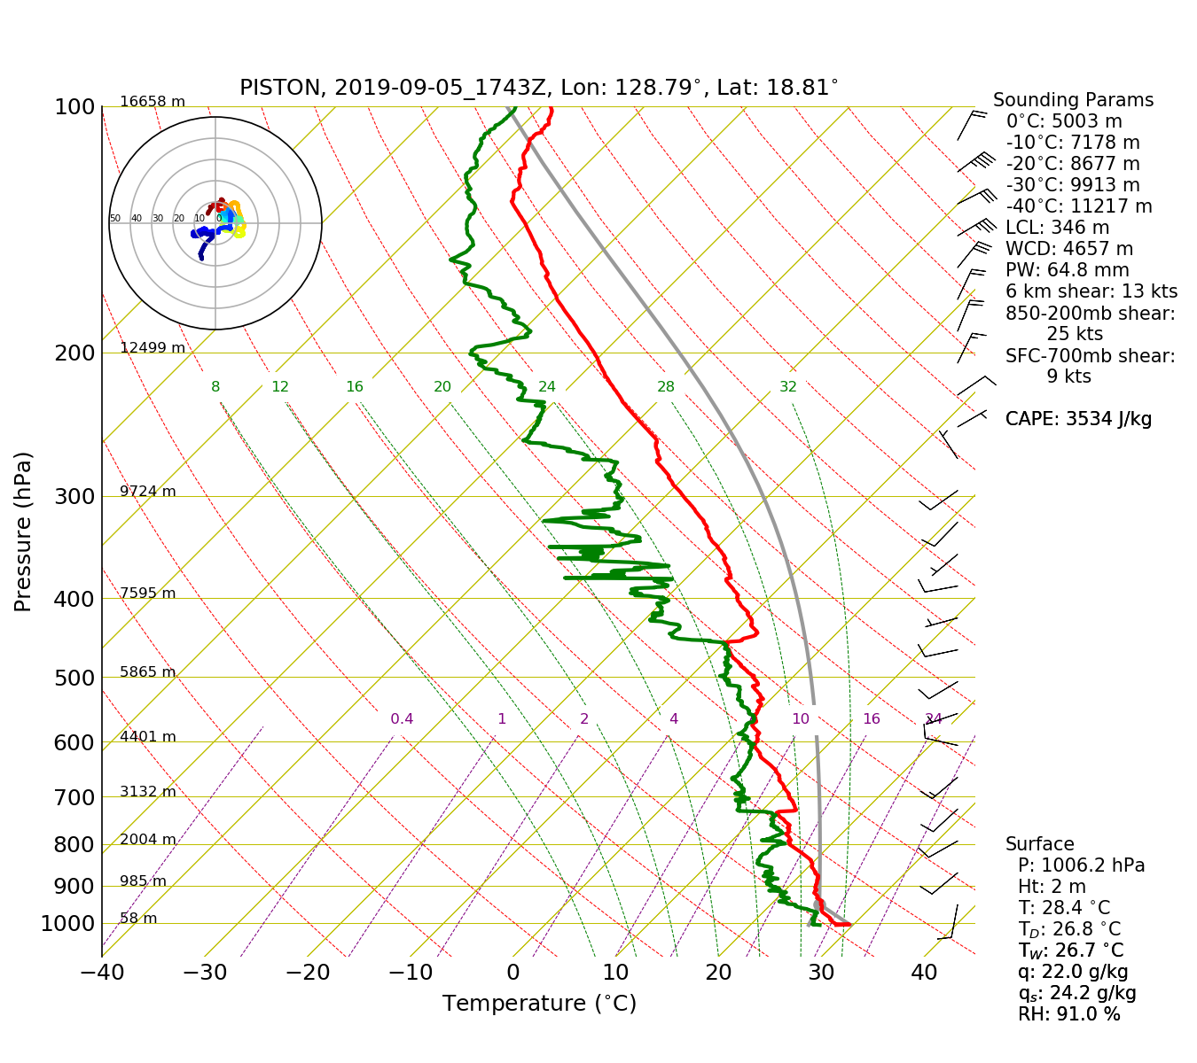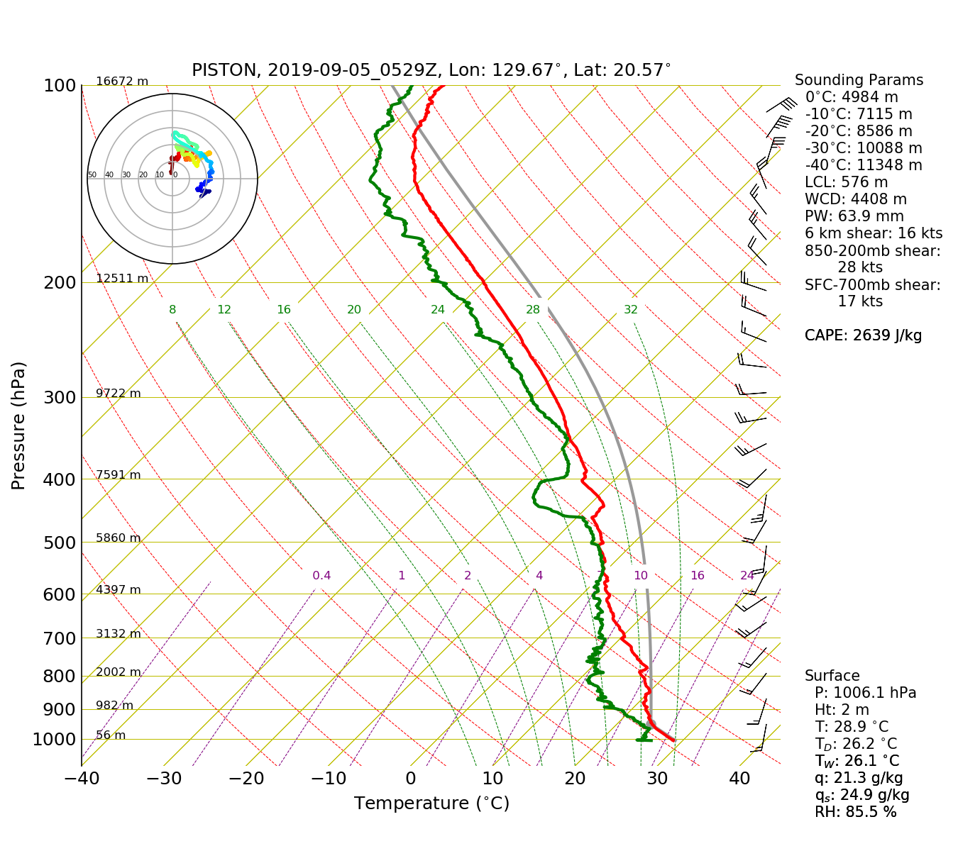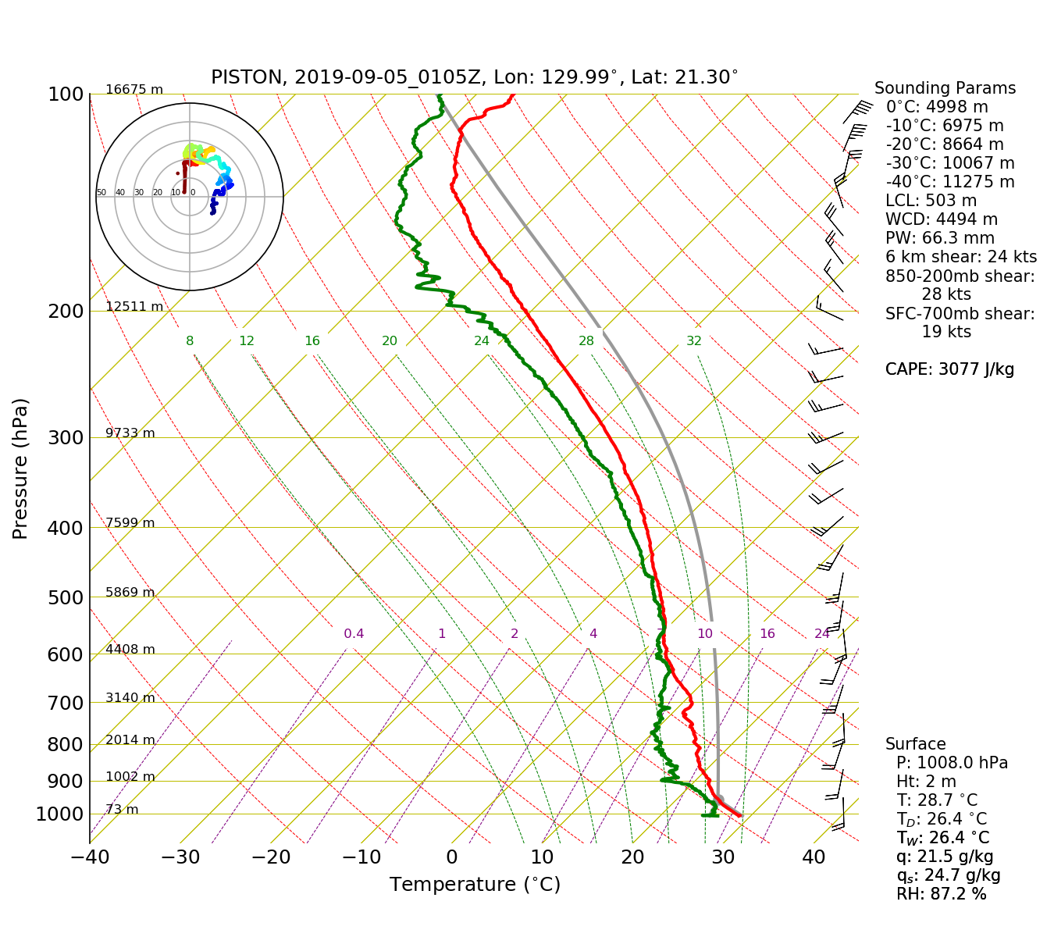PISTON 2019 Daily Science Summary

## 5 September Daily Summary: On the tails of Typhoon Lingling

**PISTON 2, R/V Sally Ride**

**Prepared by: Brenda Dolan, Kyle Chudler, Adam Clayton, and Marqi Rocque**

We have been outrunning typhoon Lingling for a couple of days now. Interestingly, the GFS seems to have done a better job in predicting not only the intensity, but also the tracks in comparison with the ECMWF. That has actually necessitated going east as fast as we can for 2 days before turning south to get to the ops area. Lingling is really large, a well formed eye, and has a complex typhoon “tail” (Fig. 1). We finally entered international waters and turned on SEA-POL to see some of this convective complex ‘tail’ to our west. There are a couple other disturbances we are keeping an eye on. To our east there is T14W which should go north of us. To the SE there is a complex of interest 93W, but is not forecasted to intensify or organize into something. Sea surface temperatures are very warm; the ship measured >29C, and the satellite-based map (Fig. 2) supports that, which will provide a nice environment for Lingling. Luckily the ship is now past the danger zone, and Jim Moum has some moorings in place that should capture the effects as it passes east of Taiwan.

We launched sondes every 6 hours today, starting at 01 Z when we entered international waters, then again at 6Z. Both had skinny CAPE, with the earlier sounding at 1 UTC being a little more unstable with over 2000 J/kg of surface-based CAPE (Fig. 3). Interestingly, the second sounding showed an elevated dry layer at about 550 mb as we move south. The 18z sounding shows noticeable drying aloft, as well as a couple inversions aloft, possible from subsidence from the nearby typhoon-tail convection.

We saw some really neat RHIs today as we scanned the convection tail of Lingling to our west. Notably, there were times when the echo tops were close to 14 km (Fig. 4), and there were some really intense rainers which had high Kdp (> 4 deg/km), high Zdr on the edge (3 dB), and high reflectivity (55+ dBZ).

Convection began to wane/move off scope around 0900 as the ship continued south towards the ops area and the typhoon moved to the north/east. A few scattered cells were in range of the radar overnight, but nothing very strong or organized. There was a cluster of small cells that tracked almost directly radially away from the radar for a few hours, which provided the opportunity to get a cool RHI time series showing the evolution of these popcorn cells (Fig 5). I think this is a good example of the kind of thing we would like to get more of with this RHI-heavy scanning strategy.

OSU did their first CTD launch around 1530 UTC, so the oceanography potion of the cruise is also underway now.



Fig. 1: Water vapor image of typhoon Lingling. The ship was approximately at the purple star at this time, and the ops area is approximately the pink box.

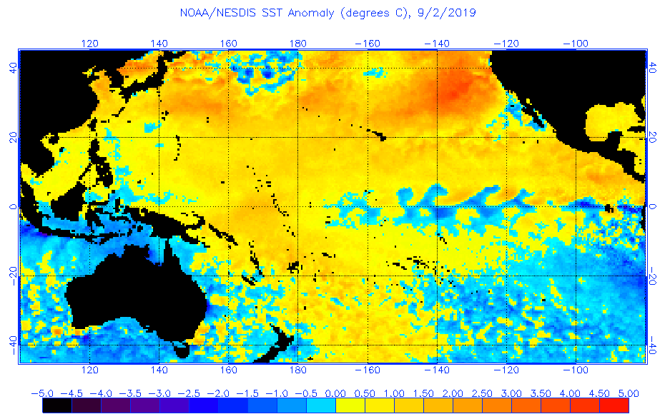

Fig. 2: Satellite Sea surface temperatures on 2 September.

Fig.3 01, 6, 12, 18 UTC Soundings

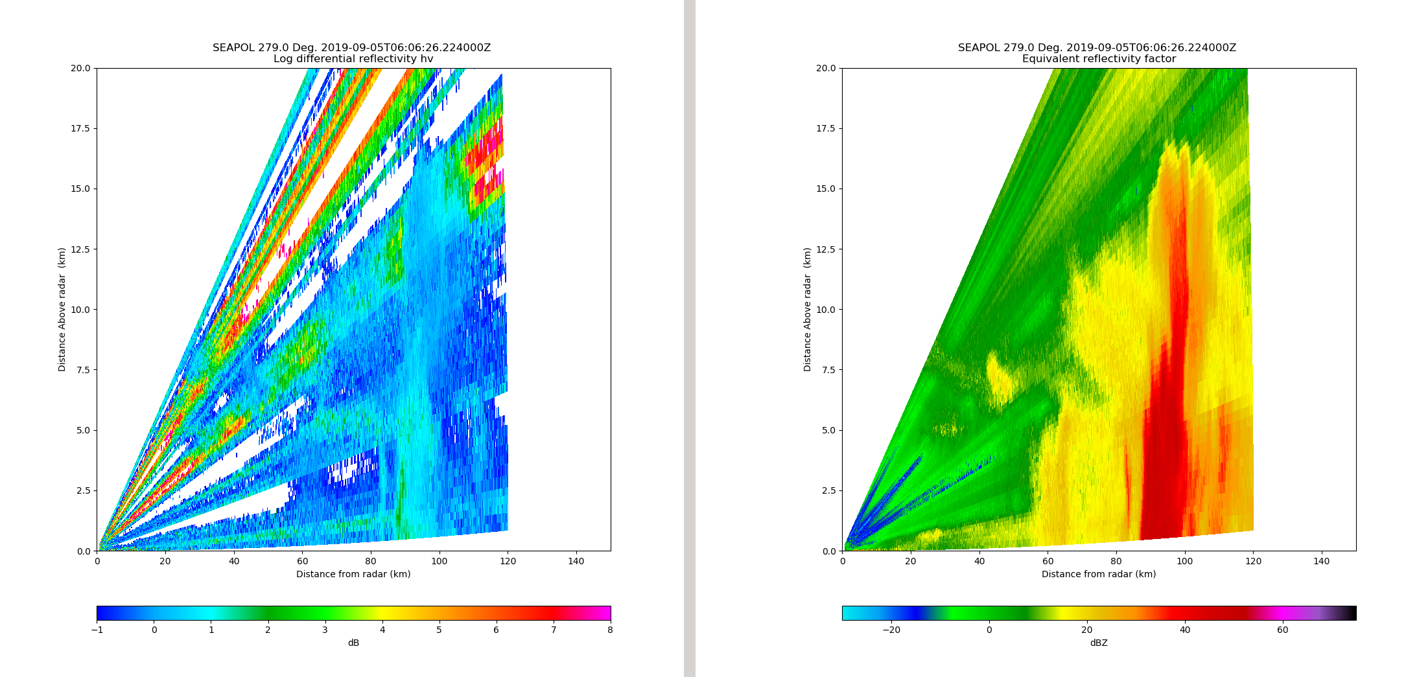

Fig 4. Deep convective cell associated with the tails of Lingling. 40 dBZ echo tops to about 15 km, and Zdr near the surface of 2-3 dB.



Fig 5. RHI loop showing evolution of some shallow, popcorn convection.