PISTON 2019 Daily Science Summary

6 September Daily Summary: All clear
PISTON 2, R/V Sally Ride

Prepared by: Brenda Dolan, Kyle Chudler, Adam Clayton, and Marqi Rocque

We are traveling from the farthest NE point of our operations domain (19N 129E) to the south west corner (17N 126 E) in order to characterize the ocean. As we made this transition, we’ve moved pretty far south of the influence of Lingling into a relatively clear area. As seen in Fig. 1, the ops area and the ship are beyond the convective ‘tail’ of Lingling, and to the north of a disturbance to the south (93W, which is not forecasted to intensify). Therefore, we expected to see some drying and calmer seas today, which was much appreciated by the oceanographers who wanted to do some testing. This morning we started with some AltoCu and mixed layer clouds, and as the day has continued we have seen even more clearing but some low level boundary layer clouds (Fig. 2). The recent soundings illustrate the drying trend and cloud layers (Fig. 3), as well as some inversion layers at 800 and 480 mb. Winds are surprisingly weak throughout the troposphere.

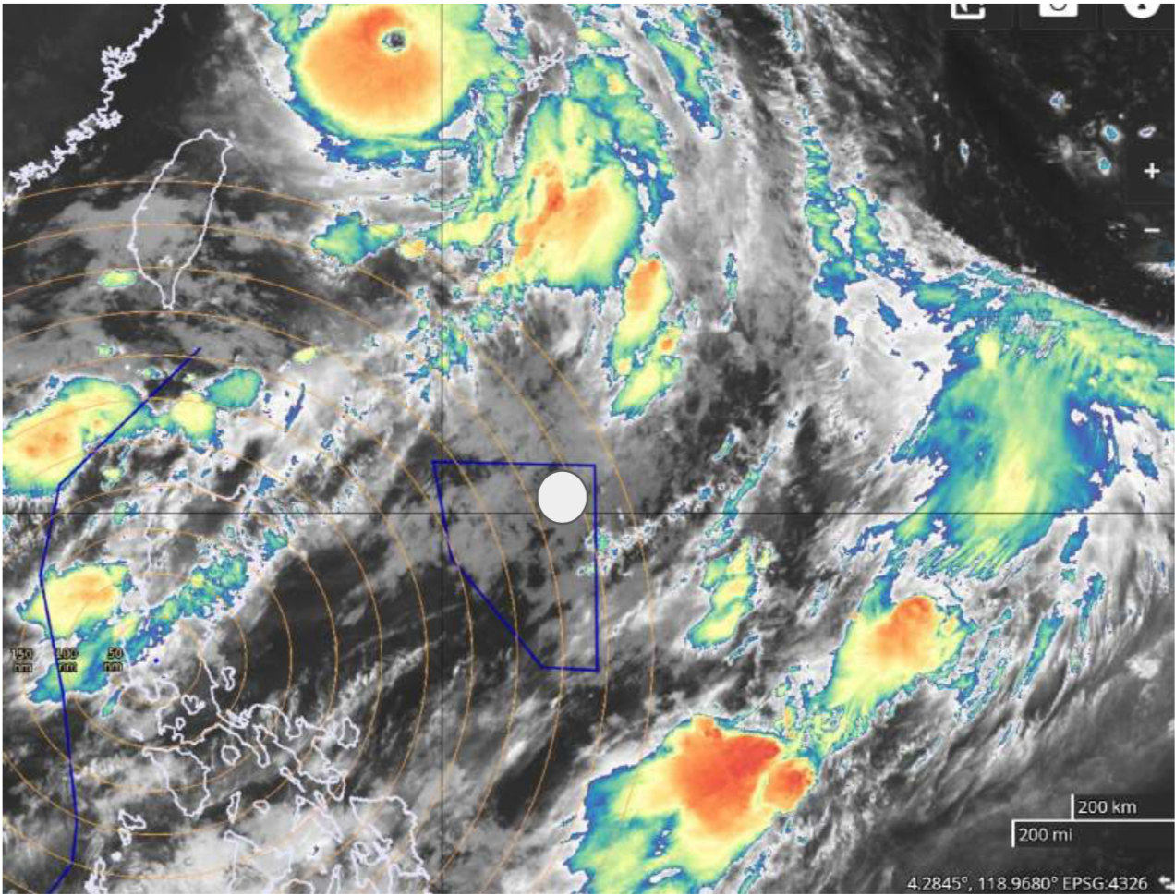
Fig. 1: Satellite overview of the ops area (blue box) and the Sally Ride location (white). During the day the Sally Ride steamed from the upper right corner to the SW edge of the box to characterize the ocean.

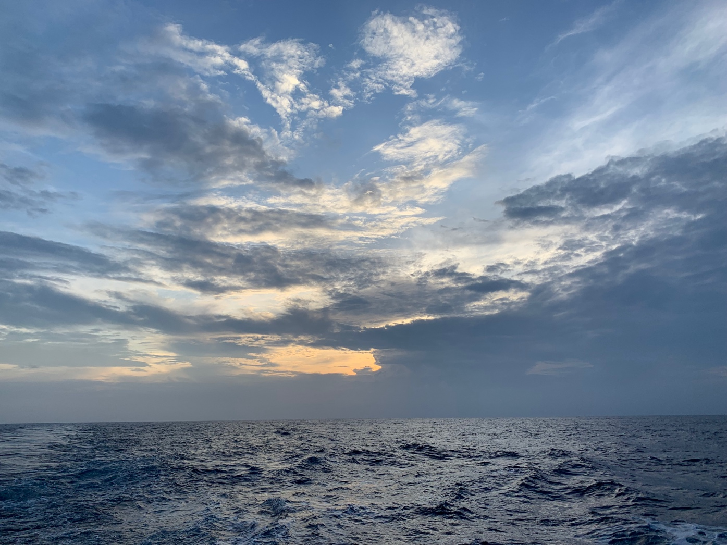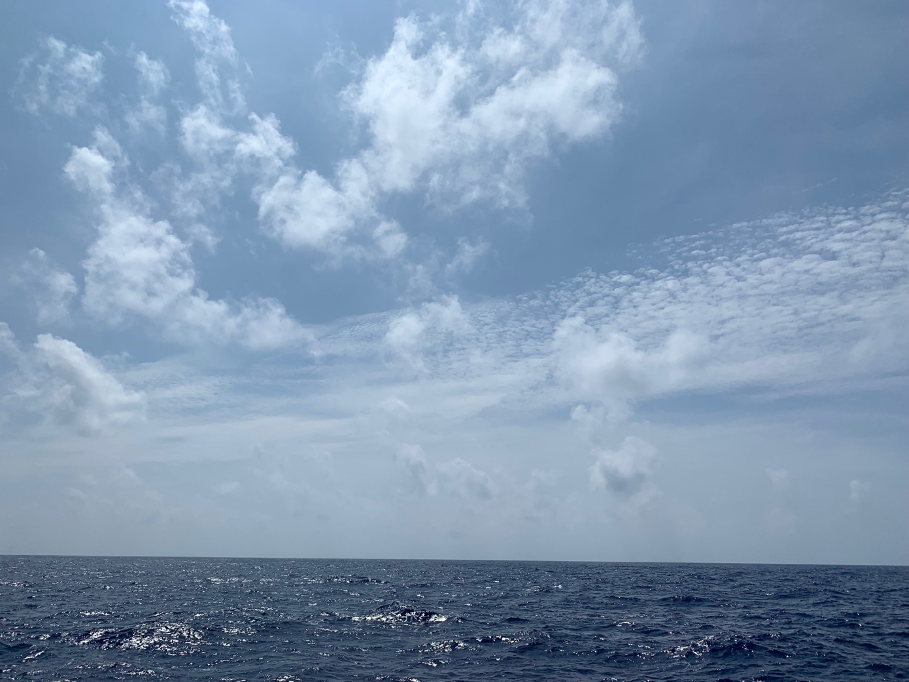
Fig. 2: Clouds at 20 Z on 5 September, and 0530 Z on 6 September.

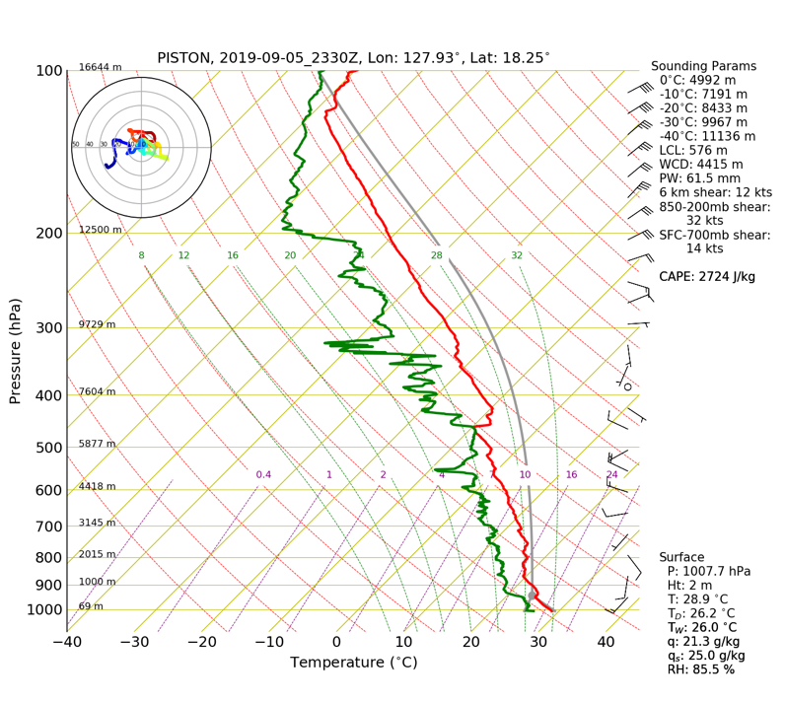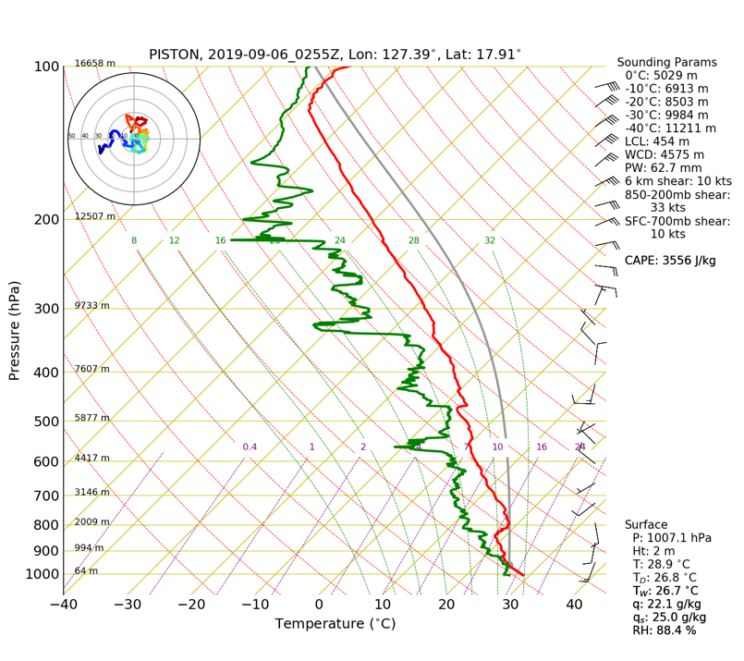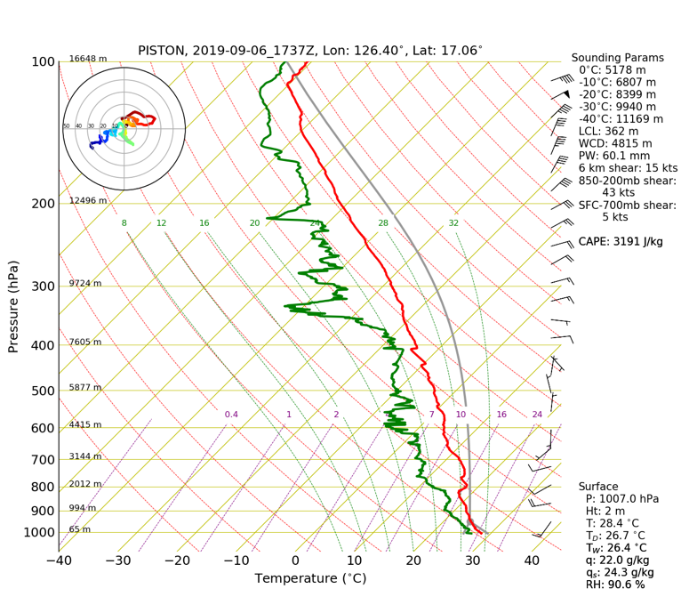
Fig. 2: 0 and 3 Z sounding.

