PISTON 2019 Daily Science Summary

7 September Daily Summary: Thunderstorm at the ship
PISTON 2, R/V Sally Ride

Prepared by: Brenda Dolan, Kyle Chudler, Adam Clayton, and Marqi Rocque

We have spent the say day in the SW corner of our domain, as the OSU team continues to begin deploying their equipment. The SurfOtter was put into the water today, and Chameleon operations commenced around 0700. Another CTD drop was also done at 0400. Despite being very close geographically to the last CTD and only about 12 hours apart, there was a significant difference noted in the location of the thermocline and halocline (Fig. 1).

Atmospherically, things remain very suppressed for most of the day. We are stationed in a clear region south of Lingling and west of the newly formed 95L (Fig. 2). Balloon soundings haven’t changed much, with weak, variable winds in the lower atmosphere and an easterly jet aloft (Fig. 3). Radar-wise, things have once again been remarkably quiet through most of the day. Few RHI’s have been taken, simply because there has been nothing to scan (not even any shallow convection). We did spend some time today characterizing the interference that we see from the HiSeas Net antennas, and discovered that the port side antenna is the problem when it points directly at SEA-POL to pick up a satellite. Therefore our best heading is east (Fig. 4). There was a GPM overpass at 1935 UTC, but the scope was mostly clear at that time.

Around 2045 UTC, some cells entered the domain from the west. We tracked them all the way to the ship along a radial, and the development is fascinating to watch. Cells would initially grow from skinny (5 km wide) upright fingers from 2-8 km in height over about 10 minutes, then grow a little bit of stratiform and rain out over the course of about an hour. Then the next cell would be ready to grow either just behind or in front of the cell. Even more notable was the lifecycle of Zdrs. As shown in Fig. 4, Zdr in new growth was very high (4-8 dB) especially on the edge, then it would rise up in height and then rain out. These same extremely large Zdrs were also noted in both SPURS and PISTON1, and should be further analyzed. Perhaps such large Zdrs are a delta effect at C-band? Perhaps size sorting in initial growth? A spectacular cell about 20 km from the ship rapidly grew a reflectivity plume that penetrated well above the melting layer (Fig 5). At this time (2236 UTC), it displayed a rather interesting disjointed reflectivity core above 5 km, with 40 dBZ up to 10 km. This rapid growth produced graupel (as noted by the near 0 Zdrs in the same ‘plume’ at 2235 and 2246 UTC), and numerous reports of lightning and thunder at the ship. An animation of these RHIs illustrates the growth and decay and associated Zdr (not shown in report). The Zdr is seen to fall out as a precipitation core below the graupel plume (Fig 5). It rained intensely at the ship for a short while around 2230 (Fig 6).

Most models have shown 95L tracking westward into the ops region over the next few days, with widely varying levels of organization. Regardless, it should bring some precipitation into the region (Fig. 7).

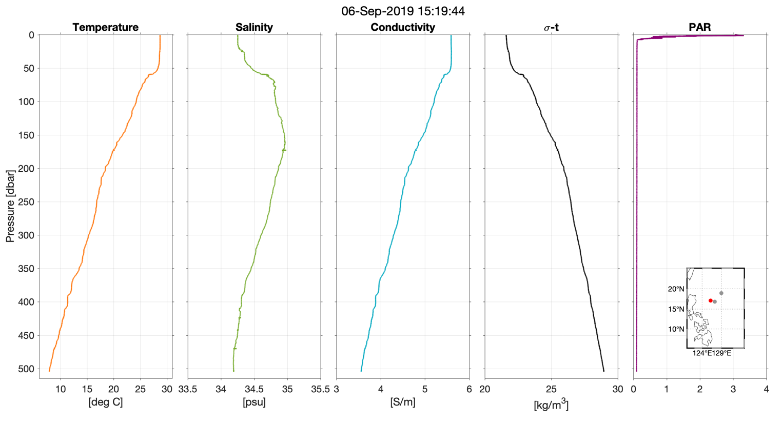
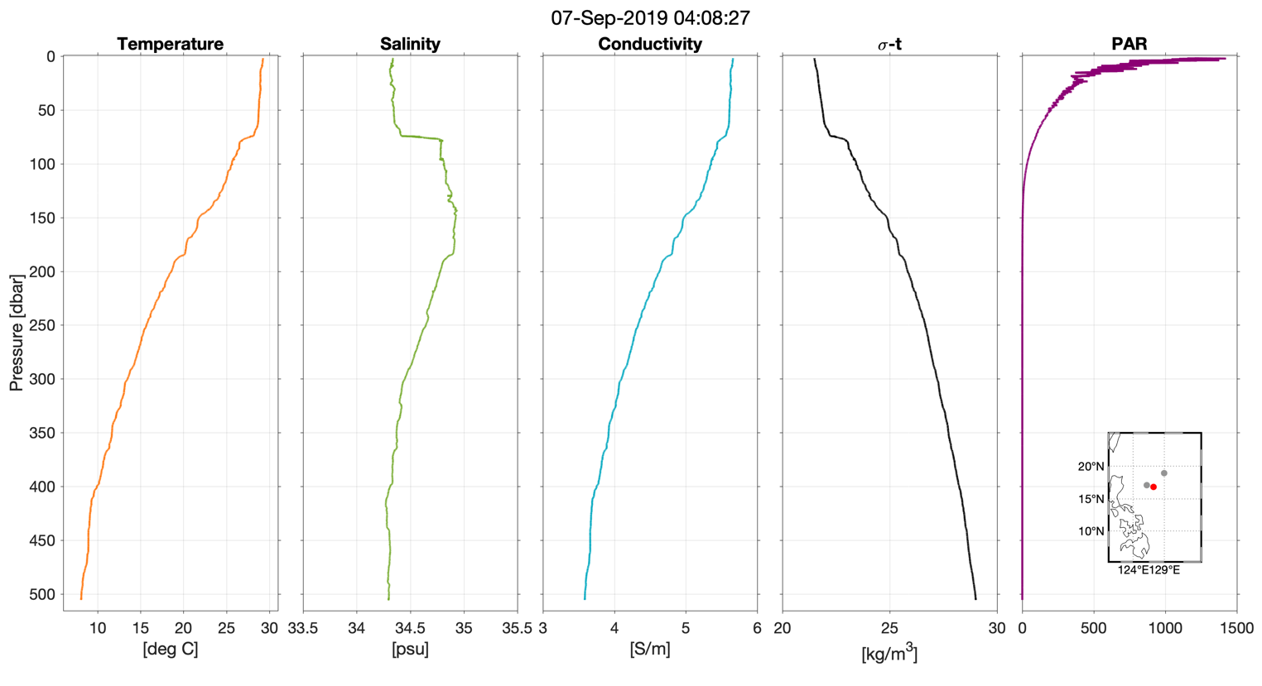

Fig. 1: CTD deployments from 9/6 (top) and 9/7 (bottom). Location of CTD is denoted by the red circle in the inset plots in the lower-right corner of each plot, with gray circles marking the location of previous CTD measurements

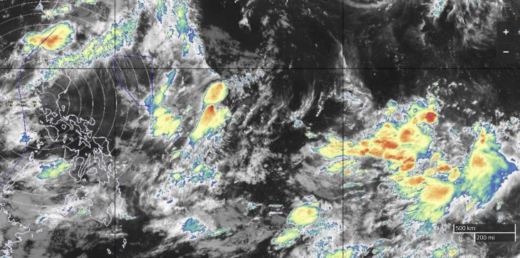
95L

Fig. 2: IR satellite overview. Red shaded area is the ops region, white dot is the current ship location.

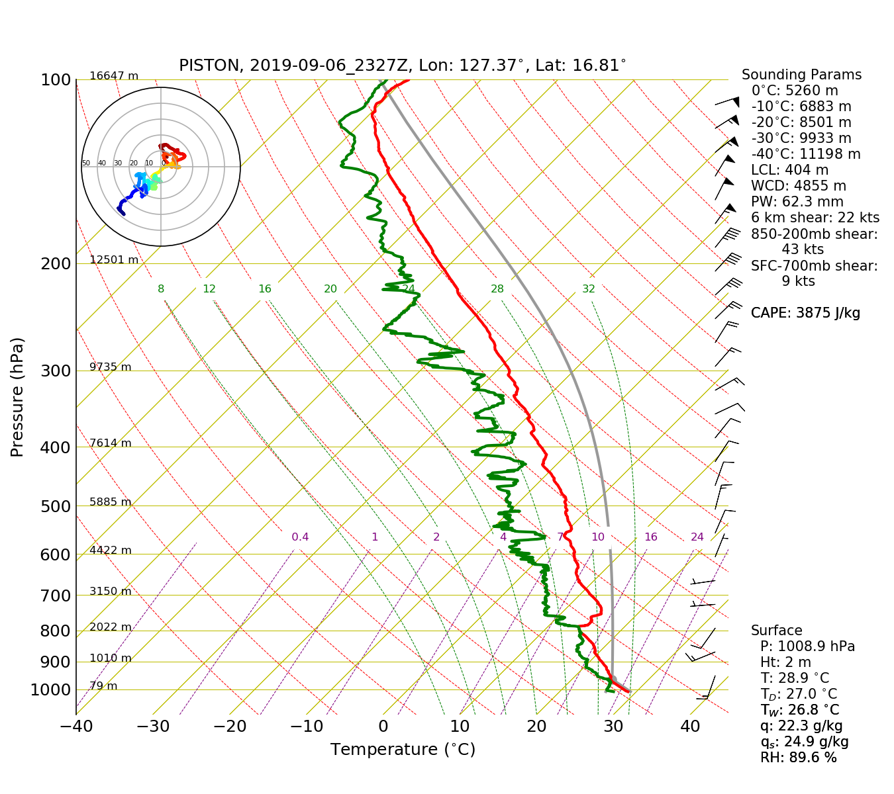
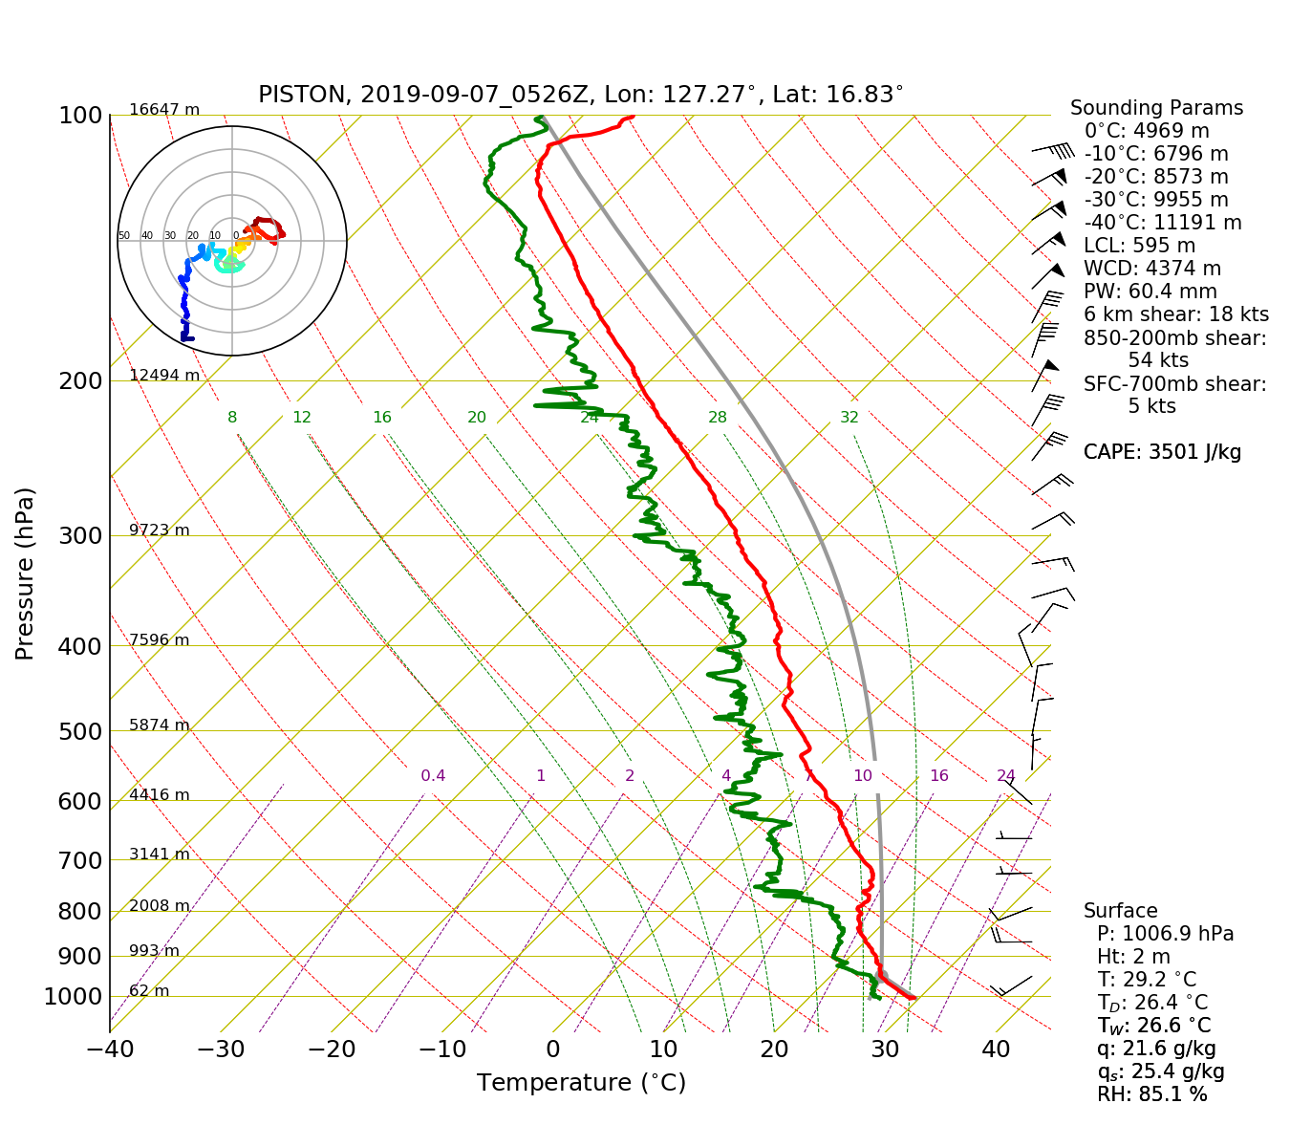

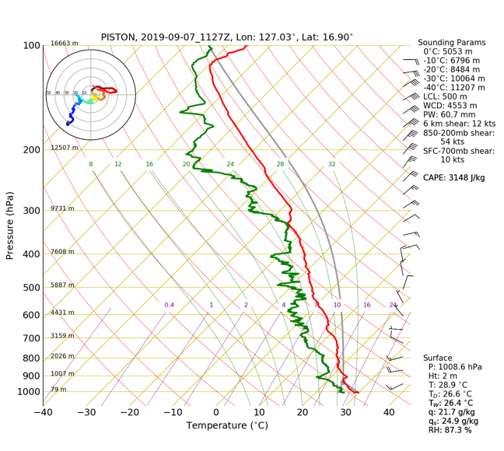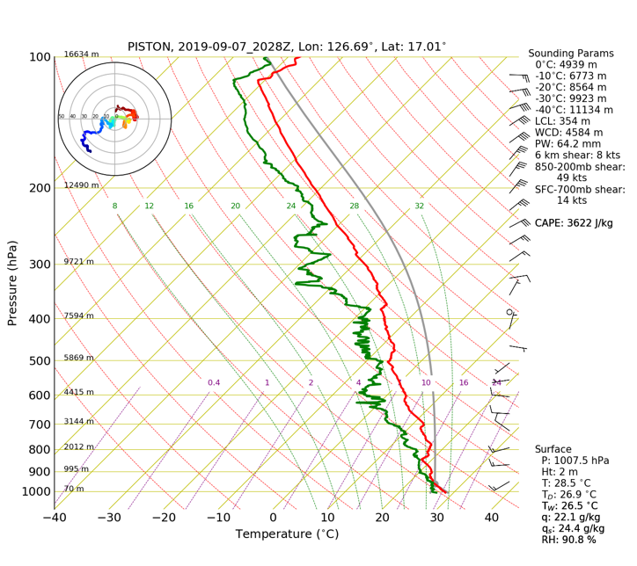

Fig. 3: 0, 6, 12, and 21 UTC Soundings

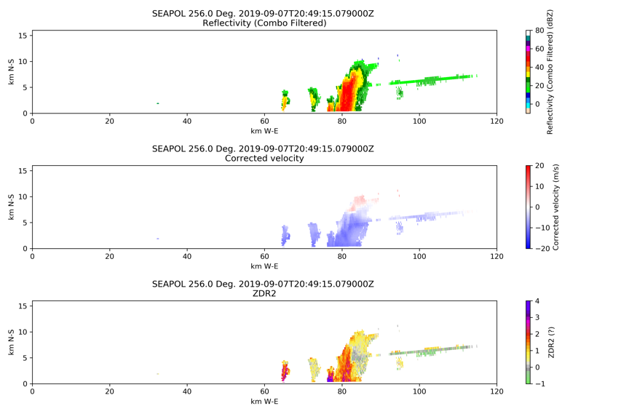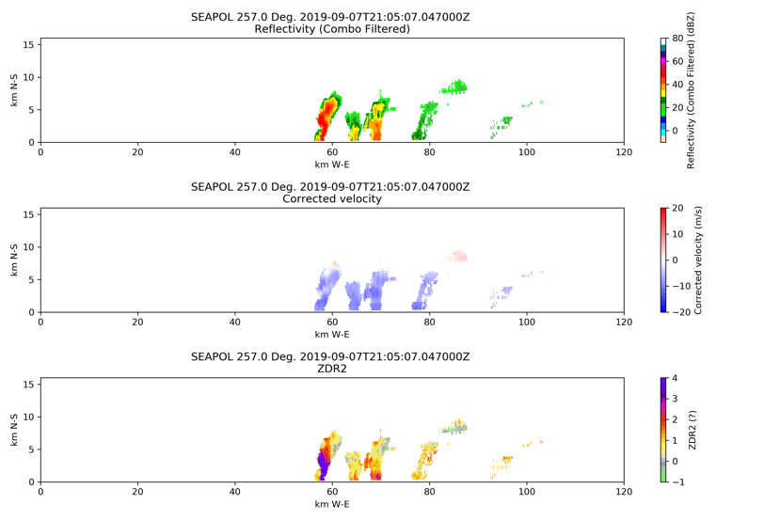
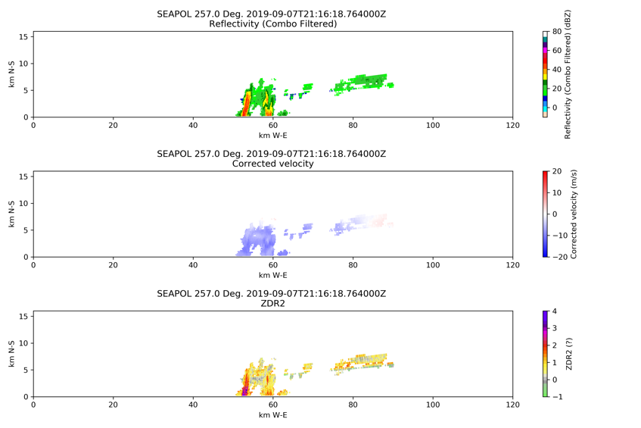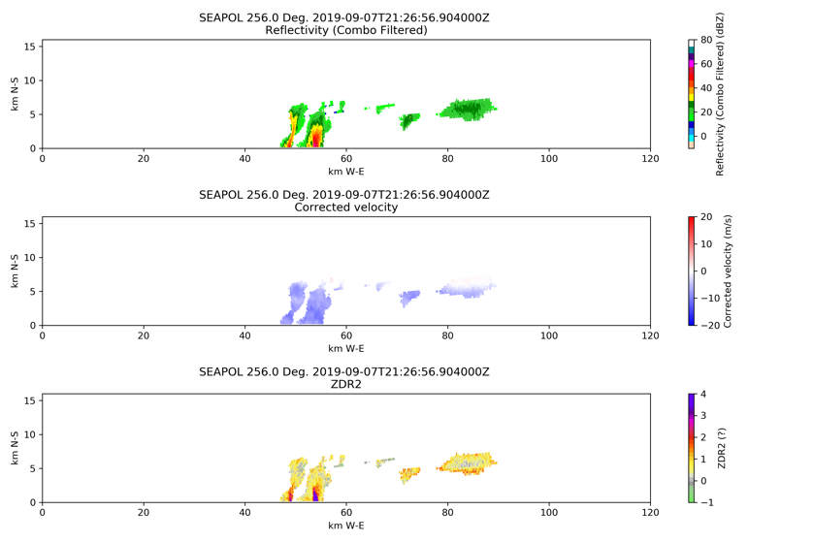
Fig 4: Life cycle of a warm rain cell at 60 km from SEA-POL. 2049 (upper left), 2105 (upper right), 2116 (lower left), and 2126 (lower right) UTC.

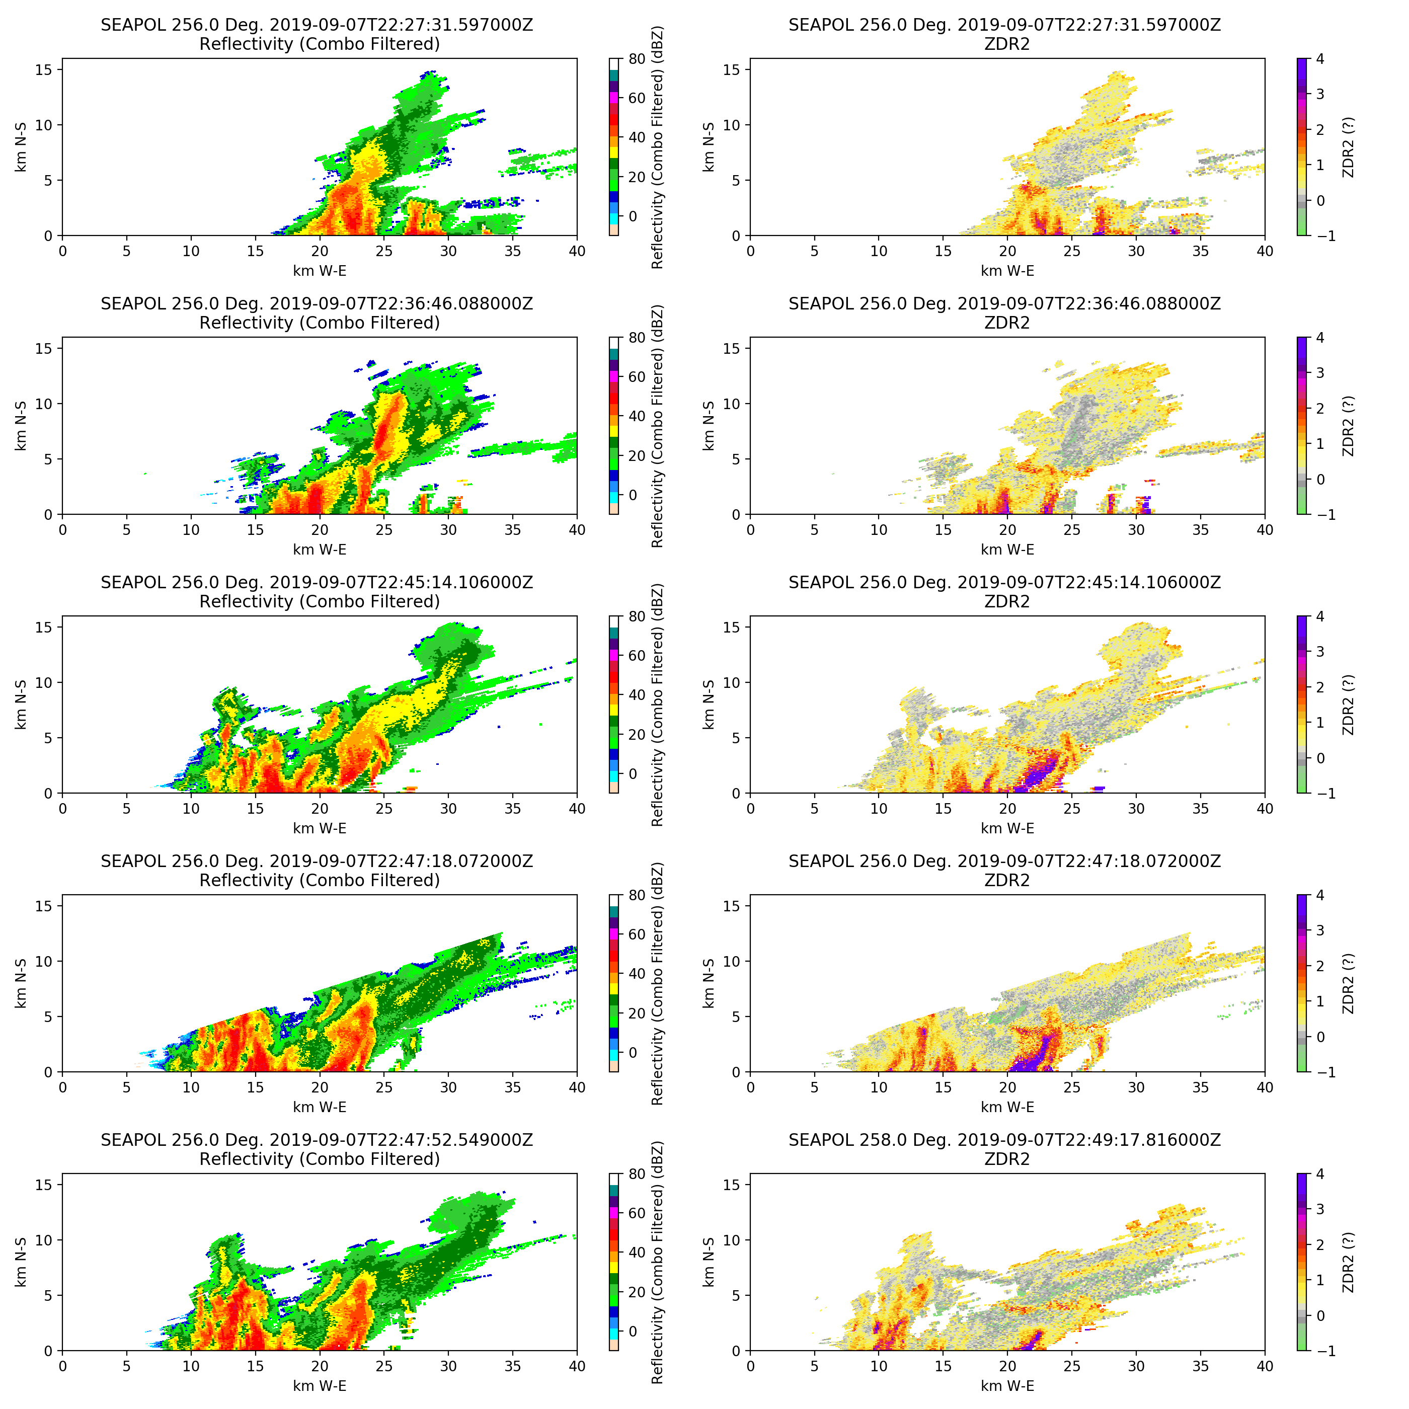
Fig. 5: Timeseries of the storm that rolled over the ship at 2320 UTC. Arrows illustrate features of Zdr of interest including the graupel core and rain out, and the reflectivity plume (blue arrow).

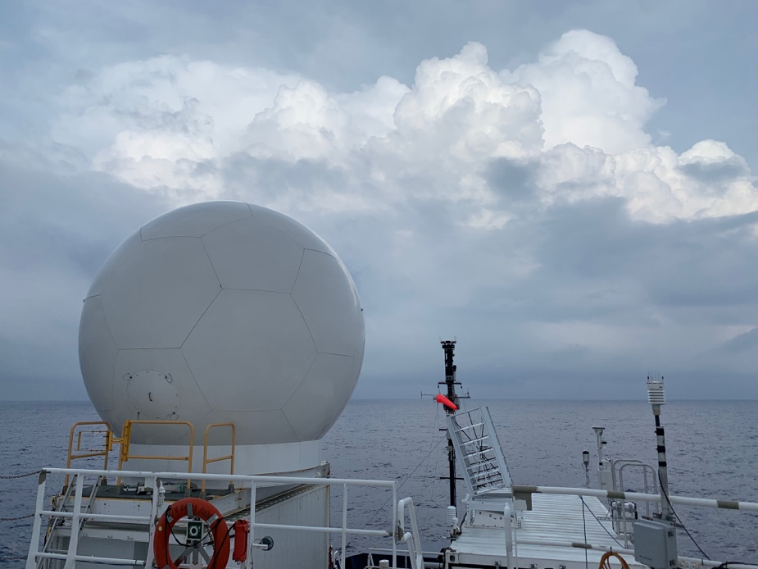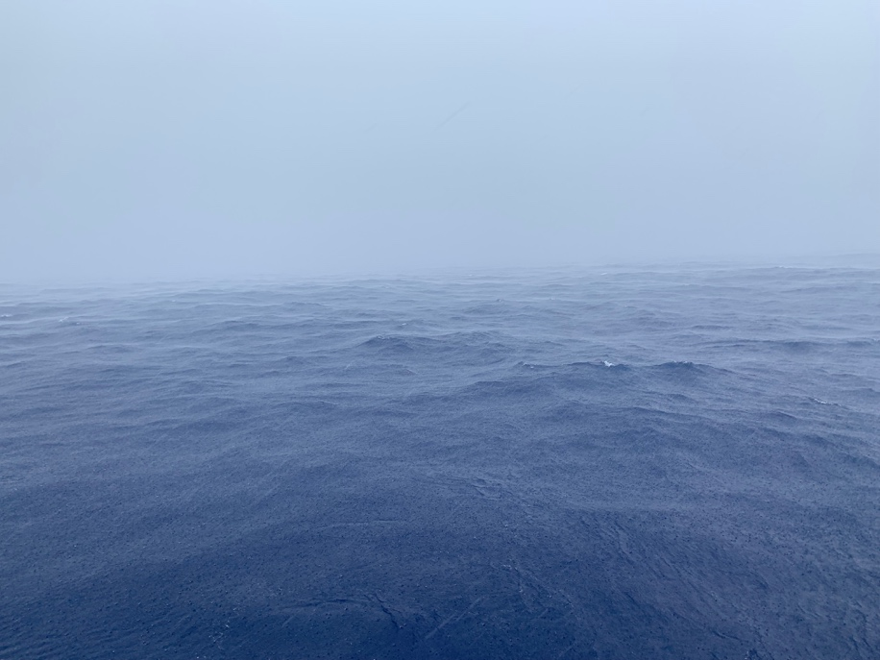
Figure 6: Left: SEA-POL scanning the incoming convection. Right: Rain at the ship.

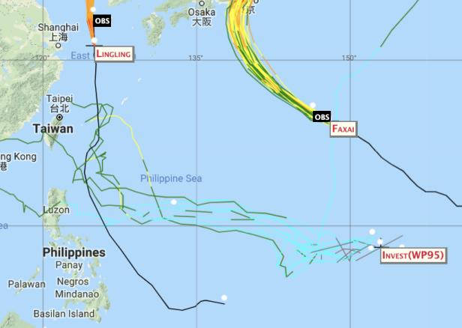
Fig 6: Model ensemble tracks for Invest 95L (WP95)

