PISTON 2019 Daily Science Summary

9 September Daily Summary: First CAMP2EX P3 Overflight
PISTON 2, R/V Sally Ride

Prepared by: Brenda Dolan, Kyle Chudler, Adam Clayton, Marqi Rocque, and Jim George

Today was the first day of coordinated operations with the NASA CAMPEx project and the NASA P3 aircraft. Initially they were going to be at the Sally Ride at 0330 – 0600 UTC in order to catch a Worldview satellite overpass at 0519 and we were instructed to be at 17.15 N and 126.23 E. We stayed at that point, within 5 km, all day. CAMPEx requested that we launch the 3 Z balloon early, at 0200 Z, so that it would be down by the time the P3 was working in the area, and we skipped the 0600 Z sounding for the same reason. They also requested that the W-band radar be off, so as not to blow out either the APR3 or the NOAA W-band. The P3 arrived at 0519 UTC, at which point we established comms via the radio. They worked around the Sally Ride from about 0519 to 0730 UTC. The main purpose of their mission was to overfly the HSRL. They did a box spiral over the ship, and several overpasses including at low altitude pass over the bow (Fig. 1).

After the passage of the MCS late on 8 Sept UTC, we had widespread coverage of pretty high clouds/ AltoCu (Fig. 2, 3) most of the day. The ceilometer and Lidar (Fig. 4) reported they were sitting at about 5 km, and were fairly thin (but optically thick). There were only stratiform fragments on the radar screen until about 0645 UTC, at which point afternoon popcorn convection started firing. The P3 reported that all clouds they were flying through were mixed phase. By 0710 UTC convection was firing in all directions, but particularly along a radial to the SE of SEA-POL (Fig. 5). I’m not sure if the P3 ended up working the developing line, but we scanned it with SEA-POL while they were in the area. We also took some RHIs, which showed echo tops were 12-14 km (Fig. 6). Soundings resumed at 09 Z, which showed a surprisingly dry upper troposphere in comparison to the 03 Z sounding (Fig. 7).

The remainder of the day was fairly quiet with some warm rain cells here and there that were followed through their lifecycle with RHIs as best we could capture it. A good example of this was an RHI series along 199º radial from 0845 to 0930 UTC (Fig. 8). One thing of note is that when we see the really large Zdrs, we see the correlation coefficient drop (Fig. 6, 8).

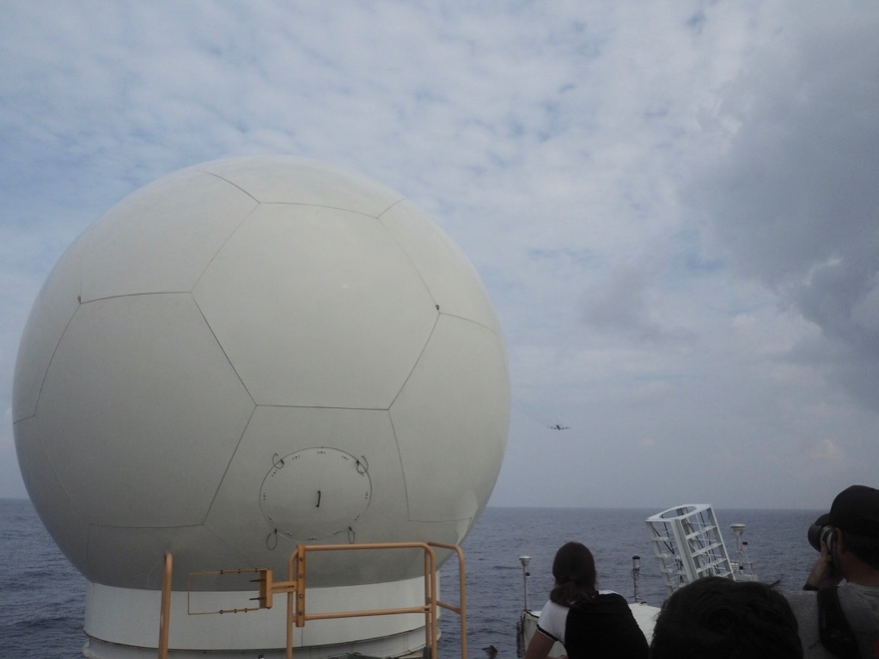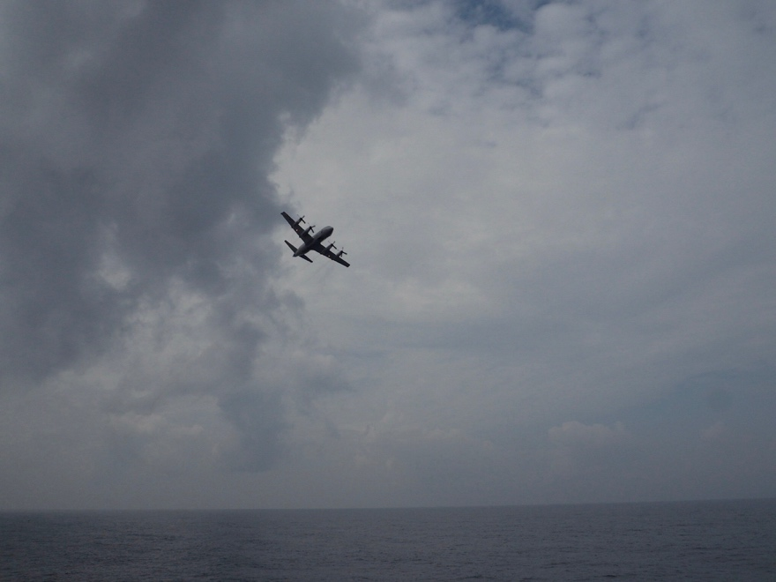
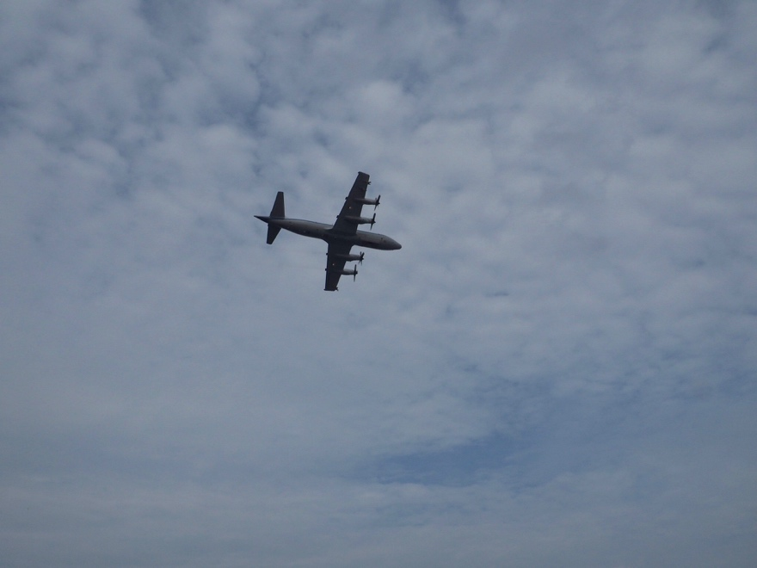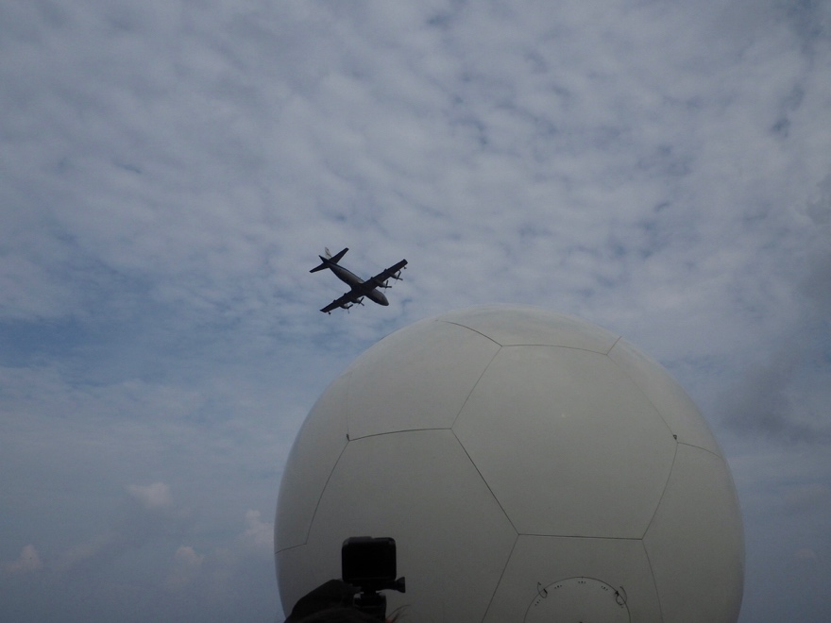
Fig. 1: P3 overflights of the Sally Ride at about 300 ft off the bow and 300 ft in altitude.

Fig. 2: IR view of the ops area around 0720 UTC.

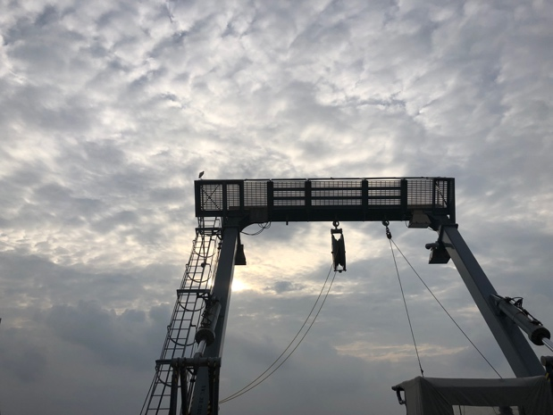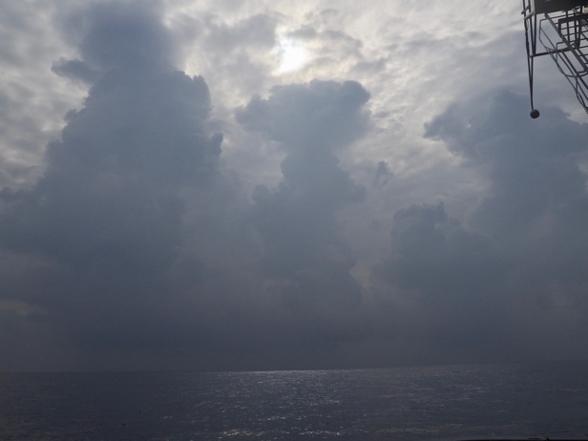
Fig. 3: Photo off the stern at 00 Z (left) and port stern at 0707 UTC (right).

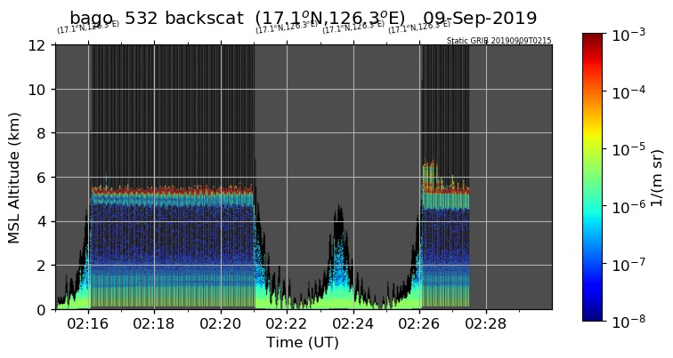
Fig. 4: HSRL backscatter from ~02 – 0230 UTC.

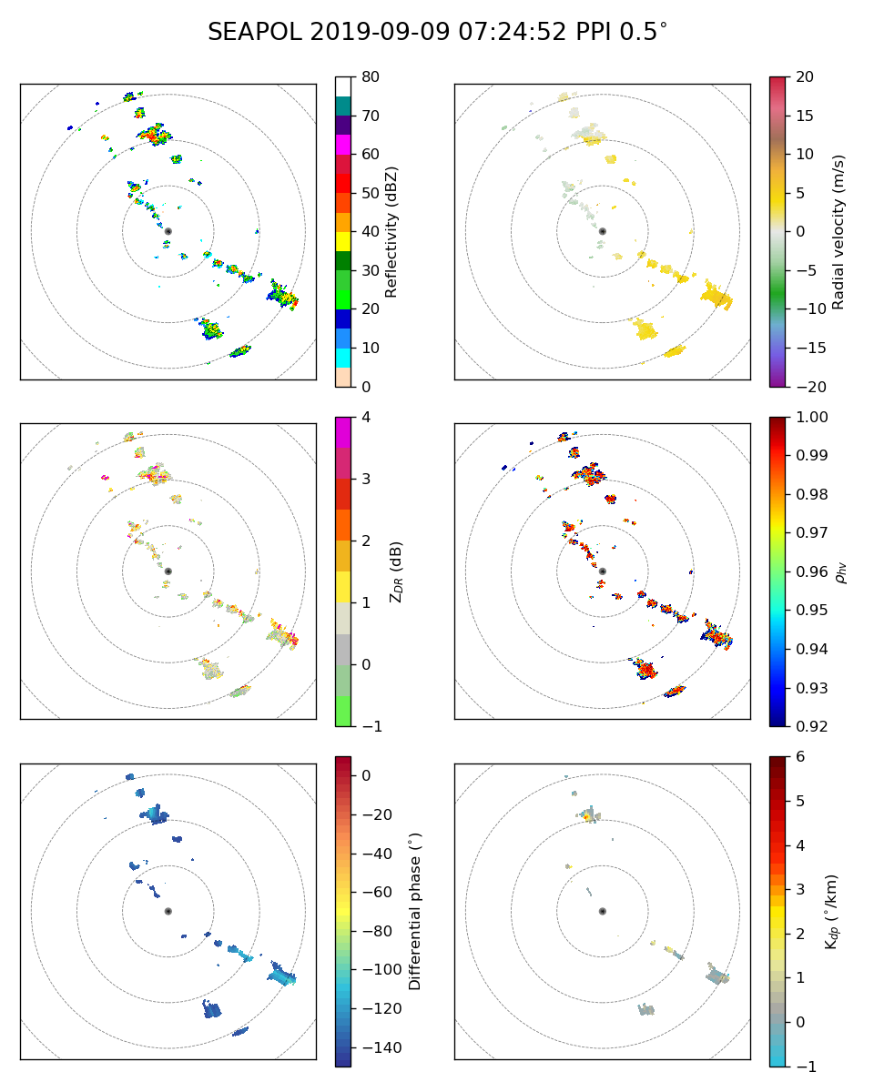
Fig. 5: PPI at 0724 UTC as the P3 was finishing the flight in the area of the Sally Ride.

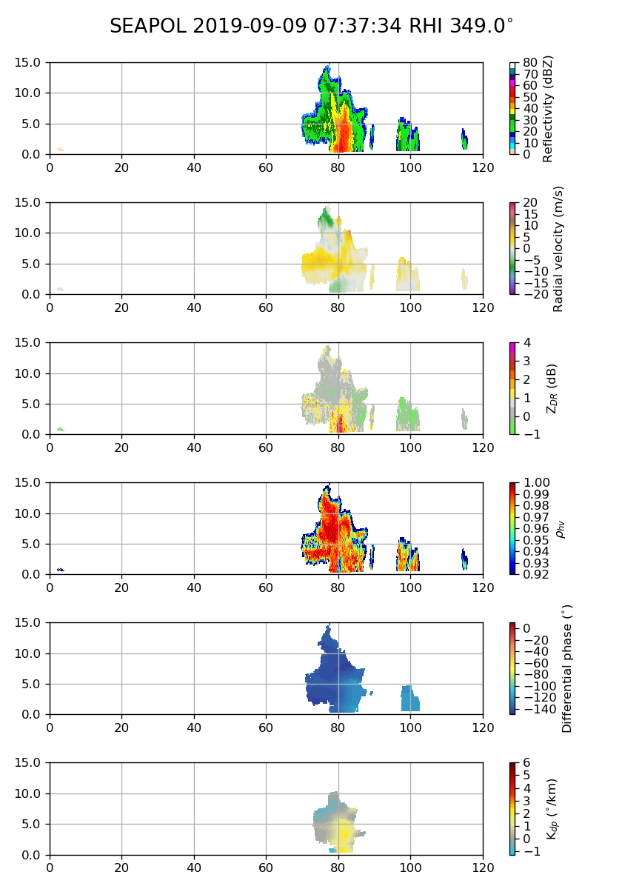
Fig. 6: RHI through convective cell to the north reaching 15 km at 0737 UTC.

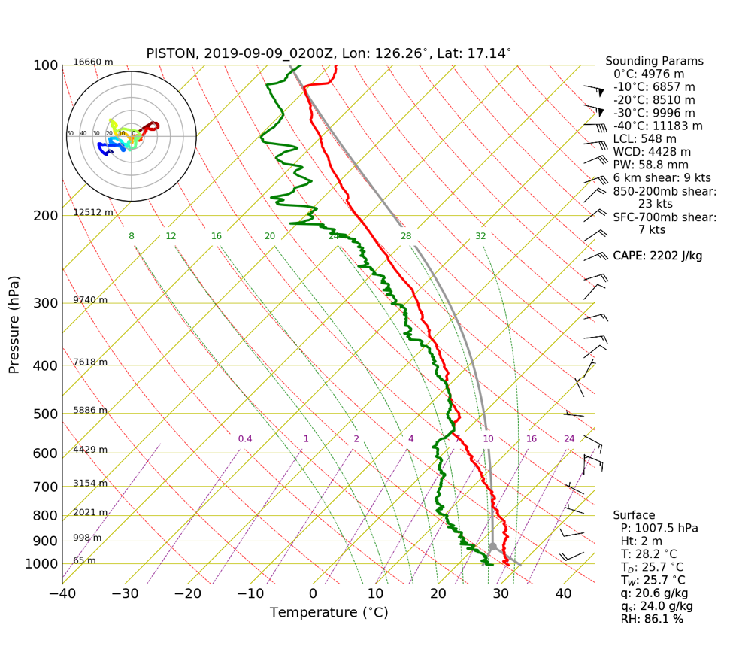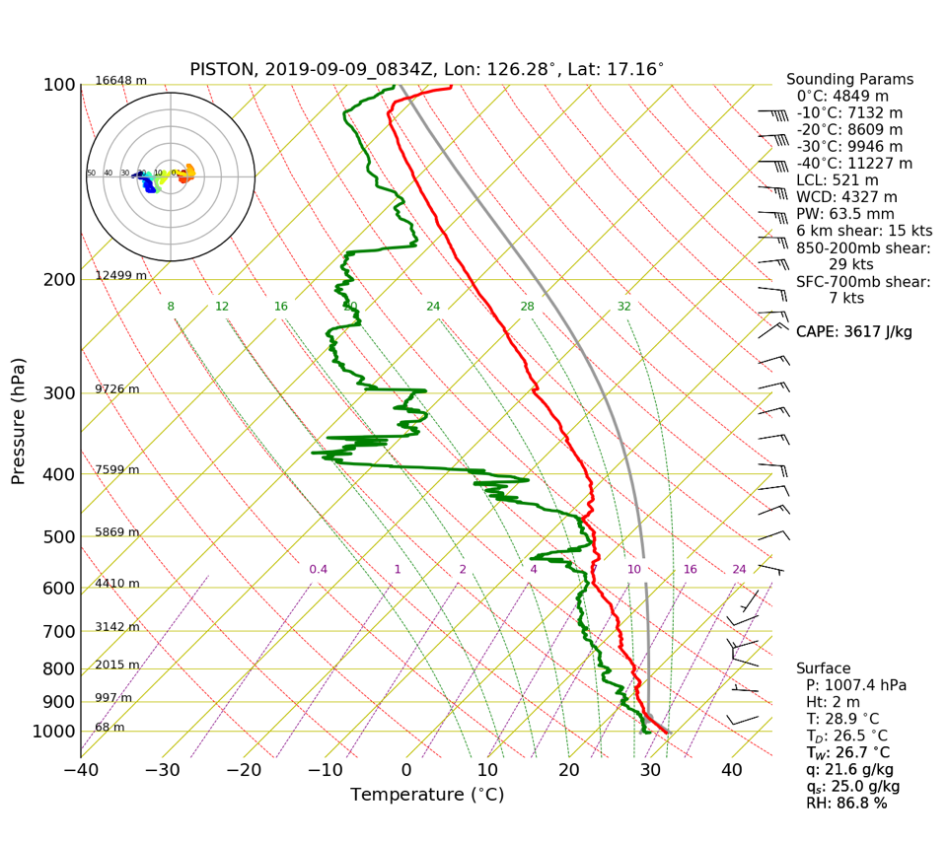
Fig. 7: 03Z and 09Z sounding.

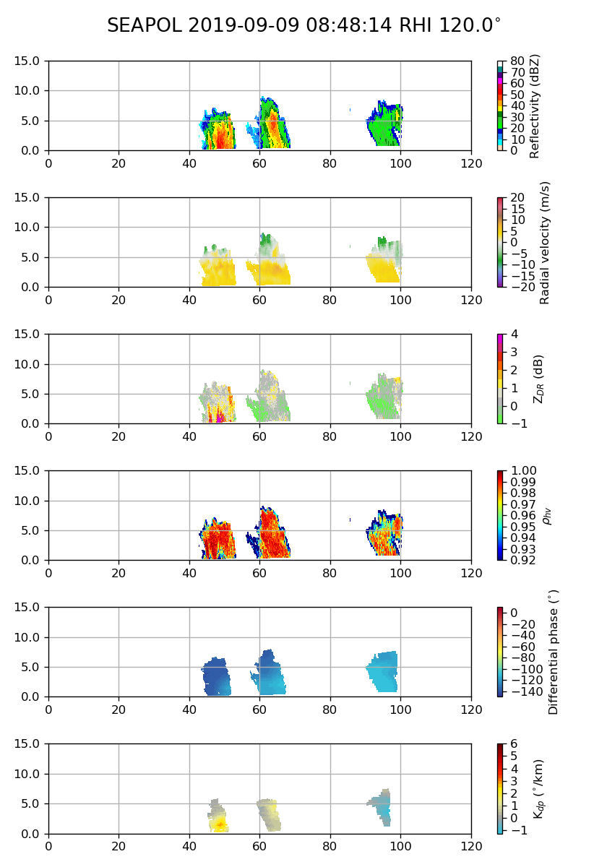
Fig. 8: Afternoon warm rain cells.

